BASH SCRIPT SESSIONS
Session-1
1.
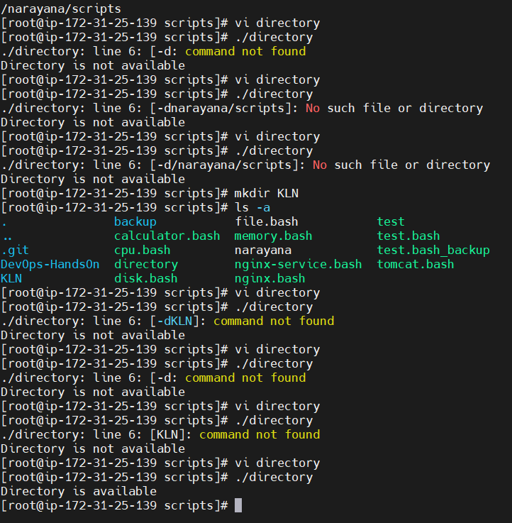
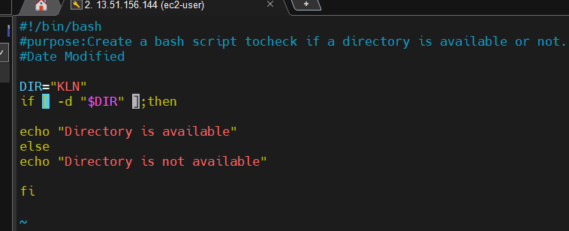

2.
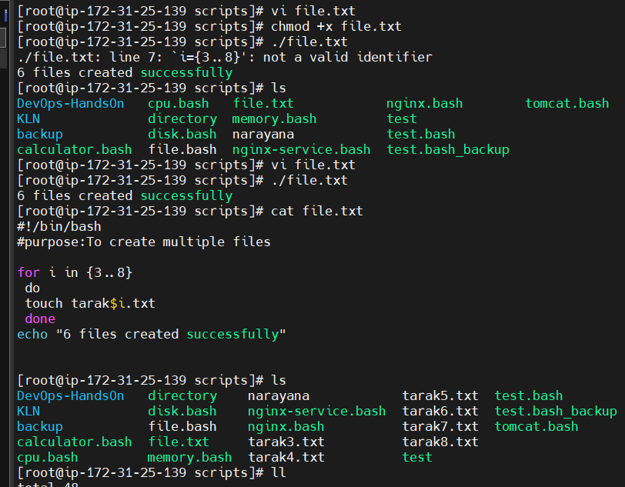

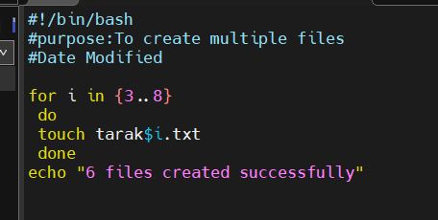

3.
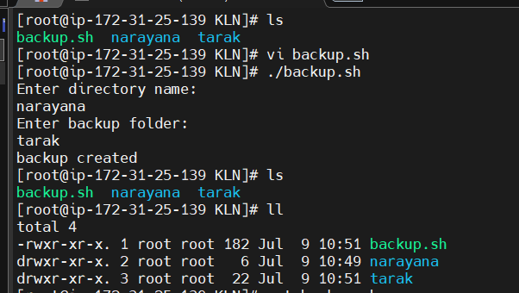
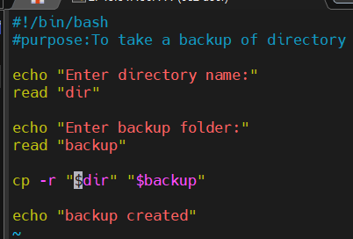
4.
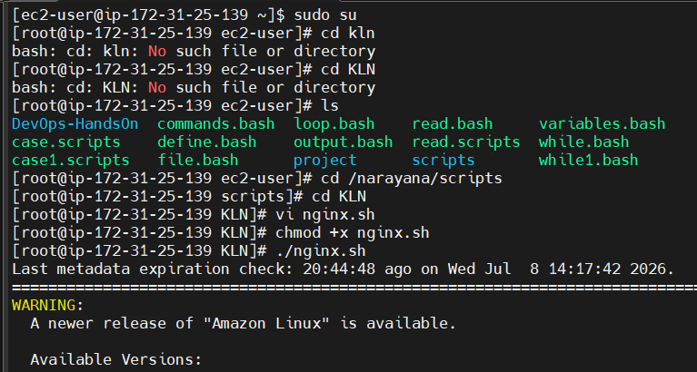
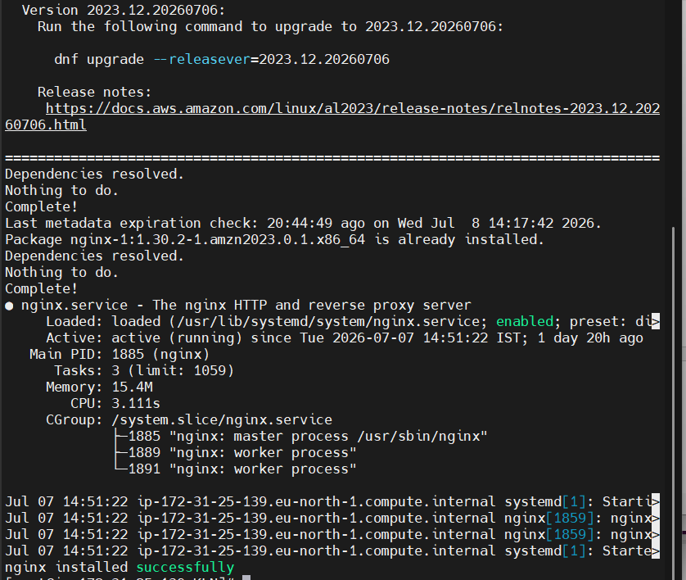

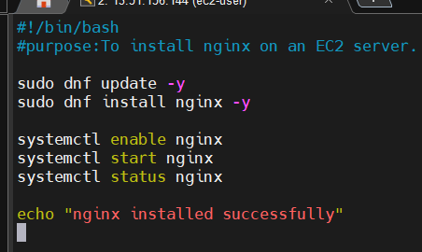
5.
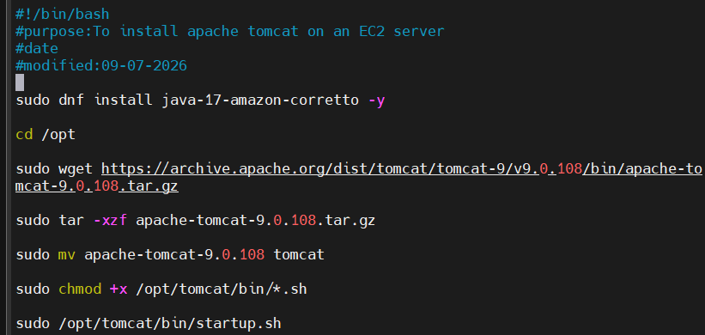
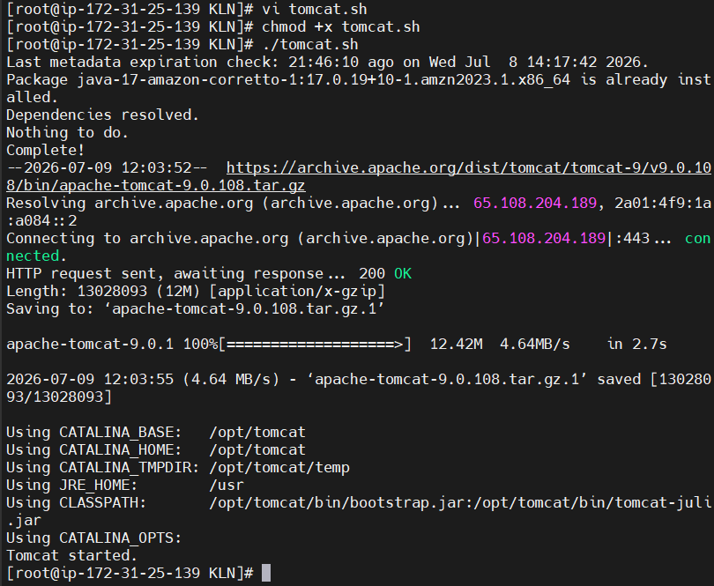
6.
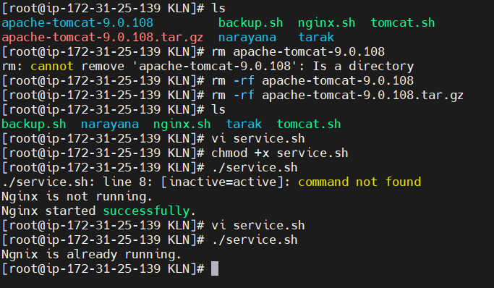
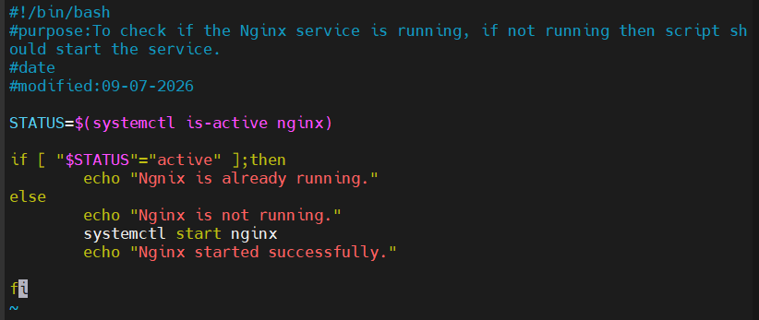

Session -2
- to check disk usage and display a warning if it exceeds 80%.

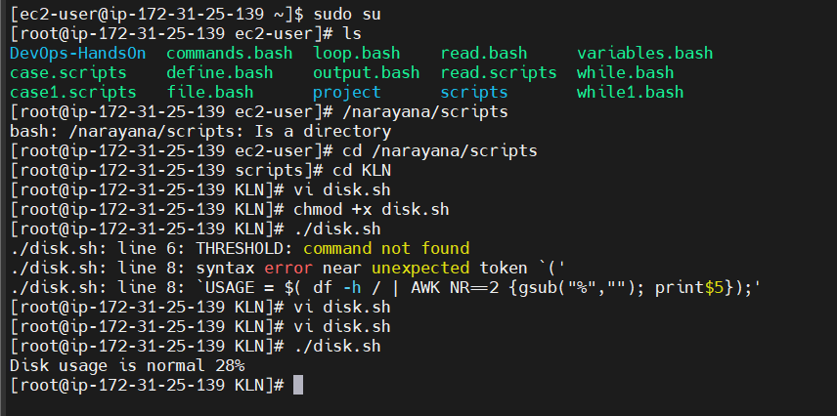
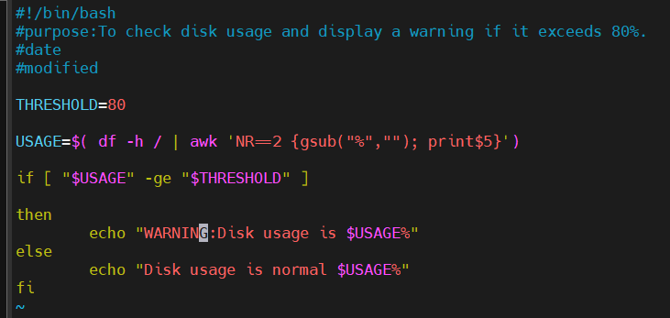
2. to monitor the current CPU usage of the system.
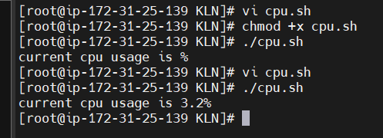
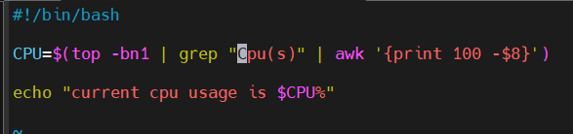

3.To back up the /var/log directory into a compressed archive with the current date in the filename.
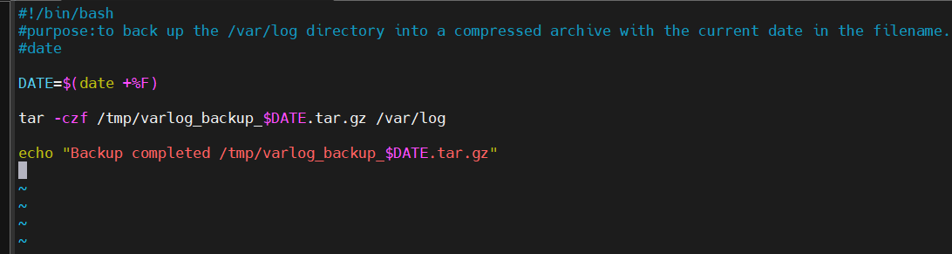
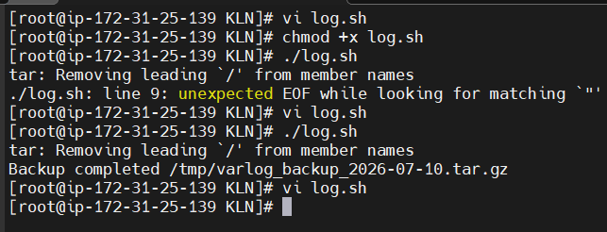

4. Bash script to create multiple Linux users from a predefined list.
Session -3
1.Write a Bash script to check whether a given file or directory exists. If it does not exist, create it.
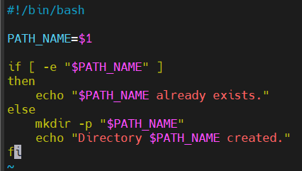
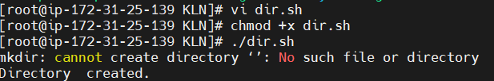
- Write a Bash script to find and display the top 5 largest files in a specified directory.

#!/bin/bash

DIR="/narayana/scripts"

if [ ! -d "$DIR" ]
then
echo "Directory does not exist."
exit 1
fi
echo "Top 5 Largest Files"
find "$DIR" -type f -exec ls -lh {} + | sort -k5 -hr | head -5
echo "Displayed top 5 largest files"

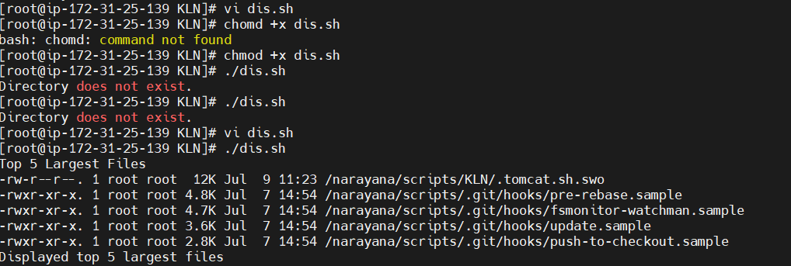

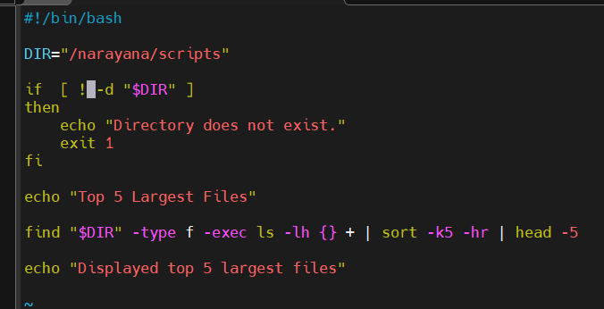

- Write a Bash script to monitor a log file in real time and display only the lines containing the word ERROR.

- Write a Bash script to check whether a website is accessible using its URL and display whether it is UP or DOWN.
- Write a Bash script to compress all .log files in a specified directory into a single .tar.gz archive.
- Write a Bash script to list all users who are currently logged into the system along with their login time.
- Write a Bash script to identify the top 5 processes consuming the highest CPU and memory.
- Write a Bash script to count the total number of files, directories, and symbolic links in a specified directory.
- Write a Bash script to find all empty files in a specified directory and delete them after user confirmation.
- Write a Bash script to generate a daily system report containing:
- Current Date & Time
- Hostname
- IP Address
- Logged-in Users
- Disk Usage
- Memory Usage
- CPU Load
- Running Services
- System Uptime

