Bash_Scripting

Bash scripting is the process of writing a series of commands in a text file (called a script) that the Bash (Bourne Again Shell) interpreter executes automatically.
Instead of typing the same Linux commands repeatedly in the terminal, you can save them in a script and run them whenever needed. Bash scripting is widely used for automation, system administration, application deployment, backups, monitoring, and task scheduling.
1: Switch to root user because we will not face any kind of issues with permission if we use root user
Command – sudo su
Change the root directory – cd
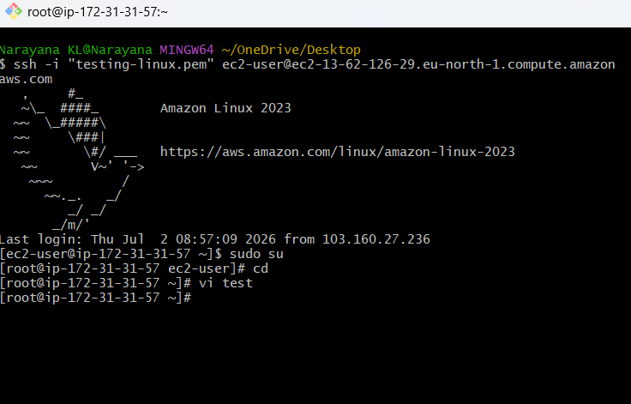
Command – vi test
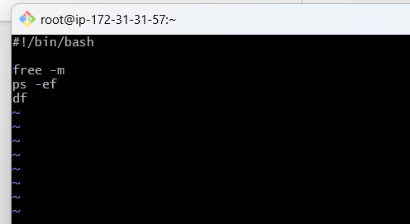Save &exit :wq!
Chmod 777 test – given all permissions to the file
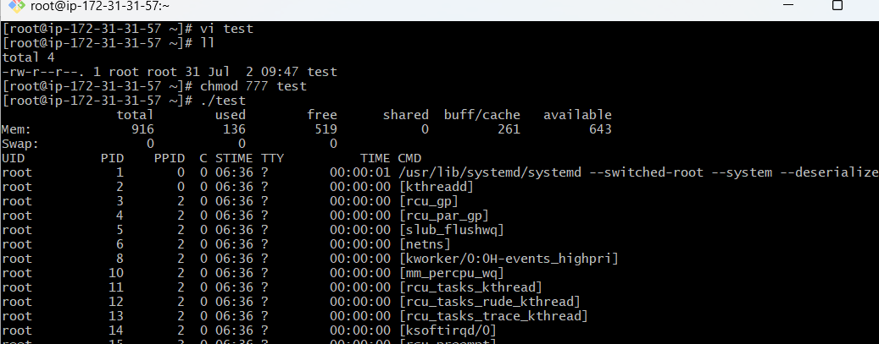
./test or bash test – to execute permssions.
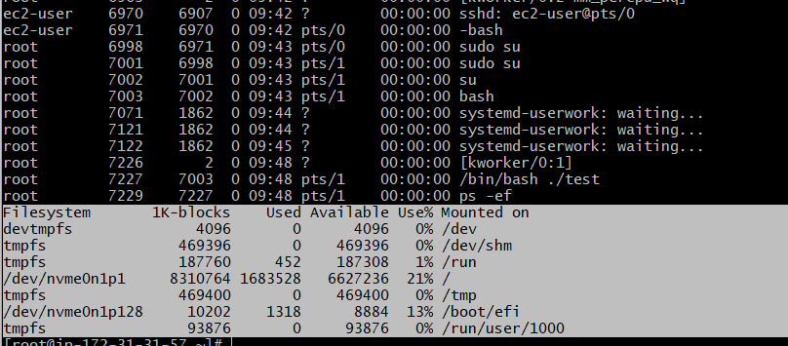
echo $0 – to check current shell which we are using.
Cat /etc/shells to check what are shells available in our machine.
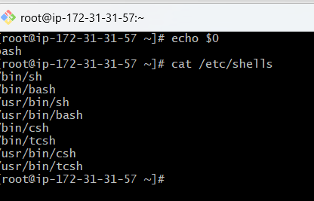
If we want to switch the shells we can use the name of the shell
Example : currently we are in bash shell if we want to csh we can execute csh and check echo $0 shows the shell csh
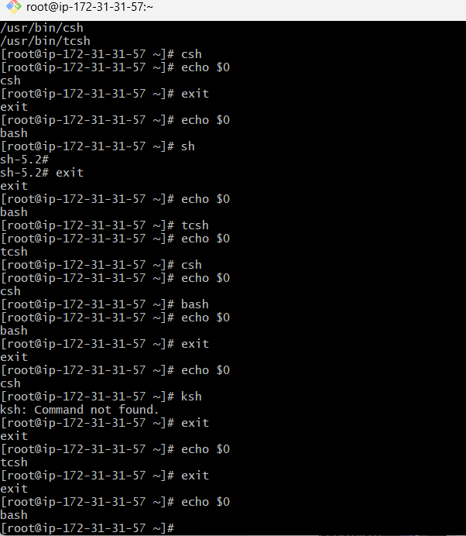

Mkdir -p /narayana/scripts – create directory
pwd to check the directory
vi helloworld – create one script
ll – to check long listing
chmod 777 helloworld – execute permissions
./helloworld or bash helloworld – to execute the script or it will configure the message which is the echo
And it is also called as relative path
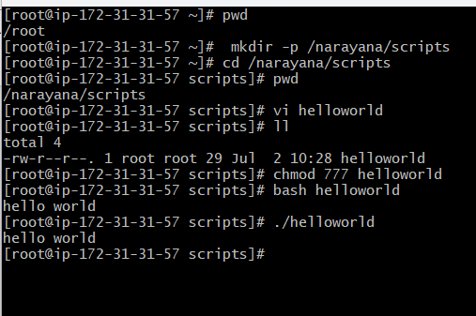
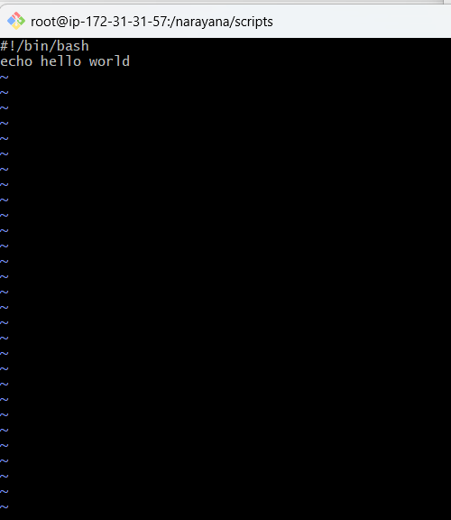
Now cd – change directory to root
Command – /narayana/scripts/helloworld
If suppose we are in root location and trying to execute script by passing directories and executing the script name it means that we are in absolute path.
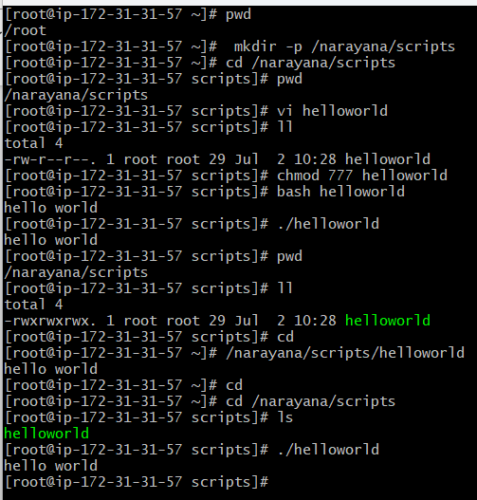
Script name should identify the function
Use cat command – cat helloworld
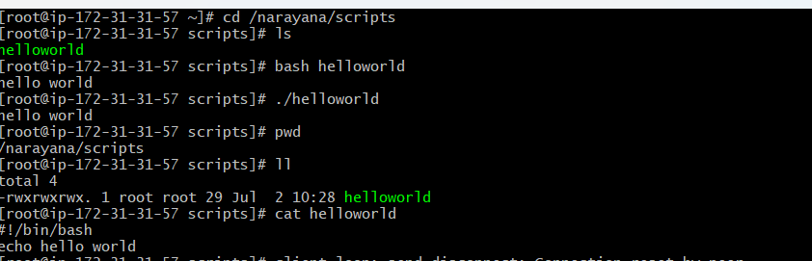
Script should end with .shell (If multiple shells are used) ex: .sh .bash
mv helloworld helloworld.bash
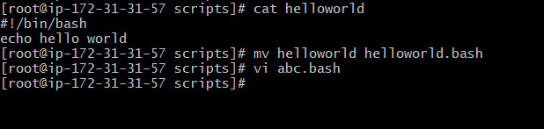
vi abc.bash
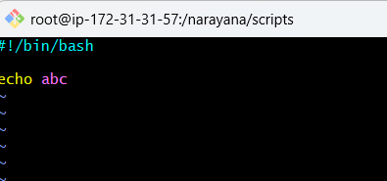
./abc.bash it fails
Error: permissiom denied
We have to execute the permissions
Where as bash abc.bash it works doesn’t throw the error because ./ need permissions
Chmod 777 abc.bash
Now try ./abc.bash now it works
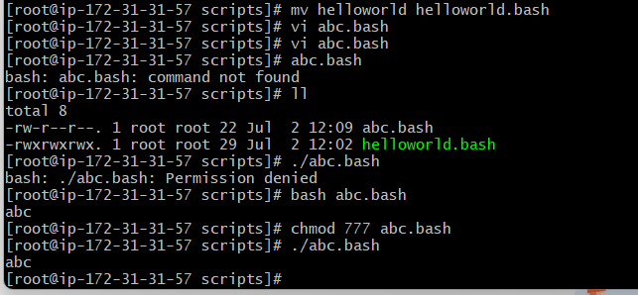
Steps which will help the other users to understand our script easily.
1) Define shell (#!/bin/bash)
2) Comments (# comments)
3) Define vairbales ( e.g name=Helloworld)
4) Commands (echo ,cp ,grep etc.)
5) Statements (if,while,for etc)
Use command – vi helloworld.bash
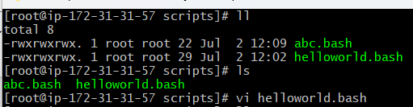
Now give the below script
Example:
#!/bin/bash
# Purpose: Testing script format
#Date: 02/07/2026
#Modification: 03/07/2026
a='Hello world'
echo $a
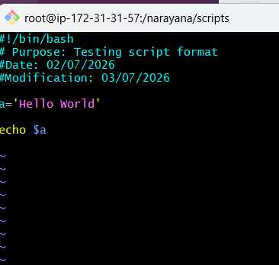
ll – longlisting
./helloworld.bash – shows the output Hello world
Now script name should identify the function
Command – cat helloworld.bash
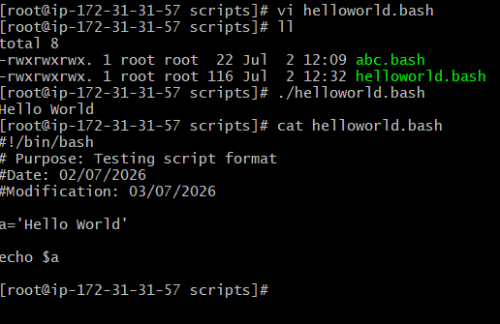

vi helloworld.bash
make the change Hello world to Hello Devops
when we use varaibles we change variable value then it will execute the same value which we changed in the script
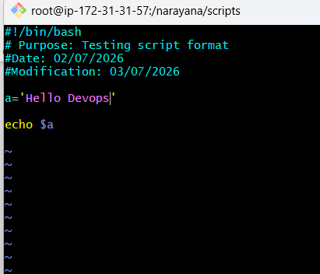
:wq!
./helloworld.bash – shows the output Hello Devops
Now script name should identify the function
Command – cat helloworld.bash
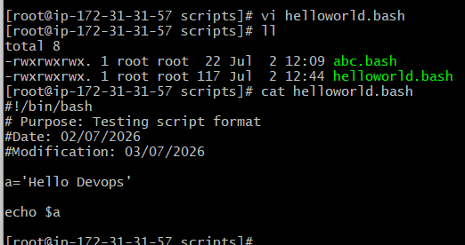
cd – now it changed to root
cat test – shows the previously executed test file
Sequence script:
Script will execute from top to bottom
Ex:
ls
date
history

cd /narayana/scripts -now it changed to another directory
rm -rf * to delete the entire directory in narayana/scripts
if use ls to check there won’t be any directories or files
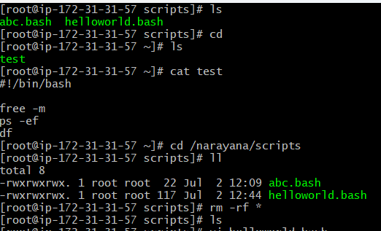
Now create another vi helloworld.bash in root directory

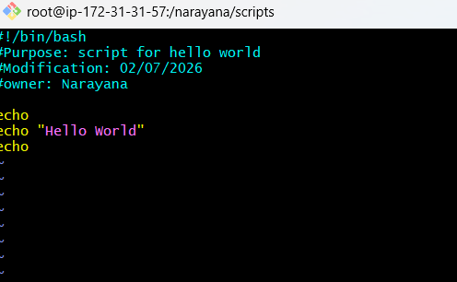
ll – longlisting
./helloworld.bash – shows the output Hello world
Now script name should identify the function
Command – cat helloworld.bash
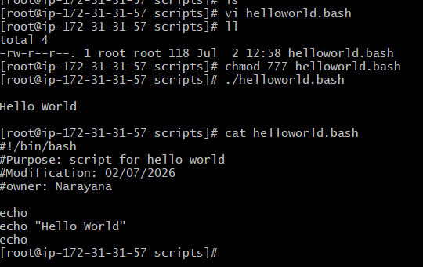
Basic Second script:
#!/bin/bash
pwd
ls
whoami
date
cal
touch a b c
vi commands.bash
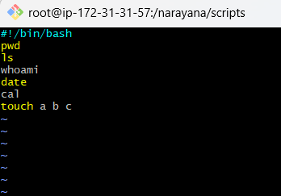
./commands.bash – shows the output
Now script name should identify the function
Command – cat commands.bash
vi command.bash
here now instead of pwd we gave pwdi there is no command pwdi so it throws error

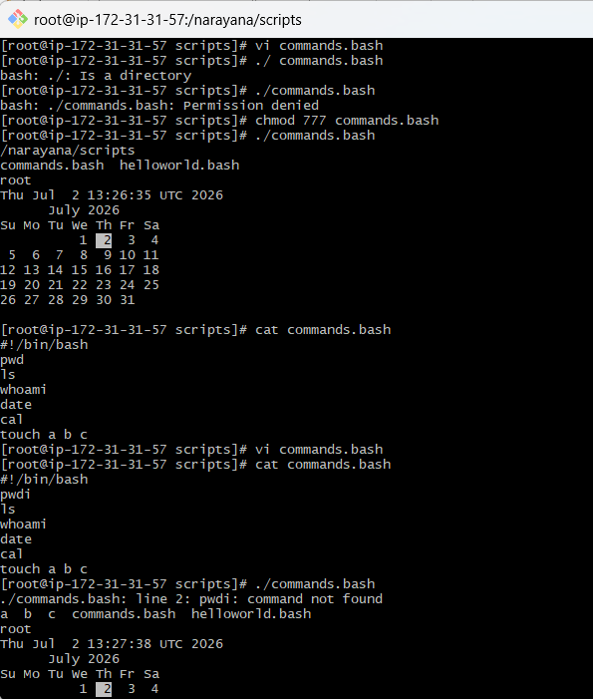
Basic Administration Tasks:
top
df -h
free -m
uptime
iostat
top get stucks because that will conitnously montior.
ctrl c to exit and it will execute other commands as well it will show below
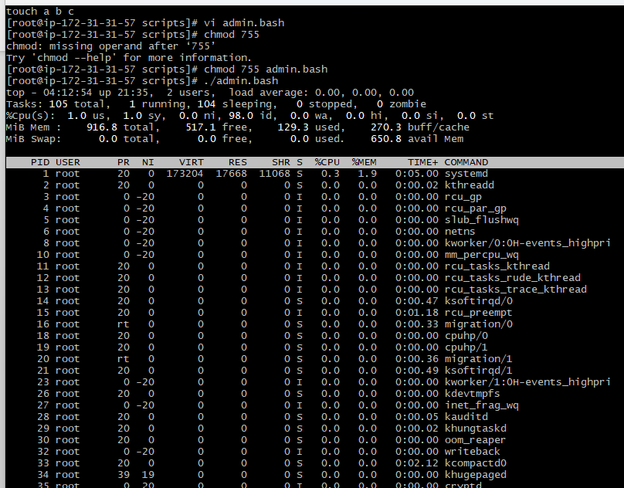
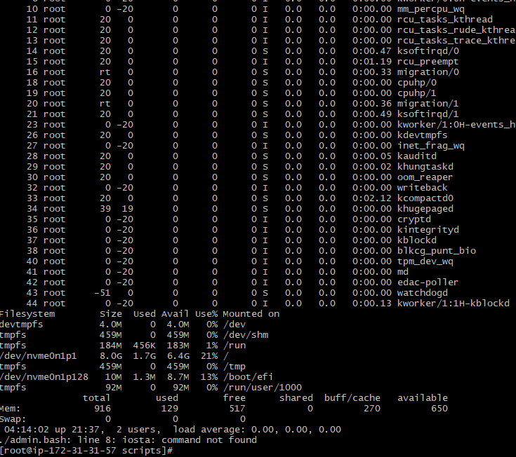
use top | head -10
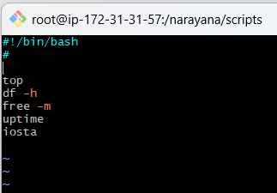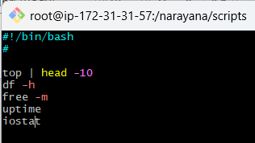
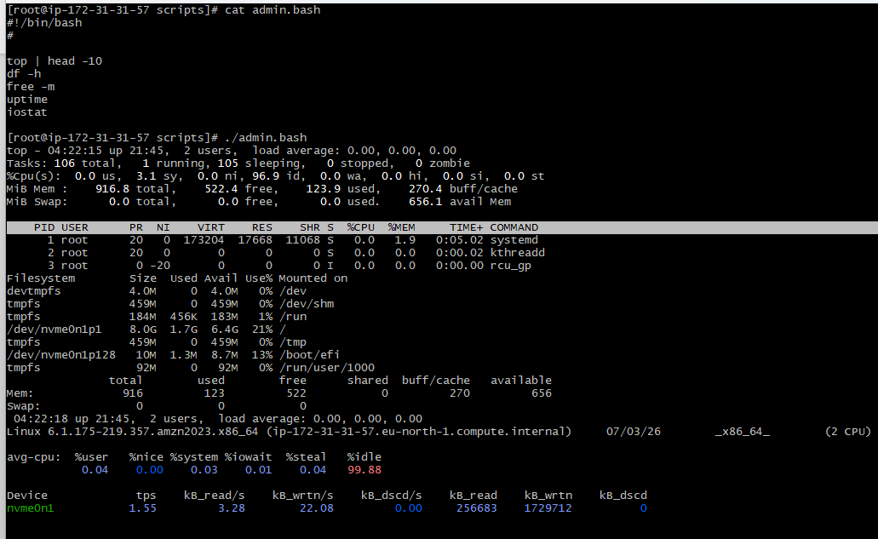
Defining Variables:
In programming, a variable is a value that can change, depending on conditions or on information passed to the program.
Example:#!/bin/bash
#Define Variables
p=pwd
l=ls
wi=whoami
d=date
c='cal 2023'

echo Run Variables tasks
echo
$p
$l
$wi
$d
$c
Commands:
vi variables.bash
chmod 777
./variables.bash
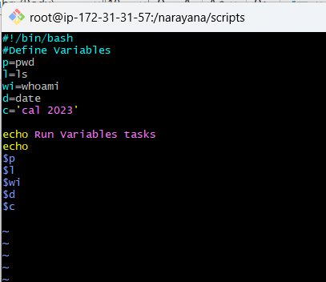
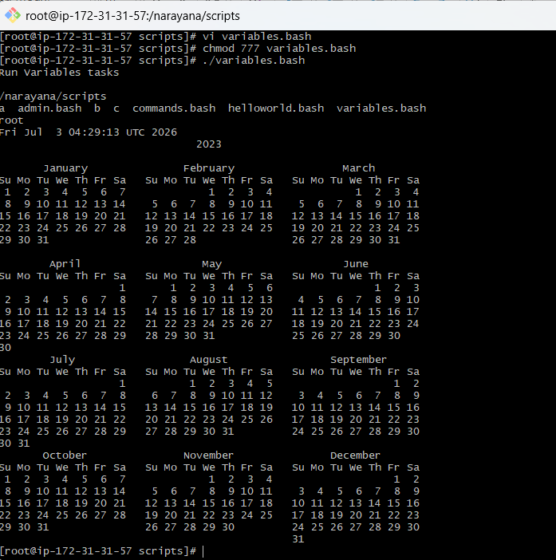
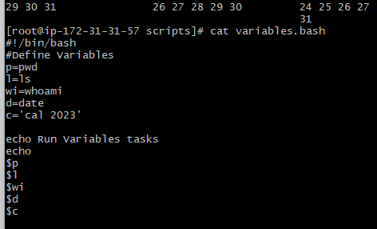
Input/Output script:
read --> To take command from user
echo --> to print the output
Ex1:#!/bin/bash
echo Hello, my name is sabair
echo
echo what is your name?
read name
echo
echo Hello $name
echo
commands : vi input.bash
chmod 777 input.bash
./input.bash
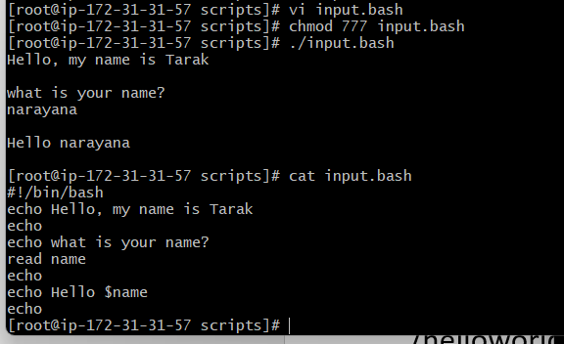
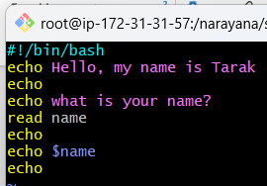
Ex2:#!/bin/bash
#we need to use the ticks if you want to use this in echo or else not required
a=`hostname`
echo Hello, my name is $a
echo
echo what is your name?
read b
echo
echo Hello $b
echo
commands:vi output.bash
chmod 777 output.bash
./output.bash
Cat output.bash
hostname
here hostname should execute the hostname but it is not executing because we need to use the ticks if you want to use this in echo or else not required
`hostname`
