04-Linux-Basics-Task2
1. Create user with name Techie and provide sudo access to user.
a. sudo means super user do and root is the super admins, now I will switch to root user using – sudo su command.
b. Now create new user Techie21 using command – useradd Techie21 and check the user – cat /etc/passwd
c. Now create password for the user using -passwd Techie21 command.
d.. Provided sudo access to the user Techie21
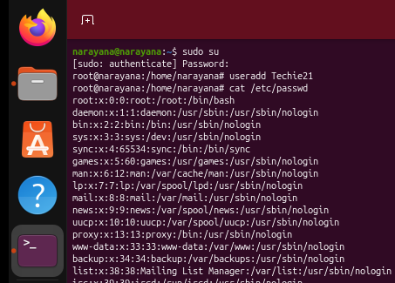
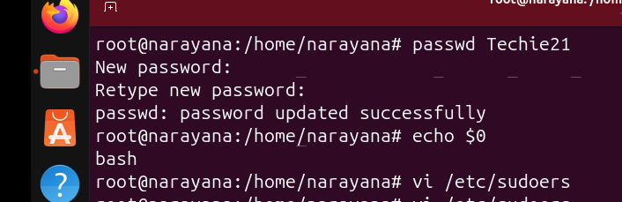
2. Navigate to the home directory.
a. Now use command -exit to Navigate to the home directory
3. Create a new directory.
a. To create directory we have to use – mkdir test1 and to create file we have to use – touch techie1, file and directory gets created by using those above commands
4. List the contents of a directory.
a. using ls - command listed the content of directory
b. ll – command is used for long listing
5. Change the current directory.
a. cd .. – command is used to change the current directory.
6. Create a new empty file.
a. using touch techie1 – command created new empty file, techie1 is file name.
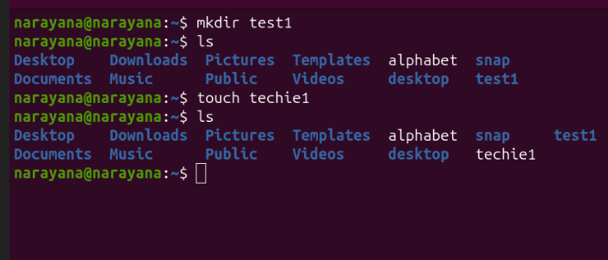
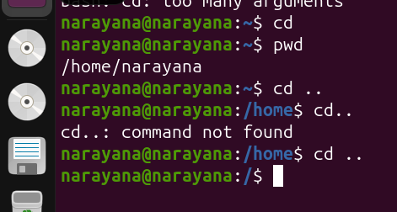
7. View the contents of a file
a. To add content to the file techie1 we have to use command vi techie1, I have added some alpabets example A,B,C,D,ABCD,GEFH and we use command – cat techie1 to view the content of files.
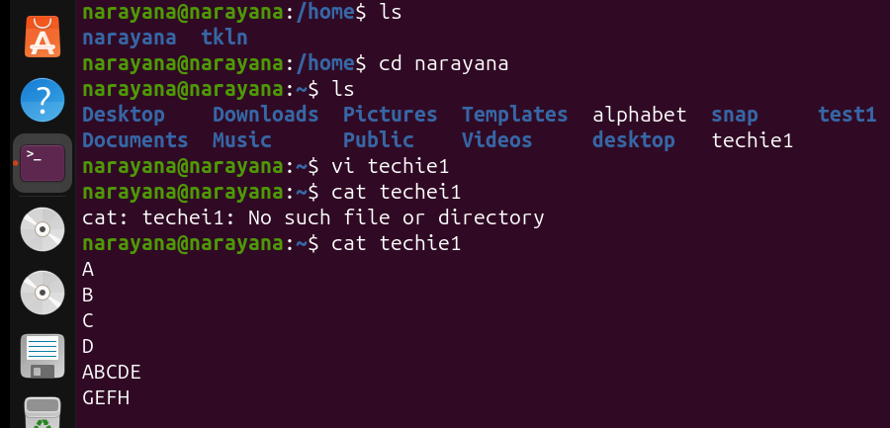
8. Copy a file to another location.
a. using cp tklnm alphabet – command we can copy the files or move the files to another location or another file.
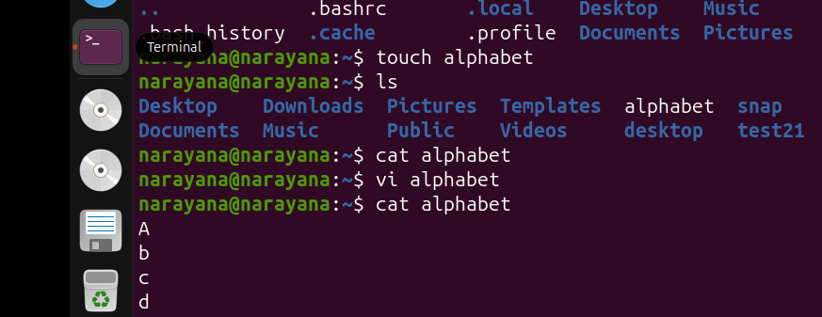

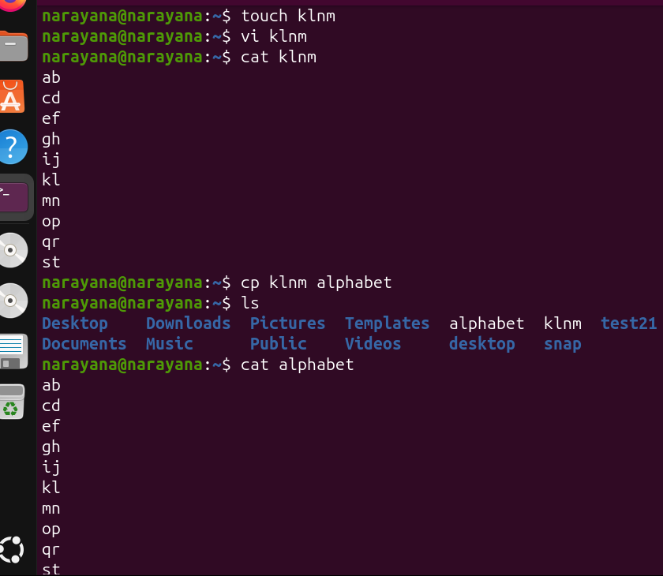
9. Move a file to another location.
a. Here file techie1 to another file alphabet we used mv techie1 alphabet – command.
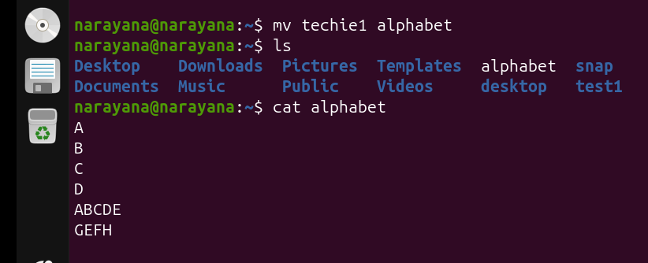

10. Rename a file.
a. we use mv alphabet alphabet21 – command to rename the file
11. Delete a file.
a. we use rm alphabet21 – command to remove the file or delete the file
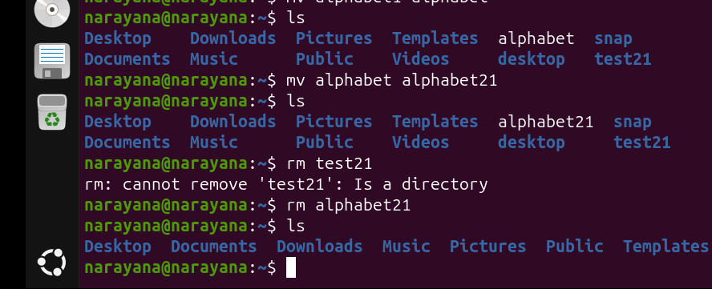
12. Grant or revoke permissions on a file or directory.
a. we use chmod 641 techie1 – command to grant or revoke permissions on a file or directory.
b. In the ss(screenshot) there is ll (long listng) of files and directories in that if there is drwxrw-r-x in this d refers to directory if there is d in the starting then we can identify it as directory
c. these three rwx|rwx|rwx are first one is user-owner, second one is user- group and third one is user-others
d. In rwx , r = read=4, w=write=2 & x=execute=1
e. If we give chmod 641 techie1 to the file it will change to rw-r----x you can refer to ss2 below.
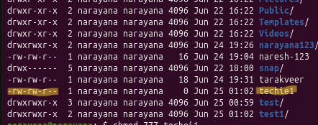

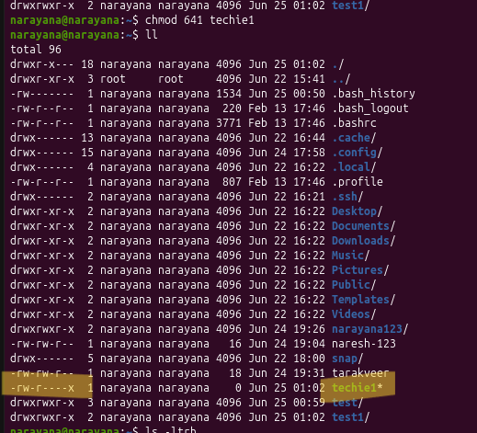
13. View the current date and time.
a. we use date – command to view the current date and time.
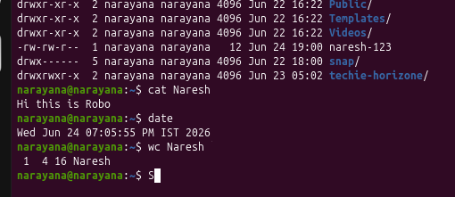
14. Check the system uptime.
a. we use uptime – command s used to display how long the system has been running.
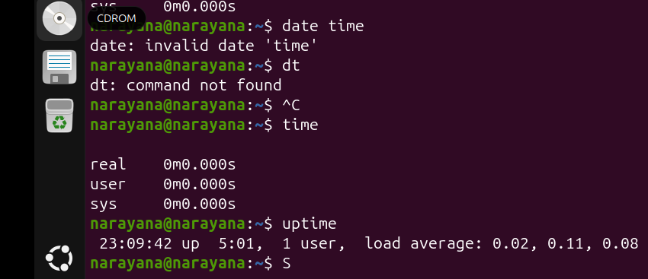
15. View the running processes.
a. we use ps -ef – command is used to display all currently running processes.
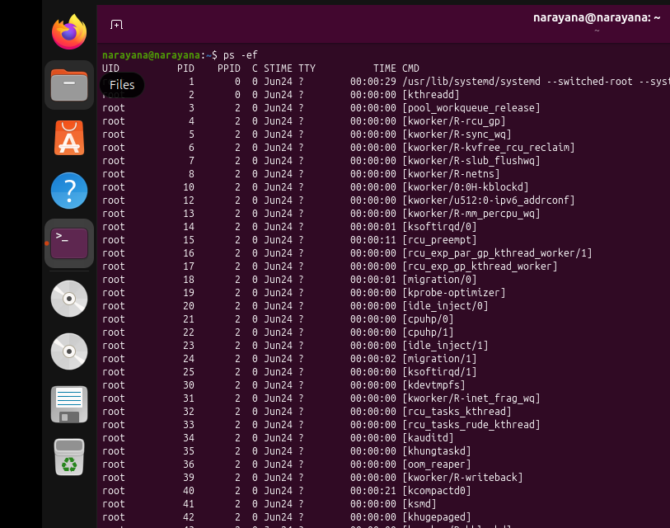
16. Kill a running process.
a. we use sudo kill -9 processid – command to kill the running process of the service.
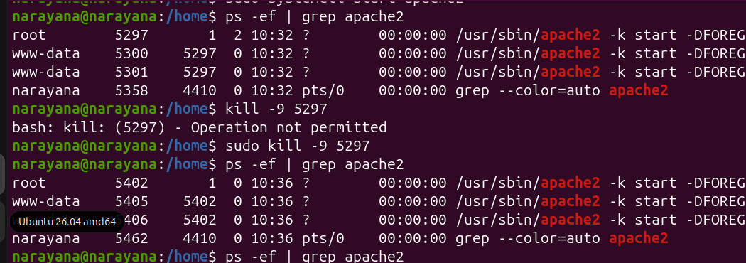

17. Install a package using the package manager.
a. we use sudo apt install apache2 – command is use tp install the package manager.
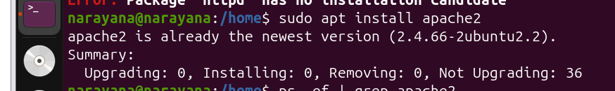
18.Update the system packages.
We use sudo apt update – command to update the system packages.
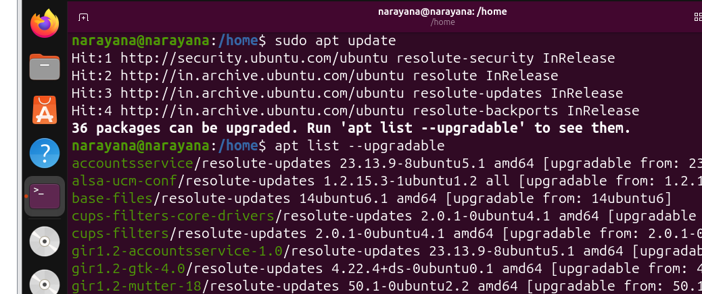
19. Create a symbolic link.
a. we use ln -s <target_file_or_directory> <symbolic_link_name> - command to create a symbolic (soft) link to another file or directory.

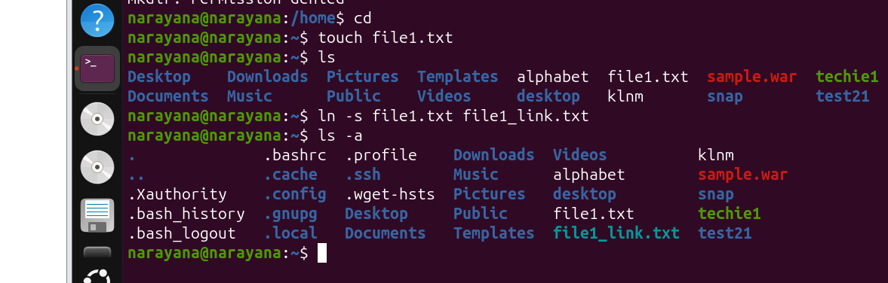
20. Search for files using the find command.
a. we use find / -name*.txt – command to search for files.
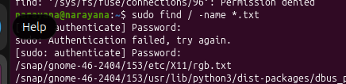
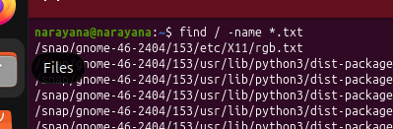

21. Compress and decompress files using tar.
a. we use tar cvf nari.tar test_tar/ – command to compress files using tar.
b. we use sudo tar xvf nari.tar – command to decompress files using tar.

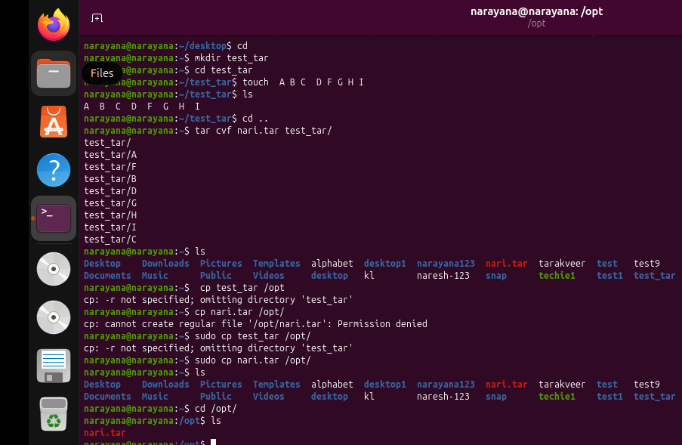
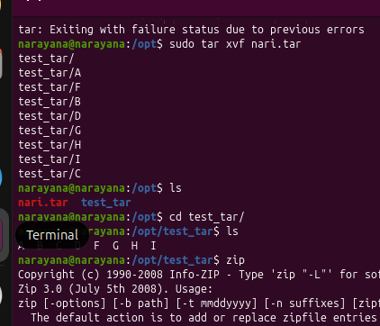

22. Monitor system resources with top or htop.
a. we use top command or htop command to monitor system resources.

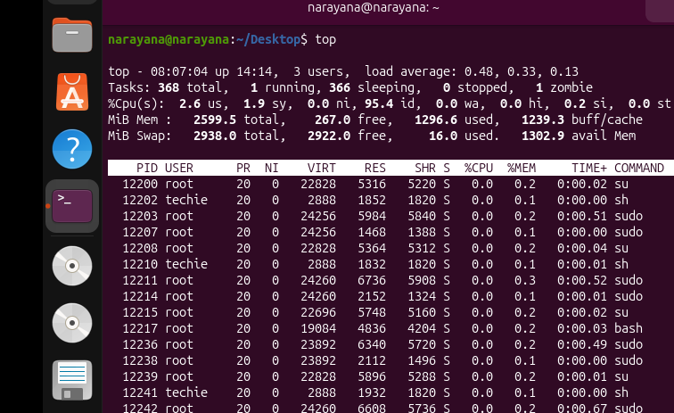
23. Create and manage user groups.
We can use adduser tkln– command to add the user(tkln- username) and we can use addgroup java – command to add the group (Java -groupname).

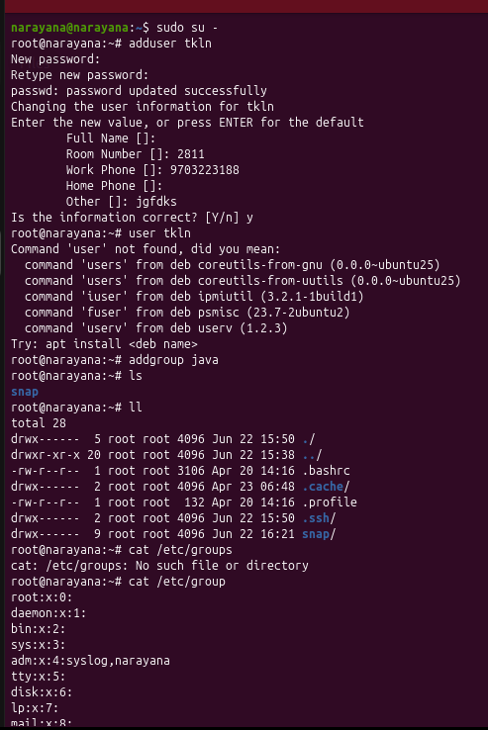
24. Set up SSH password less authentication.
a. we use whoami – command to fecth the details
and after we use ls -ld ~/.ssh – command to set up ssh password less authentication.
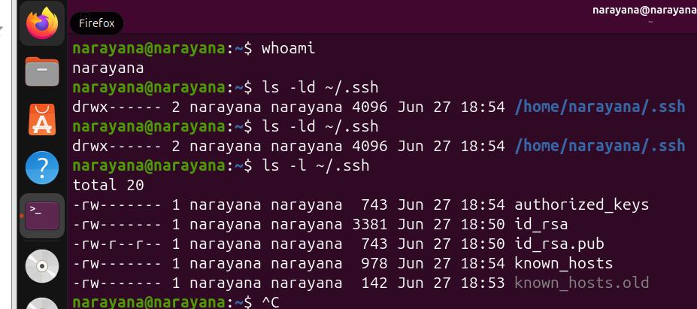
25. Monitor log files using tail or grep
a. we use tail /var/log/syslog – command is used to display the specified log file.
b. we use ps -ef | grep nginx – command is used to grep the files from nginx service
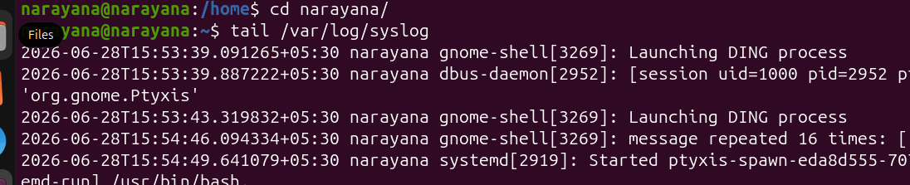

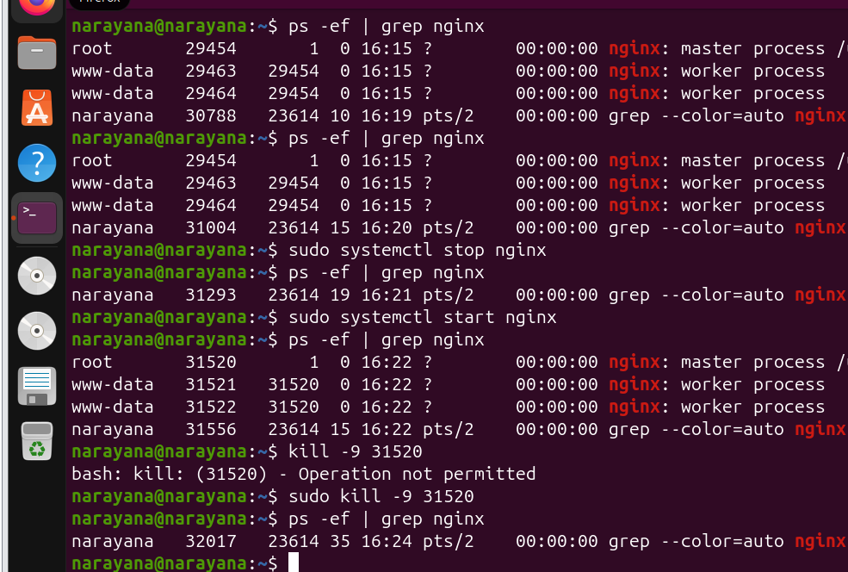
26.Set up a web server (e.g., Apache or Nginx).
a. we use sudo apt install nginx – command to install nginx services.
b.we can start the service using command – sudo systemctl start nginx
c. we can check the status of the nginx service using command – sudo systemctl status nginx
d. we can stop the service usimg command – sudo systemctl stop nginx
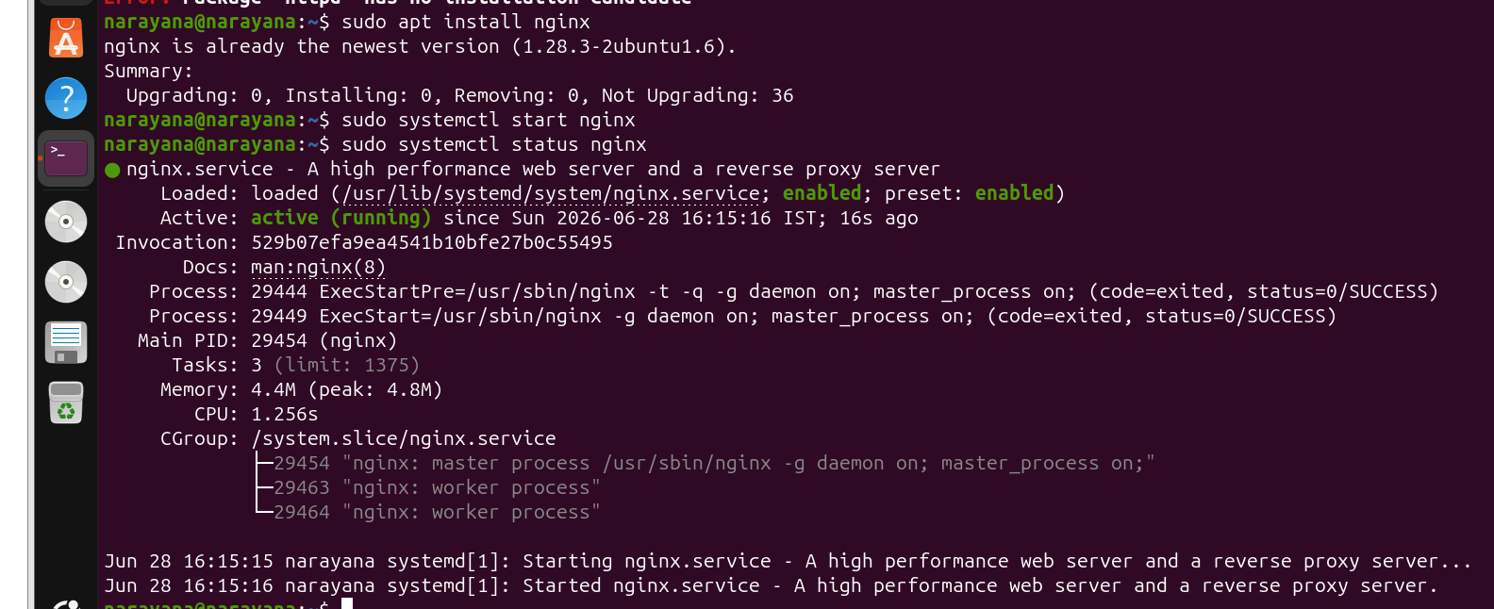

27. Configure and secure a MySQL Database.
a. we use sudo apt install mysql-server – command to configure mysql database.
- sudo systemctl start mysql
- sudo systemctl enable mysql
- sudo systemctl status mysql
b. we use sudo mysql_secure_installation – command to securea mysql database.

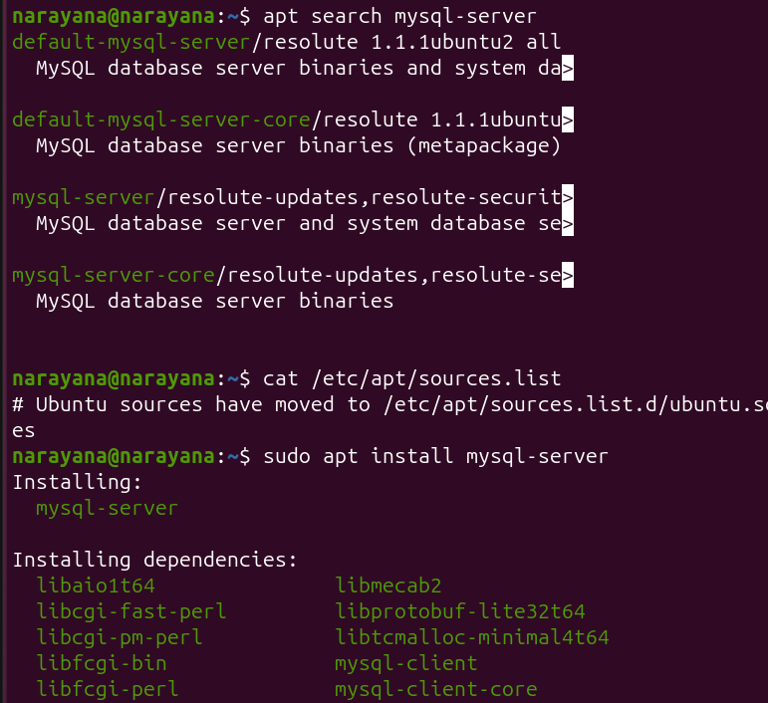
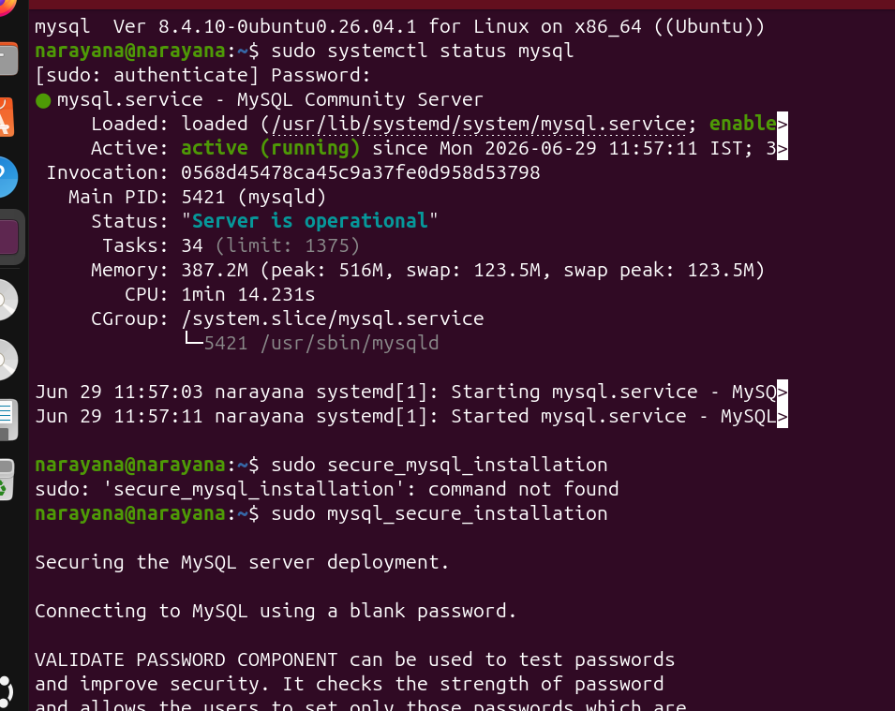
28.Set up a Application Server (e.g.,Apache Tomcat)
a. java -version
sudo apt update
sudo apt install tomcat10 -y
b. sudo systemctl enable --now tomcat10
sudo systemctl status tomcat10
sudo ss -tulnp | grep 8080
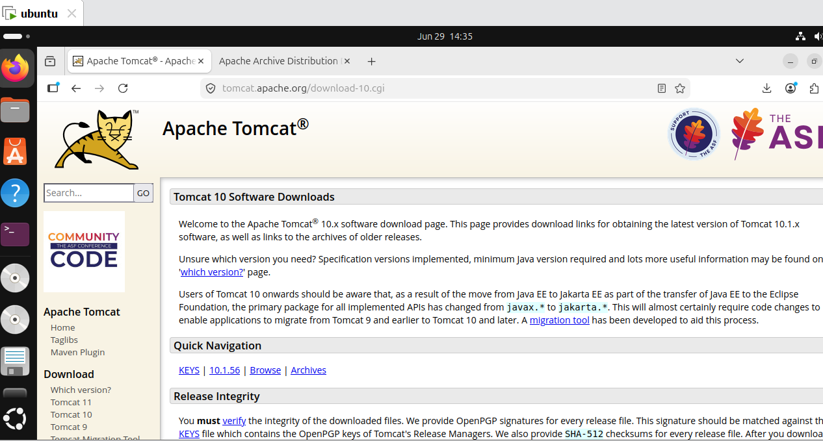
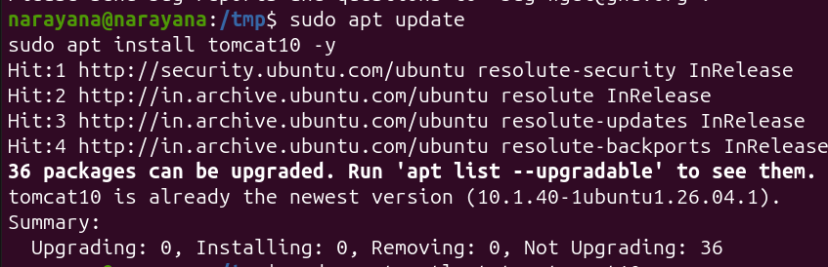
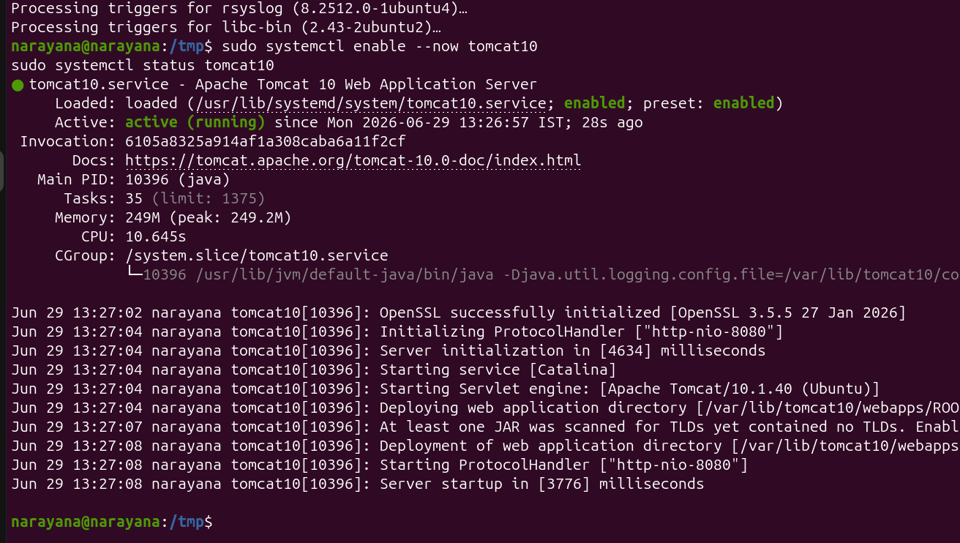

29.create a service file for Apache Tomcat.(Should execute by using systemtctl command)
a. sudo nano /etc/systemd/system/tomcat.service
b. sudo systemctl start tomcat10
sudo systemctl status tomcat10
sudo systemctl stop tomcat10

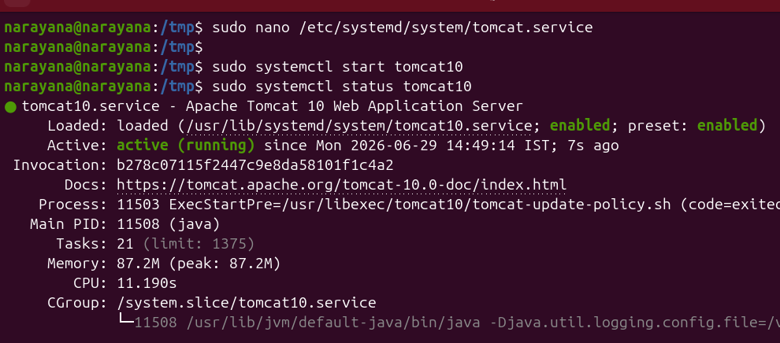
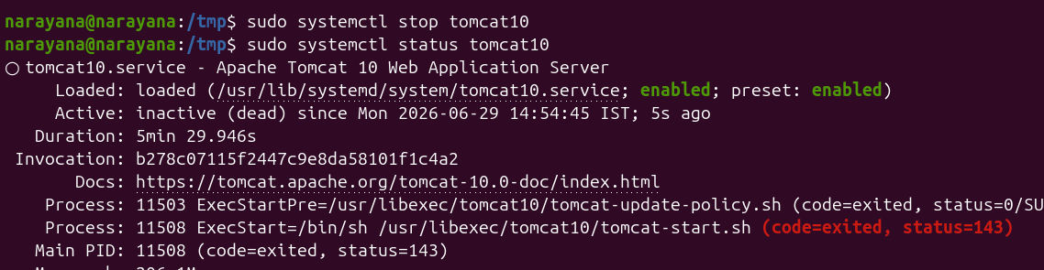

30.Print specific columns from a delimited file.
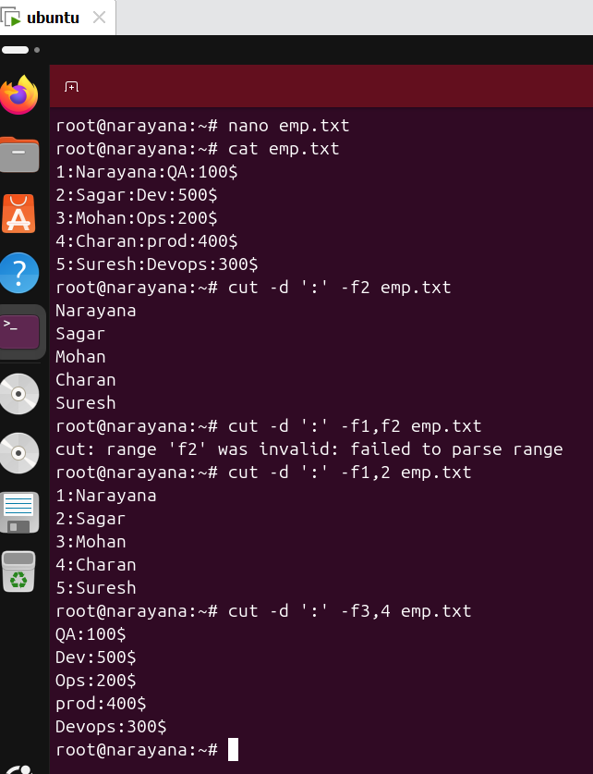
31.Filter and print lines based on a specific pattern or condition.
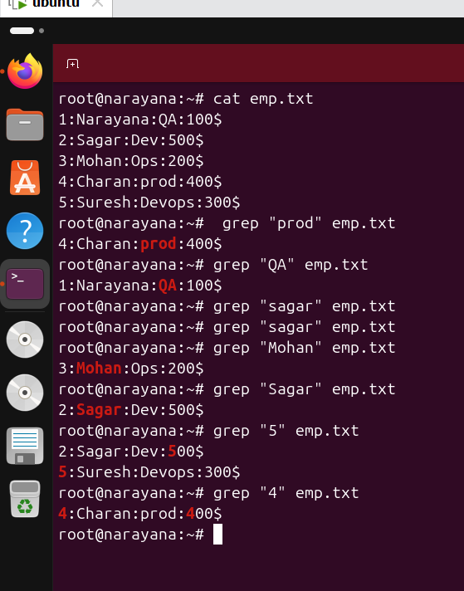
32.Calculate and print the average, sum, or other statistics of a column.
a. Calculate the Sum of the Salary Column
awk -F':' '{sum += $4} END {print "Sum =", sum}' emp.txt
b. Calculate the Average Salary
awk -F':' 'END {print "Total Records =", NR}' emp.txt
C. Count the Number of Records
awk -F':' 'END {print "Total Records =", NR}' emp.txt
d. Find the Maximum Salary
awk -F':' 'BEGIN {max=0} {if($4>max) max=$4} END {print "Maximum Salary =", max}' emp.txt
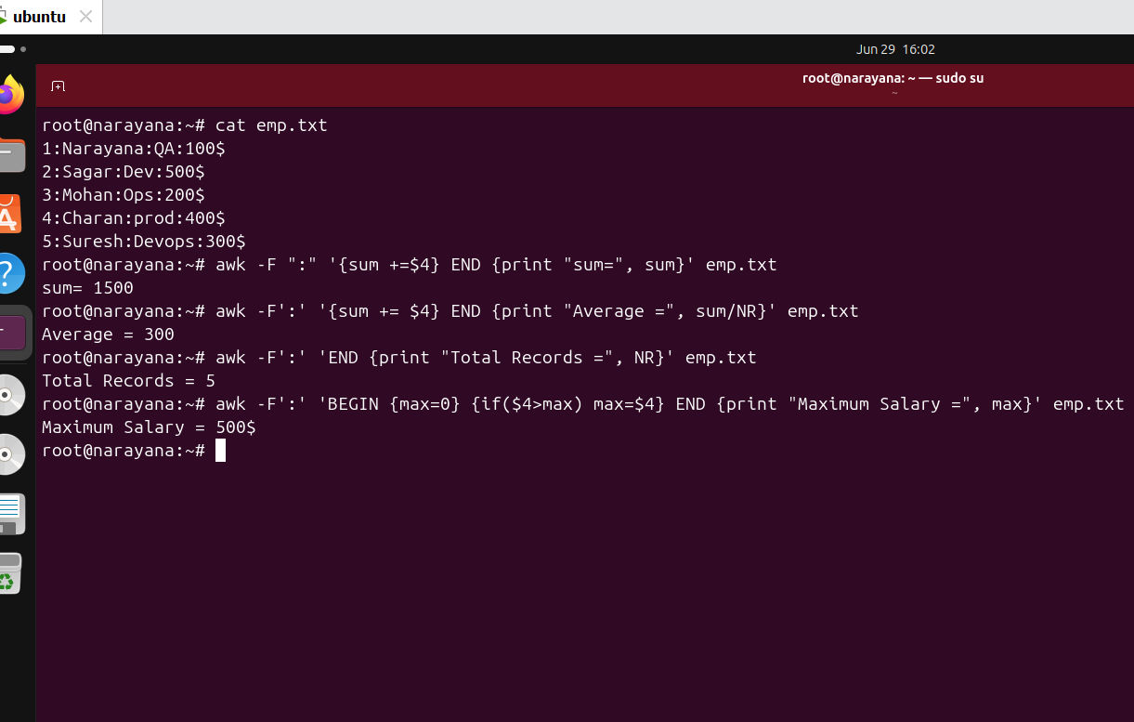
33.Perform string manipulation, such as extracting substrings or changing case.
a. awk -F':' '{print substr($2,3,4)}' emp.txt

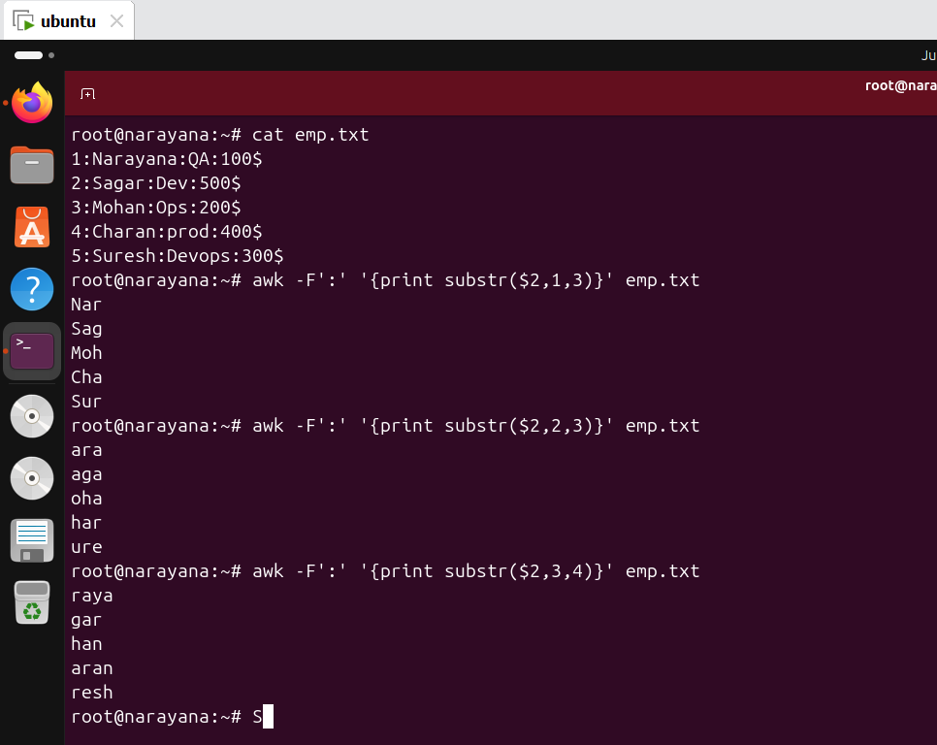

34.Count the occurrences of a specific pattern in a file.

- grep -c "Dev" emp.txt
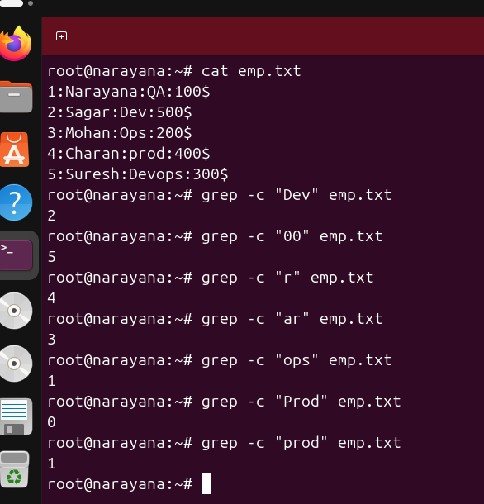
35.Sort lines based on a specific field or column.
a. sort -t':' -k2 emp.txt
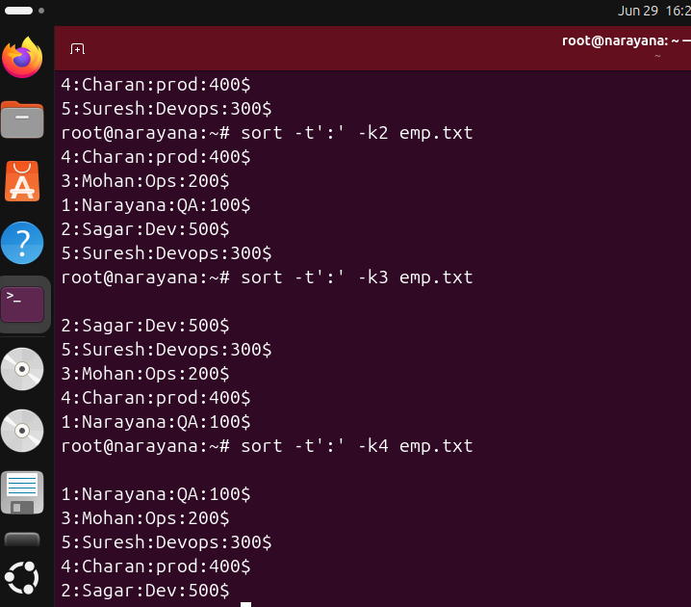

36.Merge multiple files based on a common field or column.
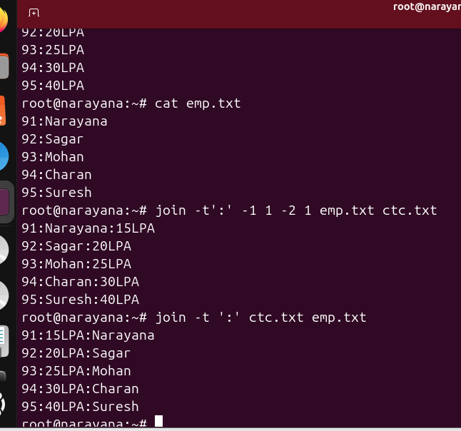
37.Substitute text in a file using search and replace.
a. sed 's/Dev/Developer/' emp.txt
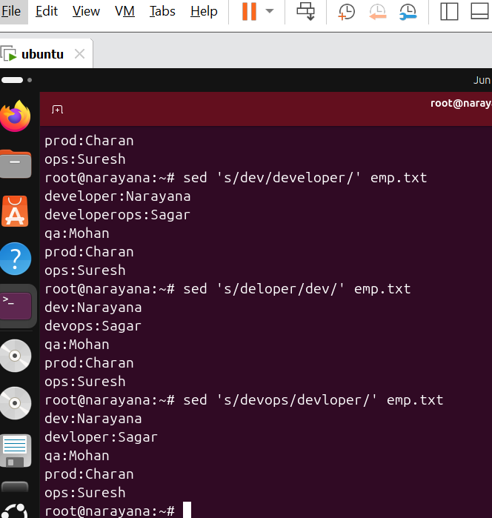

38.Delete specific lines based on a pattern or line number.
a.
Task | Command
Delete 3rd line | sed '3d' emp.txt
Delete lines 2–4 | sed '2,4d' emp.txt
Delete lines containing "Dev" | sed '/Dev/d' emp.txt
Delete blank lines | sed '/^$/d' emp.txt
Delete first line | sed '1d' emp.txt
Delete last line | sed '$d' emp.txt
Delete permanently | sed -i '3d' emp.txt

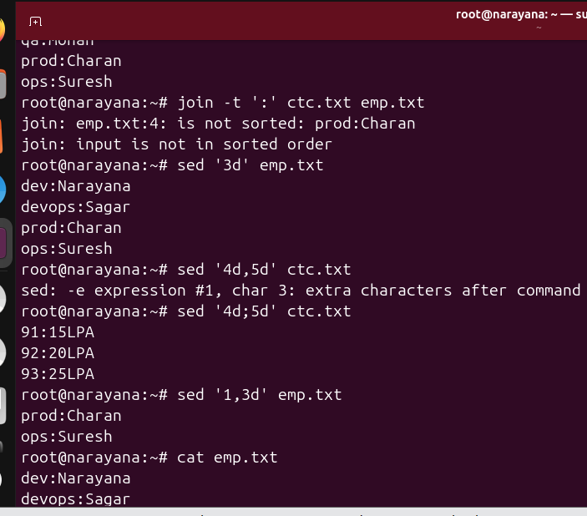
39.Append or insert text before or after a specific pattern or line.
a. sed '3a\This line is appended after line 3' emp.txt
b.sed '/ops:Suresh/i\lead:Suresh' emp.txt
c. sed '3a\manager:Ravi' emp.txt
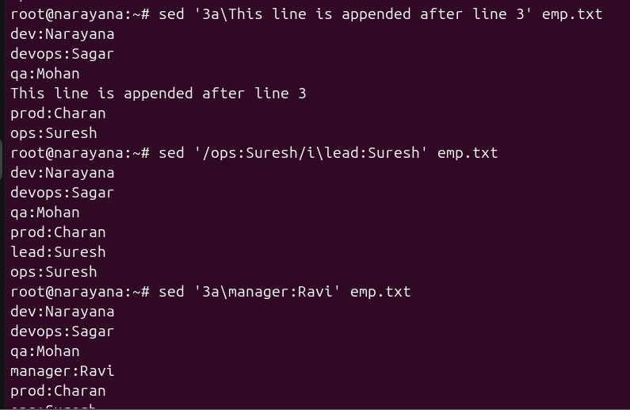
40.Print only specific lines from a file.
a. sed -n '3p' emp.txt
b. sed -n '1~2p' emp.txt
c. sed -n '2,4p' emp.txt
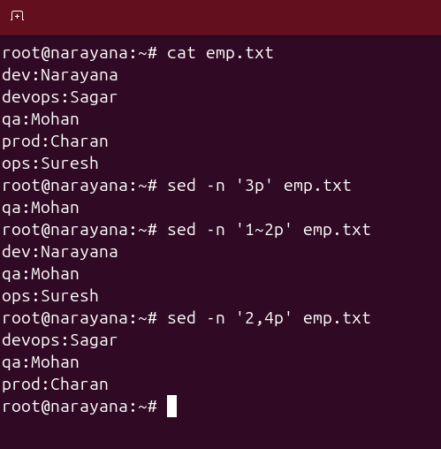

41.Copy file from linux to windows machine.
Step 1: Create a Shared Folder in Windows
- On the Windows Desktop, right-click.
- Select New → Folder.
- Name the folder: UbuntuShare.
Example Location:
C:\Users\brajk\OneDrive\Desktop\UbuntuShare

Step 2: Configure VMware Shared Folder
- Shut down the Ubuntu VM.
- Open VMware Workstation.
- Select the Ubuntu VM.
- Go to VM → Settings.
- Click the Options tab.
- Select Shared Folders.
- Choose Always enabled.
- Click Add.
- Browse to: C:\Users\brajk\OneDrive\Desktop\UbuntuShare

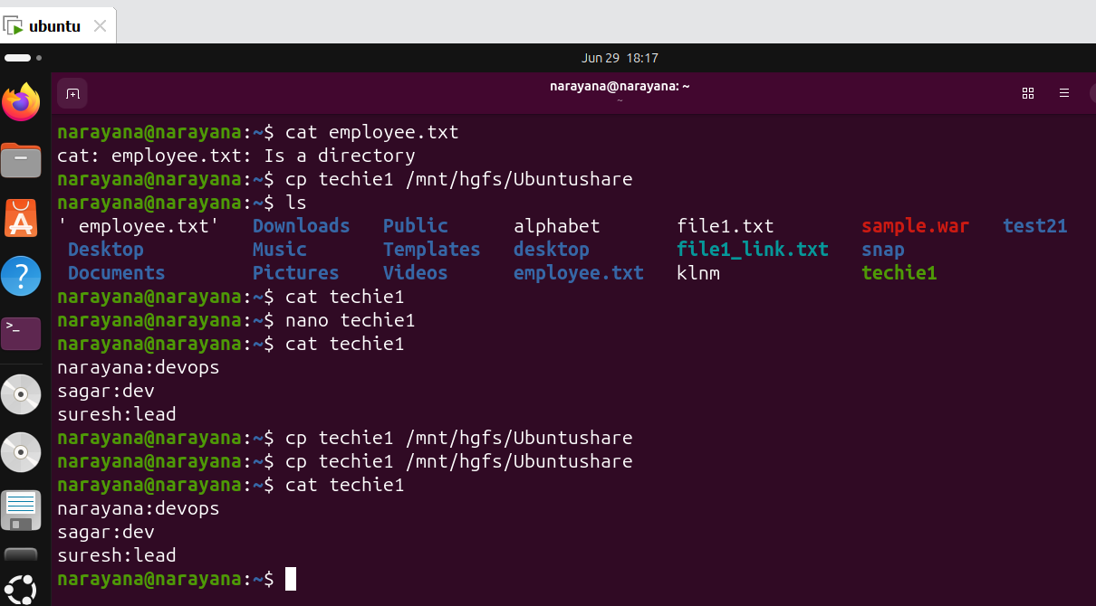
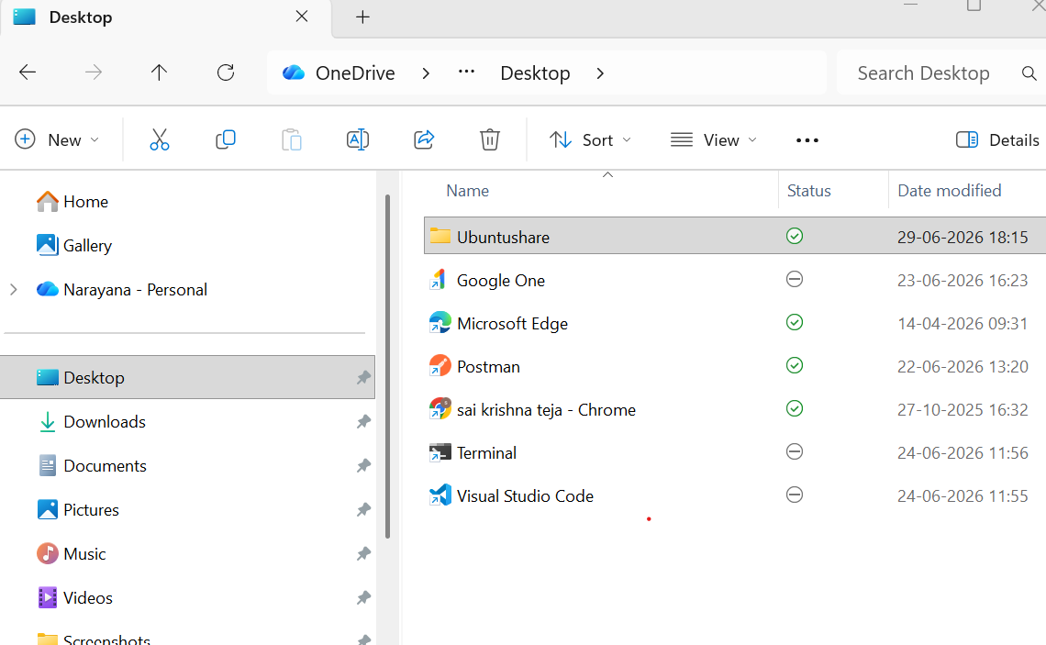
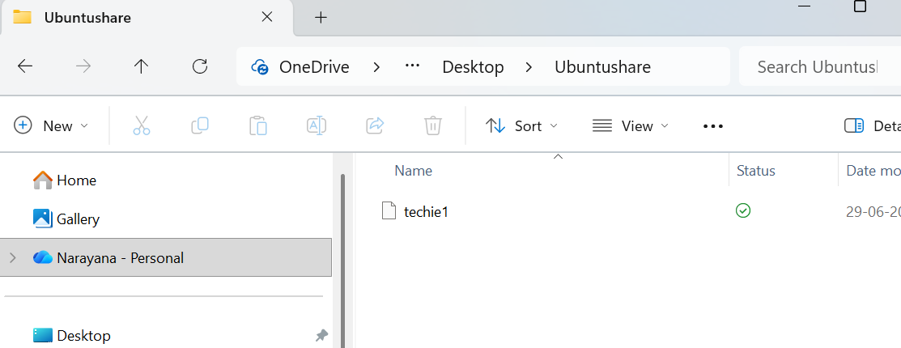

42. 5 use cases for AWK and 5 use cases for sed.
I. Use Case of awk Description Example Command
1.Print specific columns : awk '{print $1, $3}' emp.txt
a. Prints the 1st and 3rd columns of a file.
2. Filter rows based on a condition : awk '$3 > 5000' emp.txt a. Displays rows where the 3rd column value is greater than 5000.
3. Count lines or records : awk 'END {print NR}' emp.txt
a. Prints the total number of records (lines).
4. Calculate sum or average : awk '{sum += $3} END {print sum}' emp.txt
a. Calculates the sum of values in the 3rd column.
5. Change field separator : awk -F':' '{print $1}' /etc/passwd
a. uses as the field separator and prints usernames.

II . Sed Use Cases, Command Examples & discription
1.Replace text : sed 's/Linux/Ubuntu/' file.txt
a. Replaces the first occurrence of linux with Ubuntu in each line.
2. Delete specific lines : sed '3d' file.txt
a. Deletes the 3rd line from the output.
3. Insert text before a line: sed '/Manager/i New Employee' emp.txt a. Inserts New Employee before lines containing Manager.
4. Append text after a line- sed '/Manager/a Department: IT' emp.txtAdds
a. Department: IT after lines containing Manager.
5. Print specific lines: sed -n '2,5p' file.txt
a. Prints only lines 2 through 5.

