Exercise: Crontab Entries

Step 1: Verify whether cron is installed
Run:
rpm -q cronie
If you see:
package cronie is not installed
then install it.

Step 2: Install Cron
On Amazon Linux 2023:
sudo dnf install cronie -y

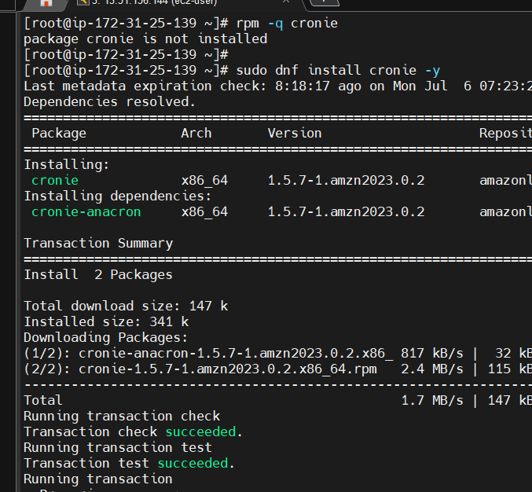

sudo systemctl start crond
Enable it to start automatically after reboot:
sudo systemctl enable crond
sudo systemctl status crond

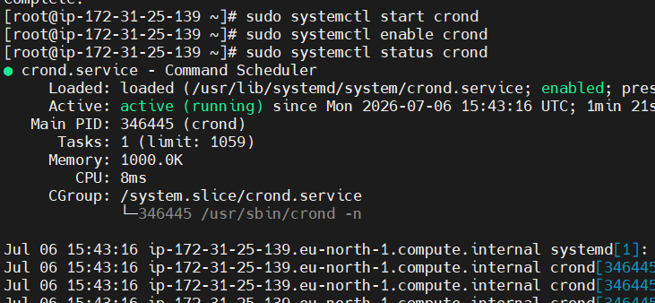

Below are the correct crontab entries for each exercise, along with an explanation.
Crontab format
┌──────── Minute (0-59)
│ ┌────── Hour (0-23)
│ │ ┌──── Day of Month (1-31)
│ │ │ ┌── Month (1-12 or Jan-Dec)
│ │ │ │ ┌─ Day of Week (0-7) (0 or 7 = Sunday)
│ │ │ │ │
* * * * * command_to_execute

1. April 5th at Midnight
Runs every year on April 5 at 12:00 AM.
Crontab -e

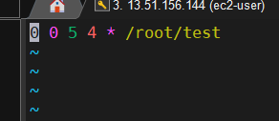

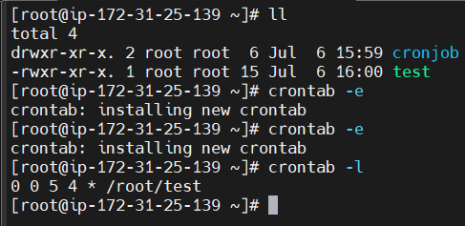

2. 5th of Every November, January, and June if it is a Thursday
Runs only when the 5th day falls on a Thursday in January, June, or November.

Step 1: Create the script

mkdir -p /home/ec2-user/scripts
cd /home/ec2-user/scripts
vi checkdate.sh

Paste:
#!/bin/bash
DAY=$(date +%d)
MONTH=$(date +%m)
WEEKDAY=$(date +%u)
# %u: Monday=1 ... Thursday=4 ... Sunday=7
if [ "$DAY" = "05" ] && [ "$WEEKDAY" = "4" ] && \
{ [ "$MONTH" = "01" ] || [ "$MONTH" = "06" ] || [ "$MONTH" = "11" ]; }
then
echo "Today is the 5th and Thursday in Jan/Jun/Nov: $(date)" >> /tmp/date.log
fi
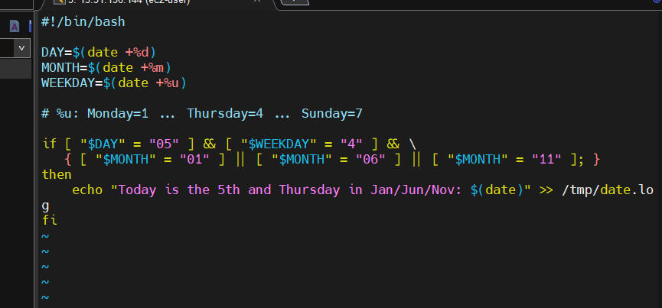

Step 2: Give execute permission
chmod +x /home/ec2-user/scripts/check-date.sh
Verify:
ls -l /home/ec2-user/scripts
Expected:
-rwxr-xr-x check-date.sh

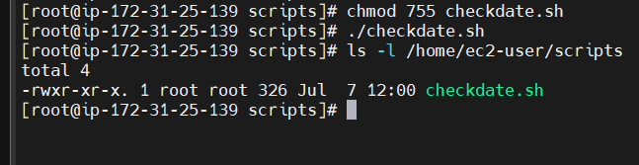
Step 3: Add the cron job
Open the crontab:
crontab -e
Add:
0 0 5 1,6,11 * /home/ec2-user/scripts/check-date.sh
This runs only on the 5th day of January, June, and November at midnight. The script itself checks whether that day is Thursday before writing to the log.

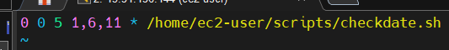

Step 4: Save and verify
crontab -l
Expected:
0 0 5 1,6,11 * /home/ec2-user/scripts/check-date.sh
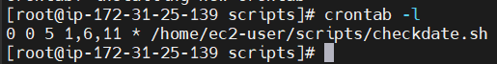

Validation
Since you don't want to wait until the next qualifying date, temporarily test it.

Modify the script for testing
Replace the if block with:
#!/bin/bash
echo "Cron executed at $(date)" >> /tmp/date.log

Change the cron schedule temporarily
* * * * * /home/ec2-user/scripts/check-date.sh
Wait one minute.
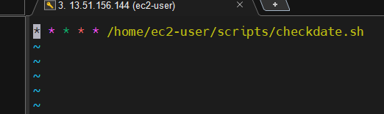

Check the log:
cat /tmp/date.log
Expected:
Cron executed at Tue Jul 7 11:30:01 IST 2026
Cron executed at Tue Jul 7 11:31:01 IST 2026

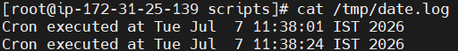

This confirms:
- crond is running.
- The cron entry is correct.
- The script executes successfully.
After testing, restore the original script and the intended schedule.

3.At 05 and 27th minutesof9, 10, 13hours every day

Add the cron job
Open the cron editor:
crontab -e
Add this line:
5,27 9-13 * * * /home/ec2-user/scripts/checkdate.sh
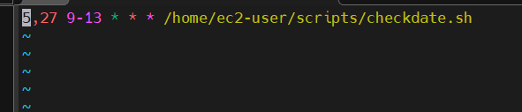

Save and exit.
Step 6: Verify the cron job
crontab -l
Output:
5,27 9-13 * * * /home/ec2-user/scripts/checkdate.sh

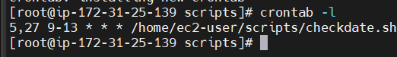

4. 34 minutesof9th houron15th August

Step 1: Create the script
mkdir -p /root/scripts
Create the file:
vi /root/scripts/aug15.sh

#!/bin/bash
echo "Happy Independence Day! Script executed at $(date)" >> /tmp/aug15.log

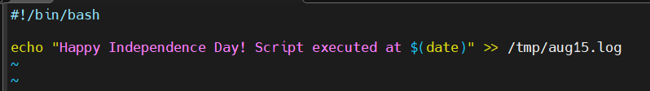

Step 2: Give execute permission
chmod +x /root/scripts/aug15.sh

Step 3: Test the script manually
Run:
/root/scripts/aug15.sh
Check the output:
cat /tmp/aug15.log
Example output:
Happy Independence Day! Script executed at Tue Jul 7 11:50:30 IST 2026
This confirms the script itself works.
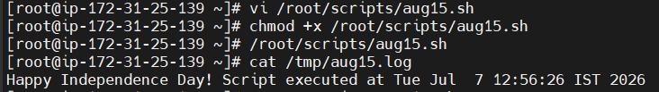
Step 4: Add the cron job
Open the cron editor:
crontab -e
Add this line:
34 9 15 8 * /root/scripts/aug15.sh

Step 5: Verify the cron job
Run:
crontab -l
Expected output:
34 9 15 8 * /root/scripts/aug15.sh

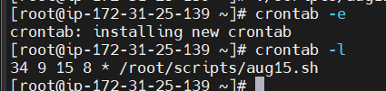

5.Every midnight
Step 1: Create the script
Create the file:
vi /root/scripts/midnight.sh

#!/bin/bash
echo "Midnight cron job executed at $(date)" >> /tmp/midnight.log

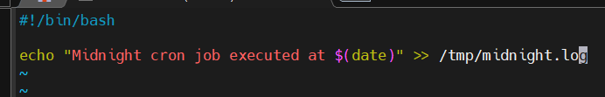

Step 2: Give execute permission
chmod +x /root/scripts/midnight.sh
Verify:
ls -l /root/scripts/midnight.sh
Expected output:
-rwxr-xr-x 1 root root ... /root/scripts/midnight.sh

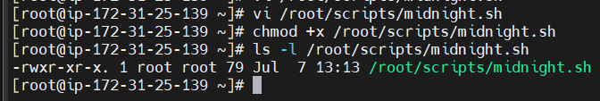

Step 3: Test the script manually
Run:
/root/scripts/midnight.sh
Check the log:
cat /tmp/midnight.log
Example output:
Midnight cron job executed at Tue Jul 7 01:20:10 IST 2026
This confirms that the script works.
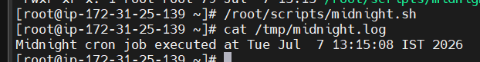

Step 4: Add the cron job
Open the crontab:
crontab -e
Add this line:
0 0 * * * /root/scripts/midnight.sh

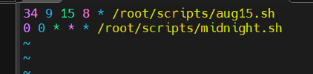

Step 5: Verify the cron job
Run:
crontab -l
Expected output:
34 9 15 8 * /root/scripts/aug15.sh
0 0 * * * /root/scripts/midnight.sh
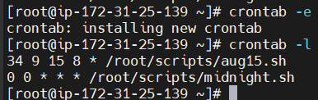
(You'll also see any other cron jobs you've already configured.)

6.Every Weekend (Saturday night 11:59 PM)
Step 1: Create the script
Open a new file:
vi /root/scripts/weekend.sh

#!/bin/bash
echo "Weekend cron job executed at $(date)" >> /tmp/weekend.log

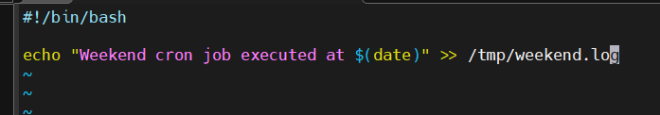

Step 2: Give execute permission
chmod +x /root/scripts/weekend.sh
Verify:
ls -l /root/scripts/weekend.sh
Expected:
-rwxr-xr-x 1 root root ... /root/scripts/weekend.sh
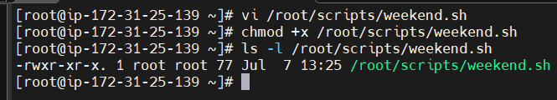

Step 3: Test the script manually
Run:
/root/scripts/weekend.sh
Check the log:
cat /tmp/weekend.log
Example:
Weekend cron job executed at Tue Jul 7 01:40:25 IST 2026
This confirms the script works.
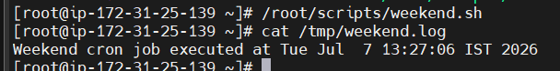

Step 4: Add the cron job
Open the cron editor:
crontab -e
Add this line:
59 23 * * 6 /root/scripts/weekend.sh
Save and exit.

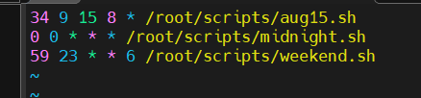

Step 5: Verify the cron job
Run:
crontab -l
Example output:
34 9 15 8 * /root/scripts/aug15.sh
0 0 * * * /root/scripts/midnight.sh
59 23 * * 6 /root/scripts/weekend.sh
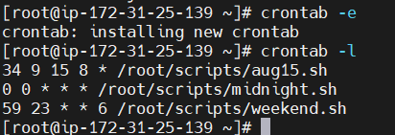

What does this cron entry mean?
59 23 * * 6 /root/scripts/weekend.sh
│ │ │ │ │
│ │ │ │ └── 6 = Saturday
│ │ │ └──── Every month
│ │ └────── Every day of the month
│ └───────── 23 = 11 PM
└──────────── 59 = 59th minute
So the script will run every Saturday at 11:59 PM

7.After every reboot
1: Create the script
Create the script:
vi /root/scripts/reboot.sh

#!/bin/bash
echo "Server rebooted successfully at $(date)" >> /tmp/reboot.log
Save the file:

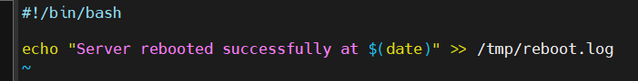

Step 2: Give execute permission
chmod +x /root/scripts/reboot.sh
Verify:
ls -l /root/scripts/reboot.sh
Expected:
-rwxr-xr-x 1 root root ... /root/scripts/reboot.sh

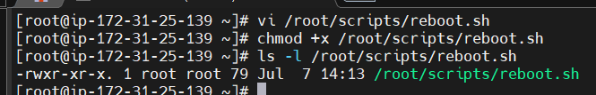
Step 3: Test the script manually
Run:
/root/scripts/reboot.sh
Check the log:
cat /tmp/reboot.log
Example:
Server rebooted successfully at Tue Jul 7 01:50:30 IST 2026
This confirms the script works.

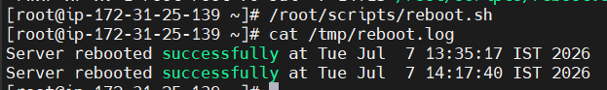

Step 4: Add the cron job
Open the crontab:
crontab -e
Add this line:
@reboot /root/scripts/reboot.sh
Save and exit.

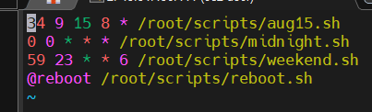

Step 5: Verify the cron entry
Run:
crontab -l
Example output:
34 9 15 8 * /root/scripts/aug15.sh
0 0 * * * /root/scripts/midnight.sh
59 23 * * 6 /root/scripts/weekend.sh
@reboot /root/scripts/reboot.sh

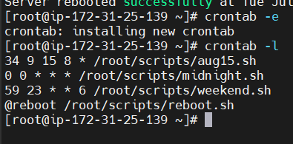

Step 6: Validation
Reboot the EC2 instance:
reboot
or
sudo reboot
Note: Your SSH session will disconnect because the server is restarting.

Step 7: Reconnect to the server
After 1–2 minutes, reconnect using SSH:
ssh -i your-key.pem ec2-user@<EC2-Public-IP>
If you're using the root account, switch to it if needed:
sudo su

Step 8: Check the log
Run:
cat /tmp/reboot.log
Expected output:
Server rebooted successfully at Tue Jul 7 02:00:10 IST 2026
This confirms that the script ran automatically after the system booted.

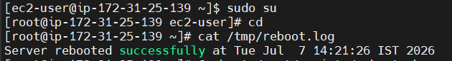

Cron Entry Explanation
@reboot /root/scripts/reboot.sh
- @reboot → Run the script once every time the system starts.
- /root/scripts/reboot.sh → The script to execute.

Final Validation Checklist
Run:
crontab -l
You should see:
34 9 15 8 * /root/scripts/aug15.sh
0 0 * * * /root/scripts/midnight.sh
59 23 * * 6 /root/scripts/weekend.sh
@reboot /root/scripts/reboot.sh
Then verify the reboot log:
cat /tmp/reboot.log

