Jenkins-04
Pre -requisites
STEP 1 — Verify Jenkins
On your Jenkins server:
java -version
Expected:
openjdk version "21..."
Check Jenkins:
sudo systemctl status jenkins
Open: http://<JENKINS-IP>:8080
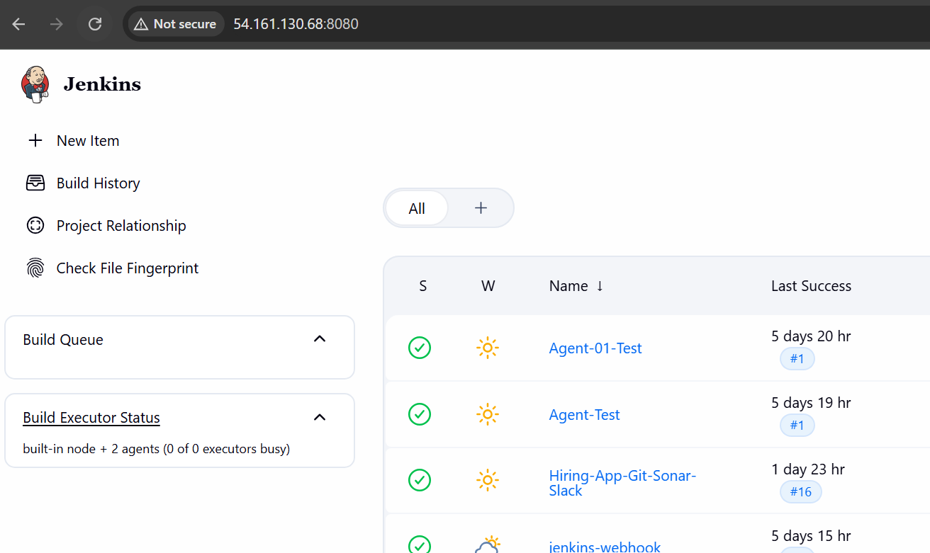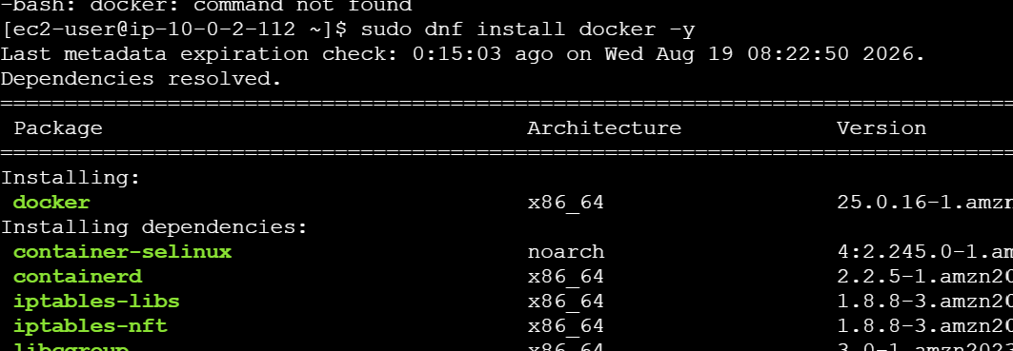

STEP 2 — Install Docker
2.1 Check Docker
docker --version
If Docker is already installed, continue.
If not: sudo dnf install docker -y
Start Docker: sudo systemctl start docker
Enable Docker: sudo systemctl enable docker
Check: sudo systemctl status docker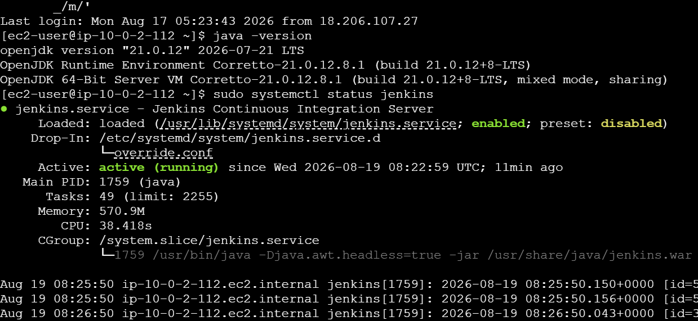
2.2 Give Jenkins permission to use Docker
Run: sudo usermod -aG docker jenkins
Restart Jenkins:sudo systemctl restart jenkins
Test: sudo -u jenkins docker ps
If you don't get a permission error, Docker is ready.
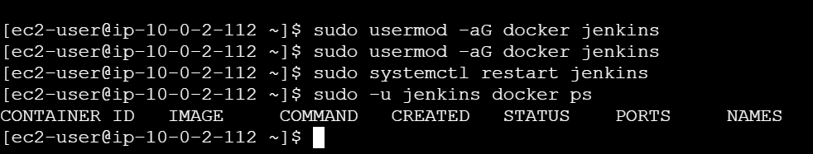
STEP 3 — Configure Maven
Check:
mvn -version
If not installed: sudo dnf install maven -y
Check again: mvn -version
You should see: Apache Maven
Java version: 21
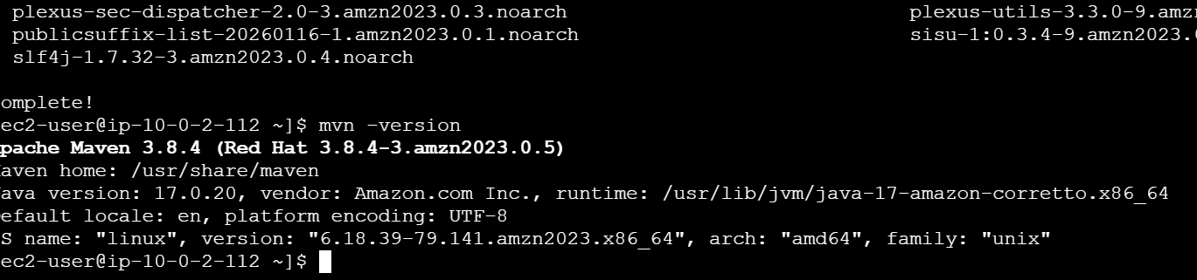

STEP 4 — Configure SonarQube
You already have SonarQube running on: http://<SONARQUBE-IP>:9000
Open it in the browser.
Go to:
Administration
↓
Security
↓
Users
Select your user.
Click: Tokens
Create: Name: jenkins-token
Click: Generate
Copy the token immediately.
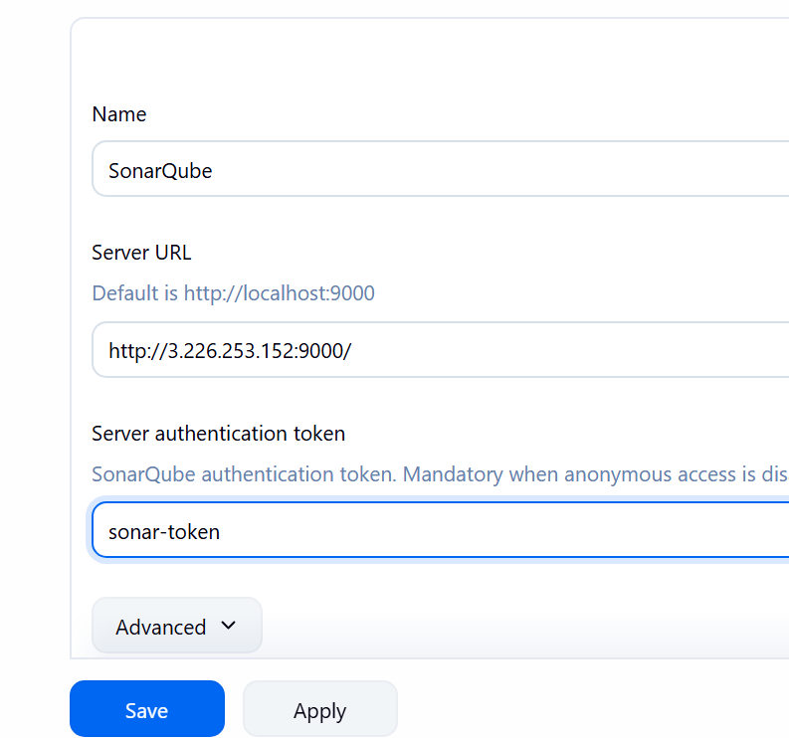

4.1 Add SonarQube Credential to Jenkins
Go to: Jenkins
→ Manage Jenkins
→ Credentials
→ System
→ Global credentials
→ Add Credentials
Select: Kind: Secret text
Enter: Secret: <SONAR-TOKEN>
ID: sonar-token
Click: Create
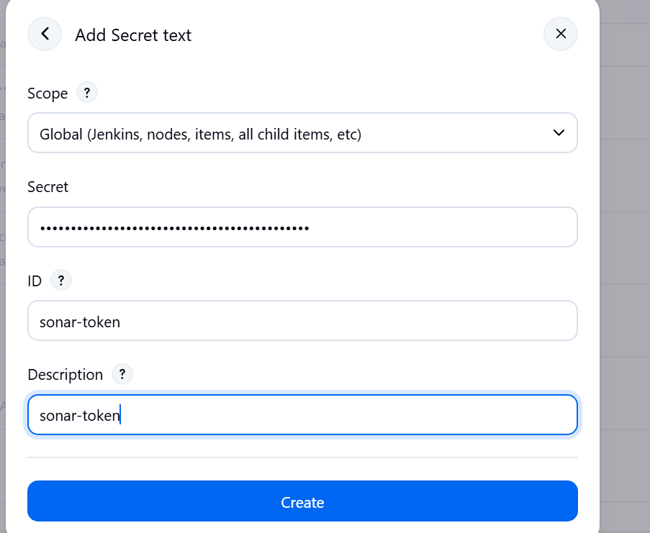

4.2 Configure SonarQube Server
Go to: Manage Jenkins
→ System
Find: SonarQube servers
Click: Add SonarQube
Enter: Name: SonarQube
Server URL: http://<SONARQUBE-IP>:9000
Select: sonar-token
Save.
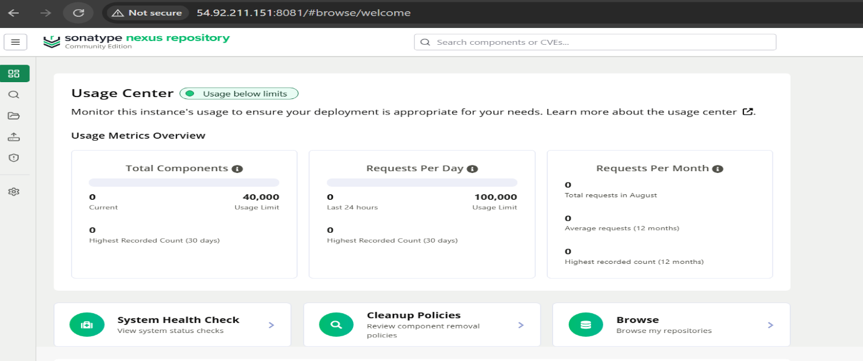
STEP 5 — Configure Nexus
Open Nexus: http://<NEXUS-IP>:8081
Login. Go to: Settings
→ Repositories
→ Create repository
Select: maven2 (hosted)
Enter: Name: maven-releases
Version policy: Release
Layout policy: Strict
Deployment policy: Allow redeploy
Click: Create repository
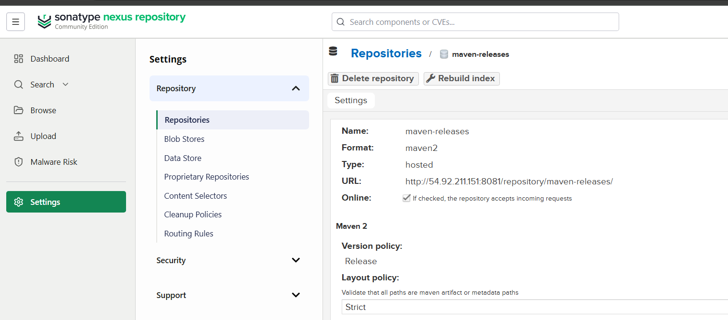

5.1 Create Nexus credentials in Jenkins
Go to: Manage Jenkins
→ Credentials
→ System
→ Global credentials
→ Add Credentials
Select: Kind: Username with password
Enter: Username: admin
Password: <NEXUS-PASSWORD>
ID: nexus-credentials
Click: Create
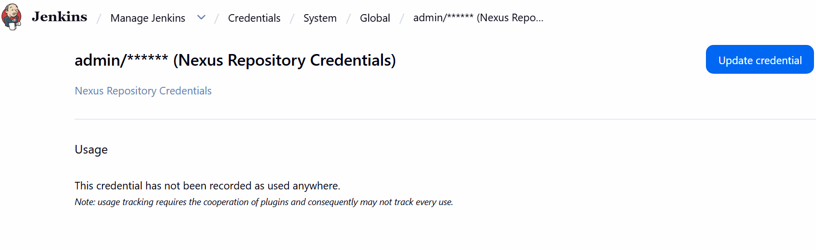

STEP 6 — Configure Slack
First install the plugin.
Go to: Manage Jenkins
→ Plugins
→ Available plugins
Search: Slack Notification
Install it.
Restart Jenkins if requested.

6.1 Configure Slack
Go to: Manage Jenkins
→ System
Find: Slack
Configure your Slack workspace/channel according to the Slack app/webhook credentials you have.
For example: Workspace: your-workspace
Channel: #jenkins
Click:Test Connection

STEP 7 — Verify Tomcat
Your Tomcat is using: 8082
Check: sudo systemctl status tomcat
If running: active (running) 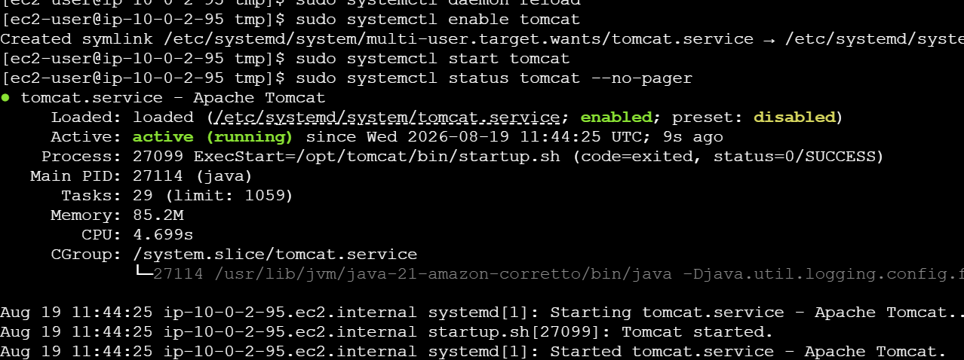
Test: curl http://localhost:8082
Open: http://<TOMCAT-IP>:8082
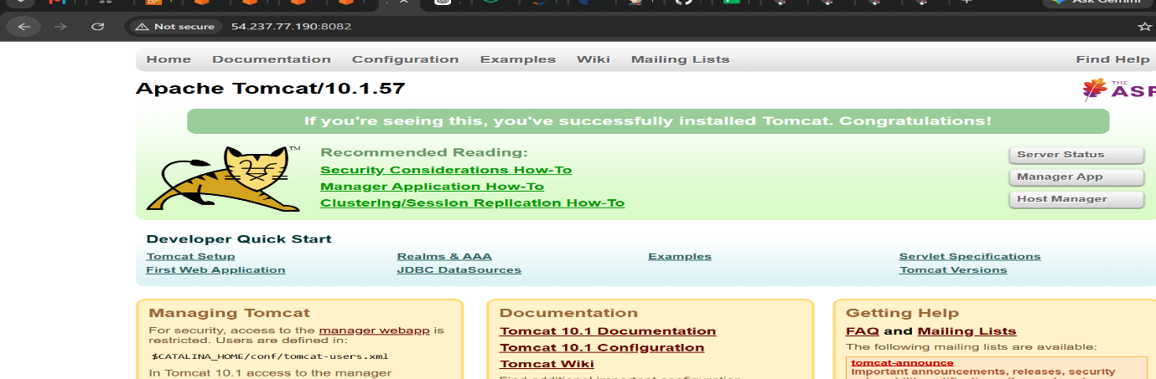

1) Setup Jenkins CICD pipeline using freestyle job using Docker containers using below code.
Repository: hiring-app

STEP 8 — Create Freestyle Job
Go to: Jenkins Dashboard
→ New Item
Enter: Hiring-App-Freestyle-Docker
Select: Freestyle project
Click: OK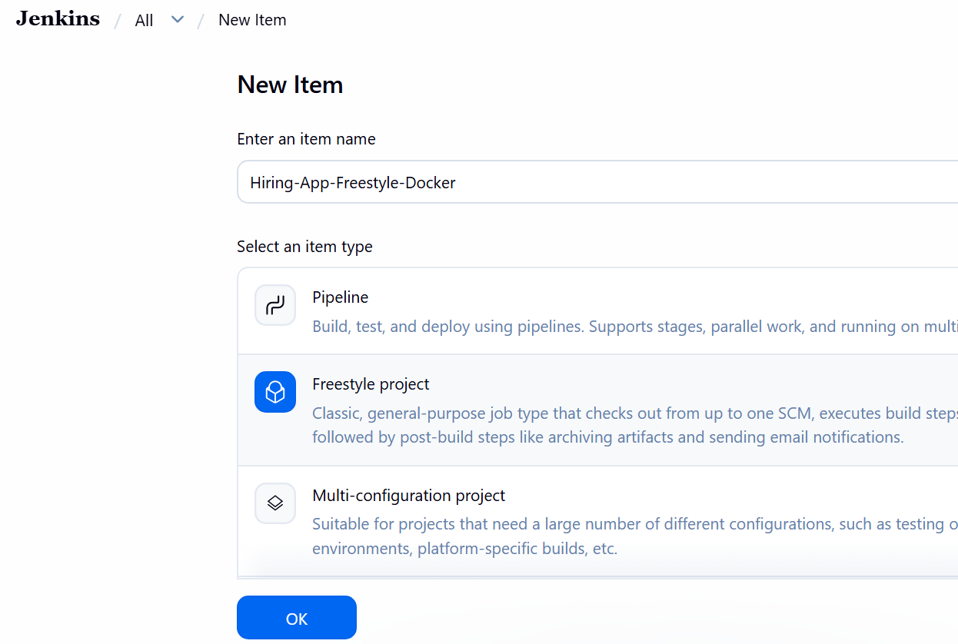

STEP 9 — Configure Git
Go to: Source Code Management
Select: Git
Repository: https://github.com/narayana-28/hiring-app
Branch: */main
Save.

STEP 10 — Git Clone
Jenkins automatically clones the repository during the build because you configured Git under:
Source Code Management → Git
So you don't need a separate git clone command. 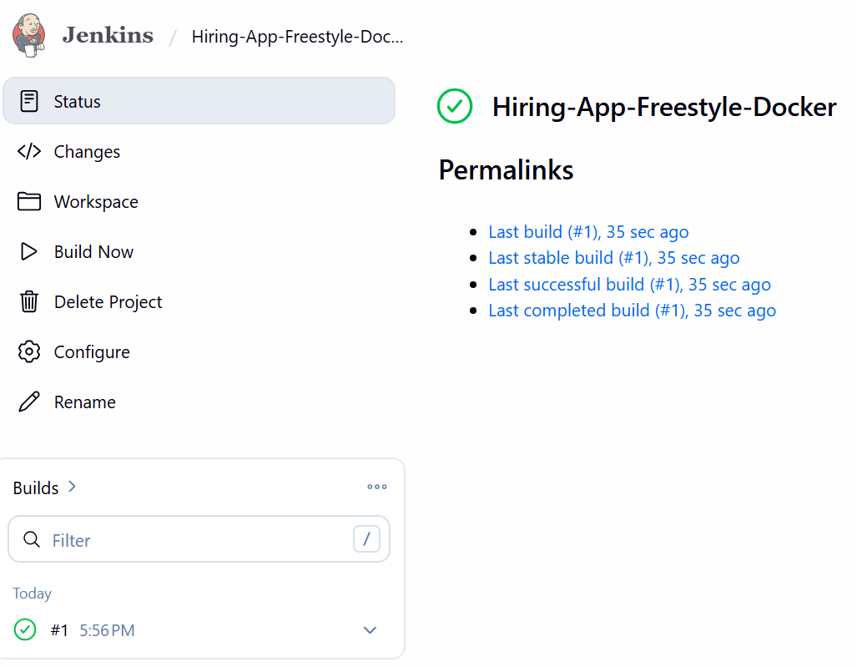
STEP 11 — Maven Build Using Docker
Go to: Build
→ Add build step
→ Execute shell
Use: docker run --rm \
-v "$WORKSPACE:/workspace" \
-w /workspace \
maven:3.9-eclipse-temurin-21 \
mvn clean package
This means:
Jenkins
↓
Docker
↓
Maven container
↓
mvn clean package
Click: Save
Click: Build Now
Check: Console Output
You should see: BUILD SUCCESS
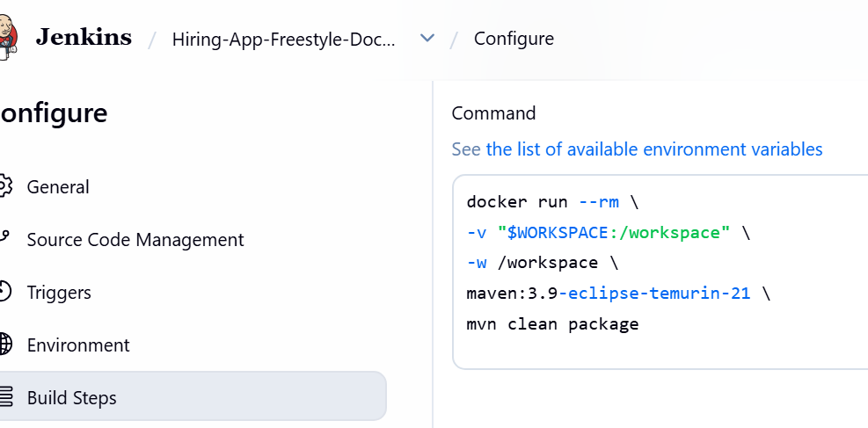

STEP 12 — SonarQube
After confirming Maven works, add another build step:
Build
→ Execute shell
For the initial test:
mvn sonar:sonar \
-Dsonar.host.url=http://<SONARQUBE-IP>:9000 \
-Dsonar.token=$SONAR_TOKEN
Make sure SONAR_TOKEN is injected from Jenkins credentials.
The important sequence is:
Git
↓
Maven
↓
SonarQube
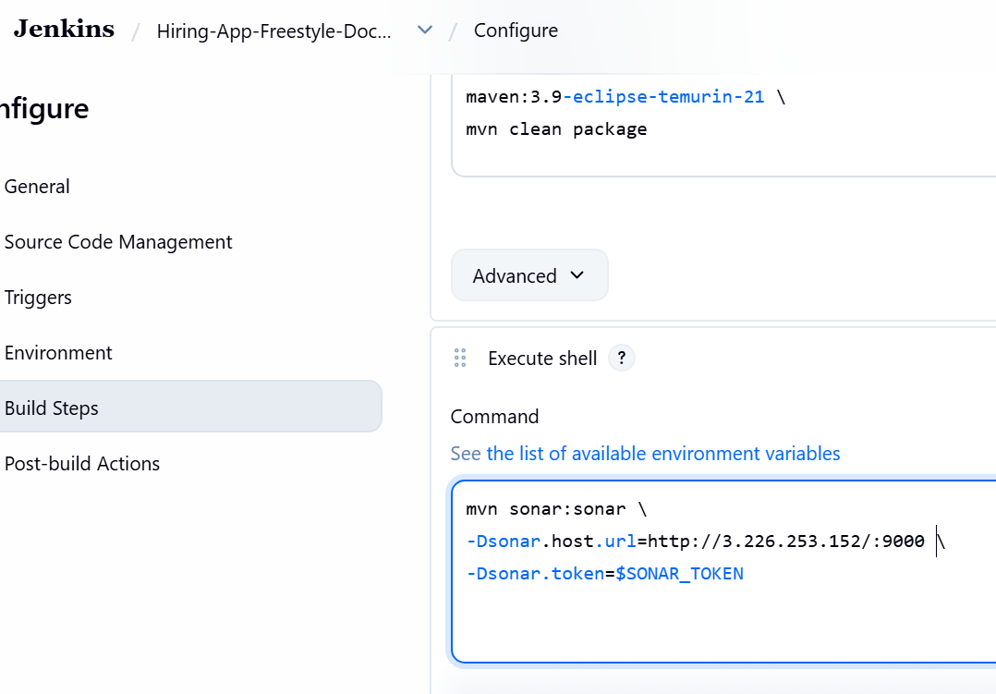
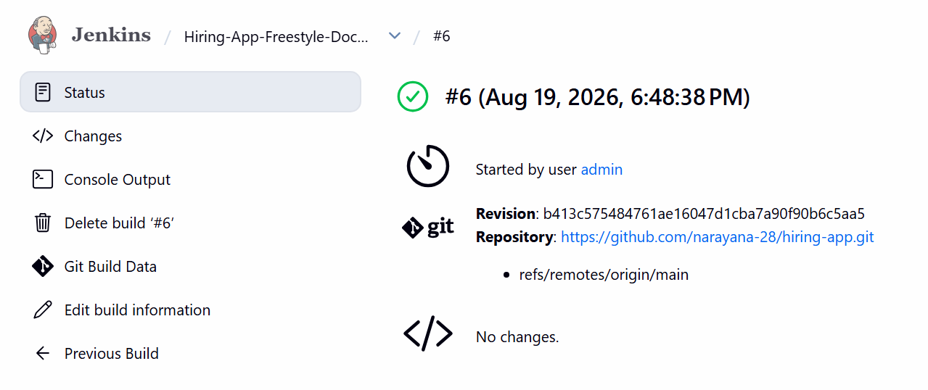
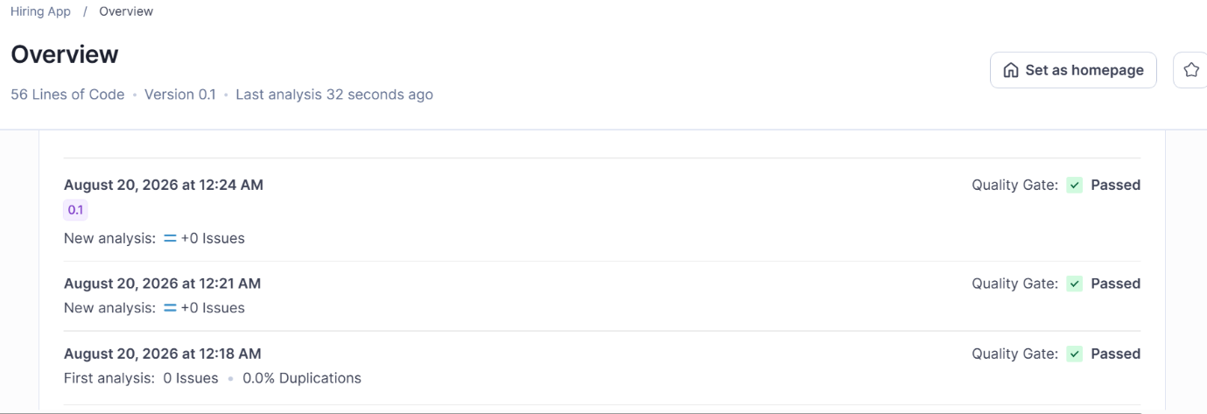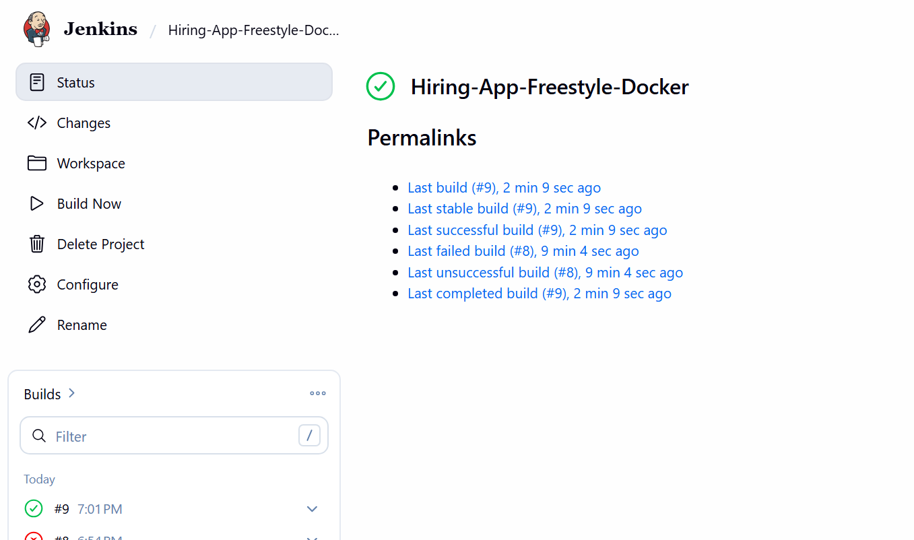
STEP 13 — Nexus
First make sure the project's pom.xml contains the Nexus repository configuration.
Then use: mvn deploy
Expected: Uploading to Nexus
Then check Nexus: Nexus
→ Browse
→ maven-releases
You should see your artifact.
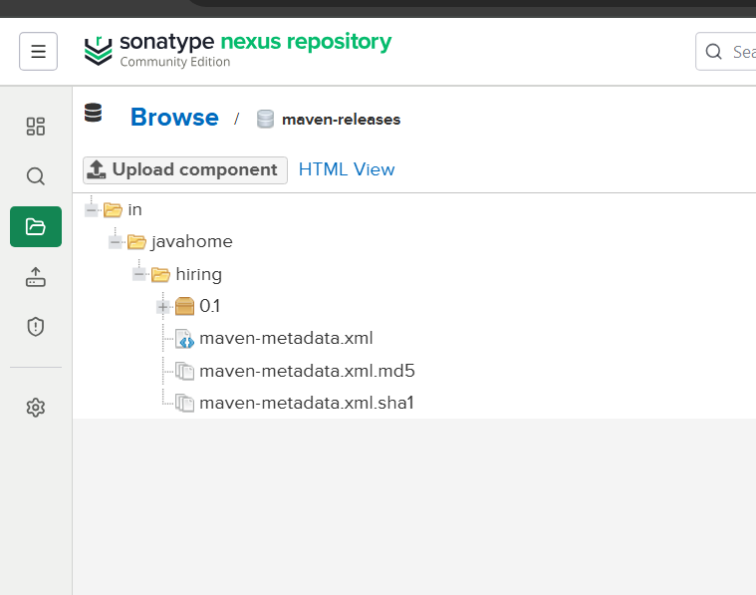
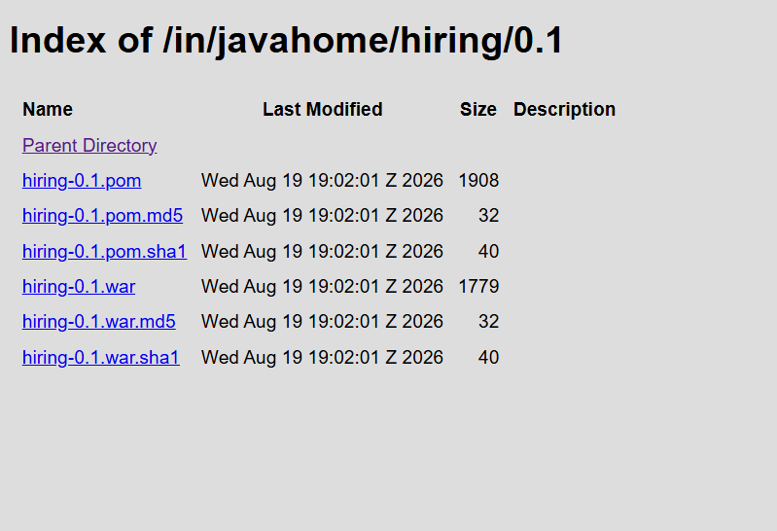

STEP 14 — Slack
In the Freestyle job: Post-build Actions
Select: Slack Notifications
Enable: Notify Success
Notify Failure
Save.
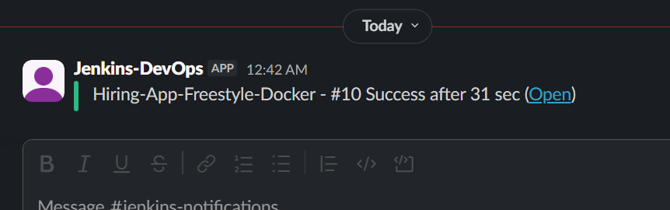

STEP 15 — Deploy to Tomcat
After Maven creates the WAR:
ls -lh target/
You should see something similar to:
application.war
Add another: Build
→ Execute shell
Use: cp target/*.war /opt/tomcat/webapps/
Restart Tomcat: sudo systemctl restart tomcat
Then open: http://<TOMCAT-IP>:8082
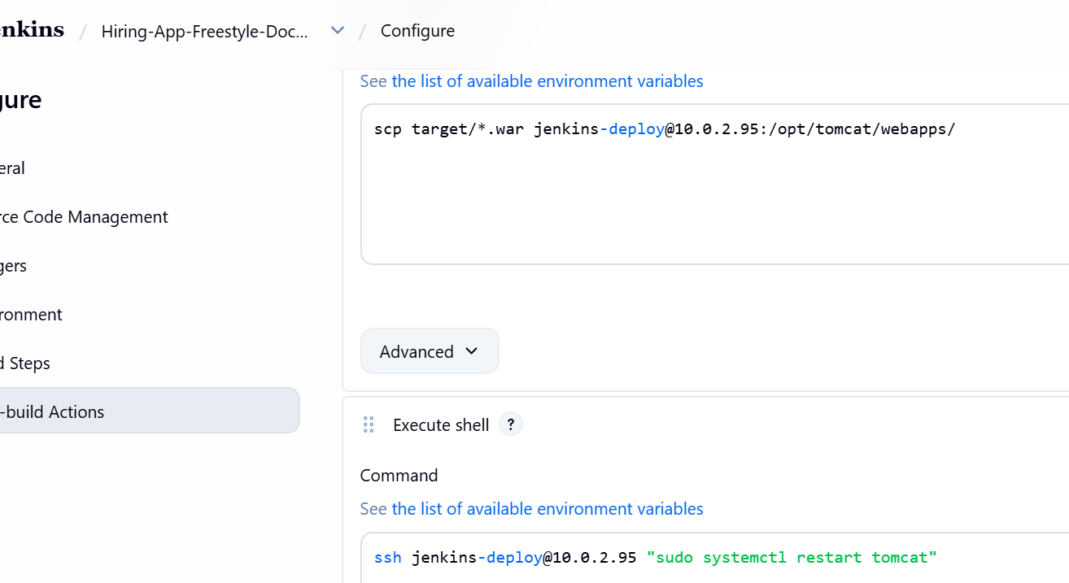

TASK 1 Final Flow
GitHub
↓
Git Clone
↓
Docker
↓
Maven
↓
SonarQube
↓
Nexus
↓
Slack
↓
Tomcat

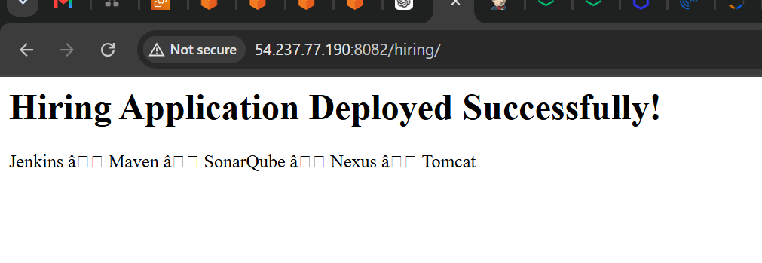
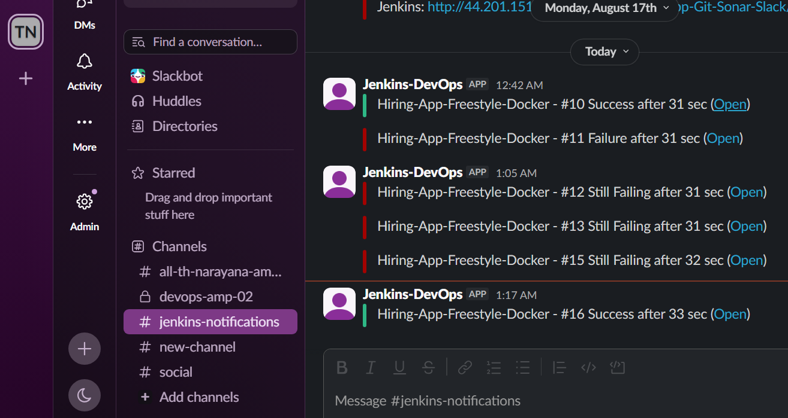

TASK 2 — Declarative Pipeline
Repository: sabear_simplecutomerapp feature-1.1

STEP 16 — Create Pipeline Job
Go to: New Item
Enter: SimpleCustomer-Declarative
Select: Pipeline
Click: OK
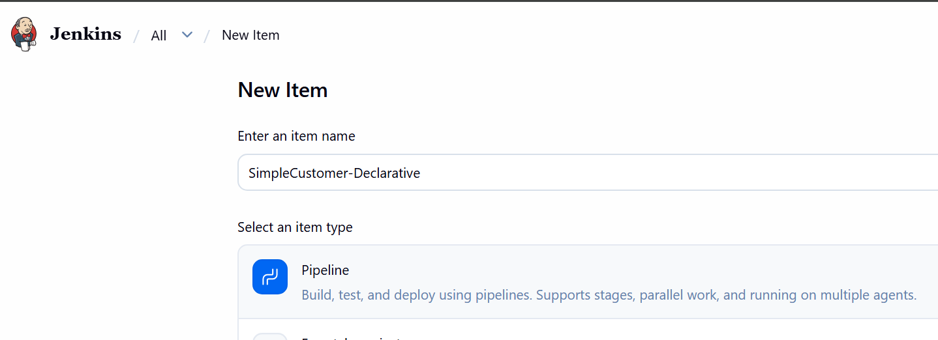
step 16.1— Create the project
From the SonarQube dashboard:
Projects → Create Project
Choose: Create a local project Enter:
Field | Value
Project display name | SimpleCustomerApp
Project key | com.javatpoint:SimpleCustomerApp
Go to: Pipeline
→ Definition
→ Pipeline script
Paste: pipeline {

agent any

stages {

stage('Git Clone') {
steps {
git branch: 'feature-1.1',
url: 'https://github.com/narayana-28/sabear_simplecutomerapp.git'
}
}

stage('SonarQube Integration') {
steps {
withCredentials([
string(
credentialsId: 'sonar-token',
variable: 'SONAR_TOKEN'
)
]) {
sh '''
mvn org.sonarsource.scanner.maven:sonar-maven-plugin:5.7.0.6970:sonar \
-Dsonar.host.url=http://34.234.170.203:9000 \
-Dsonar.token=$SONAR_TOKEN
'''
}
}
}

stage('Maven Compilation') {
steps {
sh 'mvn clean package'
}
}

stage('Nexus Artifactory') {
steps {
sh 'mvn deploy'
}
}

stage('Slack Notification') {
steps {
echo 'Sending Slack notification...'

slackSend(
channel: '#jenkins',
message: "SUCCESS: SimpleCustomerApp Build ${BUILD_NUMBER} completed Maven, SonarQube and Nexus stages."
)
}
}

stage('Deploy On Tomcat') {
steps {
sh '''
scp -i /var/lib/jenkins/.ssh/tomcat_deploy \
target/*.war \
jenkins-deploy@10.0.2.95:/opt/tomcat/webapps/
'''
}
}

stage('Restart Tomcat') {
steps {
sh '''
ssh -i /var/lib/jenkins/.ssh/tomcat_deploy \
jenkins-deploy@10.0.2.95 \
"sudo systemctl restart tomcat"
'''
}
}
}

post {

success {
slackSend(
channel: '#jenkins-notifications',
message: "SUCCESS: SimpleCustomerApp Build ${BUILD_NUMBER} deployed successfully to Tomcat."
)
}

failure {
slackSend(
channel: '#jenkins-notifications',
message: "FAILURE: SimpleCustomerApp Build ${BUILD_NUMBER} failed. Check Jenkins console output."
)
}
}
}
Important: Paste only the Groovy code into Jenkins. Don't paste the Markdown ``` markers.
Click: Save
→ Build Now
You should see:Git Clone
SonarQube Integration
Maven Compilation
Nexus Artifactory
Slack Notification
Deploy On Tomcat
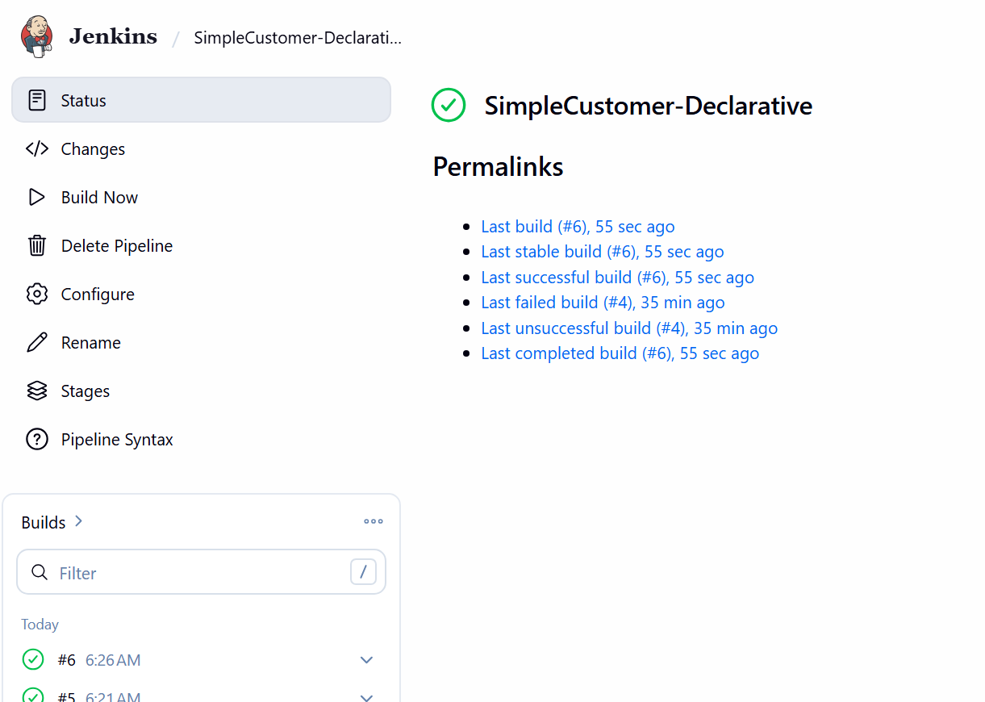
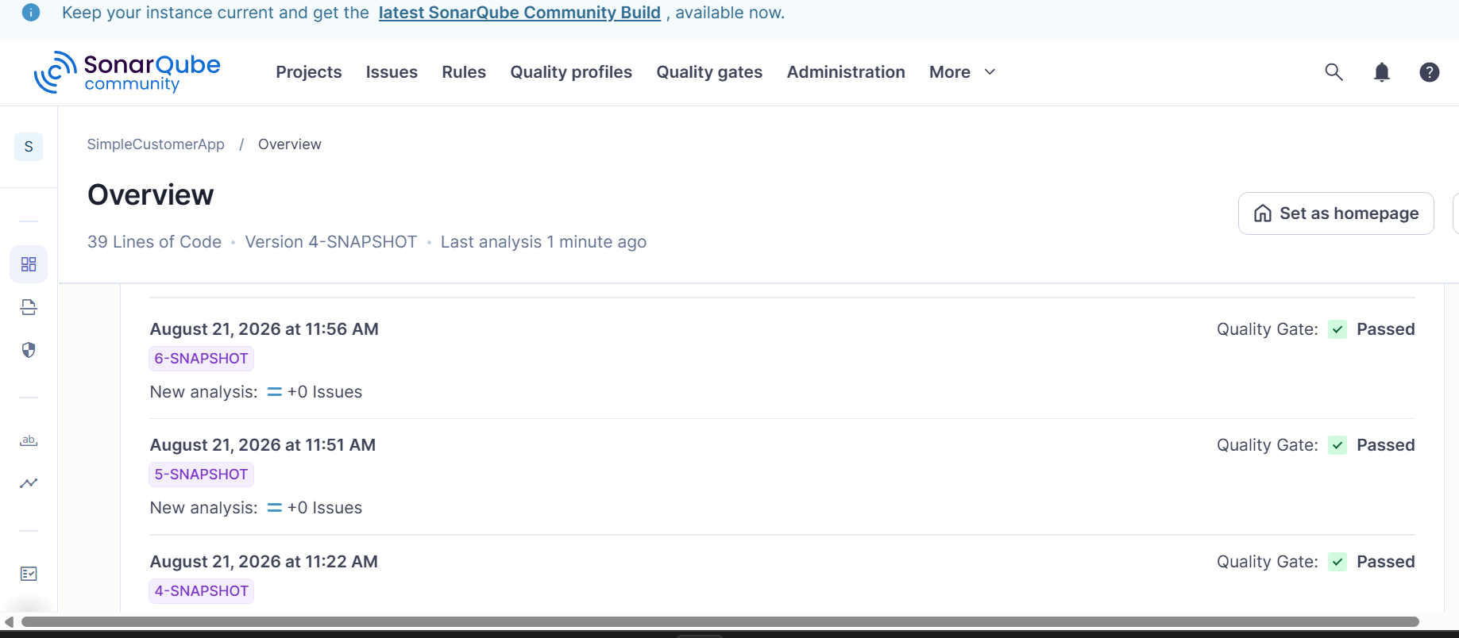
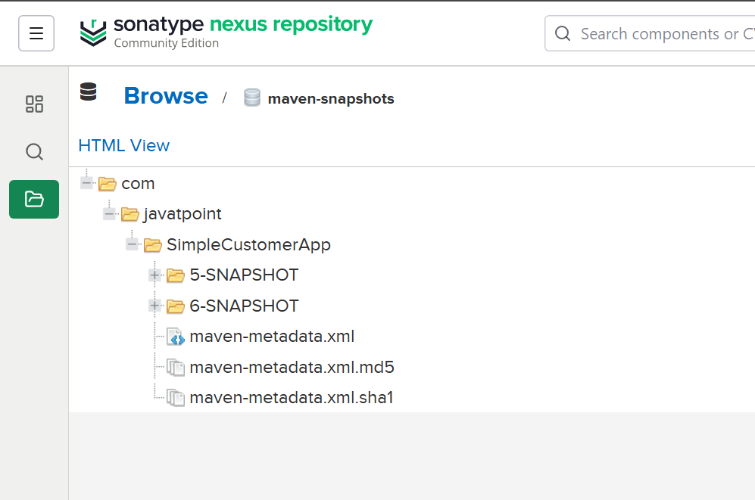
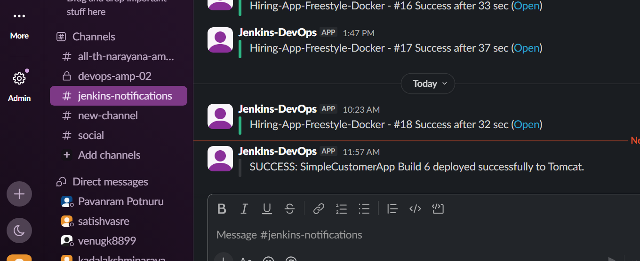
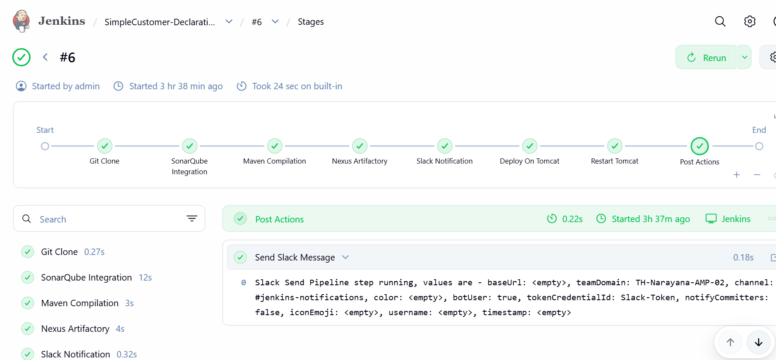

TASK 3 — Scripted Pipeline
STEP 1 — Create the Jenkins job
From Jenkins dashboard:
New Item
Enter: SimpleCustomer-Scripted
Select: Pipeline
Click: OK
STEP 2 — Configure Pipeline
Scroll down to: Pipeline
Set: Definition: Pipeline script
Paste the following exactly.
Do not paste the ```groovy markers.
node {
try {
stage('Git Clone') {
git branch: 'feature-1.1',
url: 'https://github.com/narayana-28/sabear_simplecutomerapp.git'
}
stage('SonarQube Integration') {
withCredentials([string(credentialsId: 'sonar-token', variable: 'SONAR_TOKEN')]) {
sh '''
mvn org.sonarsource.scanner.maven:sonar-maven-plugin:5.7.0.6970:sonar \
-Dsonar.host.url=http://34.234.170.203:9000 \
-Dsonar.token=$SONAR_TOKEN '''
}
}
stage('Maven Compilation') {
sh 'mvn clean package'
}

stage('Nexus Artifactory') {
sh 'mvn deploy'
}
stage('Deploy On Tomcat') {
sh '''
scp \
-i /var/lib/jenkins/.ssh/tomcat_deploy \
target/*.war \
jenkins-deploy@10.0.2.95:/opt/tomcat/webapps/
'''
}
stage('Restart Tomcat') {
sh '''
ssh \
-i /var/lib/jenkins/.ssh/tomcat_deploy \
jenkins-deploy@10.0.2.95 \
"sudo systemctl restart tomcat"
'''
}
stage('Slack Notification - Success') {
slackSend(
channel: 'jenkins-notifications',
color: 'good',
message: "SUCCESS: ${JOB_NAME} #${BUILD_NUMBER} completed successfully. Application deployed to Tomcat."
)
}

} catch (Exception e) {

stage('Slack Notification - Failure') {
slackSend(
channel: 'jenkins-notifications',
color: 'danger',
message: "FAILURE: ${JOB_NAME} #${BUILD_NUMBER} failed. Please check Jenkins Console Output."
)
}

throw e
}
}
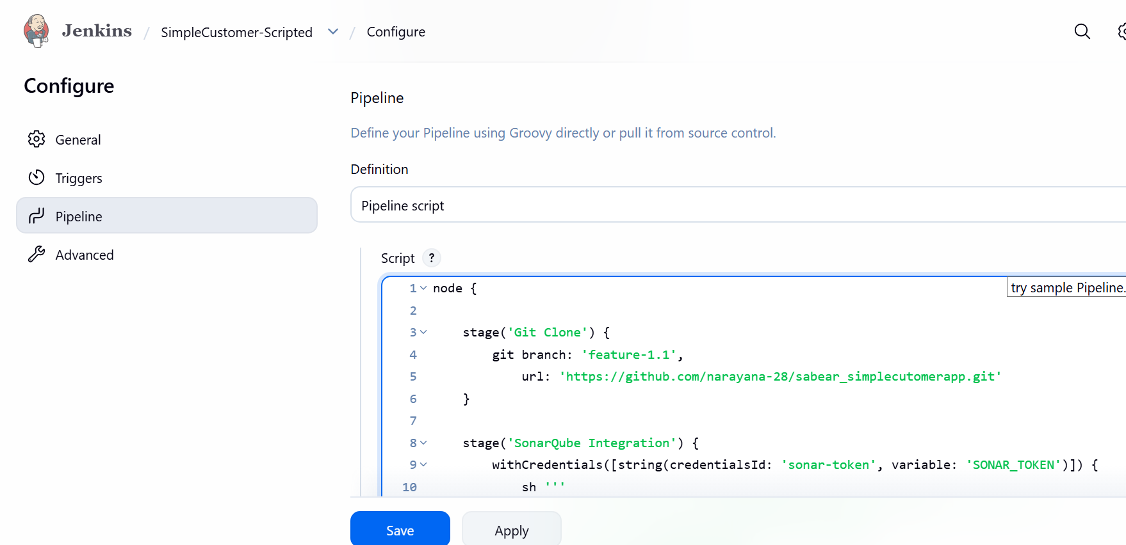
Why I'm using this version
Your previous Declarative Pipeline already proved that these pieces work:
- sonar-token credential
- SonarQube server 34.234.170.203:9000
- Nexus configuration in your GitHub POM
- /var/lib/jenkins/.ssh/tomcat_deploy
- jenkins-deploy@10.0.2.95
- passwordless sudo systemctl restart tomcat
So we're reusing the same working configuration.

STEP 3 — Save
Click: Save
You should now see the job:
SimpleCustomer-Scripted

STEP 4 — Build Now
Click: Build Now
Then click the build number, for example:
#1
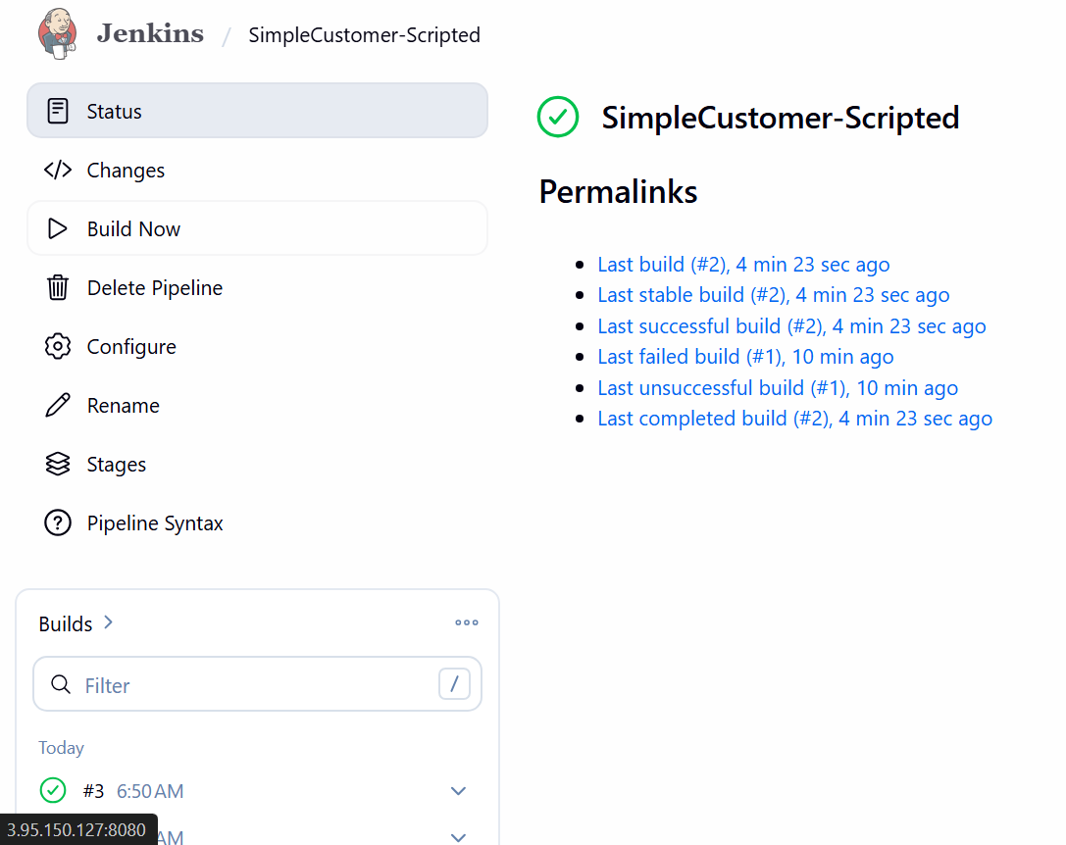
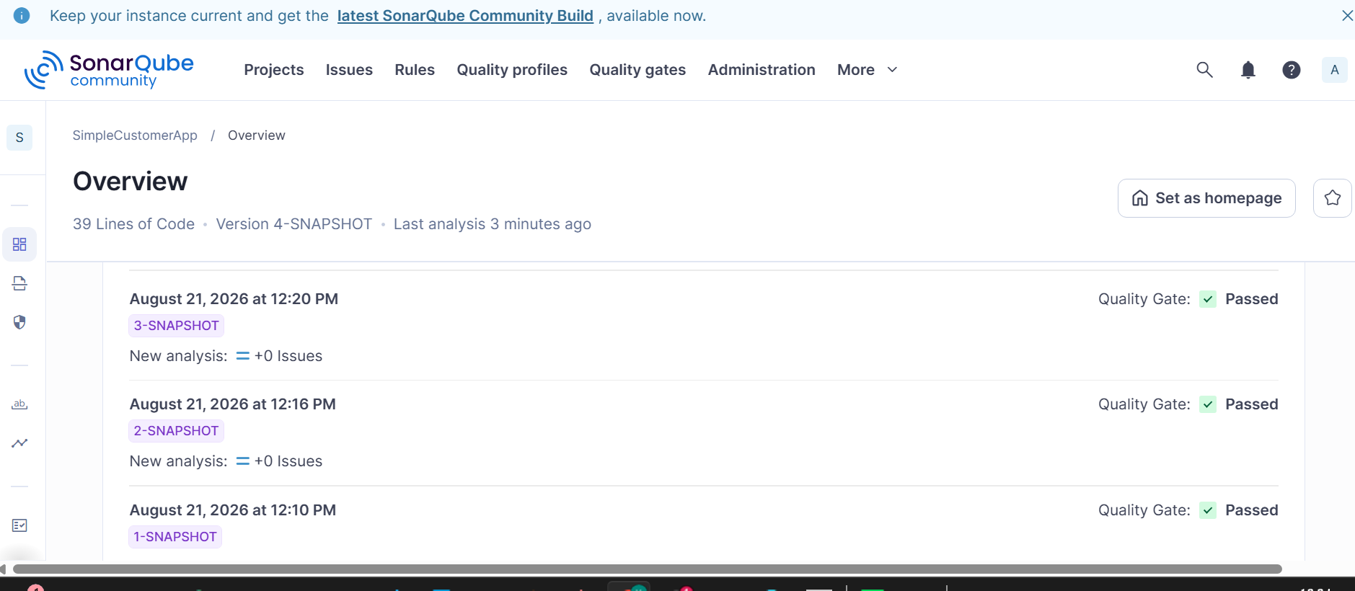
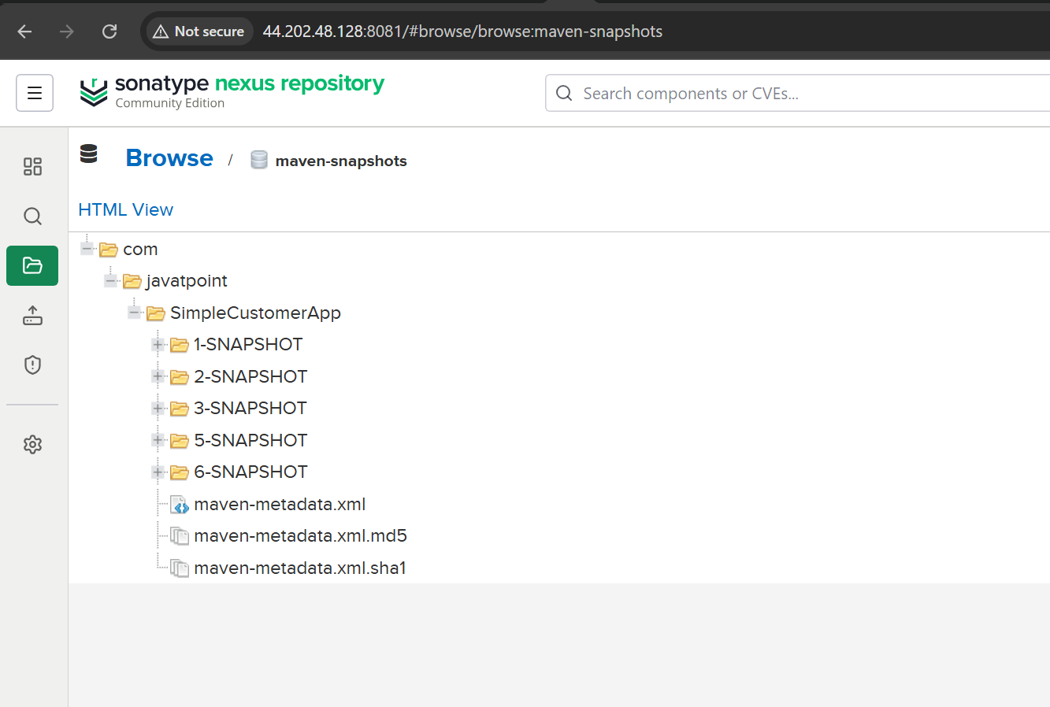
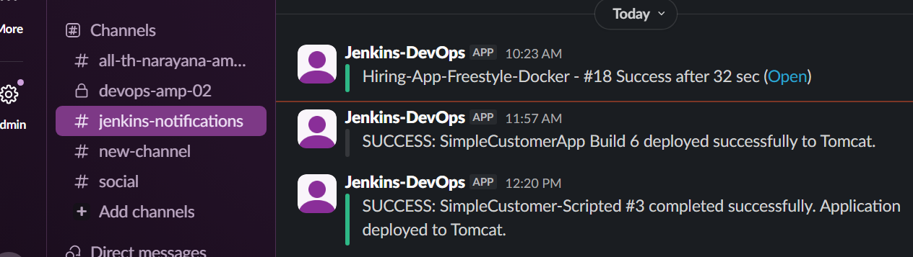
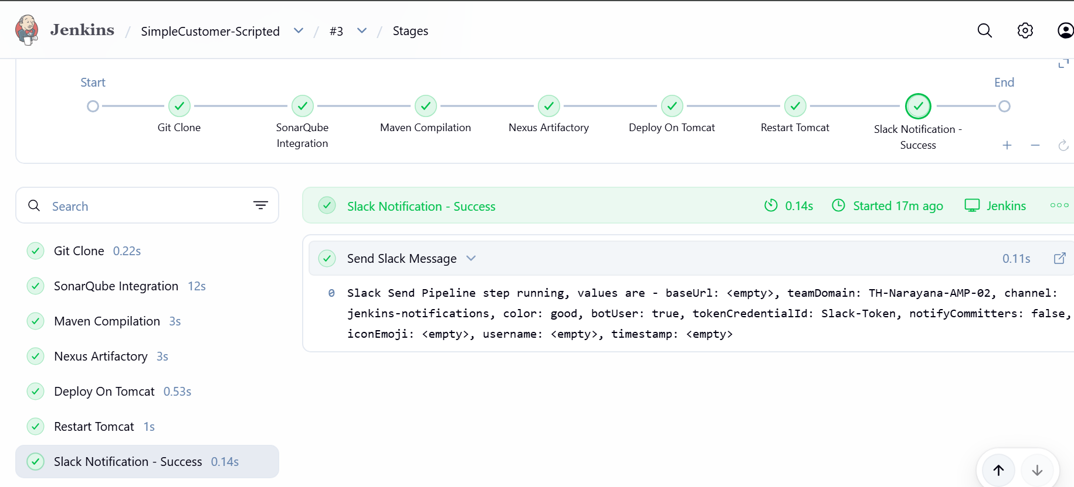

TASK 4 — Sample Skeleton of Pipelines
We will create 3 sample skeletons:
- Declarative Pipeline skeleton
- Scripted Pipeline skeleton
- Complete CI/CD Pipeline skeleton
The purpose is to understand the pipeline structure, stages, steps, and post actions.

STEP 1 — Create a new Jenkins Pipeline job
Go to: Jenkins Dashboard → New Item
Enter: Pipeline-Skeleton
Select: Pipeline
Click OK.
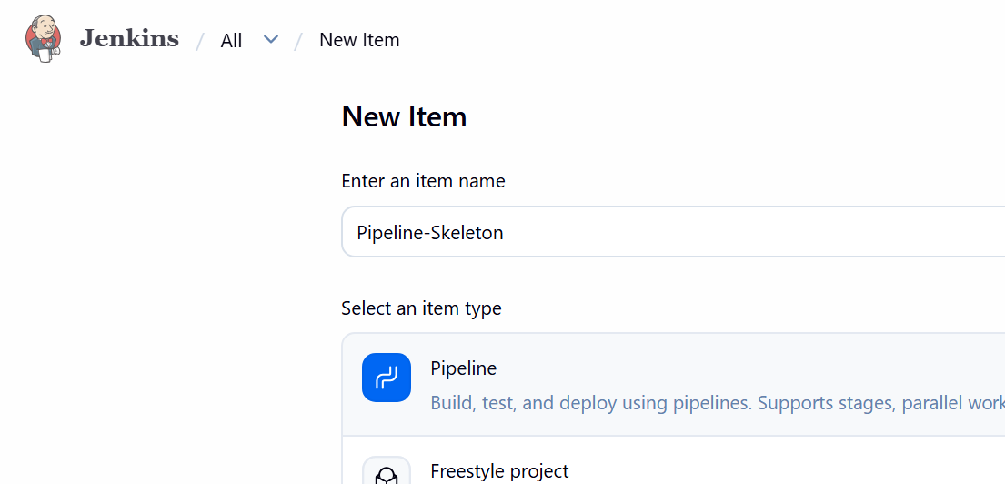

STEP 2 — Create Declarative Pipeline Skeleton
Go to: Pipeline → Definition → Pipeline script
Paste this:
pipeline {

agent any

stages {

stage('Build') {
steps {
echo 'Building application...'
}
}

stage('Test') {
steps {
echo 'Running tests...'
}
}

stage('Deploy') {
steps {
echo 'Deploying application...'
}
}
}

post {

success {
echo 'Pipeline completed successfully!'
}

failure {
echo 'Pipeline failed!'
}

always {
echo 'Pipeline execution completed.'
}
}
}
Click: Save → Build Now
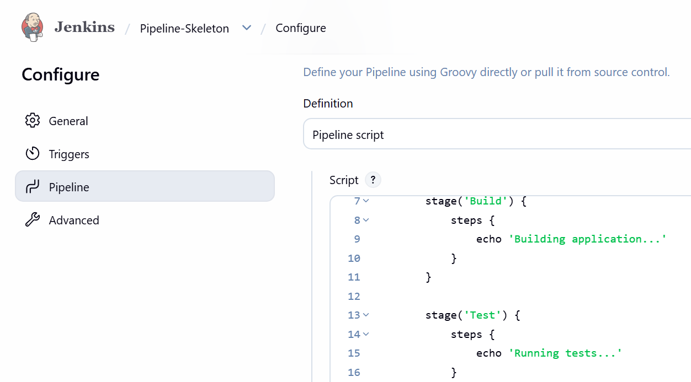

STEP 3 — Check the build
Click the build number, for example:
#1 ✅ Declarative skeleton completed.
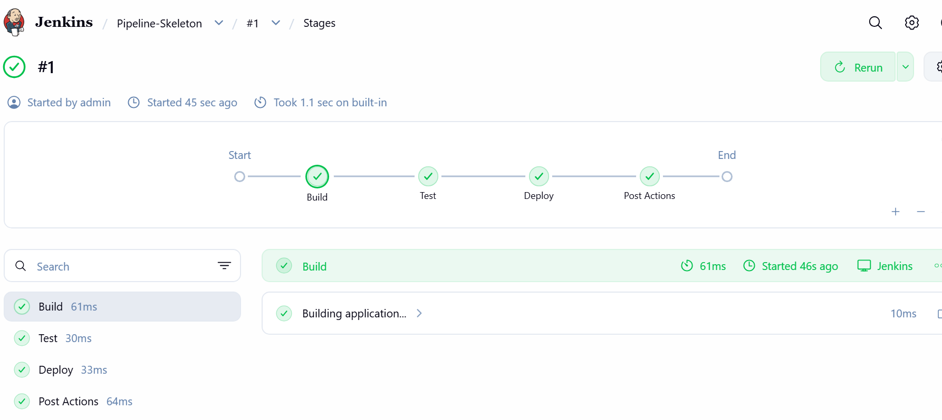

STEP 4 — Create Scripted Pipeline Skeleton
Go back to: Jenkins Dashboard → New Item
Enter: Pipeline-Skeleton-Scripted
Select: Pipeline
Click OK.
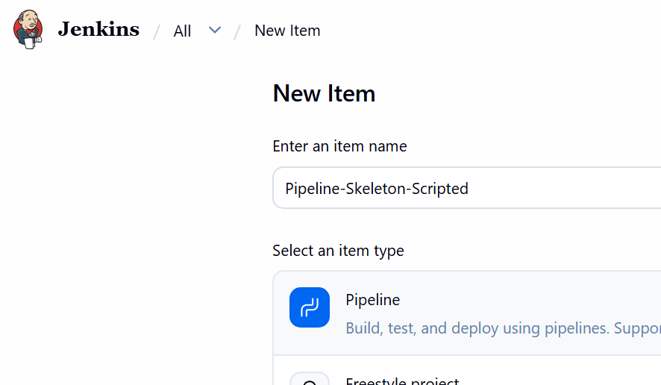
Go to:Pipeline → Pipeline script
Paste:
node {

stage('Build') {
echo 'Building application...'
}

stage('Test') {
echo 'Running tests...'
}

stage('Deploy') {
echo 'Deploying application...'
}

echo 'Pipeline completed.'
}
Click: Save → Build Now
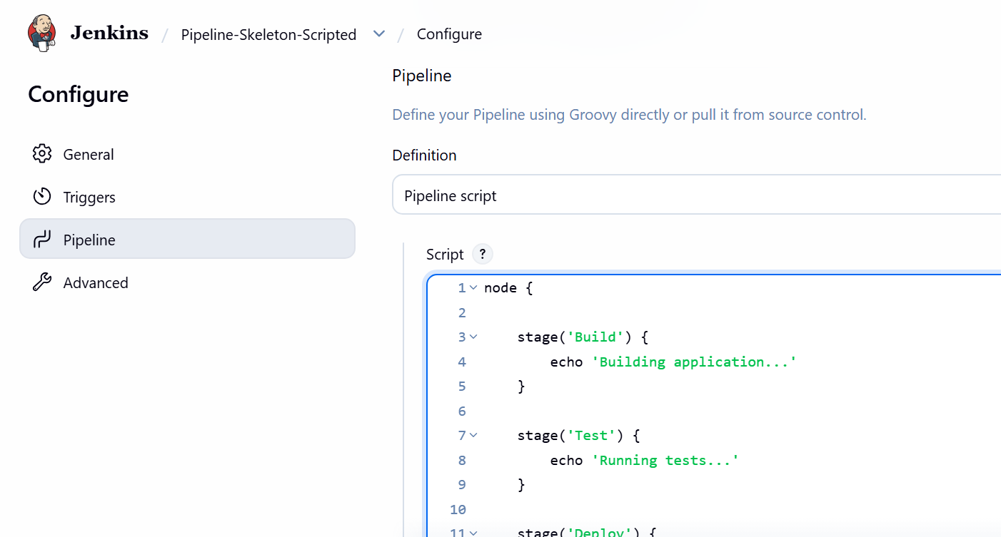

STEP 5 — Verify Scripted Pipeline
Open: ✅ Scripted skeleton completed.
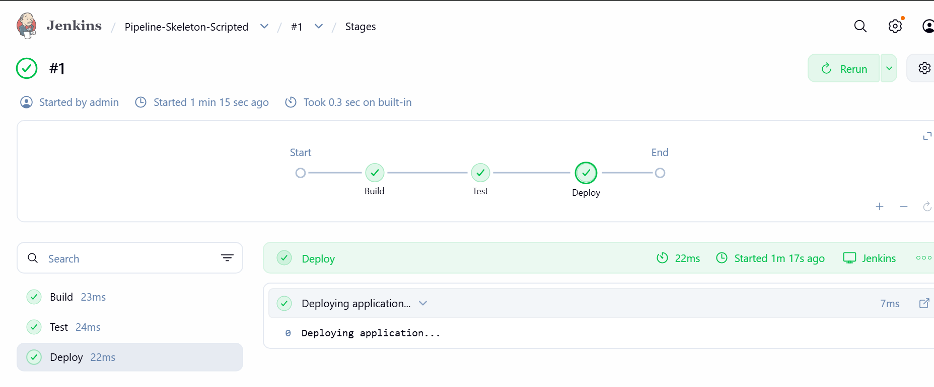

STEP 6 — Create CI/CD Skeleton
Now create one more job: Jenkins Dashboard → New Item
Name: CI-CD-Skeleton
Select: Pipeline
Click OK.
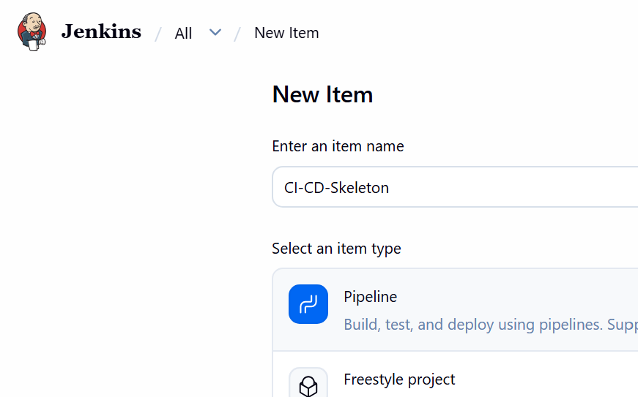
Use this pipeline:
pipeline {

agent any

stages {

stage('Checkout') {
steps {
echo 'Checking out source code...'
}
}

stage('Build') {
steps {
echo 'Building application...'
}
}

stage('SonarQube') {
steps {
echo 'Running SonarQube analysis...'
}
}

stage('Test') {
steps {
echo 'Running application tests...'
}
}

stage('Nexus') {
steps {
echo 'Uploading artifact to Nexus...'
}
}

stage('Deploy') {
steps {
echo 'Deploying application to Tomcat...'
}
}

stage('Notification') {
steps {
echo 'Sending Slack notification...'
}
}
}

post {

success {
echo 'CI/CD Pipeline SUCCESS'
}

failure {
echo 'CI/CD Pipeline FAILURE'
}

always {
echo 'Pipeline execution finished'
}
}
}
Click: Save → Build Now
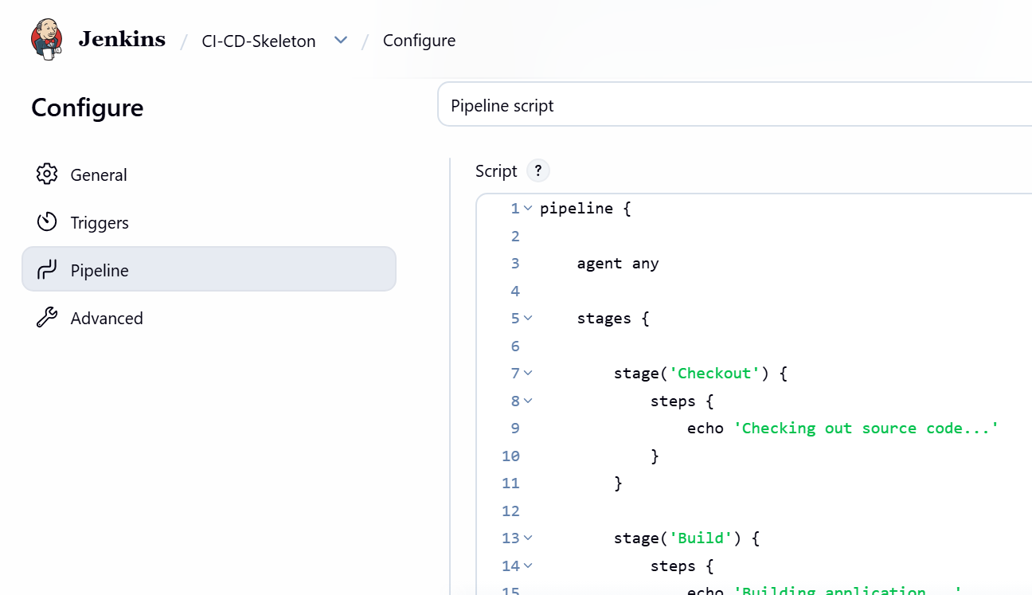

STEP 7 — Verify the CI/CD skeleton
You should see these stages:
Checkout
↓
Build
↓
SonarQube
↓
Test
↓
Nexus
↓
Deploy
↓
Notification
The pipeline will not actually perform Git checkout, Maven build, SonarQube analysis, Nexus upload, or Tomcat deployment.
It only demonstrates the pipeline structure using echo.
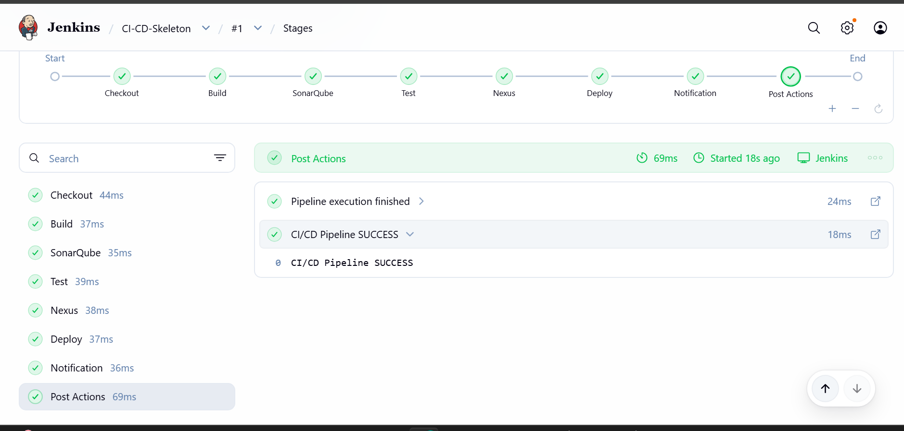

STEP 8 — Understand the Skeleton
Remember this structure for your interview:
pipeline
│
├── agent
│
├── stages
│ │
│ ├── Checkout
│ ├── Build
│ ├── Test
│ └── Deploy
│
└── post
│
├── success
├── failure
└── always
Important keywords
Keyword | Meaning
pipeline | Defines a Declarative Pipeline
agent | Specifies where pipeline runs
stages | Container for pipeline stages
stage | Individual phase of pipeline
steps | Commands executed inside a stage
node | Used in Scripted Pipeline
post | Actions after pipeline execution
success | Runs when pipeline succeeds
failure | Runs when pipeline fails
always | Runs regardless of result
echo | Prints a message in console

Task 4 Final Deliverables
You should now have 3 Jenkins jobs:
1. Pipeline-Skeleton → Declarative Pipeline
2. Pipeline-Skeleton-Scripted → Scripted Pipeline
3. CI-CD-Skeleton → Complete CI/CD structure
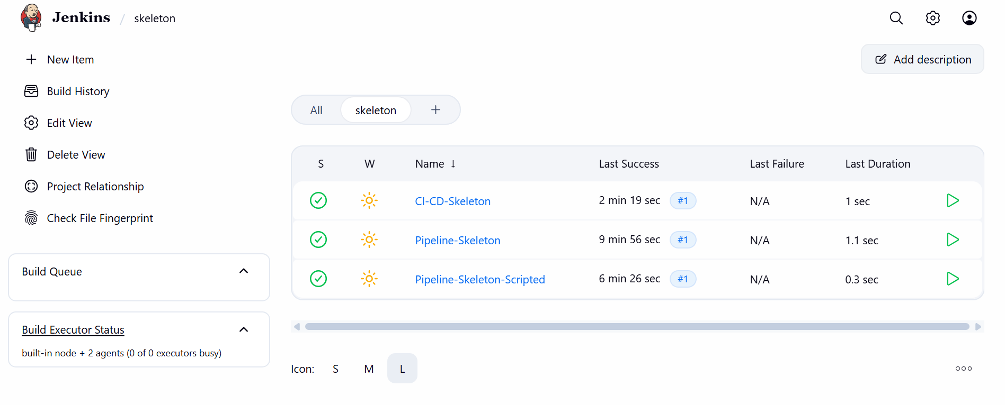

TASK 5 — Parameterized Job
Repository:
spring3-mvc-maven-xml-hello-world-1

STEP 17 — Create Job
Go to: New Item
Enter: HelloWorld-Parameterized
Select: Freestyle project
Click: OK
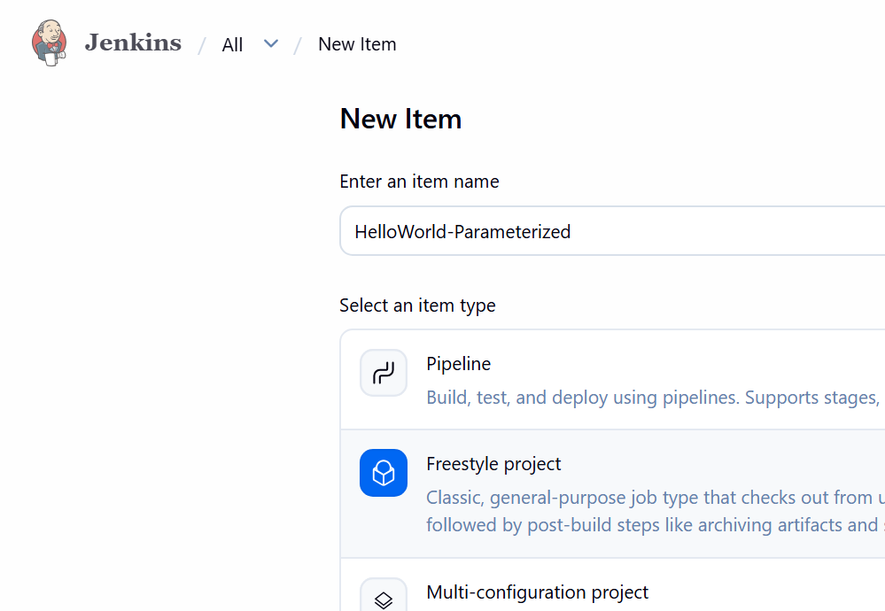

STEP 18 — Enable Parameter
Select: This project is parameterized
Click: Add Parameter
→ Choice Parameter
Enter: Name: ENVIRONMENT
Choices:DEV
UAT
PROD
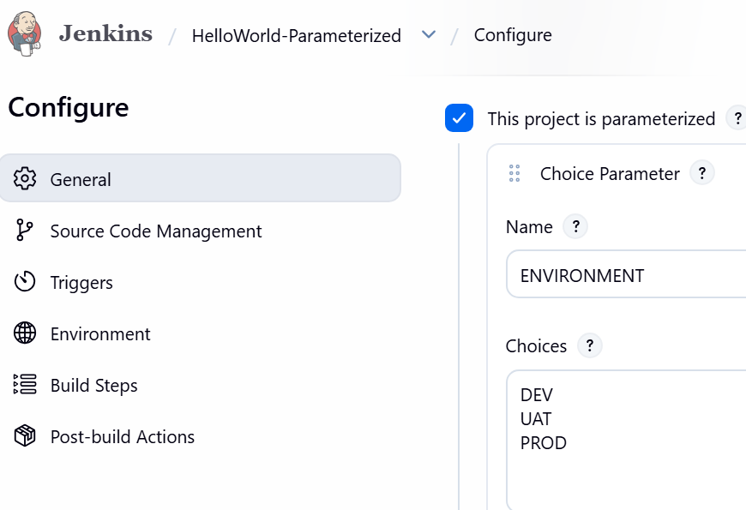
Add another: String Parameter
Name: VERSION
Default: 1.0.0
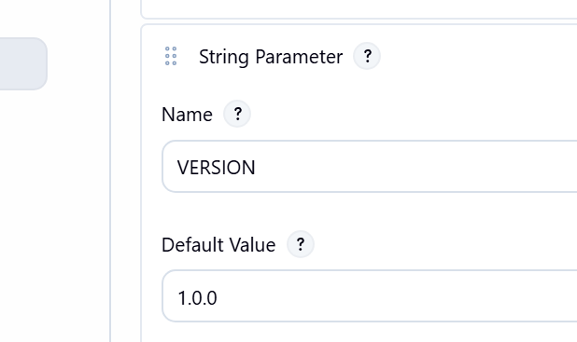

STEP 19 — Configure Git
Go to:Source Code Management
→ Git
Repository: https://github.com/betawins/spring3-mvc-maven-xml-hello-world-1.git
Use the repository's actual default branch, for example:
*/master
or:
*/main

STEP 20 — Use Parameters
Go to:
Build
→ Execute shell
Use:
echo "Environment = $ENVIRONMENT"
echo "Version = $VERSION"

mvn clean package
Save.
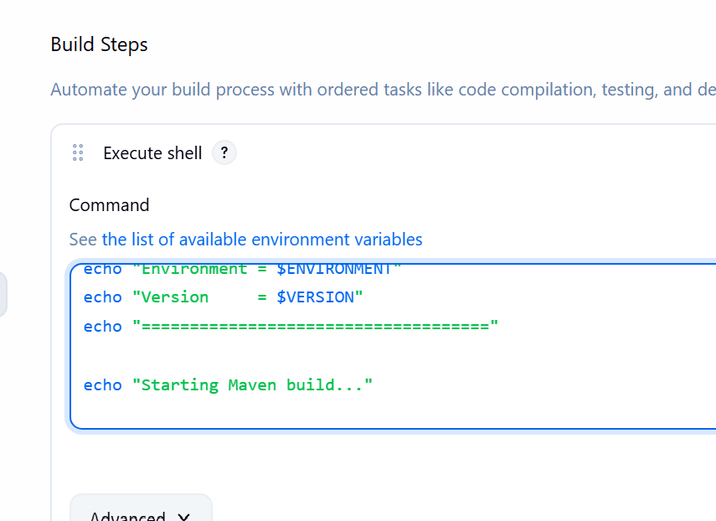
Now instead of: Build Now
you'll get: Build with Parameters
Select:ENVIRONMENT = UAT
VERSION = 1.0.5
Click:Build
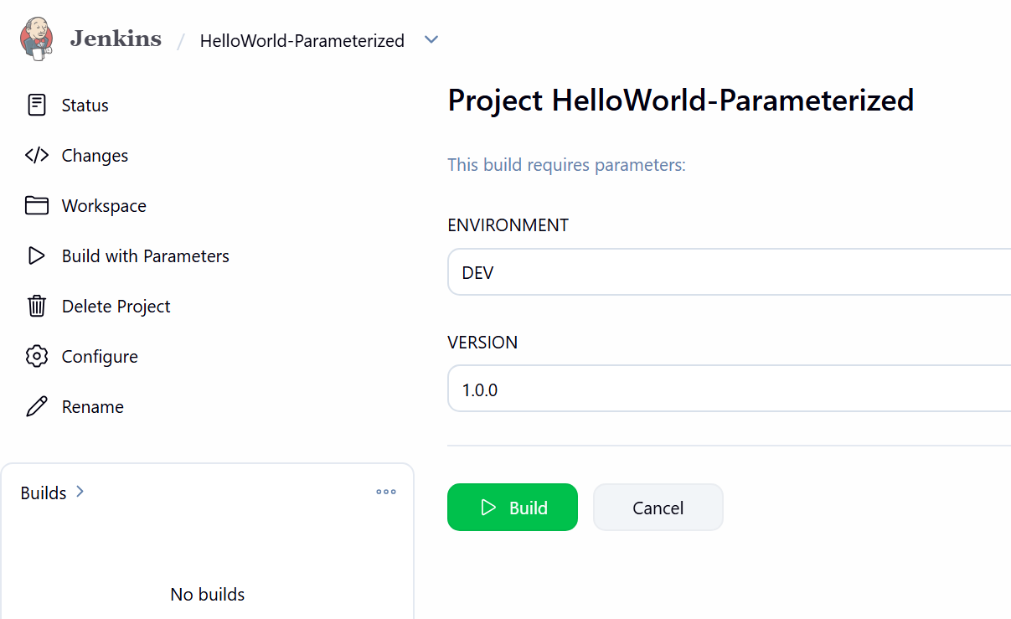
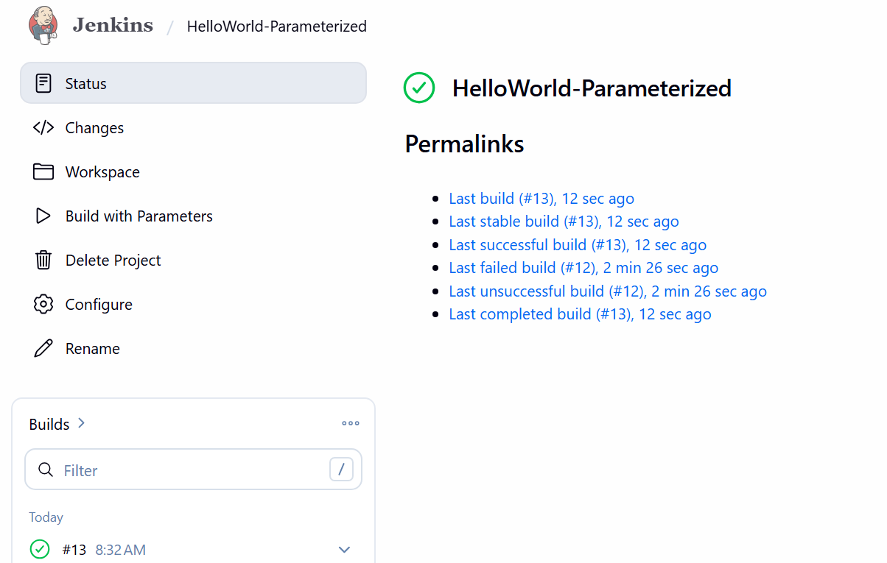
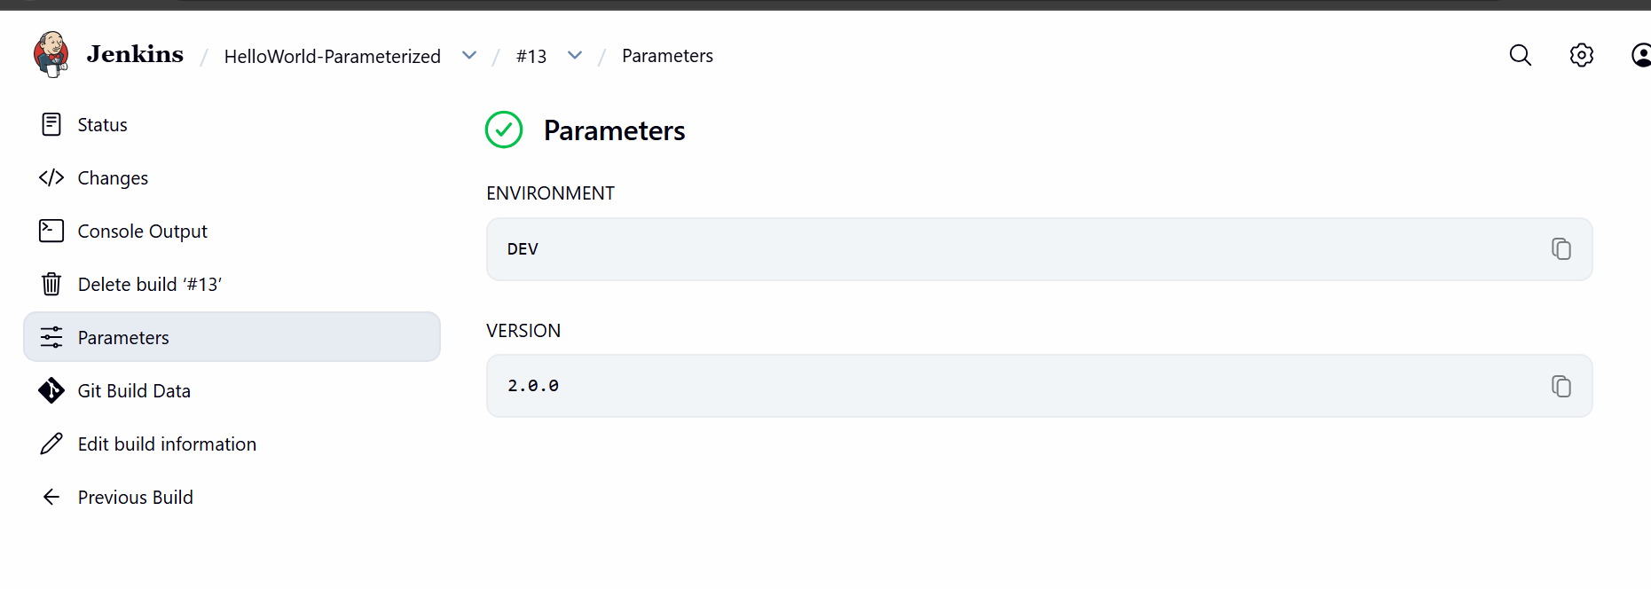
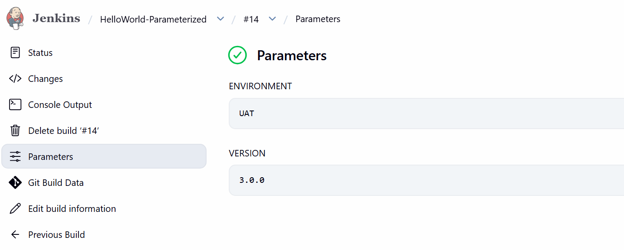

TASK 6 — Jenkins Slave/Agent
This is best done after the pipelines work.

STEP 21 — Create EC2 Agent
Launch another Amazon Linux 2023 EC2.
Call it: Jenkins-Agent-01(slave-01)
Connect: ssh -i key.pem ec2-user@<AGENT-IP>
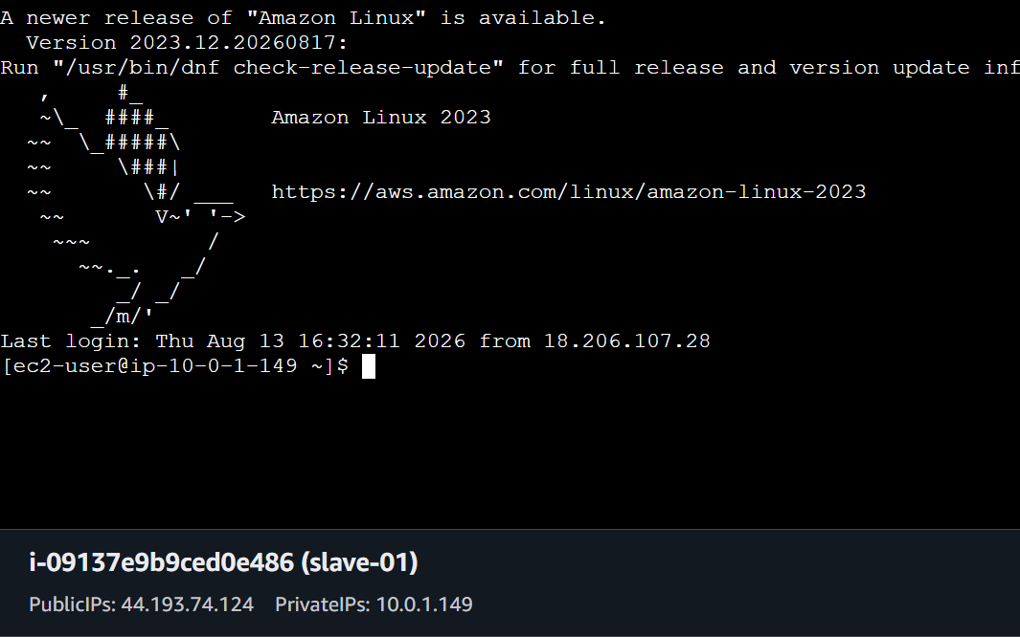

STEP 22 — Install Java
On the agent: sudo dnf install java-21-amazon-corretto -y
Check: java -version
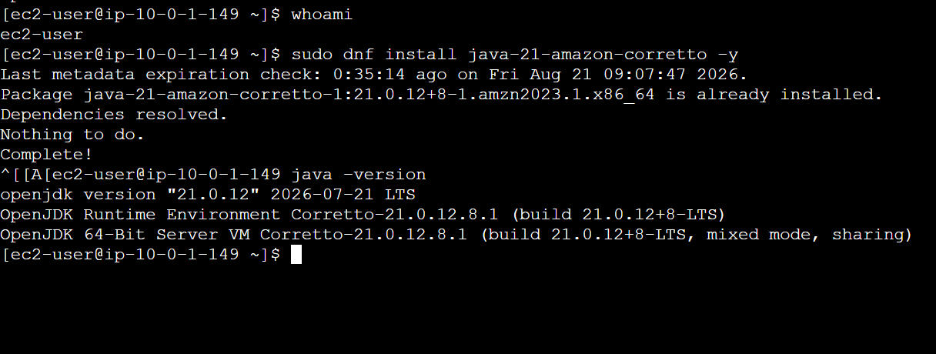

STEP 23 — Create Agent Directory
mkdir -p ~/jenkins

STEP 24 — Create Node in Jenkins
Go to:
Manage Jenkins → Nodes
→ New Node
Enter:Name: slave-01
Select: Permanent Agent
Click: Create
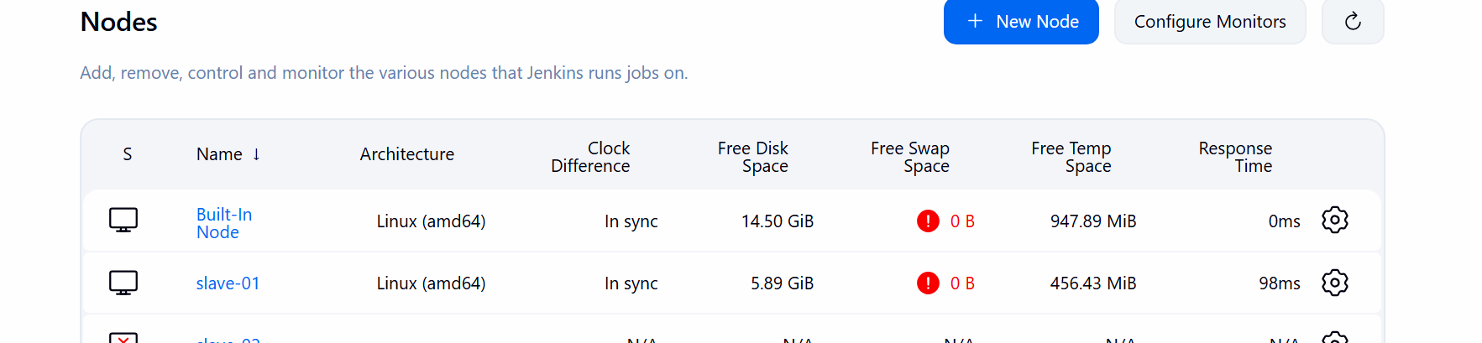

STEP 25 — Agent Configuration
Enter:Description:
Linux Jenkins Agent
Executors:
2
Remote root directory:
/home/ec2-user/jenkins
Labels: linux
Launch method: Launch agents via SSH
Host: <AGENT-IP>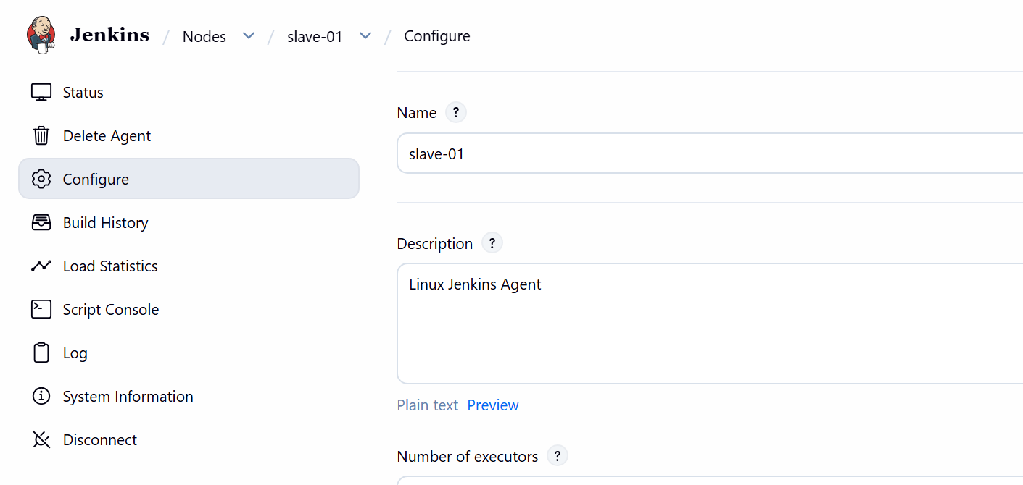

STEP 26 — SSH Credential
On Jenkins controller: sudo -u jenkins ssh-keygen -t ed25519
Display public key: sudo cat /var/lib/jenkins/.ssh/id_ed25519.pub
Copy it.
On the agent: mkdir -p ~/.ssh
chmod 700 ~/.ssh
vi ~/.ssh/authorized_keys
Paste the Jenkins public key.
Then: chmod 600 ~/.ssh/authorized_keys

STEP 27 — Test SSH
From Jenkins server: sudo -u jenkins ssh ec2-user@<AGENT-IP>
It should connect.
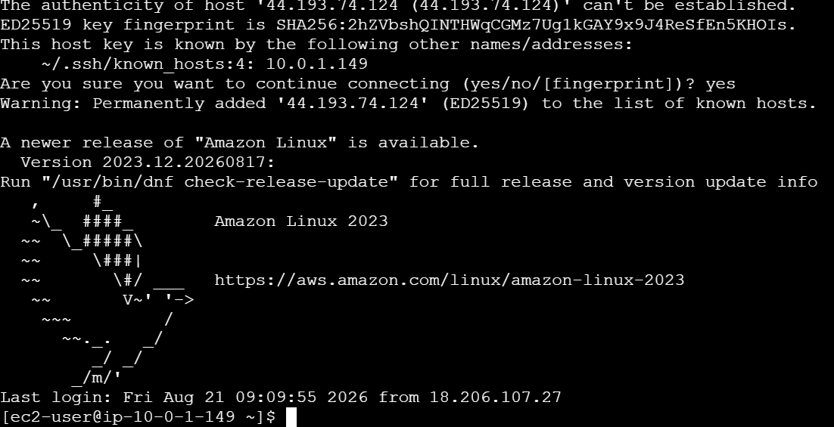

STEP 28 — Add SSH Credential
Jenkins:Manage Jenkins
→ Credentials
→ System
→ Global credentials
→ Add Credentials
Select: SSH Username with private key
Username:ec2-user
Private key: Jenkins private key
ID:slave-01-key
Save.
Go back to: Nodes
→ slave-01
→ Configure
Select:slave-01-key
Save.
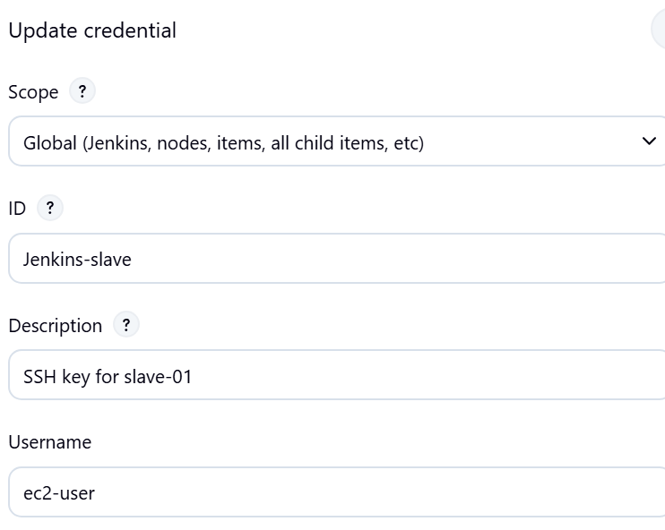
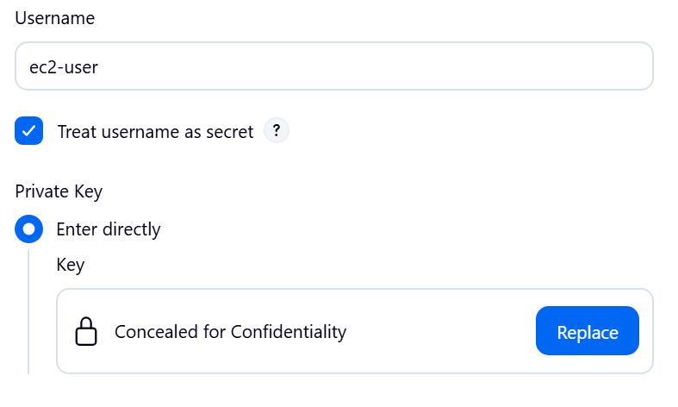

STEP 29 — Verify Agent
Go to: Manage Jenkins
→ Nodes
You should see: Built-In Node
slave-01
And: slave-01 → Connected

STEP 30
Test the Agent
Now let's prove that Jenkins actually executes a job on slave-01.
Go to: Jenkins Dashboard → New Item
Enter:Agent-Test4
Select: Pipeline
Click OK.
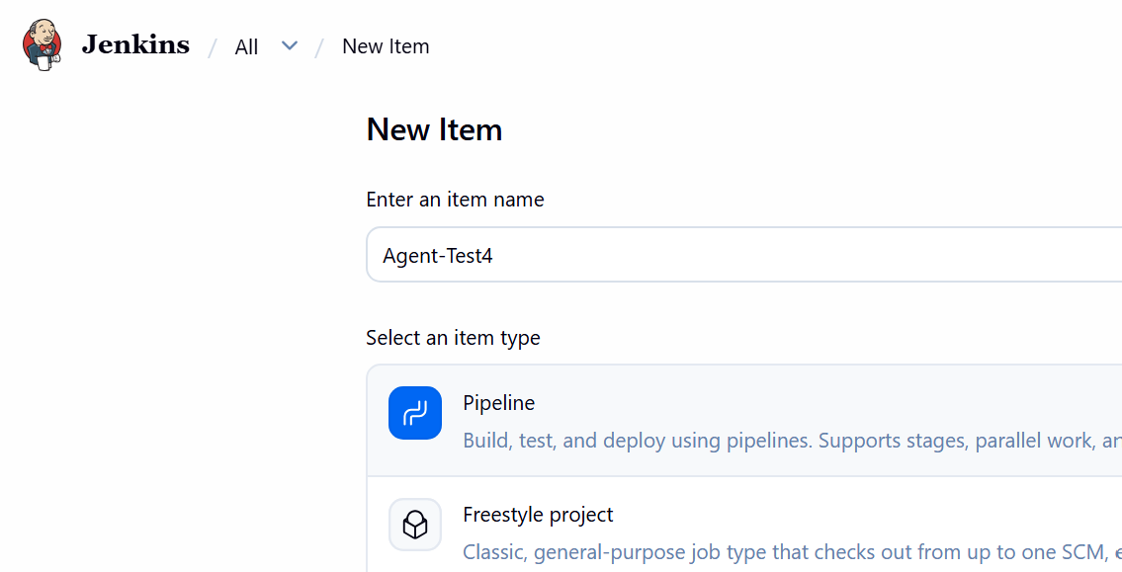
Under Pipeline, select:
Definition → Pipeline script
Paste this:
pipeline {
agent {
label 'linux'
}

stages {
stage('Agent Test') {
steps {
sh 'echo "=== Agent Information ==="'
sh 'hostname'
sh 'echo "=== Java Version ==="'
sh 'java -version'
sh 'echo "=== Current User ==="'
sh 'whoami'
sh 'echo "=== Working Directory ==="'
sh 'pwd'
}
}
}
}
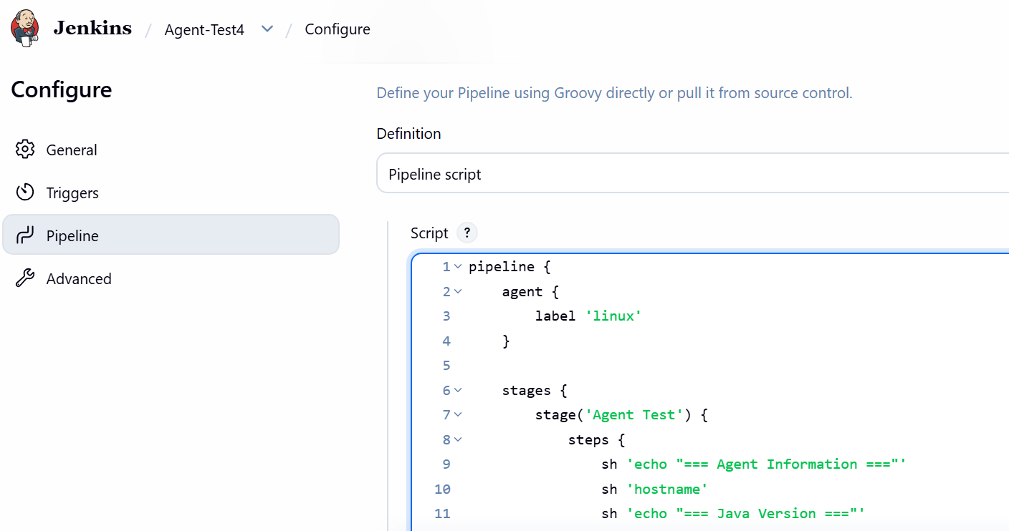
Click Save → Build Now.
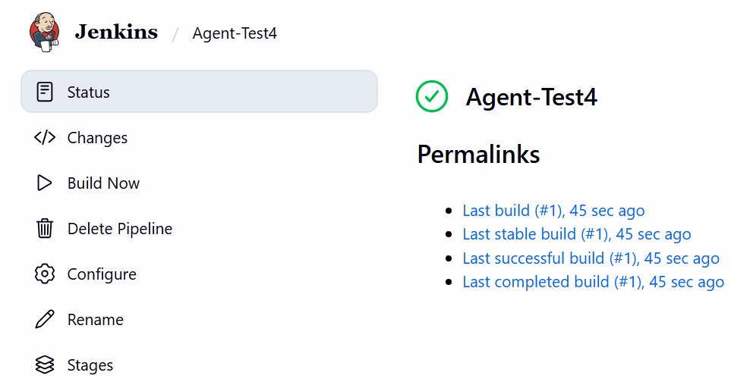
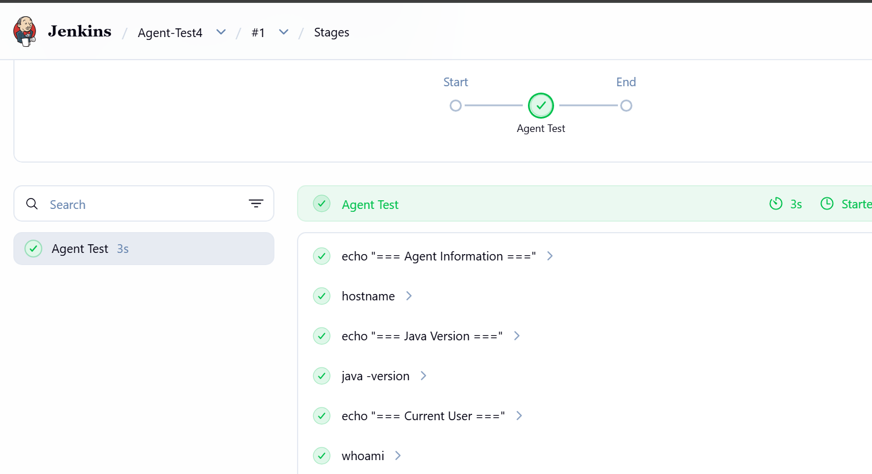
Architecture now
Jenkins Controller
3.95.150.127
|
| SSH
↓
┌───────────────┐
│ slave-01 │
│ Linux │
│ Java 21 │
│ 2 Executors │
│ label=linux │
└───────────────┘
|
↓
/home/ec2-user/jenkins
So you now have a working Jenkins Controller → Agent architecture. 🎯

