Kubernetes-03
Task 1 — ClusterIP Service for Apache
Step 1: Create the Apache Pod
On k8s-master:
kubectl run apache-pod \
--image=httpd \
--port=80
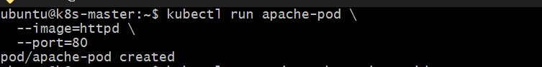
Check the pod: kubectl get pod apache-pod -o wide
You should see:
NAME READY STATUS IP NODE
apache-pod 1/1 Running 10.x.x.x k8s-worker

Step 2: Create the ClusterIP Service
Run: kubectl expose pod apache-pod \
--name=apache-service \
--type=ClusterIP \
--port=80 \
--target-port=80
Check: kubectl get svc apache-service
Expected:
NAME TYPE CLUSTER-IP PORT(S)
apache-service ClusterIP 10.x.x.x 80/TCP
Notice:
TYPE = ClusterIP
That means the service is accessible inside the Kubernetes cluster, not directly from the external internet.
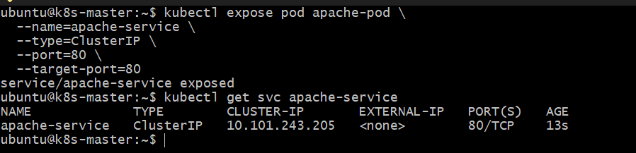Step 3: Verify the Service
Run: kubectl get pod apache-pod --show-labels
You should see a label similar to:
run=apache-pod
Now inspect the service: kubectl describe svc apache-service
Look for:
Selector: run=apache-pod
Endpoints: <pod-ip>:80
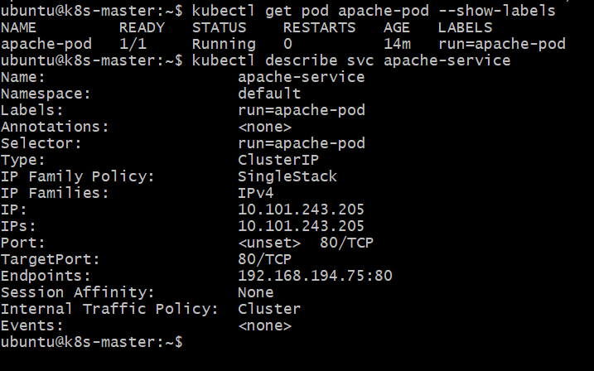
The important relationship is:
Apache Pod
|
| label: run=apache-pod
v
ClusterIP Service
|
| selector: run=apache-pod
v
Apache Pod

Step 4: Test Apache from Inside the Cluster
Create a temporary curl pod:
kubectl run test-curl \
--image=curlimages/curl \
--rm -it \
--restart=Never \
-- curl http://apache-service
You should get Apache's HTML response, something like:
<html><body><h1>It works!</h1></body></html>
That proves: Pod → ClusterIP Service → Apache Pod

Step 5: Verify Everything
Run: kubectl get pods
and:
kubectl get svc
You should have something similar to:
NAME READY STATUS RESTARTS AGE
apache-pod 1/1 Running 0 ...
and:
NAME TYPE CLUSTER-IP PORT(S)
apache-service ClusterIP 10.x.x.x 80/TCP
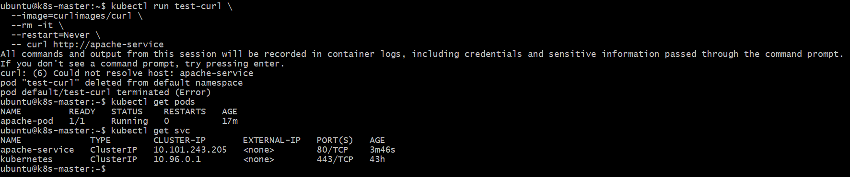
Task 2 — Expose Nginx using NodePort
Let's continue from here.
Step 1 — Create Nginx Pod
Run:
kubectl run nginx-pod \
--image=nginx \
--port=80
Then:
kubectl get pod nginx-pod -o wide
Wait until you see:
nginx-pod 1/1 Running
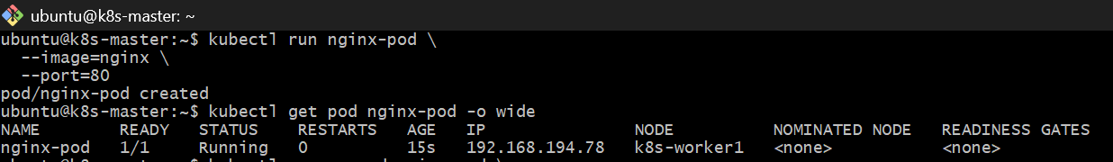
Step 2 — Create NodePort Service
Once the pod is Running, run:
kubectl expose pod nginx-pod \
--name=nginx-nodeport \
--type=NodePort \
--port=80 \
--target-port=80
Then:
kubectl get svc nginx-nodeport
You should see something similar to:
NAME TYPE CLUSTER-IP EXTERNAL-IP PORT(S)
nginx-nodeport NodePort 10.x.x.x <none> 80:30xxx/TCP
For example:
80:30080/TCP
Here:
80 → Service port
30080 → NodePort
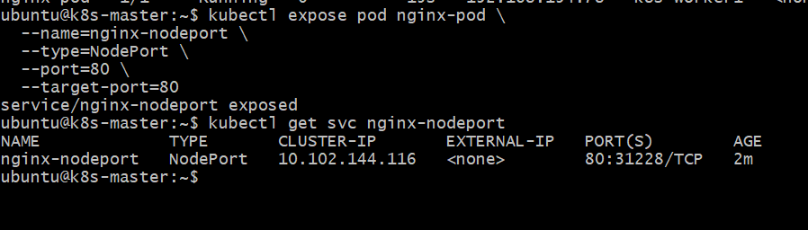
Step 3 — Check the Node IP
Run: kubectl get nodes -o wide
Step 4 — Check the Service Details
Also run: kubectl describe svc nginx-nodeport
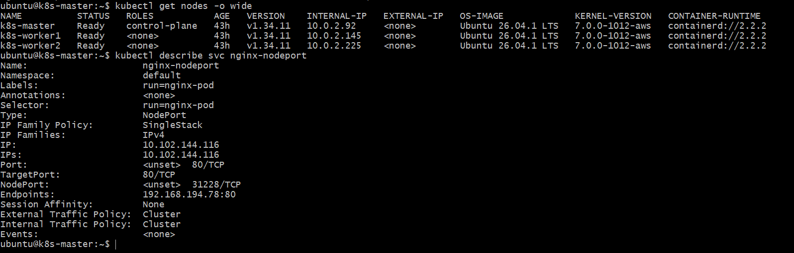
Task 2 is configured correctly. Your Nginx pod is running on k8s-worker1, and the NodePort is 31228.
Your current setup
Nginx Pod
192.168.194.78:80
|
v
nginx-nodeport Service
ClusterIP: 10.102.144.116
|
v
NodePort: 31228
And Kubernetes exposes the NodePort on all nodes:
k8s-master 10.0.2.92
k8s-worker1 10.0.2.145
k8s-worker2 10.0.2.225
Step 1 — Test NodePort from the Kubernetes master
From k8s-master, run:
curl http://10.0.2.92:31228
Then also test the worker where the pod is actually running:
curl http://10.0.2.145:31228
And the second worker:
curl http://10.0.2.225:31228
All three should return the Nginx HTML page, typically containing:
<h1>Welcome to nginx!</h1>
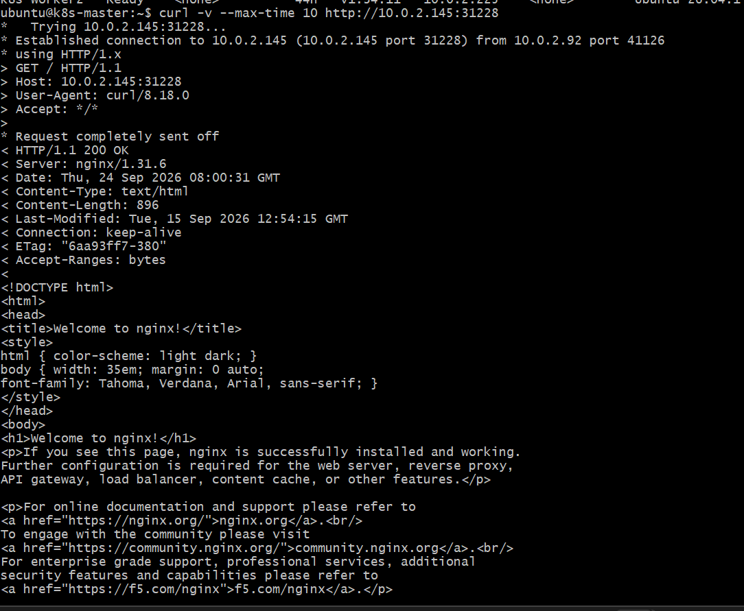
This demonstrates an important NodePort concept:
NodePort 31228
|
+----------+----------+
| | |
v v v
Master Worker1 Worker2
10.0.2.92 10.0.2.145 10.0.2.225
\ | /
\ | /
+--------v--------+
Nginx Pod
192.168.194.78:80
Step 2 — Test from your Windows machine
Because your AWS nodes currently show:
EXTERNAL-IP = <none>
you cannot directly use:
http://10.0.2.145:31228
http://3.87.58.224:31228/
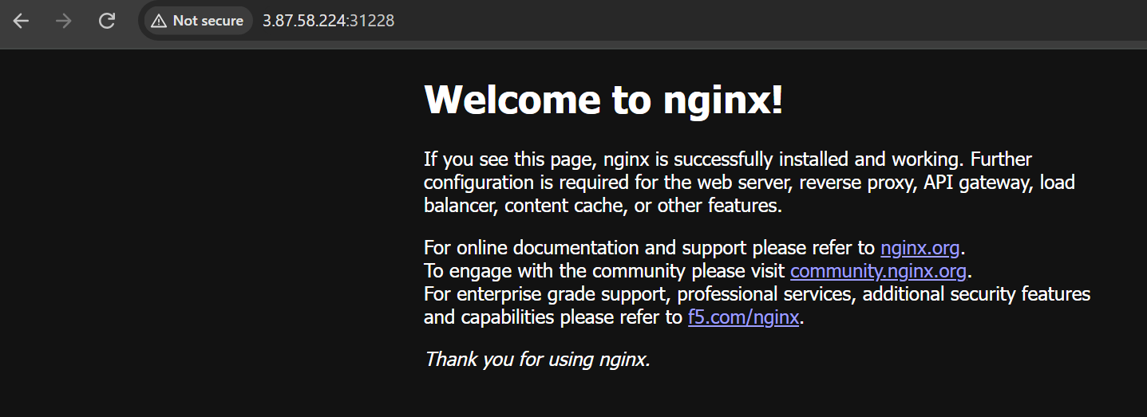
from your Windows laptop over the internet. 10.0.2.x is the private AWS VPC network.
Task 3 — ReplicationController with 3 Nginx Replicas
Objective: Create a ReplicationController that maintains 3 Nginx pods.
Step 1 — Create the ReplicationController YAML
Run: nano nginx-rc.yaml
Paste: apiVersion: v1
kind: ReplicationController
metadata:
name: nginx-rc
spec:
replicas: 3
selector:
app: nginx-rc
template:
metadata:
labels:
app: nginx-rc
spec:
containers:
- name: nginx
image: nginx
ports:
- containerPort: 80
Save:
Ctrl + O → Enter → Ctrl + X
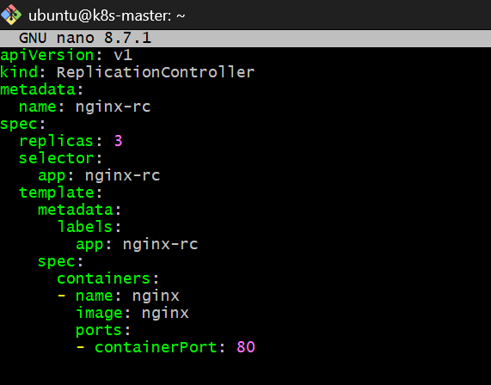

Step 2 — Create the ReplicationController
kubectl apply -f nginx-rc.yaml
Expected: replicationcontroller/nginx-rc created

Step 3 — Check the ReplicationController
kubectl get rc
Expected:
NAME DESIRED CURRENT READY AGE
nginx-rc 3 3 3 ...
The important part is:
DESIRED = 3
CURRENT = 3
READY = 3
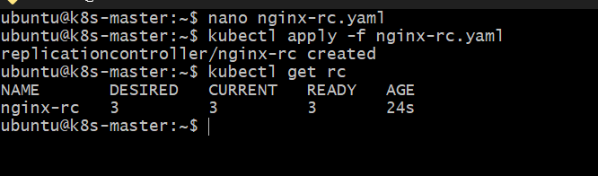
Step 4 — Check the Pods
kubectl get pods -l app=nginx-rc -o wide
You should see 3 Nginx pods, for example:
NAME READY STATUS IP NODE
nginx-rc-xxxxx 1/1 Running 192.168.x.x k8s-worker1
nginx-rc-yyyyy 1/1 Running 192.168.x.x k8s-worker2
nginx-rc-zzzzz 1/1 Running 192.168.x.x k8s-worker1
Notice that Kubernetes can distribute the pods across your worker nodes.
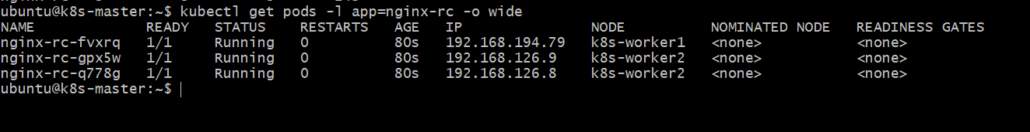
Step 5 — Verify the ReplicationController
Run: kubectl describe rc nginx-rc
Look for:
Replicas: 3 current / 3 desired
Pods Status: 3 Running / 0 Waiting / 0 Succeeded / 0 Failed
Key concept
The ReplicationController continuously maintains:
Desired state = 3 pods
If one of those pods disappears:
3 pods
↓
1 pod deleted
↓
2 pods remain
↓
ReplicationController notices
↓
creates replacement pod
↓
3 pods again
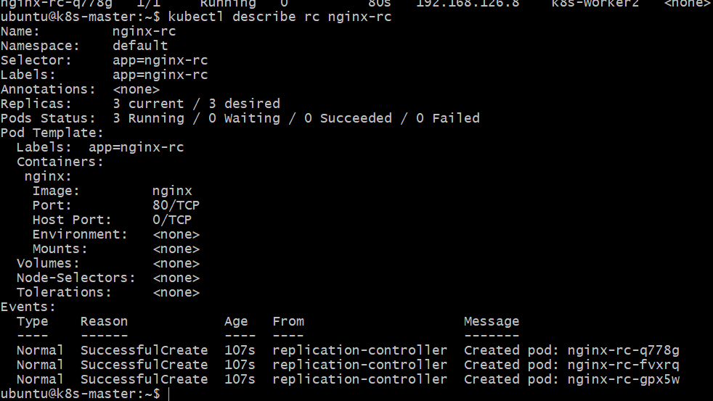
Task 4 — Scale ReplicationController from 3 → 5
Currently: 3 desired
3 current
3 ready
We will change it to: 5 desired
5 current
5 ready
Step 1 — Scale the ReplicationController
Run: kubectl scale rc nginx-rc --replicas=5
Expected: replicationcontroller/nginx-rc scaled

Step 2 — Verify the RC
kubectl get rc nginx-rc
Expected:
NAME DESIRED CURRENT READY
nginx-rc 5 5 5
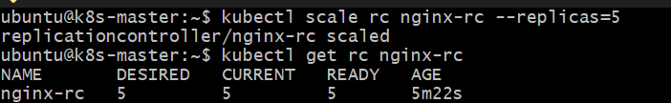
Step 3 — Verify the Pods
kubectl get pods -l app=nginx-rc -o wide
You should now see 5 Nginx pods.
For example:
NAME READY STATUS NODE
nginx-rc-xxxxx 1/1 Running k8s-worker1
nginx-rc-yyyyy 1/1 Running k8s-worker2
nginx-rc-zzzzz 1/1 Running k8s-worker2
nginx-rc-aaaaa 1/1 Running k8s-worker1
nginx-rc-bbbbb 1/1 Running k8s-worker2
The exact pod names will be different.
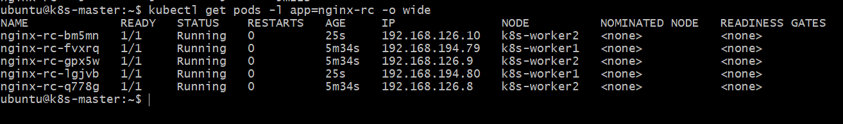
Step 4 — Verify the Replica Count
Run: kubectl describe rc nginx-rc
You should see:
Replicas: 5 current / 5 desired
Pods Status: 5 Running / 0 Waiting / 0 Succeeded / 0 Failed
Remember this
Before:
3 replicas
↓
kubectl scale rc nginx-rc --replicas=5
↓
After:
5 replicas
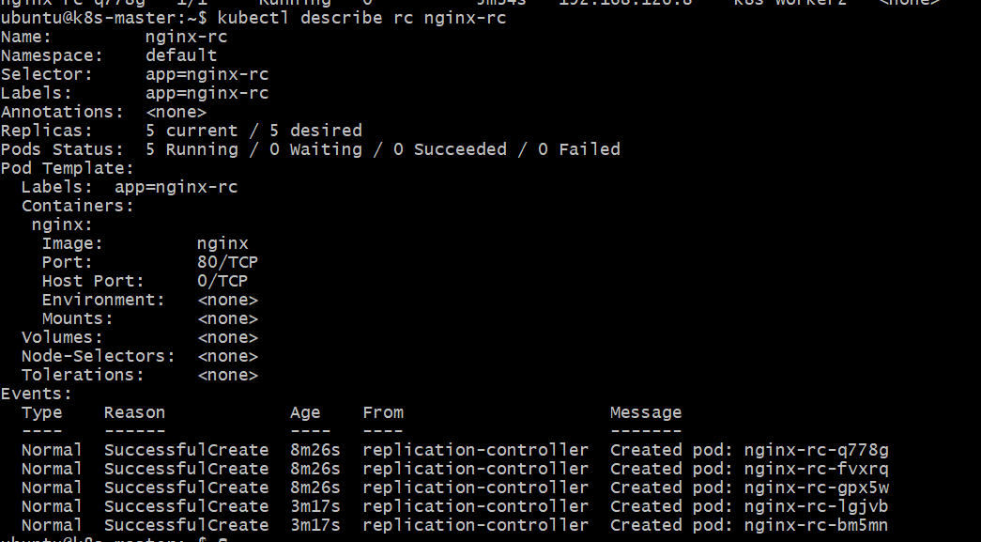

Task 5 — ReplicaSet with Multiple Labels: prod and test
For this task, we'll demonstrate a ReplicaSet managing pods based on multiple labels.
We'll create a ReplicaSet that selects pods having: environment = prod
and tier = test
This is a good way to understand that a ReplicaSet selector can contain multiple matchLabels, and all specified labels must match.Step 1 — Create the ReplicaSet YAML
Run: nano rs-prod-test.yaml
Paste:
apiVersion: apps/v1
kind: ReplicaSet
metadata:
name: nginx-prod-test-rs
spec:
replicas: 3
selector:
matchLabels:
environment: prod
tier: test
template:
metadata:
labels:
environment: prod
tier: test
spec:
containers:
- name: nginx
image: nginx
ports:
- containerPort: 80
Save:
Ctrl + O → Enter → Ctrl + X
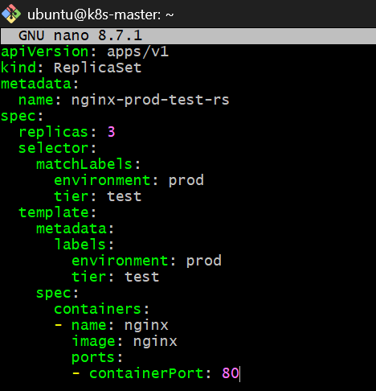

Step 2 — Create the ReplicaSet
kubectl apply -f rs-prod-test.yaml
Expected:
replicaset.apps/nginx-prod-test-rs created

Step 3 — Check the ReplicaSet
kubectl get rs
You should see:
NAME DESIRED CURRENT READY
nginx-prod-test-rs 3 3 3
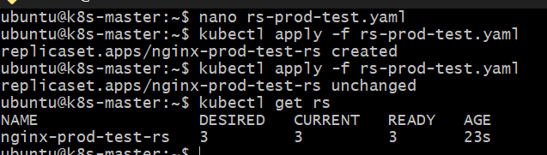
Step 4 — Check Its Pods
Run: kubectl get pods \
-l environment=prod,tier=test \
-o wide
You should see 3 pods.
Then verify their labels:
kubectl get pods \
-l environment=prod,tier=test \
--show-labels
Expected concept:
NAME LABELS
nginx-prod-test-rs-xxxxx environment=prod,tier=test
nginx-prod-test-rs-yyyyy environment=prod,tier=test
nginx-prod-test-rs-zzzzz environment=prod,tier=test
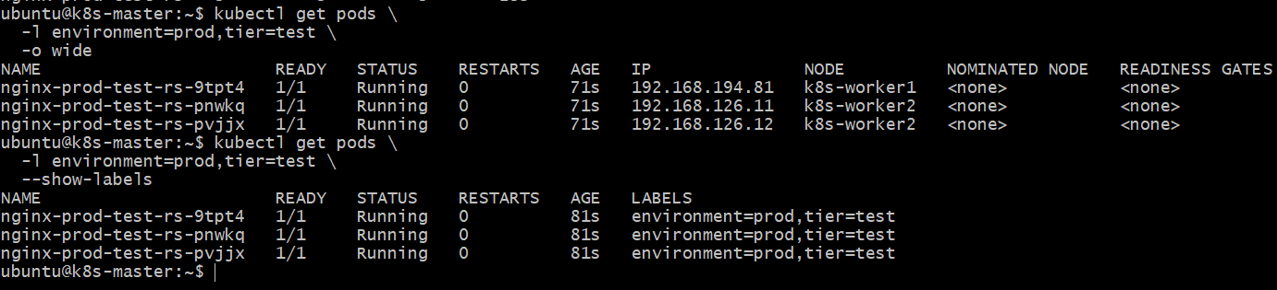

Step 5 — Understand the Selector
Your ReplicaSet contains:
selector:
matchLabels:
environment: prod
tier: test
That means a pod must have both:
environment=prod
AND:
tier=test
A pod with only:
environment=prod
❌ does not match.
A pod with only:
tier=test
❌ does not match.
A pod with:
environment=prod
tier=test
✅ matches.
Think of it as:
environment=prod
AND
tier=test
↓
ReplicaSet manages pod

Task 6 — ReplicaSet That Excludes backend
For this task we'll use a ReplicaSet selector with:
matchExpressions:
- key: role
operator: NotIn
values:
- backend
This means: The ReplicaSet manages pods whose role is not backend.
We'll create 3 Nginx pods with: role=frontend
They match the ReplicaSet because frontend is not backend
Step 1 — Create the YAML
Run: nano rs-exclude-backend.yaml
Paste:
apiVersion: apps/v1
kind: ReplicaSet
metadata:
name: nginx-exclude-backend-rs
spec:
replicas: 3
selector:
matchLabels:
role: frontend
template:
metadata:
labels:
role: frontend
spec:
containers:
- name: nginx
image: nginx
ports:
- containerPort: 80
Save:
Ctrl + O → Enter → Ctrl + X
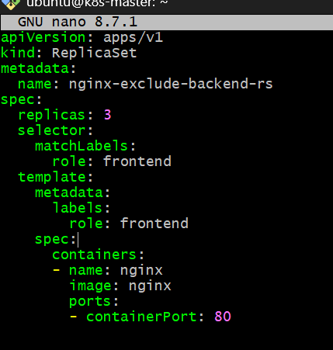

Step 2 — Create the ReplicaSet
kubectl apply -f rs-exclude-backend.yaml
Expected: replicaset.apps/nginx-exclude-backend-rs created

Step 3 — Check the ReplicaSet
kubectl get rs nginx-exclude-backend-rs
Expected:
NAME DESIRED CURRENT READY
nginx-exclude-backend-rs 3 3 3
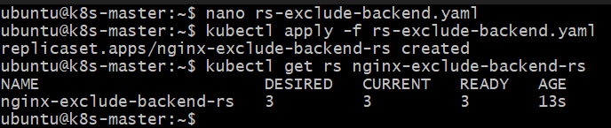

Step 4 — Check the Pods
kubectl get pods -l role=frontend --show-labels
You should see 3 new pods with: role=frontend
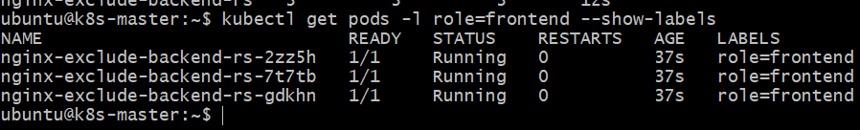
Step 5 — Demonstrate the exclusion
Create a separate backend pod:
kubectl run backend-test \
--image=nginx \
--labels=role=backend \
--port=80
Check:
kubectl get pods --show-labels
You should have:
backend-test 1/1 Running role=backend
Now check the ReplicaSet:
kubectl get rs nginx-exclude-backend-rs
It should still say:
DESIRED CURRENT READY
3 3 3
The backend-test pod is not managed by the ReplicaSet.
You can verify: kubectl get pod backend-test -o custom-columns='NAME:.metadata.name,ROLE:.metadata.labels.role,OWNER:.metadata.ownerReferences[0].name'
You should see no owner:
NAME ROLE OWNER
backend-test backend <none>
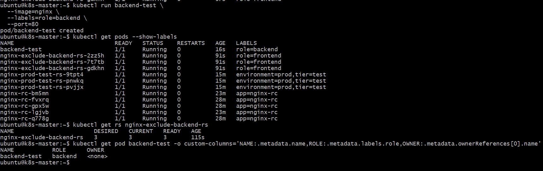
Important correction to remember
The original selector: role NotIn backend
means:
frontend → selected
database → selected
anything else → selected
NO role label → selected
backend → NOT selected
Whereas:
role=frontend
means:
frontend → selected
backend → NOT selected
NO role label → NOT selected
Task 7 — Test Load Balancing Across Multiple Pods
For this task, we'll use your existing 5 Nginx pods managed by the ReplicationController:
nginx-rc-bm5mn
nginx-rc-fvxrq
nginx-rc-gpx5w
nginx-rc-lgjvb
nginx-rc-q778g
We'll create a NodePort Service that selects them all.
Step 1 — Create the Service
Create: nano nginx-rc-nodeport.yaml
Paste:
apiVersion: v1
kind: Service
metadata:
name: nginx-rc-nodeport
spec:
type: NodePort
selector:
app: nginx-rc
ports:
- port: 80
targetPort: 80
Save:
Ctrl + O → Enter → Ctrl + X
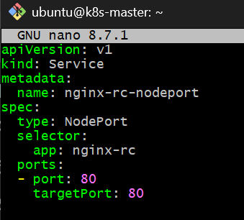
Step 2 — Create the Service
kubectl apply -f nginx-rc-nodeport.yaml
Then: kubectl get svc nginx-rc-nodeport
You'll get something like:
NAME TYPE CLUSTER-IP EXTERNAL-IP PORT(S)
nginx-rc-nodeport NodePort 10.x.x.x <none> 80:31xxx/TCP
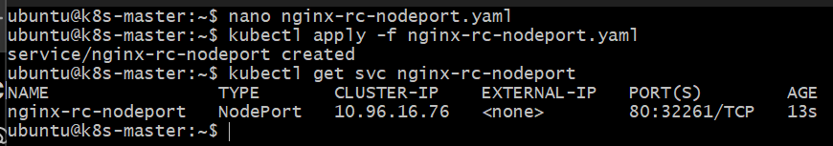
Step 3 — Verify the 5 Endpoints
This is very important.
Run: kubectl get endpoints nginx-rc-nodeport
You should see five pod IPs:
ENDPOINTS
192.168.x.x:80,192.168.x.x:80,192.168.x.x:80,192.168.x.x:80,192.168.x.x:80
You can also use the newer EndpointSlice API:
kubectl get endpointslice -l kubernetes.io/service-name=nginx-rc-nodeport

Step 4 — Find the NodePort
Run: kubectl get svc nginx-rc-nodeport
Suppose Kubernetes gives you: 80:31250/TCP
Then 31250 is your NodePort.
Don't use 31250 unless that is actually what your cluster gives you.
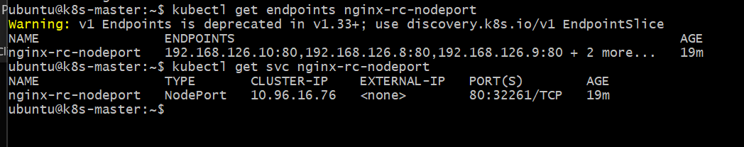

Step 5 — Test from k8s-master
Once you know your actual NodePort, run:
curl http://10.0.2.92:<NODEPORT>
For example, if your NodePort is 31250:
curl http://10.0.2.92:31250
You should receive the Nginx welcome page.
Then run the same request multiple times:
for i in {1..20}; do curl -s http://10.0.2.92:<NODEPORT> | grep -o "<title>.*</title>"; done
Important
The standard Nginx welcome page is identical on every pod, so you won't be able to tell which pod handled each request from the default page alone.
For a proper load-balancing demonstration, we'll modify the 5 pods so each responds with its own hostname. Then repeated requests will show different pod names.
Step 7.2 — Test ClusterIP from inside the cluster
Run: kubectl run curl-test --image=curlimages/curl --rm -it -- sh
When you get the shell, run: curl -v --connect-timeout 5 http://10.96.16.76:80
Then: exit
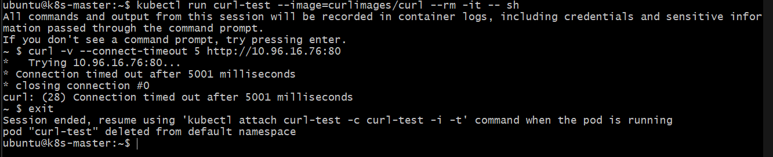
Step 7.3 — Test a pod directly
From the master, run: curl -v --connect-timeout 5 http://192.168.126.10:80
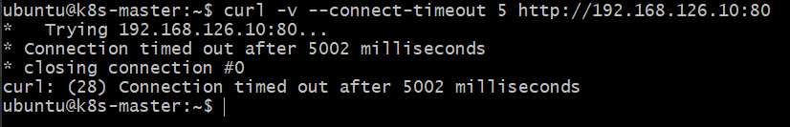
Then test the other worker's pod: curl -v --connect-timeout 5 http://192.168.194.79:80
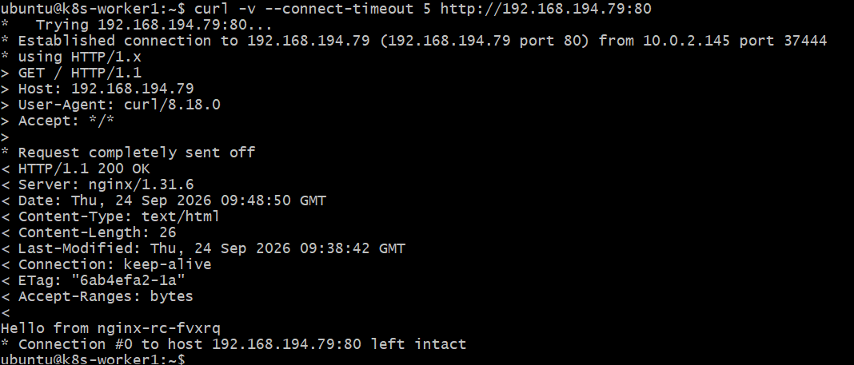
Step 7.4 — Test NodePort on the worker nodes
Because the pods are running on the workers, test the NodePort directly on them: curl -v --connect-timeout 5 http://10.0.2.145:32261
and: curl -v --connect-timeout 5 http://10.0.2.225:32261
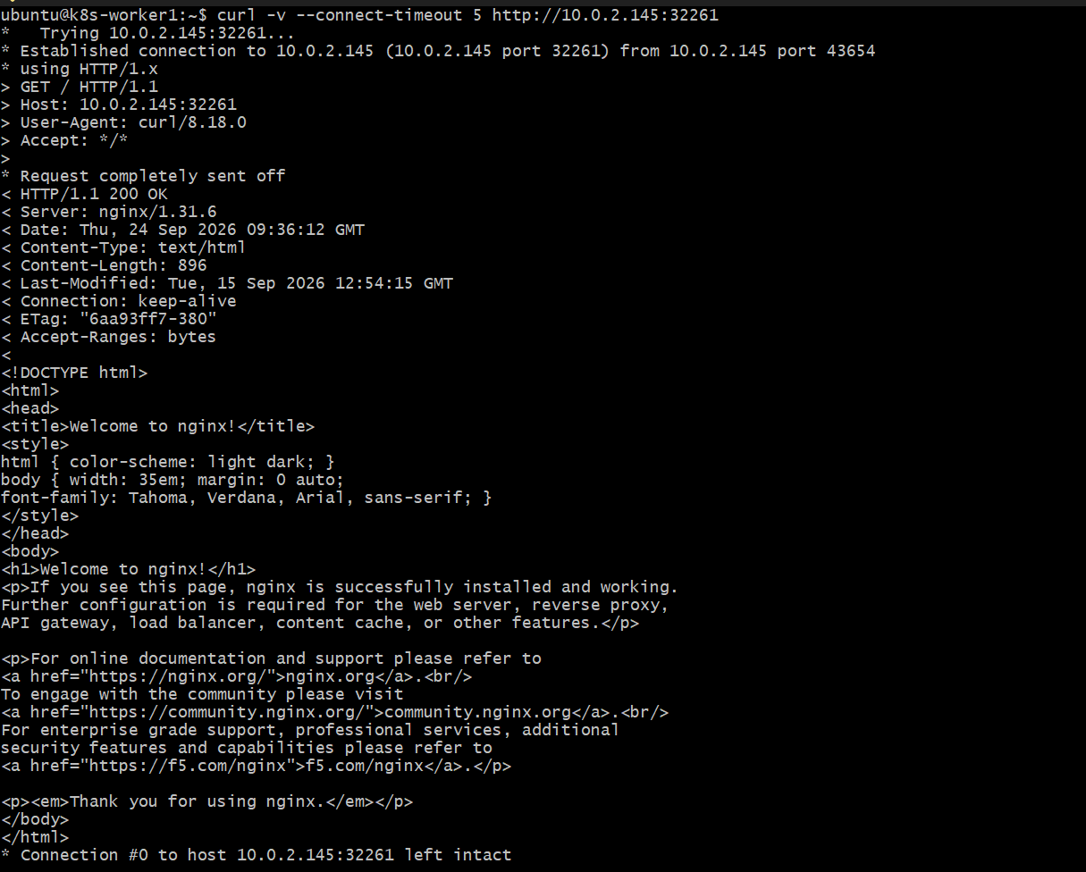
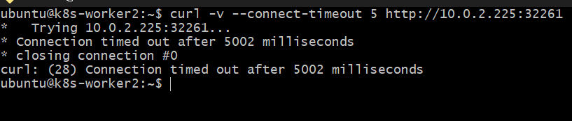
Let's make each of the 5 pods return its own hostname.
Step 7.5 — Give each Nginx pod a unique response
Run this on k8s-master: for pod in $(kubectl get pods -l app=nginx-rc -o jsonpath='{.items[*].metadata.name}'); do
kubectl exec "$pod" -- sh -c 'echo "Hello from $(hostname)" > /usr/share/nginx/html/index.html'
done
Then verify one:
kubectl exec nginx-rc-bm5mn -- cat /usr/share/nginx/html/index.html
You should get something like:
Hello from nginx-rc-bm5mn
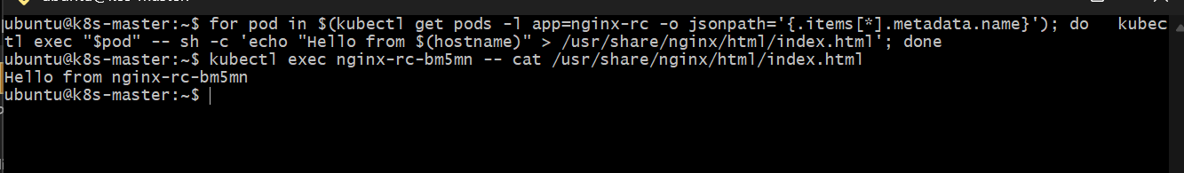
Step 7.6 — Test NodePort repeatedly
On k8s-worker1, run:
for i in {1..10}; do
curl -s http://10.0.2.145:32261
echo
done
You should see responses such as:
Hello from nginx-rc-bm5mn
Hello from nginx-rc-fvxrq
Hello from nginx-rc-gpx5w
Hello from nginx-rc-lgjvb
Hello from nginx-rc-q778g
...
The order isn't guaranteed, and you may see some pods more than once.
Why this demonstrates load balancing
The NodePort:
10.0.2.145:32261
|
v
nginx-rc-nodeport
|
+----> nginx-rc-bm5mn
+----> nginx-rc-fvxrq
+----> nginx-rc-gpx5w
+----> nginx-rc-lgjvb
+----> nginx-rc-q778g
The Service has 5 endpoints, and requests received by the working NodePort are distributed among those endpoints.
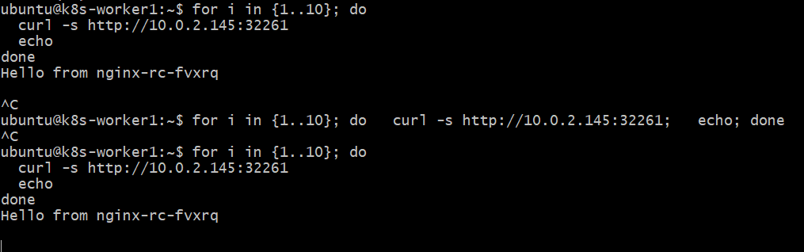
Yes — this gives us an important result.
Task 7 result
Your NodePort is definitely working:
10.0.2.145:32261
↓
nginx-rc-nodeport
↓
nginx-rc-fvxrq
nginx-rc-lgjvb
You received responses from two different pods:
Hello from nginx-rc-fvxrq
Hello from nginx-rc-lgjvb
So the Service is distributing requests across multiple backend pods.
You don't need to keep running the loop. The fact that some requests timed out/hung is related to the cluster networking issue we already identified; it doesn't invalidate the successful NodePort/load-balancing test.
✅ Task 7 — Completed
You demonstrated:
- ReplicationController has 5 Nginx pods.
- NodePort Service nginx-rc-nodeport was created.
- NodePort is 32261.
- Service has 5 endpoints.
- Requests through the NodePort reached different pods.
- Pod-specific responses confirmed the load balancing.

Task 8 — Delete a ReplicationController without affecting running pods
Proper demonstration
Step 8.1 — Create a temporary ReplicationController
Create: nano task8-rc.yaml
Put this inside:
apiVersion: v1
kind: ReplicationController
metadata:
name: task8-nginx-rc
spec:
replicas: 3
selector:
app: task8-nginx
template:
metadata:
labels:
app: task8-nginx
spec:
containers:
- name: nginx
image: nginx
ports:
- containerPort: 80
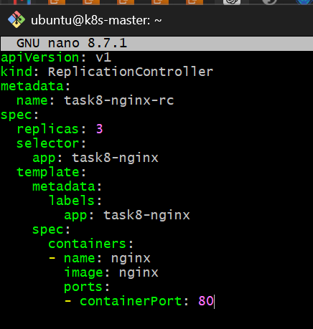
Save and apply: kubectl apply -f task8-rc.yaml
Verify: kubectl get rc task8-nginx-rc
and: kubectl get pods -l app=task8-nginx -o wide
You should have:
task8-nginx-rc 3 3 3
and 3 Running pods.
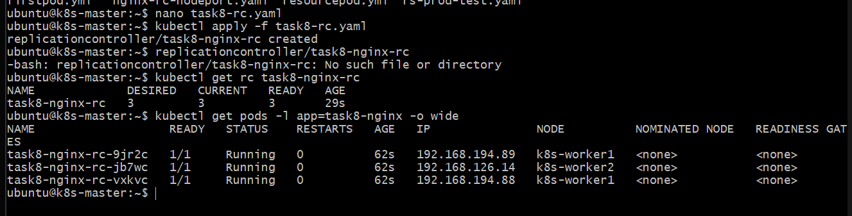
Step 8.2 — Delete RC but preserve pods
Now run: kubectl delete rc task8-nginx-rc --cascade=orphan
Then immediately verify: kubectl get rc task8-nginx-rc
Expected:
Error from server (NotFound): replicationcontrollers "task8-nginx-rc" not found
Now: kubectl get pods -l app=task8-nginx -o wide
The important result is that the 3 pods are still Running even though the ReplicationController is gone.
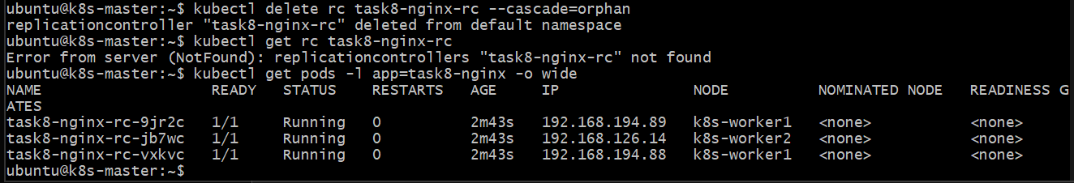
The concept to remember
Normal deletion:
kubectl delete rc nginx-rc
↓
RC deleted
↓
Pods deleted

