Kubernets-07
Task 1: Execute all yaml files shown in video.
Task 1A — Toleration with operator: Equal.
First, let's make sure the previous Task 6 taint is gone and apply the requested taint.
Step 1 — Check existing taints
kubectl describe node k8s-worker1 | grep -i taint
If you see an old special=true taint, remove it first:
kubectl taint node k8s-worker1 special=true:NoSchedule-
kubectl taint node k8s-worker1 special=true:PreferNoSchedule-
If one of those says the taint doesn't exist, that's fine.
Step 2 — Add the requested NoSchedule taint
kubectl taint nodes k8s-worker1 special=true:NoSchedule
Expected: node/k8s-worker1 tainted
Verify: kubectl describe node k8s-worker1 | grep -i taint
Expected: Taints: special=true:NoSchedule
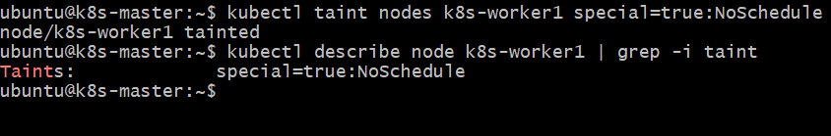
Step 3 — Create firstpod.yaml
Because you already have a nodeselector-pod, etc., we'll use the exact requested name firstpod but first make sure an old one isn't present:
kubectl delete pod firstpod --ignore-not-found
Create the YAML: nano firstpod.yaml
Paste: apiVersion: v1
kind: Pod
metadata:
name: firstpod
spec:
containers:
- name: firstcontainer
image: nginx:latest
tolerations:
- key: "special"
operator: "Equal"
value: "true"
effect: "NoSchedule"
Save:
Ctrl + O → Enter → Ctrl + X
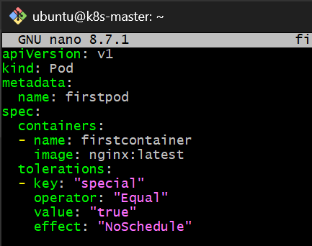
Step 4 — Apply
kubectl apply -f firstpod.yaml
Expected: pod/firstpod created
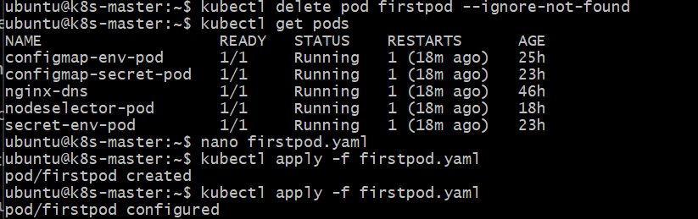
Step 5 — Verify
kubectl get pod firstpod -o wide
Because the toleration allows the Pod onto k8s-worker1, it is eligible for that node. However, remember: a toleration does not force scheduling onto the tainted node. If another suitable node is available, Kubernetes may choose that node instead.
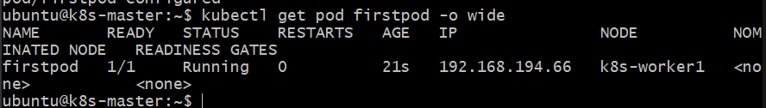
To see the toleration: kubectl describe pod firstpod | grep -A5 -i tolerations
You should see the special=true:NoSchedule toleration.
What Equal means
The taint is: special=true:NoSchedule
The Pod toleration is: key = special
operator = Equal
value = true
effect = NoSchedule
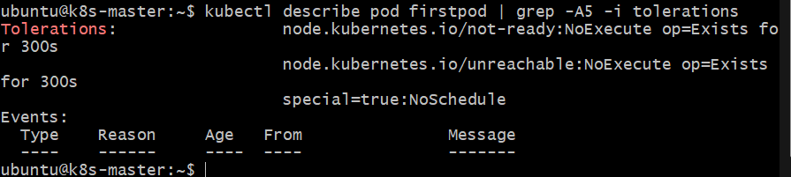
So Kubernetes checks that the key and value match.
Node taint
special=true
│
▼
key=special
value=true
operator=Equal
│
▼
MATCH ✅
Task 1B — Toleration with PreferNoSchedule
Now we'll replace the NoSchedule taint with the soft PreferNoSchedule taint.
Step 1 — Remove the current NoSchedule taint
kubectl taint node k8s-worker1 special=true:NoSchedule-
Expected: node/k8s-worker1 untainted
Step 2 — Add PreferNoSchedule
kubectl taint node k8s-worker1 special=true:PreferNoSchedule
Expected: node/k8s-worker1 tainted
Verify: kubectl describe node k8s-worker1 | grep -i taint
Expected: Taints: special=true:PreferNoSchedule
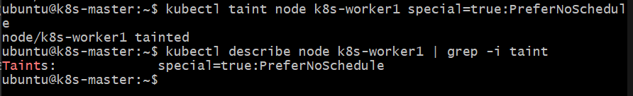
Step 3 — Update firstpod.yaml
Delete the existing Pod: kubectl delete pod firstpod
Edit: nano firstpod.yaml
Use: apiVersion: v1
kind: Pod
metadata:
name: firstpod
spec:
containers:
- name: firstcontainer
image: nginx:latest
tolerations:
- key: "special"
operator: "Equal"
value: "true"
effect: "PreferNoSchedule"
Save:
Ctrl + O → Enter → Ctrl + X
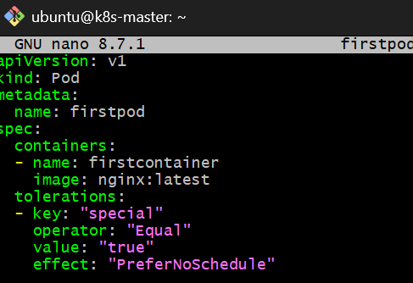

Step 4 — Apply
kubectl apply -f firstpod.yaml
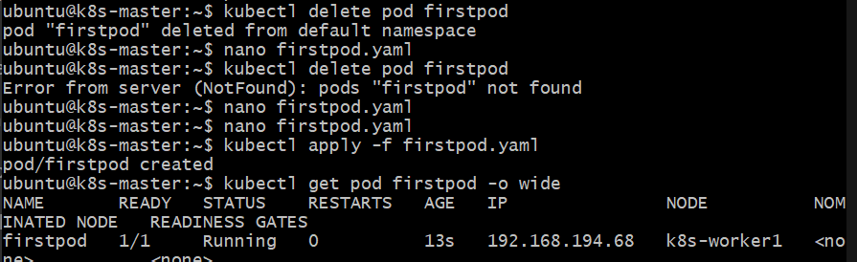
Step 5 — Verify
kubectl get pod firstpod -o wide
Then: kubectl describe pod firstpod | grep -A5 -i tolerations
You should see: special=true:PreferNoSchedule
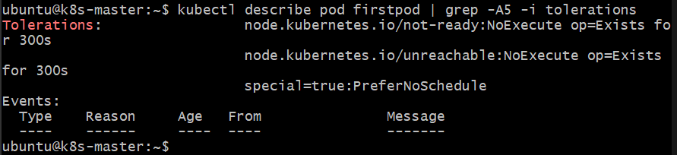
Important distinction
With PreferNoSchedule:
NoSchedule
→ avoid scheduling non-tolerating Pods
PreferNoSchedule
→ try to avoid scheduling non-tolerating Pods
but it is NOT a hard restriction
And your Pod has the matching toleration, so it is allowed to run on k8s-worker1.
Task 1C — Exists Toleration
Now we will test the Exists operator.
Step 1 — Change the taint to NoSchedule
First remove the current PreferNoSchedule taint:
kubectl taint node k8s-worker1 special=true:PreferNoSchedule-
Then add the NoSchedule taint:
kubectl taint node k8s-worker1 special=true:NoSchedule
Verify:
kubectl describe node k8s-worker1 | grep -i taint
Expected:
Taints: special=true:NoSchedule
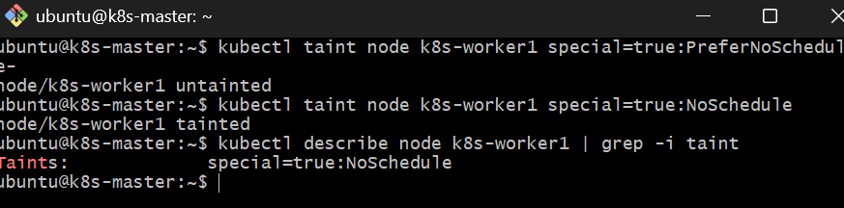
Step 2 — Update firstpod.yaml
Open: nano firstpod.yaml
Use:
apiVersion: v1
kind: Pod
metadata:
name: firstpod
spec:
containers:
- name: firstcontainer
image: nginx:latest
tolerations:
- key: "special"
operator: "Exists"
effect: "NoSchedule"
Save and exit.
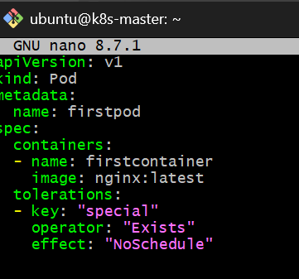
Step 3 — Recreate the pod
kubectl delete pod firstpod
Then: kubectl apply -f firstpod.yaml
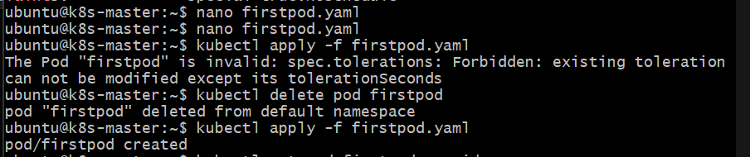
Step 4 — Verify
kubectl get pod firstpod -o wide
Expected: firstpod 1/1 Running ... k8s-worker1
Then: kubectl describe pod firstpod | grep -A5 -i tolerations
Expected to contain:
special:NoSchedule op=Exists
🧠 What Exists means
With: operator: "Exists"
Kubernetes checks that the taint key exists, but it does not check the taint value.
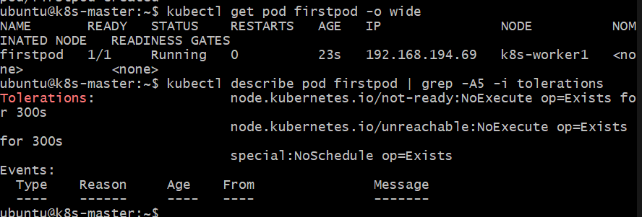
For example, this toleration can match:
special=true:NoSchedule
special=abc:NoSchedule
special=anything:NoSchedule
as long as the key is special and the effect is NoSchedule.
Task 1D — NodeSelector
Now we'll test scheduling based on a node label.
Step 1 — Remove the custom taint
First, remove the NoSchedule taint from worker1:
kubectl taint node k8s-worker1 special=true:NoSchedule-
Verify: kubectl describe node k8s-worker1 | grep -i taint
You should not see special=true:NoSchedule.
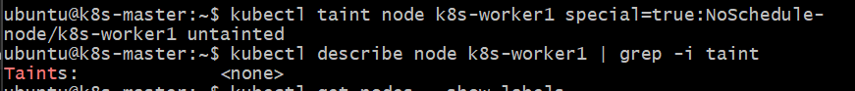
Step 1.1 — Check the current env label
Run: kubectl get nodes --show-labels
Because we previously used env=dev on k8s-worker1, it may currently show:
k8s-worker1 ... env=dev ...
For Task 1D we need:
env=prod
So after checking, run: kubectl label node k8s-worker1 env=prod --overwrite
Expected: node/k8s-worker1 labeled
Verify: kubectl get node k8s-worker1 --show-labels
You should see: env=prod
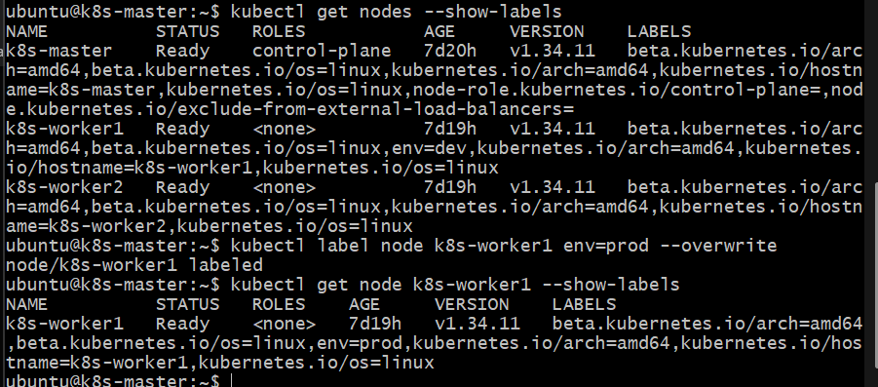
step 2 — Update firstpod.yaml with NodeSelector
Open: nano firstpod.yaml
Replace the contents with: apiVersion: v1
kind: Pod
metadata:
name: firstpod
spec:
containers:
- name: firstcontainer
image: nginx:latest
nodeSelector: env: prod
Save
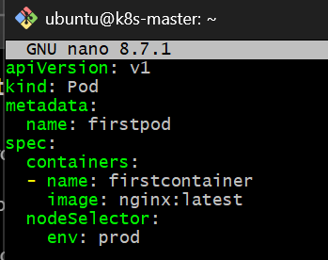
Step 3 — Recreate the Pod
Since firstpod already exists, delete it first:
kubectl delete pod firstpod
Then: kubectl apply -f firstpod.yaml
Finally: kubectl get pod firstpod -o wide
Expected
The pod should be:
firstpod 1/1 Running ... k8s-worker1
because only k8s-worker1 currently has: env=prod
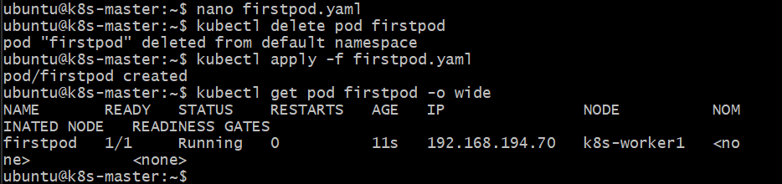
Task 1E — Node Affinity (Preferred)
Now we'll test soft node affinity using:
preferredDuringSchedulingIgnoredDuringExecution
Step 1 — Label worker2
Run: kubectl label node k8s-worker2 env=test --overwrite
Verify: kubectl get nodes --show-labels | grep -E 'k8s-worker1|k8s-worker2'
You should see approximately:
k8s-worker1 ... env=prod ...
k8s-worker2 ... env=test ...
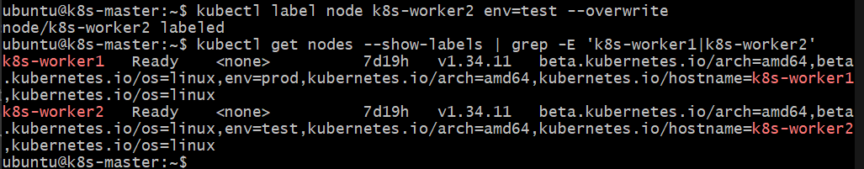
Step 2 — Update firstpod.yaml
Open: nano firstpod.yaml
Replace it with: apiVersion: v1
kind: Pod
metadata:
name: firstpod
spec:
containers:
- name: firstcontainer
image: nginx:latest
affinity:
nodeAffinity:
preferredDuringSchedulingIgnoredDuringExecution:
- preference:
matchExpressions:
- key: env
operator: In
values:
- test
weight: 1
Save and exit.
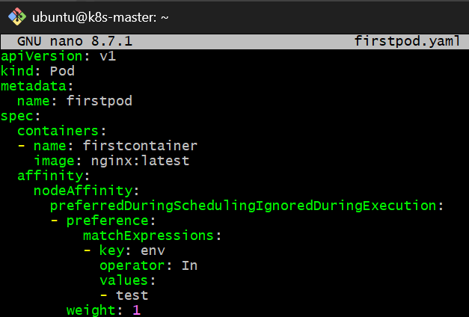
run: kubectl delete pod firstpod
Then: kubectl apply -f firstpod.yaml
Finally: kubectl get pod firstpod -o wide
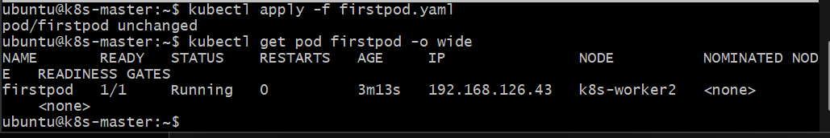
Task 2 — Taint a Node and Schedule a Tolerant Pod
Objective
We will:
- Taint one worker node with:
special=true:NoSchedule
- Create a Pod with a matching toleration.
- Verify that the Pod can schedule on the tainted node.
We'll use k8s-worker1.
Step 1 — Apply the taint
Run on k8s-master: kubectl taint nodes k8s-worker1 special=true:NoSchedule
Expected: node/k8s-worker1 tainted
Step 2 — Verify the taint
kubectl describe node k8s-worker1 | grep -i taint
Expected:
Taints: special=true:NoSchedule
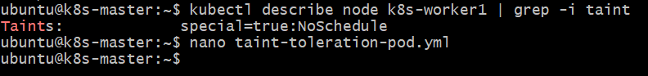
Step 3 — Create the Pod YAML
nano taint-toleration-pod.yml
Paste: apiVersion: v1
kind: Pod
metadata:
name: tolerant-pod
spec:
tolerations:
- key: "special"
operator: "Equal"
value: "true"
effect: "NoSchedule"
containers:
- name: nginx
image: nginx:latest
Save:
Ctrl + O → Enter → Ctrl + X
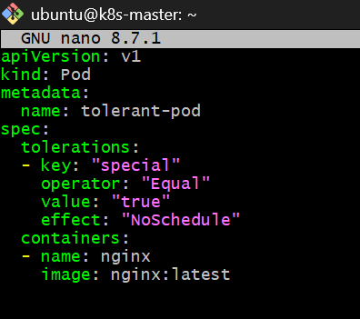
Step 4 — Create the Pod
kubectl apply -f taint-toleration-pod.yml
Expected: pod/tolerant-pod created
Step 5 — Verify where it was scheduled
kubectl get pod tolerant-pod -o wide
You should see something similar to:
NAME READY STATUS ... NODE
tolerant-pod 1/1 Running ... k8s-worker1
The important part is:
NODE: k8s-worker1
because that node has:
special=true:NoSchedule
and the Pod has the matching toleration.
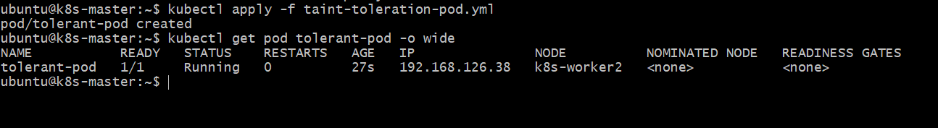
Step 6 — Verify the Pod's toleration
kubectl describe pod tolerant-pod | grep -A5 -i tolerations
You should see:
Tolerations:
special=true:NoSchedule
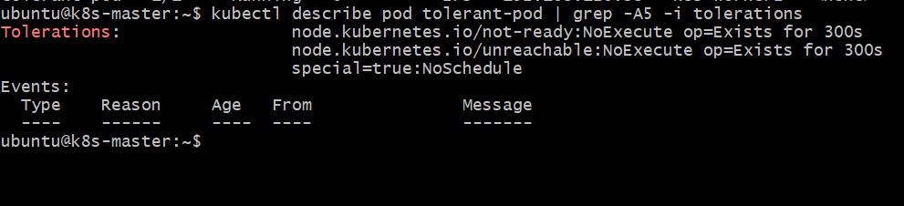
Done checkpoint.
Task 3 — Use NodeSelector to Schedule a Pod on a Specific Node
Objective
We will:
- Label k8s-worker1 with env=dev.
- Create a Pod with nodeSelector: env=dev.
- Verify that Kubernetes schedules the Pod specifically on k8s-worker1.
Step 1 — Label the node
Run on k8s-master: kubectl label nodes k8s-worker1 env=dev
Expected: node/k8s-worker1 labeled
Step 2 — Verify the label
kubectl get nodes --show-labels
Look for k8s-worker1 and confirm:
env=dev
You can also use: kubectl get node k8s-worker1 --show-labels
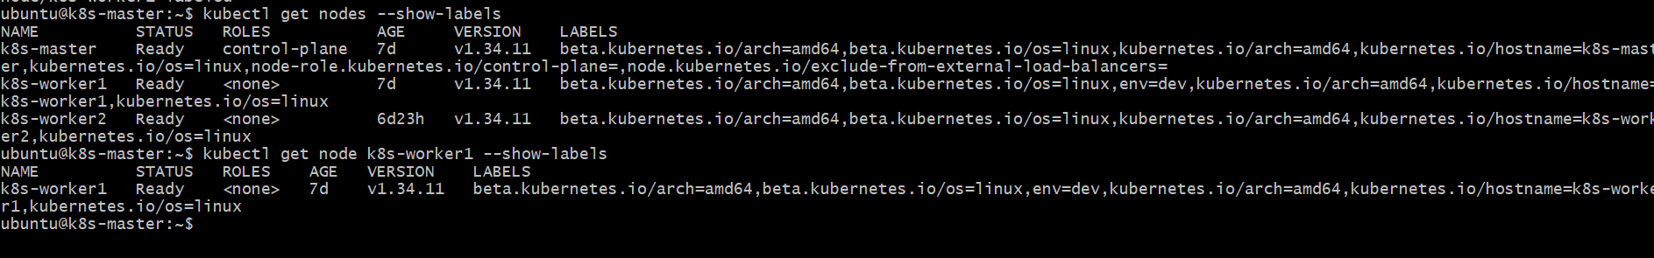
Step 3 — Create the Pod YAML
nano nodeselector-pod.yml
Paste: apiVersion: v1
kind: Pod
metadata:
name: nodeselector-pod
spec:
nodeSelector:
env: dev
containers:
- name: nginx
image: nginx:latest
Save:
Ctrl + O → Enter → Ctrl + X
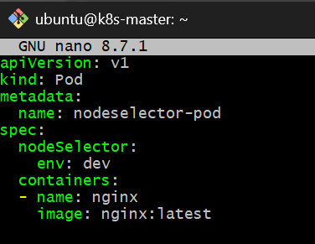
Step 4 — Create the Pod
kubectl apply -f nodeselector-pod.yml
Expected: pod/nodeselector-pod created
Step 5 — Verify scheduling
kubectl get pod nodeselector-pod -o wide
Expected:
NAME READY STATUS ... NODE
nodeselector-pod 1/1 Running ... k8s-worker1
The important part is: NODE: k8s-worker1
because our Pod contains:
nodeSelector: env: dev
and only k8s-worker1 currently has:
env=dev
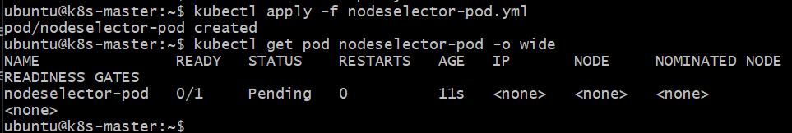
Step 6 — Verify the node selector
kubectl describe pod nodeselector-pod | grep -A3 -i "Node-Selectors"
Expected:
Node-Selectors: env=dev
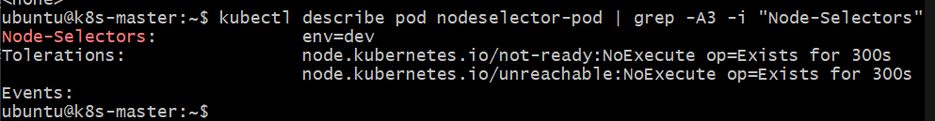
Done checkpoint.
Task 4 — Use Node Affinity with Soft Scheduling
Objective
We will:
- Label k8s-worker2 with env=test.
- Create a Pod with PreferredDuringSchedulingIgnoredDuringExecution.
- Verify it prefers k8s-worker2.
- Remove the label.
- Verify the already-running Pod continues to run.
This demonstrates soft scheduling.

Step 1 — Label k8s-worker2
Run: kubectl label nodes k8s-worker2 env=test
Expected: node/k8s-worker2 labeled
Verify:
kubectl get nodes --show-labels
You should see:
k8s-worker2 ... env=test
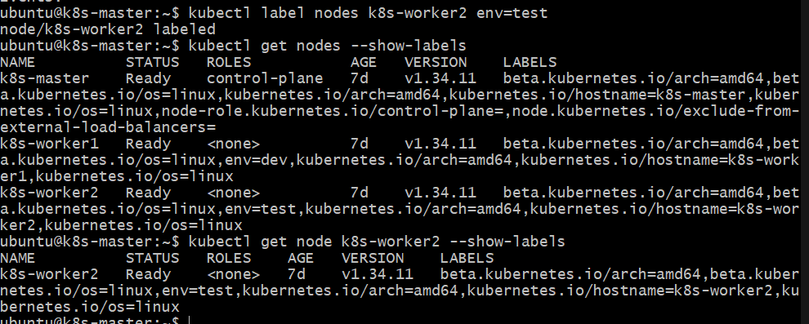
Step 2 — Create the Pod YAML
nano preferred-affinity-pod.yml
Paste: apiVersion: v1
kind: Pod
metadata:
name: preferred-affinity-pod
spec:
affinity:
nodeAffinity:
preferredDuringSchedulingIgnoredDuringExecution:
- weight: 100
preference:
matchExpressions:
- key: env
operator: In
values:
- test
containers:
- name: nginx
image: nginx:latest
Save:
Ctrl + O → Enter → Ctrl + X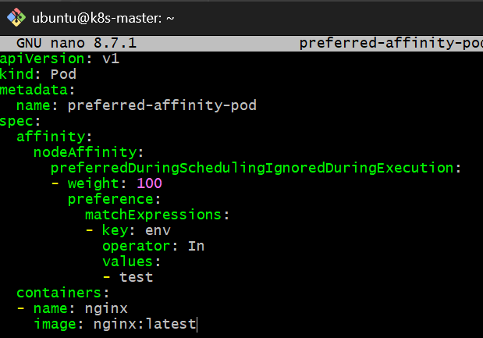
Step 3 — Create the Pod
kubectl apply -f preferred-affinity-pod.yml
Expected: pod/preferred-affinity-pod created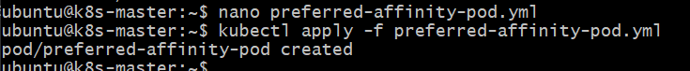
Step 4 — Verify the Pod
kubectl get pod preferred-affinity-pod -o wide
Because k8s-worker2 has env=test, Kubernetes should prefer that node.
You will ideally see:
preferred-affinity-pod 1/1 Running ... k8s-worker2
Important: Unlike nodeSelector or required affinity, preferredDuringScheduling... is only a preference. Kubernetes is allowed to choose another suitable node if necessary. 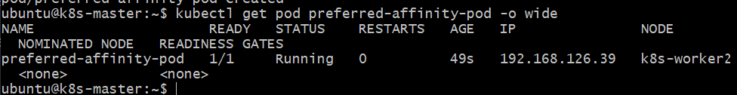
Step 5 — Remove the env=test label
Now remove the label: kubectl label node k8s-worker2 env-
Expected: node/k8s-worker2 unlabeled
Verify: kubectl get node k8s-worker2 --show-labels
There should no longer be: env=test
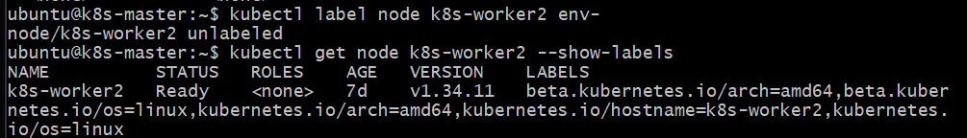
Step 6 — Verify the Pod continues running
kubectl get pod preferred-affinity-pod -o wide
You should still see:
STATUS Running
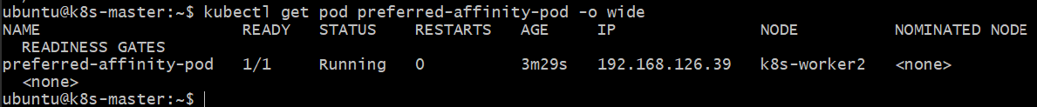
The Pod does not get evicted or rescheduled just because the label disappeared.
That's exactly what: IgnoredDuringExecution
means.
Key concept
PreferredDuringSchedulingIgnoredDuringExecution
- Preferred → Kubernetes tries to satisfy the rule but doesn't require it.
- DuringScheduling → The preference is considered when choosing a node.
- IgnoredDuringExecution → Once the Pod is running, changes to node labels don't cause the Pod to move.

Done checkpoint.
Task 5 — Implement Node Affinity with Hard Scheduling
Objective
Create a Pod using:
requiredDuringSchedulingIgnoredDuringExecution
The Pod must run only on a node with env=prod.
We'll first create the Pod without any node having env=prod and verify that it cannot schedule.
Step 1 — Confirm no env=prod label exists
Run: kubectl get nodes --show-labels
Currently you should have:
k8s-worker1 ... env=dev
k8s-worker2 ... no env label
There should be no env=prod.
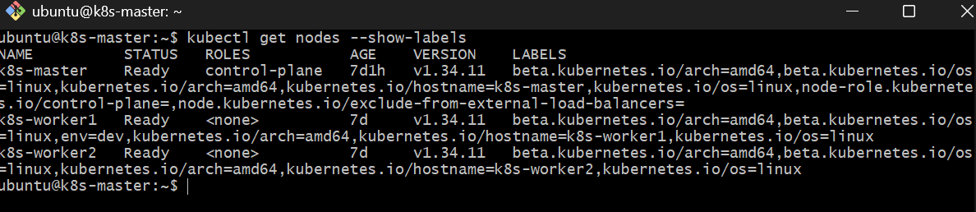
Step 2 — Create the hard-affinity Pod
nano required-affinity-pod.yml
Paste: apiVersion: v1
kind: Pod
metadata:
name: required-affinity-pod
spec:
affinity:
nodeAffinity:
requiredDuringSchedulingIgnoredDuringExecution:
nodeSelectorTerms:
- matchExpressions:
- key: env
operator: In
values:
- prod
containers:
- name: nginx
image: nginx:latest
Save:
Ctrl + O → Enter → Ctrl + X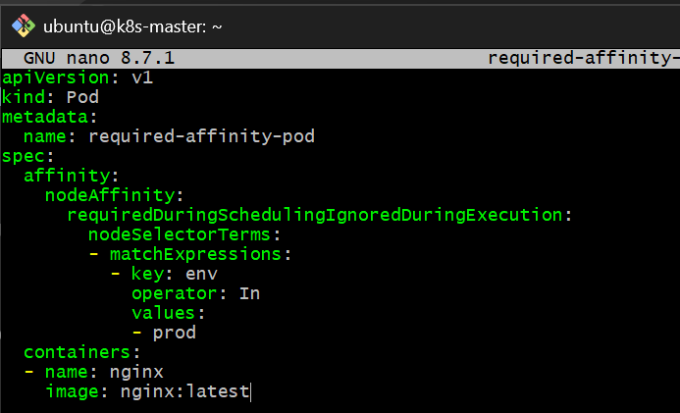
Step 3 — Create the Pod
kubectl apply -f required-affinity-pod.yml
Expected: pod/required-affinity-pod created
Step 4 — Check the Pod
kubectl get pod required-affinity-pod -o wide
Expected:
NAME READY STATUS ... NODE
required-affinity-pod 0/1 Pending <none>
The Pod should remain: Pending
because no node currently has env=prod. 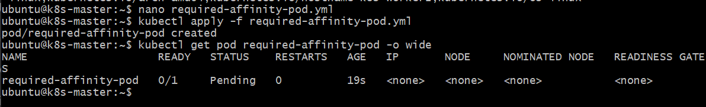
Step 5 — Check why it is Pending
Run: kubectl describe pod required-affinity-pod
At the bottom, under Events, you should see a scheduling message indicating that nodes don't satisfy the Pod's node affinity requirement.
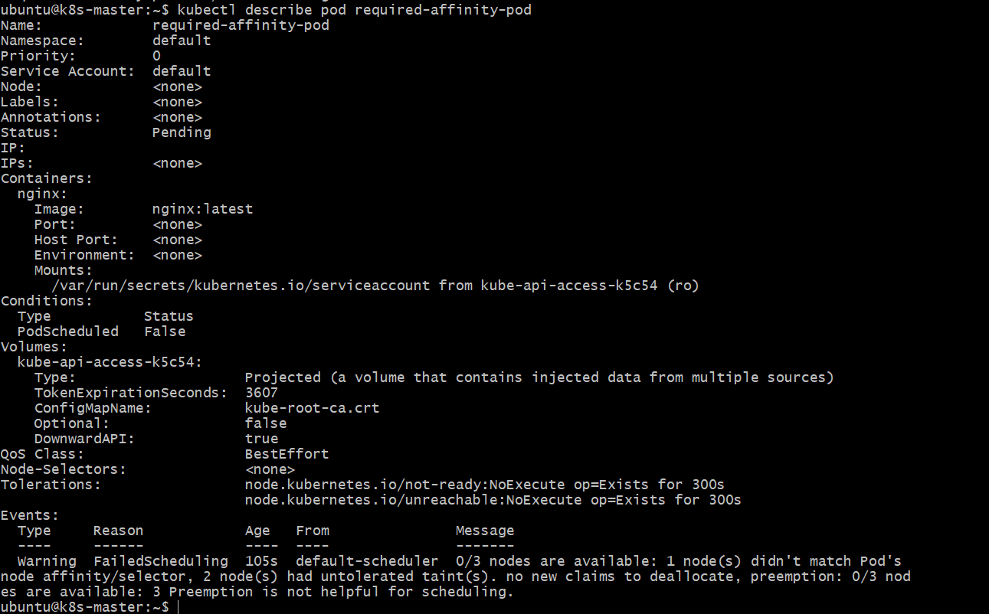
You can get just the events with:
kubectl describe pod required-affinity-pod | grep -A10 -i Events
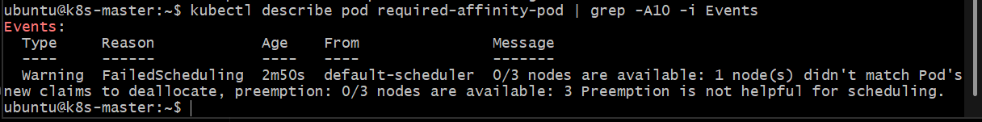
Step 6 — Now label k8s-worker2 as env=prod
Once you've verified the Pod is Pending, run:
kubectl label node k8s-worker2 env=prod
Expected: node/k8s-worker2 labeled
Verify: kubectl get nodes --show-labels
You should now see: k8s-worker2 ... env=prod
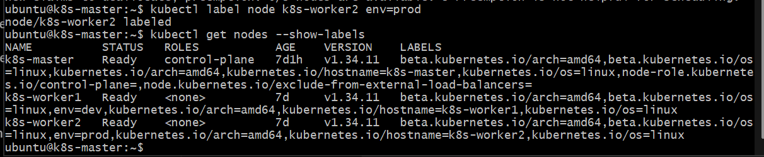
Step 7 — Watch the Pod get scheduled
Run: kubectl get pod required-affinity-pod -o wide -w
You should see it transition from: Pending
to: Running
and eventually:
NODE
k8s-worker2
Press:
Ctrl + C
to stop watching.
Important concept
requiredDuringSchedulingIgnoredDuringExecution is a hard requirement.
Before:
No env=prod node
↓
Pod = Pending
After:
k8s-worker2 = env=prod
↓
Pod = Running
And because it is IgnoredDuringExecution, removing env=prod later will not evict the already-running Pod.
Task 6 — Taint a Node and Use NoExecute with Toleration Seconds
Objective
We will:
- Taint k8s-worker2 with: special=true:NoExecute
- Create a Pod with:tolerationSeconds: 60
- Schedule it on k8s-worker2.
- Observe that after the toleration period expires, the Pod is evicted.
Important: A NoExecute taint affects Pods that are already running on the node. To make the demonstration reliable, we'll explicitly place the Pod on k8s-worker2 using nodeName.

Step 1 — Taint k8s-worker2
Run: kubectl taint nodes k8s-worker2 special=true:NoExecute
Expected: node/k8s-worker2 tainted
Verify: kubectl describe node k8s-worker2 | grep -i taint
Expected:
Taints: special=true:NoExecute
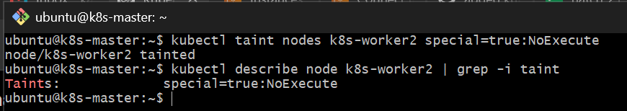Step 2 — Create the Pod YAML
Run: nano noexecute-toleration-pod.yml
Paste: apiVersion: v1
kind: Pod
metadata:
name: noexecute-toleration-pod
spec:
nodeName: k8s-worker2
tolerations:
- key: "special"
operator: "Equal"
value: "true"
effect: "NoExecute"
tolerationSeconds: 60
containers:
- name: nginx
image: nginx:latest
Save:
Ctrl + O → Enter → Ctrl + X
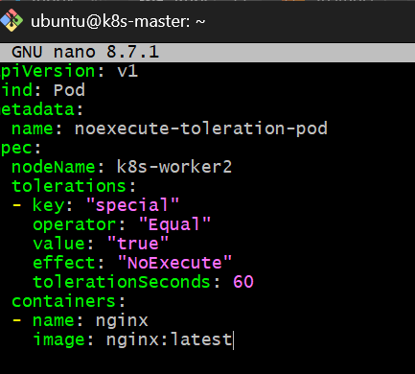
Why nodeName?
Without it, Kubernetes could choose k8s-worker1 instead. We want the Pod definitely running on the tainted k8s-worker2 so that we can observe the 60-second eviction behavior.
Step 3 — Create the Pod
kubectl apply -f noexecute-toleration-pod.yml
Expected: pod/noexecute-toleration-pod created
Immediately check: kubectl get pod noexecute-toleration-pod -o wide
We want:
NAME READY STATUS ... NODE
noexecute-toleration-pod 1/1 Running ... k8s-worker2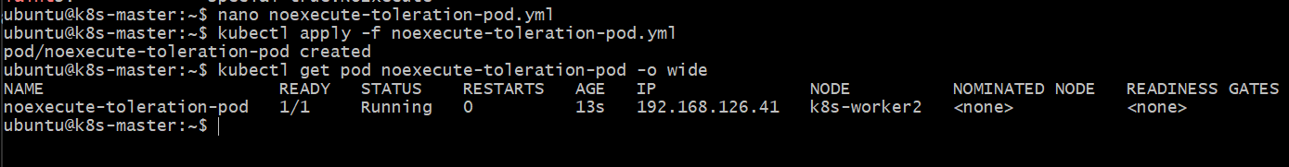Step 4 — Verify the toleration
Run: kubectl describe pod noexecute-toleration-pod | grep -A5 -i Tolerations
You should see:
special=true:NoExecute for 60s

Step 5 — Watch the Pod
Run: kubectl get pod noexecute-toleration-pod -o wide -w
Initially:
1/1 Running ... k8s-worker2
After approximately 60 seconds, Kubernetes should evict the Pod.
You may see a transition such as:
Terminating
and eventually the Pod disappears.
Press:
Ctrl + C
after you observe the eviction.
Step 6 — Verify
Run: kubectl get pod noexecute-toleration-pod -o wide
Depending on timing, you may see:
No resources found in default namespace.
or the Pod may briefly show Terminating.
You can also check events: kubectl get events --sort-by=.lastTimestamp | tail -20
Look for an eviction-related event.
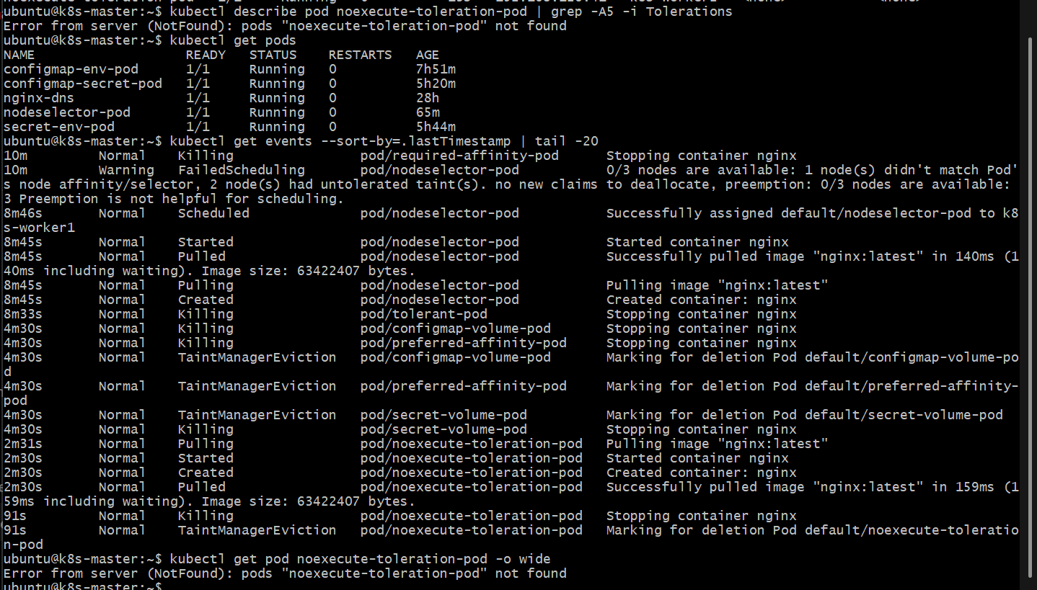
Key concept
NoExecute differs from NoSchedule:
Taint | Effect
NoSchedule | Prevents new non-tolerating Pods from being scheduled
NoExecute | Prevents scheduling and evicts existing non-tolerating Pods
tolerationSeconds: 60 | Allows the Pod to remain for 60 seconds before eviction
So our flow is:
k8s-worker2
│
├── special=true:NoExecute
│
▼
Pod starts on worker2
│
├── tolerationSeconds = 60
│
▼
60 seconds
│
▼
Pod evicted

