Kubernetes-08
Task 1 — Create and Test a Kubernetes Pod with an EmptyDir Volume
What we are learning
emptyDir creates a directory when the Pod starts.
Pod
├── Container 1
│ ↕
│ emptyDir
│ ↕
└── Container 2
Both containers can access the same volume.
The data survives container restarts, but when the Pod itself is deleted, the emptyDir data is deleted.
Step 1 — Create the YAML file
On k8s-master: vi emptydir-pod.yml
Paste: apiVersion: v1
kind: Pod
metadata:
name: emptydir-pod
spec:
containers:
- name: writer
image: busybox:1.36
command:
- sh
- -c
- |
echo "Hello from EmptyDir volume" > /data/message.txt
sleep 3600
volumeMounts:
- name: shared-data
mountPath: /data
- name: reader
image: busybox:1.36
command:
- sh
- -c
- |
sleep 5
cat /data/message.txt
sleep 3600
volumeMounts:
- name: shared-data
mountPath: /data
volumes:
- name: shared-data
emptyDir: {}
Save: Esc
:wq
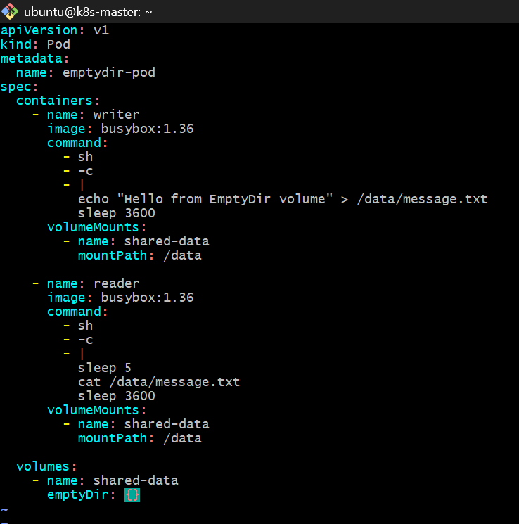
Step 2 — Create the Pod
kubectl apply -f emptydir-pod.yml
Expected: pod/emptydir-pod created
Step 3 — Check the Pod
kubectl get pod emptydir-pod -o wide
You should eventually see:
NAME READY STATUS RESTARTS AGE IP
emptydir-pod 2/2 Running 0 ... ...
Step 4 — Verify the writer container created the file
kubectl exec emptydir-pod -c writer -- cat /data/message.txt
Expected: Hello from EmptyDir volume
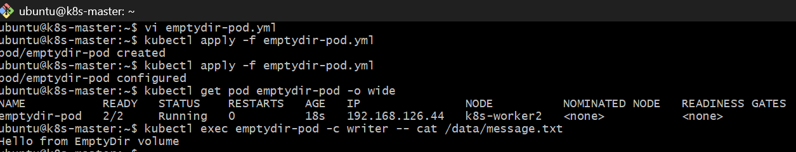
Step 5 — Verify the reader container can access the same file
kubectl logs emptydir-pod -c reader
Expected: Hello from EmptyDir volume
Step 6 — Verify the volume from both containers
Writer: kubectl exec emptydir-pod -c writer -- ls -l /data
Reader: kubectl exec emptydir-pod -c reader -- ls -l /data
Both should show: message.txt
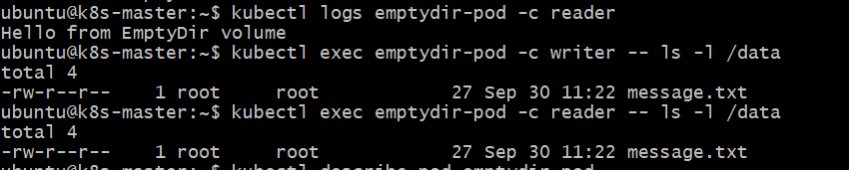
Step 7 — Inspect the Pod volume configuration
kubectl describe pod emptydir-pod
Look for:
Volumes:
shared-data:
Type: EmptyDir
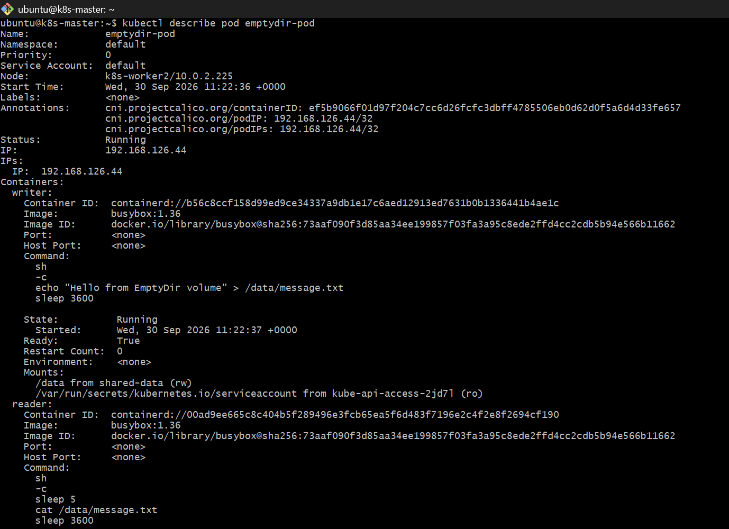
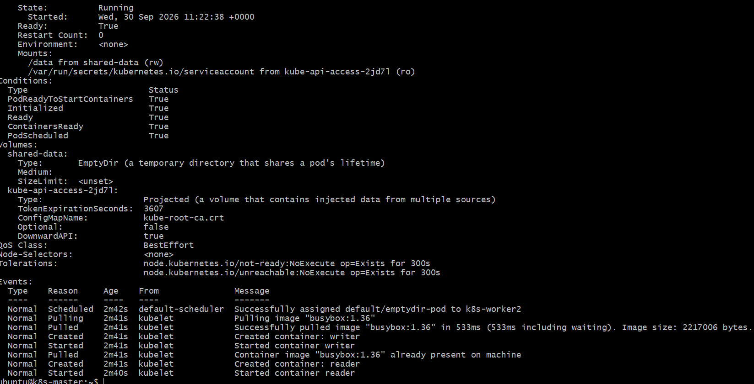
Step 8 — Final verification
Run: kubectl get pod emptydir-pod
kubectl logs emptydir-pod -c reader
If you get:
2/2 Running
and: Hello from EmptyDir volume
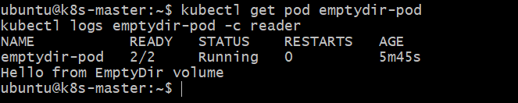
Task 2 — Configure a HostPath Volume and Validate Data Persistence
Here we will intentionally run the Pod on k8s-worker1 so the HostPath location is fixed to that node.
Step 1 — Create the HostPath directory on worker1
From k8s-master, SSH to worker1:
ssh -i ~/jenkins.pem ubuntu@10.0.2.145
Run: sudo mkdir -p /data/hostpath
sudo chmod 777 /data/hostpath
echo "Data created on k8s-worker1" | sudo tee /data/hostpath/message.txt
cat /data/hostpath/message.txt
Expected: Data created on k8s-worker1
Then return to master: exit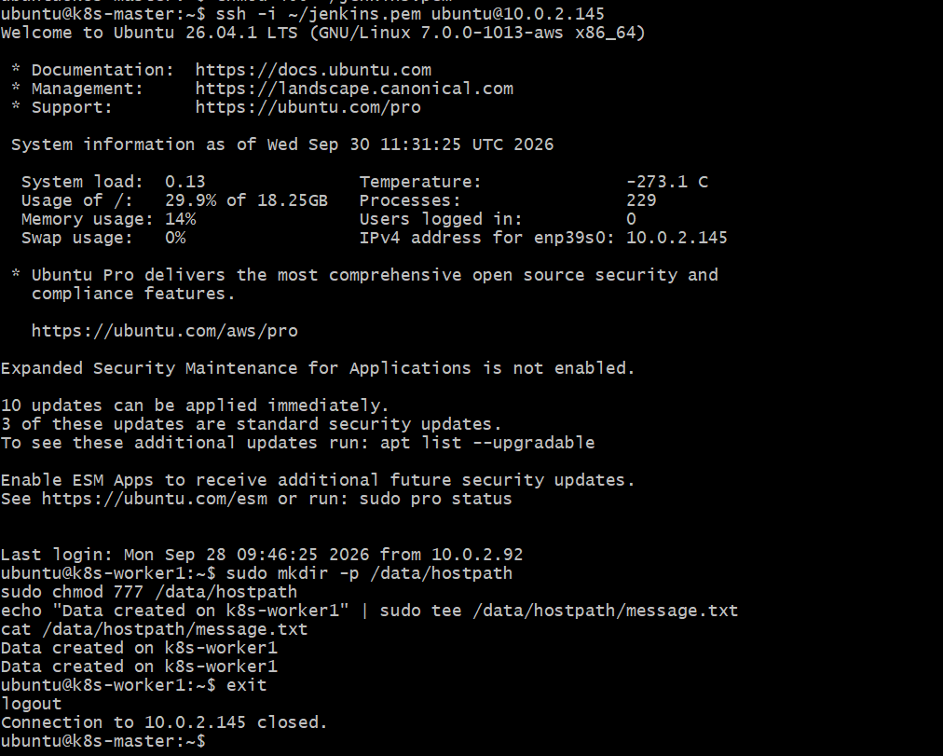

Step 2 — Create the Pod YAML
On k8s-master: vi hostpath-pod.yml
Paste: apiVersion: v1
kind: Pod
metadata:
name: hostpath-pod
spec:
nodeSelector:
kubernetes.io/hostname: k8s-worker1
containers:
- name: hostpath-container
image: busybox:1.36
command:
- sh
- -c
- |
echo "Data written from Kubernetes Pod" > /data/pod-message.txt
sleep 3600
volumeMounts:
- name: host-data
mountPath: /data
volumes:
- name: host-data
hostPath:
path: /data/hostpath
type: Directory
Save:Esc
:wq!
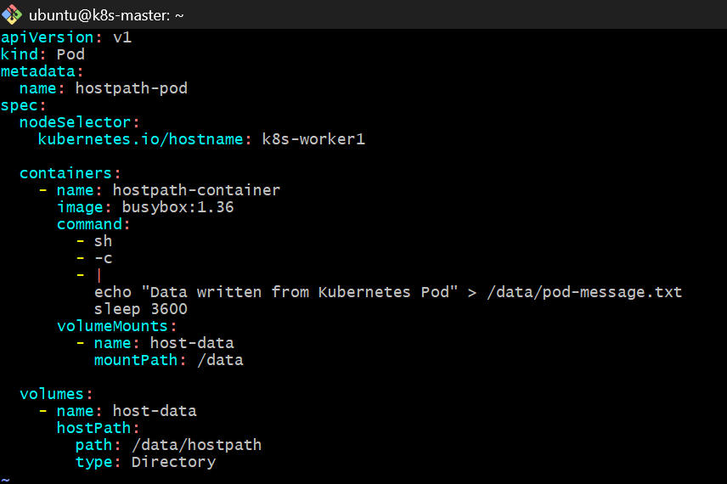
Step 3 — Create the Pod
kubectl apply -f hostpath-pod.yml
Expected: pod/hostpath-pod created
Check: kubectl get pod hostpath-pod -o wide
Make sure it says:
NODE
k8s-worker1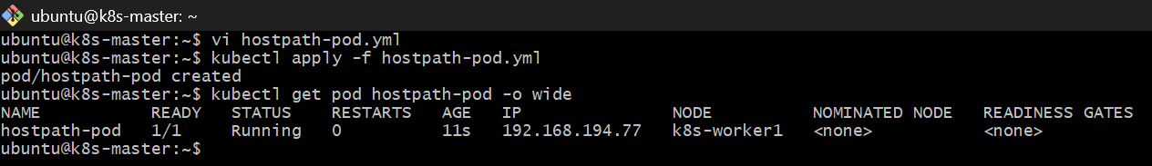

Step 4 — Verify the existing HostPath data
Run: kubectl exec hostpath-pod -- cat /data/message.txt
Expected: Data created on k8s-worker1
This proves the Pod is reading the file directly from the worker's filesystem.
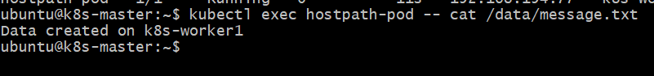
Step 5 — Write new data from the Pod
kubectl exec hostpath-pod -- cat /data/pod-message.txt
Expected: Data written from Kubernetes Pod
Now list the directory: kubectl exec hostpath-pod -- ls -l /data
You should see:
message.txt
pod-message.txt
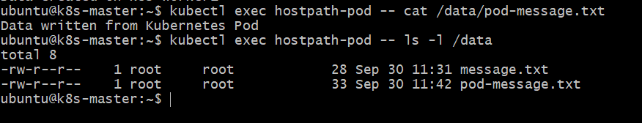
Step 6 — Verify from the worker node
SSH to worker1 again:
ssh -i ~/jenkins.pem ubuntu@10.0.2.145
Run: sudo ls -l /data/hostpath
Then: sudo cat /data/hostpath/pod-message.txt
Expected: Data written from Kubernetes Pod
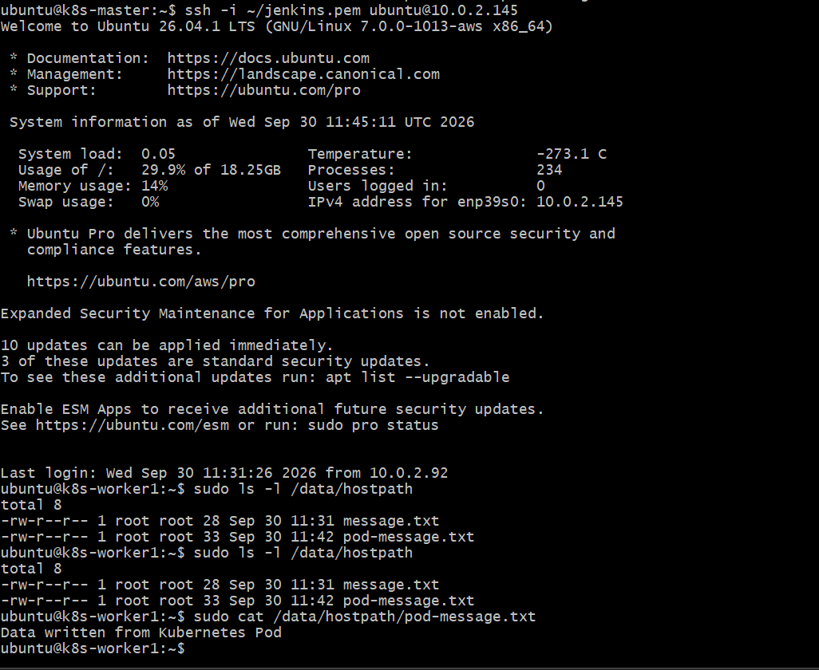
This is the key HostPath demonstration:
k8s-worker1
└── /data/hostpath
├── message.txt
└── pod-message.txt
↑
|
Kubernetes Pod
Exit: exit
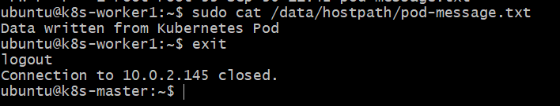
Step 7 — Delete the Pod
Back on k8s-master: kubectl delete pod hostpath-pod
Expected: pod "hostpath-pod" deleted
Verify: kubectl get pod hostpath-pod
Expected: Error from server (NotFound)
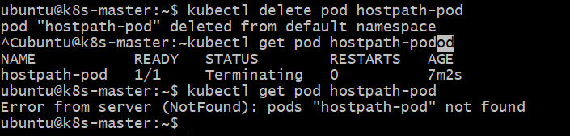
Step 8 — Recreate the Pod
kubectl apply -f hostpath-pod.yml
Check: kubectl get pod hostpath-pod -o wide
Again make sure:
NODE
k8s-worker1
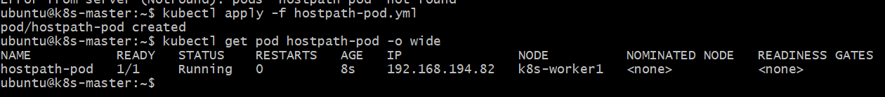
Step 9 — Validate persistence
Now run: kubectl exec hostpath-pod -- cat /data/message.txt
Expected:
Data created on k8s-worker1
And: kubectl exec hostpath-pod -- cat /data/pod-message.txt
Expected:
Data written from Kubernetes Pod
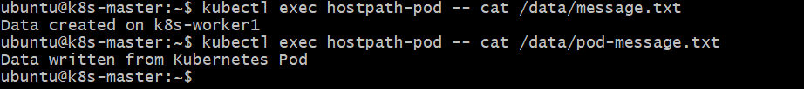
✅ What this proves
The Pod was deleted, but the files remained because they were stored on the worker node's filesystem:
Pod 1
↓
HostPath
↓
k8s-worker1:/data/hostpath
↓
Pod 1 deleted ❌
↓
Files remain ✅
↓
Pod 2
↓
Same HostPath
↓
Files available ✅
Task 3 — Amazon EBS Volume using PV + PVC
Goal
We will build this:
AWS EBS Volume
↓
EBS CSI Driver
↓
StorageClass
↓
PersistentVolumeClaim (PVC)
↓
PersistentVolume (PV)
↓
Pod
↓
/data
Your environment:
AWS Region : us-east-1
Kubernetes : kubeadm
Master : 10.0.2.92
Worker1 : 10.0.2.145
Worker2 : 10.0.2.225
Your workers currently have no IAM instance profile, no EBS CSI driver, and no StorageClass.

Part A — Configure AWS IAM
Do these commands in Windows Git Bash.
You should see:
Narayana KL@Narayana MINGW64 ~/Downloads
$
Step 1 — Verify AWS CLI
aws --version
Then: aws sts get-caller-identity
Then: aws configure get region
Expected: us-east-1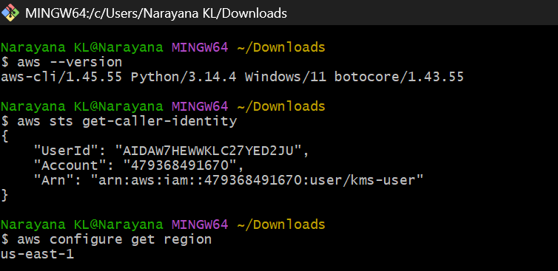
Step 2 — Create EBS CSI trust policy
Run: cat > ebs-trust-policy.json <<'EOF'
{
"Version": "2012-10-17",
"Statement": [
{
"Effect": "Allow",
"Principal": {
"Service": "ec2.amazonaws.com"
},
"Action": "sts:AssumeRole"
}
]
}
EOF
Check it:cat ebs-trust-policy.json
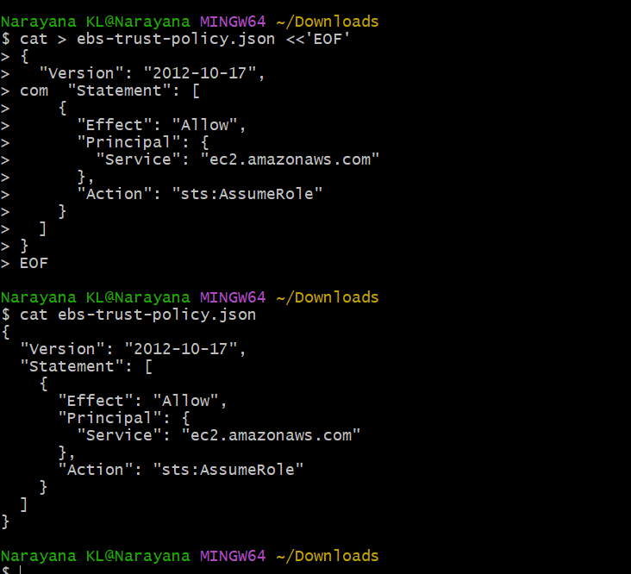
Step 3 — Create IAM role
aws iam create-role \
--role-name AmazonEBSCSIDriverRole \
--assume-role-policy-document file://ebs-trust-policy.json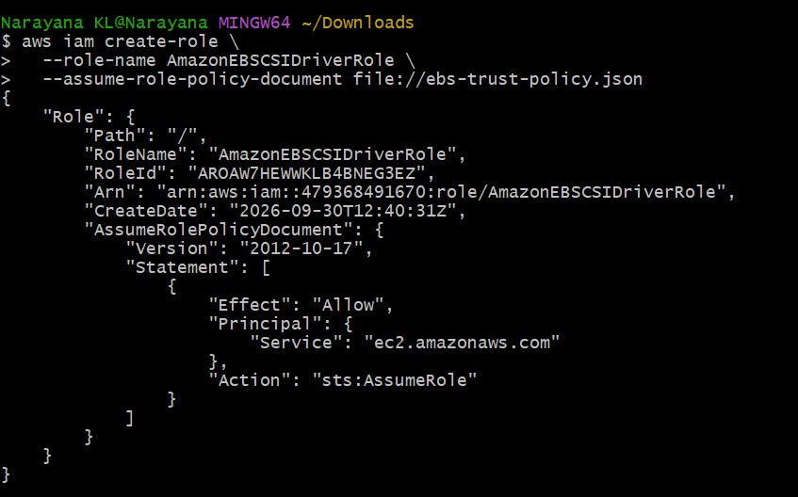
Step 4 — Attach EBS CSI policy
aws iam attach-role-policy \
--role-name AmazonEBSCSIDriverRole \
--policy-arn arn:aws:iam::aws:policy/service-role/AmazonEBSCSIDriverPolicy
Verify:
aws iam list-attached-role-policies \
--role-name AmazonEBSCSIDriverRole
You should see:
AmazonEBSCSIDriverPolicy
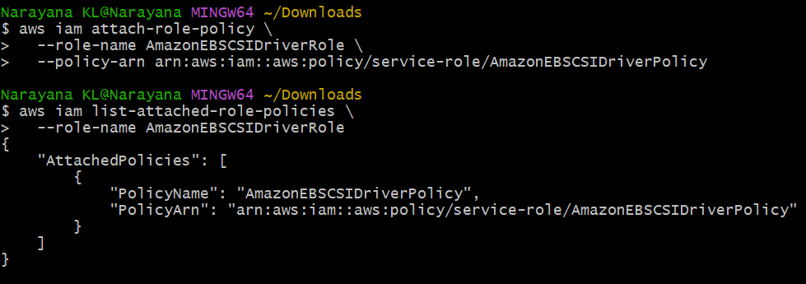
Part B — Create EC2 Instance Profile
Step 5 — Create instance profile
aws iam create-instance-profile \
--instance-profile-name AmazonEBSCSIDriverProfile
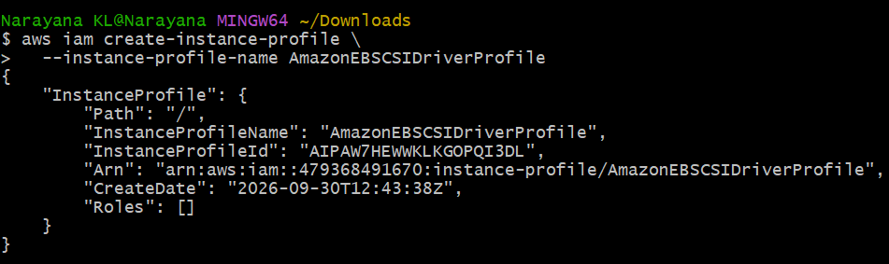
Step 6 — Add role to profile
aws iam add-role-to-instance-profile \
--instance-profile-name AmazonEBSCSIDriverProfile \
--role-name AmazonEBSCSIDriverRole
Verify: aws iam get-instance-profile \
--instance-profile-name AmazonEBSCSIDriverProfile
You should see:
AmazonEBSCSIDriverProfile
AmazonEBSCSIDriverRole
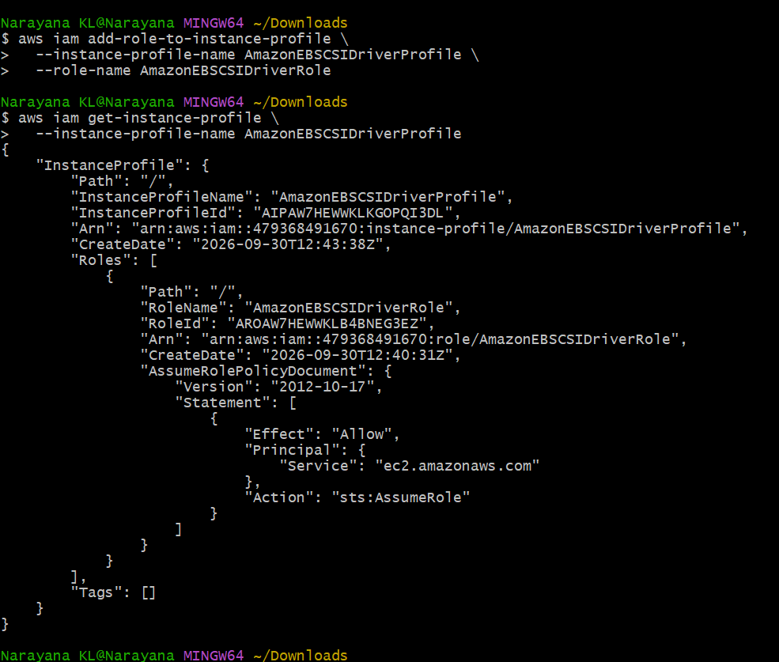Part C — Attach IAM Profile to Kubernetes Workers
Your worker instance IDs are: worker1 = i-007b4603e001d3d07
worker2 = i-08819529e0ae3c34b
Step 7 — Attach profile to worker1
aws ec2 associate-iam-instance-profile \
--instance-id i-007b4603e001d3d07 \
--iam-instance-profile Name=AmazonEBSCSIDriverProfile
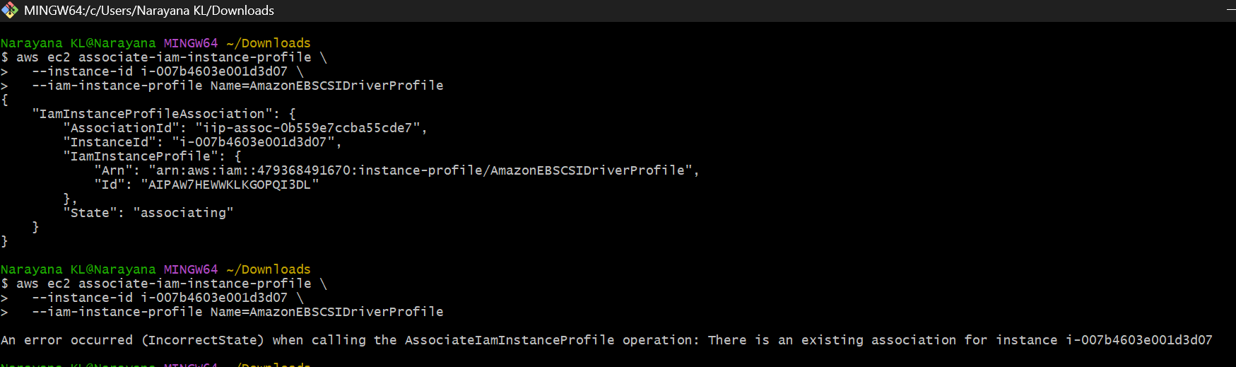
Step 8 — Attach profile to worker2
aws ec2 associate-iam-instance-profile \
--instance-id i-08819529e0ae3c34b \
--iam-instance-profile Name=AmazonEBSCSIDriverProfile
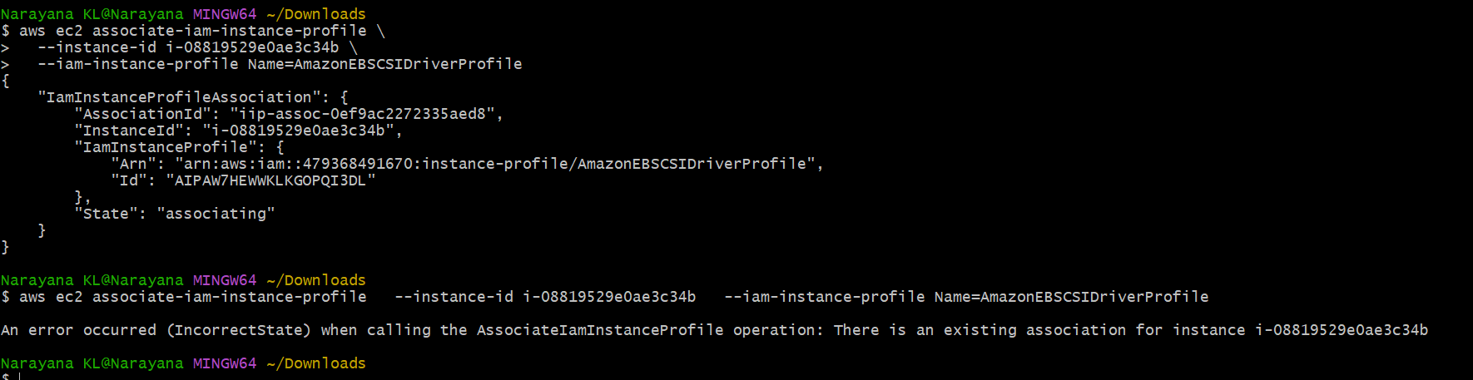
Verify:
aws ec2 describe-instances \
--instance-ids i-007b4603e001d3d07 i-08819529e0ae3c34b \
--query "Reservations[].Instances[].[InstanceId,IamInstanceProfile.Arn]"
Both workers should show an IAM instance profile ARN. 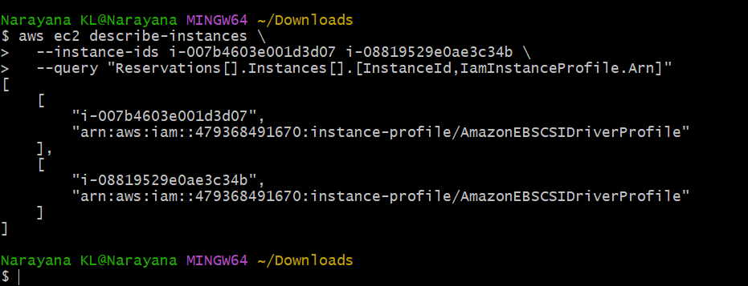
Part D — Install AWS EBS CSI Driver
Now switch to your k8s-master SSH session.
Check: kubectl get csidrivers
Currently you have only: csi.tigera.io
We need: ebs.csi.aws.com
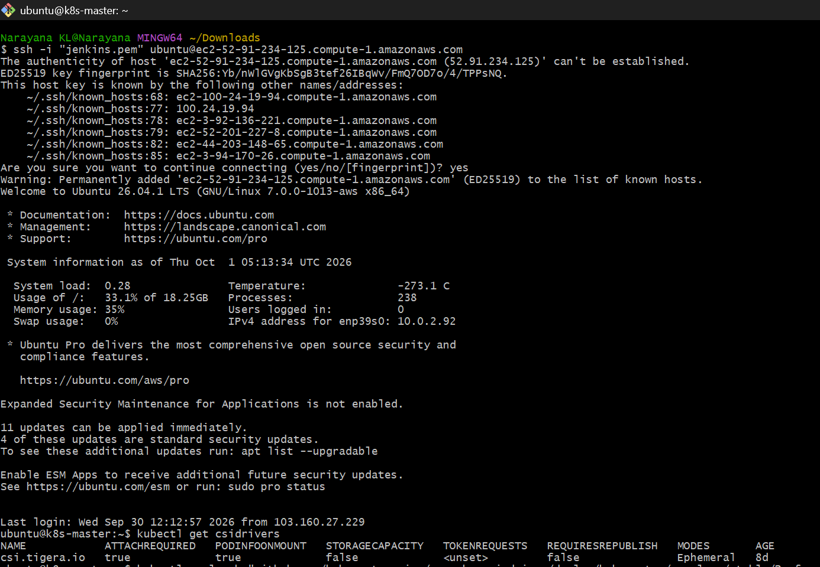
Step 9 — Install EBS CSI Driver
For this lab, install the AWS EBS CSI driver using its official Kubernetes manifests:
kubectl apply -k "github.com/kubernetes-sigs/aws-ebs-csi-driver/deploy/kubernetes/overlays/stable/?ref=release-1.53"
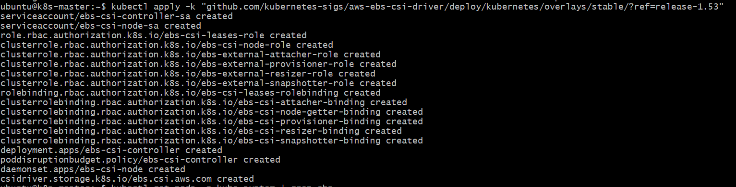
Then check: kubectl get pods -n kube-system | grep ebs
You should eventually see EBS CSI components such as:
ebs-csi-controller-...
ebs-csi-node-...
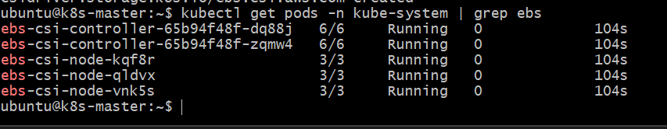
Check the CSI driver: kubectl get csidrivers
Expected: ebs.csi.aws.com
csi.tigera.ioPart E — Create StorageClass
Step 10 — Create StorageClass
Create: vi ebs-storageclass.yml
Paste: apiVersion: storage.k8s.io/v1
kind: StorageClass
metadata:
name: ebs-sc
provisioner: ebs.csi.aws.com
volumeBindingMode: WaitForFirstConsumer
parameters:
type: gp3
fsType: ext4
reclaimPolicy: Delete
allowVolumeExpansion: true
Save:Esc
:wq
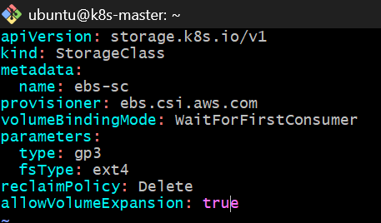
Apply: kubectl apply -f ebs-storageclass.yml
Check: kubectl get storageclass
Expected:
NAME PROVISIONER RECLAIMPOLICY VOLUMEBINDINGMODE
ebs-sc ebs.csi.aws.com Delete WaitForFirstConsumer
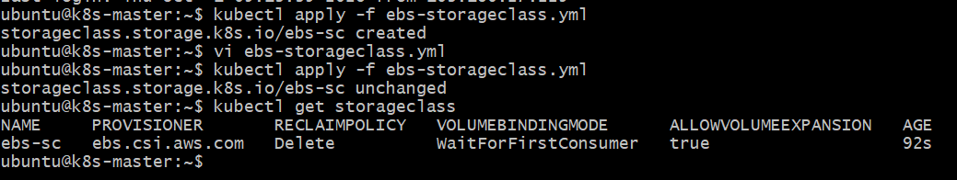
Part F — Create PVC
Step 11 — Create PVC
vi ebs-pvc.yml
Paste: apiVersion: v1
kind: PersistentVolumeClaim
metadata:
name: ebs-pvc
spec:
accessModes:
- ReadWriteOnce
storageClassName: ebs-sc
resources:
requests:
storage: 5Gi
Save: Esc
:wq
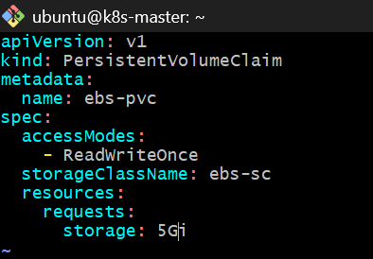
Apply: kubectl apply -f ebs-pvc.yml
Check: kubectl get pvc
Initially you may see:
STATUS Pending
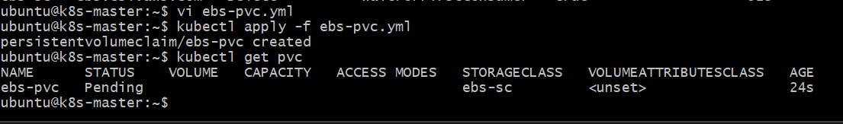
That is expected.
Because our StorageClass uses:
WaitForFirstConsumer
the EBS volume won't be provisioned until a Pod consumes the PVC.

Part G — Create Pod using PVC
Step 12 — Create Pod
vi ebs-pod.yml
Paste: apiVersion: v1
kind: Pod
metadata:
name: ebs-pod
spec:
containers:
- name: ebs-container
image: busybox:1.36
command:
- sh
- -c
- |
echo "Hello from Amazon EBS" > /data/message.txt
sleep 3600
volumeMounts:
- name: ebs-storage
mountPath: /data
volumes:
- name: ebs-storage
persistentVolumeClaim:
claimName: ebs-pvc
Save: Esc
:wq
Apply: kubectl apply -f ebs-pod.yml
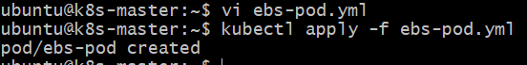
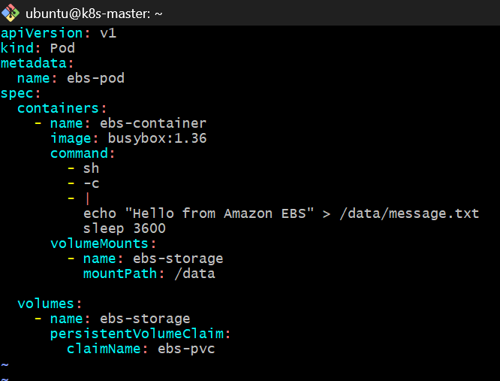Part H — Verify EBS
Step 13 — Check Pod
kubectl get pod ebs-pod -o wide
Expected: ebs-pod 1/1 Running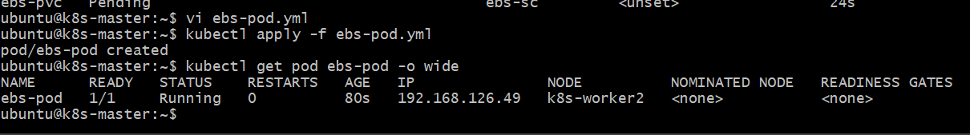Step 14 — Check PVC
kubectl get pvc
Expected:
NAME STATUS VOLUME
ebs-pvc Bound pvc-xxxxxxxx
Step 15 — Check PV
kubectl get pv
Expected:
STATUS CLAIM
Bound default/ebs-pvc
Step 16 — Verify data
kubectl exec ebs-pod -- cat /data/message.txt
Expected: Hello from Amazon EBS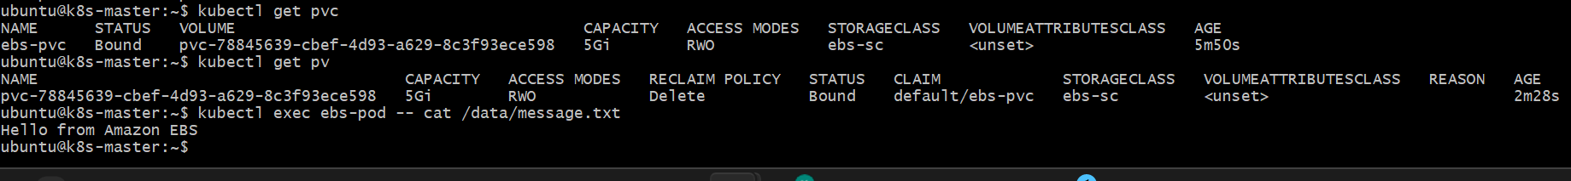
Step 17 — Inspect the PVC
kubectl describe pvc ebs-pvc
Look for:
StorageClass: ebs-sc
Status: Bound
Capacity: 5Gi
Access Modes: RWO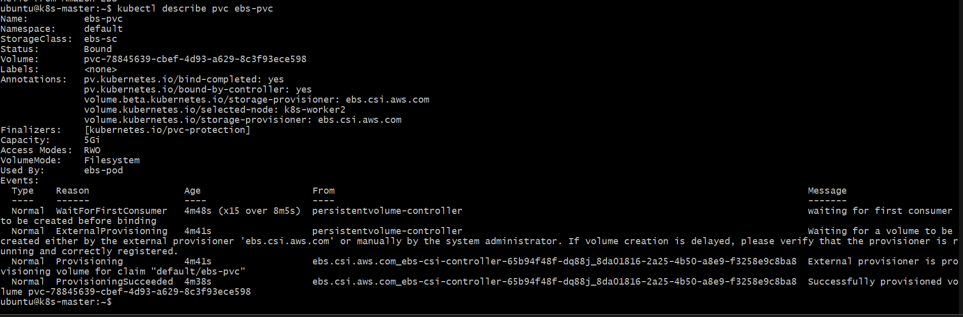
Part I — Verify the actual AWS EBS volume
From Windows Git Bash:
aws ec2 describe-volumes \
--region us-east-1 \
--filters Name=tag:CSIVolumeName,Values=*
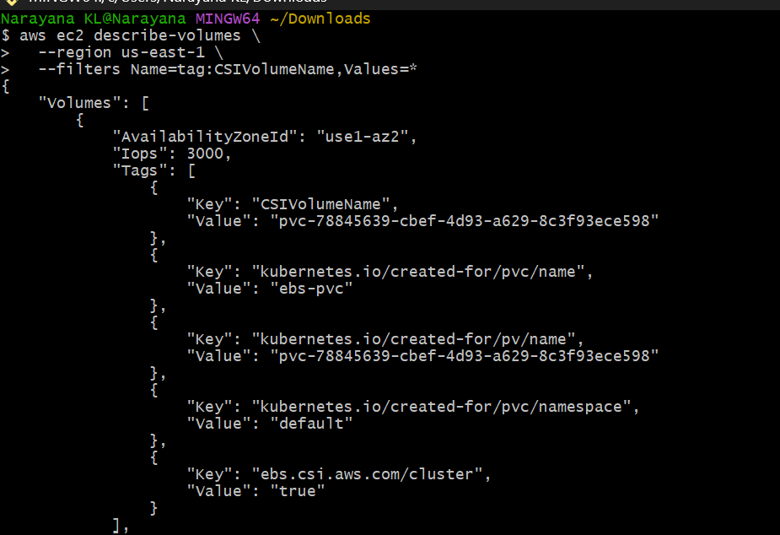
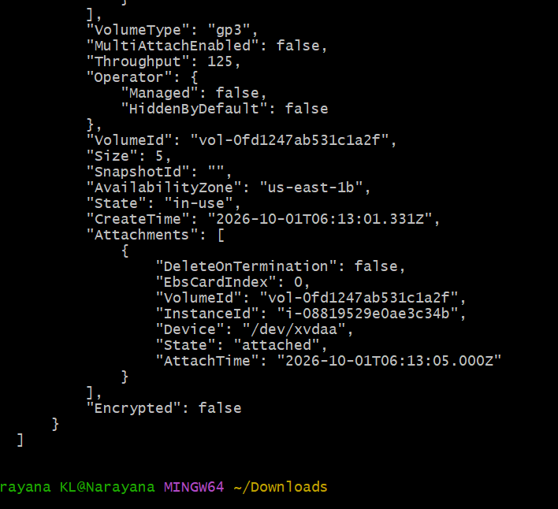
The easier Kubernetes-side check is:kubectl describe pv
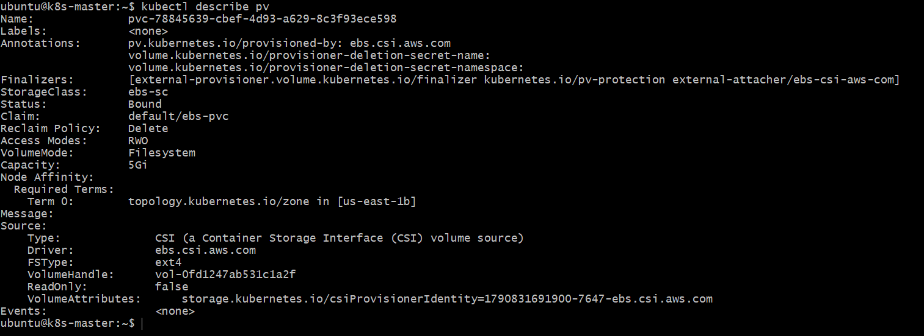
Look for the EBS CSI volume handle:
ebs.csi.aws.com
You can also check AWS volumes:
aws ec2 describe-volumes \
--region us-east-1 \
--query "Volumes[?State=='in-use'].[VolumeId,Size,VolumeType,State]"
You should see a gp3 volume of approximately 5 GiB.
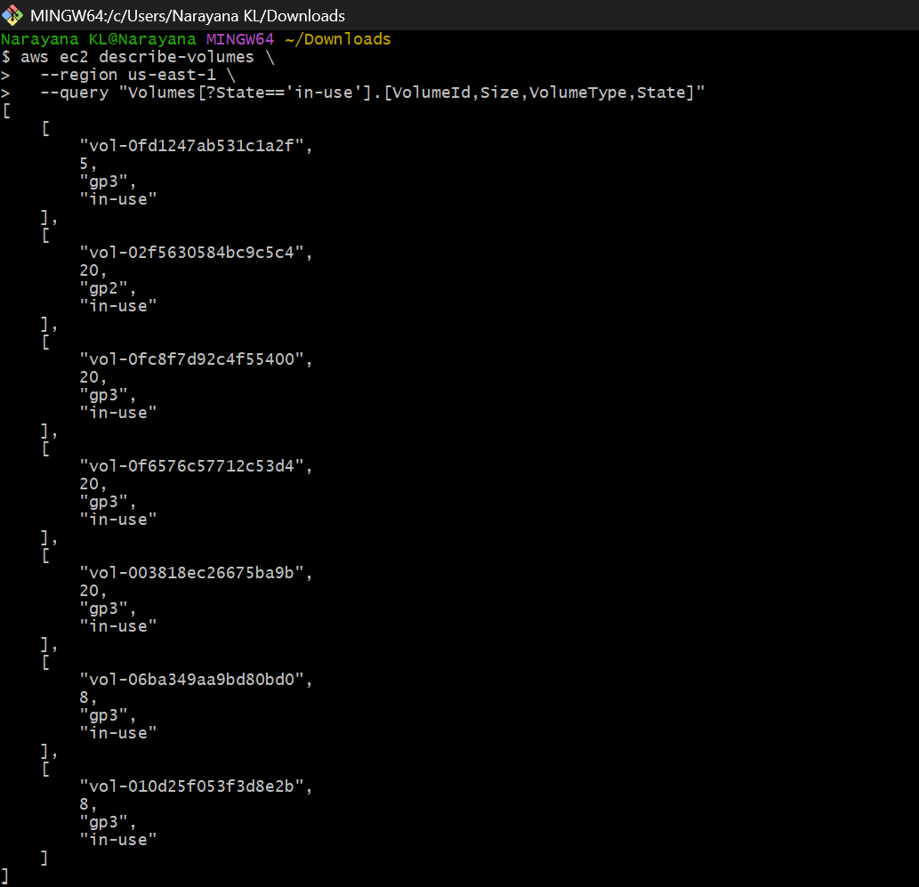
Task 4 — Amazon EFS + Multiple Pods
This task will demonstrate shared storage.
Unlike EBS, which is normally mounted as ReadWriteOnce, EFS supports multiple Pods accessing the same filesystem concurrently.
We'll build:
AWS EFS
│
EFS CSI Driver
│
PersistentVolume
│
PVC
/ \
/ \
Pod-1 Pod-2
/data /data
\ /
Shared files
We'll test it by having Pod 1 create a file and Pod 2 read the same file.
First check
On k8s-master, run: kubectl get csidrivers
and:
kubectl get pods -A | grep -i efs
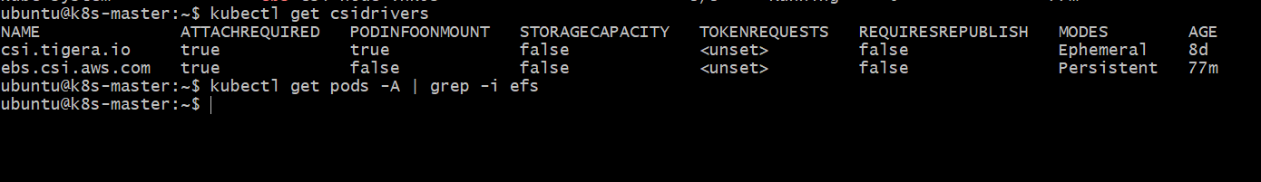
Step 1: Install EFS CSI Driver
Your cluster currently has:
- csi.tigera.io ✅
- ebs.csi.aws.com ✅
- efs.csi.aws.com ❌
The current EFS CSI driver documentation supports installation with Kustomize/Helm, and the current driver line is v3.x. GitHub
For our lab, we'll use the public ECR manifest, avoiding extra Docker Hub dependencies.
On k8s-master, run:
kubectl apply -k "github.com/kubernetes-sigs/aws-efs-csi-driver/deploy/kubernetes/overlays/stable/?ref=v3.5.0"
Then check:
kubectl get csidrivers
You should eventually see:
efs.csi.aws.com
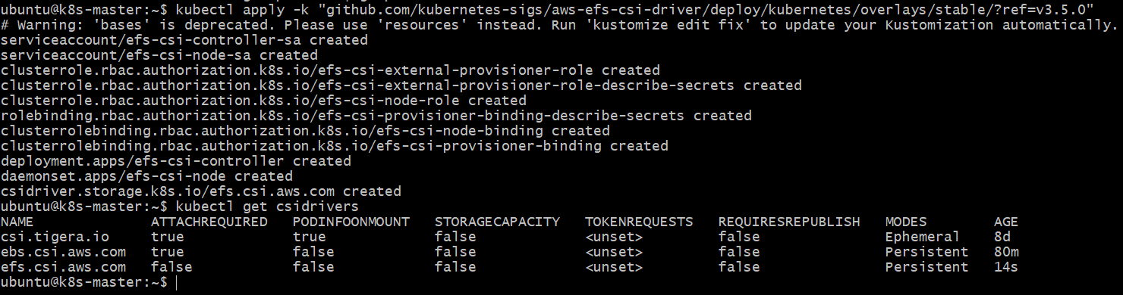
Now check the EFS CSI pods:
kubectl get pods -n kube-system | grep efs
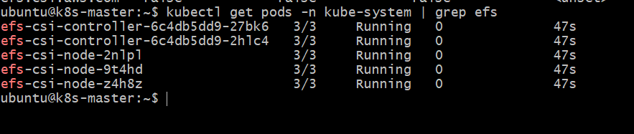
You should see an EFS controller and EFS node pods.
Step 1.2 — Wait for the driver
Run:
kubectl get pods -n kube-system -w
Wait until the EFS CSI pods show Running.
Press: Ctrl+C
to stop watching.
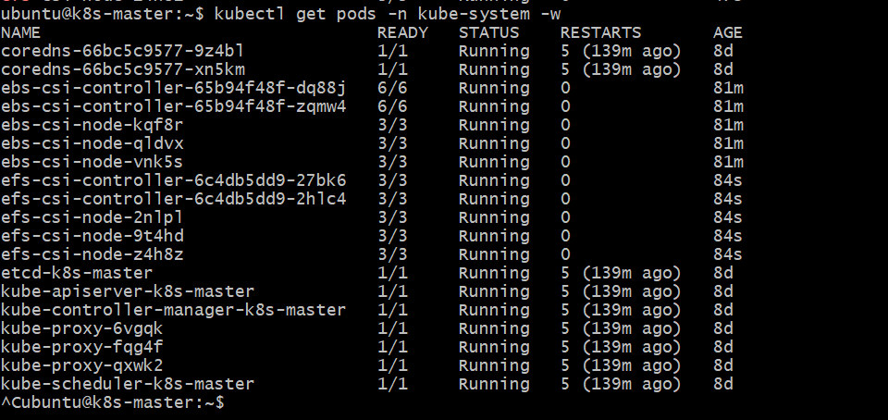
Step 2 — Create EFS filesystem
Do this from Windows Git Bash — not k8s-master.
2.1 Check your VPC
Run: aws ec2 describe-vpcs \
--vpc-ids vpc-03b4412156c533bef \
--query 'Vpcs[0].{VpcId:VpcId,Cidr:CidrBlock}' \
--output table
Expected:
VpcId Cidr
----------------------- -----------
vpc-03b4412156c533bef 10.0.0.0/16
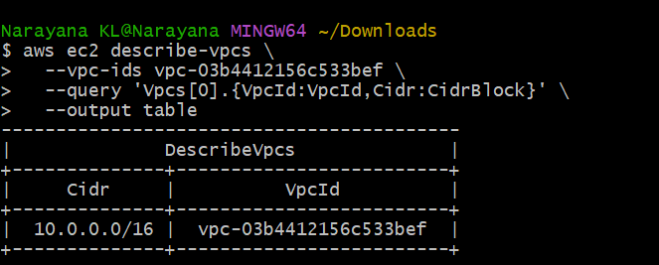
2.2 Find the worker subnet/AZ information
Run:
aws ec2 describe-instances \
--instance-ids i-007b4603e001d3d07 i-08819529e0ae3c34b \
--query 'Reservations[].Instances[].{InstanceId:InstanceId,PrivateIp:PrivateIpAddress,SubnetId:SubnetId,AZ:Placement.AvailabilityZone,SG:SecurityGroups[0].GroupId}' \
--output table
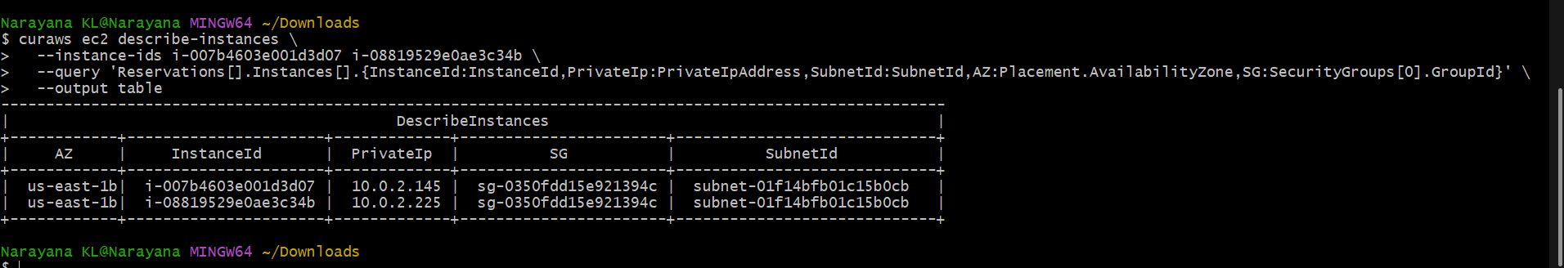
Step 3: Create EFS File System
Continue in Windows Git Bash.
3.1 Create the EFS filesystem
aws efs create-file-system \
--region us-east-1 \
--performance-mode generalPurpose \
--throughput-mode bursting \
--encrypted \
--tags Key=Name,Value=k8s-efs-lab
You'll get output containing something like:
"FileSystemId": "fs-xxxxxxxxxxxxxxxxx"
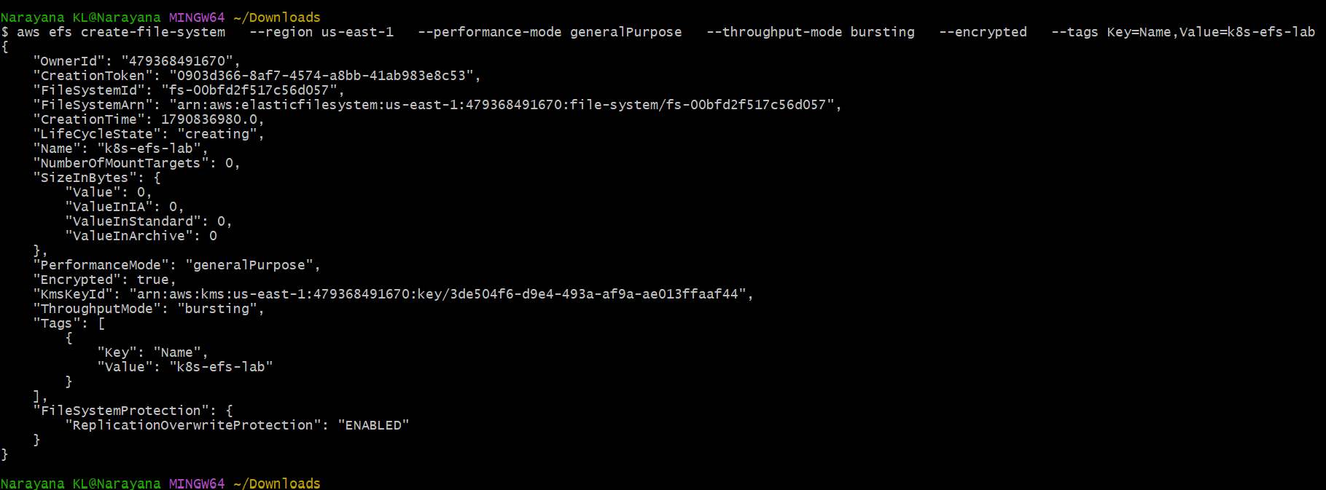
3.2 Save the filesystem ID
Copy the FileSystemId from the output.
For example, if you get:
fs-0123456789abcdef0
set:
EFS_ID=fs-00bfd2f517c56d057
Verify:
echo $EFS_ID
It should print your actual EFS ID.
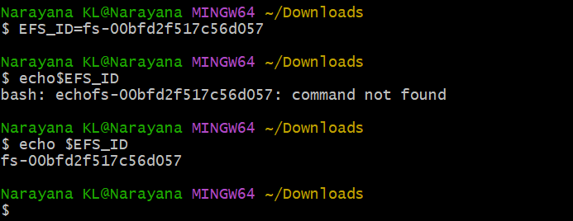
3.3 Get the VPC security group
We already know the worker SG: sg-0350fdd15e921394c
EFS uses NFS TCP port 2049. We need to allow the worker nodes to access EFS.
Run: aws ec2 authorize-security-group-ingress \
--group-id sg-0350fdd15e921394c \
--protocol tcp \
--port 2049 \
--source-group sg-0350fdd15e921394c
If you get:
InvalidPermission.Duplicate
that's okay—the rule already exists.
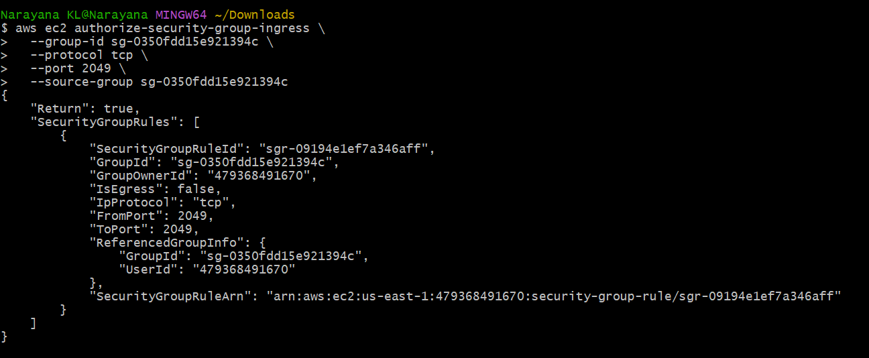
3.4 Create the EFS mount target
Because your Kubernetes workers are in us-east-1b and the same subnet, create the mount target there:
aws efs create-mount-target \
--file-system-id $EFS_ID \
--subnet-id subnet-01f14bfb01c15b0cb \
--security-groups sg-0350fdd15e921394c
Expected output will contain:
"LifeCycleState": "creating"
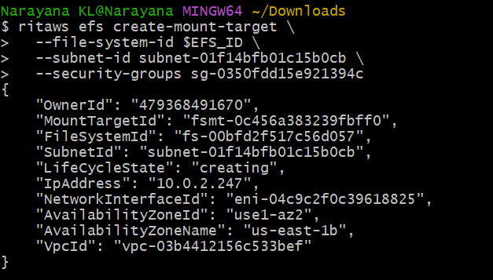
3.5 Wait and verify
Run:
aws efs describe-mount-targets \
--file-system-id $EFS_ID \
--query 'MountTargets[].{MountTargetId:MountTargetId,State:LifeCycleState,Subnet:SubnetId,AZ:AvailabilityZoneName,IP:IpAddress}' \
--output table
Wait until the state becomes:
Available
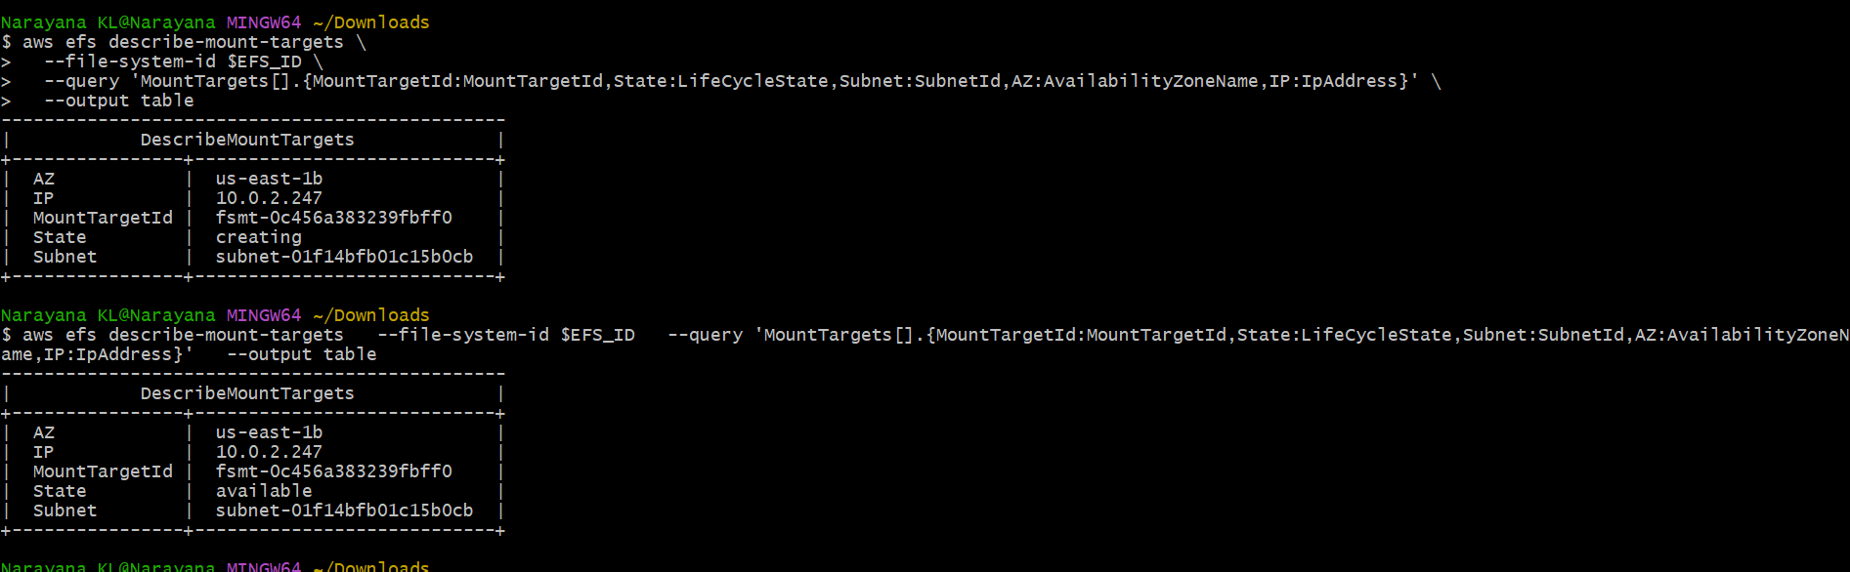
Step 4: Create EFS Persistent Volume
Switch to k8s-master.
4.1 Confirm your EFS ID
From Windows Git Bash, run:
echo $EFS_ID
You should have something like:
fs-xxxxxxxxxxxxxxxxx
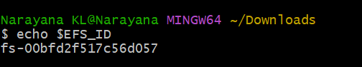
Keep that ID ready.
4.2 Create the PV YAML
On k8s-master:
nano efs-pv.yml
Paste:apiVersion: v1
kind: PersistentVolume
metadata:
name: efs-pv
spec:
capacity:
storage: 5Gi
volumeMode: Filesystem
accessModes:
- ReadWriteMany
persistentVolumeReclaimPolicy: Retain
storageClassName: efs-sc
csi:
driver: efs.csi.aws.com
volumeHandle: fs-XXXXXXXXXXXX
Important
Replace:
fs-00bfd2f517c56d057
with your actual EFS filesystem ID.
For example:
volumeHandle: fs-0123456789abcdef0
Save: Ctrl+O Enter Ctrl+X
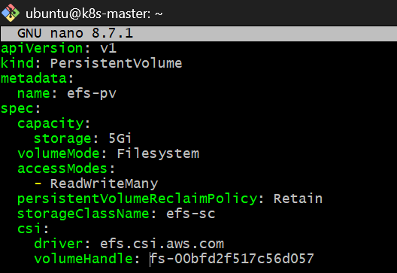
4.3 Create the PV
kubectl apply -f efs-pv.yml
Check:
kubectl get pv
You should see:
NAME CAPACITY ACCESS MODES RECLAIM POLICY STATUS CLAIM
efs-pv 5Gi RWX Retain Available
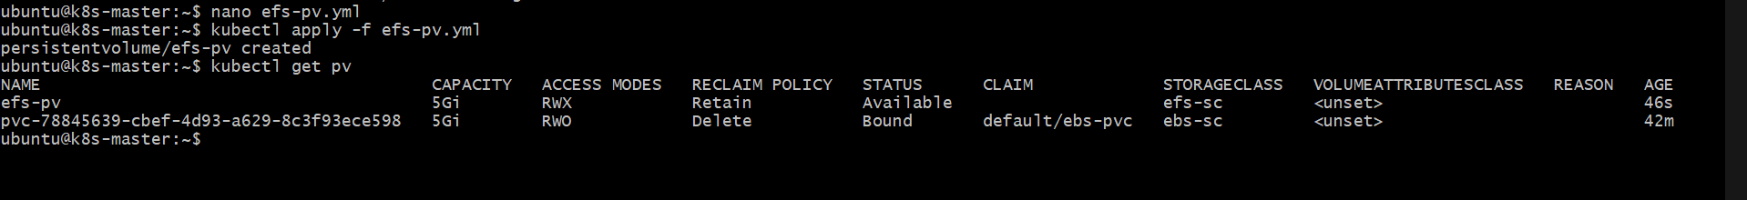
Step 5: Create PVC
Create: nano efs-pvc.yml
Paste:
apiVersion: v1
kind: PersistentVolumeClaim
metadata:
name: efs-pvc
spec:
accessModes:
- ReadWriteMany
storageClassName: efs-sc
resources:
requests:
storage: 5Gi
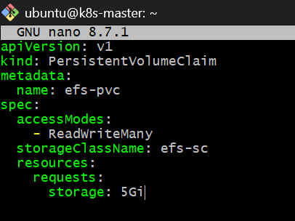
Save and apply:
kubectl apply -f efs-pvc.yml
Check: kubectl get pvc
Expected:
NAME STATUS VOLUME CAPACITY ACCESS MODES
efs-pvc Bound efs-pv 5Gi RWX
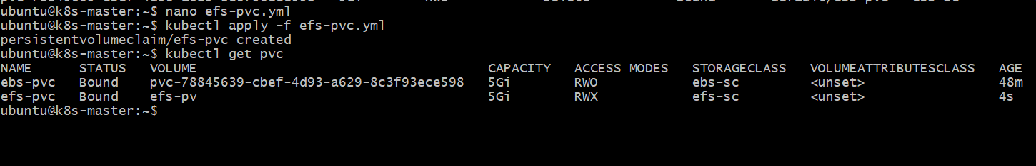
Check both:
kubectl get pv efs-pv
kubectl get pvc efs-pvc
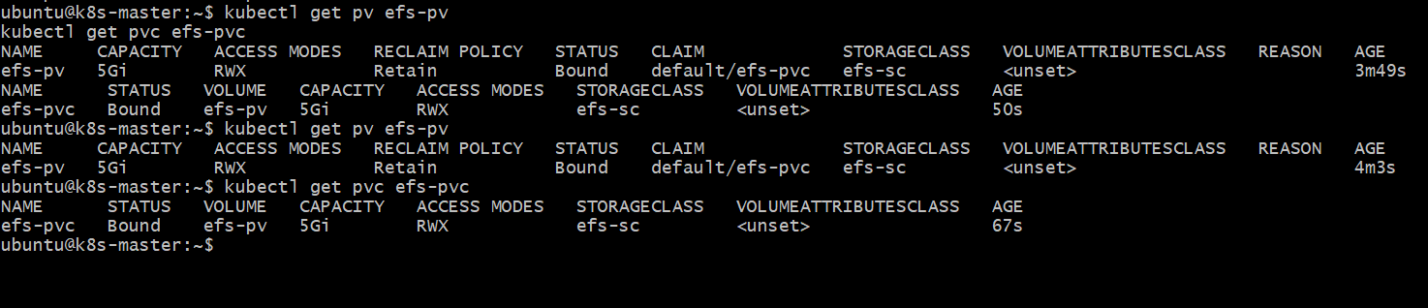
Step 6: Create Pod 1
On k8s-master: nano efs-pod1.yml
Paste: apiVersion: v1
kind: Pod
metadata:
name: efs-pod1
spec:
containers:
- name: efs-container
image: busybox:1.36
command:
- sh
- -c
- |
echo "Hello from EFS - written by Pod 1" > /data/shared.txt
sleep 3600
volumeMounts:
- name: efs-storage
mountPath: /data
volumes:
- name: efs-storage
persistentVolumeClaim:
claimName: efs-pvc
Save
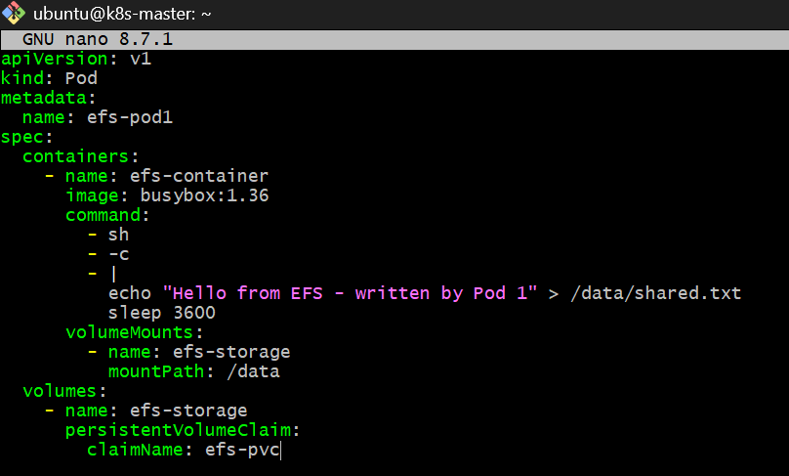
Create it: kubectl apply -f efs-pod1.yml
Check: kubectl get pod efs-pod1 -o wide
Wait until: 1/1 Running
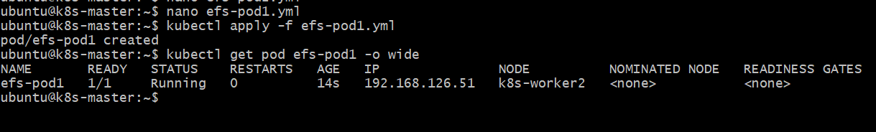
Then verify the file: kubectl exec efs-pod1 -- cat /data/shared.txt
Expected: Hello from EFS - written by Pod 1
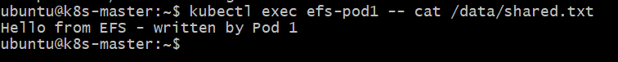Step 7: Create Pod 2
Create: nano efs-pod2.yml
Paste: apiVersion: v1
kind: Pod
metadata:
name: efs-pod2
spec:
containers:
- name: efs-container
image: busybox:1.36
command:
- sh
- -c
- |
sleep 3600
volumeMounts:
- name: efs-storage
mountPath: /data
volumes:
- name: efs-storage
persistentVolumeClaim:
claimName: efs-pvc
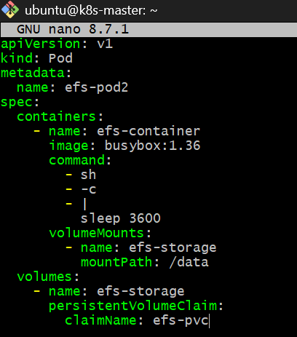
Apply: kubectl apply -f efs-pod2.yml
Check: kubectl get pods -o wide | grep efs
You should have:
efs-pod1 1/1 Running
efs-pod2 1/1 Running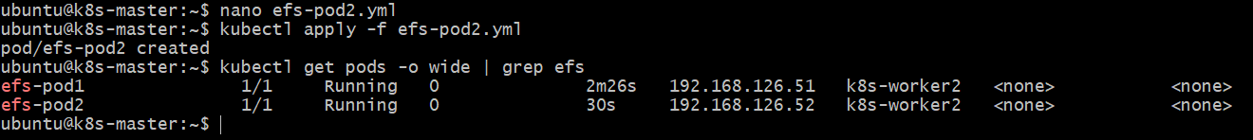
Step 8: Test Shared Data
Now the important test.
Pod 1 wrote the file. Pod 2 should be able to read it.
Run: kubectl exec efs-pod2 -- cat /data/shared.txt
Expected: Hello from EFS - written by Pod 1
Now write another file from Pod 2:
kubectl exec efs-pod2 -- sh -c 'echo "Hello from Pod 2 using shared EFS" > /data/pod2.txt'
Read it from Pod 1: kubectl exec efs-pod1 -- cat /data/pod2.txt
Expected: Hello from Pod 2 using shared EFS
Finally:
kubectl exec efs-pod1 -- ls -l /data
kubectl exec efs-pod2 -- ls -l /data
Both Pods should see:
shared.txt
pod2.txt
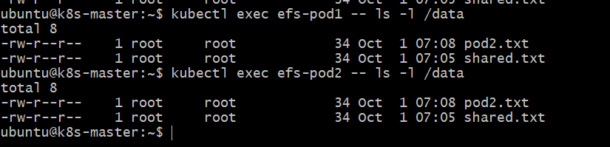
🎯 What we proved
Amazon EFS
│
efs.csi.aws.com
│
efs-pvc
│
┌───────┴───────┐
│ │
Pod 1 Pod 2
│ │
/data /data
│ │
└── shared ─────┘
storage
This demonstrates ReadWriteMany (RWX) shared storage.
Task 5 — Liveness and Readiness Probes
Objective
We will create one Nginx Pod with:
- Liveness probe → checks whether the container is healthy
- Readiness probe → checks whether the Pod is ready to receive traffic
- A Kubernetes Service
- Then we will deliberately break the health endpoint and observe Kubernetes behavior.
Step 1 — Create the Pod
On k8s-master: nano probe-pod.yml
Paste: apiVersion: v1
kind: Pod
metadata:
name: probe-pod
labels:
app: probe-demo
spec:
containers:
- name: nginx
image: nginx:1.27
ports:
- containerPort: 80
livenessProbe:
httpGet:
path: /healthz
port: 80
initialDelaySeconds: 10
periodSeconds: 5
timeoutSeconds: 2
failureThreshold: 3
readinessProbe:
httpGet:
path: /ready
port: 80
initialDelaySeconds: 5
periodSeconds: 5
timeoutSeconds: 2
failureThreshold: 3
Save
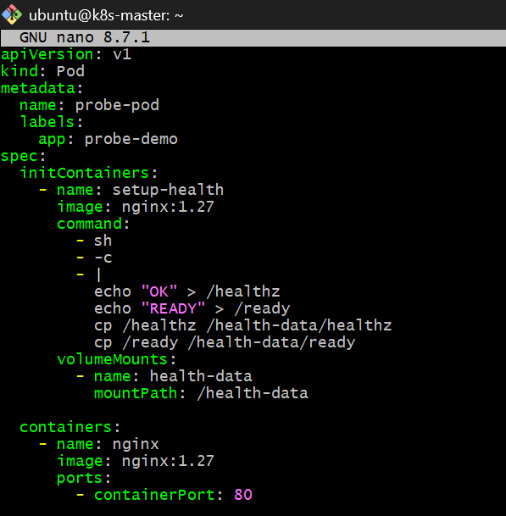
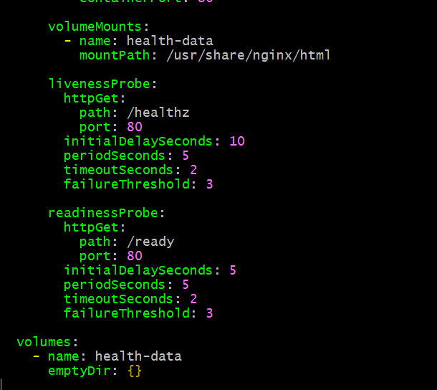
Important
Nginx does not normally provide /healthz and /ready.
So before creating the Pod, we need to create those files inside the Nginx container. The cleanest lab approach is to use an emptyDir plus an init container.
Don't apply the YAML above yet.
We'll modify it in the next step so the probes have real endpoints to check.
Run: nano probe-pod.yml
Replace the complete contents with:
apiVersion: v1
kind: Pod
metadata:
name: probe-pod
labels:
app: probe-demo
spec:
initContainers:
- name: setup-health
image: nginx:1.27
command:
- sh
- -c
- |
echo "OK" > /healthz
echo "READY" > /ready
cp /healthz /health-data/healthz
cp /ready /health-data/ready
volumeMounts:
- name: health-data
mountPath: /health-data
containers:
- name: nginx
image: nginx:1.27
ports:
- containerPort: 80
volumeMounts:
- name: health-data
mountPath: /usr/share/nginx/html
livenessProbe:
httpGet:
path: /healthz
port: 80
initialDelaySeconds: 10
periodSeconds: 5
timeoutSeconds: 2
failureThreshold: 3
readinessProbe:
httpGet:
path: /ready
port: 80
initialDelaySeconds: 5
periodSeconds: 5
timeoutSeconds: 2
failureThreshold: 3
volumes:
- name: health-data
emptyDir: {}
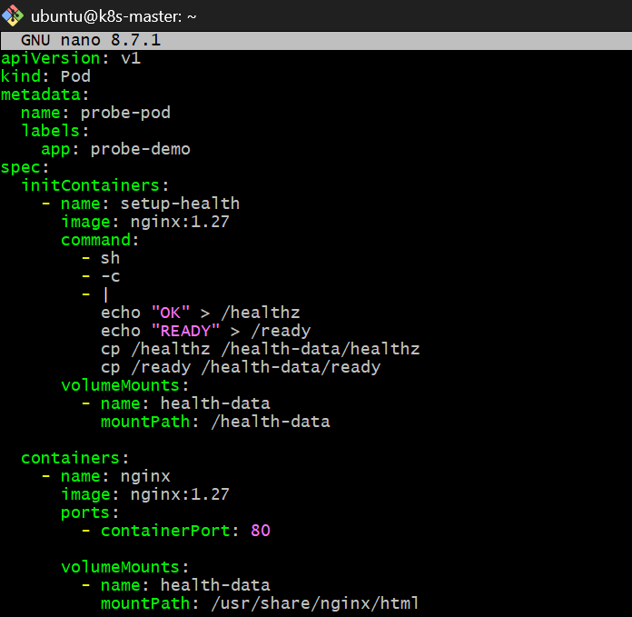
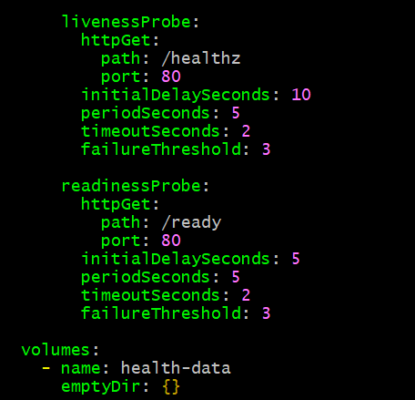

Then: kubectl apply -f probe-pod.yml
Check: kubectl get pod probe-pod
Wait for:
1/1 Running
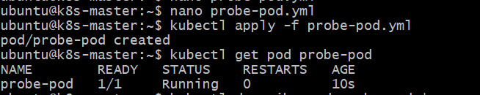
Then: kubectl describe pod probe-pod | grep -A8 -i "Liveness"
and: kubectl describe pod probe-pod | grep -A8 -i "Readiness"
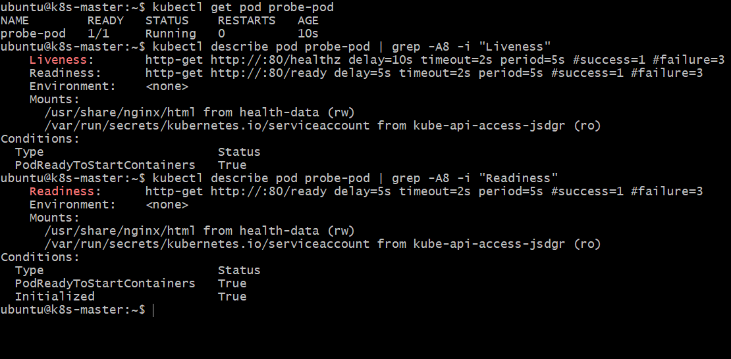
Step 2: Test Readiness Probe
First confirm the Pod is currently ready:
kubectl get pod probe-pod
Expected: probe-pod 1/1 Running
Now we will break only the readiness endpoint.
Run: kubectl exec probe-pod -- rm /usr/share/nginx/html/ready
Wait about 15–20 seconds:
sleep 20
Then: kubectl get pod probe-pod
You should see something similar to:
probe-pod 0/1 Running
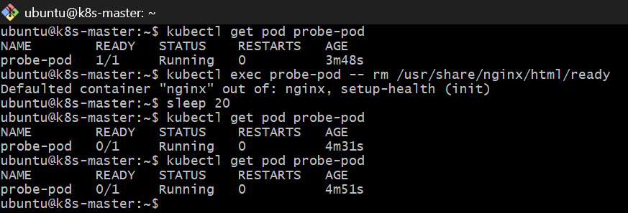
Important observation
The Pod should remain:
STATUS: Running
but: READY: 0/1
This demonstrates:
Readiness failure does NOT restart the container.
Check the events:
kubectl describe pod probe-pod | tail -20
You should see readiness probe failures.
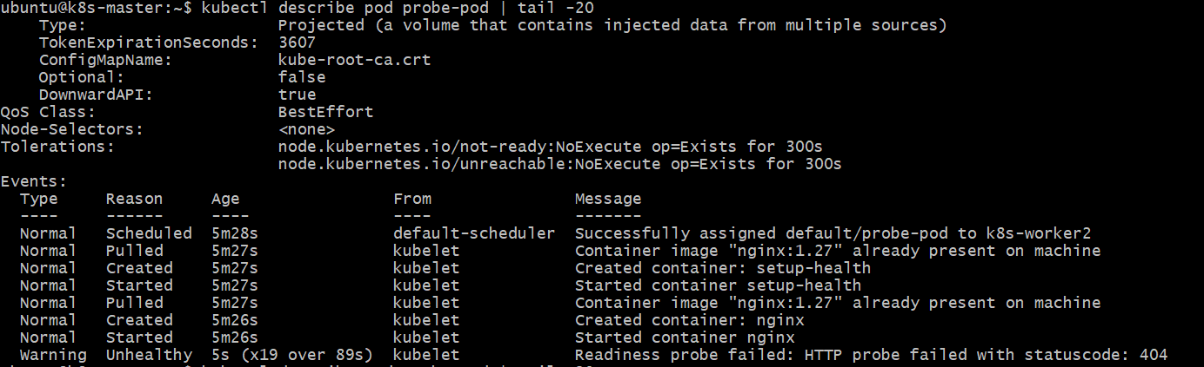
Step 2.1: Restore Readiness
Put the file back: kubectl exec probe-pod -- sh -c 'echo READY > /usr/share/nginx/html/ready'
Wait: sleep 10
Check: kubectl get pod probe-pod
It should return to: probe-pod 1/1 Running
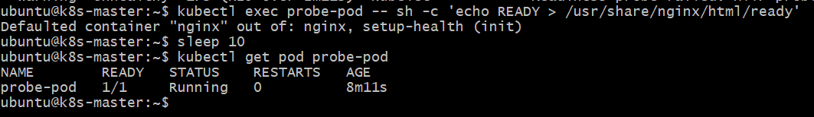
Step 3: Test Liveness Probe
Now we'll test the difference.
The liveness endpoint is:
/healthz
Currently it exists: kubectl exec probe-pod -- cat /usr/share/nginx/html/healthz
Expected: OK
Check the current restart count: kubectl get pod probe-pod
It should show: RESTARTS 0
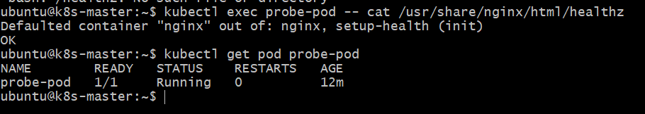
Step 4 — Break the Liveness Endpoint
Run: kubectl exec probe-pod -- rm /usr/share/nginx/html/healthz
Now wait about 25 seconds: sleep 25
Check: kubectl get pod probe-pod
This time you should see the RESTARTS count increase, for example:
NAME READY STATUS RESTARTS
probe-pod 1/1 Running 2
The exact restart count may vary slightly depending on timing.
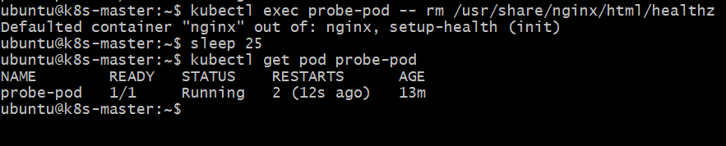
Check the liveness failure event
kubectl describe pod probe-pod | tail -25
Look for something similar to: Liveness probe failed
and: Killing
Why this is different
Probe | Failure result
Readiness | Pod becomes 0/1, container keeps running
Liveness | Container is restarted

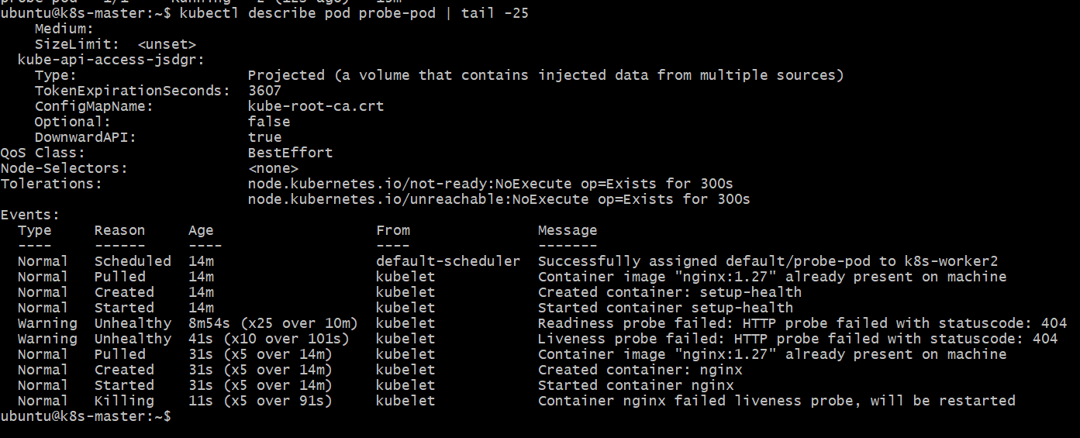
Step 5 — Restore the Liveness Endpoint
Because the container has restarted, the healthz file is still missing. Restore it:
kubectl exec probe-pod -- sh -c 'echo OK > /usr/share/nginx/html/healthz'
Check: kubectl exec probe-pod -- cat /usr/share/nginx/html/healthz
Expected: OK
Then wait: sleep 10
Check: kubectl get pod probe-pod
It should remain:
1/1 Running
and the restart count should stop increasing.
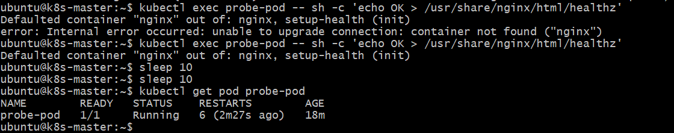
Finally:
kubectl describe pod probe-pod | grep -A8 -i "Liveness"
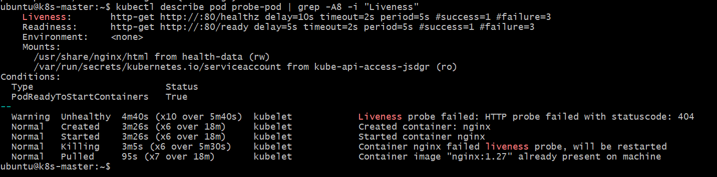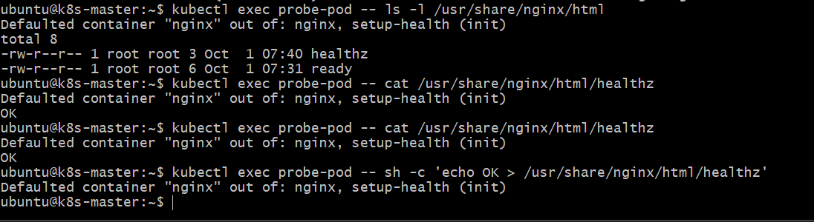
Your final verification is exactly what we wanted:
READY 1/1
STATUS Running
RESTARTS 6
The restart count stayed at 6 during the 20-second test, so the liveness probe is now healthy.
Both endpoints work:
/healthz → OK
/ready → READY
And the Pod conditions are all healthy:
Initialized True
Ready True
ContainersReady True
PodScheduled True
The old probe-failure events are gone from the current event output.
