Kubernetes-05
Task 1 — Namespace + ResourceQuota
Objective
Create dev-environment and restrict:
- Maximum Pods = 3
- Maximum Services = 2
Step 1. Create namespace
kubectl create namespace dev-environment
Verify: kubectl get namespaces
You should see: dev-environment
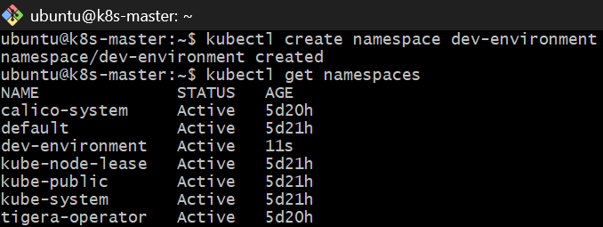
Step 2. Create ResourceQuota
Create the YAML: vi dev-resource-quota.yml
Add: apiVersion: v1
kind: ResourceQuota
metadata:
name: dev-quota
namespace: dev-environment
spec:
hard:
pods: "3"
services: "2"
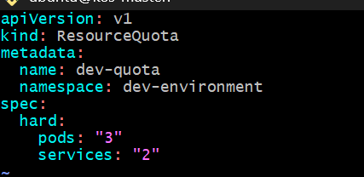
Save and apply: kubectl apply -f dev-resource-quota.yml
Step 3. Verify
kubectl get resourcequota -n dev-environment
Detailed: kubectl describe resourcequota dev-quota -n dev-environment
Expected:
Resource Used Hard
-------- ---- ----
pods 0 3
services 0 2
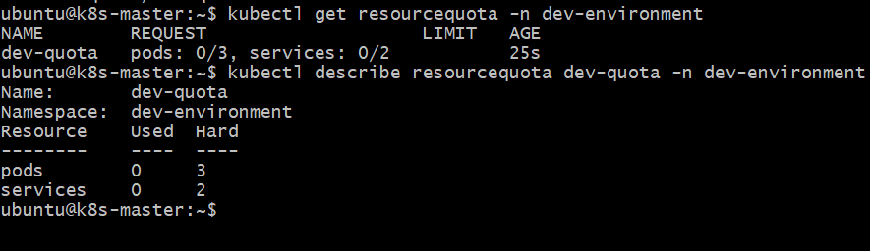
Done checkpoint
Task 2 — Pod with Requests and Limits
Objective
Create namespace: prod-environment
Pod resources:
Resource | Request | Limit
CPU | 0.2 CPU | 0.5 CPU
Memory | 200Mi | 500Mi

Step 1. Create namespace
kubectl create namespace prod-environment
Step 2. Create Pod YAML
vi prod-pod.yml
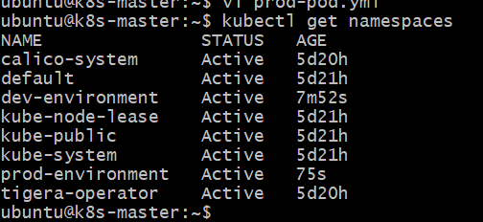
Add: apiVersion: v1
kind: Pod
metadata:
name: prod-pod
namespace: prod-environment
spec:
containers:
- name: nginx
image: nginx:1.27
resources:
requests:
cpu: "200m"
memory: "200Mi"
limits:
cpu: "500m"
memory: "500Mi"
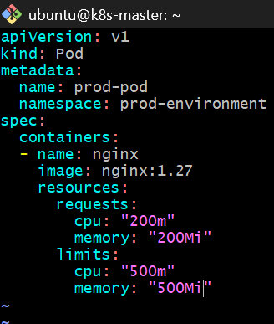
Apply: kubectl apply -f prod-pod.yml
Step 3. Verify
kubectl get pod -n prod-environment
Then: kubectl describe pod prod-pod -n prod-environment
Look for:
Requests:
cpu: 200m
memory: 200Mi
Limits:
cpu: 500m
memory: 500Mi
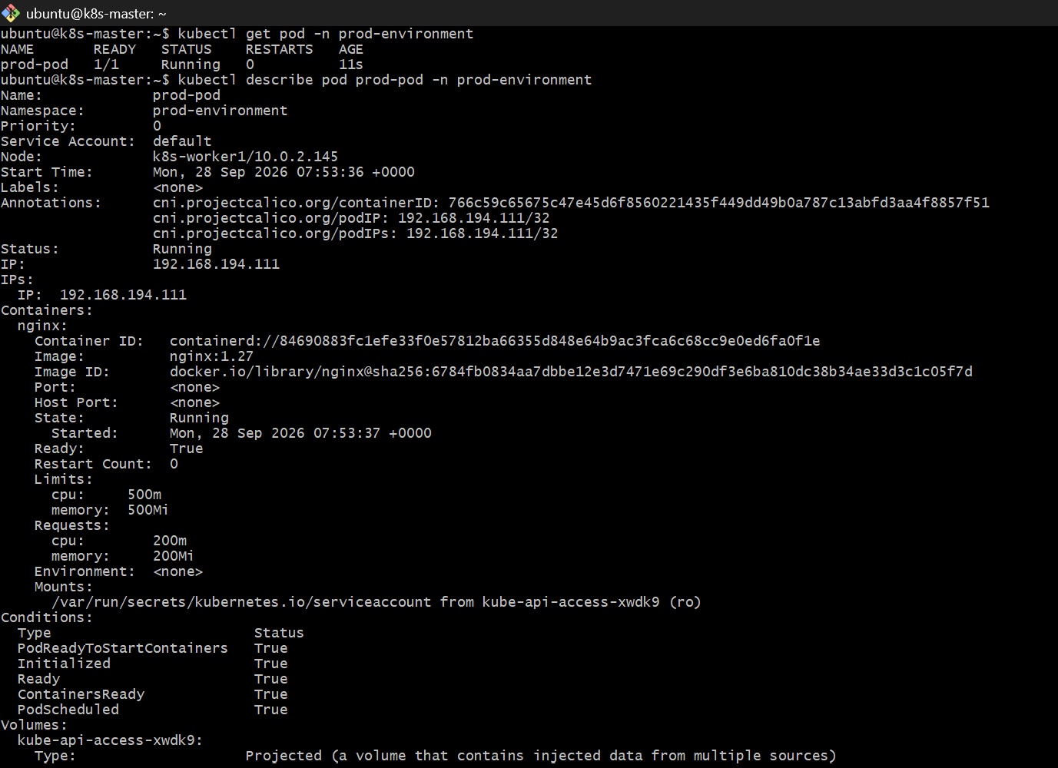
You can also check: kubectl get pod prod-pod -n prod-environment -o yaml
Done checkpoint
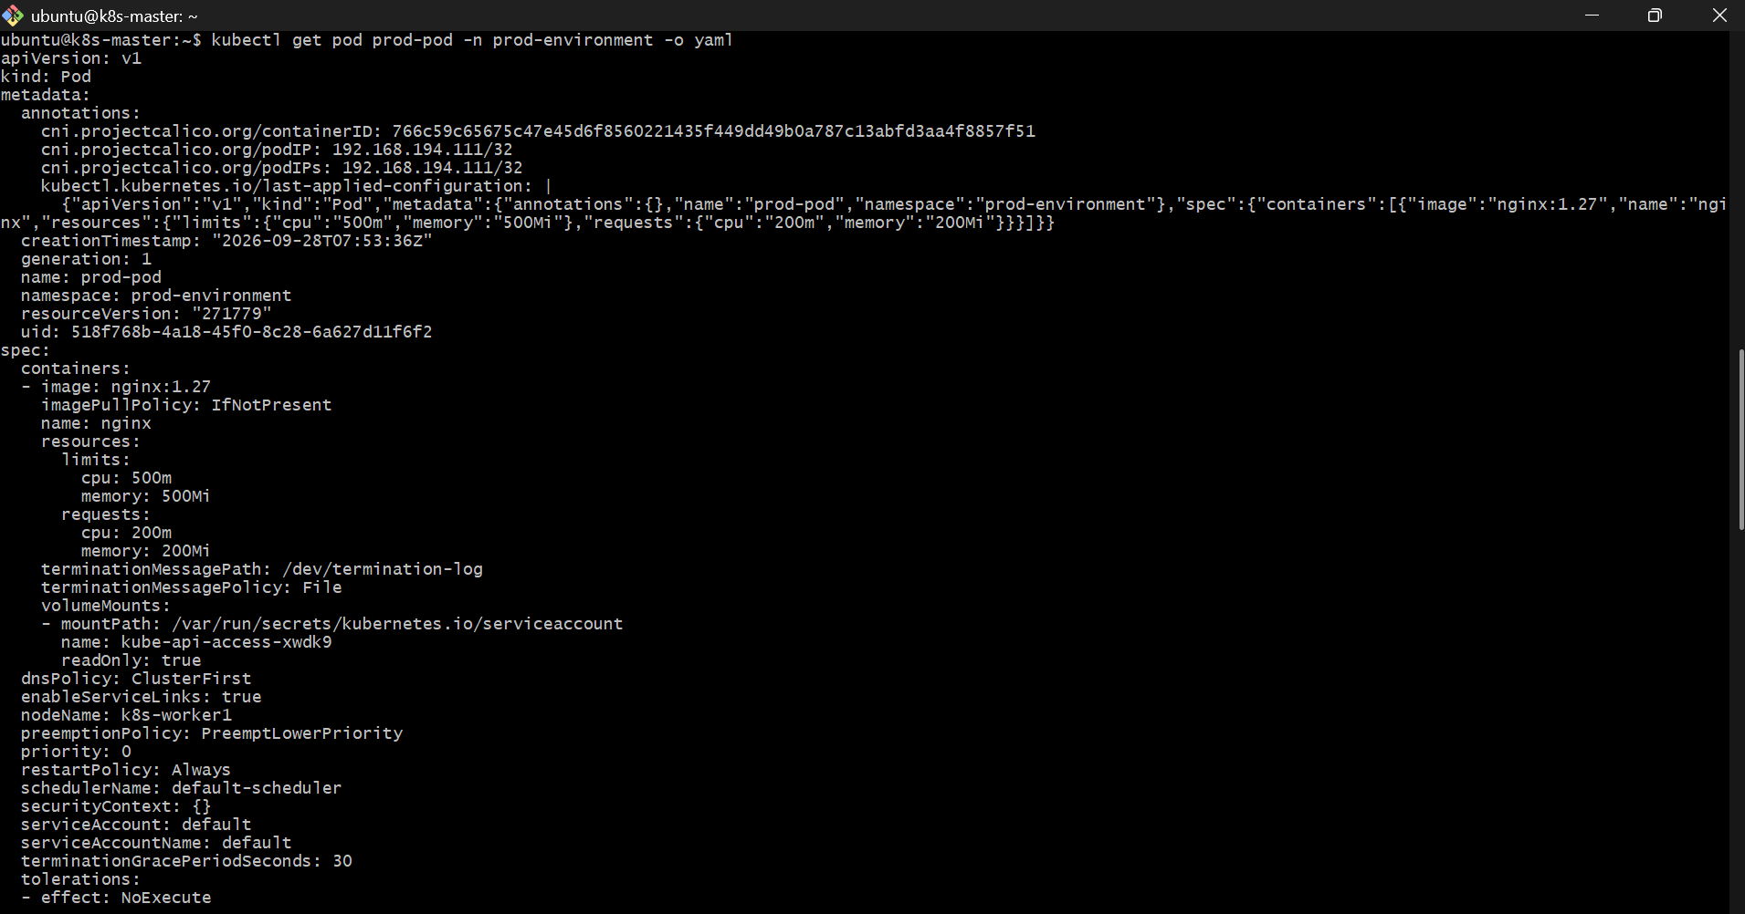
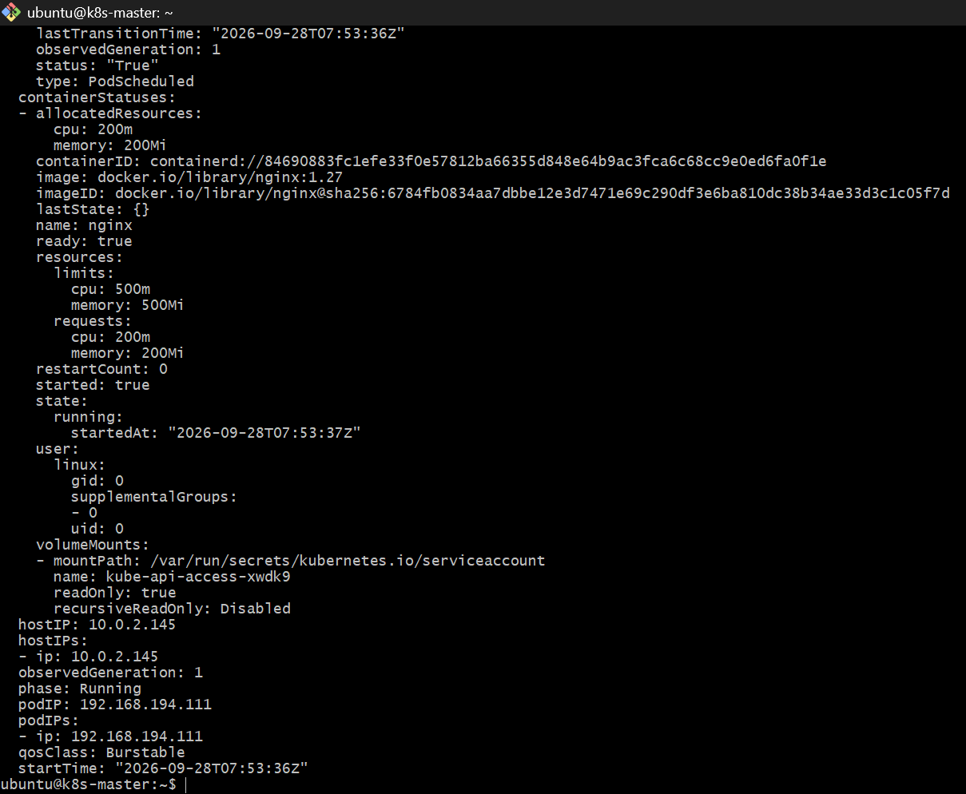
Task 3 — LimitRange in staging-environment
Objective
Create: staging-environment
Configure default:
- CPU limit = 300m
- Memory limit = 600Mi
- Minimum CPU
- Maximum CPU
Since your task doesn't specify the exact minimum/maximum CPU values, we'll use:
- Minimum CPU = 100m
- Maximum CPU = 500m
So the configuration is: min CPU = 100m
default CPU limit = 300m
max CPU = 500m
default memory limit = 600Mi
Step 1. Create namespace
kubectl create namespace staging-environment
Step 2. Create LimitRange
vi staging-limitrange.yml
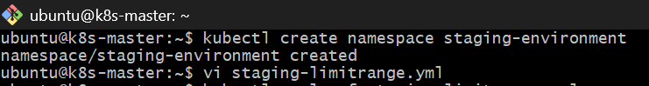
Add: apiVersion: v1
kind: LimitRange
metadata:
name: staging-limits
namespace: staging-environment
spec:
limits:
- type: Container
min:
cpu: "100m"
max: cpu: "500m"
default:
cpu: "300m"
memory: "600Mi"
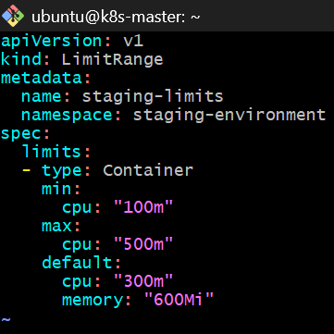
Apply: kubectl apply -f staging-limitrange.yml
Step 3. Verify
kubectl get limitrange -n staging-environment
Detailed: kubectl describe limitrange staging-limits -n staging-environment
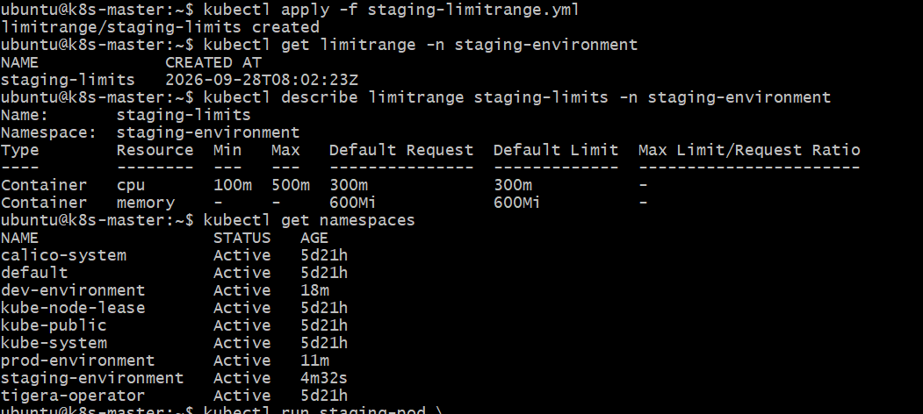
Step 4. Test the default limits
Create a pod without specifying resources: kubectl run staging-pod \
--image=nginx:1.27 \
-n staging-environment
Check: kubectl describe pod staging-pod -n staging-environment
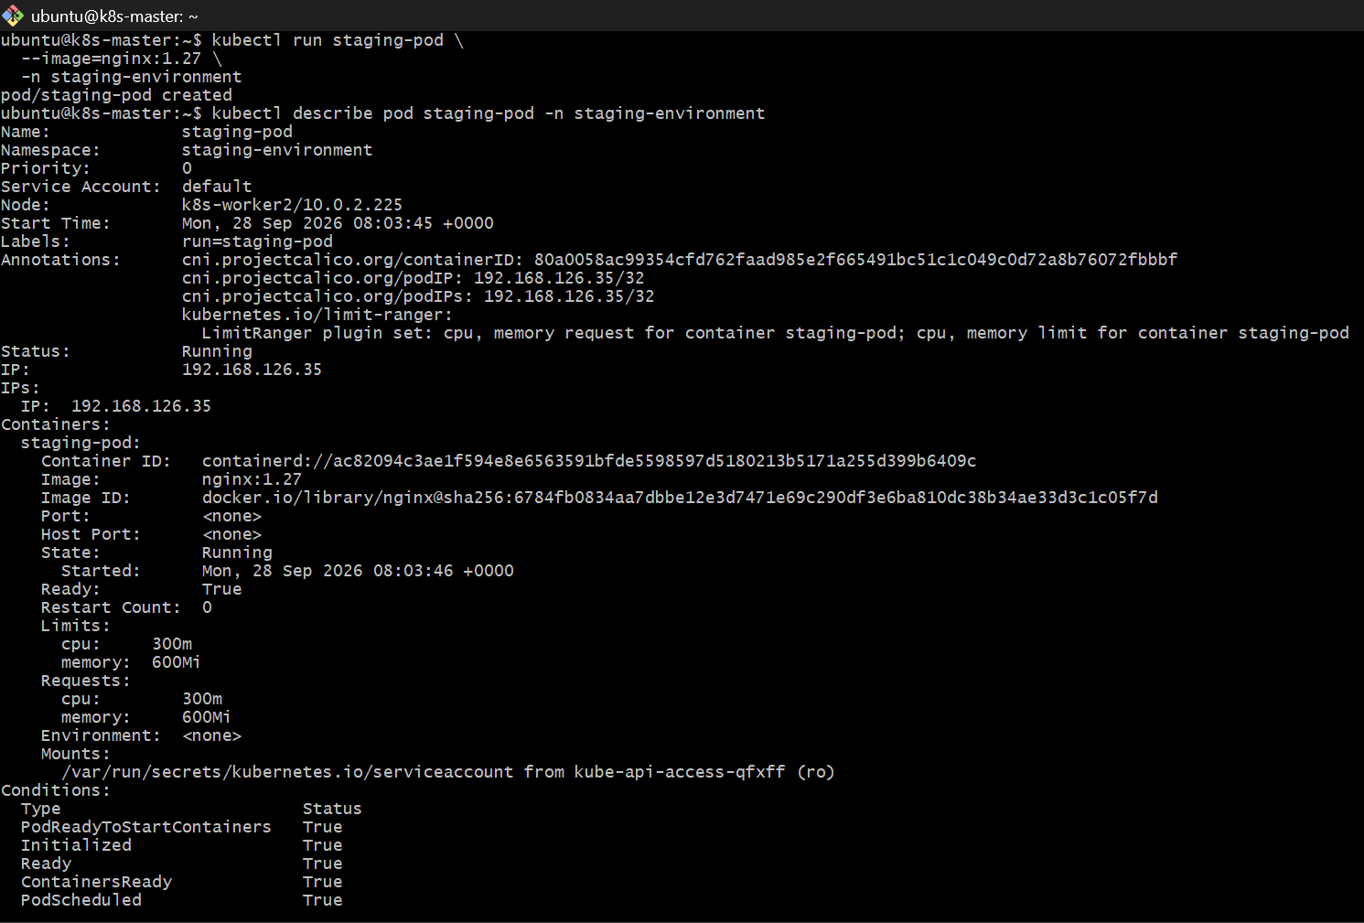The LimitRange should automatically assign:
CPU limit: 300m
Memory limit: 600Mi
You can verify directly: kubectl get pod staging-pod -n staging-environment -o yaml
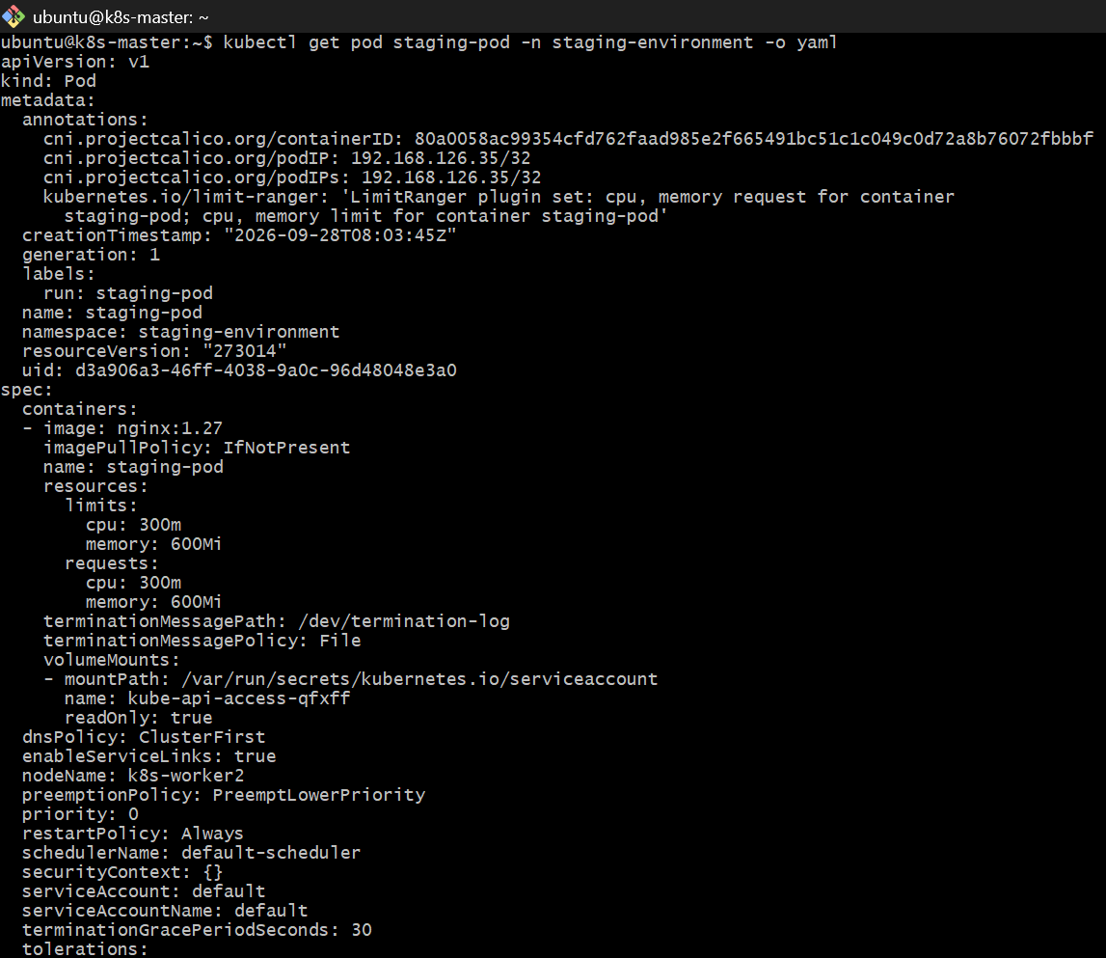
Important
default means automatically applied when the Pod doesn't specify a value.
min and max are validation boundaries.
For example, a container requesting: cpu: "50m"
should be rejected because: 50m < 100m
And: cpu: "600m"
should be rejected because: 600m > 500m
Done checkpoint
Task 4 — Pod + NodePort + Service DNS
This task demonstrates an important Kubernetes concept:
Services provide stable DNS names for Pods.
We'll create: default namespace
|
+-- nginx pod
|
+-- NodePort service
^
|
| DNS
|
test namespace
|
+-- test pod
Step 1. Create Pod in default namespace
kubectl run nginx-dns \
--image=nginx:1.27 \
--labels=app=nginx-dns
Verify: kubectl get pod -o wide
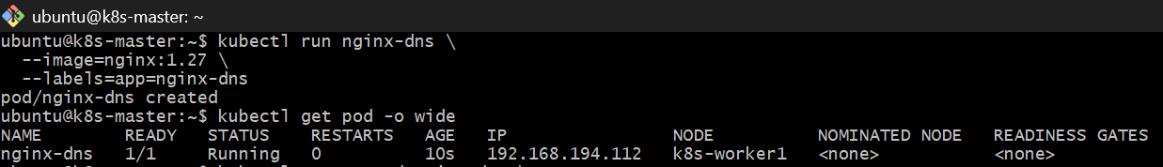Step 2. Create NodePort Service
kubectl expose pod nginx-dns \
--name=nginx-dns-service \
--port=80 \
--target-port=80 \
--type=NodePort
Verify: kubectl get svc nginx-dns-service
You should see something similar to:
NAME TYPE CLUSTER-IP EXTERNAL-IP PORT(S)
nginx-dns-service NodePort 10.x.x.x <none> 80:3xxxx/TCP
Check the endpoints: kubectl get endpoints nginx-dns-service
There should be an endpoint pointing to the nginx Pod.
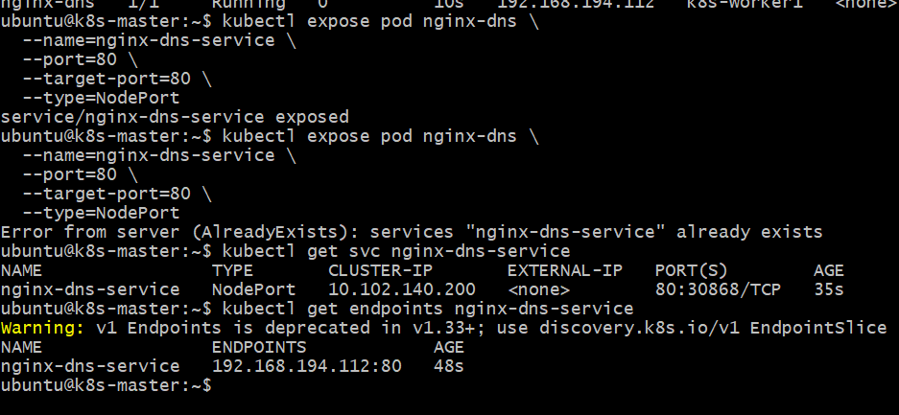Step 3. Create test namespace
kubectl create namespace test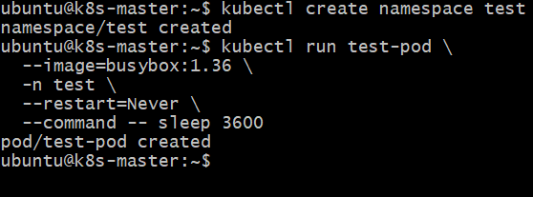Step 4. Create test Pod
We'll use BusyBox because it contains wget, which is useful for testing HTTP connectivity.
kubectl run test-pod \
--image=busybox:1.36 \
-n test \
--restart=Never \
--command -- sleep 3600
Verify: kubectl get pod -n test
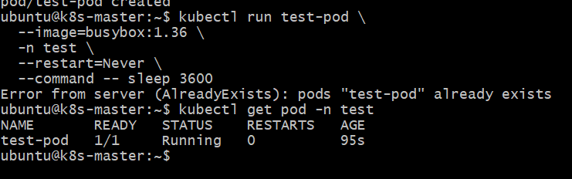Step 5. Test Service DNS
Now check the new Pod: kubectl get pod test-pod -n test -o wide
Then run the tests from k8s-master: kubectl exec -n test test-pod -- ping -c 3 192.168.126.35
kubectl exec -n test test-pod -- nslookup kubernetes.default.svc.cluster.local
One important point
The previous: worker1 host → 192.168.126.35
working does not prove that the SG change fixed Pod traffic. We specifically need: test-pod 192.168.194.x
↓
worker1
↓
worker2
↓
staging-pod 192.168.126.35
So let's test that from the newly recreated test-pod.
Don't make any more configuration changes yet. Paste the three outputs from k8s-master.
Run: kubectl exec -n test test-pod -- wget -qO- -T 5 http://nginx-dns-service.default.svc.cluster.local
You should receive nginx HTML output such as:
<!DOCTYPE html>
<html>
<head>
<title>Welcome to nginx!</title>
...
Why this works
Kubernetes DNS follows this general format: service-name.namespace.svc.cluster.local
Therefore: nginx-dns-service.default.svc.cluster.local
| |
| +---- namespace
|
+---------------------- service
Because the test Pod is in a different namespace, using only: nginx-dns-service
will normally search the test namespace.
So we explicitly use: nginx-dns-service.default.svc.cluster.local
Done checkpoint
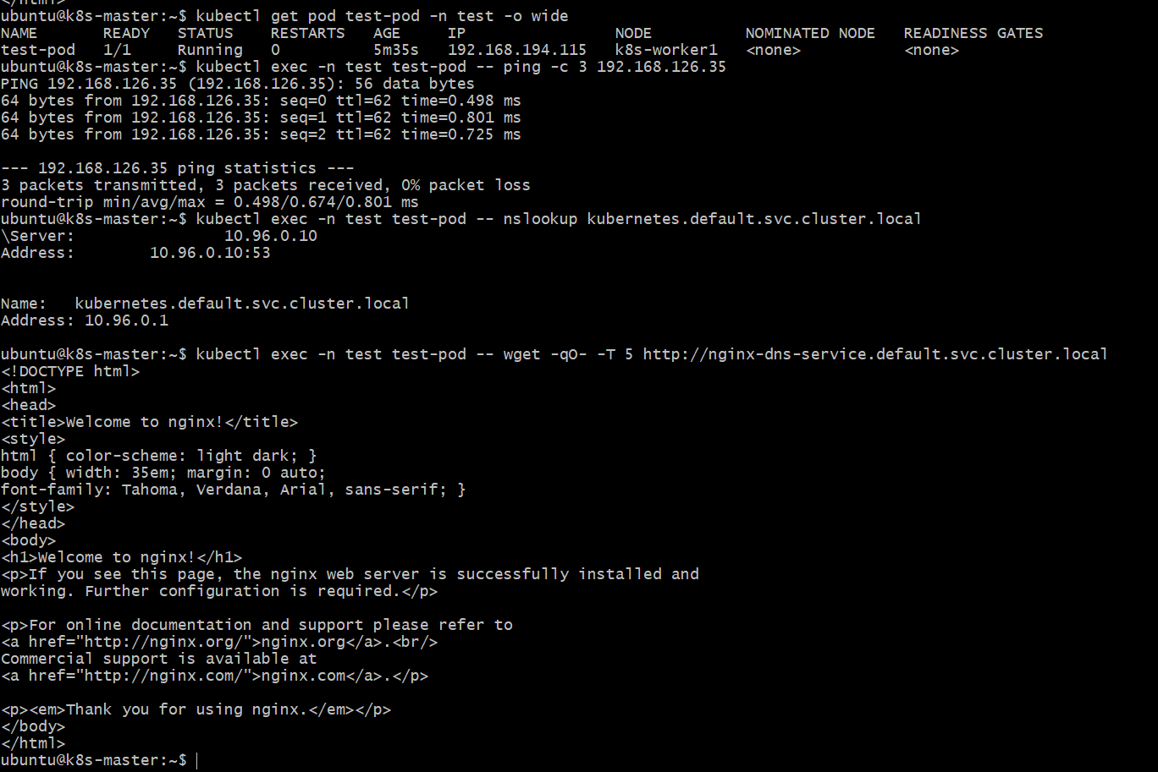
Task 5 — Memory Limit/Request Ratio
Objective: Learn how Kubernetes LimitRange can enforce a maximum ratio between a container's memory limit and memory request.
We will use namespace: performance-environment
The rule will be: maxLimitRequestRatio:
memory: "2"
So a container's memory limit cannot be more than 2× its memory request.
Step 5.1 — Create the namespace
Run on k8s-master: kubectl create namespace performance-environment
Verify:kubectl get namespace performance-environment
Expected: NAME STATUS AGE
performance-environment Active ...
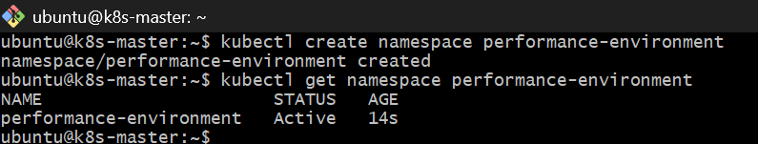
Step 5.2 — Create a LimitRange
Now create a LimitRange that enforces a maximum memory limit/request ratio of 2.
Run on k8s-master: cat > limit-range.yaml <<'EOF'
apiVersion: v1
kind: LimitRange
metadata:
name: memory-limit-range
namespace: performance-environment
spec:
limits:
- type: Container
maxLimitRequestRatio:
memory: "2"
EOF
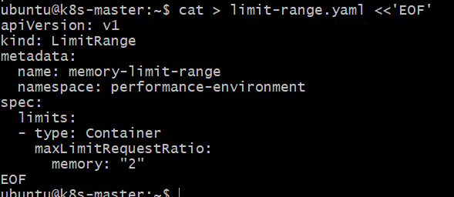
Apply it: kubectl apply -f limit-range.yaml
Verify: kubectl get limitrange -n performance-environment
Then inspect it: kubectl describe limitrange memory-limit-range -n performance-environment
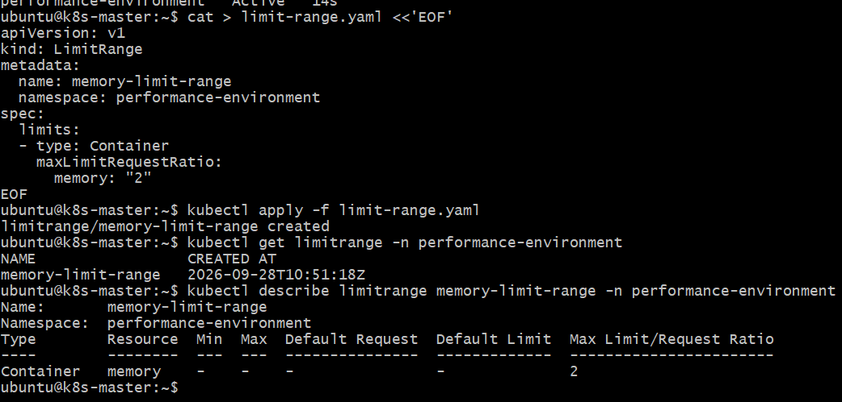
The LimitRange is correctly configured:
Resource: memory
Max Limit/Request Ratio: 2
This means: memory limit ≤ 2 × memory request
Step 5.3 — Create a valid Pod
Now we'll create a Pod that satisfies the LimitRange.
Run on k8s-master: cat > performance-pod.yaml <<'EOF'
apiVersion: v1
kind: Pod
metadata:
name: performance-pod
namespace: performance-environment
spec:
containers:
- name: nginx
image: nginx:latest
resources:
requests:
memory: "128Mi"
limits:
memory: "256Mi"
EOF
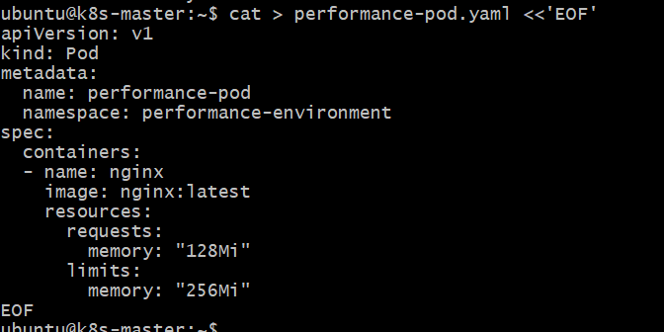
Apply it: kubectl apply -f performance-pod.yaml
Verify: kubectl get pod performance-pod -n performance-environment
Then: kubectl describe pod performance-pod -n performance-environment | grep -A8 -i "Limits"
Here: 128Mi request
256Mi limit
and: 256 / 128 = 2
So it is exactly at the allowed ratio.
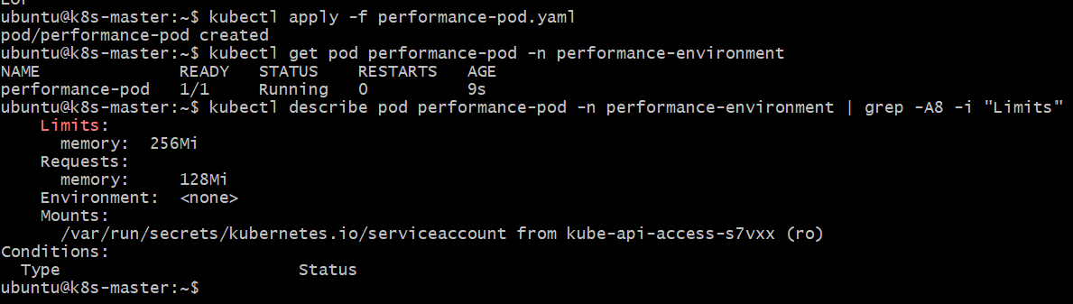
So it satisfies: Maximum Limit/Request Ratio = 2
Step 5.4 — Test an invalid Pod
Now we'll prove that the LimitRange actually rejects a Pod whose memory limit is more than 2× its request.
Create this test manifest: cat > invalid-performance-pod.yaml <<'EOF'
apiVersion: v1
kind: Pod
metadata:
name: invalid-performance-pod
namespace: performance-environment
spec:
containers:
- name: nginx
image: nginx:latest
resources:
requests:
memory: "128Mi"
limits:
memory: "512Mi"
EOF
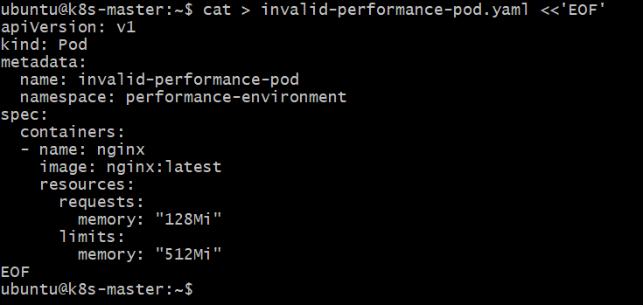
Here: 512Mi / 128Mi = 4
But our maximum is: 2
Now try to create it: kubectl apply -f invalid-performance-pod.yaml
Expected: Kubernetes should reject the Pod with an error similar to:
memory max limit to memory request ratio per Container is 2
Step 5.5 — Verify the namespace
Run: kubectl get pods -n performance-environment
Then: kubectl get limitrange -n performance-environment
We should see only: performance-pod
and the memory-limit-range.
performance-environment
├── LimitRange: memory-limit-range
│ └── maxLimitRequestRatio: memory = 2
│
└── Pod: performance-pod
├── Request: 128Mi
└── Limit: 256Mi
