Docker-01
Task 1 — Create Ubuntu EC2 Instance
Go to AWS Console → EC2 → Instances → Launch instance.
Use:
Setting | Value
Name | docker-lab
AMI | Ubuntu Server 24.04 LTS
Architecture | 64-bit
Instance type | t3.medium recommended
Key pair | Your existing .pem key
Network | Your VPC
Subnet | Public subnet
Auto-assign Public IP | Enable
Storage | 20 GiB gp3
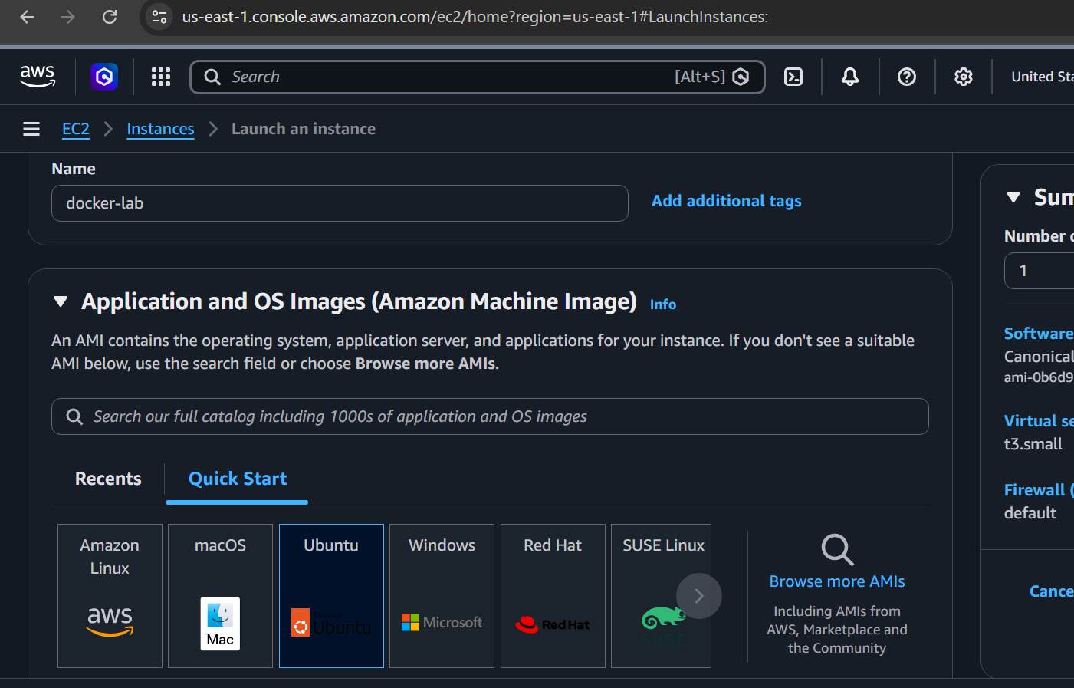
Security Group
For this lab, add:
Type | Port | Source
SSH | 22 | My IP
Custom TCP | 81 | My IP / 0.0.0.0/0
Custom TCP | 8080 | My IP
Port 81 is for Nginx.
Port 8080 will be used later for Jenkins.
For a real environment, don't expose Jenkins to 0.0.0.0/0; restrict it to your IP or use a load balancer/reverse proxy.Connect to Ubuntu
From your terminal: ssh -i your-key.pem ubuntu@<EC2-PUBLIC-IP>
Verify: whoami
Expected: ubuntu
Check OS: cat /etc/os-release
You should see Ubuntu information.
Check IP: hostname -I
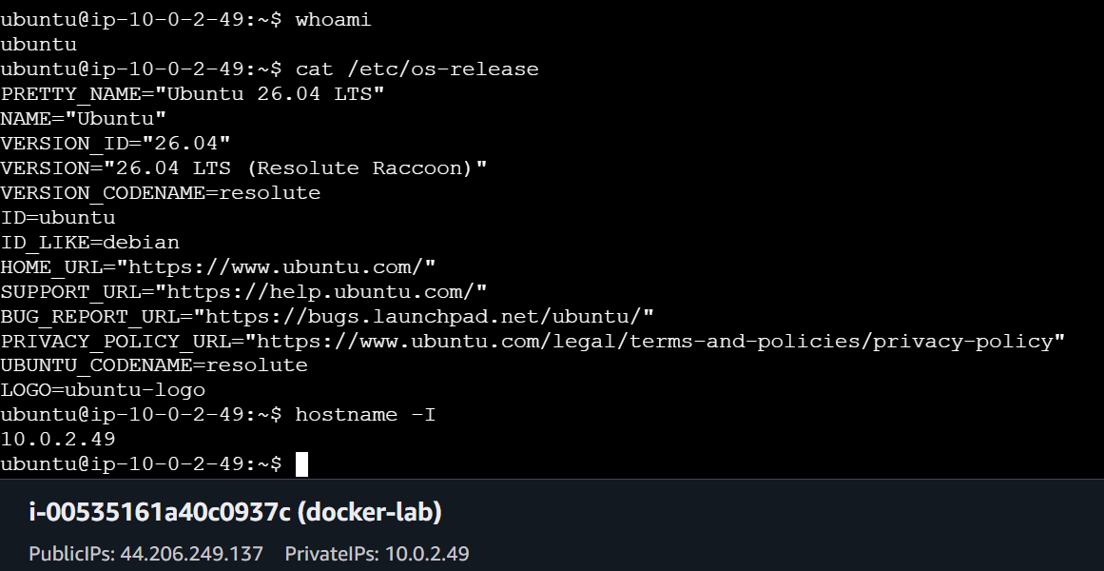
Task 2 — Install Docker
First update packages: sudo apt update
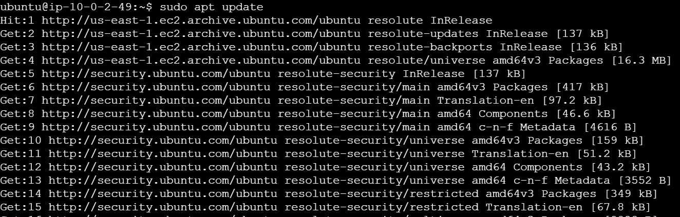
Install Docker: sudo apt install -y docker.io
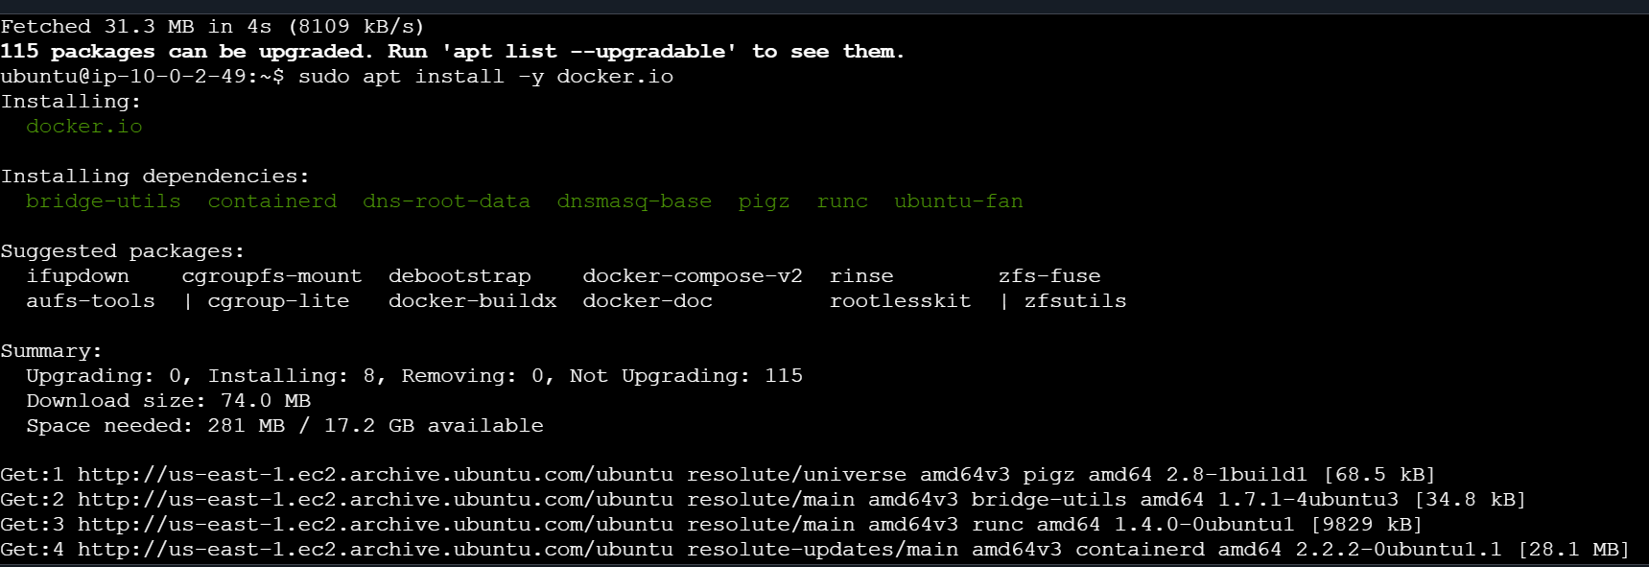
Check version: docker –version Example: Docker version 28.x.x
Start Docker: sudo systemctl start docker
Enable Docker at boot: sudo systemctl enable docker
Check service: sudo systemctl status docker
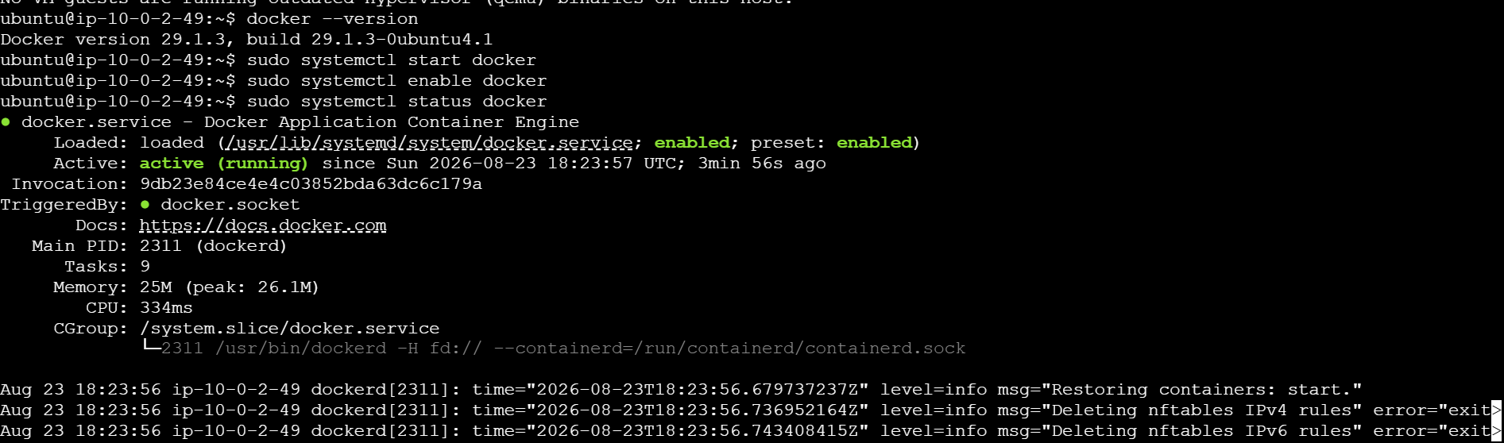

Allow Ubuntu user to run Docker without sudo
Run: sudo usermod -aG docker ubuntu
Then either log out and reconnect: exit
Reconnect: ssh -i your-key.pem ubuntu@<EC2-PUBLIC-IP>
Or run: newgrp docker
Test: docker ps
If it works without sudo, Docker is configured correctly.
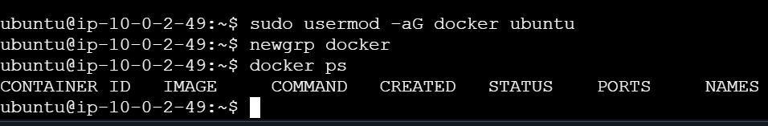Task 3 — Pull 5 Docker Images
We need:
- Nginx
- Apache Tomcat
- Ubuntu
- Jenkins
- SonarQube
1. Nginx - docker pull nginx
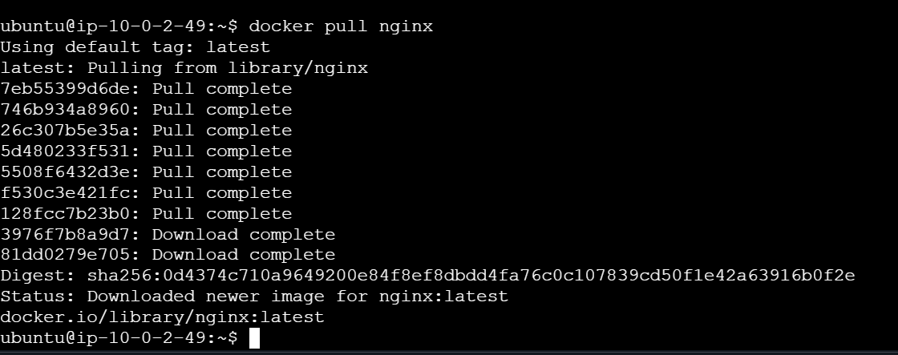
2. Tomcat - docker pull tomcat
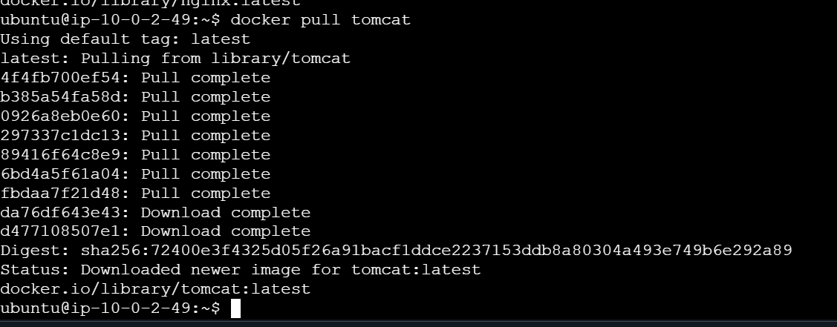
3. Ubuntu - docker pull ubuntu
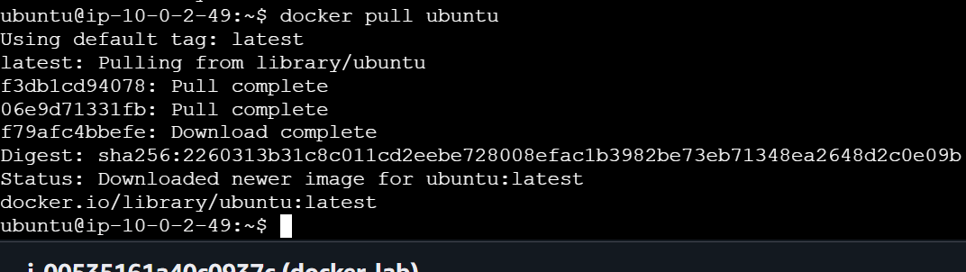
4. Jenkins
For Jenkins, use the LTS image: docker pull jenkins/jenkins:lts
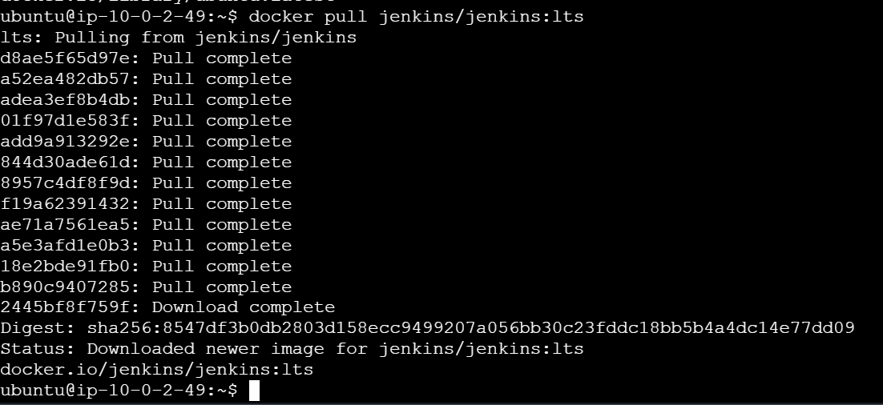

- SonarQube- docker pull sonarqube:lts-community
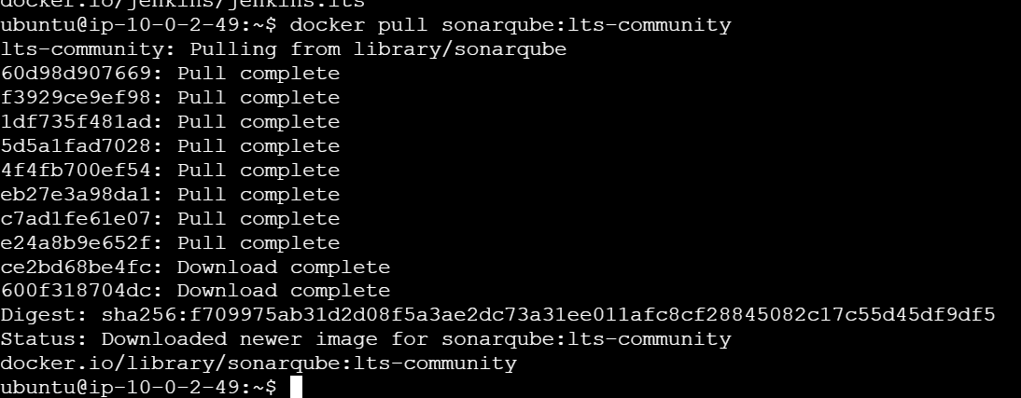
Now check all images: docker images
You should see something similar to:
REPOSITORY TAG
nginx latest
tomcat latest
ubuntu latest
jenkins/jenkins lts
sonarqube lts-community
Verify specifically - docker image ls
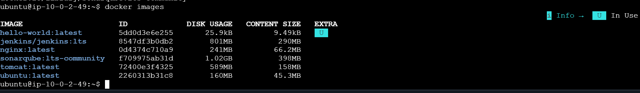Task 4 — Run Nginx on Port 81
Run: docker run -d --name nginx-container -p 81:80 nginx
Understand the port mapping: EC2 Port 81 ──────> Container Port 80
Check container: docker ps
You should see: nginx-container and: 0.0.0.0:81->80/tcp
Test from EC2- curl http://localhost:81
You should receive Nginx HTML output.
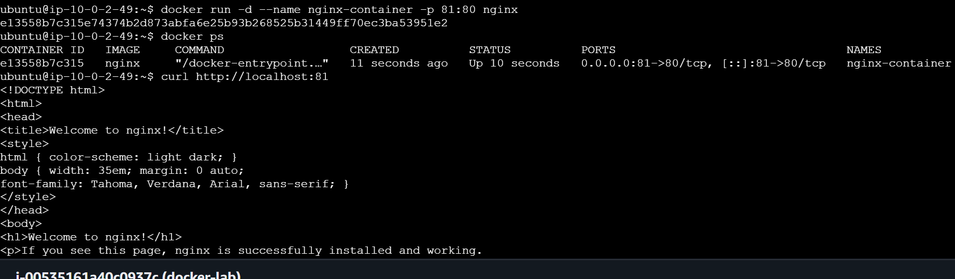
Test from your browser
Open: http://44.206.249.137:81/
You should get: Welcome to nginx!
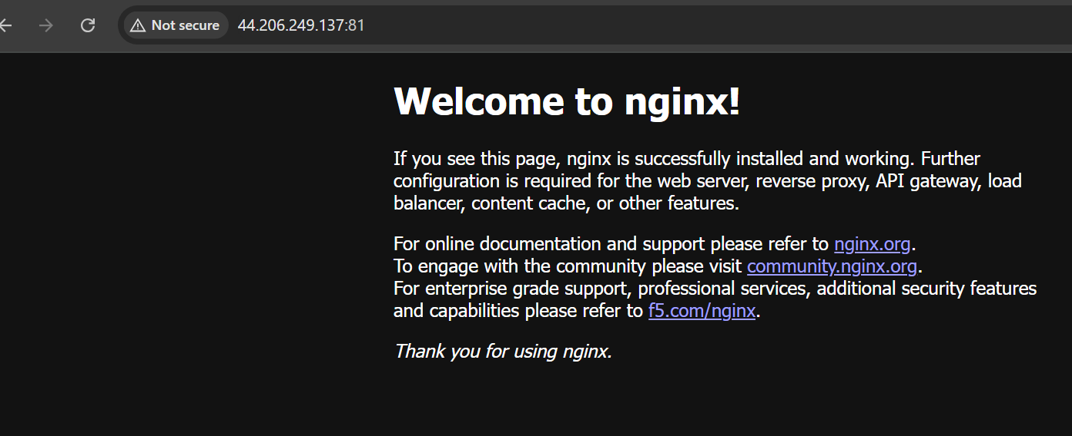
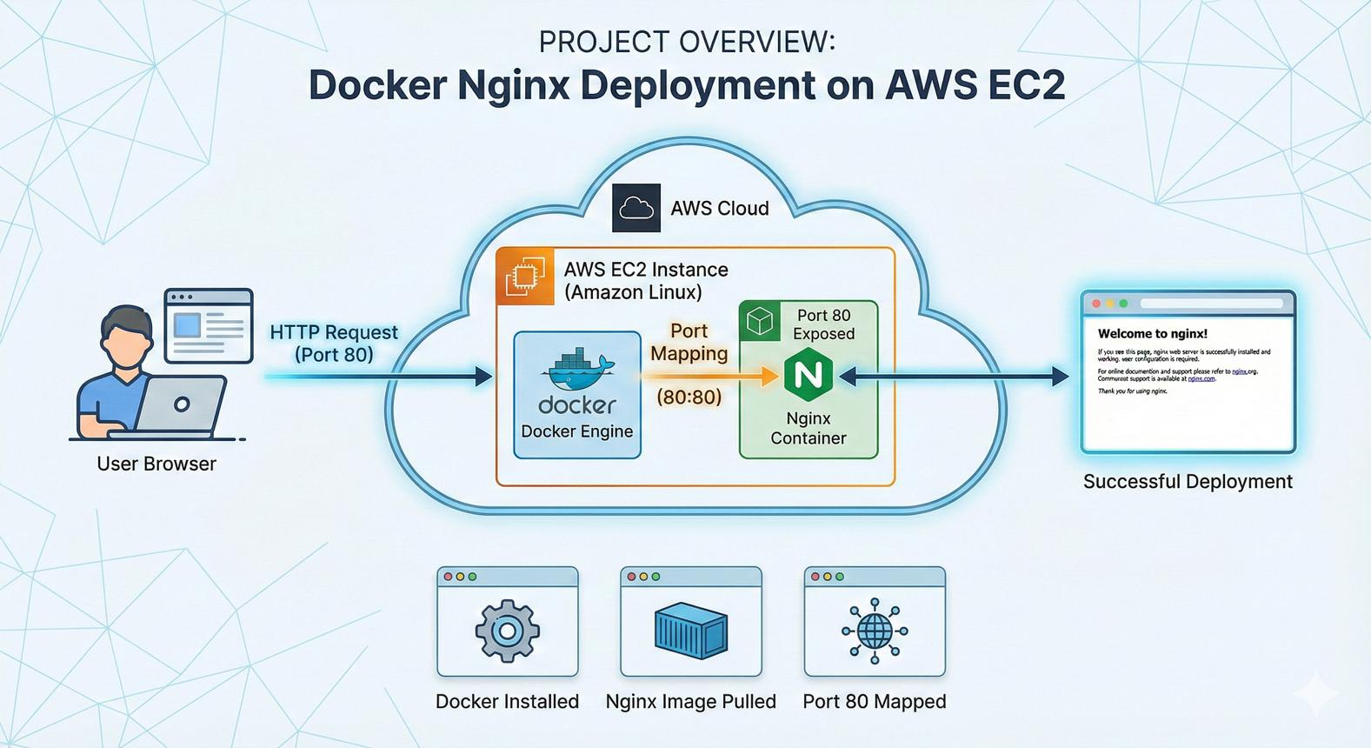
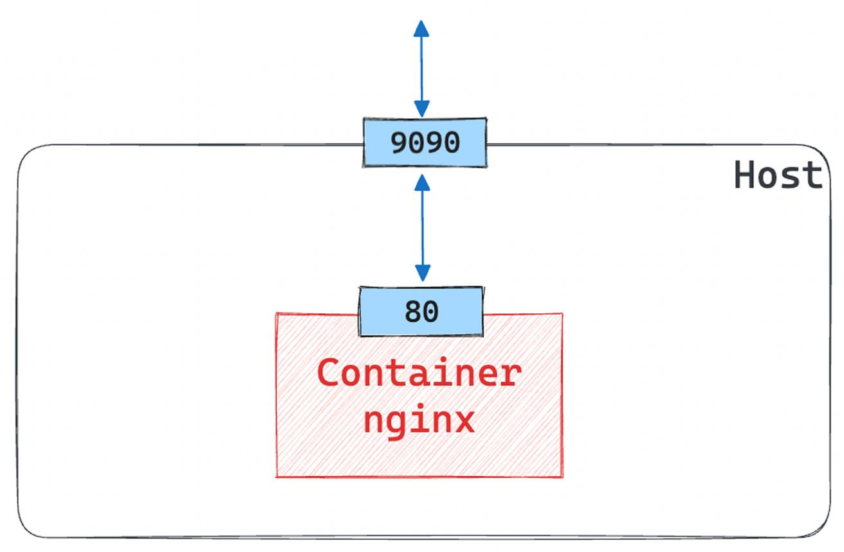
4.If it doesn't open, check the EC2 security group's inbound rule for TCP 81Task 5 — Delete Apache Tomcat Image
First verify that Tomcat exists: docker images tomcat
Remove it: docker rmi tomcat:latest
Verify: docker images
Tomcat should no longer appear.
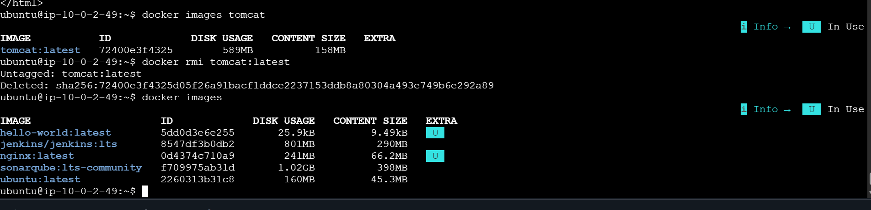
If Docker says image is being used
Check containers: docker ps -a
If you created a Tomcat container, remove the container first:
docker rm <container-id>
Then: docker rmi tomcat:latest
For this lab, since we're only pulling the image and not running Tomcat, normally: docker rmi tomcat:latest
is enough.Task 6 — Inspect Jenkins and SonarQube Images
This is an important Docker hands-on command.
Inspect Jenkins Run: docker image inspect jenkins/jenkins:lts
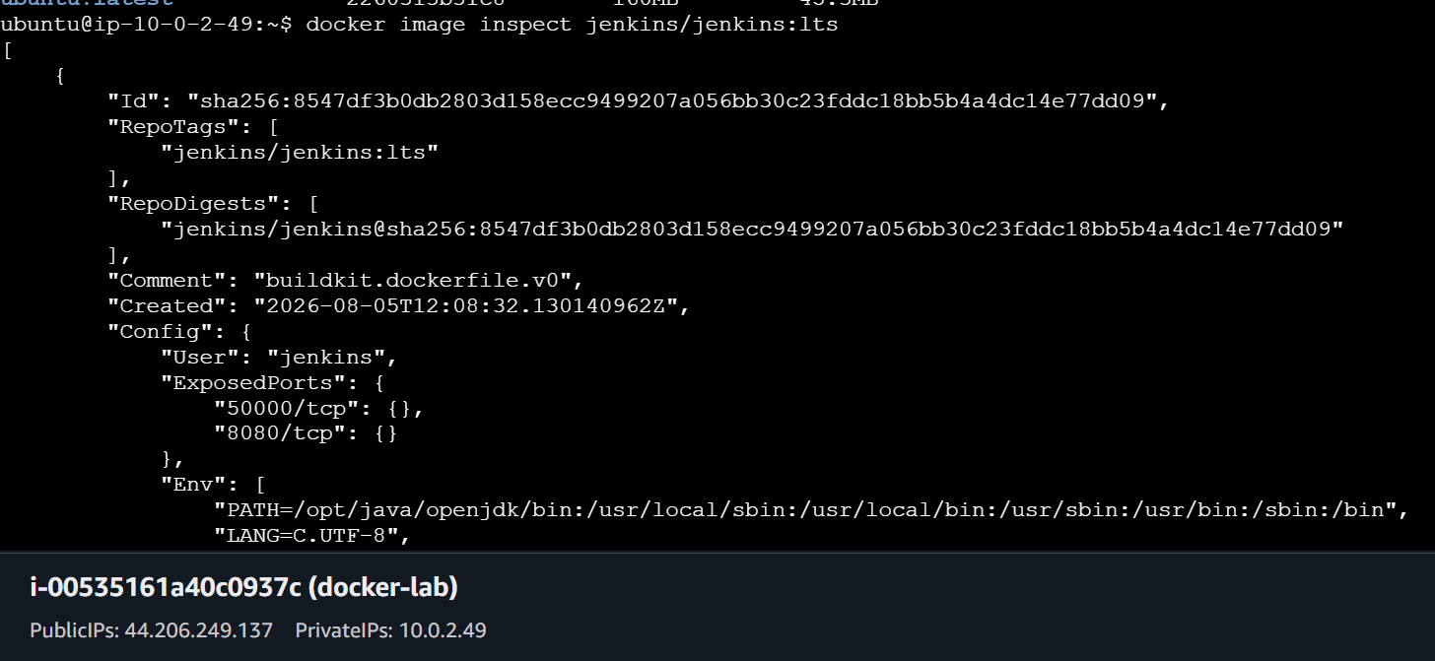
This produces a large JSON output.
Instead, you can use: docker image inspect jenkins/jenkins:lts | less
Important things to identify:
- Image ID
- Architecture
- OS
- Created date
- Entrypoint
- CMD
- Environment variables
- Exposed ports
- Volumes
- Working directory
Check exposed ports - docker image inspect jenkins/jenkins:lts \
--format='{{json .Config.ExposedPorts}}'
Check volumes - docker image inspect jenkins/jenkins:lts \
--format='{{json .Config.Volumes}}'
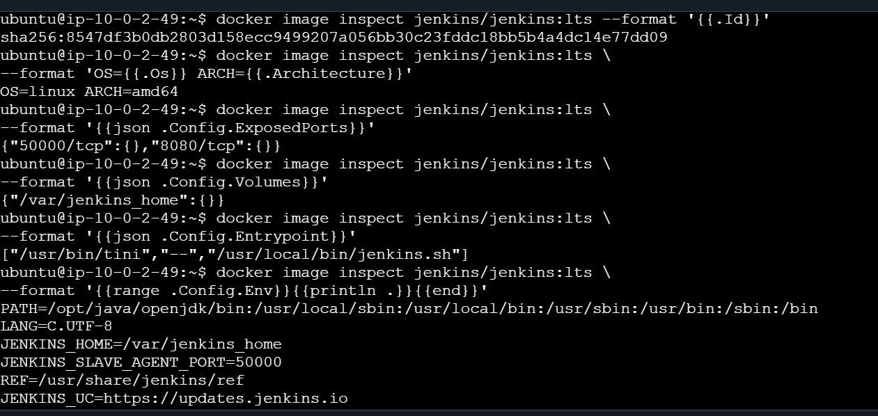

Inspect SonarQube
docker image inspect sonarqube:lts-community
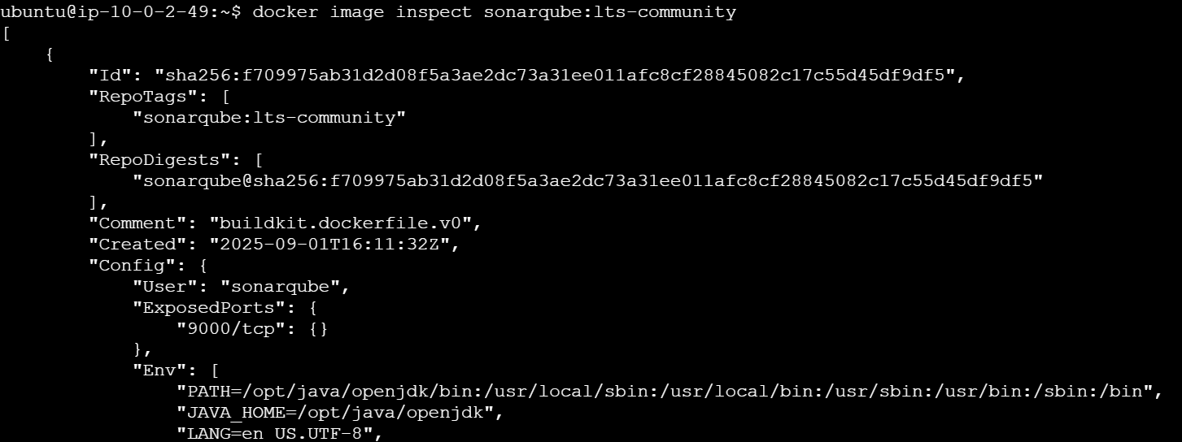
Check exposed ports: docker image inspect sonarqube:lts-community \
--format='{{json .Config.ExposedPorts}}'
You should see port 9000 exposed.
You can also check: docker image inspect sonarqube:lts-community \
--format='OS={{.Os}} ARCH={{.Architecture}}'
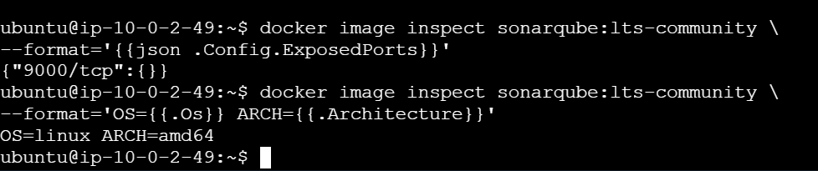

Task 7 — Run Jenkins Container
Now we'll run Jenkins.
First create a Docker volume: docker volume create jenkins_home
Verify: docker volume ls
Run Jenkins: docker run -d \
--name jenkins \
-p 8080:8080 \
-p 50000:50000 \
-v jenkins_home:/var/jenkins_home \
jenkins/jenkins:lts
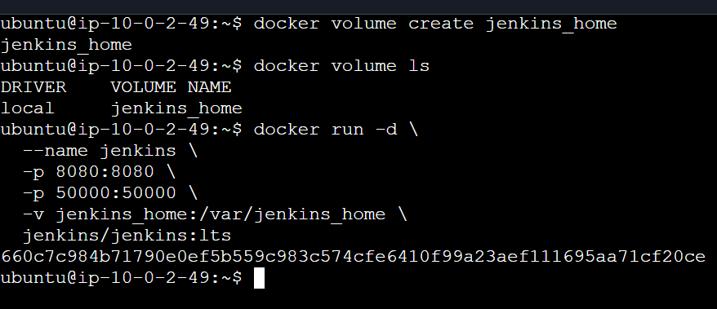
Check: docker ps
You should see: jenkins
with: 0.0.0.0:8080->8080/tcp
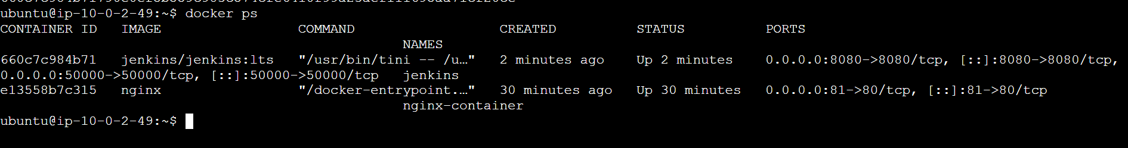

Get Jenkins Initial Admin Password
Run: docker exec jenkins cat /var/jenkins_home/secrets/initialAdminPassword
Copy the password.
Now open: http://44.206.249.137:8080
You should get the Jenkins unlock page.
Paste the initial password.
Choose:Install suggested plugins
Then create your Jenkins admin user.
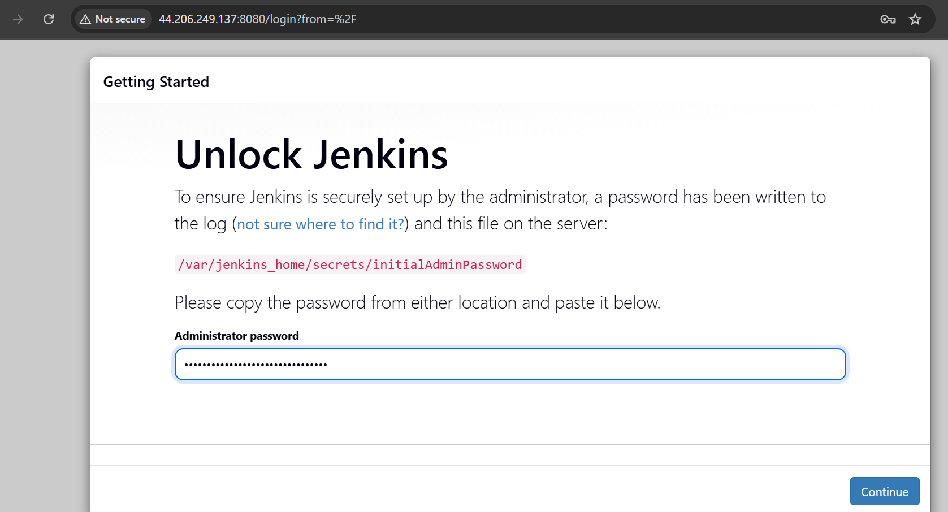
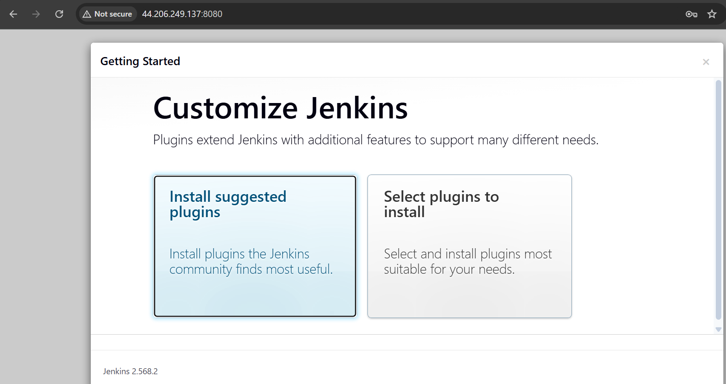
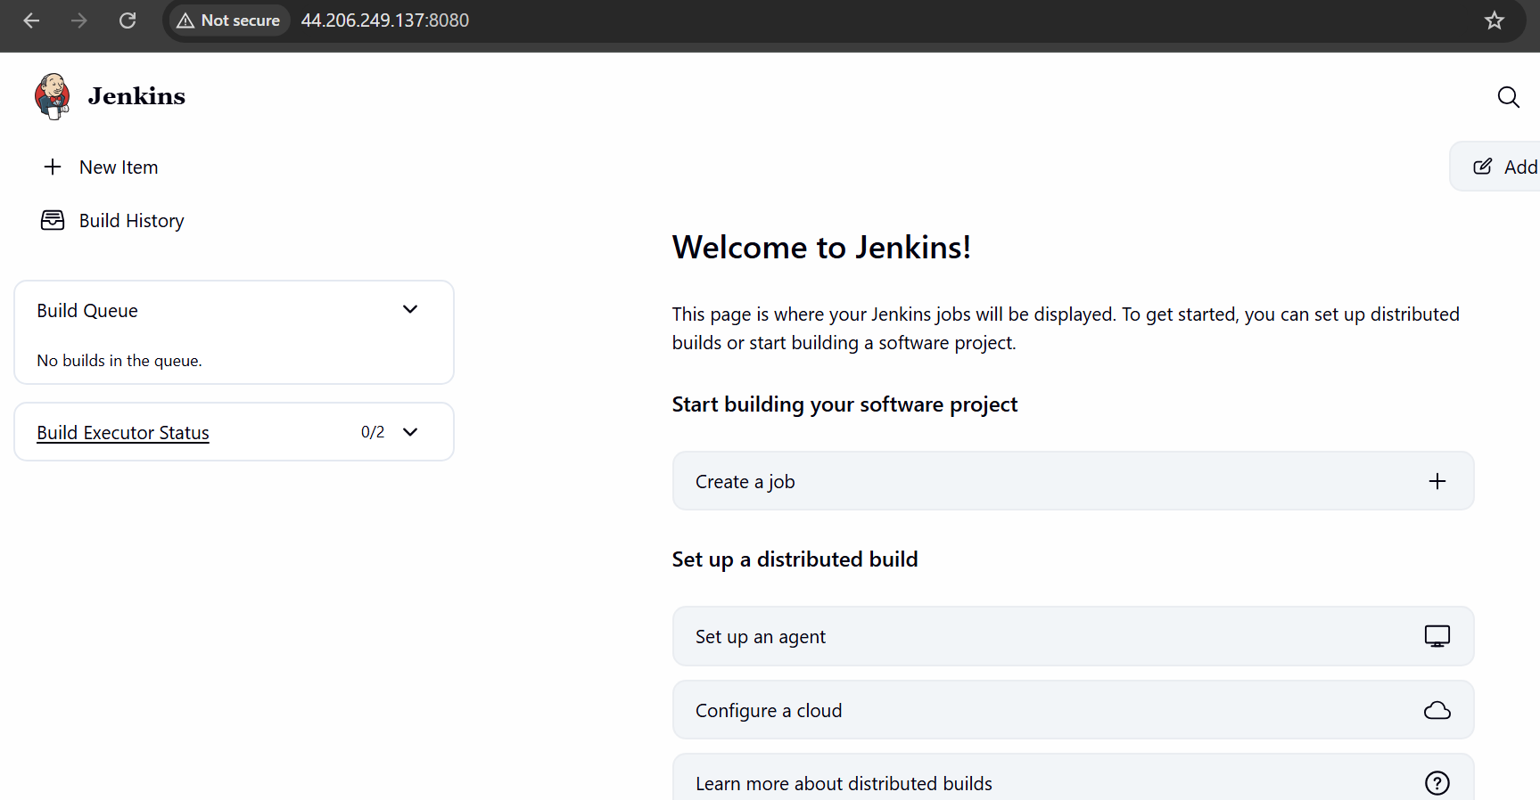

Create a Sample Jenkins Job
Once Jenkins is ready:
1. Click
New Item
2. Enter: Docker-Sample-Job
Choose: Freestyle project
Click: OK
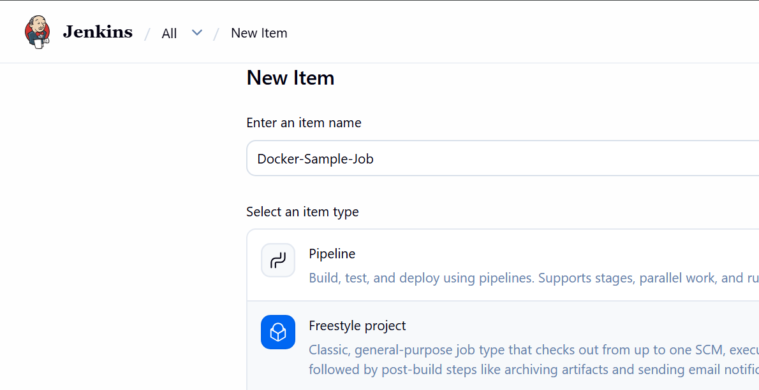
3. Add Build Step
Go to: Build → Add build step → Execute shell
Enter:
echo "================================="
echo "Hello from Jenkins Docker!"
echo "================================="
echo "Current date:"
date
echo "Hostname:"
hostname
echo "Jenkins workspace:"
pwd
echo "Files in workspace:"
ls -la
echo "Jenkins sample job completed successfully!"
Click: Save
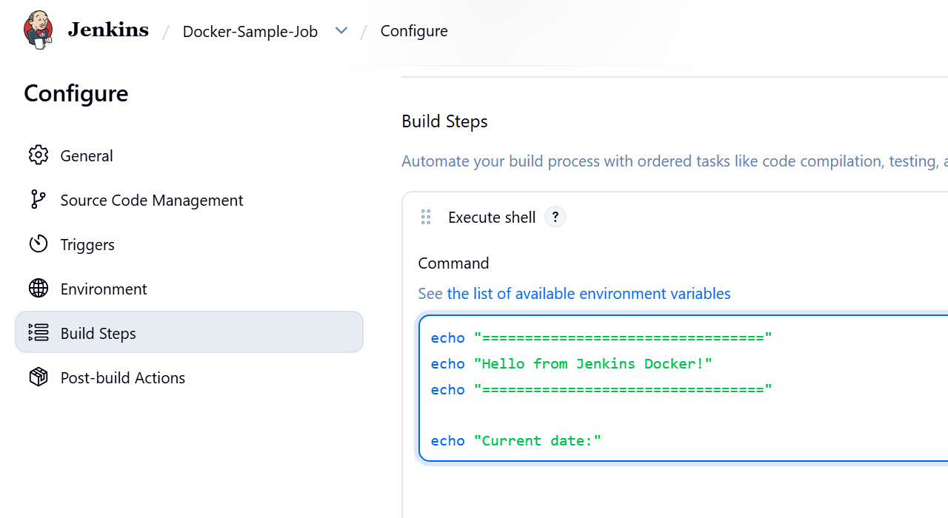
4. Run the job
Click: Build Now
You should see: Build #1
Click: Console Output
Expected output will look approximately like:
Hello from Jenkins Docker Container
Current date:
Sat Aug 22 ...
Hostname: xxxxxxxxxxxx
Jenkins workspace: /var/jenkins_home/workspace/Docker-Sample-Job
Finished: SUCCESS
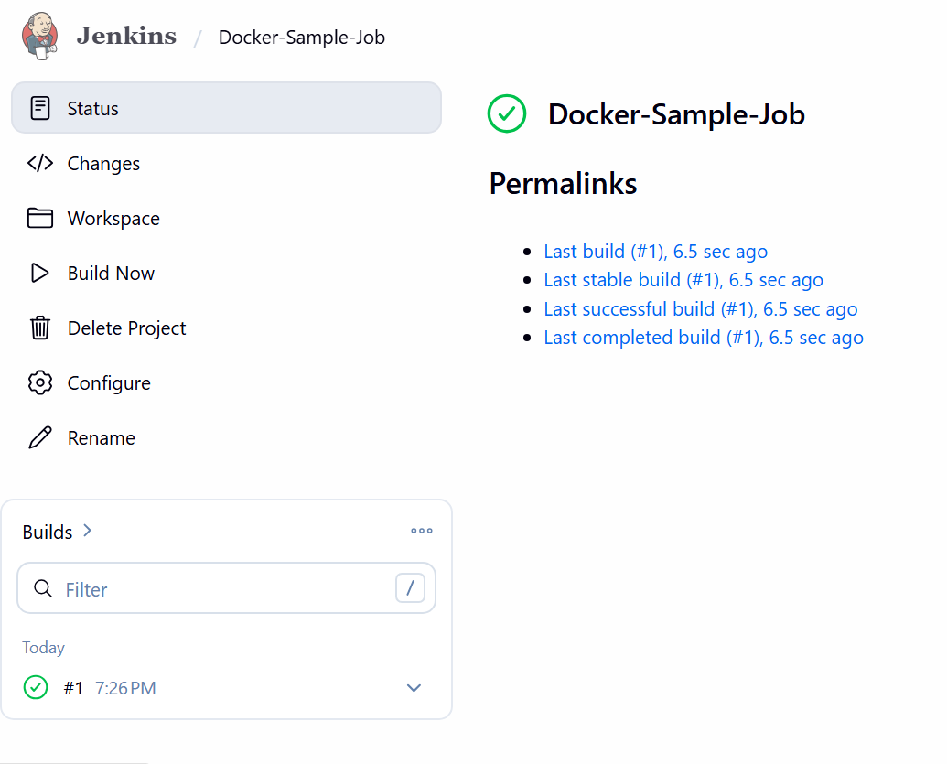

Final Verification
Run these commands on the EC2 instance: Docker version
docker --version
Docker service
sudo systemctl status docker --no-pager
Running containers docker ps
Expected: nginx-container
Jenkins
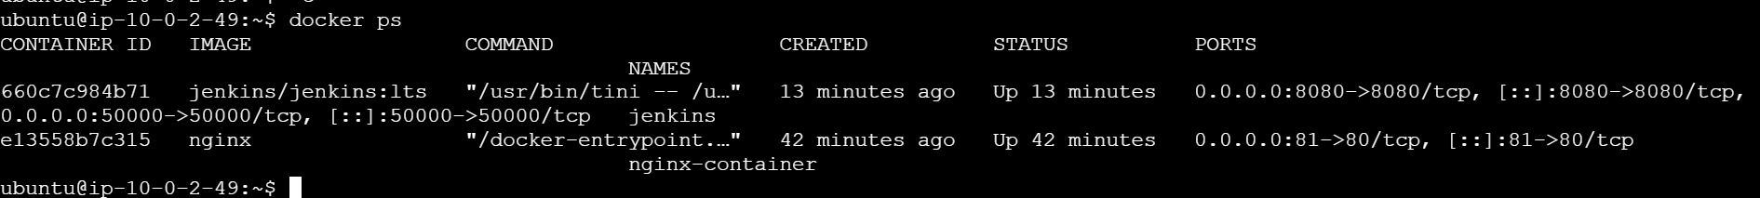
All images
docker images
Expected images:nginx
ubuntu
jenkins/jenkins
sonarqube
Tomcat should be deleted.
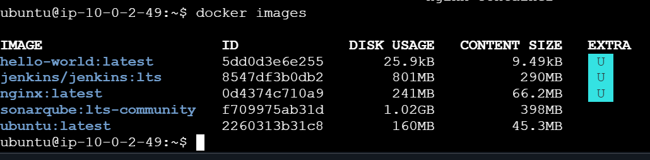
Volumes
docker volume ls
Expected: jenkins_home
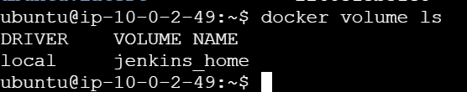

Docker Image → Container → Port Mapping → Volume → Docker Engine
For example:
Ubuntu EC2
│
Docker Engine
│
┌─────────────┼─────────────┐
│ │ │
Nginx Jenkins SonarQube
│ │ │
81:80 8080:8080 9000:9000
│ │
Browser Browser

Your final architecture is:
AWS EC2 Ubuntu
│
Docker Engine
│
┌────────────┴────────────┐
│ │
Nginx Container Jenkins Container
│ │
Port 80 Port 8080
│ │
EC2 :81 EC2 :8080
│ │
Browser Browser
│
Sample Job
│
Build #1
│
SUCCESS

And importantly:
- docker pull → downloads an image
- docker run → creates and starts a container
- docker ps → shows running containers
- docker ps -a → shows all containers
- docker images → shows local images
- docker rmi → removes an image
- docker exec → executes a command inside a running container
- docker inspect → displays detailed Docker object information
- -p 81:80 → maps EC2 port 81 → container port 80
- -v jenkins_home:/var/jenkins_home → persists Jenkins data outside the container

