Terraform-06.
1). Watch the Terraform-06 video.
2). Execute the script shown in the video.
1.Create folder structure
cd C:\Desktop\terraform-06
mkdir terraform-module
cd terraform-module
mkdir modules
mkdir modules\ec2
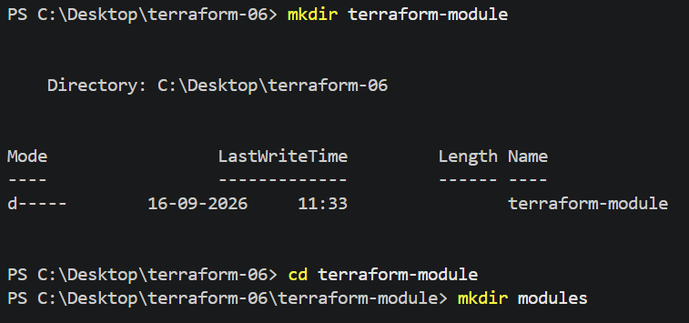
Structure:
terraform-module
│
├── main.tf
│
└── modules
└── ec2
└── main.tf
2. Create child module
modules/ec2/main.tf
resource "aws_instance" "web" {
ami = var.ami
instance_type = var.instance_type
key_name = var.key_name
subnet_id = var.subnet_id
tags = {
Name = var.name
}
}
variable "ami" {}
variable "instance_type" {}
variable "key_name" {}
variable "subnet_id" {}
variable "name" {}
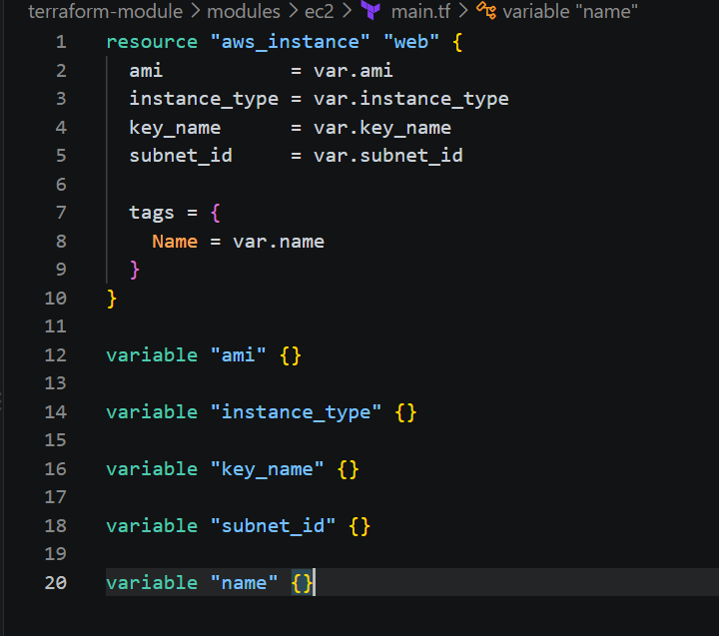
3. Call the module
Root main.tf:
provider "aws" {
region = "us-east-1"
}
module "ec2" {
source = "./modules/ec2"
ami = "ami-0bdc7d025135d7b49"
instance_type = "t3.small"
key_name = "jenkins"
subnet_id = "subnet-01f14bfb01c15b0cb"
name = "module-server"
}
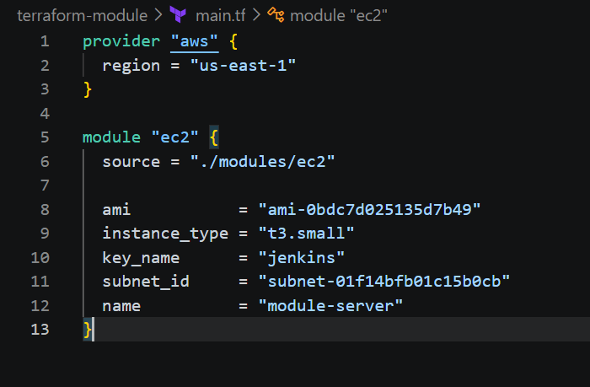
4. Initialize
terraform init
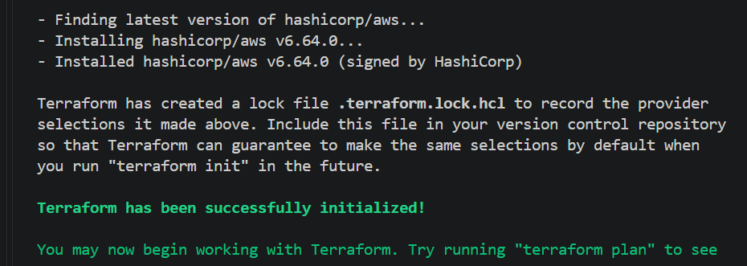
5. Validate
terraform validate
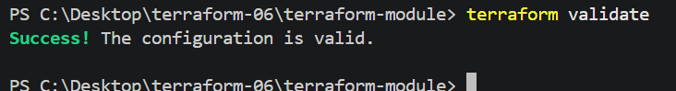
6. Plan
terraform plan
You should see: module.ec2.aws_instance.web
7. Create EC2
terraform apply
Enter: yes
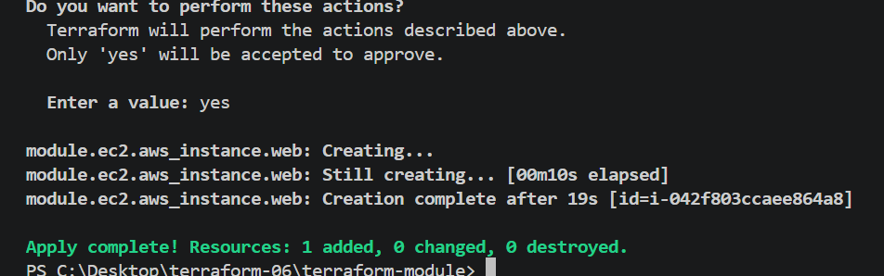
8. Verify :terraform state list
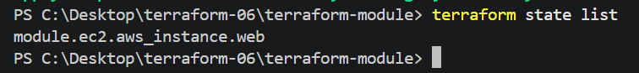
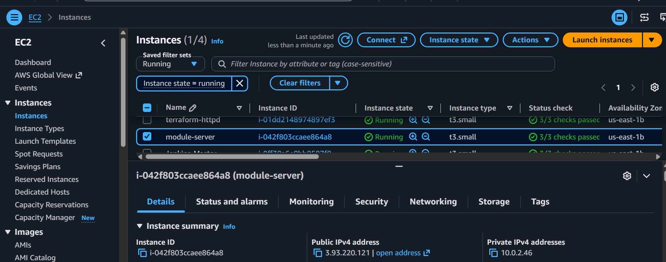
3). Provision EC2, S3, and VPC using Terraform modules.
Step 1: Create folder structure
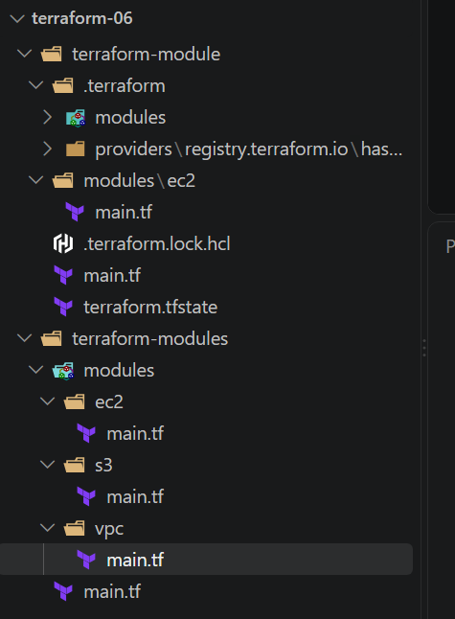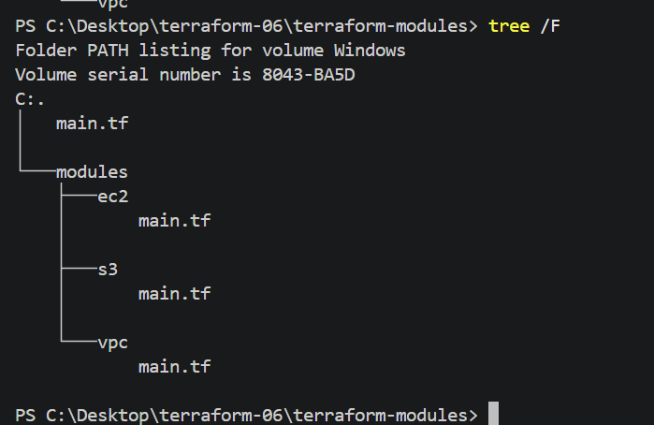
Step 2: Create EC2 module
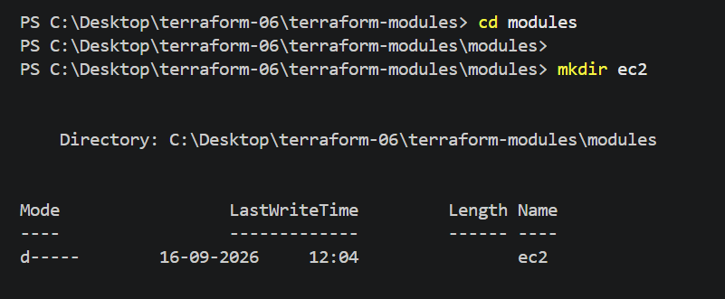
Open: modules/ec2/main.tf
Add: resource "aws_instance" "ec2" {
ami = "ami-0bdc7d025135d7b49"
instance_type = "t3.small"
key_name = "jenkins"
subnet_id = "subnet-01f14bfb01c15b0cb"
tags = {
Name = "module-ec2"
}
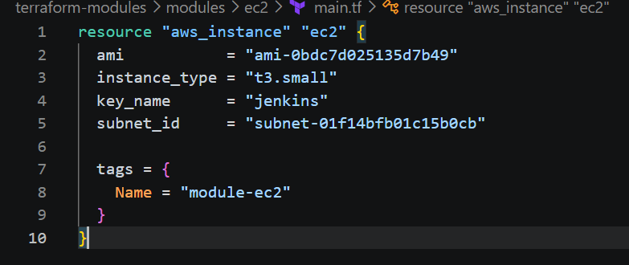
This module creates one EC2 instance.
Step 3: Create S3 module
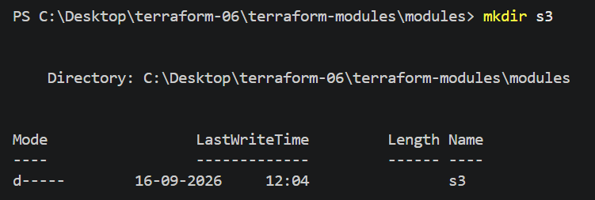
Open: modules/s3/main.tf
Add: resource "aws_s3_bucket" "bucket" {
bucket = "terraform-module-narayana-2026-0916"
}
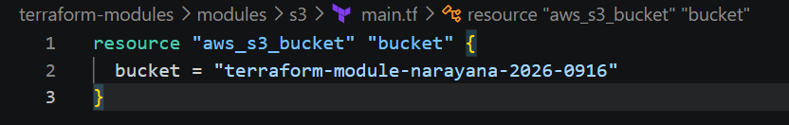
This module creates an S3 bucket.
S3 bucket names are globally unique. If this name already exists, change it.
Step 4: Create VPC module
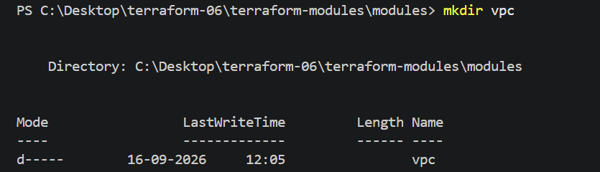
Open: modules/vpc/main.tf
Add: resource "aws_vpc" "vpc" {
cidr_block = "10.10.0.0/16"
tags = { Name = "module-vpc"
}
}
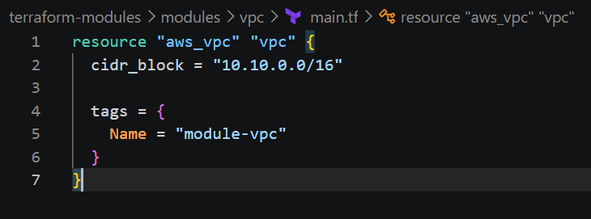
This module creates a VPC.
Step 5: Call the modules
Now open the root:
main.tf
Add: provider "aws" {
region = "us-east-1"
}
module "ec2" {
source = "./modules/ec2"
}
module "s3" {
source = "./modules/s3"
}
module "vpc" {
source = "./modules/vpc"
}
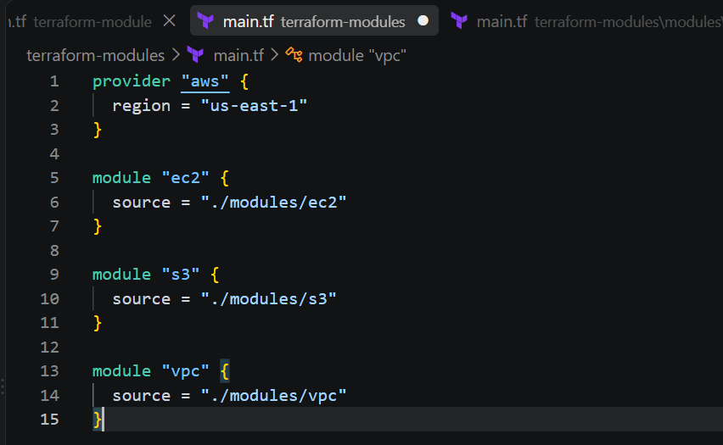
Step 6: Initialize Terraform
From the terraform-modules folder:
terraform init
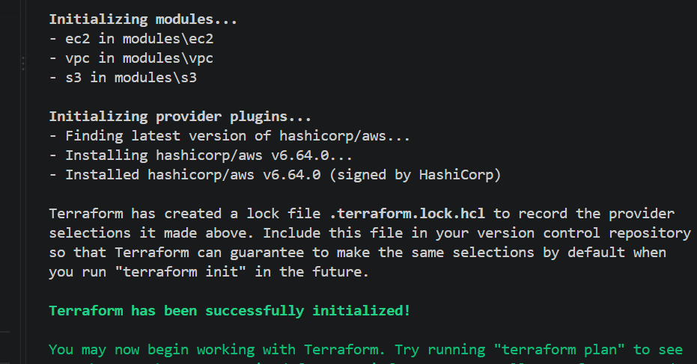
Terraform has been successfully initialized!
Step 7: Validate
terraform validate
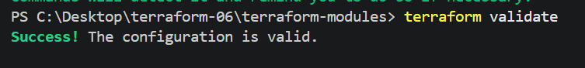
Expected: Success! The configuration is valid.
Step 8: Plan
terraform plan
Terraform should show resources for:
EC2
S3
VPC
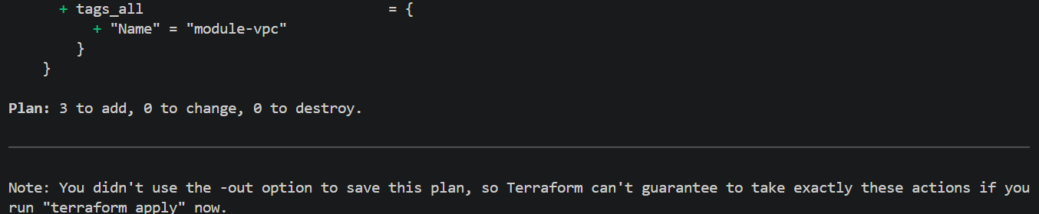
Step 9: Apply
terraform apply
Enter: yes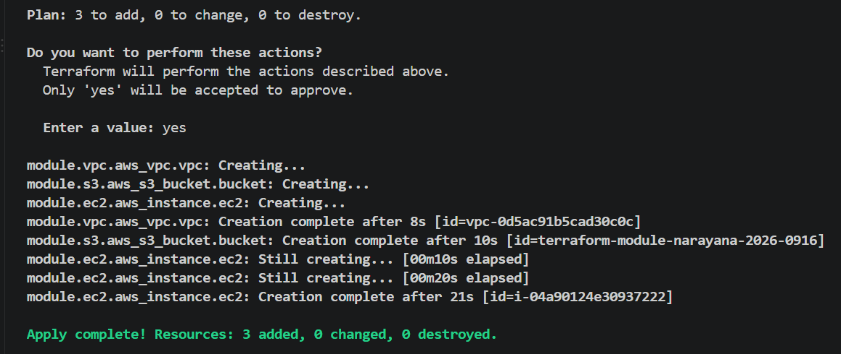
Terraform will create:
EC2
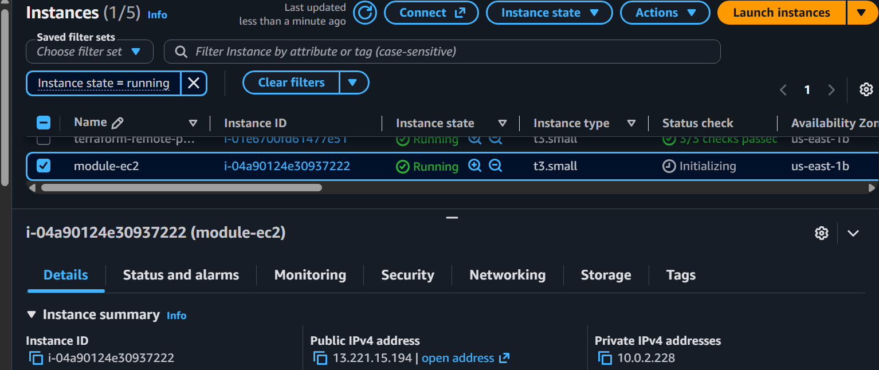
S3 Bucket
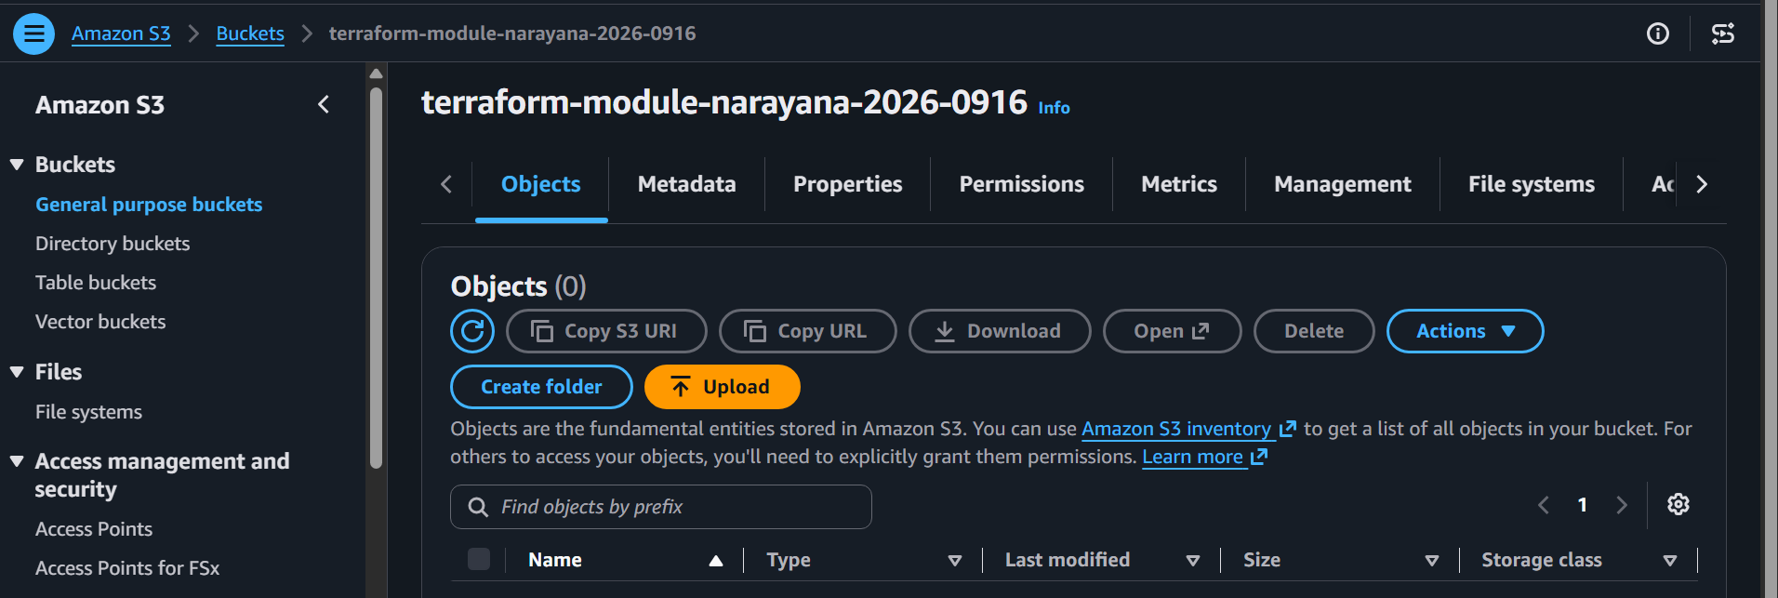
VPC
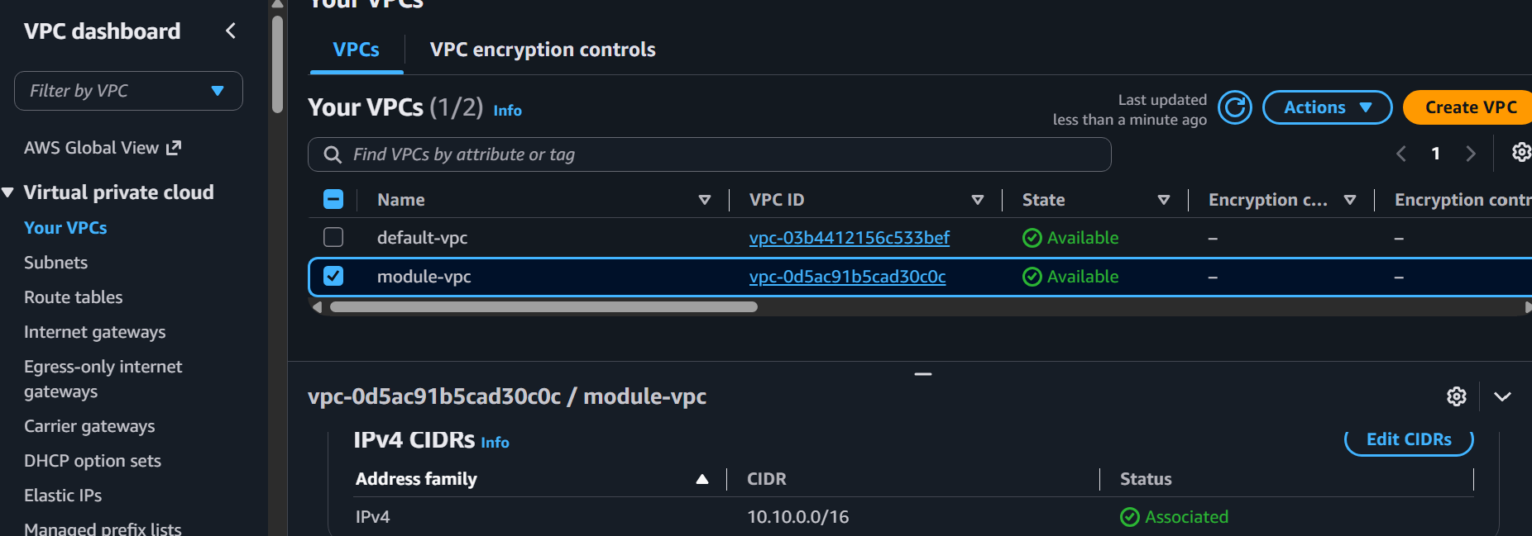
Step 10: Verify
Run: terraform state list
You should see: module.ec2.aws_instance.ec2
module.s3.aws_s3_bucket.bucket
module.vpc.aws_vpc.vpc
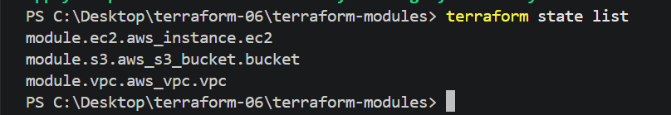
Simple flow to remember for exam
main.tf
↓
calls modules
↓
EC2 module → creates EC2
S3 module → creates S3
VPC module → creates VPC
Definition for interview/exam: A Terraform module is a reusable collection of Terraform configuration files used to organize
and reuse infrastructure code.
4). Provision EC2 for 3 different environments (Dev, Staging, and Prod) using Terraform
workspaces.
1. Create folder
cd C:\Desktop\terraform-06
Create: terraform-workspace
└── main.tf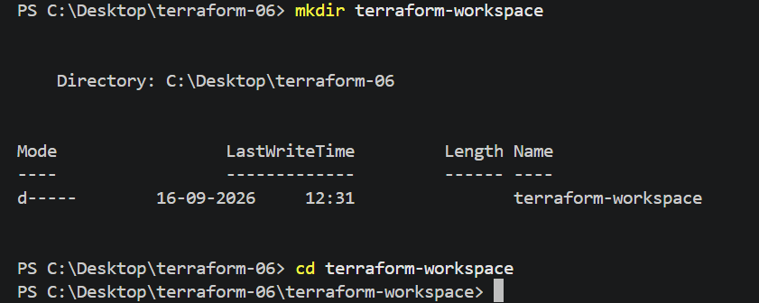
2. Add main.tf
provider "aws" {
region = "us-east-1"
}
locals { instance_type = {
dev = "t3.micro"
staging = "t3.small"
prod = " c7i-flex.large"
}
}
resource "aws_instance" "web" {
ami = "ami-0bdc7d025135d7b49"
instance_type = local.instance_type[terraform.workspace]
key_name = "jenkins"
subnet_id = "subnet-01f14bfb01c15b0cb"
tags = { Name = "${terraform.workspace}-server"
}
}
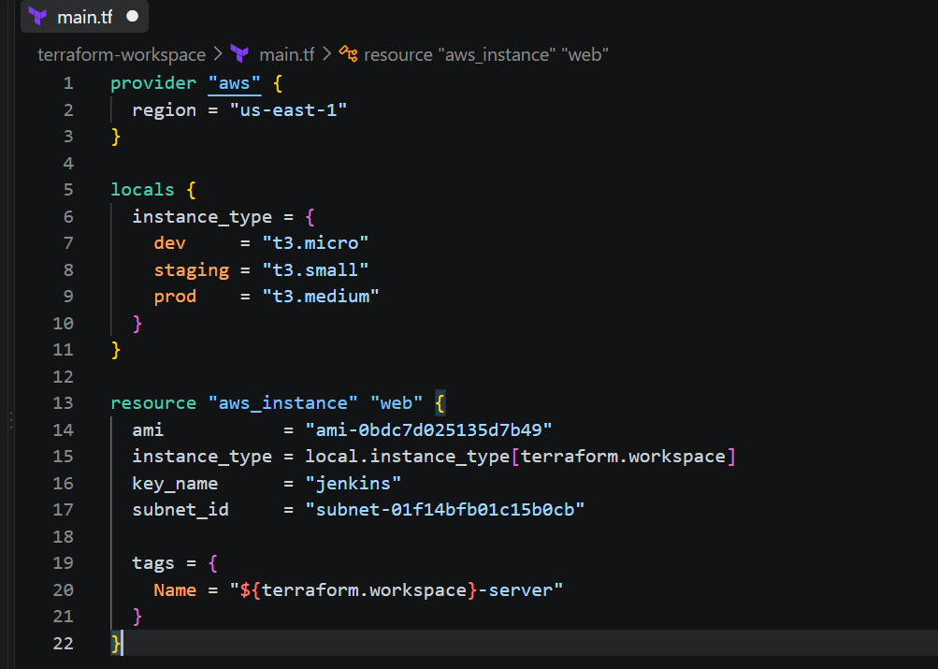
3. Initialize
PS C:\Desktop\terraform-06\terraform-workspace>
terraform init
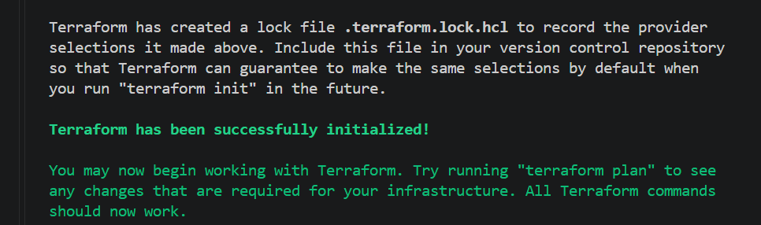
terraform validate
4. Dev
terraform workspace new dev
terraform workspace show
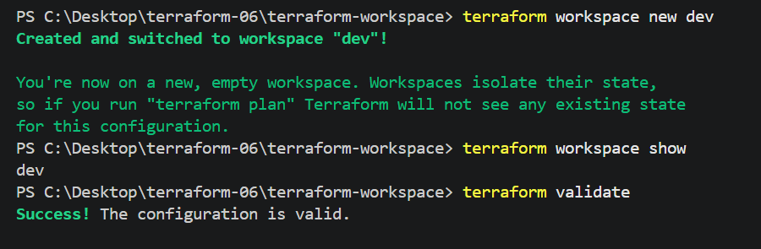
terraform plan
terraform apply
Enter: yes
Creates: dev-server
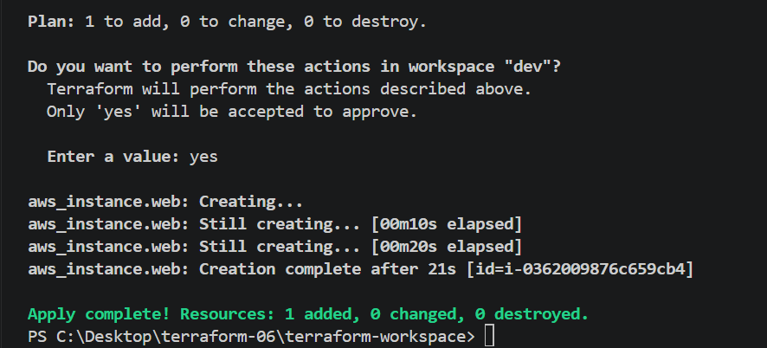
5. Staging
terraform workspace new staging
terraform workspace show
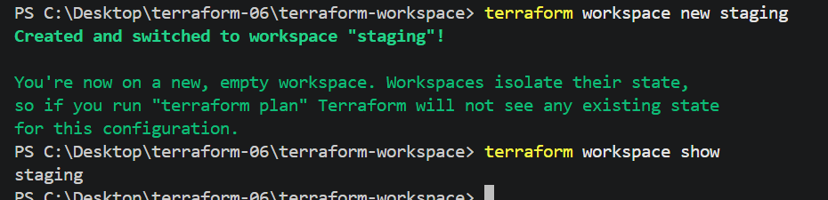
terraform plan
terraform apply
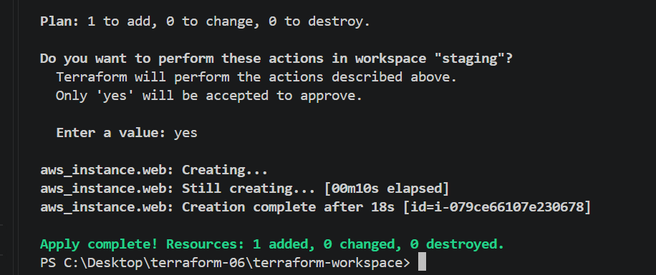
Creates: staging-server
6. Prod
terraform workspace new prod
terraform workspace show
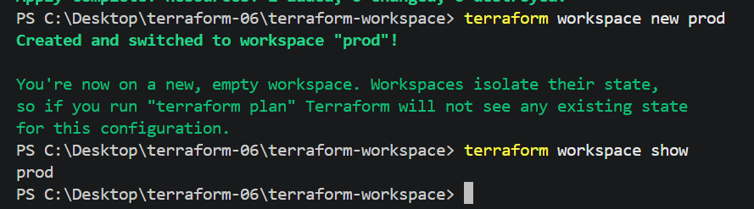
terraform plan
terraform apply
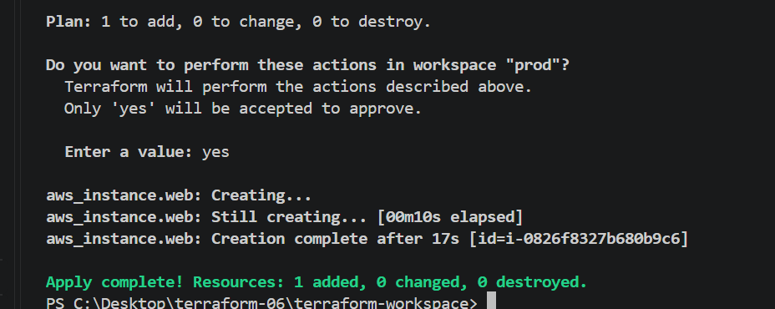
Creates: prod-server
7. Verify workspaces
terraform workspace list
Expected: default
dev
staging
* prod
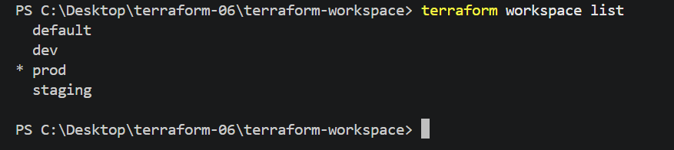
8. Verify AWS
EC2 should show:
dev-server
staging-server
prod-server
Key point: Same main.tf + separate workspaces = separate environment states.
