Docker-02
Prerequisites / EC2 setup
Part 1 — Create a separate Amazon Linux instance
Since this is a new lab, I recommend one fresh EC2 instance and we'll perform all six Docker tasks on it.
Step 1 — Launch EC2
In AWS Console: EC2 → Instances → Launch instances
Use:
Setting | Value
Name | Docker-server
AMI | Amazon Linux 2023
Instance type | t3.micro
Key pair | Your existing key pair
Network | Your default VPC is fine
Subnet | Any available subnet
Auto-assign Public IP | Enable
Security Group | Create new
Storage | Default 8 GiB gp3
Step 2 — Security Group
For this lab, add:
Type | Port | Source
SSH | 22 | My IP
Custom TCP | 8080 | My IP
Custom TCP | 8081 | My IP
HTTP | 80 | My IP
Important: For a learning lab, My IP is safer than 0.0.0.0/0.
We need 8080 and 8081 because we'll later access the Tomcat containers from your browser.
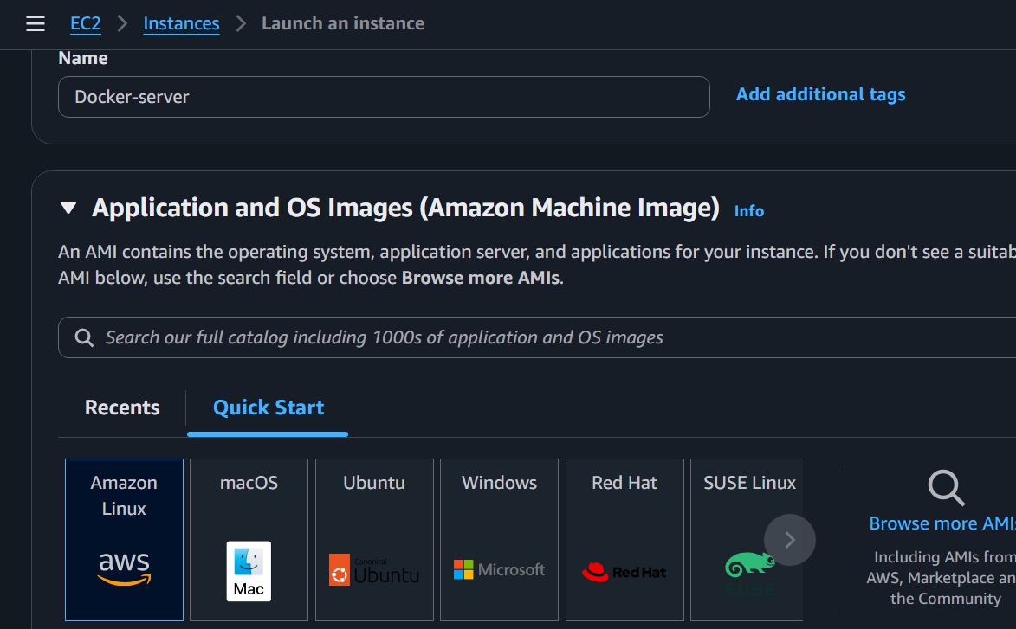
Step 3 — Launch
Click: Launch instance
Wait until:Instance state → Running
Status checks → 3/3 checks passed
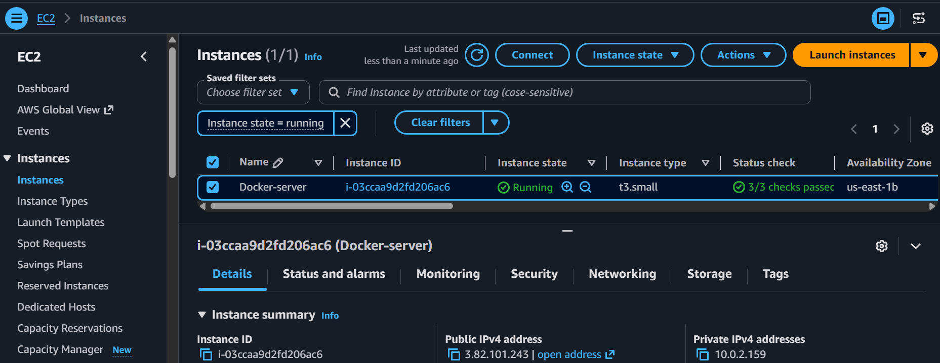
Connect to the instance
From your Windows machine, connect using SSH.
For example:
ssh -i your-key.pem ec2-user@<PUBLIC-IP>
You should get something similar to:
__| __|_ )
_| ( / Amazon Linux 2023
___|\___|___|
Then verify: whoami
Expected:ec2-user
Check OS: cat /etc/os-release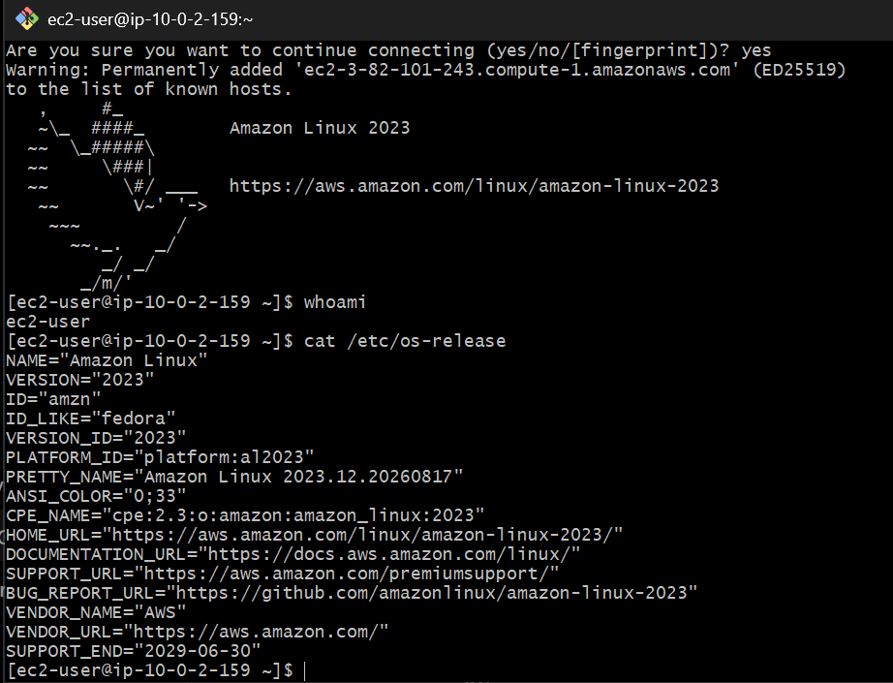
Update the system
Run: sudo dnf update -y
This may take a few minutes. 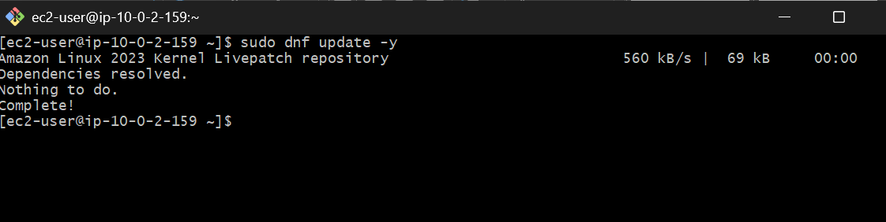Install Docker
Amazon Linux 2023 uses dnf.
Run: sudo dnf install docker -y
Verify: docker --version
You should see something similar to:
Docker version 25.x.x
The exact version can be different. 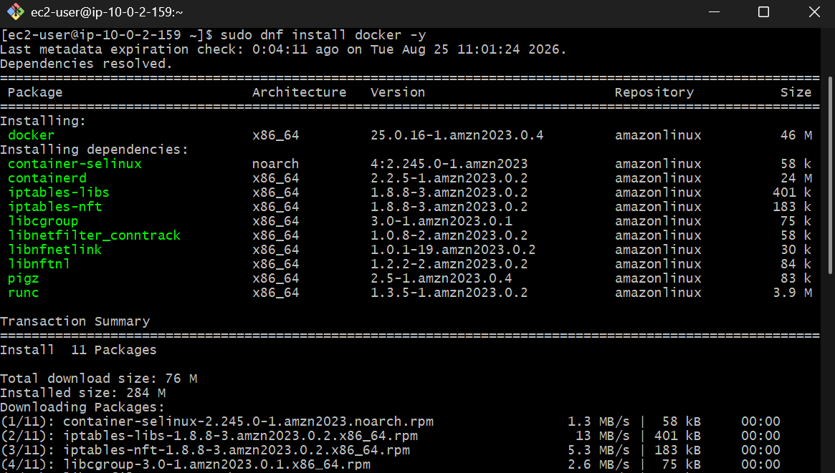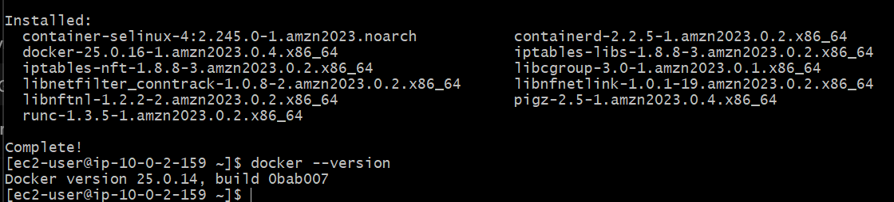 Start Docker
Run: sudo systemctl start docker
Enable Docker after reboot: sudo systemctl enable docker
Check: sudo systemctl status docker
You should see: Active: active (running)
Press: q
to exit the status screen.
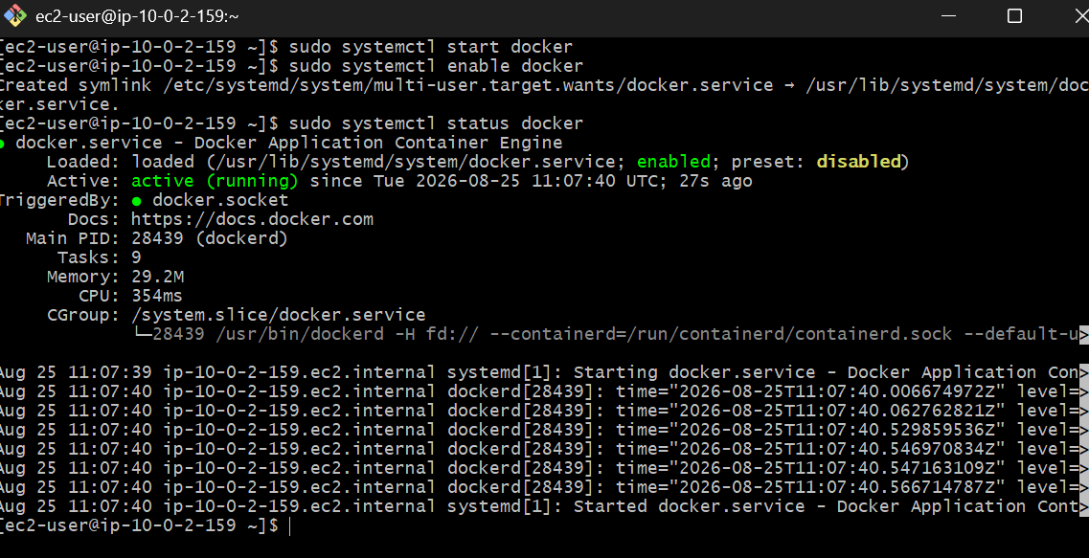
Allow ec2-user to use Docker
Currently, Docker commands may require sudo.
Instead, add ec2-user to the Docker group: sudo usermod -aG docker ec2-user
Now exit the SSH session: exit
Reconnect: ssh -i your-key.pem ec2-user@<PUBLIC-IP>
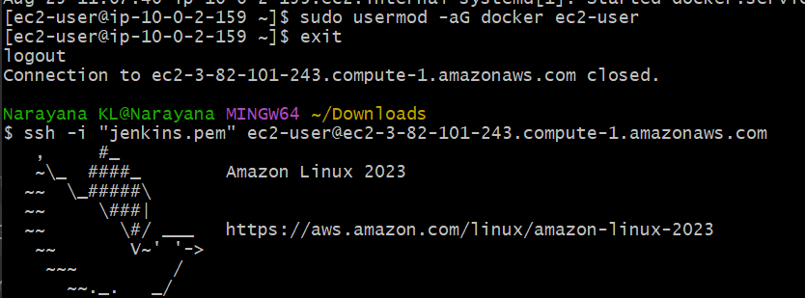
Now test: docker ps
Expected: CONTAINER ID IMAGE COMMAND CREATED STATUS PORTS NAMES
It is okay if the list is empty.
Test Docker completely
Run: docker run hello-world
You should eventually see: Hello from Docker!
This confirms that:
- Docker is installed
- Docker daemon is running
- ec2-user can use Docker
- Docker can pull images
- Containers can run

Check the Docker environment
Run these commands:
docker version
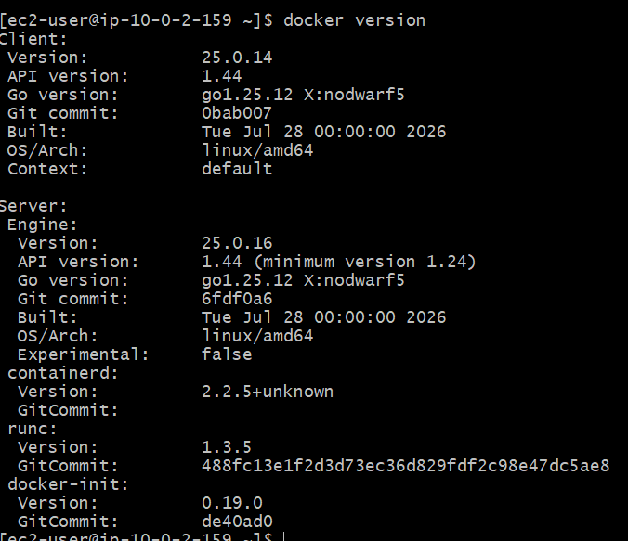
docker info
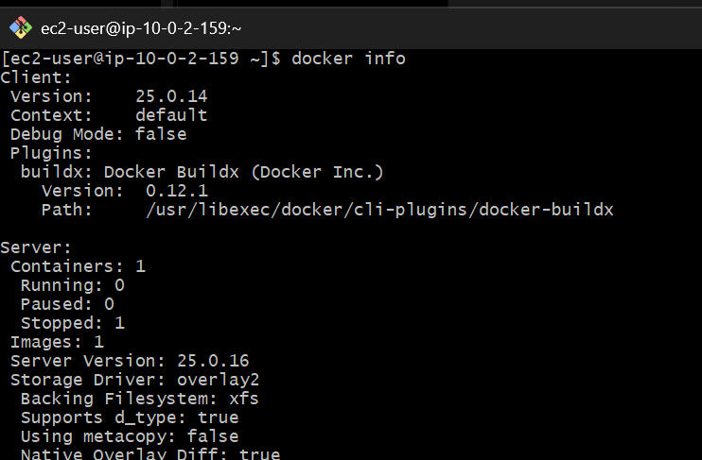
docker images
docker ps -a
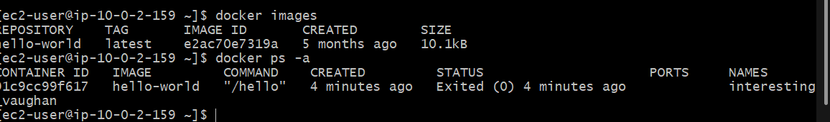
Task 1 — Create Tomcat container on port 8080
Our goal is:
Browser
|
| http://PUBLIC-IP:8080
↓
EC2 Instance :8080
|
↓
Docker Tomcat Container :8080
|
↓
Sample Application
Step 1 — Pull the Tomcat image
Run: docker pull tomcat:10.1
Then verify: docker images
You should see something similar to:
REPOSITORY TAG IMAGE ID CREATED SIZE
tomcat 10.1 xxxxxxxxxxxx ... ...
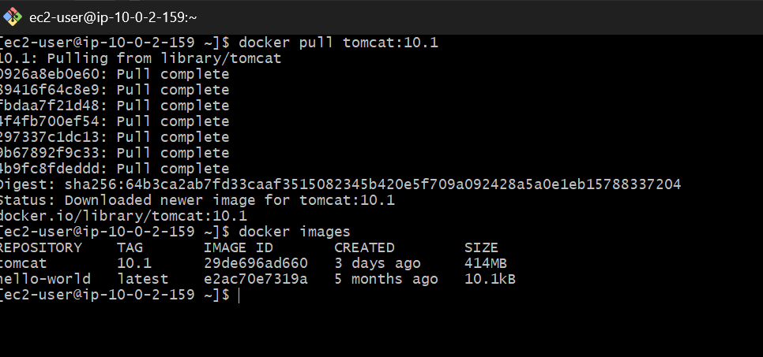

Step 2 — Create a directory for our application
Run: mkdir -p ~/tomcat-lab/sample-app
Go into it: cd ~/tomcat-lab/sample-app
Check: pwd
Expected: /home/ec2-user/tomcat-lab/sample-app

Step 3 — Create the sample application
We'll make a very simple HTML application.
Run:
cat > index.html <<'EOF'
<!DOCTYPE html>
<html>
<head>
<title>Docker Tomcat Lab</title>
</head>
<body>
<h1>Hello from Docker Tomcat!</h1>
<h2>Task 1 - Tomcat Container</h2>
<p>Application deployed successfully.</p>
</body>
</html>
EOF
Verify: cat index.html
You should see the HTML content.
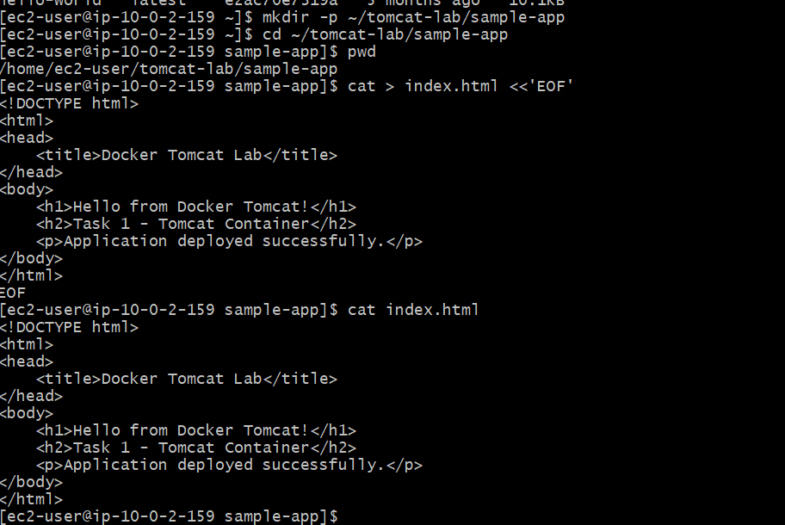

Step 4 — Create the Tomcat container
Now run: docker run -d \
--name tomcat-8080 \
-p 8080:8080 \
tomcat:10.1
Explanation:
Option | Meaning
-d | Run container in background
--name tomcat-8080 | Container name
-p 8080:8080 | EC2 port 8080 → container port 8080
tomcat:10.1 | Tomcat image
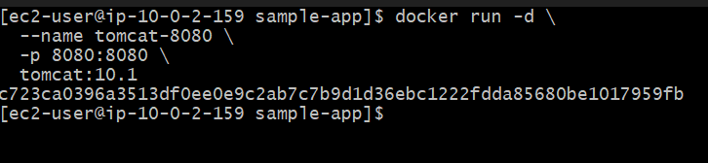
Step 5 — Check the container
Run: docker ps
Expected:
CONTAINER ID IMAGE COMMAND STATUS PORTS
xxxxxxxxxxxx tomcat:10.1 ... Up ... 0.0.0.0:8080->8080/tcp
The important part is:
0.0.0.0:8080->8080/tcp
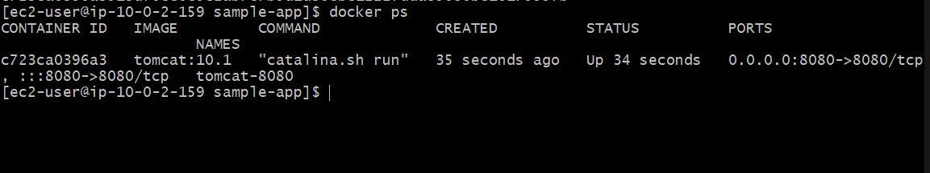
Step 6 — Check Tomcat from the EC2 server
Run: curl http://localhost:8080
Important
With recent Tomcat images, the default Tomcat landing page may not be available in the same way as older Tomcat images. That's okay.
Our actual requirement is to deploy our sample application, so we'll put the application into Tomcat's webapps directory next.

Step 7 — Find the Tomcat webapps directory
First check the container:docker exec tomcat-8080 ls -la /usr/local/tomcat
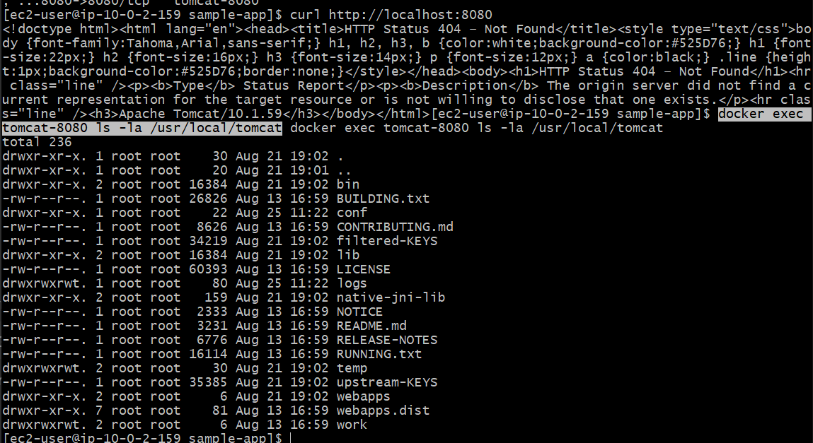
Then: docker exec tomcat-8080 ls -la /usr/local/tomcat/webapps
You should see the Tomcat application directory.
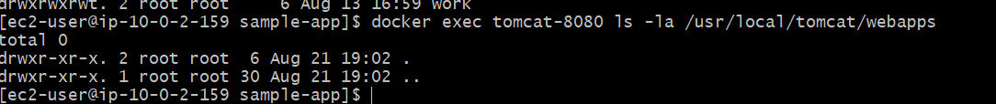
Step 8 — Deploy our sample application
Step 1 — Create the ROOT application directory
Run: docker exec tomcat-8080 mkdir -p /usr/local/tomcat/webapps/ROOT
Verify: docker exec tomcat-8080 ls -la /usr/local/tomcat/webapps
You should now see: ROOTStep 2 — Copy the application again
Run: docker cp ~/tomcat-lab/sample-app/index.html tomcat-8080:/usr/local/tomcat/webapps/ROOT/index.html
Expected: Successfully copied ...
Step 3 — Verify the file
Run: docker exec tomcat-8080 ls -la /usr/local/tomcat/webapps/ROOT
You should see:index.html
Then: docker exec tomcat-8080 cat /usr/local/tomcat/webapps/ROOT/index.html
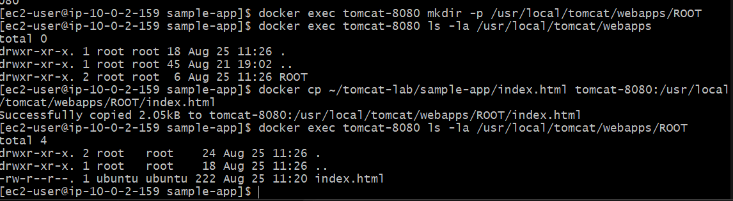
Step 9 — Test from EC2
Run: curl http://localhost:8080
You should see:
<h1>Hello from Docker Tomcat!</h1>
<h2>Task 1 - Tomcat Container</h2>
<p>Application deployed successfully.</p>
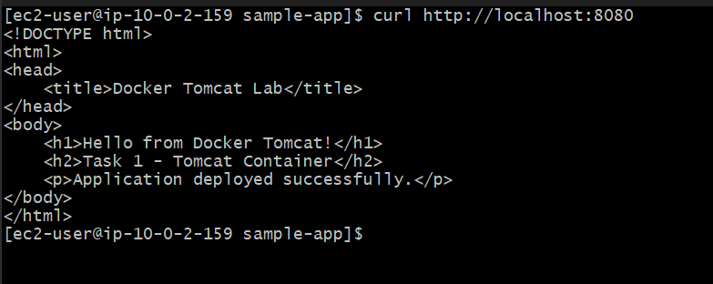
Step 10 — Test from your browser
Find the EC2 Public IPv4 address.
For example, if it is: 3.xx.xx.xx
Open: http://3.xx.xx.xx:8080
You should get: Hello from Docker Tomcat!
with: Task 1 - Tomcat Container
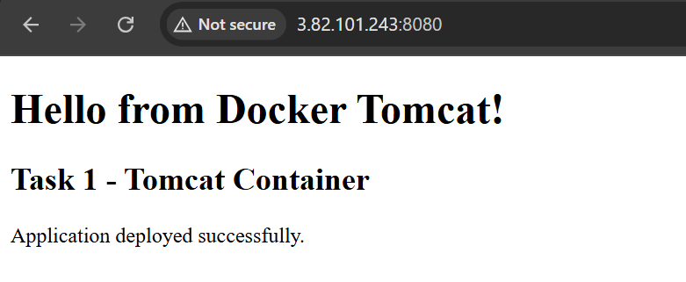
Task 2 — Create a Docker volume and deploy Tomcat on port 8081
For this task, we'll learn Docker volumes.
Our setup will be:
Docker Volume
│
▼
Tomcat Container
tomcat-8081
│
│ container port 8080
▼
EC2 host port 8081
So: http://<EC2-Public-IP>:8081
will access the second Tomcat container.
Step 1 — Create the Docker volume
Run: docker volume create tomcat-data
Expected: tomcat-data
Now verify: docker volume ls
You should see: DRIVER VOLUME NAME
local tomcat-data
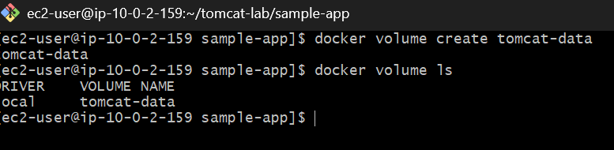
Step 2 — Inspect the volume
Run: docker volume inspect tomcat-data
You'll see information similar to:
[
{
"CreatedAt": "...",
"Driver": "local",
"Name": "tomcat-data",
"Mountpoint": "/var/lib/docker/volumes/tomcat-data/_data",
"Scope": "local"
}
]
Don't manually modify the mountpoint.
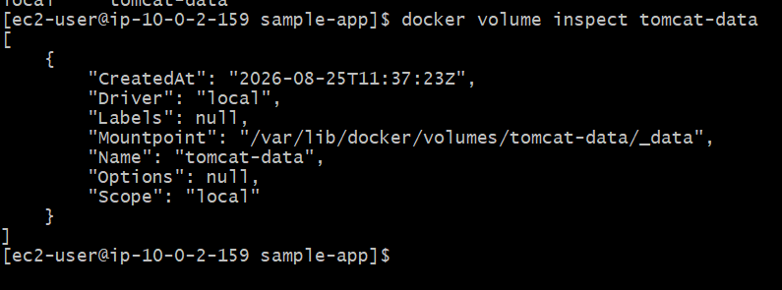

Step 3 — Create the second Tomcat container
Run: docker run -d \
--name tomcat-8081 \
-p 8081:8080 \
-v tomcat-data:/usr/local/tomcat/webapps \
tomcat:10.1
Understand this carefully
-v tomcat-data:/usr/local/tomcat/webapps
means: Docker volume Container
tomcat-data ───────────> /usr/local/tomcat/webapps
And: -p 8081:8080
means: EC2 host Container
8081 ─────────────> 8080
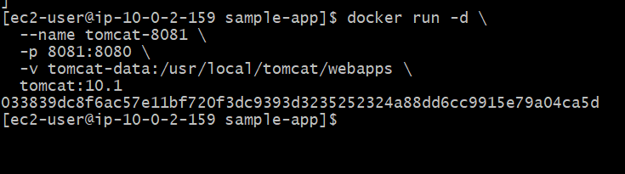
Step 4 — Check both containers
Run: docker ps
You should now have two Tomcat containers:
tomcat-8080
tomcat-8081
with ports similar to: 0.0.0.0:8080->8080/tcp
0.0.0.0:8081->8080/tcp
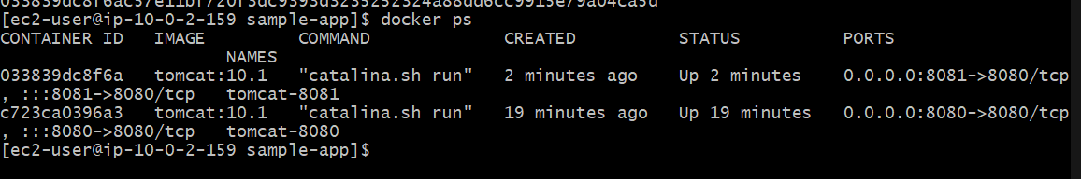
Step 5 — Check the volume inside the container
Run: docker exec tomcat-8081 ls -la /usr/local/tomcat/webapps
Because the volume is initially empty, you should see an empty directory.
This is expected.
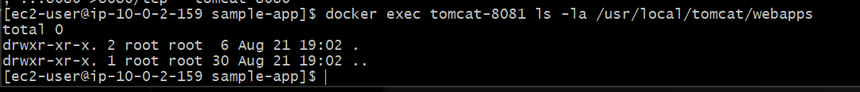
Step 6 — Create the second sample application
Create another directory:
mkdir -p ~/tomcat-lab/app-8081
Create the HTML file:
cat > ~/tomcat-lab/app-8081/index.html <<'EOF'
<!DOCTYPE html>
<html>
<head>
<title>Docker Volume Lab</title>
</head>
<body>
<h1>Hello from Tomcat 8081!</h1>
<h2>Task 2 - Docker Volume</h2>
<p>Tomcat application is using a Docker volume.</p>
</body>
</html>
EOF
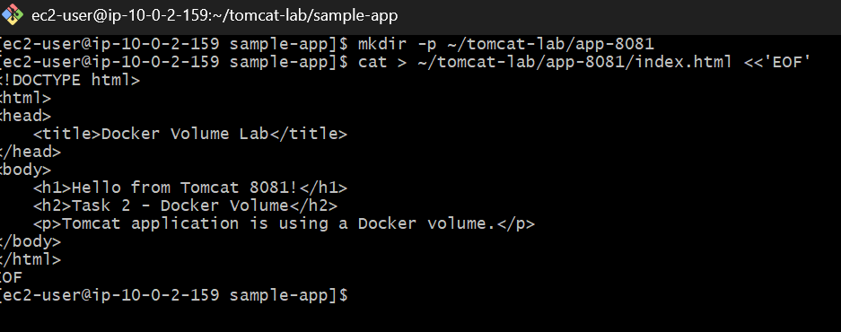
Step 7 — Create ROOT directory in the volume
Because the volume is mounted over webapps, create the ROOT directory:
docker exec tomcat-8081 mkdir -p /usr/local/tomcat/webapps/ROOT

Step 8 — Copy the application
Run:docker cp ~/tomcat-lab/app-8081/index.html tomcat-8081:/usr/local/tomcat/webapps/ROOT/index.html
Verify: docker exec tomcat-8081 ls -la /usr/local/tomcat/webapps/ROOT
You should see: index.html
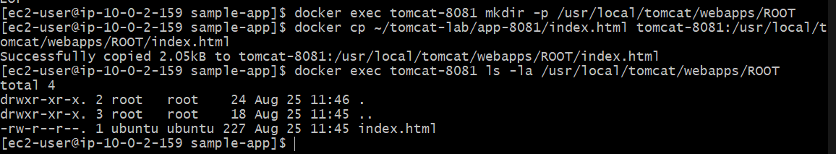
Step 9 — Test locally
Run: curl http://localhost:8081
Expected: <h1>Hello from Tomcat 8081!</h1>
<h2>Task 2 - Docker Volume</h2>
<p>Tomcat application is using a Docker volume.</p>
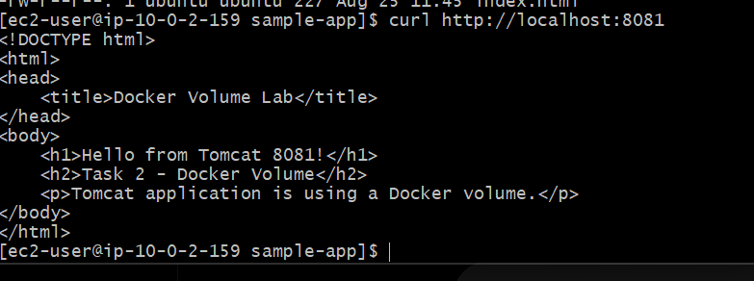
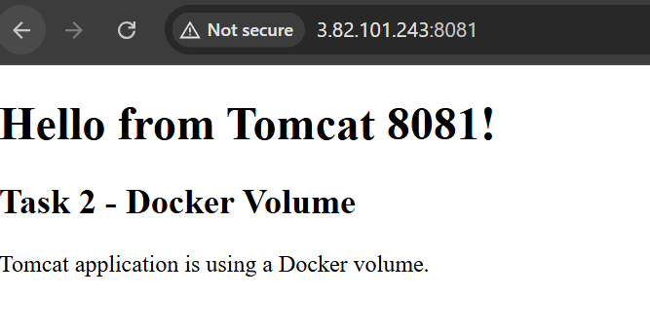

Task 3 — Limit Nginx to 500 MB memory
We'll use Docker's --memory option.
Step 1 — Pull Nginx : docker pull nginx:latest
Verify: docker images nginx
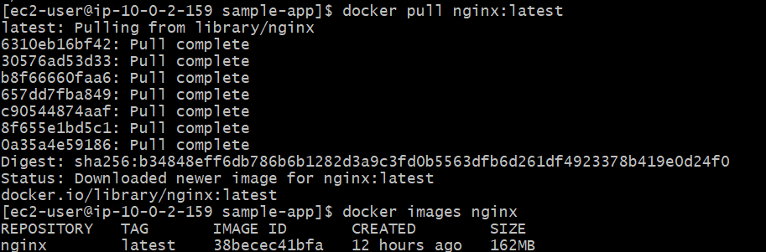
Step 2 — Run Nginx with 500 MB memory limit
Run: docker run -d \
--name nginx-500mb \
-p 8082:80 \
--memory=500m \
nginx:latest
We're using host port 8082 so it doesn't conflict with Tomcat's 8080 and 8081.
The mapping is:
EC2 :8082
↓
Nginx :80
Step 3 — Verify the container
docker ps
You should see: 0.0.0.0:8082->80/tcp
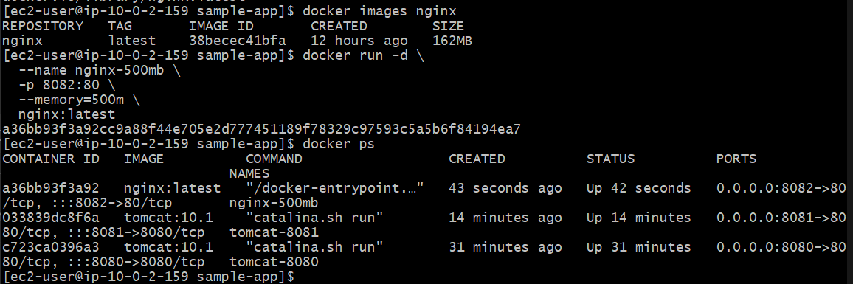
Step 4 — Verify the memory limit
Run: docker inspect nginx-500mb --format '{{.HostConfig.Memory}}'
You should get: 524288000
Why? 500 MB × 1024 × 1024 = 524,288,000 bytes
You can also use: docker stats nginx-500mb --no-stream
This shows the container's current memory usage and limit.
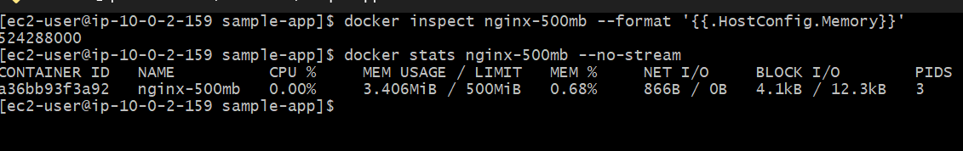
Step 5 — Test Nginx
From the EC2 instance: curl http://localhost:8082
You should receive the default Nginx HTML response containing:
Welcome to nginx!
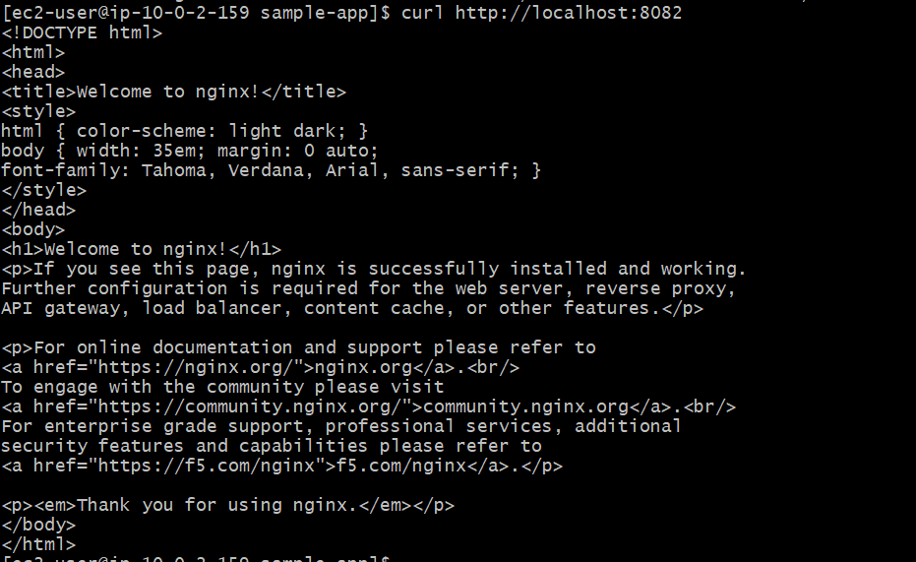
Step 6 — Test from your browser
Open: http://<PUBLIC-IP>:8082
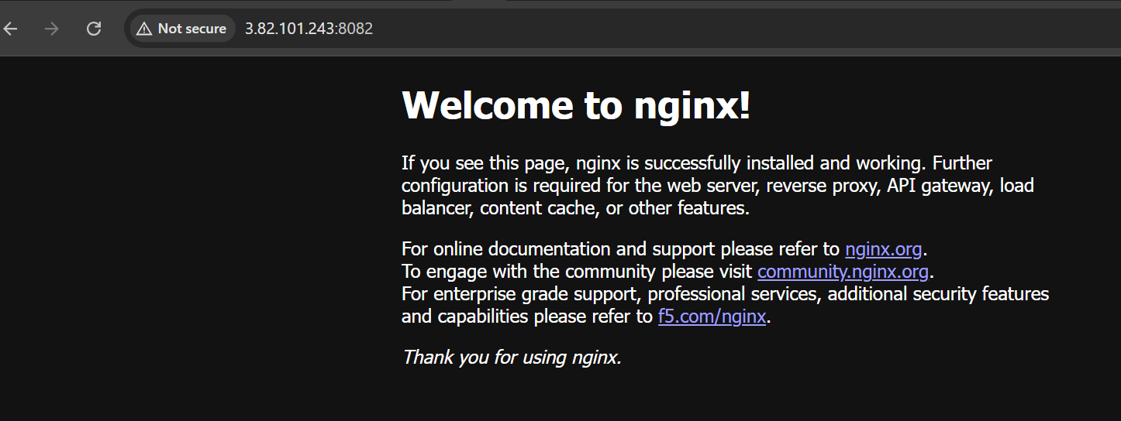
Task 4 — Create the Dockerfile
Our requirements are:
Base image → amazonlinux:latest
Maintainer → Your name
Install nginx
COPY index.html
Expose port 80
Start nginx
We'll create everything in a separate directory.
Step 1 — Create the project directory
mkdir -p ~/docker-nginx
cd ~/docker-nginx
Check: pwd
Expected: /home/ec2-user/docker-nginx
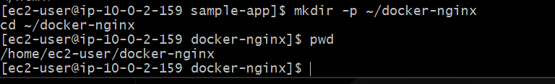Step 2 — Create index.html
Run: cat > index.html <<'EOF'
<!DOCTYPE html>
<html>
<head>
<title>My Docker Image</title>
</head>
<body>
<h1>Hello from my custom Docker image!</h1>
<h2>Amazon Linux + Nginx</h2>
<p>Dockerfile task completed successfully.</p>
</body>
</html>
EOF
Verify: cat index.html
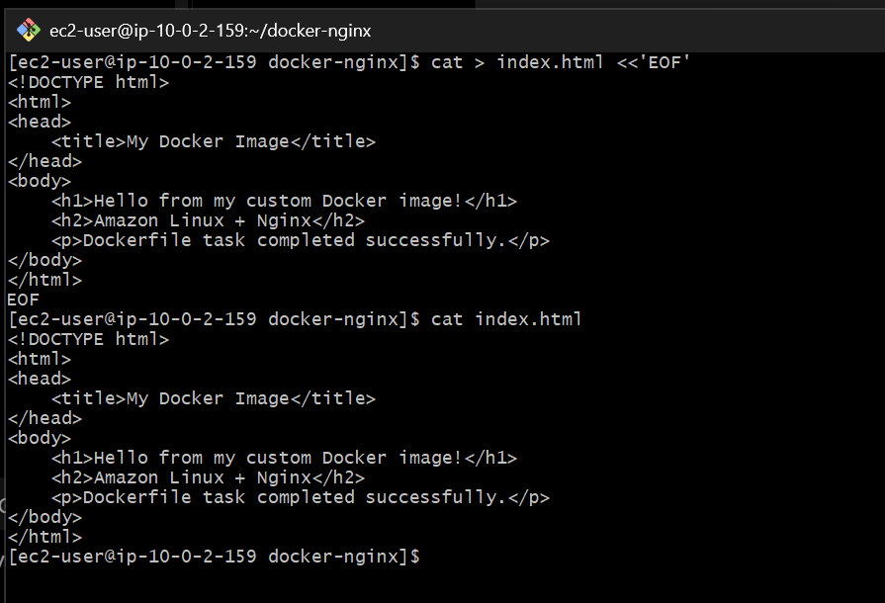

Step 3 — Create the Dockerfile
We'll use your name as the maintainer.
cat > Dockerfile <<'EOF'
FROM amazonlinux:latest
LABEL maintainer="Narayana"
RUN dnf install -y nginx && \
dnf clean all
COPY index.html /usr/share/nginx/html/index.html
EXPOSE 80
CMD ["nginx", "-g", "daemon off;"]
EOF
What each line does
FROM amazonlinux:latest
Uses Amazon Linux as the base image.
LABEL maintainer="Narayana"
Identifies the image maintainer.
Note: MAINTAINER is an old Dockerfile instruction and is deprecated. LABEL maintainer is the modern equivalent.
RUN dnf install -y nginx
Installs Nginx.
COPY index.html /usr/share/nginx/html/index.html
Copies our HTML file into Nginx's default web directory.
EXPOSE 80
Documents that Nginx listens on port 80.
CMD ["nginx", "-g", "daemon off;"]
Starts Nginx in the foreground so the Docker container continues running.
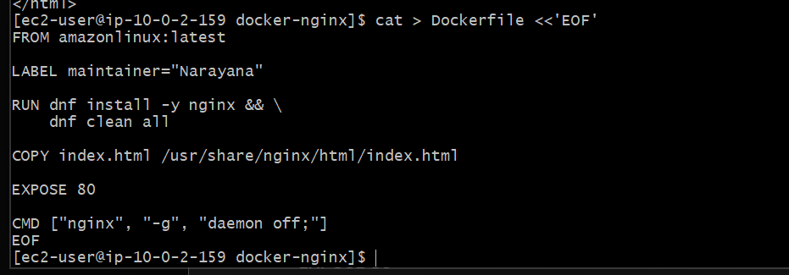Step 4 — Check the files
Run: ls -la
You should have: Dockerfile
index.html
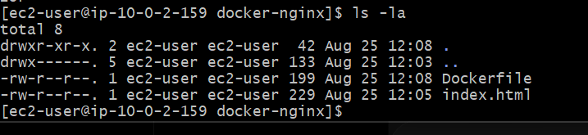Step 5 — Build the Docker image
Run: docker build -t my-nginx:1.0 .
The final part: .
means Docker should use the current directory as the build context.
Wait for the build to complete.
You should eventually see: Successfully tagged my-nginx:1.0
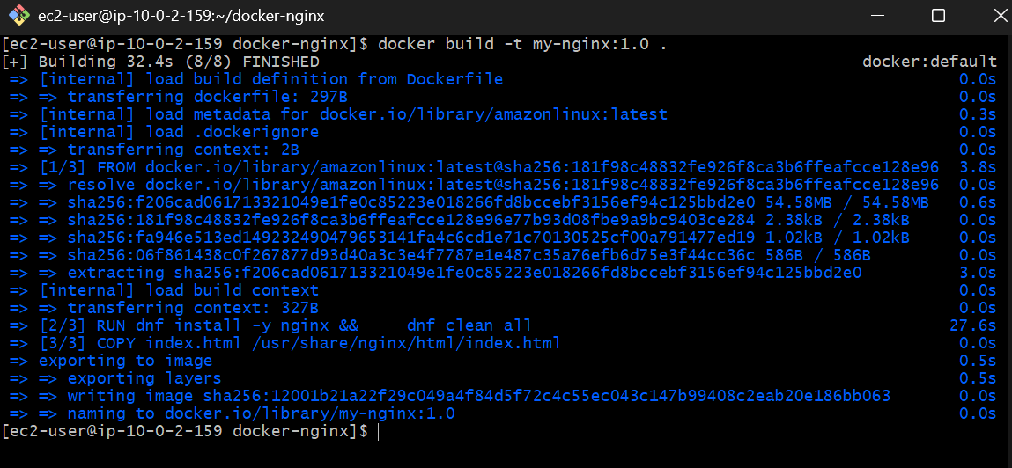
Step 6 — Verify the image
Run: docker images
You should see: my-nginx 1.0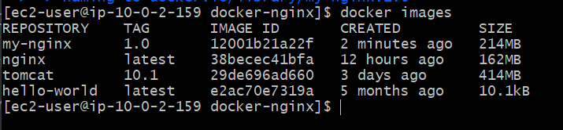
You can also check: docker image inspect my-nginx:1.0
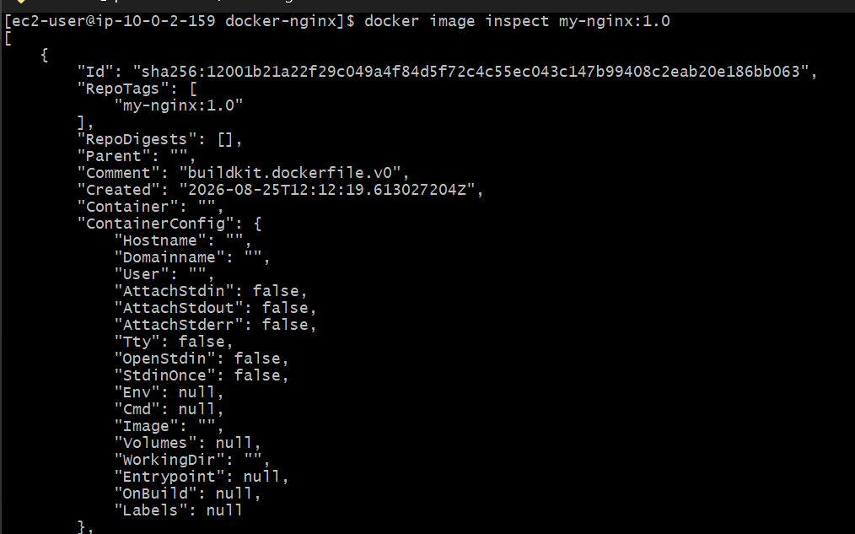
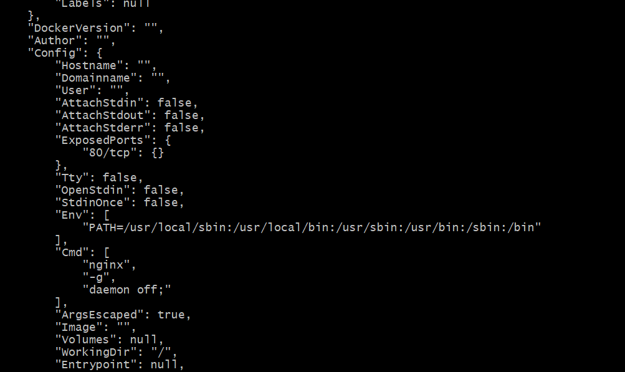
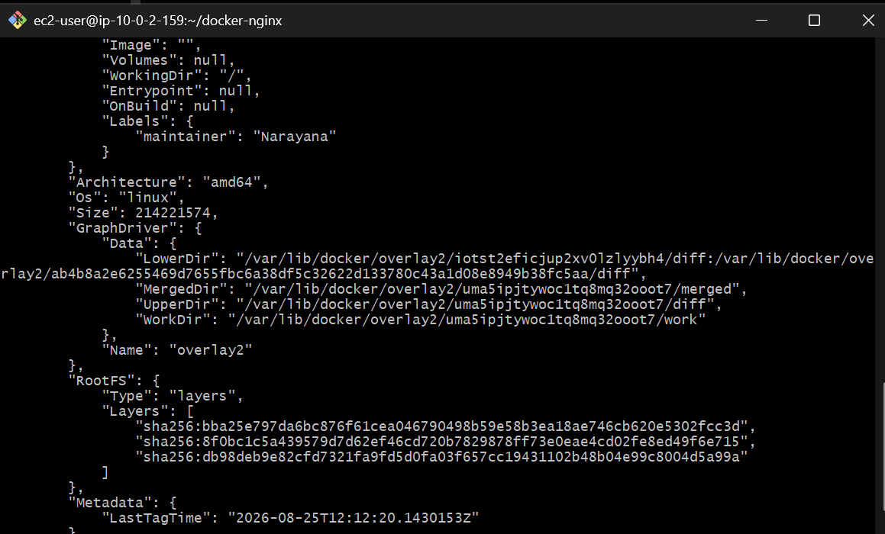
Step 7 — Run our custom image
Use port 8083 so we don't conflict with the existing containers:
docker run -d \
--name my-nginx \
-p 8083:80 \
my-nginx:1.0
Architecture: EC2 :8083
↓
Docker :80
↓
Nginx
↓
index.html
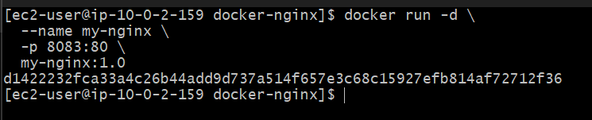
Step 8 — Verify
docker ps
You should see: 0.0.0.0:8083->80/tcp
Then: curl http://localhost:8083
You should get: <h1>Hello from my custom Docker image!</h1>
<h2>Amazon Linux + Nginx</h2>
<p>Dockerfile task completed successfully.</p>
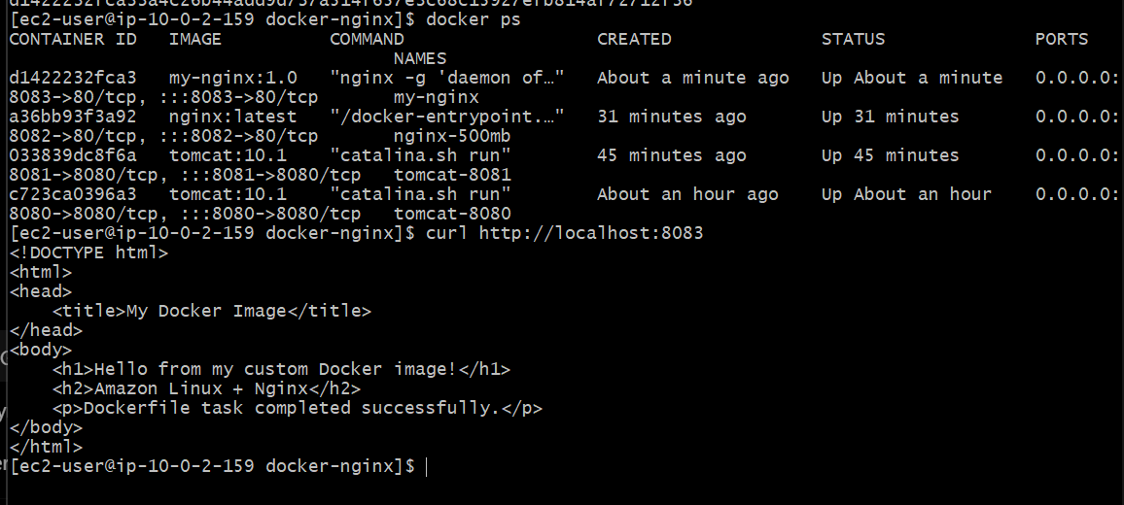
Step 9 — Browser test
If you want to test externally: http://<PUBLIC-IP>:8083
http://3.82.101.243:8083/
Make sure the Security Group allows TCP 8083 from your IP.
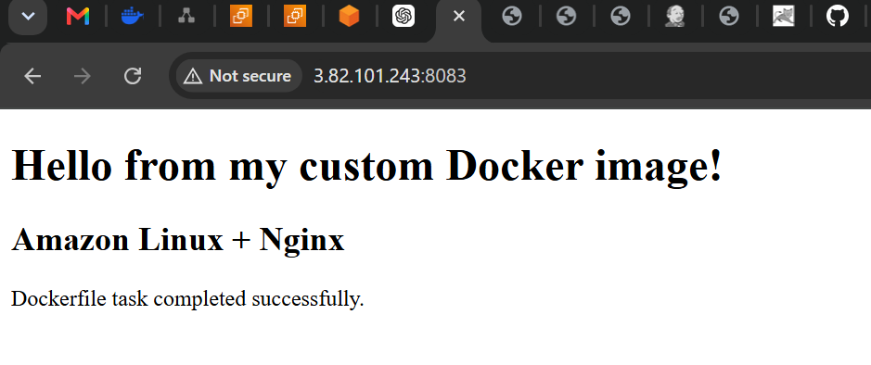

Task 5 — Push the image to Docker Hub
For this task, we need your Docker Hub username and a repository name.
We'll use: Docker Hub username → YOUR_USERNAME
Repository → my-nginx
Tag → 1.0
Step 1 — Check Docker Hub login
Run: docker login
Docker will ask for: Username:
Password:
Enter your Docker Hub credentials.
If Docker asks for a device code/browser authentication, follow the displayed instructions.
You should eventually see: Login Succeeded
Important Don't send me your Docker Hub password, access token, or any secret.
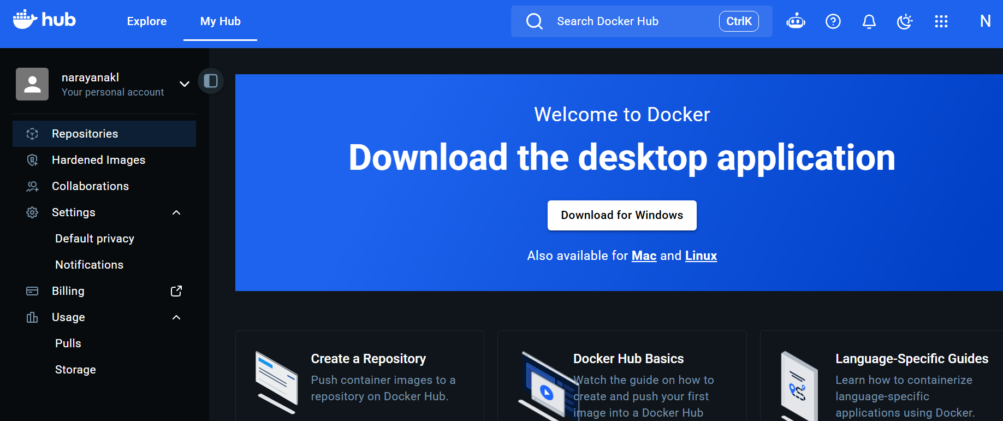Step 2 — Tag the image
docker tag my-nginx:1.0 narayanakl/my-nginx:1.0
Verify: docker images
You should see: my-nginx 1.0
narayanakl/my-nginx 1.0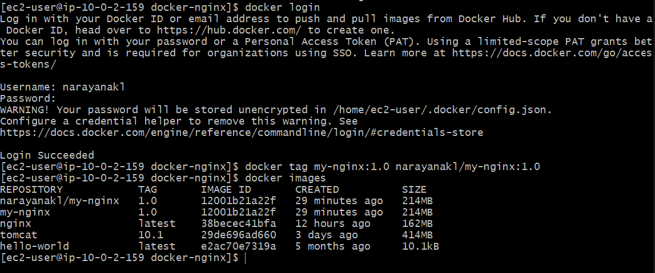
Step 3 — Push to Docker Hub
docker push narayanakl/my-nginx:1.0
Wait until all layers finish uploading.
You should see a final line similar to:
1.0: digest: sha256:xxxxxxxx...
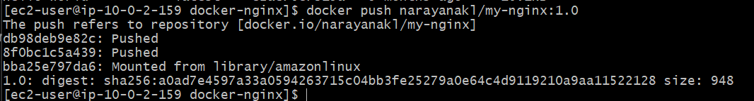
Step 4 — Verify
Open your Docker Hub repository:
Docker Hub — narayanakl
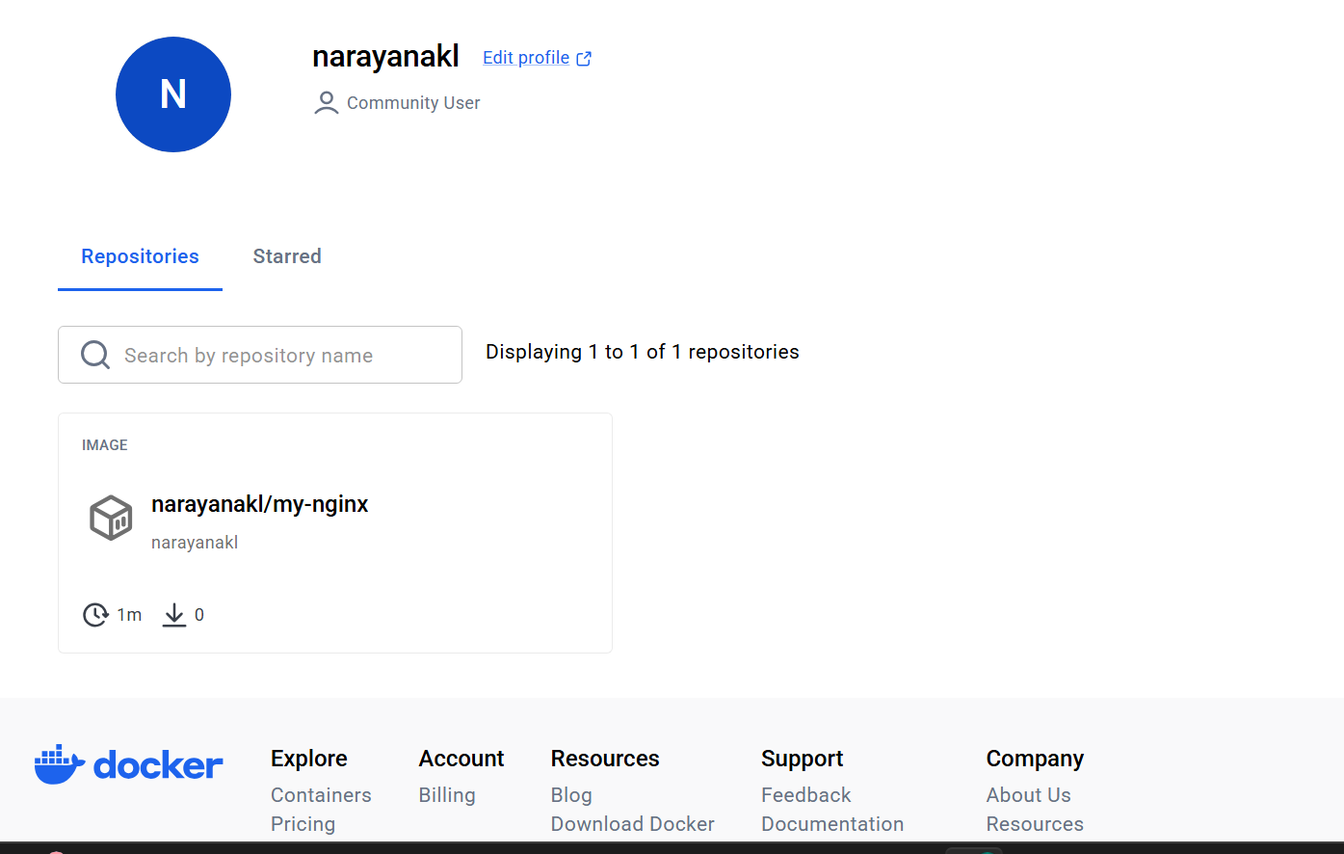
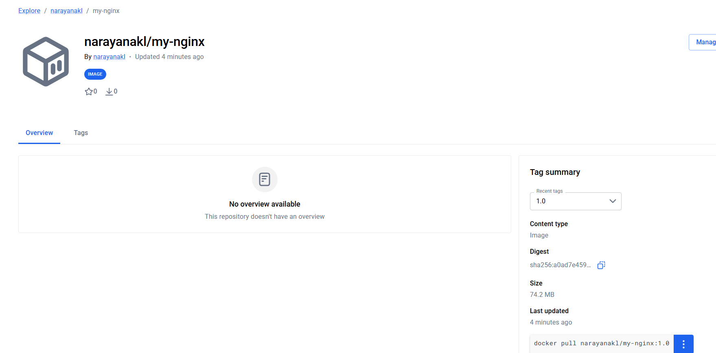
You should see the my-nginx repository with the 1.0 tag.
Task 6 — Push Image to AWS ECR
Now we'll push the same image to Amazon Elastic Container Registry (ECR).
Our flow:
Local Docker Image
│
│ docker tag
▼
AWS ECR Repository
│
│ docker push
▼
ECR Image
Step 1 — Go to EC2
In AWS Console: EC2 → Instances → Docker-Lab-Instance
Select the instance.
Then: Actions → Security → Modify IAM role
Look for an existing IAM role that has ECR permissions.
If you already have an appropriate role
Select it and click: Update IAM role
Then come back to the terminal and run:
aws sts get-caller-identity
If it returns something like:
{
"UserId": "...",
"Account": "123456789012",
"Arn": "arn:aws:iam::123456789012:role/..."
}
we're ready. 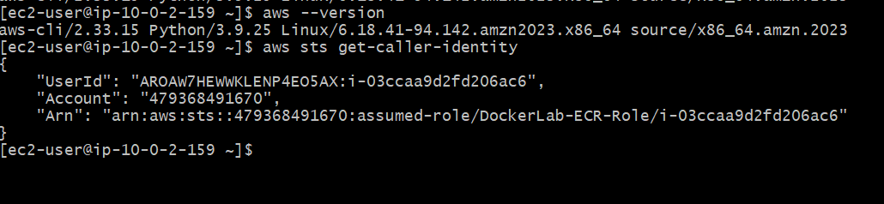
If you don't have an IAM role
We'll create one.
Step 2 — Open IAM
AWS Console: IAM → Roles → Create role
Trusted entity
Select: Trusted entity type:AWS service
Then:Use case: EC2
Click: Next

Step 3 — Add ECR permissions
For this lab, search for:
AmazonEC2ContainerRegistryPowerUser
Select: AmazonEC2ContainerRegistryPowerUser
Click: Next
Then:Role name
Use: DockerLab-ECR-Role
Click: Create role

Step 4 — Attach the role to our EC2 instance
Go back to: EC2 → Instances → Docker-Lab-Instance
Select it.
Then: Actions → Security → Modify IAM role
Select: DockerLab-ECR-Role
Click: Update IAM role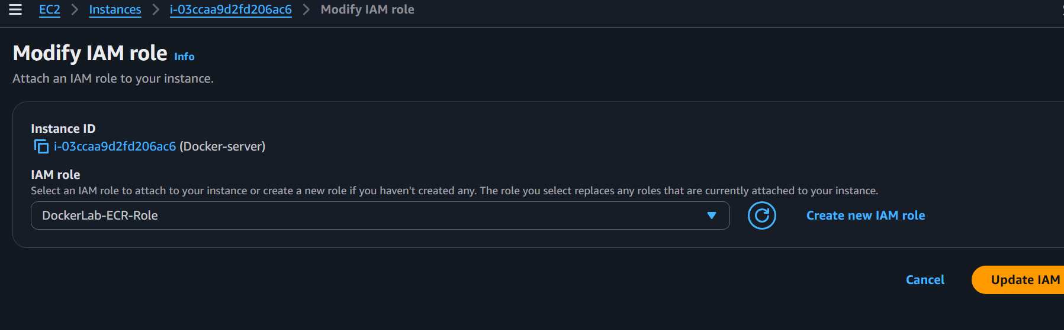

Step 5 — Verify from the EC2 instance
Back in your SSH terminal, run:
aws sts get-caller-identity
This time it should work.
You'll get something similar to:
{
"UserId": "AROA........:i-........",
"Account": "123456789012",
"Arn": "arn:aws:sts::123456789012:assumed-role/DockerLab-ECR-Role/i-........"
}
Important
Don't send me any secrets. The output of get-caller-identity is okay to share, but you can also just tell me "it worked".

Step 6 — Set the AWS CLI region
Once get-caller-identity works,
run: aws configure set region us-east-1
Verify: aws configure get region
Expected: us-east-1
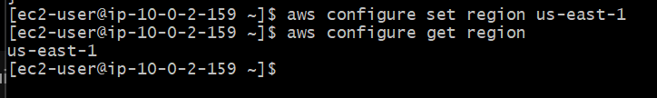

Step 7 — Step 1 — Create ECR repository from AWS Console
Open: AWS Console → ECR → Private registry → Repositories
Make sure the region at the top-right is:
US East (N. Virginia) — us-east-1
Click: Create repository
Use: Repository name: docker-nginx
Leave the other settings at their defaults for this lab.
Then click: Create

Step 2 — Verify the repository
You should now see: docker-nginx
Open the repository.
The repository URI should be: 479368491670.dkr.ecr.us-east-1.amazonaws.com/docker-nginx
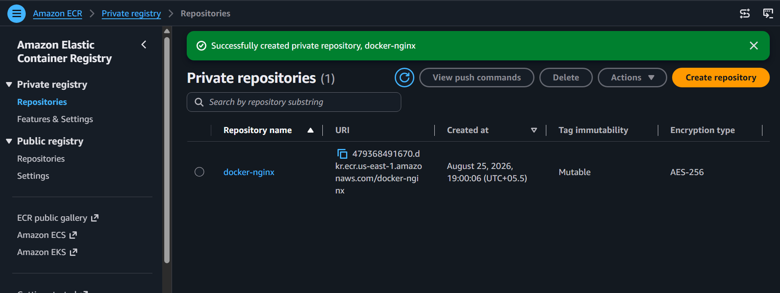

Step 3 — Return to the EC2 terminal
Don't create the repository with the CLI anymore.
Run: aws ecr describe-repositories \
--repository-names docker-nginx \
--region us-east-1
This should now work because you're only querying the repository.
You should see: "repositoryName": "docker-nginx"
and: "repositoryUri": "479368491670.dkr.ecr.us-east-1.amazonaws.com/docker-nginx"
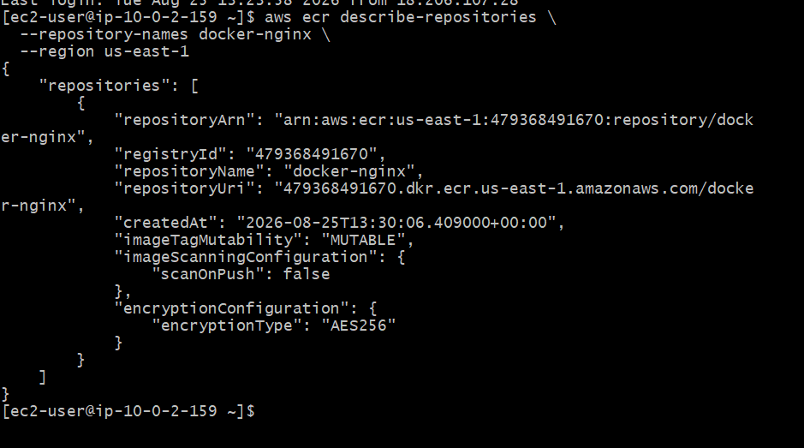

ECR login
↓
Tag image
↓
docker push
↓
Verify image in ECR
Step 4: Login Docker to ECR
Run: aws ecr get-login-password --region us-east-1 | \
docker login --username AWS --password-stdin 479368491670.dkr.ecr.us-east-1.amazonaws.com
Expected: Login Succeeded

Step 5 — Tag your image for ECR
Your current image is: narayanakl/my-nginx:1.0
Tag it with the ECR repository: docker tag narayanakl/my-nginx:1.0 \
479368491670.dkr.ecr.us-east-1.amazonaws.com/docker-nginx:1.0
Verify: docker images | grep docker-nginx
You should see: 479368491670.dkr.ecr.us-east-1.amazonaws.com/docker-nginx 1.0
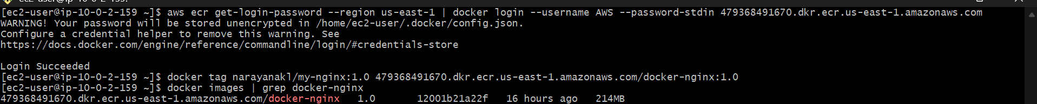

Step 4 — Push the image to ECR
Run: docker push 479368491670.dkr.ecr.us-east-1.amazonaws.com/docker-nginx:1.0
You'll see layers being uploaded: Preparing
Waiting
Pushed
At the end, expect something similar to:
1.0: digest: sha256:xxxxxxxx...
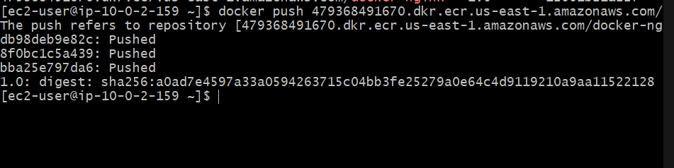

Step 5 — Verify from AWS CLI
After the push completes:
aws ecr list-images \
--repository-name docker-nginx \
--region us-east-1
You should see:
"imageTag": "1.0"
You can also check:
aws ecr describe-images \
--repository-name docker-nginx \
--region us-east-1

