Ansible-01
Ansible lab — execution plan
EC2-1: Ansible Master
Ubuntu 24.04 · Ansible installed
Control node
Worker 1
172.31.21.77
SSH · TCP 22
Worker 2
172.31.19.206
SSH · TCP 22
These are the worker IPs listed in your document. Confirm they are still the instances' current private IP addresses in AWS.
Task 1: Set up the three EC2 instances
We’ll use the settings in your document:
- AMI: Ubuntu Server 24.04 LTS
- Instance type: t3.micro, if available
- Storage: 8 GiB gp3
- One SSH key pair for all three instances
- Same VPC, preferably the same subnet
- Security group allowing SSH from your computer to the master and SSH from the master to both workers
Step 1 — Check your EC2 instances
Open AWS Console → EC2 → Instances.
Confirm that these three instances exist and are running:
- ansible-master
- ansible-worker1
- ansible-worker2
Wait until their instance status checks pass.
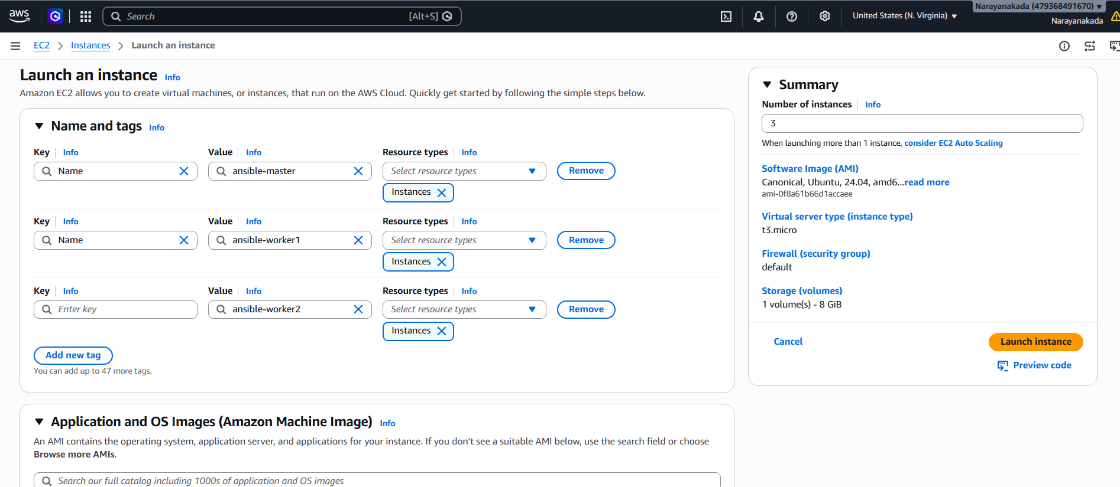
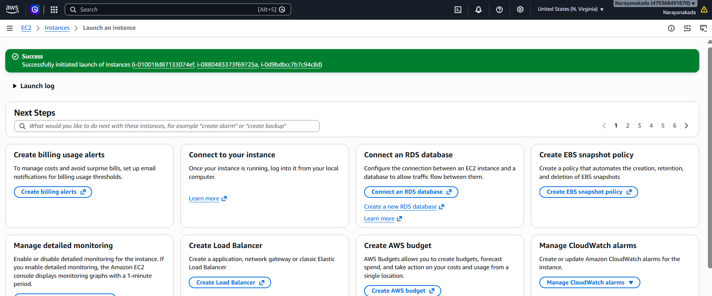
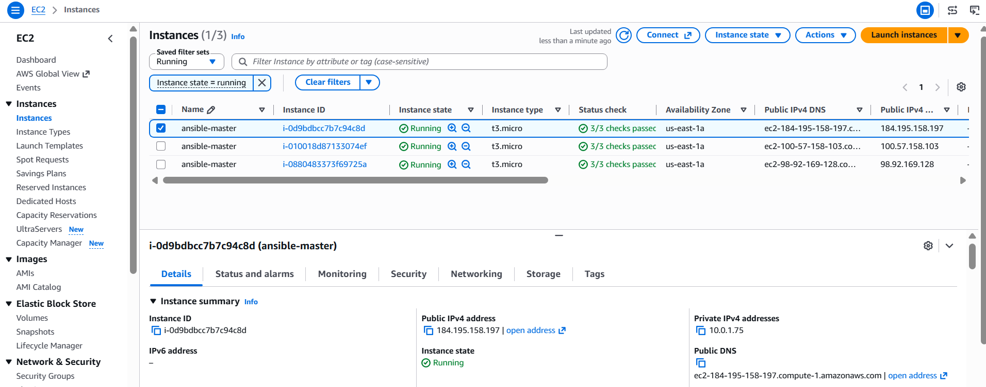
Step 2 — Connect to the Ansible Master from Git Bash
1. Open Git Bash on Windows
Navigate to the folder where you saved jenkins.pem. If it is in your Downloads folder, run:
cd ~/Downloads
ls
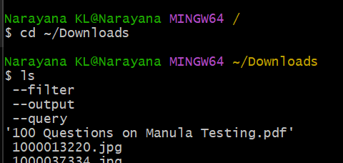
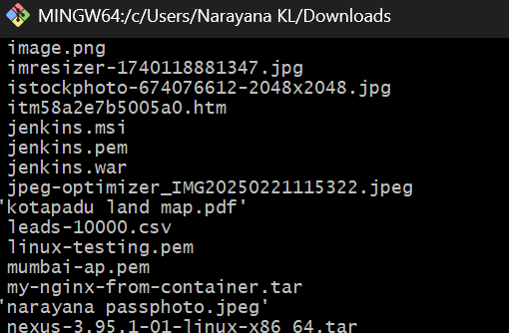
Confirm that jenkins.pem appears in the output.
2. Set the private key permissions
Run: chmod 400 jenkins.pem
3. Get the master's public IP address
In AWS Console:
- Go to EC2 → Instances.
- Select ansible-master.
- Copy its Public IPv4 address.
4. Connect to the master
Replace MASTER_PUBLIC_IP with the actual public IP you copied.
ssh -i jenkins.pem ubuntu@MASTER_PUBLIC_IP
For example, the command format is: ssh -i jenkins.pem ubuntu@<your-master-public-ip>
Do not type the angle-bracket placeholder literally; replace it with the actual IP.
If prompted to continue connecting, verify the instance address and type yes.
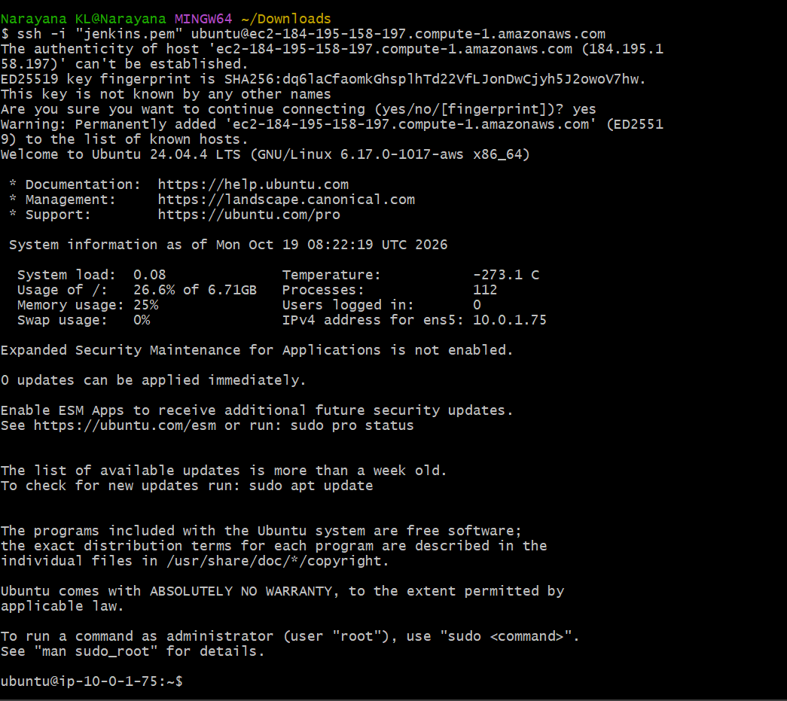
5. Verify the connection
Once connected, run: whoami
hostname
Expected output: ubuntu
ip-172-31-xx-xx
The hostname will vary depending on your instance.
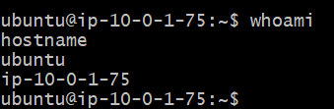
Step 3 — Install Ansible
Run these commands in your current SSH terminal (ubuntu@ip-10-0-1-75).
1. Update package lists
sudo apt update
Wait until it completes.
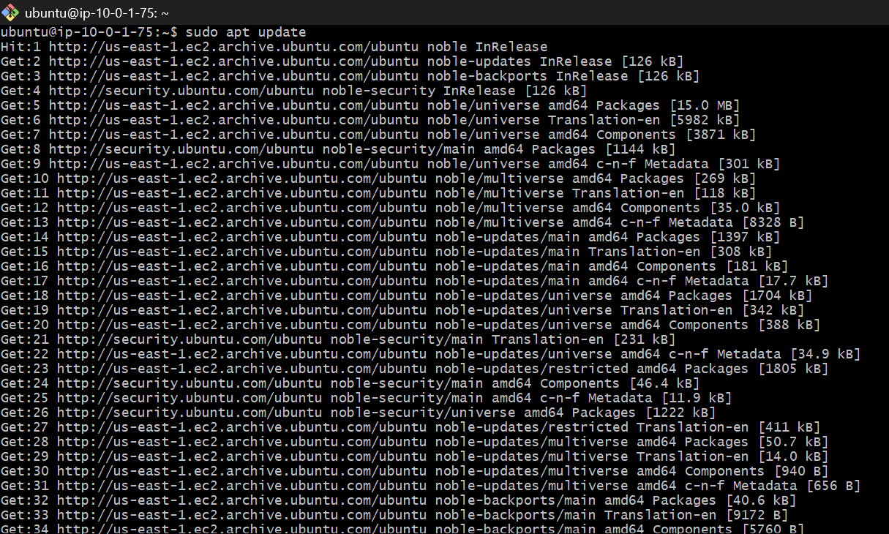
2. Install Ansible, SSH client, and Python 3
sudo apt install ansible openssh-client python3 -y
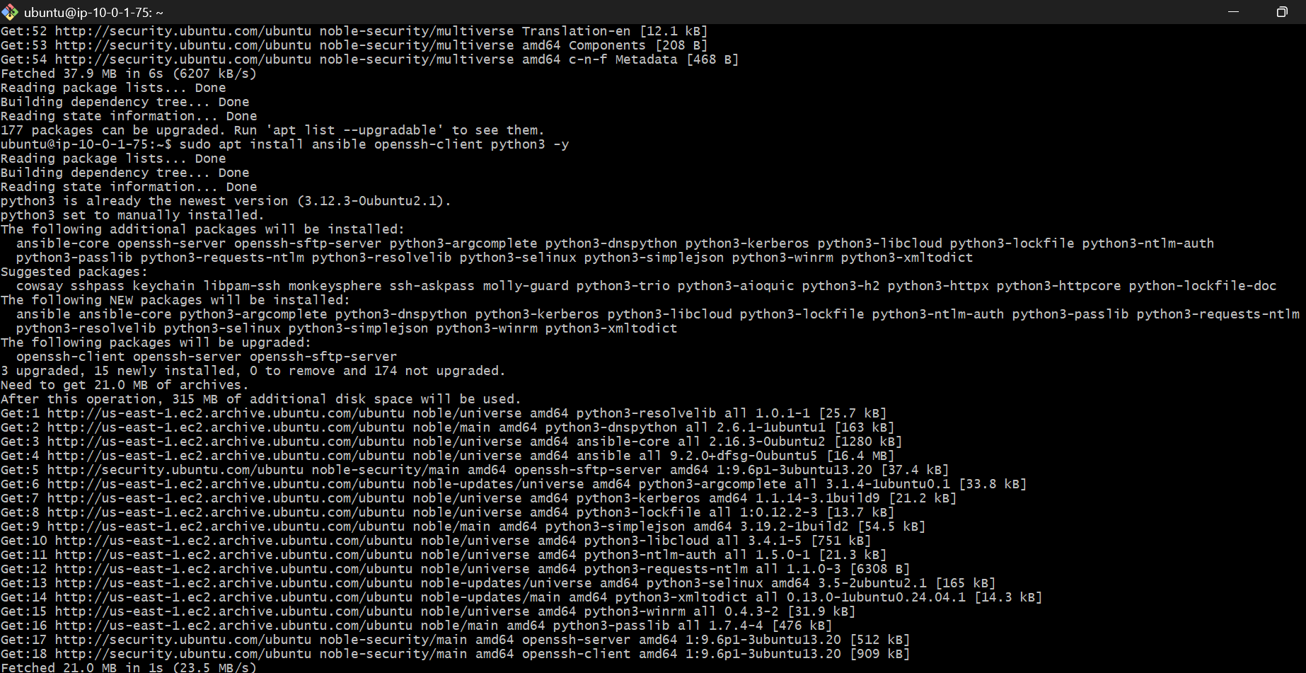
3. Verify the installation
ansible –version
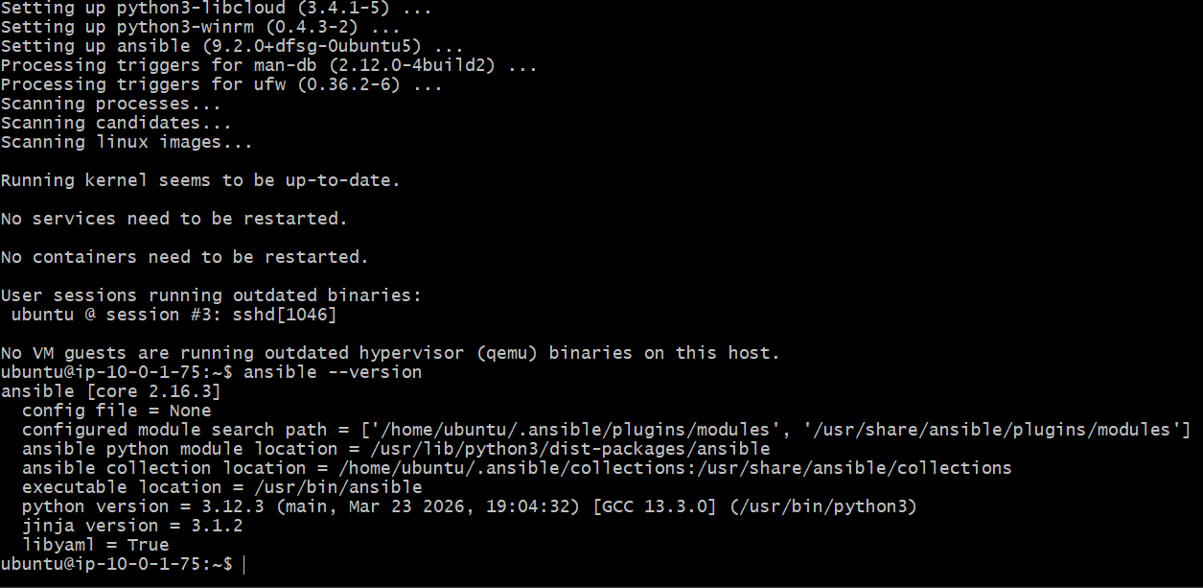
Step 4 — Copy jenkins.pem to the master
Your master needs the private key to connect to the workers over SSH.
4.1 Open a NEW Git Bash terminal on Windows
Keep your current SSH session open. Open another Git Bash window on your Windows computer.
Navigate to the directory containing your key: cd ~/Downloads
ls jenkins.pem
Now copy the key to your master. Replace MASTER_PUBLIC_IP with the actual public IPv4 address of ansible-master.
scp -i jenkins.pem jenkins.pem ubuntu@MASTER_PUBLIC_IP:/home/ubuntu/jenkins.pem
For example, the command structure is: scp -i jenkins.pem jenkins.pem ubuntu@184.195.158.197:/home/ubuntu/jenkins.pem
Replace the placeholder with the real IP; do not type the angle brackets.
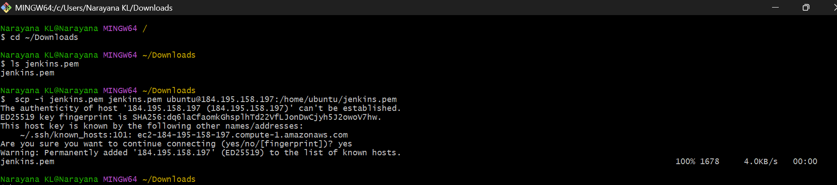
4.2 Return to your master SSH session
Run: chmod 400 ~/jenkins.pem
Verify the file exists:
ls -l ~/jenkins.pem
You should see permissions similar to:
-r-------- 1 ubuntu ubuntu ... /home/ubuntu/jenkins.pem
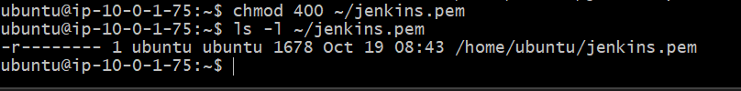
Step 5 — Configure SSH access to both workers
Your lab network:
Instance | Private IP
Ansible Master | 10.0.1.75
Worker 1 | 10.0.1.8
Worker 2 | 10.0.1.184
5.1 Verify the worker security group
In AWS Console, open EC2 → Security Groups and select the security group attached to your workers.
Ensure there is an inbound rule:
Type | Protocol | Port | Source
SSH | TCP | 22 | Ansible master's security group
Using the master's security group as the source is preferable to opening SSH to all IP addresses. If all instances share the same security group, you can reference that same group in the inbound rule.
5.2 Test SSH to Worker 1
Run this command in your existing master SSH terminal:
ssh -i ~/jenkins.pem ubuntu@10.0.1.8
If prompted to trust the host, verify that the IP matches Worker 1, then type yes.
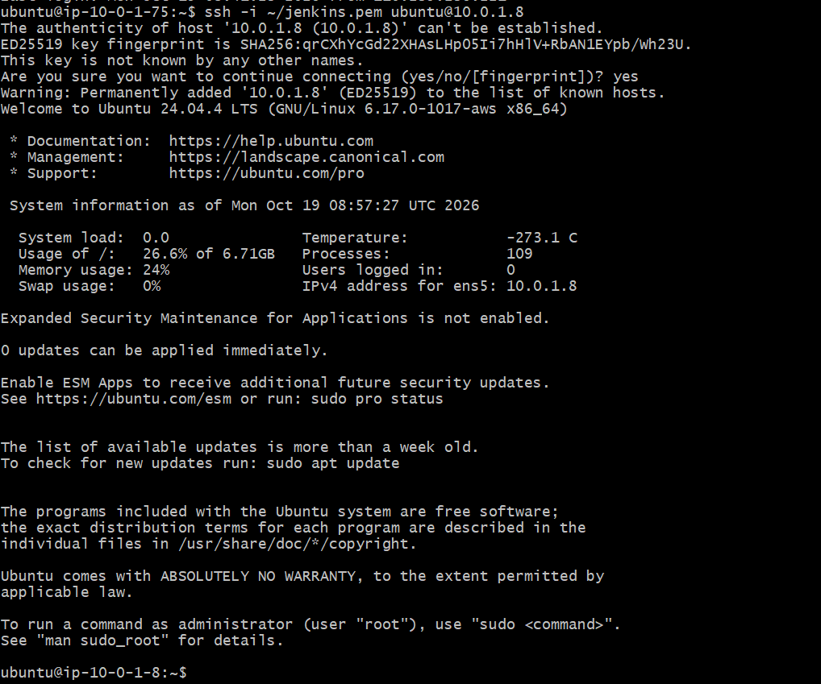
Once connected, verify:
hostname
You should see a hostname corresponding to Worker 1.
Return to the master:
Exit
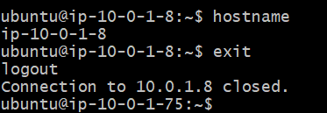
5.3 Test SSH to Worker 2
Back on the master, run:
ssh -i ~/jenkins.pem ubuntu@10.0.1.184
After connecting, run:
hostname
Then return to the master:
Exit
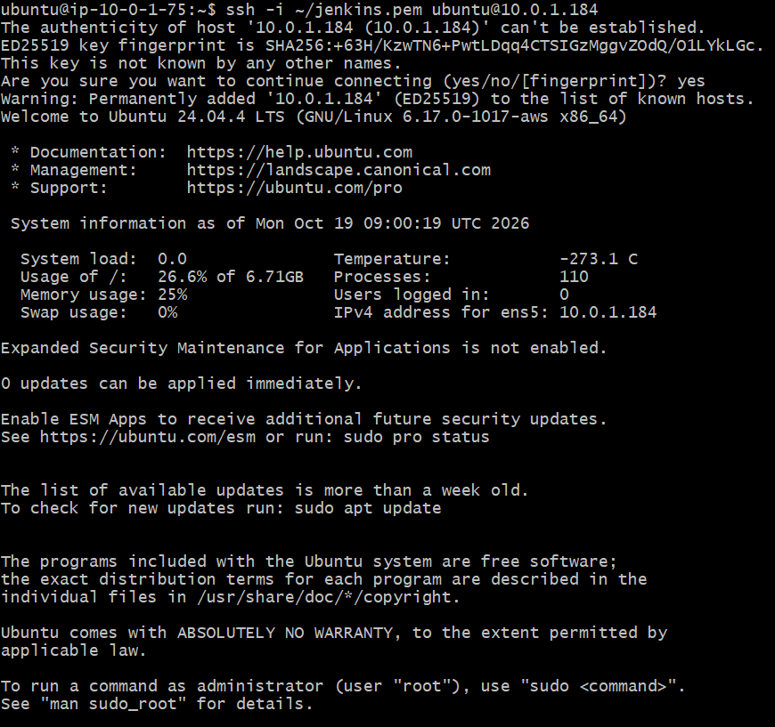
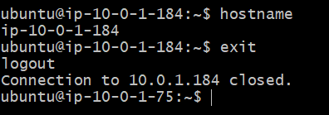
Step 6 — Create the Ansible inventory file
You are back on the master:
ubuntu@ip-10-0-1-75:~$
6.1 Create the lab directory
Run these commands on the master:
mkdir -p ~/ansible-lab
cd ~/ansible-lab
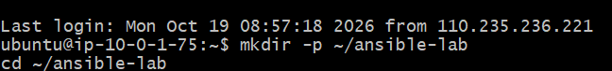
6.2 Create inventory.ini
Open the file:
nano inventory.ini
Paste the following configuration exactly:
[workers]
worker1 ansible_host=10.0.1.8
worker2 ansible_host=10.0.1.184
[workers:vars]
ansible_user=ubuntu
ansible_ssh_private_key_file=/home/ubuntu/jenkins.pem
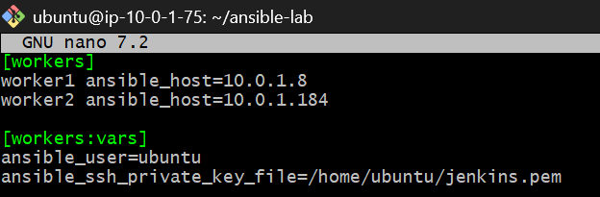
What this configuration means:
- [workers] defines the group containing both worker nodes.
- worker1 and worker2 are the inventory names.
- ansible_host specifies each worker's actual private IP.
- ansible_user=ubuntu specifies the SSH login user.
- ansible_ssh_private_key_file tells Ansible to use your jenkins.pem key.
Save and Exit
6.3 Verify the inventory
Run: cat inventory.ini
Confirm that both IP addresses and the key path match the configuration above.
Step 7 — Verify the workers with Ansible
7.1 List the inventory hosts
Run: ansible workers -i inventory.ini --list-hosts
Expected output:
hosts (2):
worker1
worker2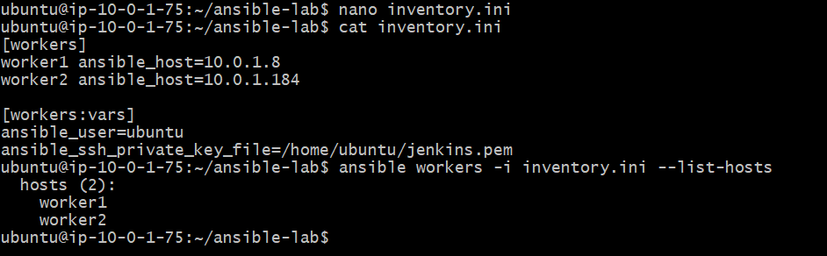
7.2 Run the Ansible ping test
Run: ansible workers -i inventory.ini -m ping
Expected result:
worker1 | SUCCESS => {
"changed": false,
"ping": "pong"
}
worker2 | SUCCESS => {
"changed": false,
"ping": "pong"
}
The order may vary. Both workers should return "ping": "pong".
Important: Ansible's ping module is not an ICMP network ping. It verifies that Ansible can connect over SSH and execute its Python-based module on the remote worker.
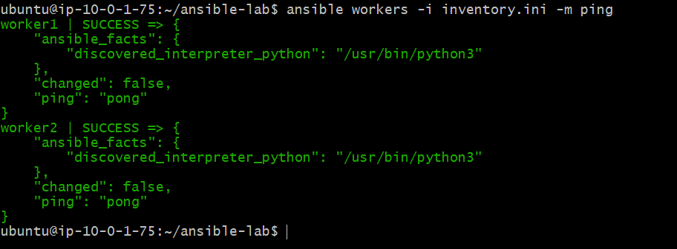
Task 2 — Execute Ansible ad-hoc commands
We'll now run the commands from your document, in order, using your existing inventory.ini.
Make sure you're on the master in this directory:
cd ~/ansible-lab
Command 1 — Check connectivity between workers
Your document's command is:
ansible all -m ping
Run the inventory-specific version:
ansible all -m ping -i inventory.ini
Expected result: both worker1 and worker2 return "ping": "pong".
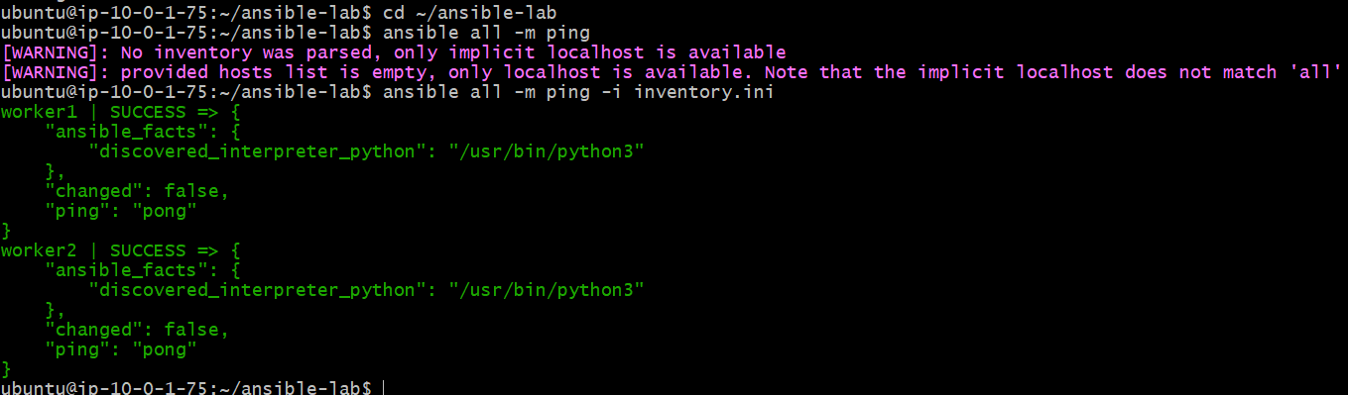
Command 2 — Gather facts from worker machines
Run:
ansible all -m setup -i inventory.ini
What it does: Collects system information from both workers, including operating system details, hostname, IP addresses, processor information, memory, and Python configuration.
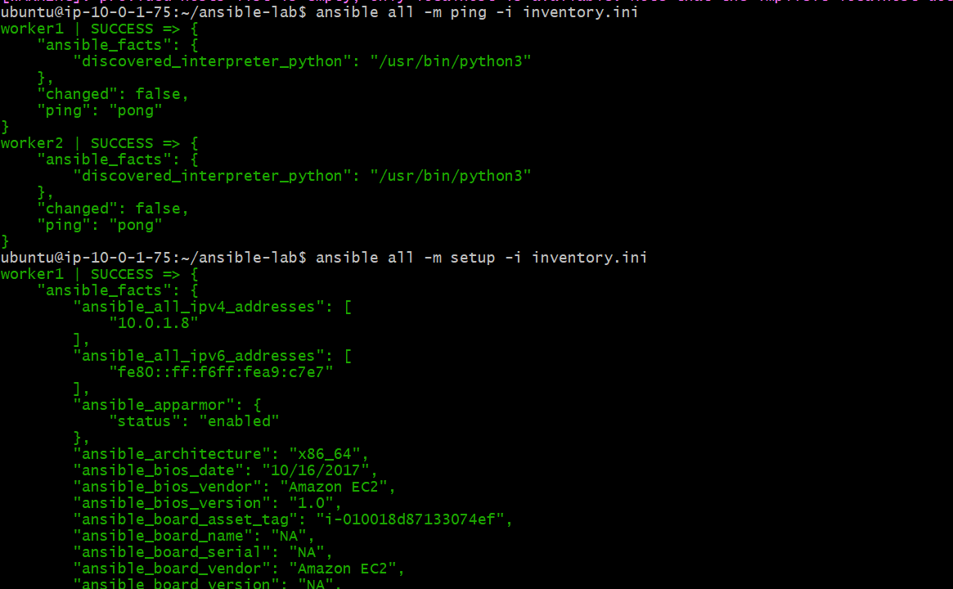
The output will be long. To view a smaller selection of facts, you can optionally run: ansible all -m setup -a "filter=ansible_distribution*" -i inventory.ini
This filtered command is optional.
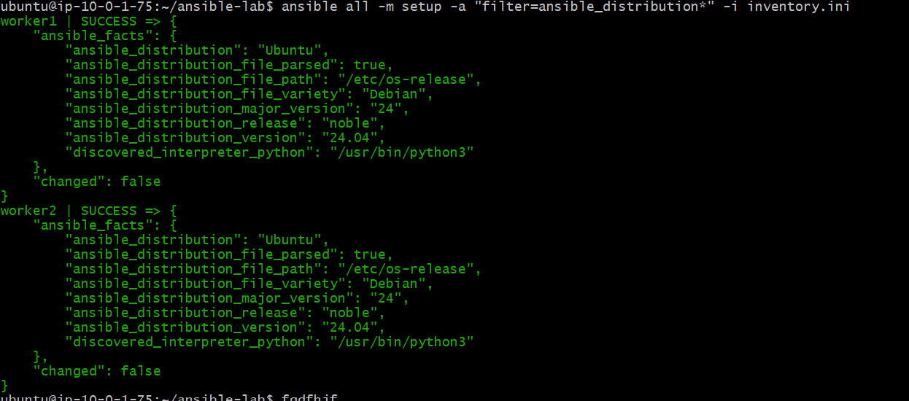
Command 3 — Test username and password authentication
Your document specifies:
ansible all -m ping --user=ansadm --ask-pass
Command 3A — Create the ansadm user
Run this command on the Ansible master:
ansible all -m user -a "name=ansadm state=present create_home=yes" -b -i inventory.ini
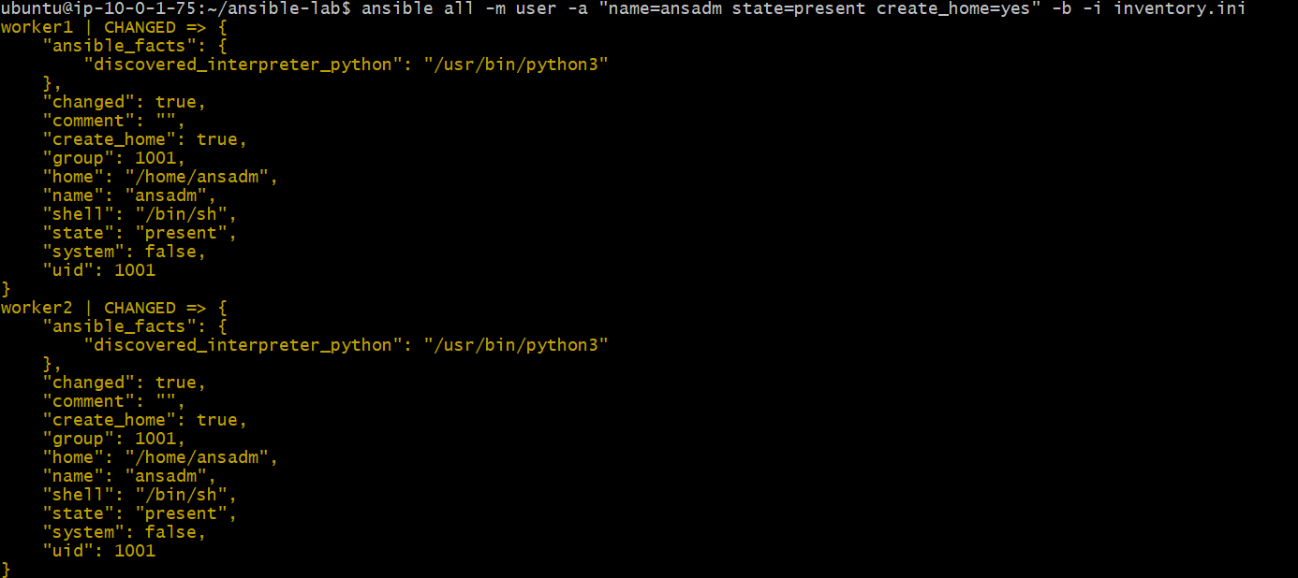
Step 3B — Generate password hash on master
On the Ansible master, run: openssl passwd -6
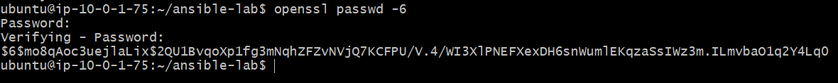
Apply the password to both workers
Run: ansible all -m user -a 'name=ansadm password=<PASTE_HASH_HERE> update_password=always' -b -i inventory.ini
Replace: <PASTE_HASH_HERE>
with the hash generated by openssl passwd -6.
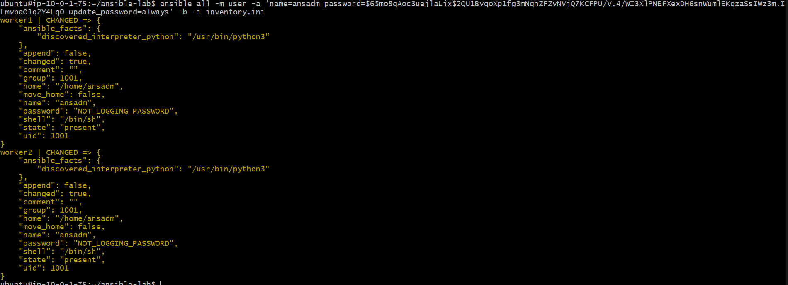
After password setup
We will check SSH password authentication:
ansible all -b -m shell -a "sshd -T | grep passwordauthentication" -i inventory.ini
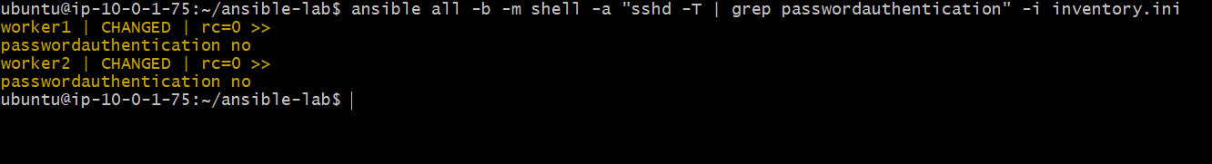
Then we will run your document command:
Run the Ansible ping command
Execute this from ~/ansible-lab: ansible all -m ping --user=ansadm --ask-pass -i inventory.ini
When prompted:
SSH password: Enter the password you configured for ansadm on both workers.
Expected successful output:
worker1 | SUCCESS => {
"changed": false,
"ping": "pong"
}
worker2 | SUCCESS => {
"changed": false,
"ping": "pong"
}
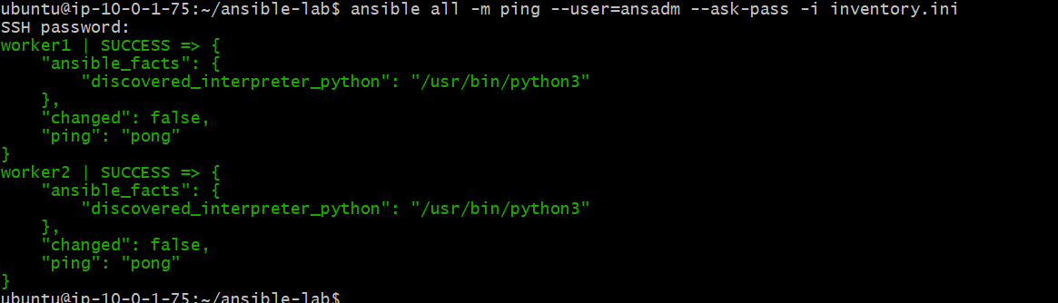
Command 4: Check uptime
Run this command from your current directory, ~/ansible-lab:
ansible all -a uptime -i inventory.ini
Expected output will look similar to this:
worker1 | CHANGED | rc=0 >>
15:20:10 up 2 hours, 1 user, load average: 0.00, 0.01, 0.00
worker2 | CHANGED | rc=0 >>
15:20:12 up 2 hours, 1 user, load average: 0.00, 0.01, 0.00
The actual uptime and load averages will differ. CHANGED here does not mean Ansible modified the system; it is the usual status for a command execution.
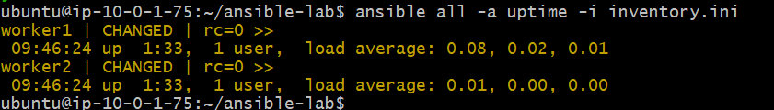
Command 5: Check memory usage
Run this command on the Ansible master:
ansible all -a "free -m" -i inventory.ini
This displays memory usage on both workers in megabytes.
The actual values will depend on your EC2 instance sizes and current usage. free -m is a read-only command.
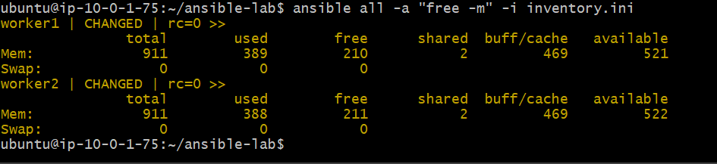
Command 6: Check the ansadm user
The original lab command uses an older Ansible option. We'll use the modern equivalent with shell and privilege escalation.
Run: ansible all -m shell -a "cat /etc/passwd | grep -i ansadm" -b -K -i inventory.ini
- -m shell — executes a shell command, allowing the pipe (|).
- -b — runs the command with privilege escalation (sudo).
- -K — prompts for the remote sudo/become password.
- -i inventory.ini — selects your inventory.
Important: If the ubuntu account on your workers does not require a sudo password, try this instead: ansible all -m shell -a "cat /etc/passwd | grep -i ansadm" -b -i inventory.ini
Expected output should contain an entry similar to:
ansadm:x:1001:1001::/home/ansadm:/bin/sh
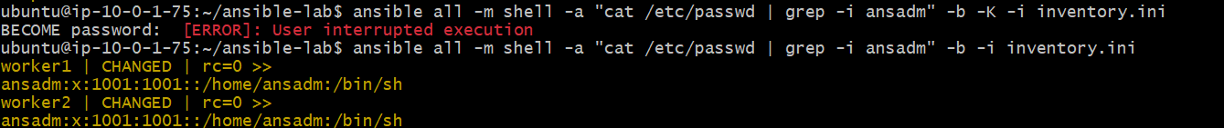
Command 7: Create a directory as ansadm
Run this command from your Ansible master:
ansible all -m file -a "path=/home/ansadm/test state=directory owner=ansadm group=ansadm mode=0755" -b -i inventory.ini
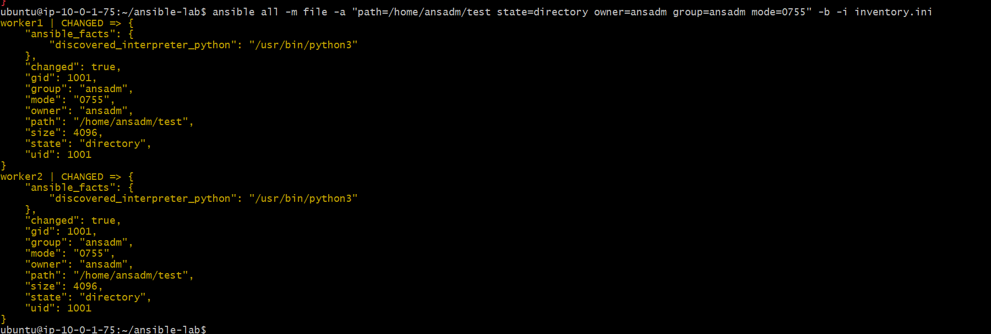
Step 2: Verify the directory
If Step 1 succeeds, run:
ansible all -m command -a "ls -ld /home/ansadm/test" -b -i inventory.ini
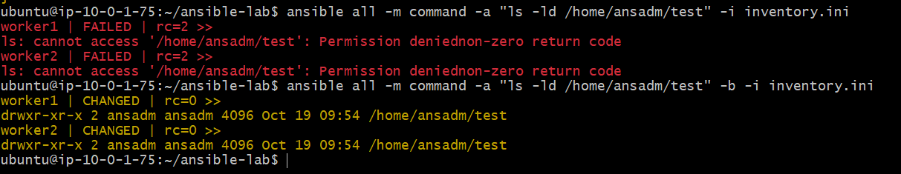
Command 8: Create a group
Now create a Linux group named test on both workers.
Run: ansible all -m group -a "name=test state=present" -b -i inventory.ini
Explanation:
- -m group — uses Ansible's group module.
- name=test — specifies the group to create.
- state=present — ensures the group exists.
- -b — uses privilege escalation to create the group.
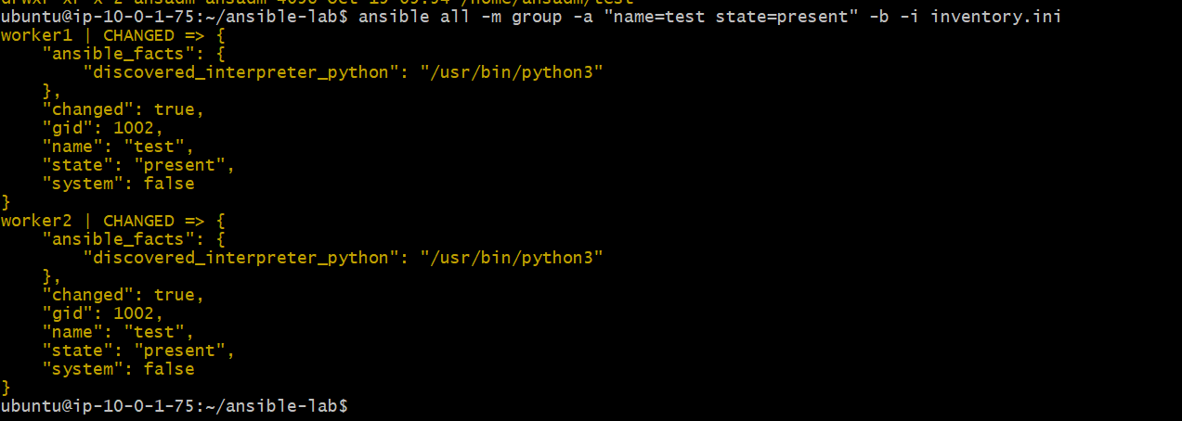
Command 9: Create a file
Your lab document has a likely typo in the path (/home/asnadm/testfile). Since the user you created is ansadm, we'll use the corrected path /home/ansadm/testfile.
Run: ansible all -m file -a "path=/home/ansadm/testfile state=touch mode=0755 owner=ansadm group=ansadm" -b -i inventory.ini
What this does:
- state=touch — creates an empty file if it doesn't exist.
- mode=0755 — sets file permissions.
- owner=ansadm group=ansadm — assigns the file to ansadm.
- -b — runs with elevated privileges.
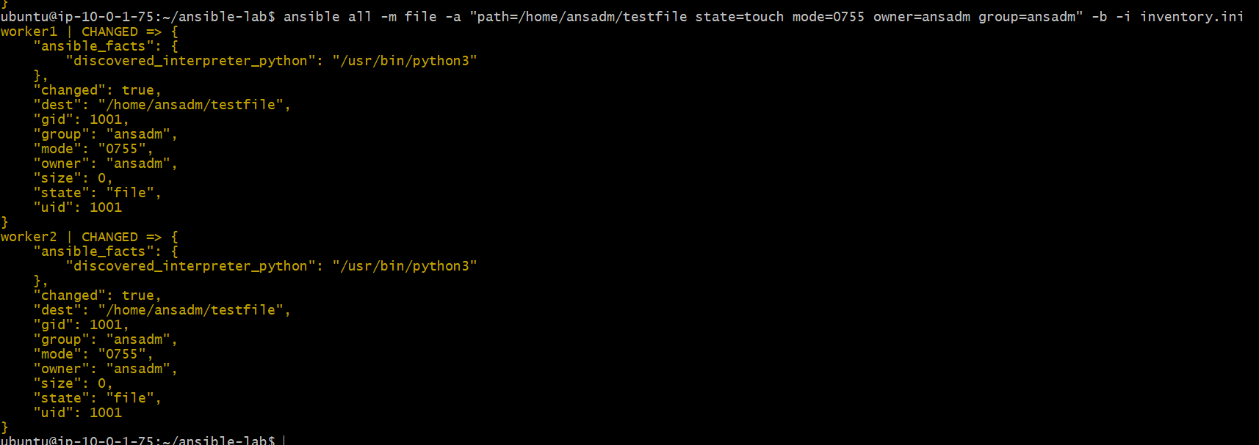
Command 10: Change file ownership and group
Your lab command is:
ansible all -m file -a "path=/home/ansadm group=weblogic owner=weblogic" -b -i inventory.ini
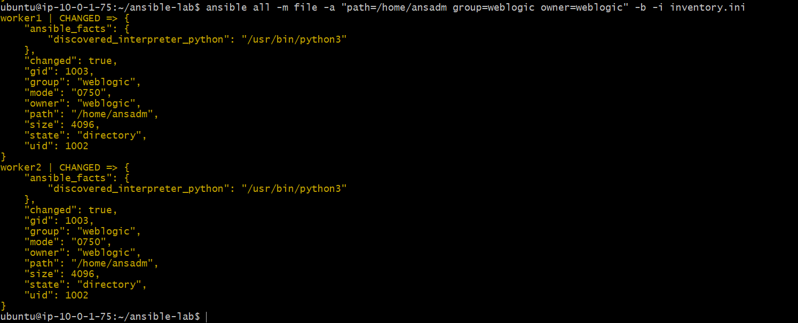
Command 11: Install Apache
Your lab instructions may use yum, but your worker machines run Ubuntu. Therefore, use the apt module instead.
Run: ansible all -m apt -a "name=apache2 state=present update_cache=yes" -b -i inventory.ini
What this does:
- -m apt — uses Ubuntu's package manager.
- name=apache2 — selects the Apache web server package.
- state=present — ensures Apache is installed.
- update_cache=yes — refreshes the package index.
- -b — enables privilege escalation.
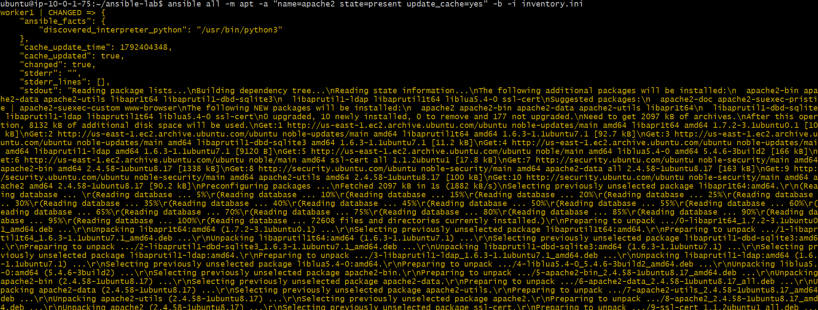
Command 12: Start and enable Apache
Run this command on your Ansible master:
ansible all -m service -a "name=apache2 state=started enabled=yes" -b -i inventory.ini
This will:
- state=started — ensure Apache is running.
- enabled=yes — configure Apache to start automatically after reboot.
- -b — use elevated privileges.
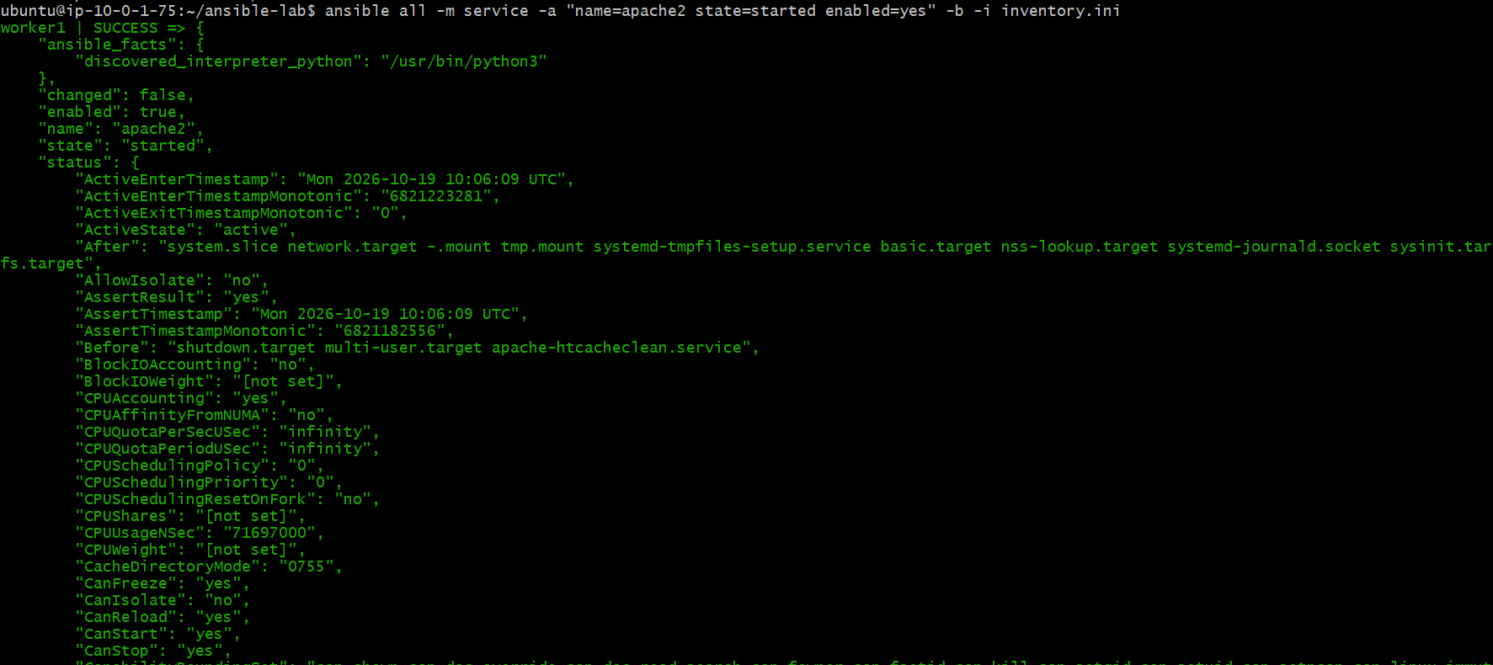
Final verification: Check Apache's HTTP response
Run this command on the Ansible master:
ansible all -m command -a "curl -I http://127.0.0.1" -b -i inventory.ini
