Day -2

PUBLIC KEY & PRIVATE KEY MECHANISM

Before keys existed, systems relied mainly on passwords. Passwords created many problems: they can be guessed, reused, stolen, shared, or leaked. In large systems like servers, cloud platforms, Git repositories, and CI/CD pipelines, passwords become a security risk and an operational headache. Public and private keys were created to solve this exact problem—secure identity verification without sharing secrets.

Lets explain it in simple example:
Think of public key and private key like a lock and a key.
- The public key is the lock
- The private key is the physical key
You can give the lock to anyone. There is no risk.
But the key must stay with you. If someone gets your key, they become you.
In DevOps terms:
- Public key → stored on servers, Git platforms, cloud services
- Private key → stays on your laptop, jump server, or CI/CD system

- What Actually Happens During Authentication (No Math, Just Logic)
When you try to connect to a server using SSH:
- The server already has your public key
- The server sends a challenge
- Your system answers the challenge using the private key
- The server verifies the answer using the public key
- If it matches → access granted

Many people confuse here:
Public key can be shared.
Private key must never be shared.
- Where Public/Private Keys Are Used in Real DevOps Work
As a DevOps engineer, you use key pairs every single day, even if you don’t notice it.
- SSH access to Linux servers
- Git authentication (GitHub, GitLab, Bitbucket)
- CI/CD pipelines accessing servers or repositories
- Cloud access (AWS key pairs for EC2)
- Secure communication between services
- Bastion host / jump server access
- Automation tools (Ansible, Terraform, Jenkins agents)
- Types of Key Pairs You Will Encounter
  - RSA keys (older, widely used)
  - ED25519 keys (modern, faster, more secure)
  - ECDSA keys (used in some environments)

Practicals:
METHOD 1: SSH KEY CREATION USING ssh-keygen
- This is the default and most widely used method across Linux, macOS, WSL, cloud VMs, and CI/CD servers. If you remember only one method, remember this.
- SSH access needs a secure identity. ssh-keygen creates a pair of keys together so they mathematically match. You never create public and private keys separately.
- Now go to any server, or open powershell/command prompt in local machine
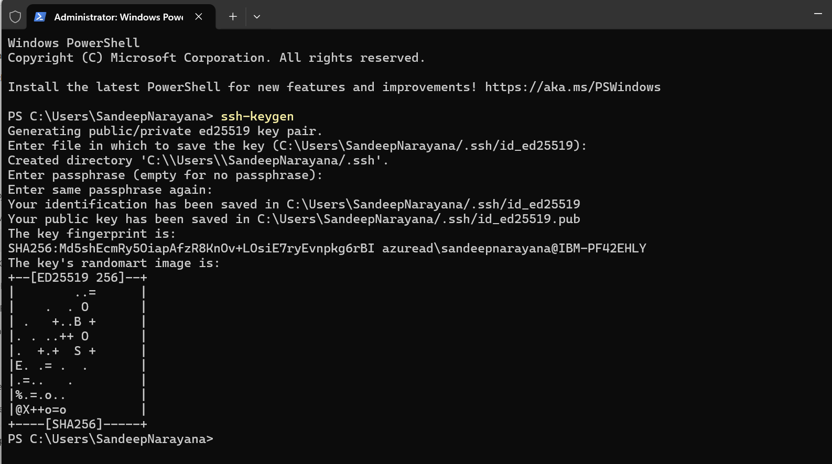
The system asks where to save the key. By default, it uses:
~/.ssh/id_rsa
This creates:
  - id_rsa → private key
  - id_rsa.pub → public key

