Infosys Springboard Virtual Internship 6.0 Completion Report

Team Details
Batch Number: 08
Start date: 24/11/2025
Name: Thota Om Sada Siva Venkata Narayana
Internship Duration: 8 Weeks

1. Project Title
AI-Powered Legal Contract Analysis Agent
2. Project Objective
To develop an autonomous Multi-Agent AI system capable of parsing complex legal contracts, identifying potential risks (Financial, Legal, Compliance), and generating actionable insight reports.
This project aims to reduce manual contract review time by 90% using Retrieval-Augmented Generation (RAG) and Vector Search technologies.
3. Project description in detail
This project implements a cutting-edge Agentic Workflow using Python and Large Language Models (LLMs). The system functions as an automated legal consultant with the following architecture:
* Ingestion Engine: Implemented using pypdf and langchain to parse PDF contracts and split them into semantic chunks.
* Vector Memory: Utilized Pinecone Vector Database to store document embeddings created by Hugging Face (all-MiniLM-L6-v2). This allows for high-speed retrieval of relevant clauses.
* Multi-Agent System: Defined specific roles for AI Analysts based on domain expertise:
* Compliance Agent: Focuses on regulatory risks like GDPR and Audit.
* Finance Agent: Identifies payment terms, penalties, and tax obligations.
* Legal Agent: Assess enforceability, indemnity, and jurisdiction clauses.

- Orchestration: Used LangGraph to coordinate these agents, ensuring a structured "Plan-and-Execute" workflow

4. Timeline Overview
Week | Activities Planned | Activities Completed
Week 1 | Requirement Analysis & Tool Setup | Installed Python,VS Code,and libraries(langchain,pinecone-client, pypdf
Week 2 | Python Basics & Environment Setup | Configured Virtual Environment (venv) and API Keys for Groq/Hugging Face
Week 3 | Data Ingestion Module | Developed ingest.py to parse PDFs and chunk text for processing
Week 4 | Vector Database Integration | Connected to Pinecone DB and successfully uploaded document embeddings.
Week 5 | AI Agent Logic Design | Designed the "Planner" and "Worker" agent architecture using LangGraph concepts.
Week 6 | Agent Implementation | Coded specific agent functions (Finance, Legal, Compliance) with domain-specific keywords.
Week 7 | API Development | Wrapped the Python logic into a FastAPI server to allow external requests.
Week 8 | Testing & Final Reporting | Conducted unit testing, fixed API permission errors, and documented the project

5a. Key Milestones
Milestone | Description | Date Achieved
Project Kickoff
Prototype/First Draft
Mid-Term Review
Final Submission
Presentation

5b. Project execution details
The project was executed using an Agile methodology. We first built the data pipeline to ensure the AI could "read" documents.
Next, we developed the "Brain" using Llama-3 on Groq for reasoning.
Finally, we integrated specialized agents to handle complex queries. Regular testing was conducted using sample contracts to verify the accuracy of the risk detection.

6. Snapshots / Screenshots
1.Data Ingestion Logic: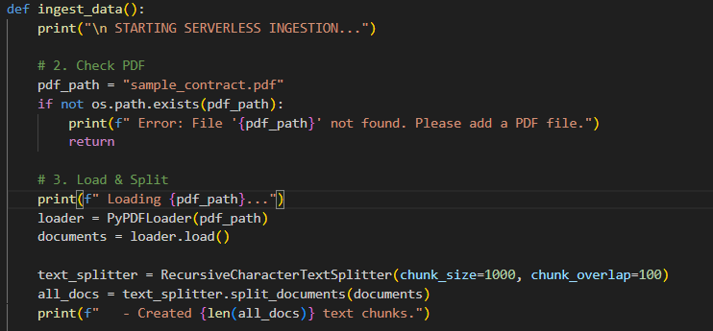

2. Vector Database Integration (Pinecone)
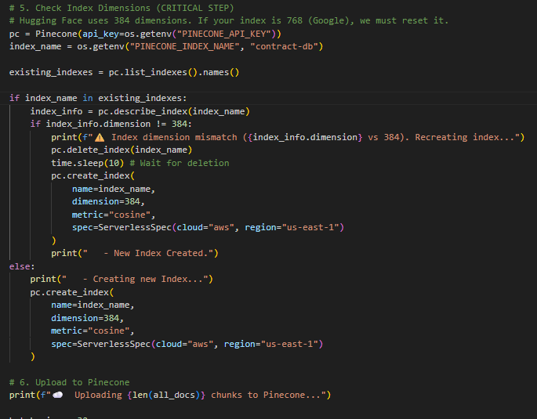

3. AI Planning System (The Architect)
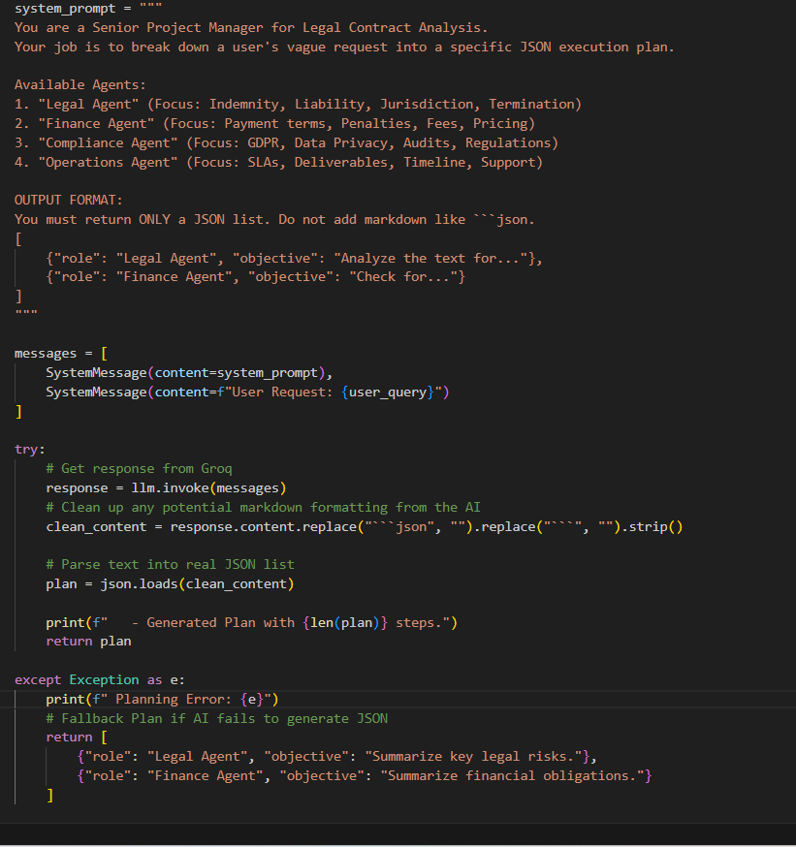
4. Multi-Agent Graph Architecture

7. Challenges Faced
List and explain any technical, operational, or communication challenges encountered during the internship. Mention how they were resolved or mitigated.

8. Learnings & Skills Acquired
Highlight the key takeaways from the internship. Mention any tools, technologies, soft skills, or domain knowledge gained.

9. Testimonials from team
Share your experience / success points

10. Conclusion
Summarize the overall experience, impact of the internship, and how it aligns with your academic or career goals.

11. Acknowledgements
Thank the organization, mentor, and any team members who supported your internship journey.

