**HW7- Created a simple front-end application by using Node and React+Vite by using the given tutorial links:**

**Vite, React and JavaScript installed through npm:**

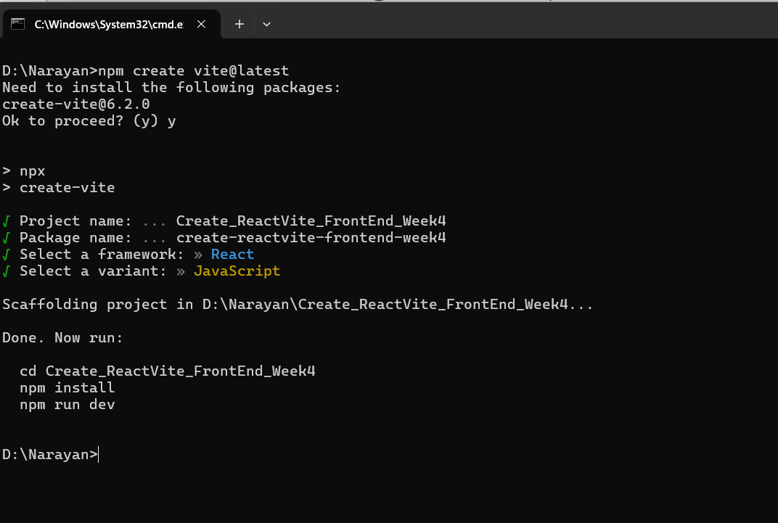

**Started the Vite server**

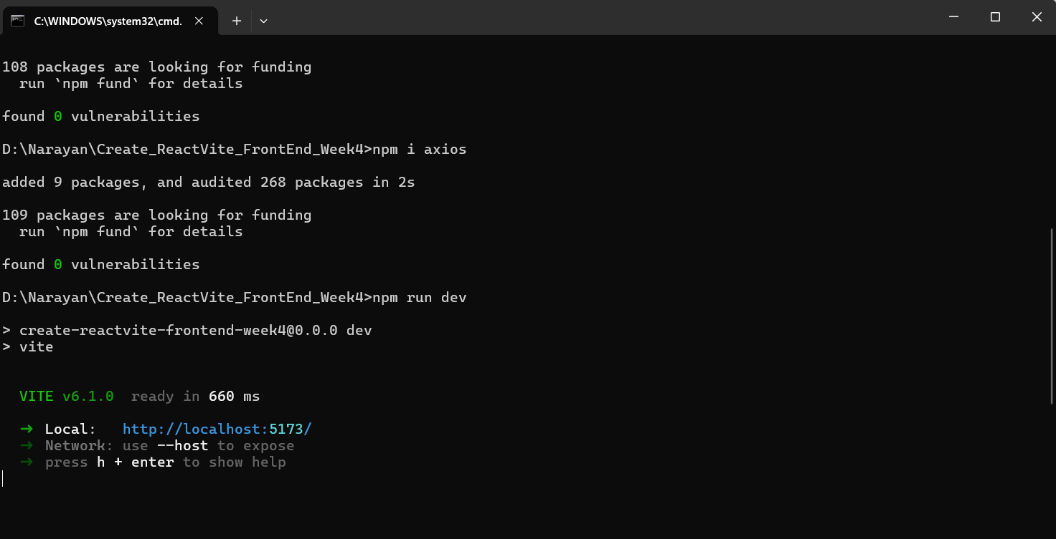

**Default application page with Vite + React Logo’s displayed**

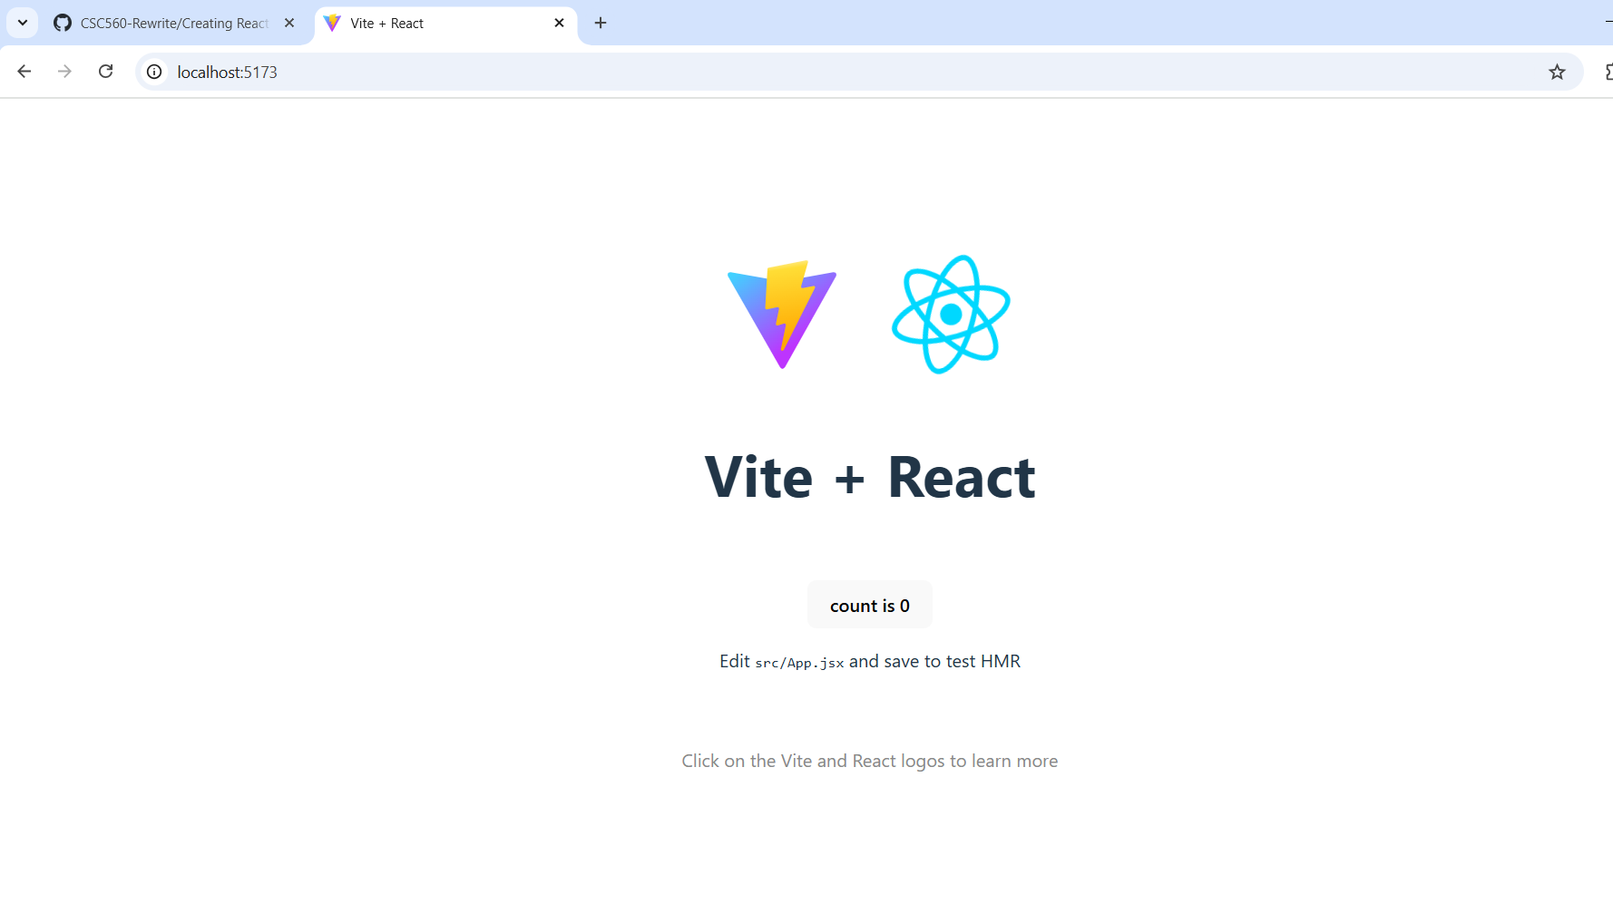

**The Created Vite+React project structure and added Random Button component**

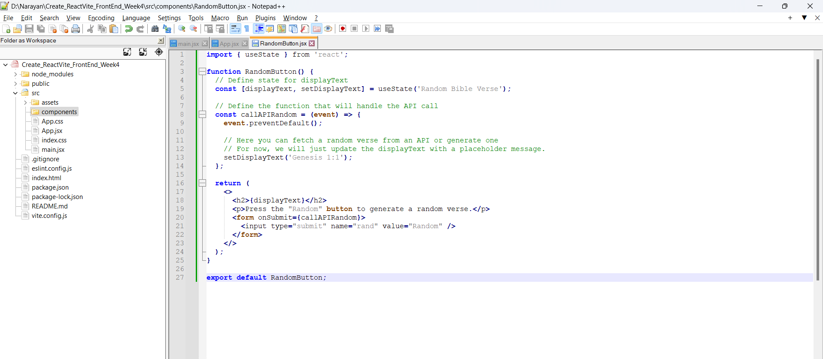

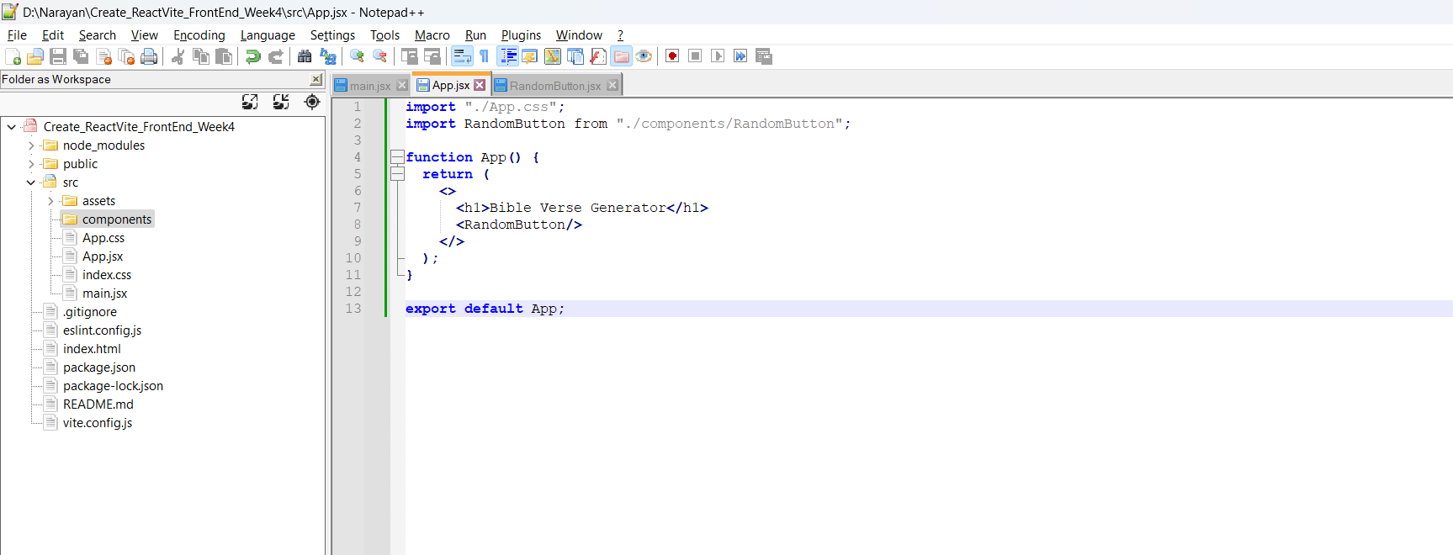

**Application after adding Bible Verse component**

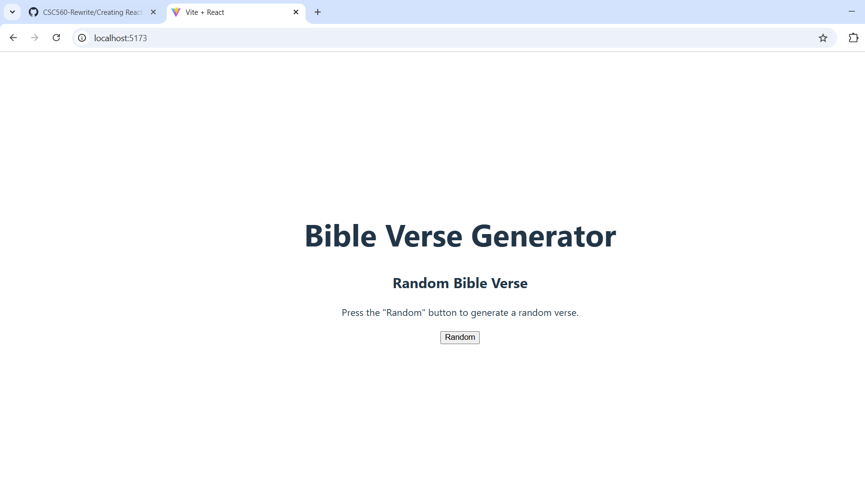

**Clicked on Random Button**

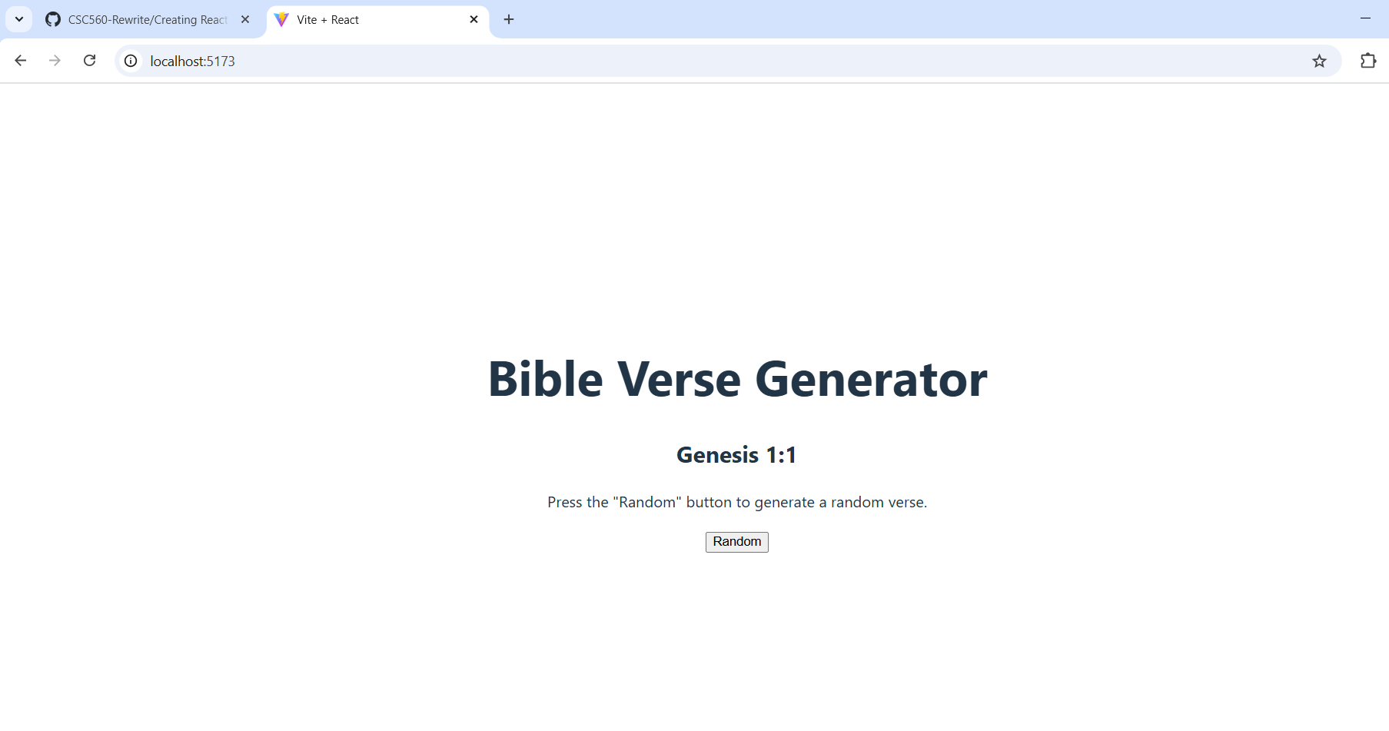

**After adding code to the Random Button component to fetch the Bible verses as Random click**

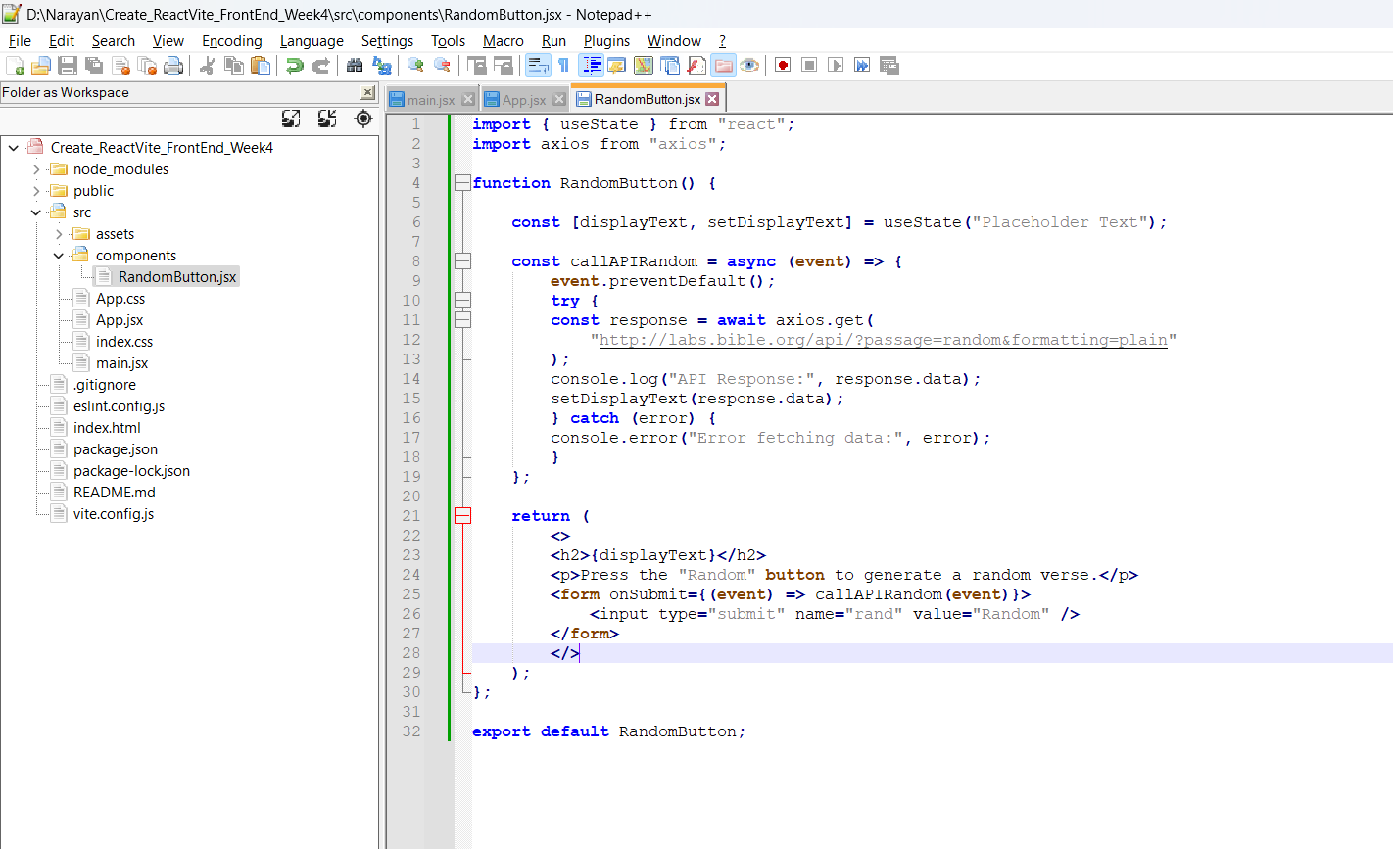

**Click#1**

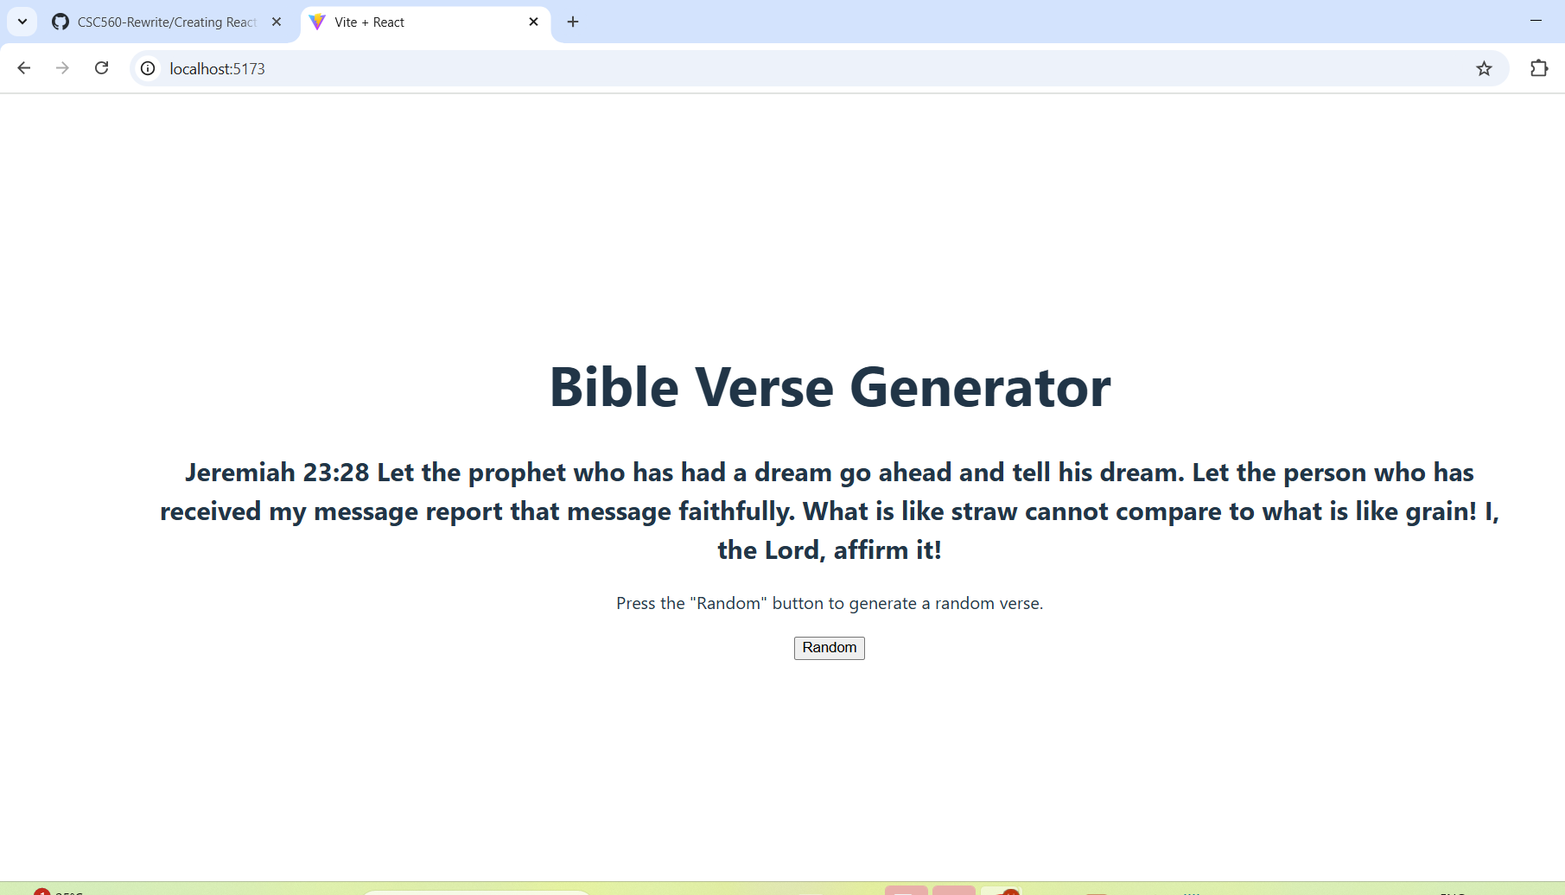

**Click#2**

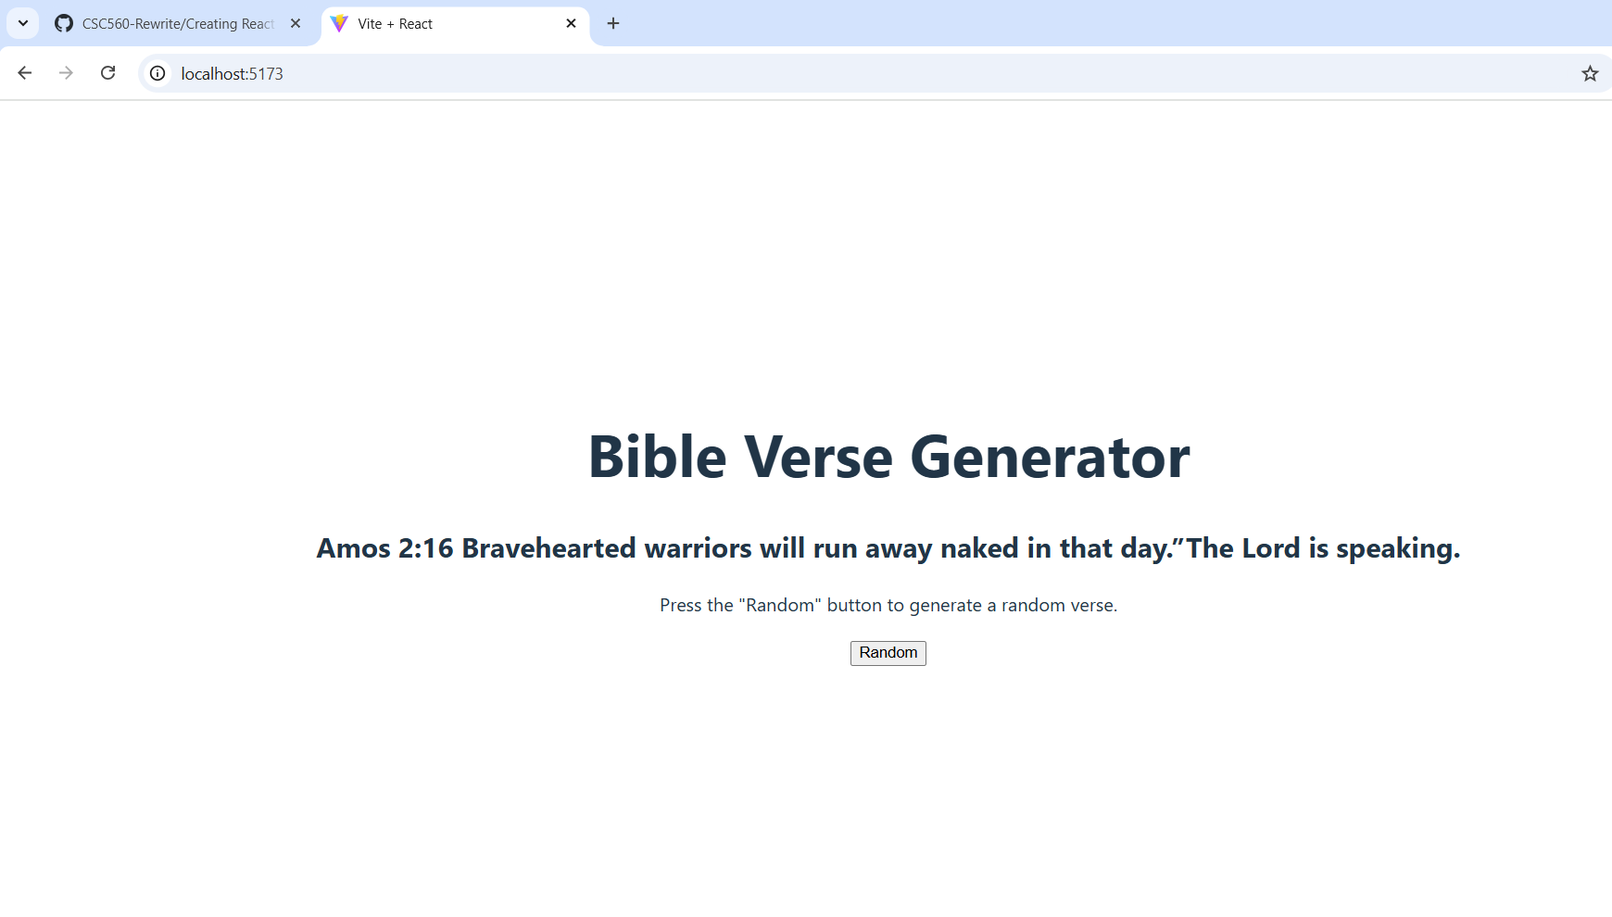**Retrieval Component to get the Specific verse to see the specific verse from the bible org.**

**By Default, ‘John+3:16-17’ sample verse displayed in the text option**

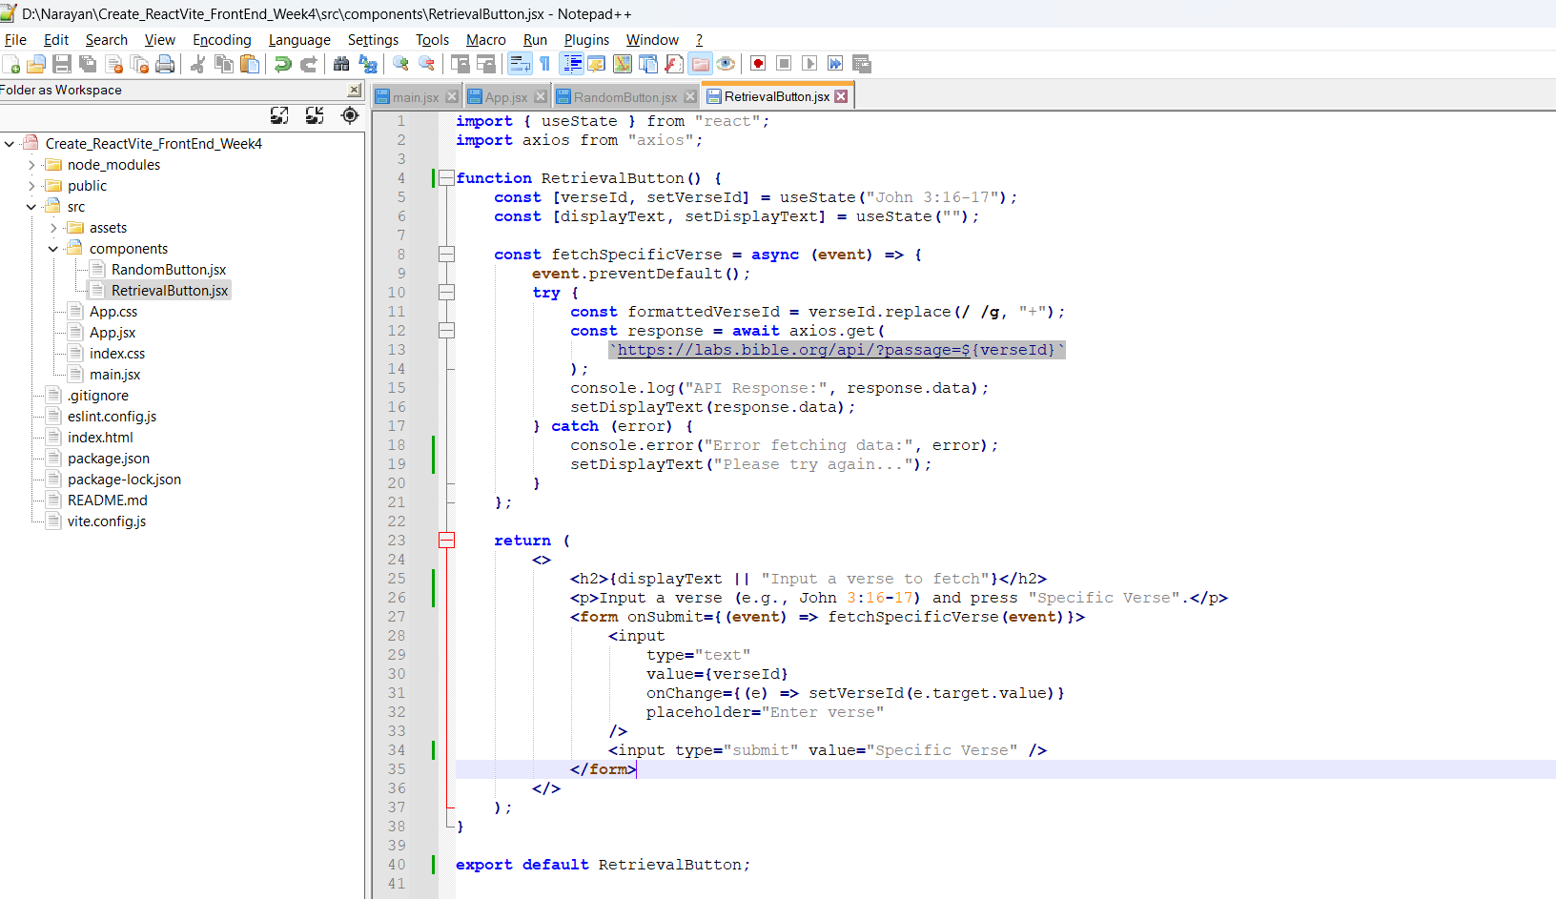

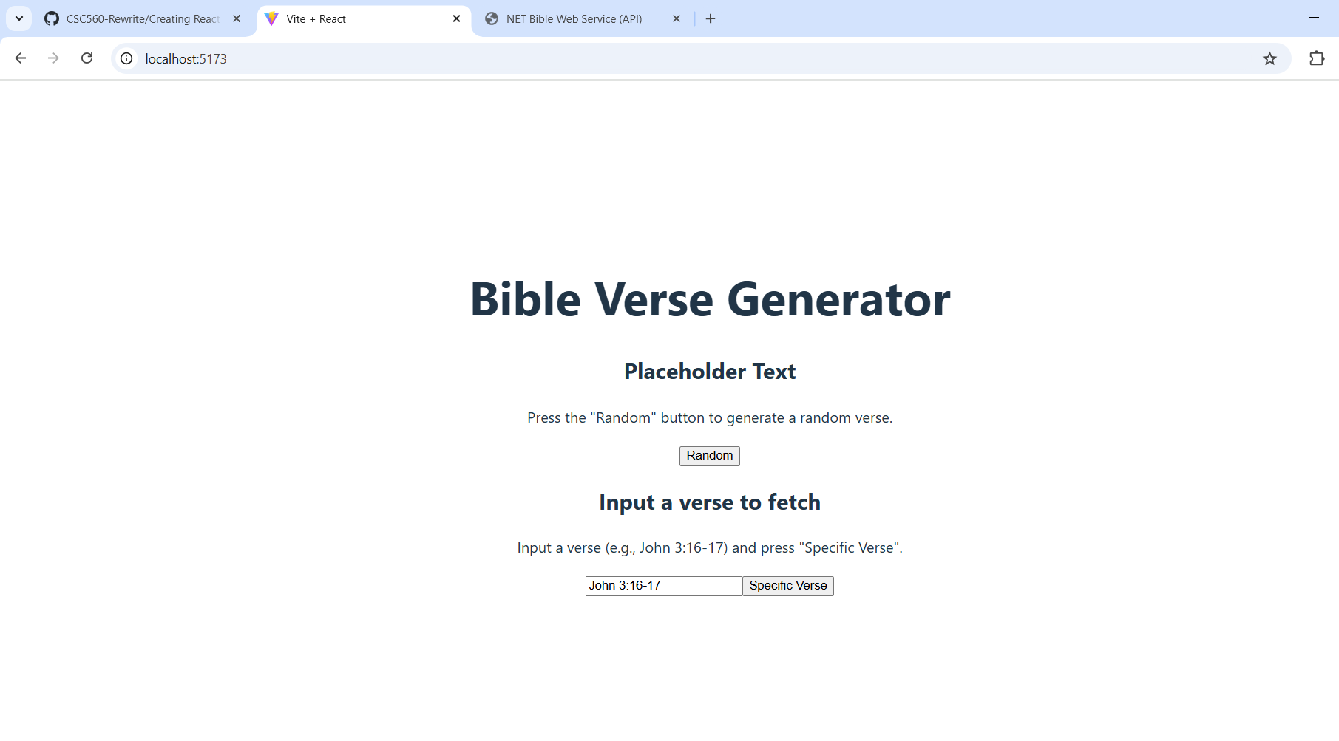

**Click on Specific Verse button with different values**

