**Completed Creating an API with MEN and Created GET, POST, PATCH and DELETE API calls from the tutorial reading 2:**

**Initialized npm path and installed dependencies:**

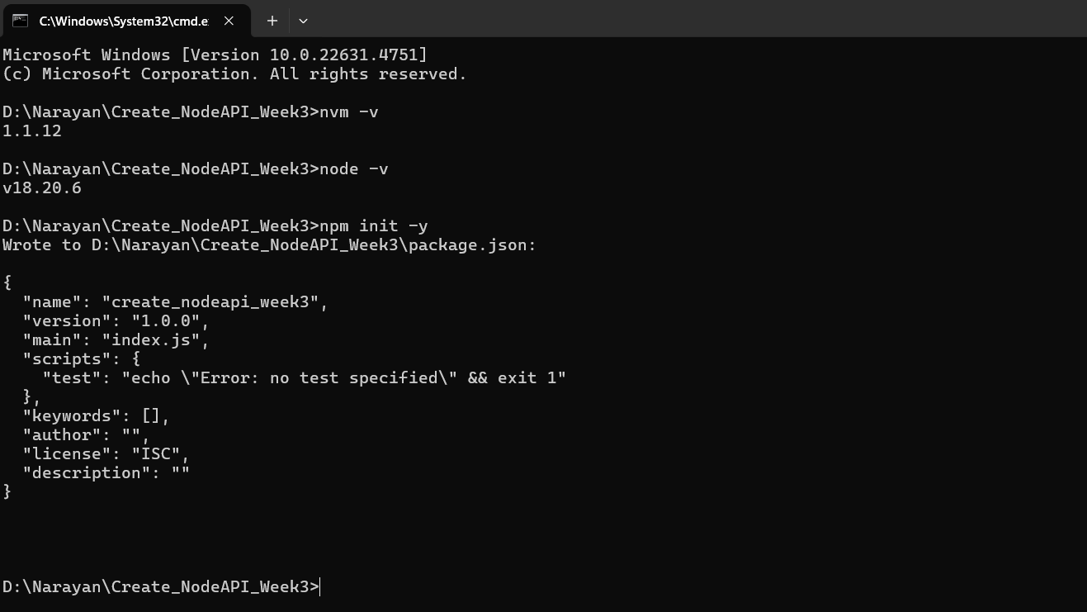

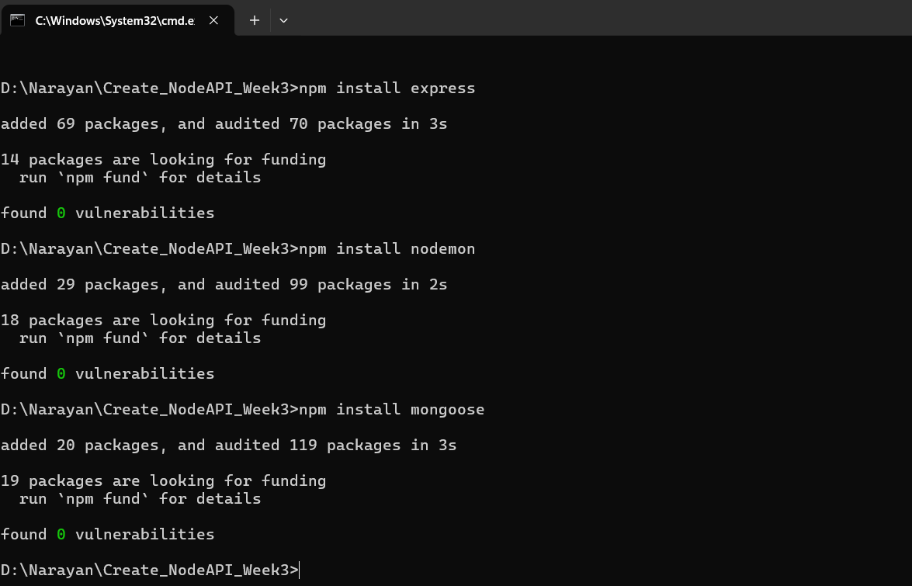

**package.json file:**

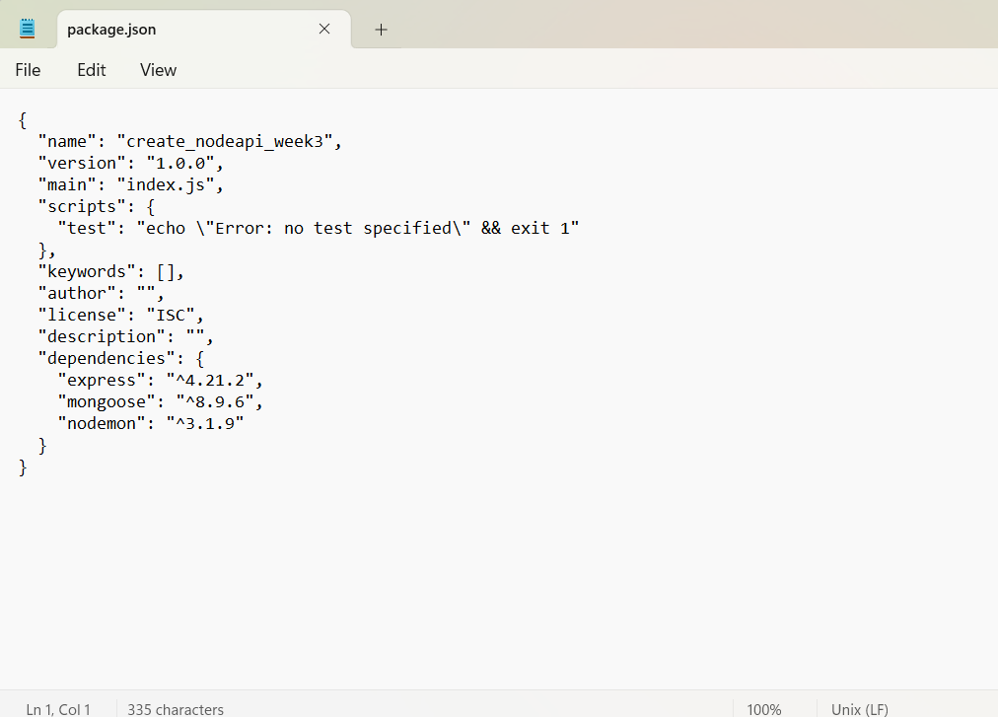

**Created Server.js and able to access the server from the address localhost:3000**

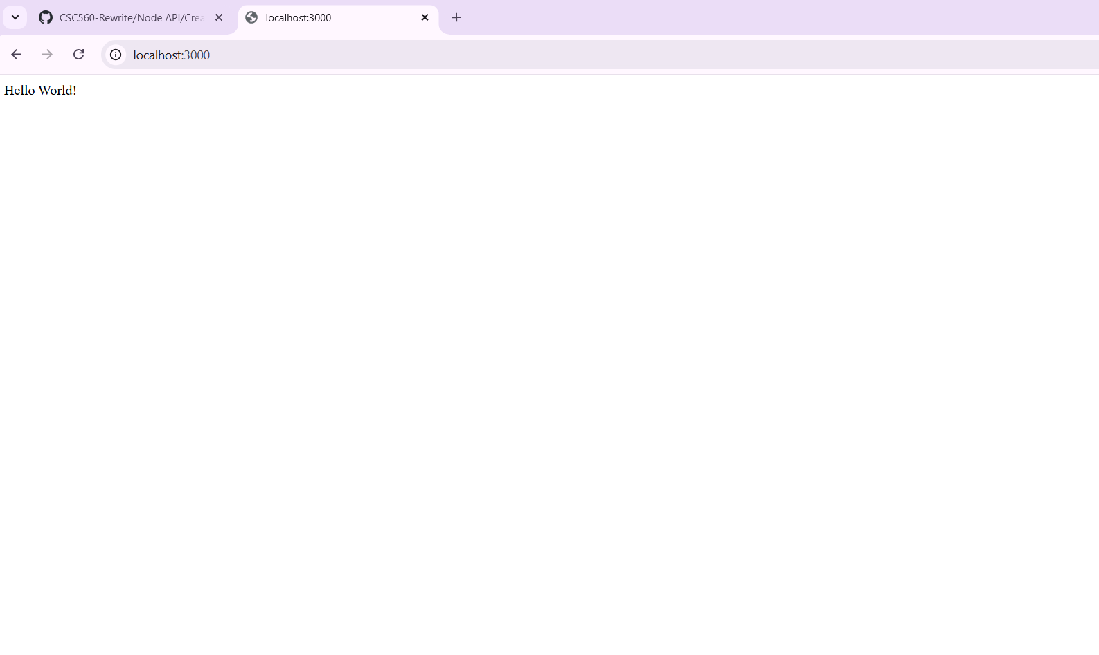

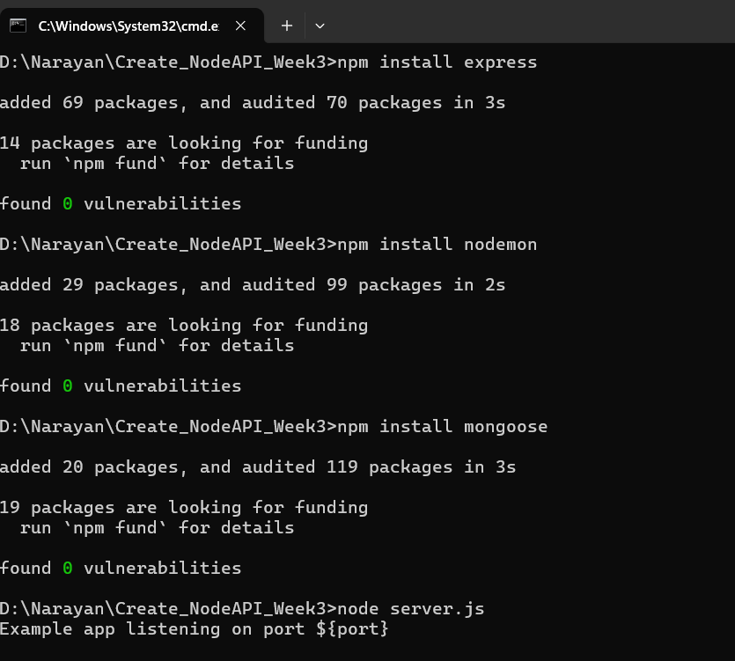

**Created Routes and able to access the Sending players url:**

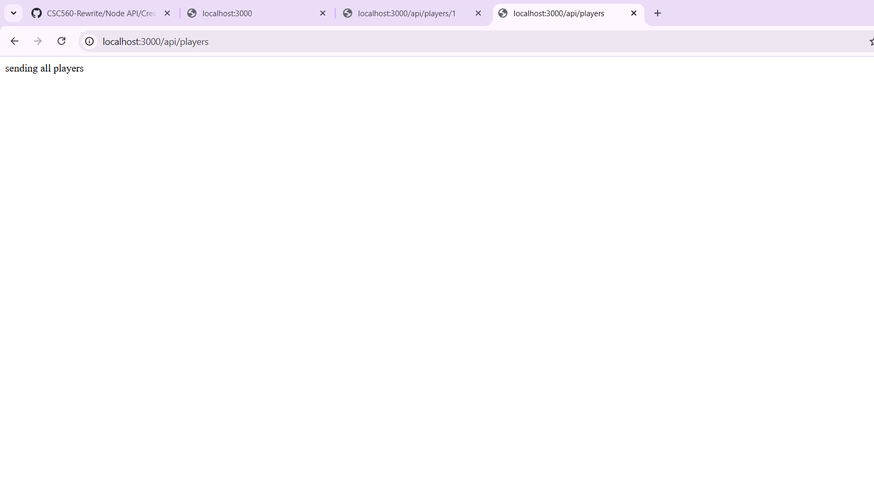

**Linked to a MongoDB database-** Created Models and Schemas – Able to access the API’s in Postman.

**POST API:**

**URL: localhost:3000/api/players**

User#1 – Sample payload

{

"name": "Jordan Love",

"number": 10,

"position": "quarterback"

}

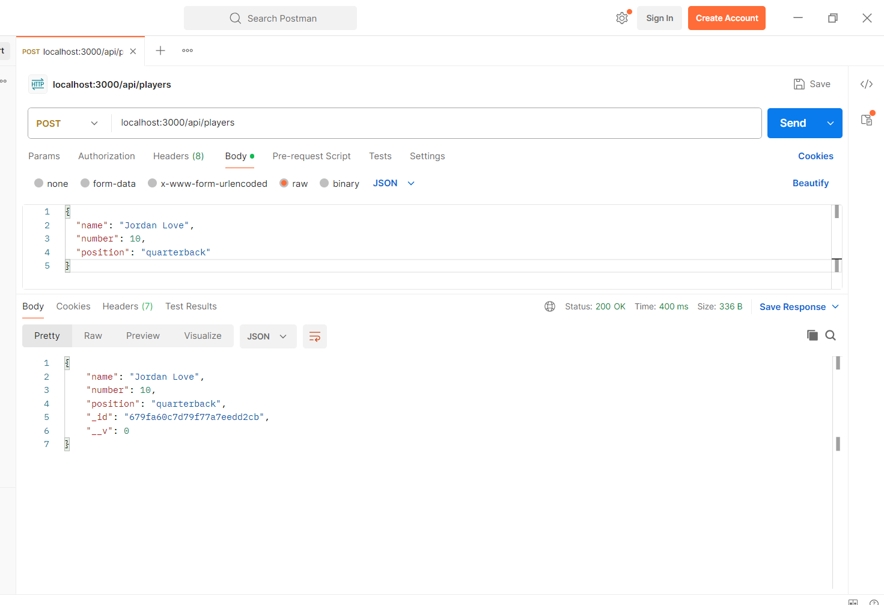

User#2

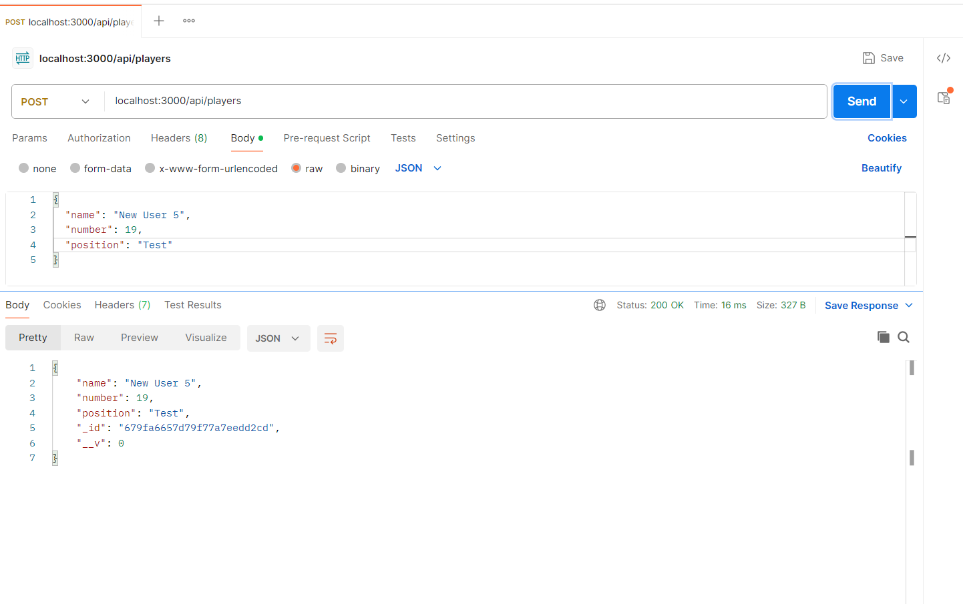

User#3

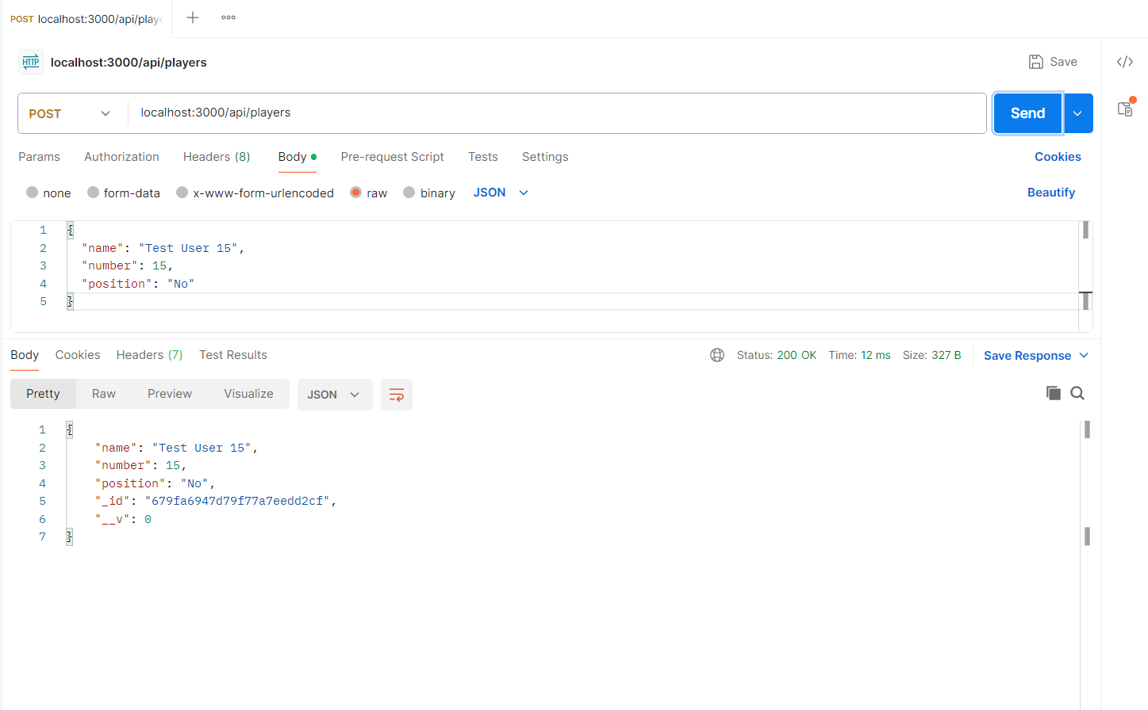

User#4

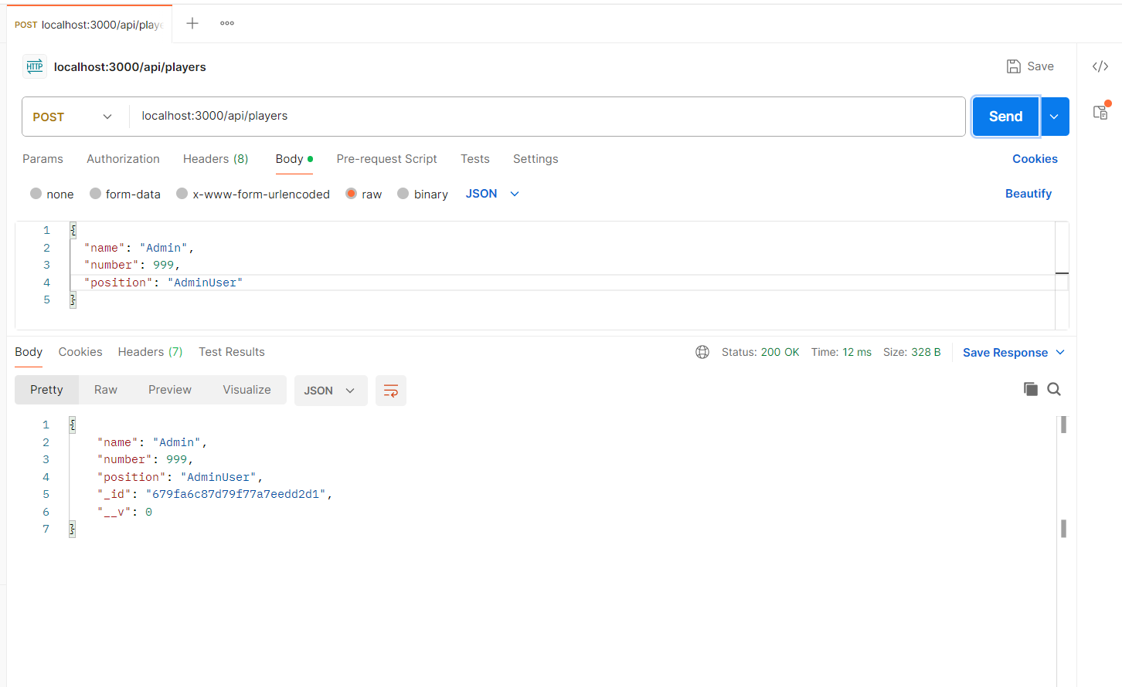

**GET API: All players**

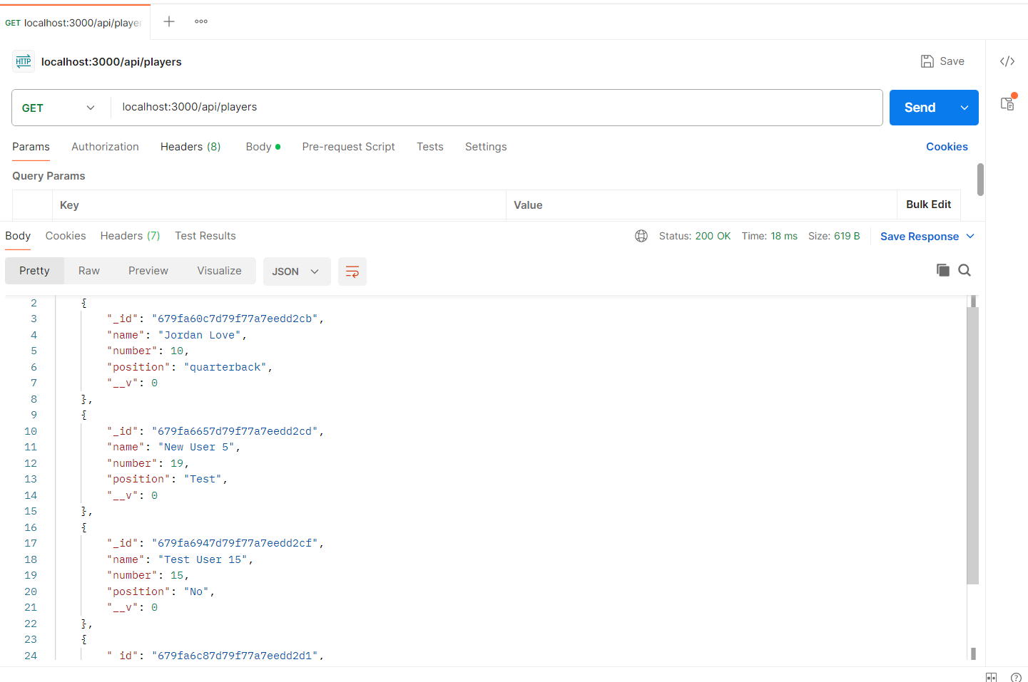

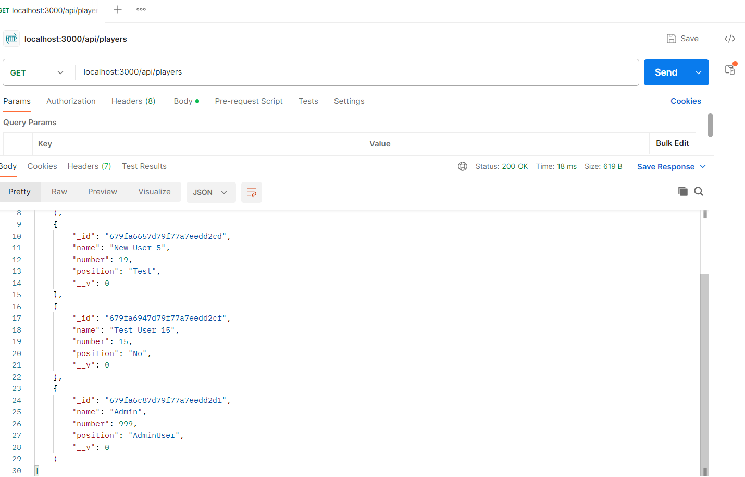

**GET API - Single User** By using id:

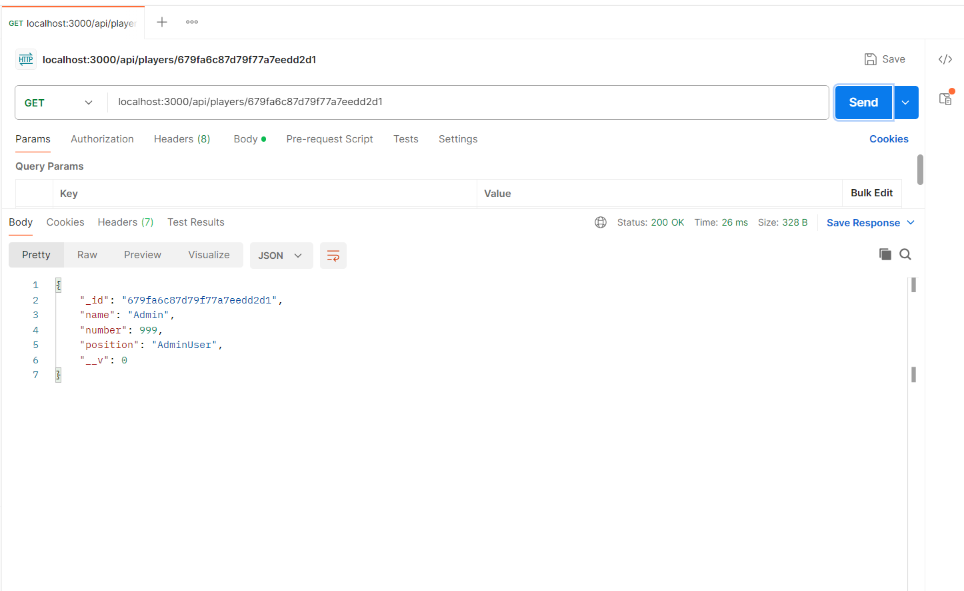

**PATCH API: to update the user data (Test User 15)**

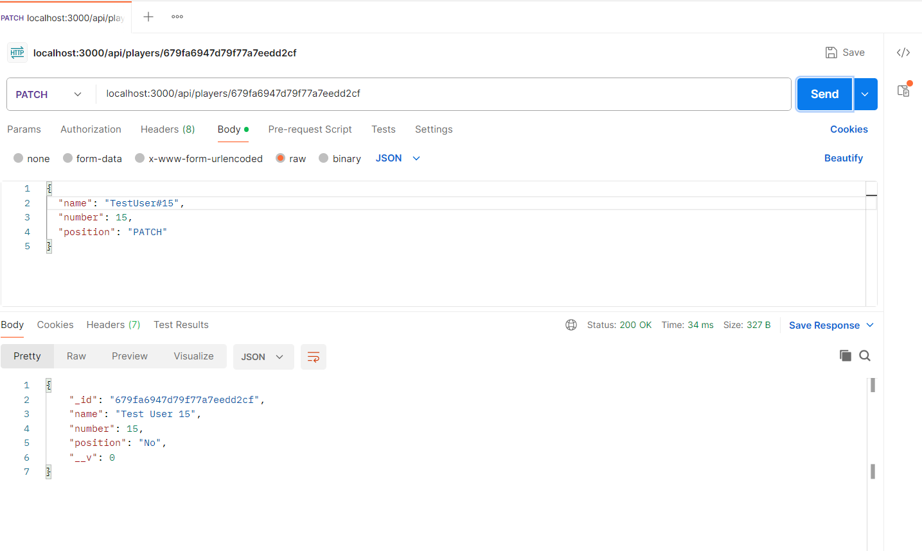

**GET API for the Patch user**

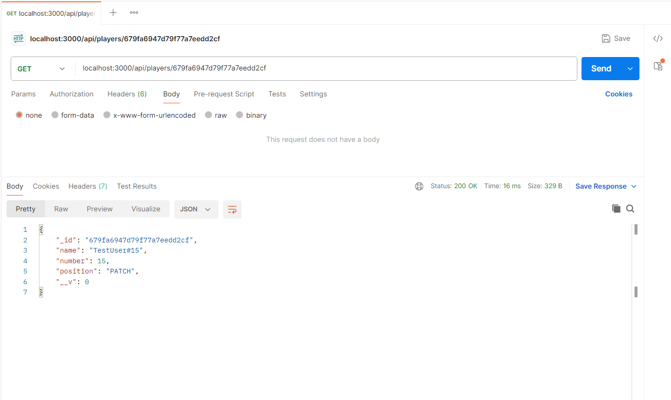

**DELETE API – Deleted the user by using the unique id**

**Deleted ‘New User 5’ by using the id**

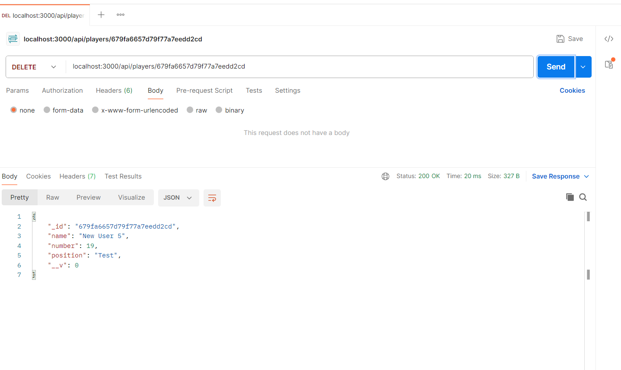

**GET API for all players after Deleting a user**

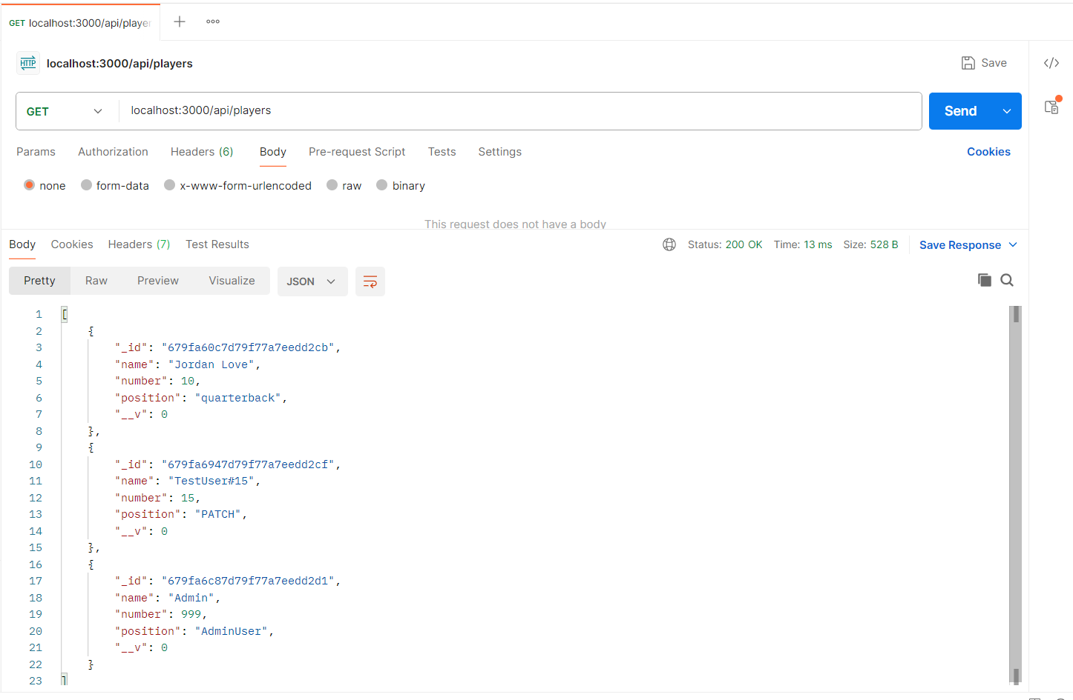

**All Players on Browser by using the localhost**

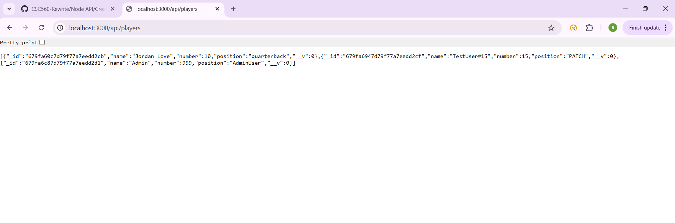

**Server.js – API calls**

