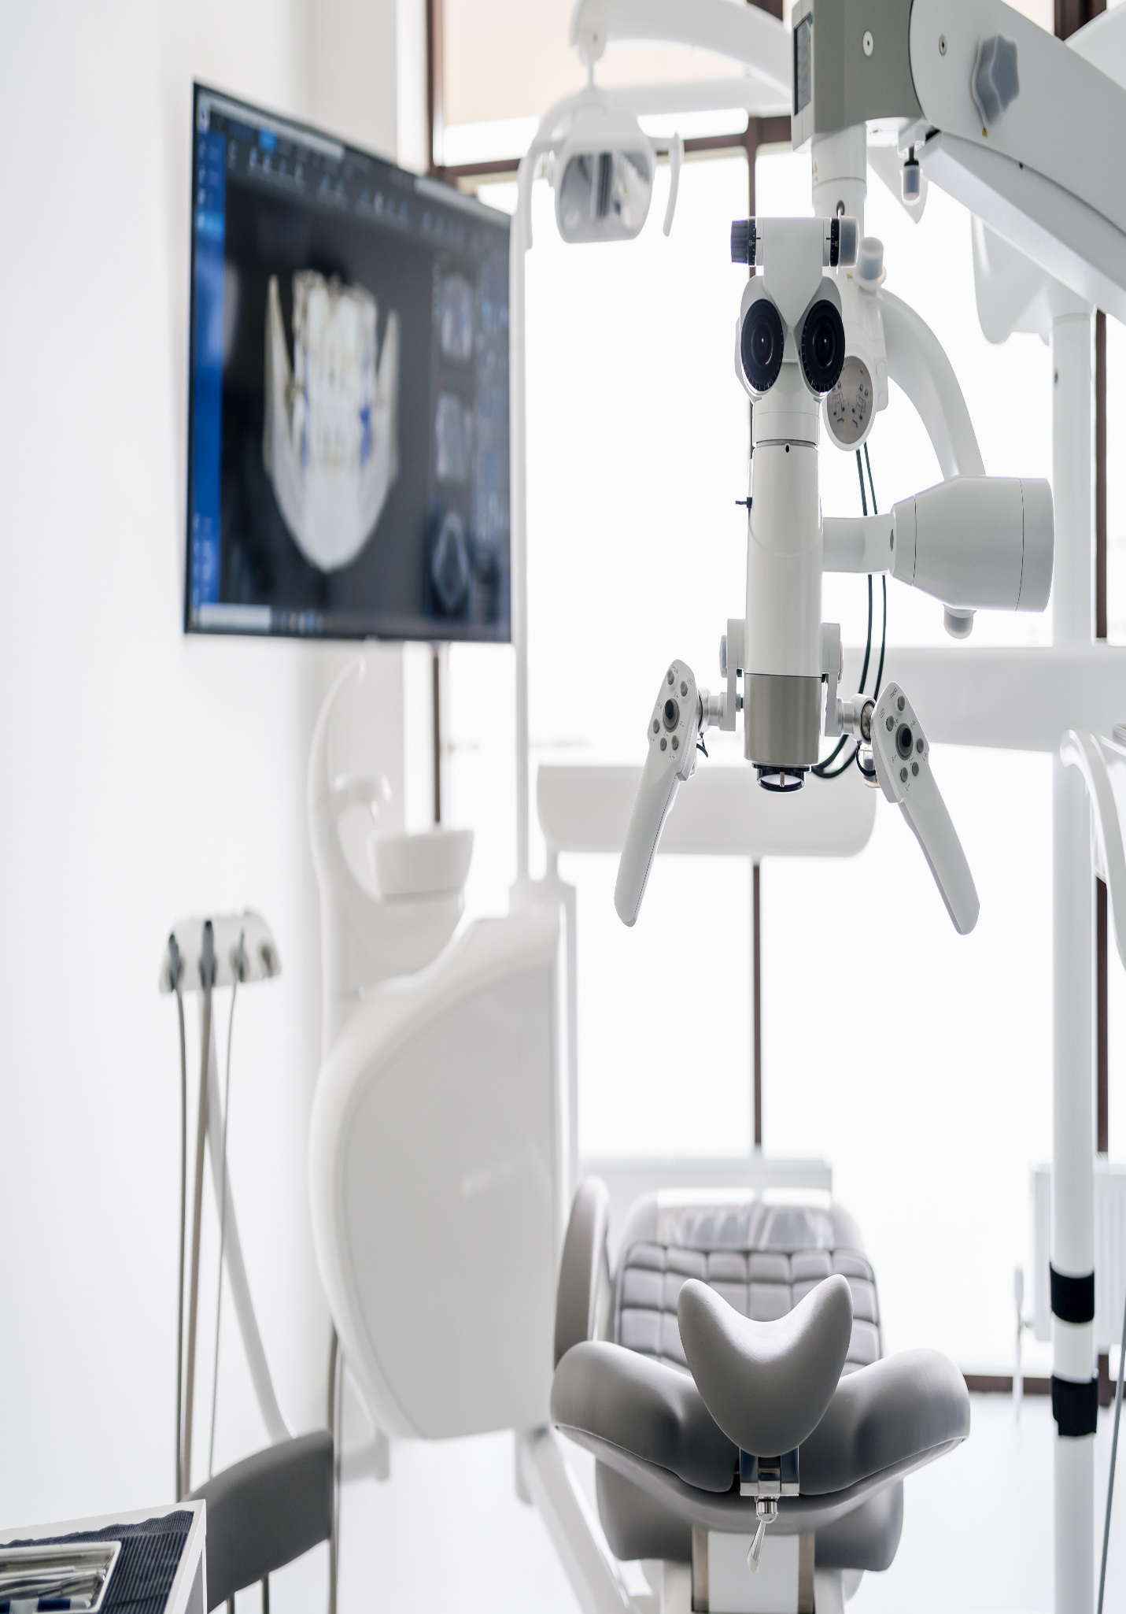
Testing RFP Title

Full Address
June 19, 2023

Executive Summary
test_merged_code_001's Vision and Values are a strong reminder of the higher purpose and drivers that make the organisation what it is.
The commitment to the values of Hospitality, Compassion, Respect, Justice, and Excellence, especially to those most in need, provide clear direction as to what is important to test_merged_code_001. At KPMG, our vision, purpose, and values align strongly with yours and so we can commit to the SJCHC Vision and Values in partnering with you to deliver your HRIS project to enable your Mission.
We love that central to this implementation of an HRIS is the non-negotiable objective to have a positive impact on caregivers. Like you, we know that caregivers are critical to Patient Experience, Customer Experience, and the Clinical Experience. This single objective for caregivers looms large in our response and our team – we commit to supporting you towards this objective and holding accountability to improve the caregiver experience. This is not a tech slam and we are drawing upon all our private health industry and HR expertise to bring the right team to test_merged_code_001.
We recognise in our response and approach your two guiding pprinciples:
- To optimise your processes and relationships – Implementing an HRIS will enable test_merged_code_001 to improve and drive efficiency in many workforce processes. Further, this project will enable further enhancement of the new operating model for all workforce services. By having an integrated architecture across all workforce systems, test_merged_code_001 for the first time will be able to truly understand the caregiver baseline, make talent decisions based on real-time data and insight and ensure you are creating meaningful connections within the organisation.
- To strengthen your culture – The data and insight generated by an integrated landscape for workforce data will enable test_merged_code_001 to better understand key indicators of culture around performance, tenure, engagement, and absence. With a strong analytical platform at its core, HRIS will help Workforce, and leadership better understand indicators of culture and take actions to strengthen where required.
The scene for the criticality of this HRIS implementation is set amongst the key trends driving unprecedented growth in health globally and Australia. Trends we all know well:
- A growing population.
- An ageing population.
- A rise in chronic illness and associated co-morbidities.
Growth in the global health system is set at about 5% per year in an already USD 10 trillion industry. This presents an amazing opportunity for test_merged_code_001 to continue to fulfil its mission of caring for those most in need.
However, the reality is that this is a challenging time for private hospital and aged care operators:
- The impact and uncertainty of the COVID 19 pandemic continues to loom large over private hospital providers.
- People are moving away from private health insurance – particularly young people. This is reducing demand for elective surgery.
- There is a steady shift of private patients to public hospitals.
- The long-term financial viability of many of the community services you provide is under immense pressure – driven by government regulation, increased service standards, workforce challenges, and the health insurance industry.
Through our work with test_merged_code_001 Workforce, we know the challenges you face and how important the HRIS implementation is to deliver a contemporary operating model. We can see how the HRIS will help to reduce the risks, including:
- The ability to recruit quickly enough to meet the demand from hospitals and services.
- Understanding the workforce profile and key data and insights that would enable proactive interventions in areas such as performance and engagement.
- The ability to accurately workforce plan and develop learning programs to support test_merged_code_001 building a future-fit workforce.
With the increase of demand seen through 2021 for Group Workforce, we understand the need to create efficiencies in implementing the HRIS and improving the caregiver experience.
To ensure the project is successful we recognise that Change Management will be critical. This is not a 'Tech Slam', it is about changing the Workforce ecosystem and enabling it through leading technology. Implementing the HRIS impacts the operating model, the processes, the Workforce teams, line leaders, caregivers, and applicants. We are bringing our best in these areas to test_merged_code_001. A team that has been integral to the most complex change management projects in health over the past few years.

We Understand the Healthcare Sector
KPMG brings its depth of global and local experience working across the Health Sector, specifically within Private Health. We understand the challenges and the nuances of supporting complex transformation in the Health Sector and have experience in engaging with clinicians of various levels and clinical specialities. KPMG’s experts bring significant clinical, administration, management, and leadership experience within the Health Sector. With first-hand experience and knowledge of HRIS systems, processes, awards, and agreements, they will form part of this project, providing challenge and guidance to ensure that the project's outputs are fit-for-purpose and future-fit across test_merged_code_001.
We will appoint a senior member from our Health Sector team, Daniel McCluskie to support the engagement as our Healthcare sector Subject Matter Expert (SME). This will enable test_merged_code_001 to obtain first-hand the required sector knowledge, and expertise from Daniel’s team. Daniel understands the challenges from an end-user perspective as he is a practicing clinician, who works as a casual Registered Nurse in the Intensive Care Unit at test_merged_code_001 Ballarat. He has led many large-scale system implementations in the health setting including Electronic Medical Record systems and currently an ERP implementation at one of Australia's largest private hospital providers. Daniel comes forearmed with learnings and insights valuable to pre-empt any risks associated with this project.

We Are a Leading Implementation Partner of Workday in Healthcare
KPMG and Workday have a strategic global alliance, and this partnership makes KPMG one of the leading implementation partners of Workday in Healthcare. KPMG recently won a Workday Partner Industry Innovation Award for their innovation, expertise, and commitment to bringing accelerated Healthcare industry innovation to customers.
KPMG won the award for its Labour Distribution Enabled by Workday Prism Analytics solution in the Healthcare industry. This solution allows customers to create a customised data source for reporting time and cost through a data hub that blends Workday transactional data with external operational data. We intend to leverage this solution to assist test_merged_code_001 solve for the Labour Costing analysis and insights, understanding that labour costs carry the significant expense line item for the organisation.
With over 30 Workday implementations in the Health Sector, we have assembled a team for test_merged_code_001 that brings deep HRIS technical expertise in all the required implementation competencies and the HR consulting expertise.
With a view of opening international borders, KPMG is committed to bringing experienced Workday in Healthcare leaders to Perth to support this implementation. This will augment our Australian healthcare expertise and Workday expertise from other industries. Partnering with test_merged_code_001 on this HRIS implementation is very important to KPMG and we are committed to doing what is required to ensure our proposal is the best it can be.
Further, we have expanded this capability to incorporate key players within the Healthcare ecosystem to add significant value across the Workday Platform for test_merged_code_001. Our Healthcare SME’s will prove valuable by designing and evaluating the reporting and analytic use case requirements and streamlining the business process workflows. We aim to establish a trusted team that will work with you throughout this initiative to deliver a single modern HRIS worthy of the Healthcare community.

We Bring You a “Model” Answer which is More Then Technology and focus on Change
KPMG’s Powered Enterprise for Workday is our unique and proven approach to HRIS transformation. KPMG’s Powered Enterprise fuses decades of our HRIS functional experience, leading HRIS practices, and future HRIS trends to develop pre-configured deliverables, including job catalogue, leading practice business processes with embedded controls, test scripts, and scenarios. All these pre-configured assets are aligned to Workday, providing you with 80% of the model answer allowing the project to focus on the remaining 20% unique to test_merged_code_001 and what will drive you towards being the leading private healthcare provider in Australia by 2025.
KPMG Powered Enterprise is our "secret sauce" designed to bring greater certainty to your business case benefits and the guardrails needed to the budget, timeline, and quality to your HRIS implementation.
Success in this project cannot just focus on the Workday technology and End-User Training, it requires a broader Change Management capability to embed new ways of working and there needs to be a focus on the Service Delivery Model optimised to drive benefits from the Business Case. The Workday implementation requires a focus on people, process, data, integration, and culture to deliver on the business outcomes and caregiver experience.
We know that even the best technical solution is only successful with appropriate engagement, prototyping, testing, and training. We will apply our tried and tested methodologies to secure buy-in to the case for change, deliver against end-user requirements in the Solution Design, promote ease-of-mind during implementation and generate user uptake of the end solution, enhancing the user experience.
Managing the people and change impacts will be critical to success and will need to be a significant focus for the project. At KPMG, we understand that change is personal; individuals experience changes to different extents and process change at different speeds. The impacts and changes to the ways of working will be experienced very differently across Workforce and caregivers and people managers; further these impacts will vary by the care setting in which the caregivers work.
Leveraging KPMG’s ‘Powered Change and Deployment’ methodology, we address the personal needs and look at a holistic solution to manage business change, drive business readiness, and maximise change adoption to deliver against required business outcomes. At the heart of our approach, Change and Training must work together, and we will ensure that Training and Change work shoulder-to-shoulder as one-team.

We Are Committed to the Long-term
This project represents the continuation of your digitisation journey, following the implementation of Kronos and now the implementation of Workday. With the revised Workforce operating model being defined and rolled out, this is an exciting time for Workforce as it moves to a more contemporary approach and model.
KPMG are committed to supporting test_merged_code_001 and Workforce now and in the future. As such we would welcome the opportunity to discuss with you the provision of our AMS for a continued partnership with clearly aligned goals and a commitment to work together. We call our service “Powered Evolution” to focus on evolving your deployment to deliver rapid ongoing improvements and maintain agility and continuous innovation. Our response provides details on our capability and approach on the same.

A Commercially Competitive Offer
As a valued KPMG client, we have sought to invest in this significant project for test_merged_code_001, bringing the best team to bear and the commercial investment we are willing to make. We are fully committed to work in partnership with test_merged_code_001 to modernise its technology platforms to transform Workforce to industry “leading practice", to become the best performing healthcare organisation in Australia by 2025. Our investment of $680,000 equivalent to approximately 21% of the services fees comprises the following:
- A discretionary discount to the value of $387,000, already included in our pricing, reflecting the knowledge and experience gained through the prior work we have completed with test_merged_code_001 and our firm's commitment to work in partnership with you to successfully deliver this project.
- Global Healthcare Workday implementation expertise, equivalent to the value of $93,000, from KPMG's US based practice to provide solution best practice insights during process harmonisation activities and solution design.
- A KPMG advisory panel with a depth of industry experience, Workday implementation, and HR transformation expertise, free of charge to test_merged_code_001, to the value of $100,000, discounted from our pricing.
- Commercial discount of $100,000, with the objective of test_merged_code_001 partnering with KPMG for joint marketing activities in relation to test_merged_code_001's HRIS project, discounted from our pricing.
We believe the work we have already done with test_merged_code_001 will be invaluable during the process harmonisation activities to achieve a unified design for Group Workforce. Based on our depth of knowledge of test_merged_code_001's Group Services and hospital operations we have carefully and realistically estimated the work effort and have established a team structure and resource plan accordingly. The team includes Mark Bowden as your Project Director, who you know, and will work side by side with test_merged_code_001 to make this project a success.
Ultimately, we have challenged ourselves in reviewing projects of a similar scope, complexity, and scale to implementing Workday HCM in the Private Health Sector when estimating this project for test_merged_code_001 and are confident we have offered a commercially competitive bid for test_merged_code_001 to consider.
Our offer includes important value-add services that, in our experience, have proven to increase delivery success. It helps you get to a faster outcome as it relates to caregiver adoption and experience, modernising your integration architecture, and increasing payroll resilience.
We would welcome the opportunity to deliver a fixed price offer that is outcome-driven and commercially competitive after a detailed discussion with test_merged_code_001 to align on the proposed implementation and AMS approach and assumptions. We look forward to shaping our commercial offer with you demonstrating our conviction to partner with you and have “skin in the game”.
We thank you again for the opportunity and look forward to working with test_merged_code_001 in the following stages of this process and would be pleased to discuss any aspect of our response in further detail with you.

Our methodology: Powered Enterprise
KPMG’s proprietary Powered Enterprise (PE) methodology was developed to address the unique challenges of implementing transformation solutions enabled by cloud-based technology.
Powered Enterprise is based on the premise of achieving business transformation and sustainable change using technology as an enabler. PE brings an integrated, market-leading approach to transform all back office business functions including Finance, Human Resources, Supply Chain and IT.
The foundation of Powered Enterprise is the Target Operating Model (TOM) framework which we introduced and utilized significantly during Phase 1. Our TOM framework is tailored and fully integrated with Workday functionality and will continue to be leveraged to drive key process design and configuration decisions within the Workday platform. This approach will enable us to deliver a seamless process and technology enabled solution for CW. Further, our work together on the CW TOM assessment from Phase 1 will help accelerate the TOM changes needed to optimize your implementation by informing the design requirements for Workday. In our experience, without a TOM foundation in place, a Workday implementation becomes just a lift-and-shift of obsolete, outdated processes into a new technology. We will make sure CW avoids this trap.

Powered Enterprise target operating model
The TOM framework we utilized in Phase 1 to complete the assessment work and define the implementation strategy is summarized below. As stated earlier we will continue to use this framework for the implementation as it is fully integrated with our PE solution for Workday.

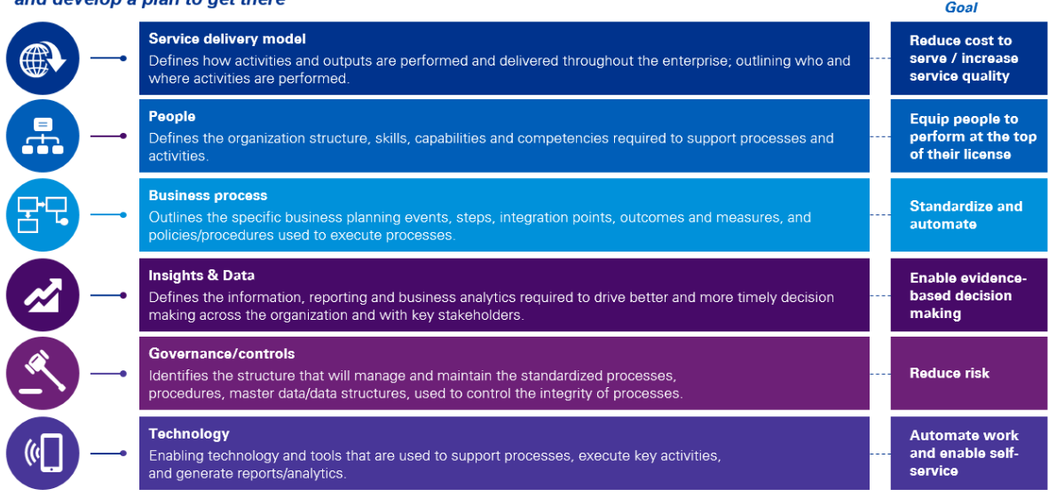

The Value of Powered Enterprise for Workday enabled transformation
The real value of the Powered Enterprise solution for Workday goes beyond providing leading practices. The PE solution, by starting with a leading practice model that is typically 80% compatible with business requirements of healthcare systems like CW, provides a key operating model design accelerator which helps mitigate time line risk in addition to driving you toward a leading practice design. We are confident the PE approach is a good fit for CW and will help our collective teams achieve:
- Leading practice end to end process design
- Leading practice roles and responsibility design
- Process performance metrics including identifying how each process would be improved through Workday
- Alignment of process design to Workday configuration documentation
- Linkage of roles and responsibility design to Workday global risk and compliance (GRC) configuration
Reporting strategy with linkage to Workday financial data model (FDM) design and business reporting needs
An overview of the value we will bring to CW through our PE approach is summarized below.

Implementation Approach

Our Approach
KPMG Powered Enterprise is KPMG's approach and methodology to functional transformation. That is business-led and user experience, orientated designed to:
- Engage business users early and throughout the project.
- Start with the model answer to allow the project to focus on those truly unique requirements to test_merged_code_001.
- Drive a business outcome that realises benefits.
- Avoid recreation of any exiting disparate or cumbersome processes from legacy applications.
Cloud SaaS solutions offer limited to no ability to customise the product. Where there are unique requirements that cannot be fulfilled through the product's configuration, clients must adapt their operating model (processes, policies, roles) to meet the needs. In response to this, KPMG's approach to a Workday HCM implementation is not just focused on the technology. To achieve user adoption and reap the benefits of Workday, KPMG takes a holistic view of both the technology, the operating model, and workforce management practices.
KPMG leads every Workday implementation using KPMG Powered Enterprise enabled by Workday. Our innovative and proven approach to transformation combines deep Workday HCM functional knowledge, leading HR practices, Change Management enablers and pre-configured Workday HCM business processes coupled with process automation to drive a greater certainty of outcome and sustainable development change.
Fundamental to our approach is the use of KPMG Powered Enterprise for Workday HCM, and we believe that the most significant benefit to test_merged_code_001 is access to the pre-configured solution, out-of-the-box business processes, and delivery tools, meaning:
- test_merged_code_001 can adopt 80% of the future state business processes and Workday HCM from the start of the project, which would enable the SMEs and stakeholders to make informed design decisions and achieve greater standardisation.
- KPMG’s implementations focus with test_merged_code_001 would be more about the user uplift and adoption, refinements to the new operating model and less about the Workday technology itself.
- test_merged_code_001 will have access to KPMG materials, which have been designed through extensive global research and hands-on experience.
- test_merged_code_001 can leverage the relevant industry KPMG Powered Enterprise Workday assets developed specifically for Healthcare.
Our implementation framework and validation-based approach through KPMG Powered Enterprise enables test_merged_code_001 to achieve greater certainty of the outcome on your Return on Investment (ROI).
We’ve made cloud transformation – the new way to create business value that lasts – more straightforward, faster, and more predictable.
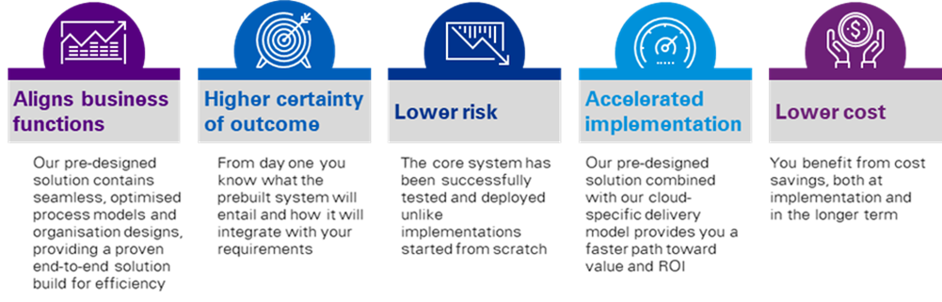
Figure 6: KPMG Powered Enterprise Benefits to test_merged_code_001.
How Do We Achieve the Best Outcome? We Start With the “Model” Answer.
KPMG’s Powered HR contains our leading practices and Workday across a six-layer operating model, as described in below. We have codified our experience over decades of HR transformation and Workday programs into the assets, toolsets, and methods to deliver lasting organisational transformation anchored around the Employee Experience.
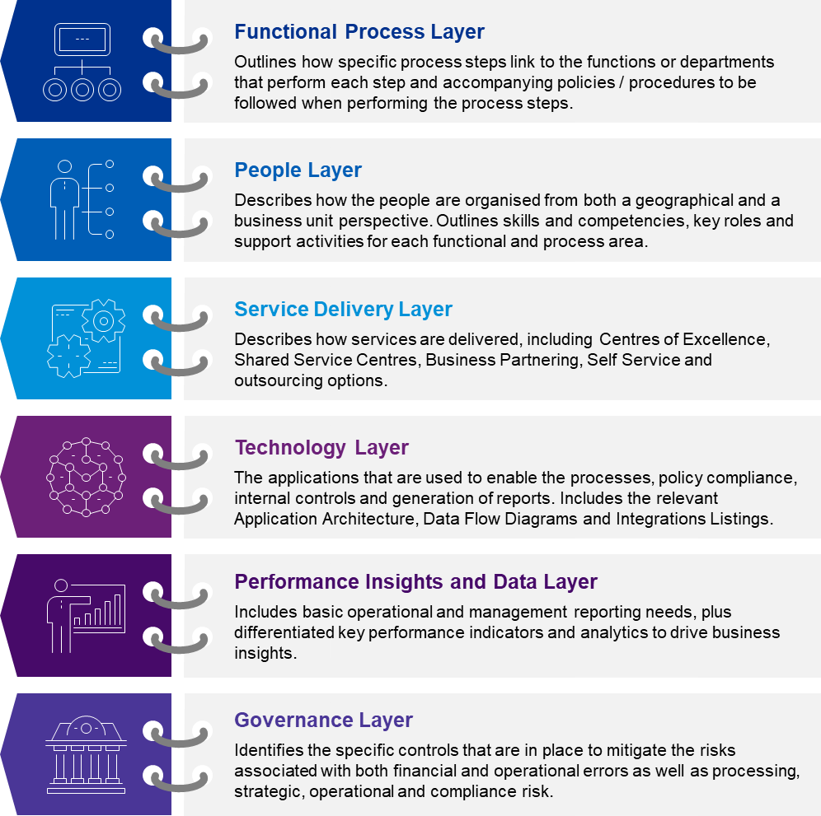
Figure 7: KPMG Powered Enterprise Six-Layer TOM Framework.
While we start with the model answer, we recognise the complexities across Workforce services, Solution Design, and stakeholder groups in test_merged_code_001, as such we have allowed for sufficient time between the Plan and Architect stages for business SMEs and stakeholders to align on the future state of the Solution Design, while still benefiting from the KPMG Powered Enterprise assets and methodology of engaging users in the future state processes and technology as early as possible.
Core to the KPMG Powered Enterprise approach is focusing on "validating" business processes with business stakeholders to identify why the process will not work. This is with the objective of focusing on what is unique to test_merged_code_001 and follows a similar process as to that which was conducted as part of the Corporate Systems Evaluation Project early in 2021.
Note: We have proposed up-front TOM Alignment workshops during a four-week kick start period in order to understand test_merged_code_001's new Operating Model in detail to note any alignment required to our Process, People, and Service Delivery layers of the KPMG Powered Enterprise TOM.
This is detailed further below in Section 2.5 Implementation Deliverables.
Implementation Timeline and System Implementation Approach.
We have fused leading HR practices and future HR trends to develop pre-configured deliverables, within each layer, most notably the roles, leading practice business processes with embedded controls, test scripts, scenarios, and the Workday Job Catalogue. A summary of assets within each layer is further outline in Figure 8 and Figure 9 below.
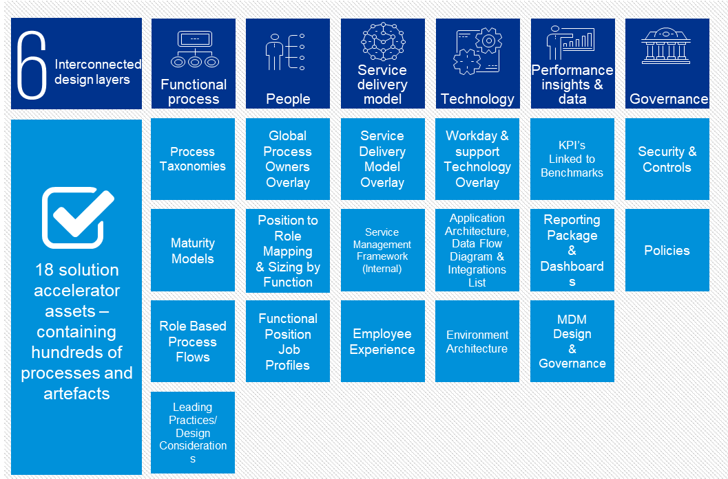
Figure 8: KPMG Powered HR TOM Assets.
As these are already aligned with Workday, there is no need to start from scratch. We provide you with 80% of the model answer, focusing on the remaining 20% unique to your business and what will make you competitive in the market.
Figure 9: KPMG Powered HR for Workday Assets.
Powered Enterprise provides the intellectual property and thought leadership required to design optimal processes alongside the Workday Platform. The result is refining the operating model to support test_merged_code_001 in enhancing the efficiency and effectiveness of operations.
Experience Led Approach
KPMG understands the design of the Workday Platform is crucial to support the Workforce team, caregivers, and line managers. Therefore, with test_merged_code_001 we would like to allocate six weeks upfront during the plan stage to address the following:
- Kick Start: We’ll workshop and agree design principles that will form the basis for the Workday design, align the deployment with the operating model, prepare the basis for Job Architecture design and engage the leadership teams
- Discovery: We'll workshop process harmonisation and identify any unique requirements which can be built into the first Foundation to support decision making during the architect phase.
test_merged_code_001 will have the opportunity to complete transactions in Workday to provide feedback on processes and streamline design decisions which increases platform awareness and saves costs on changes down the track. As part of the Architect phase, we will have localisation workshops at the start of each new wave to drive customisation and align to be fit-for-purpose.

KPMG Powered Enterprise Enabled by Workday for Healthcare
KPMG have developed industry assets specific to Healthcare on the Workday Platform – "Powered Healthcare for Workday". While the assets are across HCM, Finance, and Supply Chain Management, the HCM assets would be leveraged for test_merged_code_001's HRIS Implementation on Workday.
Powered Healthcare for Workday was launched globally in October 2021 and would be available for test_merged_code_001 based on KPMG's unique depth of experience globally and locally in the Healthcare sector.
The six-layer KPMG Powered Enterprise TOM assets are updated across a few layers with a unique Healthcare lens:
- Functional Process: Process Taxonomy and Role Based Process Flows.
- Technology: Supporting Technology Overlay and Application Architecture.
- Performance Insights and Data: Diversity and HR Healthcare specific dashboards.
An overview of Powered Healthcare for Workday assets launched is detailed below
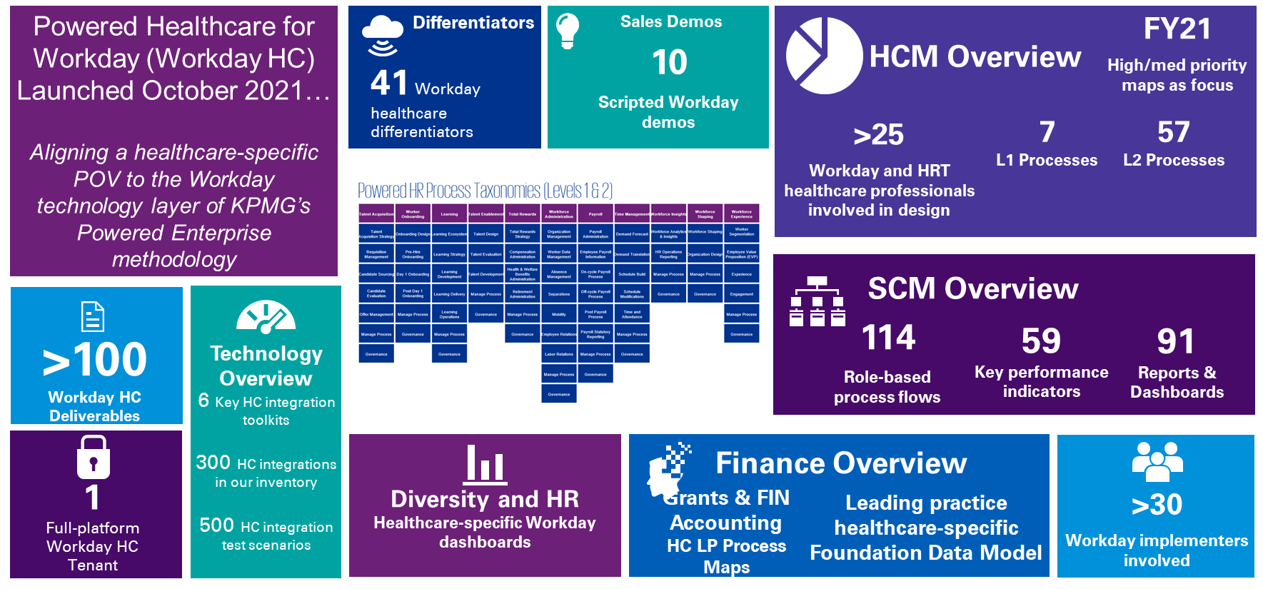
Figure 10: Powered Healthcare for Workday

Implementation Timeline
We propose that Workday HCM be implemented to support the centralised HR functions across test_merged_code_001, with Kronos remaining as the critical workforce management tool for time and attendance integrated with Ascender Pay. Further details on the integration solution between Workday and the other solutions that sit within your broader application landscape is detailed in this document.
We are confident that our proposed timeline strikes the right balance between the velocity needed to carefully design and deploy the Workday solution and test_merged_code_001's decision making timelines and resource capacity to adopt the Workday solution. We believe that our approach will help test_merged_code_001 balance the right amount of internal resource involvement to drive change and increased adoption, leading to a successful transformation.
This implementation will deploy Workday functionality across the business in a single go-live requiring a robust change and communications project. Our timeline is per the following scope:
- Establishing the critical foundations. The functional scope of this phase includes the implementation of Workday‘s Core HCM, Core Compensation, Onboarding, Talent & Performance, Recruiting, Benefits, Absence Management and Cloud Connect Third-Party (Payroll Integration with Ascender Pay). This will be implemented over 15 months with additional interactive workshops in the plan stage and excluding post-go-live support (hypercare) as defined in the figure below.
- Continuous evolution. During our hypercare/post go-live stage we ensure your business is working effectively on the ground with the full capability of Workday and integrated systems. To ensure this all runs smoothly, we support with up to 3-month hypercare.
In addition, there is option to explore a phased go-live with HCM and Talent Management however, we would welcome the opportunity to conduct a joint deployment planning session with test_merged_code_001 to align the assumptions, start dates, and proposed approach.
Our top five fundamental design principles underpinning this approach to deliver the Business Case benefits are as follows:
- Out-of-the-box, Workday solution will be adopted – there is zero product customisation.
- 80% of KPMG's Powered HCM solution will be adopted – there are minimal business process and role variations.
- A unified business Go-Live – reducing the effort required to support the interim states.
- Clear project sponsorship and decision making driving the Solution Design and management of change.
- test_merged_code_001 caregivers (super users and SME's) actively engaged from the project outset to champion user adoption.
Project Kick start and Process Harmonisation
Based on test_merged_code_001 outlining not being ready to go straight into the technical implementation and the preparation projects you have proposed, such as data cleansing, job architecture etc. We have taken this into consideration combined with the KPMG Powered Enterprise approach and Workday's proven implementation methodology, to architect the proposed process harmonisation activities.
KPMG acknowledges process harmonisation is fundamental to test_merged_code_001's objective for caregivers to have consistent processes across the employee life cycle. We have considered the objectives and requirements of the process harmonisation phase of work, including detailed process design, conducting fit / gap analysis, process documentation, and application of industry best practices.
In our experience implementing Workday, there is a unique opportunity for the business stakeholders to have early visibility into how the solution will work for them – in contrast to theoretical paper-based process map documentation. Leveraging this cloud technology and KPMG Powered HR enabled by Workday for Healthcare, we have carefully considered an approach that will meet test_merged_code_001's process harmonisation objectives and allow sufficient time to align leadership and stakeholders efficiently and effectively to the required unified future state processes. This includes the following key activities across the Plan and Architect Stages of the proposed implementation timeline:
- Leadership alignment workshops during Plan.
- Operating model alignment workshops during Plan.
- Kick starts any preparation activities in advance of the Foundation Tenant Build, including data initialisation, job architecture etc.
- Leveraging KPMG Powered Enterprise and Powered Healthcare for Workday assets, identify key Level 2 processes with unique requirements for test_merged_code_001.
- Conduct Architect Workshops with the objective of validating whether our leading practice processes will work for test_merged_code_001 or not. If not, this is captured as process deviations (like a fit / gap analysis).
- Once process deviations are captured, we will conduct playback sessions with the relevant stakeholders on how these deviations for test_merged_code_001's unique requirements will be addressed and incorporated into the detailed process design workbooks. Business Process Design Workbooks include the process documentation to Level 4/5.
- These targeted activities will allow caregivers to visualise their future state solution early and leverage the KPMG Powered Enterprise approach for the right business outcome.
These activities will be spread across four months to allow for sufficient stakeholder input, review, and alignment to achieve the best outcome for unified processes for test_merged_code_001.

Proposed Plan on a Page
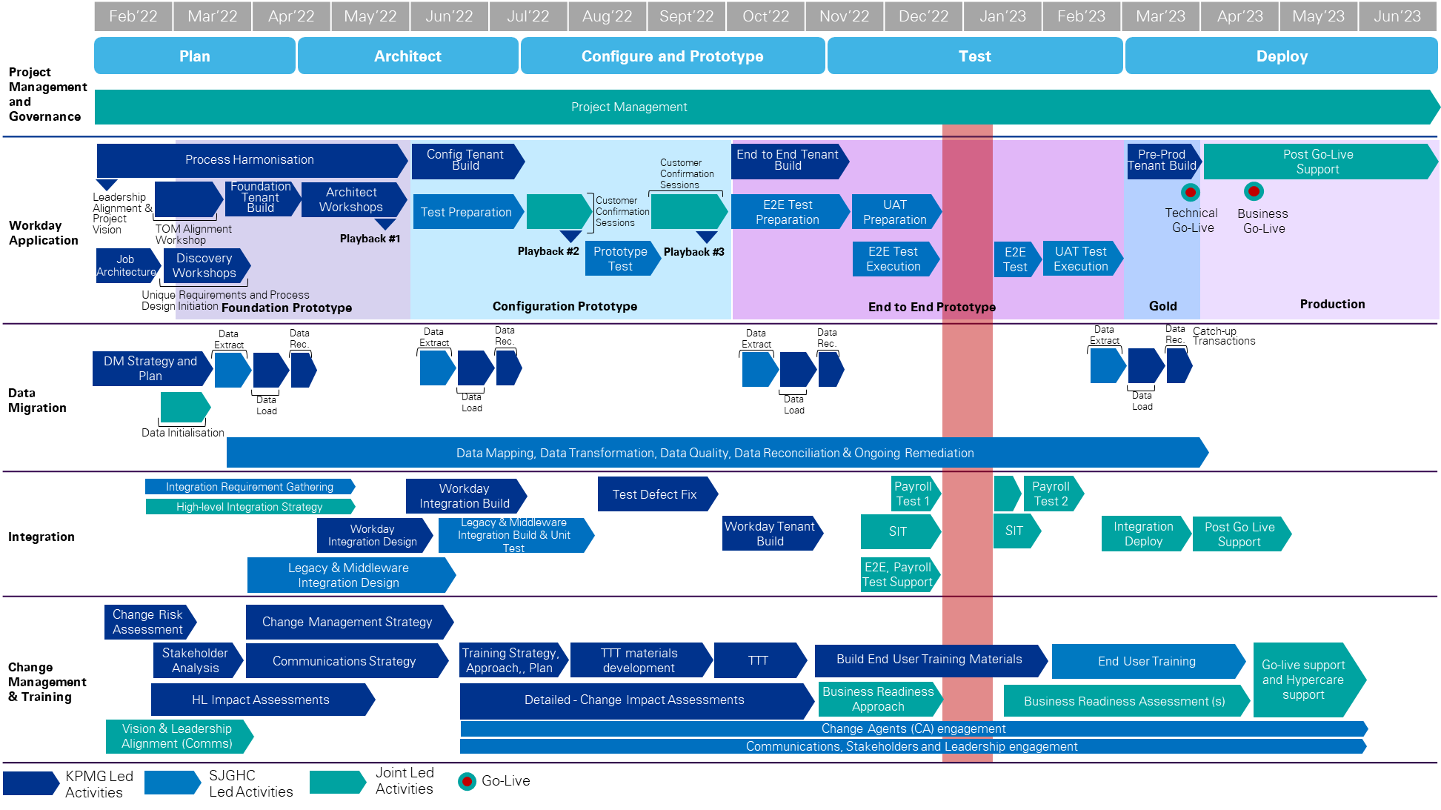
Figure 11: KPMG Proposed Timeline.

Guided by our tried and tested Powered methodology, we have a clear list of deliverables based on project milestones. Along with the key dependencies for each, these are described in detail below.
Proposed High-Level Schedule
The proposed schedule including key milestones in line with our proposed Project timeline for test_merged_code_001 is as set out in Table 8 below. Note: the key milestone dates are indicative and are subject to change based on project start dates and joint planning with SJCHC.
Functional Scope: Workday Core HCM, Core Compensation, Onboarding, Recruiting, Absence Management Talent & Performance, Benefits and Cloud Connect Third-Party (Payroll Integration).
Table 8: KPMG Proposed Schedule.
No. | Milestones | Description | Estimated Due Date | High-Level Dependencies/Approval Requirements
1 | Project Governance Established | Governance is planned and established for project delivery. | June 19, 2023 | Project governance, including reporting, has been endorsed.
2 | Vision and Leadership Alignment Endorsed | [CLIENT_NAME] Leaders are aligned and engaged with the scope and governance of the transformation. | m  June 19, 2023 | Change Risk Assessment is complete and Operating Model Alignment workshop is complete.
3 | Foundation Tenant Complete | The first Workday Prototype build is complete incorporating sample data from [CLIENT_NAME], and KPMG Powered Healthcare enabled by Workday HCM business processes. | June 19, 2023 | Sample organisation data is provided by [CLIENT_NAME].
4 | Architect Workshops Complete | Architect workshops completed to review the Foundation prototype and discuss the future state business process design. | June 19, 2023 | Availability of [CLIENT_NAME] SMEs and caregivers as per the planned sessions.
5 | Configuration Tenant Complete | The second Workday Prototype build is complete incorporating agreed future state business processes in the Architect Workshops and agreed deviations from KPMG Powered Enterprise leading practice processes and configuration unique to [CLIENT_NAME]. | June 19, 2023 | Future state business processes and solution designs completed and approved by [CLIENT_NAME].  The Master Test Plan is complete and approved by [CLIENT_NAME].
6 | Customer Confirmation Sessions Complete | KPMG and [CLIENT_NAME] co-lead the playback of the Configuration Prototype Tenant with key [CLIENT_NAME] business stakeholders. | June 19, 2023 | Configuration Tenant Complete.  Configuration Tenant Data Extract provided by [CLIENT_NAME] in the required format.
7 | Prototype Test Complete | [CLIENT_NAME] have conducted and completed testing of the Configuration Prototype Tenant. | June 19, 2023 | Prototype Test Scenarios are defined.  Test Closure Memo Approved.
8 | End-to-End Tenant Build Complete | The third Workday Prototype build is complete incorporating agreed future state business processes, final configuration unique to [CLIENT_NAME] and final [CLIENT_NAME] security. | June 19, 2023 | Final solution designs completed and approved by [CLIENT_NAME].  End-to-End Tenant Data Extract Complete and provided by [CLIENT_NAME] in the required format.
9 | End-to-End Test Complete | [CLIENT_NAME] have conducted and completed testing of the End-to-End Prototype Tenant. | June 19, 2023 | End-to-End Test Scenarios are defined.  End-to-End Test achieved the Acceptance Criteria and is Accepted.  Test Closure Memo Approved.
10 | SIT is Complete and Accepted | SIT of the Solution has been executed successfully. | June 19, 2023 | The SIT Test Plan, Test Specifications, and Test Materials are Approved.  The SIT has achieved the Acceptance Criteria and is Accepted.  Test Closure Memo Approved.
11 | Exit of User Acceptance Test (UAT) | All Deliverables and Services associated with UAT are complete. | June 19, 2023 | UAT has achieved the Acceptance Criteria and is Accepted.
12 | Data Migration is Complete | All Data Migration Services have been provided, and the Data Migration Plan has been executed successfully. | June 19, 2023 | The Approved Data Migration Plan has been successfully executed.  Relevant Acceptance Criteria is achieved and Accepted.
13 | Production Deployment is Complete | The solution is deployed into production in accordance with the approved cutover plan. | June 19, 2023 | Test Categories that occur prior to Technical Go-Live are complete and Accepted.  The solution has been deployed into production per the Go-Live Checklist.
14 | Business Go-Live is complete | The solution is deployed to the business in accordance with the approved business readiness plan. | June 19, 2023 | The solution has been deployed to the business per the Go-Live and Business Readiness Checklist.
15 | Handover to Ongoing Support is Complete | Support for the Solution has been transitioned to the operational support team. | June 19, 2023 | Handover Documentation (Solution Design documentation) is complete, approved [CLIENT_NAME], and stored in [CLIENT_NAME] identified repository.

Resource Effort
Please refer below to for KPMG's resource loading, including total number of days per stream by project stage.
Table 9: KPMG Resource Pattern by Project Stage.
Stream | Plan | Architect | Configure and Prototype | Test | Deploy
Project Management | 55.00 | 53.50 | 66.00 | 39.00 | 37.50
Functional and Solution Stream | 96.00 | 326.00 | 305.00 | 114.00 | 146.00
Change Management and Training | 24.00 | 111.00 | 159.50 | 61.50 | 13.50
Integration | 19.50 | 39.50 | 89.00 | 48.00 | 59.00
Data Migration | 60.00 | 34.00 | 43.00 | 21.00 | 32.00
Total | 254.50 | 564.00 | 662.50 | 283.50 | 288.00

IMAGE
Images:
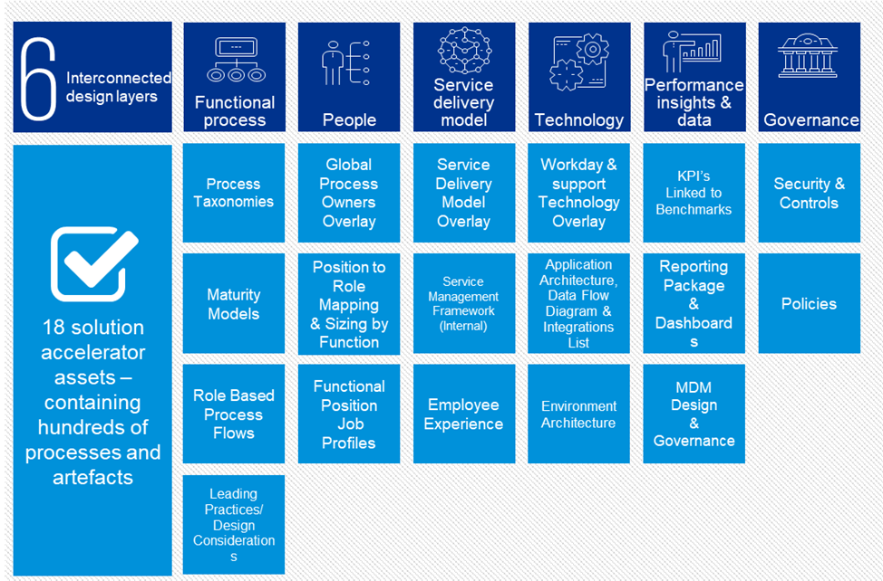
Images:
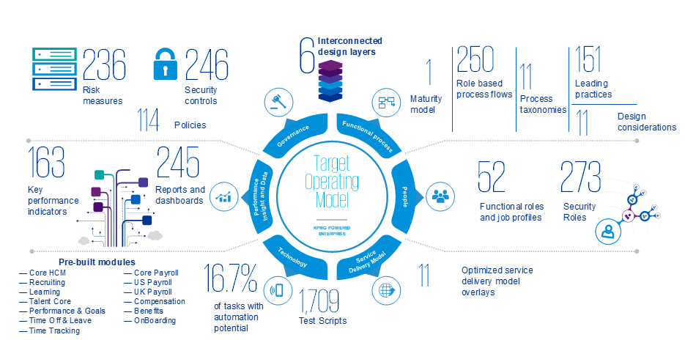
Images:
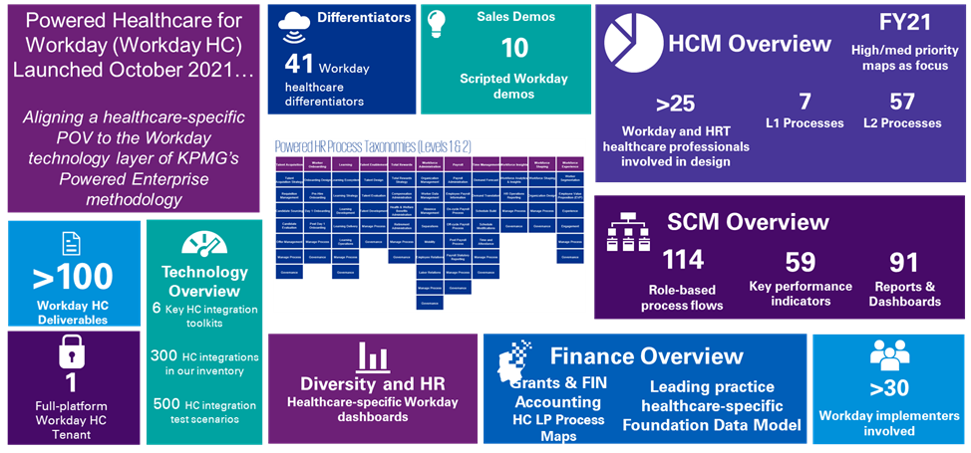

4. Deployment options and recommended approach
Considering the timeline requested by test_merged_code_001 to meet system sunset requirements, KPMG strongly advises a big-bang implementation for all countries on both Phase 1 and Phase 2 scope: Core HR, HR ticketing, Compensation, Benefits, Talent management and reporting. Given Workday is a very integrated system across functions, it is our recommendation that test_merged_code_001 enters design sessions with the end-picture in mind. For example, we have found that options in Advanced Compensation are dependent on configuration of the organization, HR processes and basic compensation.

Enabling an efficient and timely Go Live
To enable test_merged_code_001’s People & Talent organization leverage the functionality within Workday and KPMG’s Powered Enterprise as quickly as possible, we advise a Big Bang-styled Workday approach.
test_merged_code_001 intends to harmonize processes and procedures, maximize self-service, modernize the user experience, and reduce operating costs through this transformation. Through this approach, test_merged_code_001 will be able to experience these improvements even sooner.

Big Bang Go Live approach
In a Big Bang Workday approach, we implement all desired modules of the Workday solution simultaneously, with a singular Go Live date. This simplified approach to implementation and Go Live offers key efficiencies, not limited to:
- Avoid developing integrations to be retired in following Go Live waves
- Expedited retirement of legacy solutions and licensing fees
- More efficient use of resources and project budget
- Greater excitement and attention from employees around the Go Live
This approach is most frequently selected by our customers. To meet your desired sunset date for SAP SuccessFactors functionality, KPMG advises a single Go Live date, inclusive of all modules proposed for the Phase 1 and Phase 2 implementations.
As part of a single Go Live approach, planning activities would commence in November 2021. The architect stage, including system design, will commence in December 2021 and run through the end of February 2022. The configure, prototype, and test phase, involving P1 and P2 builds, unit testing, and end-to-end testing, will run through the Winter and Summer of 2022. In late August 2022, gold build activities will commence, ending with a completed production tenant live in November 2022. Six weeks of hypercare support will follow the Go Live, enabling a complete handoff from KPMG to test_merged_code_001.

Staged Go Live approach
Should test_merged_code_001 be unable to support a single Go Live from a timeline approach, KPMG is happy to support through a staged Go Live approach.
The staged approach would implement the Phase 1 modules along the timeline noted above. After the completion of hypercare, abbreviated Architect, Configure, Prototype, and Test phases would take place, for a period of 3-4 months, dependent on project breaks during the 2022 winter holidays.
If desired, additional information on a staged Go Live approach can be provided.

