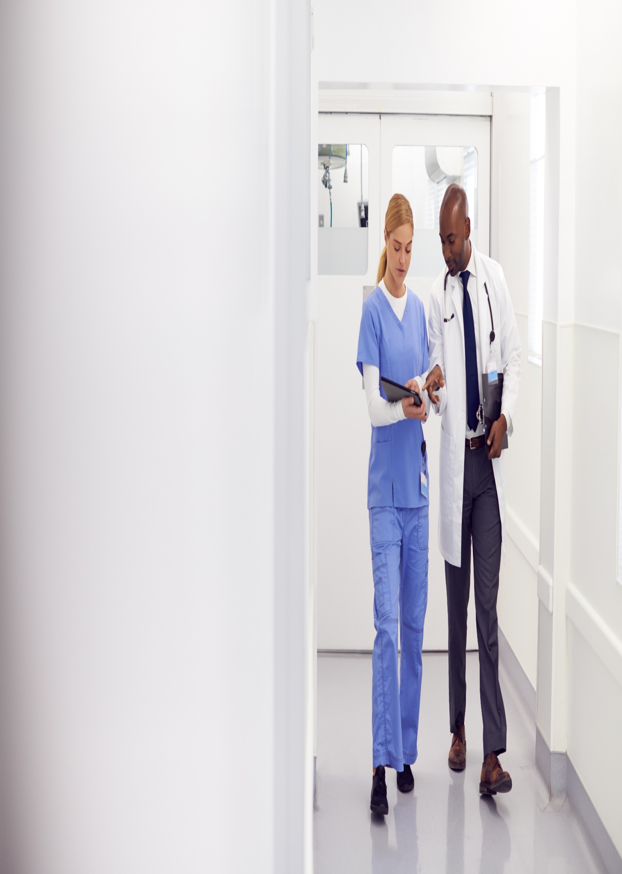

**151 Pirie Street, Adelaide SA 5000**

**July 10, 2023**

**ASDDF**