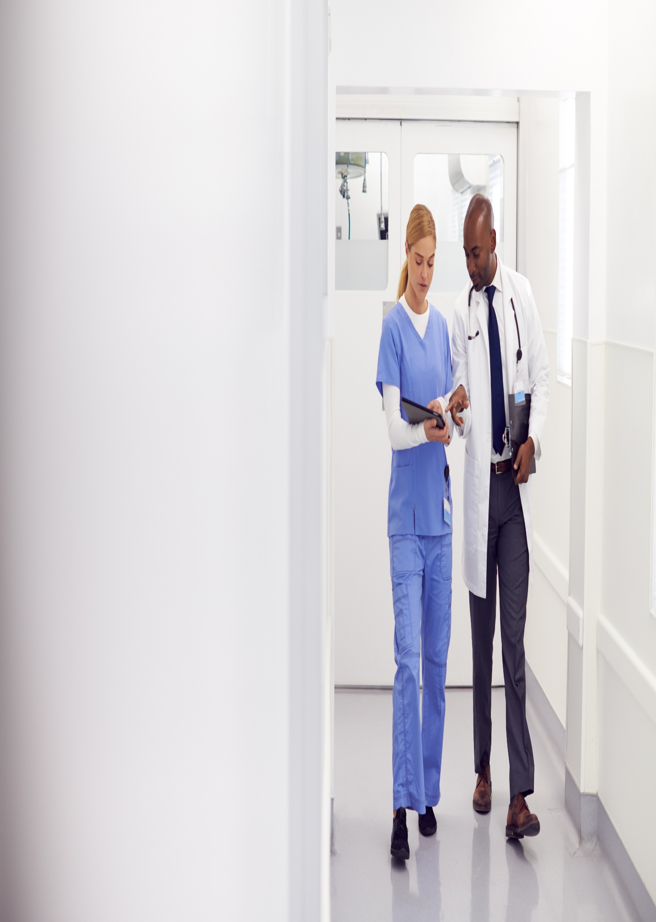

**151 Pirie Street, Adelaide SA 5000**

**July 04, 2023**

**CONTROL11**