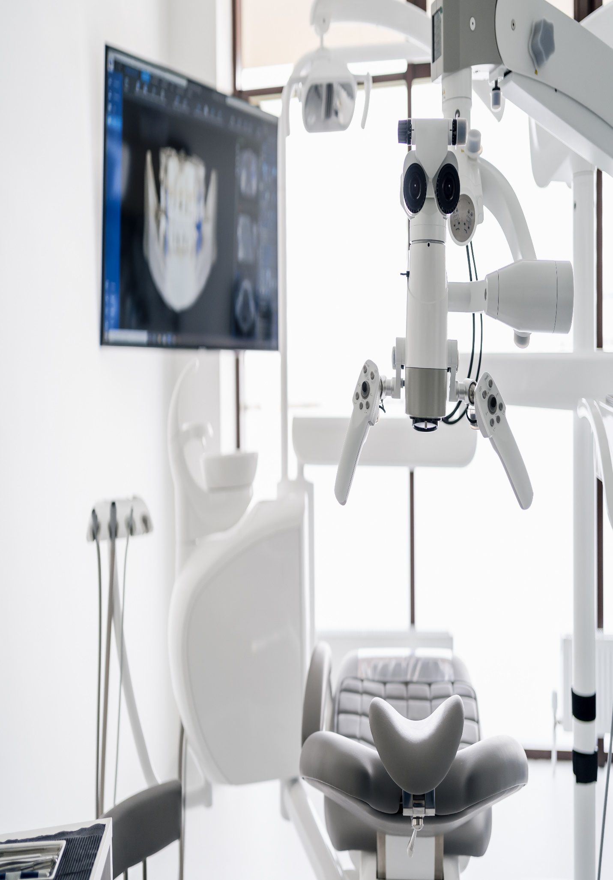

**151 Pirie Street, Adelaide SA 5000**

**July 11, 2023**

**Shubhamam**