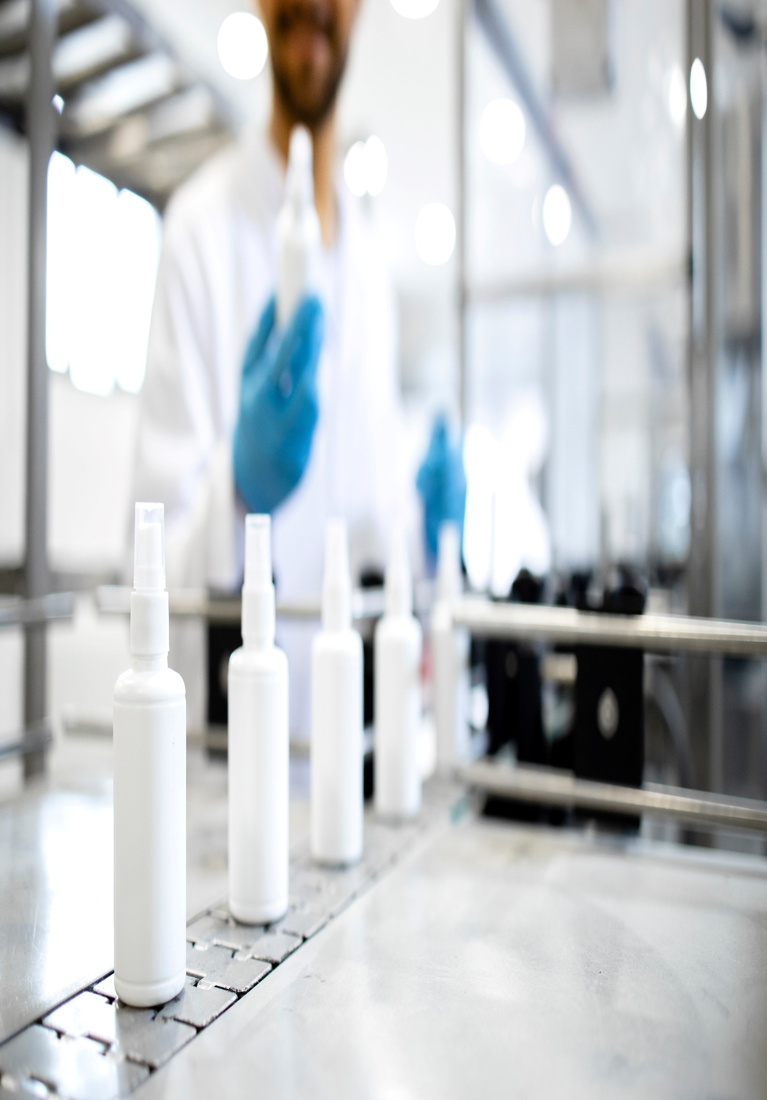

**TestTitle**

**Level 9, Constitution Place, 1 Constitution Avenue**

**June 30, 2023**