## Statement of Capability

Please refer to Workday's responses to SJGHC's requirements as detailed in Appendix A – Requirements of the RFP document for Workforce Administration, Talent Management, and Non-functional requirements. KPMG have included supplementary statements of capability for Workforce Administration and Talent Management based on our experience of implementing Workday HCM. In addition, KPMG have included a response to the integration of Workday HCM with SJGHC's corporate systems.

As well as KPMG having the necessary technology implementation skills, this is coupled with a depth of HR domain knowledge and experience. We have outlined our understanding of SJGHC's key challenges in Workforce Administration and Talent Management below, in Table 5 and Table 6 respectively, along with our point of view on how Workday addresses these challenges based on our experience.

### Workforce Administration

Please refer to Workday's product responses to SJGHC's requirements as detailed in Appendix A - Requirements of the RFP document for Workforce Administration. Please refer below to KPMG's point of view on how Workday can address SJGHC's key Workforce Administration challenges.

Table 5: Workforce Administration: Our Understanding.

| Key Challenges: Our Understanding | How Workday addresses these challenges |
| --- | --- |
| * Onboarding is not enabled through eRecruit and is a mix of email and Learning Management System (LMS) with Line Manager and new caregiver. * Pre-onboarding forms that are needed to be completed by the caregiver are emailed and sent back via email creating manual effort. | * Workday's robust functionality allows a streamlined onboarding experience automatically triggered following the completion of the recruitment and hire business processes. You can design specific content, bulletins and/or announcements including embedding video's directly in Workday. * Within Workday you can embed documents direct on the Workday Platform. This will allow new caregivers to download, sign, and reupload the document where necessary. In addition, you can create checklists/questionnaires and checkbox fields of acknowledgement confirmation. |
| * Most Day 1 onboarding is left to the site to manage and the Line Manager, there are limited guidelines, and they vary by operation. * Limited situation where no show or need to change start date. | * Onboarding setup templates allow Managers/Administration to pre-populate information direct to the new caregiver and their team for Day 1 i.e., people to meet on their first day. This ensures a consistent onboarding experience with specific actions and tasks to complete and ensures accountability across the whole organisation. * Workday's functionality allows for a 'no show' through the termination process for tracking purposes. In addition, the new caregiver hire date can be changed in real-time however, consideration should be emphasised on changes to employment contract via the recruitment process. |
| * All annual uplifts are managed via Excel with extracts from Ascender and then individually changed to update the new salary. * Ad-hoc salary increases will be discussed with HR and form completed and approved by Workforce. | * Within the Workday system you can request compensation changes on an annual/frequent basis which is reflected in real-time data and sent via integrations to Ascender. * Once offline discussions have been completed, you can request a compensation change via Workday which can be routed for approval to the appropriate manager(s)/administration. |
| * Purchased and deferred leave administered via a manual form by Workforce. | * Workday Absence Management allows for time off plans to be created for purchased/deferred leave however, this can be managed by Administration roles on a case-by-case basis. |
| * There is an organisation structure within Ascender, but it is not managed in terms of associated FTE. * Reporting lines are 95% accurate, with cultural challenges around managing that structure. * Limited ability to do bulk organisation changes. | * Workday HCM Core is designed using supervisory organisations with associated caregiver FTE headcount. This is reportable and can be integrated with various 3rd party systems. * Workday architecture is designed like a hierarchy therefore caregivers will have associated line managers where business processes are routed accurately. This ensures reporting lines are accurate given managers sit in the supervisory organisation above those they manage. * Workday allows bulk changes with organisations and other functional areas. |
| * Limited amount of data that can be managed by caregivers through Employee Self Service (ESS), including no access to bank accounts. * Bank and Super done by Workforce for new joiners but if changes once started, managed by Payroll. * Significant number of amendments to contracts but not always issuing a new contract, includes a change of cost centre. * Circa 20,000 amendments to contracts yearly which are manually entered, the majority of which are a change in working hours. | * Workday allows ESS empowerment. This will ensure caregivers can update personal details directly in Workday including bank accounts which is integrated to Ascender. * Workday allows for changes on an individual level within all aspects of Workday. * Changes to weekly scheduled hours aligned to FTE percentage is available in Workday. |
| * All types of leave are managed via MyPay, owned by Payroll. * Sick leave can be entered by the caregiver or Line Manager and is not clear as to when entered – at the start of absence, at the end, or not at all. * HR enter parental leave, deferred salary leave, and part of the purchased leave establishment in caregivers' occupancy – back end leave accruals and bookings completed by Payroll. * No analysis of leave trends or impacts on performance. * Some manual forms such as Long Service Leave and some other types of ad-hoc leave. | * Absence Management includes time off plans/leave of absence plans which is in scope for this engagement. * Workday allows recording of events via the associated business processes. Depending on the design, you can allow caregivers, managers, and/or administration to request absence which is routed via business process approval. * HR Administrators will have the ability to enter specific absences depending on design. * Workday Standard Reporting allows functionality to support the assessment of leave trends. * Workday can be configured to meet the regulatory requirements including Long Service Leave however this is complex configuration. |

### Talent Management

Please refer to Workday's product responses to SJGHC's requirements as detailed in Appendix A – Requirements of the RFP document for Workforce Administration. Please refer below to KPMG's point of view on how Workday can address SJGHC's key Talent Management challenges.

Table 6: Talent Management: Key Challenges.

| **Key Challenges** | How Workday addresses these challenges |
| --- | --- |
| * Facilitated through a SharePoint form which in turn is used to raise requisition and approval in eRecruit. * Workflow management is manually assigned to teams. | * Workday Recruitment functionality will allow you to create a job requisition in line with budgeting requirements. This enables administration to track, complete, and report on requisitions. In addition, all business processes can be routed for approval. * Workflow management is standardised via the Workday business processes and approvals routed based on security group assignment. |
| * Most sourcing done through advert response, limited direct approach and no use of referral program except for an external government system used for JMO and intern recruitment for Midland. * Applications are submitted through eRecruit. | * Workday Recruitment functionality includes the design of the external career site which allows referral availability. * Workday Recruitment has various connection points throughout the process which ensures from the time the candidate applies through to shortlist, review, offer, hire, etc. this ensures all recruitment activity is tracked. |
| * Successful candidates interview notes are captured in personnel file, not eRecruit. | * Workday allows for comments to be placed throughout all processes on the framework. |

### Integration

Please refer to the below section for KPMG's Statement of Capability related to Integration services including proposed integration architecture and scope for SJGHC's HRIS Implementation.

Australian private hospital providers are required to use several information systems to meet their operational requirements. It is common for providers to have separate systems for finance, payroll, HR, rostering, procurement, asset management, home care, and residential care. These disparate systems add inefficiencies and expense, as providers can be forced to establish manual processes around data transfer, checking, and reporting. We have placed heavy importance on the success of integration delivery in our approach.

For SJGHC, better integration of information systems will eventually translate into an improved experience for the highly mobile (potentially virtual) and geographically dispersed workforce. Front-line workers, clinicians, social workers, and care coordinators will be able to more efficiently access information that can support them in effectively delivering health, aged, and community care services.

SJGHC workforce will refer to a single view of their HRIS record and avoid entering data or validating multiple systems. This will save them time (and frustrations), which will help them maintain focus on the most important things, their clients, and their health. The integration strategy allows organisations to cut complexity and drive tangible business value. For SJGHC, this translates into delivering the best care to their patients and investing in their caregivers.

By quickly connecting new information and operationalising it across the Group, SJGHC can increase automation, ensure tighter security, and create competitive advantages in their industry.

KPMG has developed a framework to help organisations ignite digital transformation through innovation and agility, while de-risking implementation leveraging our KPMG Powered Integration framework enabled by Workday. Our framework is a market differentiator on how to maximise the value of your Workday implementation by laying the foundation that will help SJGHC automate end-to-end business processes and easily scale the solution in the future and promoting re-use.

Key benefits we have seen in our approach are:

* Deliver your Employee 360 Experience: Empowering businesses by creating connected experiences, unlocking, and unifying data.
* Fast-Track Workday Integrations: Accelerate Workday implementation with up to 20-25% savings using our library of pre-built assets. Moreover, it sets the foundation of microservices to easily extend and scale the solution in the future.
* Mitigate Integration Scope Creep: Our Powered methodology allow us to quickly validate your integration requirements from a business and process lens perspective earlier in the process.

|  |  |
| --- | --- |
|  | “The ability to leverage the experience from KPMG had gained from previous implementations truly accelerated our ability to deliver value to the business in a quick way. There is a strong cultural connection with how we worked together, and KPMG engaged well with the business to understand our requirements to ensure the outcome we were looking for”.  Andrew Coffey – Chief Information Officer  7 Eleven |

Our integration approach can bridge the gap between integration strategy and your specific business outcomes by leveraging our KPMG Powered Integration framework enabled by Workday. Based on the integration requirements provided to us, our recommendation to SJGHC is to utilise a middleware solution to deliver the required value and maximise the re-use, and extensibility, along with decreasing operational costs.

We have broken down our integration response between two options:

* Option #1 Workday Integrations: KPMG would be responsible for delivering the Workday integrations as highlighted in our High-level Integration Architecture and Scope, Figure 3 below. While SJGHC would be responsible for the middleware environments and integration development to the in-scope systems.
* Option #2 End-to-End integrations**[1]**: KPMG would be responsible for delivering the Workday integrations as highlighted in our High-level Integration Architecture and Scope, Figure 3, along with a modern, flexible approach for building integrations using microservices architecture, and open standards, and tools to mitigate proprietary technology dependencies. Our suite of services can include:
  + MuleSoft Platform Setup: Full cloud solution up and running within 1-2 weeks.
  + MuleSoft Platform Common Services: Pre-built reusable runtime services that can save time and provide standardisation and consistency across projects within the business portfolio (e.g., Error Handling, Monitoring, Logging).
  + DevOps Framework for MuleSoft: Configurable framework to enable a Continuous Integration environment, including automated API testing. Our framework allows organisations to significantly improve quality and reduce overhead.
  + Integration Governance framework: Best practices, patterns, standards, and processes to support the development of integrations / APIs within the organisation in a consistent way.
  + MuleSoft Integrations: Leverage our library of MuleSoft pre-built APIs to accelerate, integrate SJGHC systems and deliver new employee experiences (e.g., fully automated onboarding, offboarding processes).
  + Enterprise Security by Design: Boosting business agility with security.
  + Full support to Healthcare solutions: Deliver a connected and interoperable patient journey in real-time through support of health standards such as FHIR, HL7, and SMART.

#### High-level Integration Architecture and Scope

The recommended reference integration architecture has been depicted below in Figure 3. Please refer to Appendix A: Interface Inventory Scope for KPMG's proposed interface inventory scope of for Workday HCM.

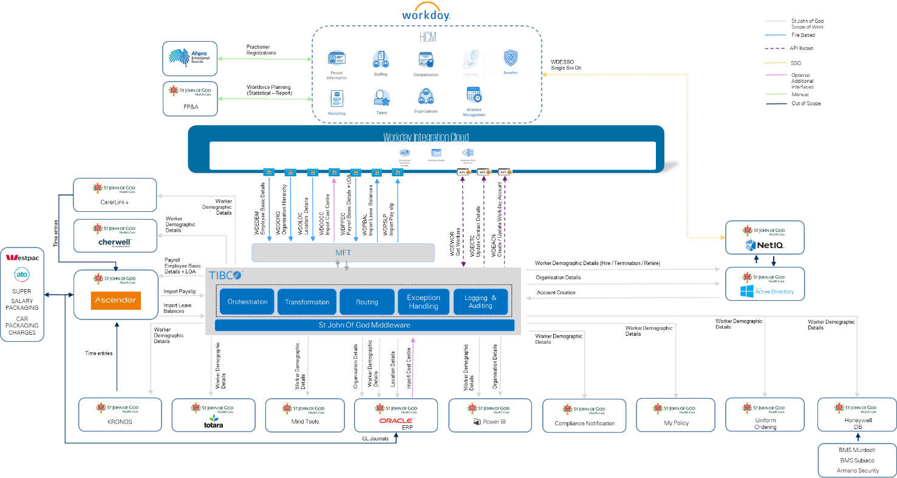

Figure 3: KPMG Proposed Integration Architecture.

#### Workday Integration Cloud

Workday Integration Cloud is a complete solution to build, deploy, and manage integrations to, and from Workday. An Integration Platform-as-a-Service, Workday Integration Cloud is a foundational element of the Workday technology stack and powered by an embedded Enterprise Service Bus (ESB) at its core.

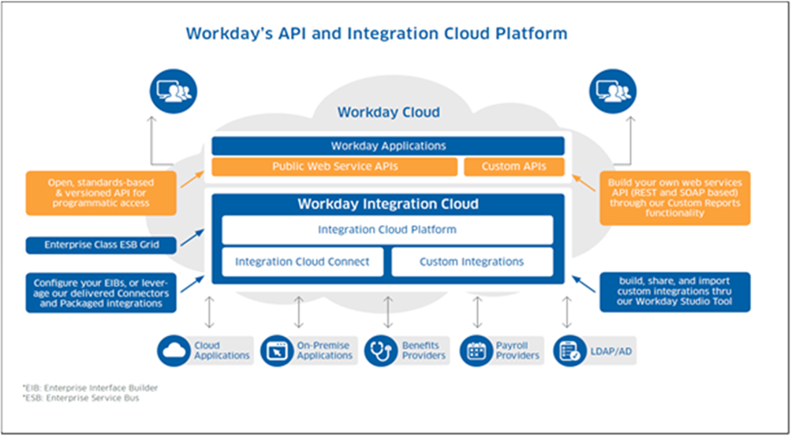

Figure 4: Workday's API and Integration Cloud Platform.

Workday Integration Cloud approach provides simpler connectivity to third-party services, and applications. Workday’s enterprise-class Integration Platform-as-a-Service (iPaaS) allows all integrations to deploy to, and run in, the Workday cloud.

The Workday Integration Cloud would help SJGHC to fulfil the following objectives:

* Facilitate the creation, deployment, optimisation, maintenance, and monitoring using Workday UI.
* Provide scalable and flexible integration layer.
* Interconnect and support the latest industry standards, protocols, and formats.
* To simplify and accelerate the process of integrating with Workday, we provide a series of pre-built and configurable connectors.

#### Workday Connectors and Tools

Certified Connectors

Certified connectors are built, implemented, and supported by Workday, and their partners. They are adaptable and configurable, and dramatically lower the time required for you to implement integrations by providing everything required to integrate a third-party system with Workday, such as processing logic, data transformation, and error handling routines. Workday, in conjunction with their partners, maintains these packaged integrations. Workday adapt them to address new features and functionality within Workday core applications (for example, compliance updates), as well as update the tooling and technology powering these connectors.

EIB

The Workday EIB tool would provide an easy-to-use graphical and guided interface to define inbound and outbound integrations without requiring any programming. The EIB tool could be used by both business and IT users to address a variety of integration needs.

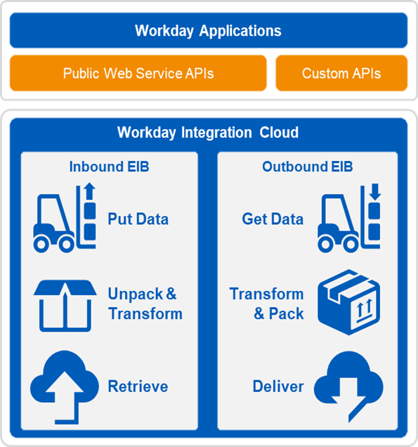

Figure 5: Workday Connector and Tools.

Outbound EIBs

Outbound EIBs would extract information from the Workday system, and either attach it back to the SJGHC tenant for future use or reference or send it somewhere for further processing. Currently, over 75% of outbound EIBs currently in the Workday production environment globally send a file to an external destination via sftp.

Inbound EIBs

For use cases that have significant data requirements there may be a requirement to upload information directly to the Workday system. In this case, an inbound file would be provided and associated with a custom transformation. This transformation would convert the data into a format suitable for sending to a Workday Web Service.

Workday Studio

Workday Studio is a development tool that would enable development of sophisticated integrations to and from Workday. These integrations would be deployed and run on the Client’s behalf on integration servers in Workday’s data centre. The Workday Studio would be used by technical developers for integrations that may have characteristics such as:

* Multiple different data sources and/or delivery requirements.
* Scalable and efficient processing of potentially very large data sets (up to tens of gigabytes).
* Complex looping or branching logic based on dynamic data or external variables.
* Sophisticated change detection requirements.
* Complex error scenarios and corresponding need to react differently to error conditions.
* Need for rigorous source code control, unit testing, debugging, logging, and other formal development Disciplines.

Workday Integration Cloud aligns with the requirements for the SJGHC HRIS Project. The diagram below depicts the integration architecture that we have considered for SJGHC and incorporates two phases per the deployment approach proposed.

As suggested by SJGHC, first 4-5 months will be dedicated to detailed process harmonisation and requirements gathering (Functional and Non-Functional) across Group Services and Hospitals. KPMG would carry out the following activities to achieve scalable, agile, performant integration Solution Design at the end of the phase:

KPMG proposes to conduct multiple integration discovery workshops during requirement gathering phase with business stakeholders, SJGHC solution architects, security /infrastructure architects and key personnel to understand integration needs both functional and non-functional.

This will enable us to validate:

* The reference architecture.
* Confirm the scope of work by validating integration interface inventory and validate the timelines.
* Define and confirm high-level enterprise integration design patterns.
* Understand security and compliance requirement such as adherence to HL7 messaging protocols.
* Understand high availability, scalability, and reliability requirement.

Currently we have assumed that most of the integrations will follow asynchronous file-based integration using Workday predefined format and Canonical Data Model (CDM). However, this will be validated during design phase.

During Design phase, KPMG team will arrange multiple design sessions to finalise the respective integration interface design.

This will include workshops to finalise the transformation / mapping, exception handling frameworks, and necessary building blocks to implement the interfaces. KPMG team will try to leverage the KPMG powered integration assets to expedite overall implementation phase.

#### Our Implementation Experience

Table 7 below describes our experience integrating to SJGHC key systems.

Table 7: KPMG's Integration Experience with SJGHC Corporate Applications.

|  |  |  |  |
| --- | --- | --- | --- |
| SJGHC System | Domain | Experience Integrating to Specific System | Experience Integrating to Other Systems, but Same Domain |
| Ascender Pay | Payroll | Yes | Yes |
| Totara Learn | Learning | No | Yes |
| Kronos Time & Attendance | Time Tracking | Yes | Yes |
| Oracle ERP | Finance | Yes | Yes |
| Patient Administration System | Care | No | Yes |
| Data Warehouse Solution | Analytics | Yes | Yes |
| Identity Management and Active Directory | Identity Management | Yes | Yes |

### Non-Functional Requirements

Please refer to Workday's product responses to SJGHC's requirements as detailed in Appendix A – Requirements of the RFP document for non-functional requirements.

1. KPMG would like to welcome the opportunity in discussing Option #2 with SJGHC to understand your strategy more broadly and how KPMG can support SJGHC in achieving those business goals. Our pricing reflects Option #1.