## Our methodology: Powered Enterprise

KPMG’s proprietary Powered Enterprise (PE) methodology was developed to address the unique challenges of implementing transformation solutions enabled by cloud-based technology.

Powered Enterprise is based on the premise of achieving business transformation and sustainable change using technology as an enabler. PE brings an integrated, market-leading approach to transform all back office business functions including Finance, Human Resources, Supply Chain and IT.

The foundation of Powered Enterprise is the Target Operating Model (TOM) framework which we introduced and utilized significantly during Phase 1. Our TOM framework is tailored and fully integrated with Workday functionality and will continue to be leveraged to drive key process design and configuration decisions within the Workday platform. This approach will enable us to deliver a seamless process and technology enabled solution for CW. Further, our work together on the CW TOM assessment from Phase 1 will help accelerate the TOM changes needed to optimize your implementation by informing the design requirements for Workday. In our experience, without a TOM foundation in place, a Workday implementation becomes just a lift-and-shift of obsolete, outdated processes into a new technology. We will make sure CW avoids this trap.

### Powered Enterprise target operating model

The TOM framework we utilized in Phase 1 to complete the assessment work and define the implementation strategy is summarized below. As stated earlier we will continue to use this framework for the implementation as it is fully integrated with our PE solution for Workday.

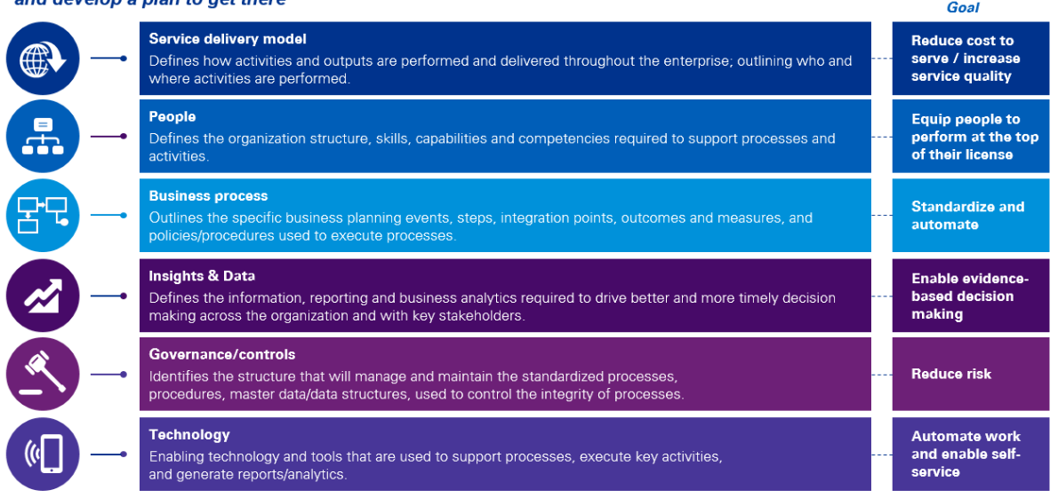

### The Value of Powered Enterprise for Workday enabled transformation

The real value of the Powered Enterprise solution for Workday goes beyond providing leading practices. The PE solution, by starting with a leading practice model that is typically 80% compatible with business requirements of healthcare systems like CW, provides a key operating model design accelerator which helps mitigate time line risk in addition to driving you toward a leading practice design. We are confident the PE approach is a good fit for CW and will help our collective teams achieve:

* Leading practice end to end process design
* Leading practice roles and responsibility design
* Process performance metrics including identifying how each process would be improved through Workday
* Alignment of process design to Workday configuration documentation
* Linkage of roles and responsibility design to Workday global risk and compliance (GRC) configuration

Reporting strategy with linkage to Workday financial data model (FDM) design and business reporting needs

An overview of the value we will bring to CW through our PE approach is summarized below.