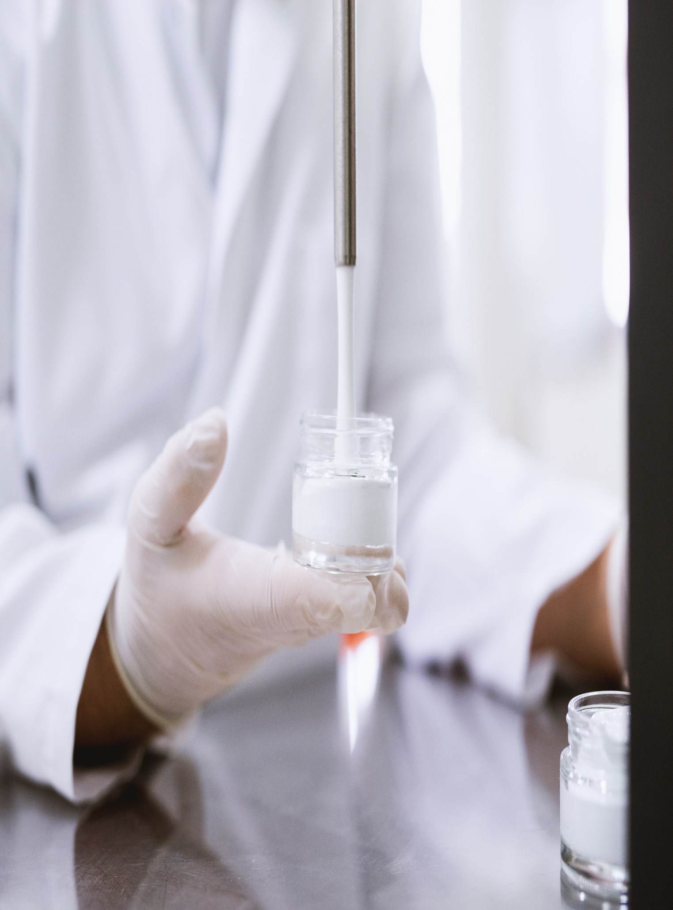

**151 Pirie Street, Adelaide SA 5000**

**July 05, 2023**

**ASDFRETFDS**