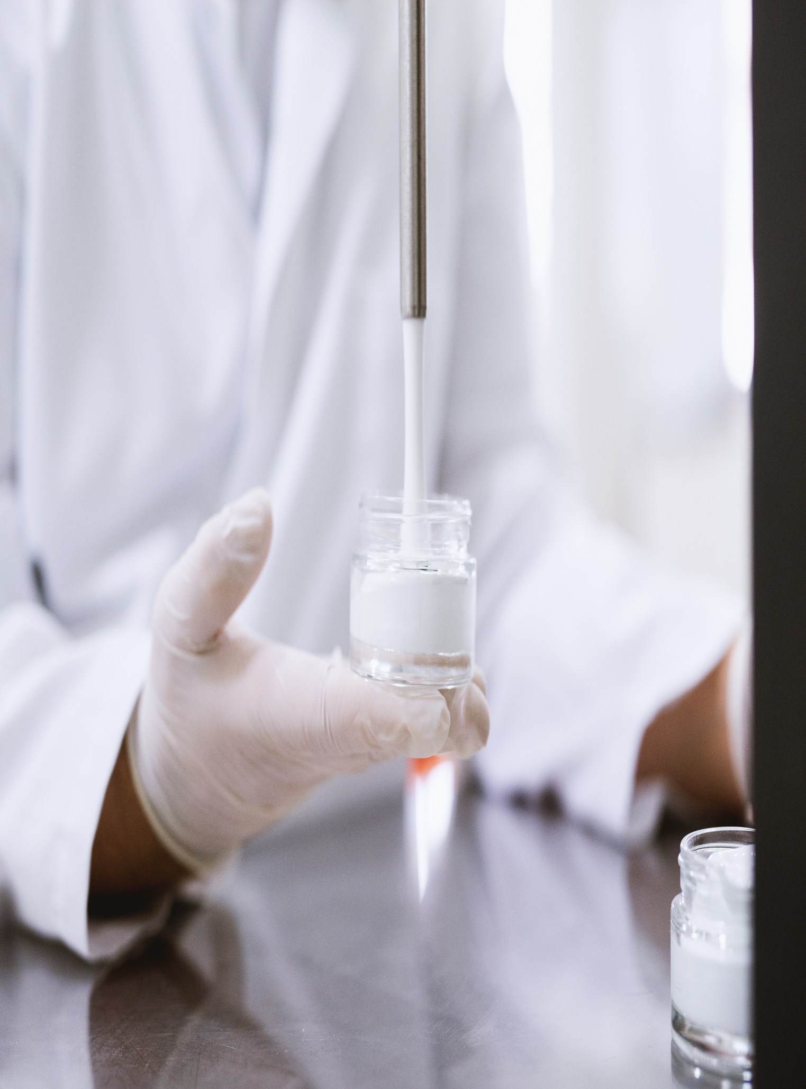

**Level 9, Constitution Place, 1 Constitution Avenue**

**July 13, 2023**

**Checkclient**