#### Training Methodology

We have designed the training to be delivered in two packages. As a starting package we offer our Train the Trainer (TTT) package, which will utilise your existing trainers who we know are embedded in your organisation. Our extended optional package is our end user training (EUT) package. We have designed this so that you can opt for one or both packages, providing you with greater flexibility.

For both packages, we will work closely with SJGHC’s Change Management lead to ensure an integrated approach to Change and Training – taking a holistic approach to these activities as they go hand in hand.

From our experience, we have developed a set of principles for what makes training in a Powered Workday implementation successful:

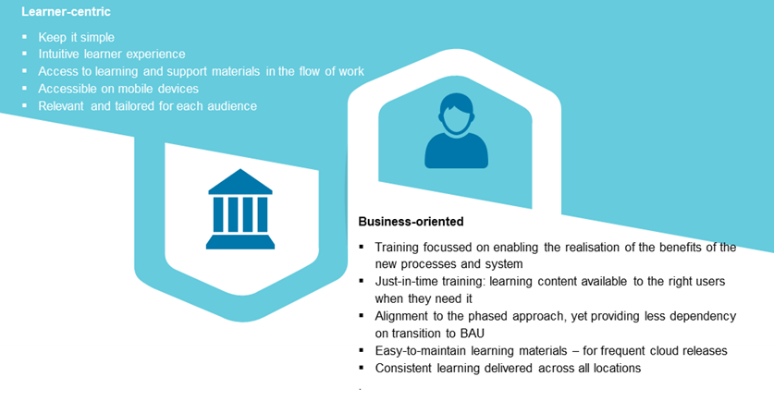

Figure 26: Training Principles.

The roll-out of the HRIS for SJGHC will create impacts associated with the system, process, role, policy, and new ways of working. We understand that SJGHC is moving from a non-intuitive solution that is difficult to navigate to an integrated contemporary solution that better supports the caregiver and ultimately enables them to spend more time on patient care. It is important to note that the impact is not just in your Group Workforce team. The impacts include facility-based clinical and non-clinical caregivers who will need to access the system with appropriate privacy and security on shared desktops or laptops (cognisant that use of personal mobile devices is not considered appropriate in clinical units and wards). This new way of working must be a key focus of the Change and Training approach.

Training Methods/Approaches

Fundamental to our approach is that we train for the job and not just the technology. This means training is designed based on the way people actually work, which is informed from the early workshops to validate ways of working and the Change Impact Assessments. Our approach is both learner and business-centric, balancing the needs of both aspects.

We will work with you to understand your different persona or role profiles and how they map to roles in the system. This will ensure caregivers can understand what their learner journey will look like and what they will experience during the deployment. Above everything, it provides the training that is relevant to them in their role.

We can use our learning content team consisting of a mixture of onshore and offshore learning professionals, Instructional Designers, and Learning Developers. We can provide a diverse set of learning elements and a blend of different digital approaches to quickly support learners with learning in the flow of work/just-in-time learning. Leveraging our offshore resources provides a significant price differential for developing short e-Learning videos and electronic quick reference guides. No data is required to be taken offshore to develop these materials.

Outlined below in more detail is each type of learning included in the full end-to-end approach including both TTT and EUT, with the flow of learning and the deliverables for each element.

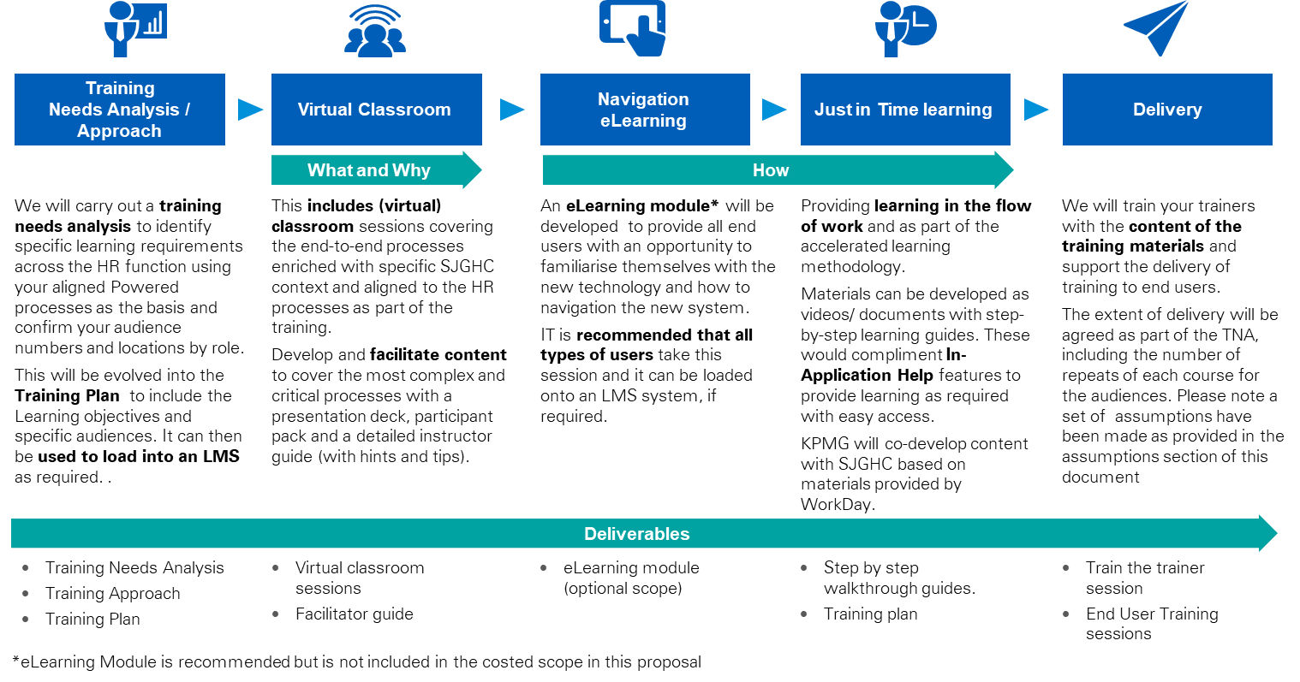

Figure 27: Blended Learning Approach.

As illustrated above, a range of blended learning solutions are recommended to meet the needs of different users using the right channel and timings. Some of the sample deliverables are highlighted below. Given the benefit of the pre-built Powered assets, we will have a range of assets that we can leverage and tailored for your purposes.

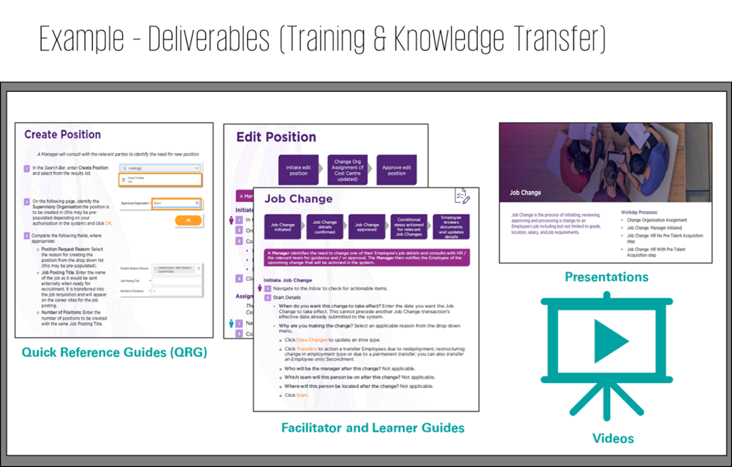

Figure 28: Examples of Training Deliverables.

TTT Services

As a base training package, we propose a TTT approach to delivering the training across your diverse, geographically dispersed workforce. We propose to work together with you to develop a capable group of your own trainers.

KPMG’s team would initially consist of a Training Manager who would undertake the Training Needs Analysis (TNA) and produce the SJGHC specific training strategy, approach, and plan. The training strategy, approach, and plan will include both TTT (detailed) and EUT (initial) planning. The Training Manager is responsible for overseeing the development of the TTT materials.

We will work with your Change Leader, process owners and change champions to confirm, and highlight areas with a high degree of change as identified in the CIA. The CIA is a critical input into the TNA. We will continue to evolve the TNA as we incorporate more significant levels of granularity as these emerge and your learner population are mapped against the new processes. This enables us to adjust the training approach to become specific to SJGHC using our core training content.

The training strategy and plan will include learning objectives, audience demographics, device types, learning mediums, and logistics to deliver the training. Training will be tailored to SJGHC scope, business context, and user audiences, and roles or personas. The training courses and deliveries will be confirmed during the TNA.

We propose, KPMG will train SJGHC trainers, who will become capable to deliver training (e.g., to superusers as part of EUT). SJGHC trainers will be capable of delivering capability uplift to champions. KPMG will develop the facilitation guides for these sessions.

In summary, training deliverables by KPMG will include:

* TNA, training strategy, approach, and plan.
* TTT preparation of materials.
* TTT virtual classroom preparation (as required).
* TTT training for trainers.
* Facilitator guides.
* Quick reference guides.

End User Training Services

In our optional EUT package, we will confirm the strategy, approach, and plan for delivering end user training. We acknowledge that if you select this option it may be because you would like KPMG to take responsibility for planning the approach for training of end-users, develop materials for EUT, and manage the EUT. We expect that your trainers would still be utilised. We can provide trainers if there is a requirement to do so but would recommend you use SJGHC caregivers.

We propose that in this option, e-Learning, and/or just-in-time training materials are developed. In our experience these types of resources are best suited for the majority of all end-users across SJGHC. E-Learning modules are designed to be bite-sized and easily digestible. They can be accessed at a time and place that is suitable to the end-user.

Some end-users will be nominated super users and champions and will require additional levels of training.

We can use a mixture of our onshore and offshore content developers for all training materials. EUT material development will be co-reviewed with resources from KPMG and SJGHC, leveraging super users, and Workday champions to ensure format and language resonate with SJGHC users.

In this optional package we will continue to work with your trainers, supporting them as they deliver training to champions in line with the roll-out plans, and as they support end-user questions more broadly, as part the EUT activities.

We will work closely together with the Change Team. An element of a learner's journey is the links to the change activities where we communicate information, when needed, to the various audience types per the agreed communications plan.

In summary, EUT training deliverables by KPMG will include:

* Virtual classroom preparation.
* Super user training.
* e-Learning guides.
* Support to SJGHC trainers.
* Connections with the change team.

Note, SJGHC trainers will deliver training to champions and will be responsible for deploying the e-Learning Module for EUT.

SJGHC will nominate and be responsible for availability of trainers, champions, and super users.