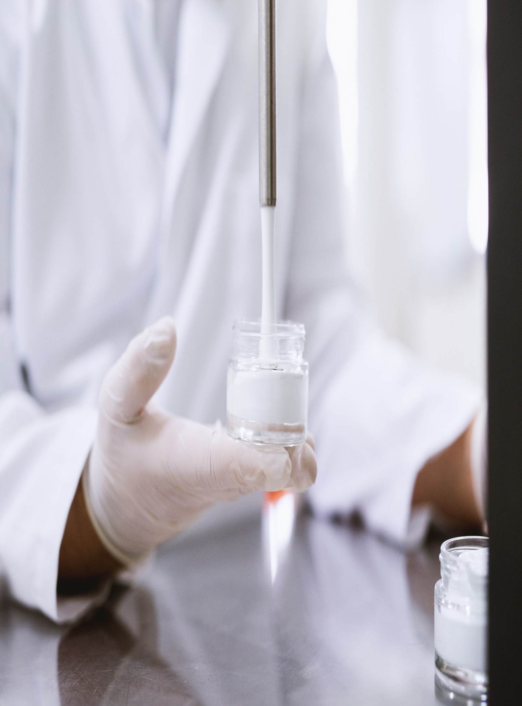

**151 Pirie Street, Adelaide SA 5000**

**July 13, 2023**

**priyamvadap@kpmg.com**