## Company Profile

Table 1: KPMG Contact Information.

|  |  |
| --- | --- |
| Name | [KPMG_GEO] Technology Solutions Pty Limited |
| Address | [KPMG_ADDRESS] |
| Contact Persons | Mark Bowden  Director  08 9278 2014  04 1929 0944  mbowden@kpmg.com.au  Hilda Carmichael  Partner  03 9838 4824  0412 414 315  hcarmichael@kpmg.com.au  Jonathan Di Michiel  Partner  02 9335 839  0401 997 949  jdimichiel@kpmg.com.au |

Table 2: KPMG Background and Financial Standing.

| Background, Financial standing |
| --- |
| [KPMG_GEO] Technology Solutions Pty Limited was established in 2015. The KPMG network was formed in 1987 when Peat Marwick International and Klynveld Main Goerdeler merged with their respective member firms.  KPMG is a private partnership and therefore does not produce a full-disclosure annual report. Financial arrangements relating to the partners are not published or available.    However, Our 2021 financial year performance is contained in our [Impact Report](https://assets.kpmg/content/dam/kpmg/au/pdf/2021/kpmg-australia-impact-report-fy21.pdf), in what will now be an annual assessment detailing KPMG’s activity to enhance accountability around financial, environmental, social, governance, and community benchmarks.    KPMG's 2021 Impact Report can be found here:  [KPMG's Impact Report FY21](https://assets.kpmg/content/dam/kpmg/au/pdf/2021/kpmg-australia-impact-report-fy21.pdf)  In this report we focus our analysis on ten material topics organised around four important categories:   * Planet * People * Prosperity * Governance     [KPMG_GEO] recorded revenue of $2.022 billion ($1.911bn excluding recoverable expenses, year on year growth of 9.4%) last financial year, delivering strong growth, and profitability despite the volatile market conditions. In FY21, KPMG’s financial performance.  In providing enhanced support for our clients and people we are ensuring the firm is well positioned for accelerating growth as we come out of the pandemic. Our key financial and operational measures compare favourably with those of our competitors. Our operations are characterised by strong annual financial results, limited litigation, or other exposures, a diversified Client base, and most important, strong leadership possessing the vision to direct the firm into the future. These characteristics position KPMG for consistent achievement well into the next decade.  2021 ($m) – 2,022  2020 ($m) – 1,905  2019 ($m) – 1,780  2018 ($m) – 1,640 |

Table 3: KPMG Services Provided.

| Services provided |
| --- |
| KPMG combines our multi-disciplinary approach with deep, practical industry knowledge to help clients meet challenges and respond to opportunities.   * Tax and Legal. * Audit & Assurance. * Risk Consulting. * Deal Advisory. * Enterprise. * Management Consulting. |

Table 4: KPMG Size and Presence.

| Size of organisation, presence across Australia and in Western Australia including a brief overview of the practice/ business including size of the practice, number of staff, and clients, and presence in Australia and Western Australia |
| --- |
| At [KPMG_GEO], we help our clients not just grow, but grow meaningfully – consciously, collaboratively, transparently, and empathetically. It’s our deep belief that how you grow matters. KPMG has 14 office locations around Australia. In Western Australia, we have an office in Perth. Nationally, over 9,000 people are dedicated to this belief across our network, while providing audit, assurance, and risk consulting, deals, tax, and legal, management consulting, and innovation, and digital solutions to entities and organisations that span the nation’s industrial, governmental, and not-for-profit landscapes. As of June 19, 2023: Total Partner Numbers: 576 (30 in WA). Total Staff Numbers: 7,780 (411 in WA). Total Partner & Staff Numbers: 8,356 (441 in WA). Total Contractor Numbers: 1,048 (15 in WA). |

### Other Relevant Information

Leading Implementation Partner in Healthcare

KPMG as a Healthcare industry leading implementation partner, with over 140 dedicated health sector experts nationally, is uniquely placed to support you through your HRIS implementation. KPMG has a deep understanding of the unique and complex operating environment within the Australian Health Sector and the challenges faced by Private Health providers such as kpmg_test_dev_here_004. This experience includes experts from both clinical and health sector backgrounds who know what good looks like and how to achieve it in the health sector context.

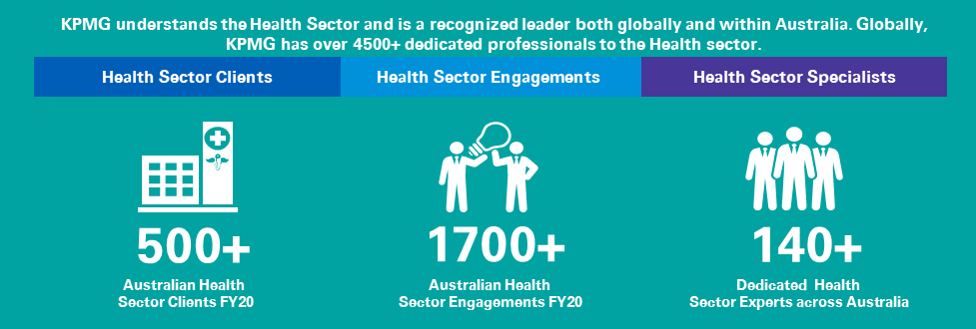

Figure 1: KPMG Healthcare Experience.

Our health sector expertise starts with an understanding of the health sector operating environment and the important role that your entire workforce and especially your clinicians and caregivers play in ensuring that your patients receive the; hospitality, respect, compassion, and excellent care that is afforded to everyone. We recognise that the care services you provide are not undertaken in isolation but are part of a larger even more complex health ecosystem. We also know that in the current challenging health care environment there are several system stressors and factors that are limiting your ability to recruit and retain clinicians and caregivers.

KPMG Connected Healthcare Framework

We know from our experience what the importance of having a unique employee value proposition and positive employee experience means to retaining and attracting the right talent. Failure to address this will limit your ability to not only provide care for those currently in your charge but also your ability to reach those still in need. To address this, we would leverage our unique health sector-based Connected Framework to work in partnership with kpmg_test_dev_here_004 so that your HR transformation is not just viewed as a HR system implementation but a critical component to supporting the care provided to your patients.

Connected Healthcare is a sector-specific blueprint for delivering complex business-led transformation. We believe that to fully realise the benefits of an enterprise-wide integrated Workday HCM system, kpmg_test_dev_here_004 must position this initiative within the broader transformation underway in the organisation and broader health care, aged care, home care, and community care sector.

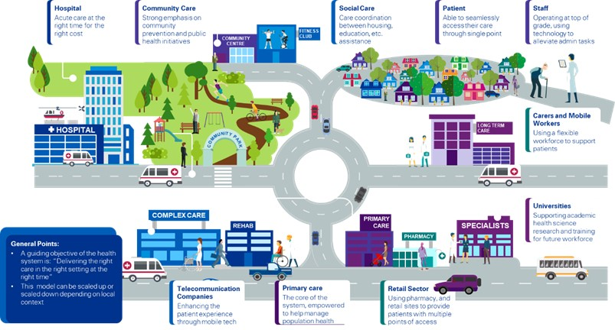

Figure 2: KPMG Connected Health.

KPMG’s Connected Health framework provides innovative insights, best practice methods, and end-to-end capability for successful transformation – connecting front end care delivery and patient experience channels through to middle office (HR management systems) and to back-office technology to support kpmg_test_dev_here_004's journey to becoming the best performing healthcare organisation in Australia by 2025. The key to the framework is that the relationships between the front (consumer/patient-facing), middle, and back-office functions are aligned so that the digital tools, technology, and processes implemented within the HR function promote efficient and effective workflows across kpmg_test_dev_here_004 operations.

Our framework leverages a globally adopted maturity assessment tool that provides a genuine stress test as to whether the requirements defined for your new HCM will deliver on kpmg_test_dev_here_004's promise to patients, consumers, and staff.

We will use the Connected Framework to work with kpmg_test_dev_here_004 in the Workday HCM implementation to:

* Quickly and effectively define the scope and vision of the HRIS within kpmg_test_dev_here_004's broader business context and objectives.
* Ensures the HRIS enables the revised Workforce operating model and drives the transformation that requires Workday to be fully effective.
* Challenge stakeholders with industry best practices in HRIS processes so that the future state processes are truly forward-looking and not focused on remedying current system shortfalls.
* Provide recommendations that arise from the functional and non-functional requirements to connect the caregivers to the HRIS.

With a clear business-oriented vision articulated for the project, we will use KPMG's full suite of transformation assets and tools to partner with kpmg_test_dev_here_004 to deliver the right outcome and contemporary experience for caregivers.