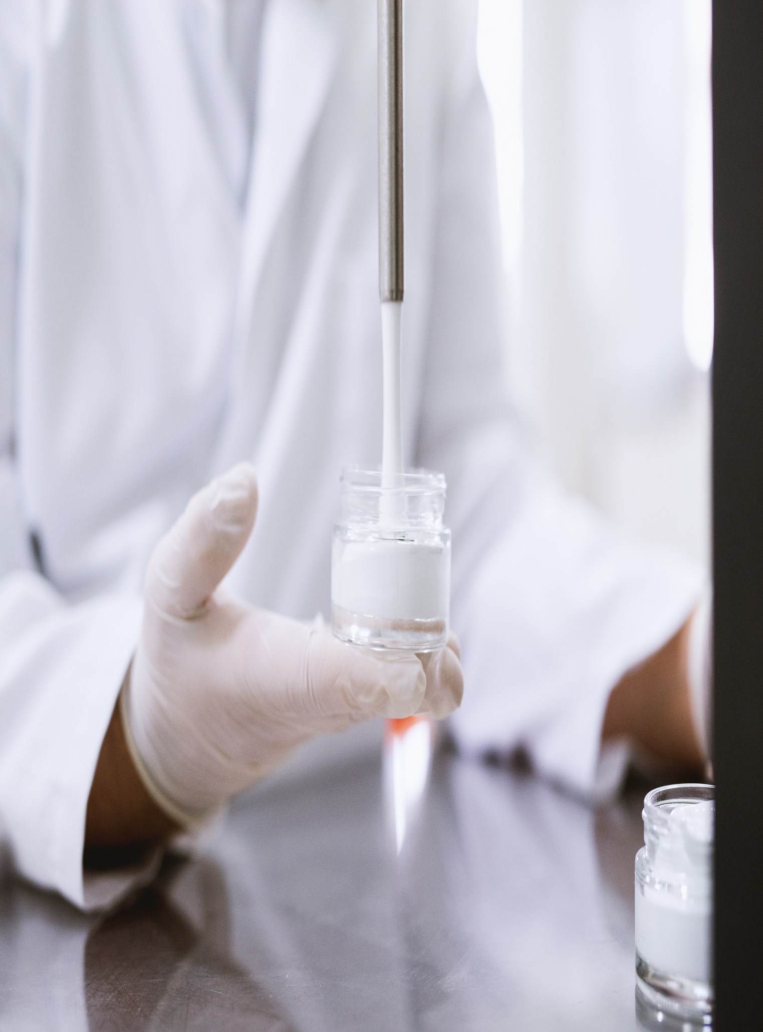

**None**

**This is first title**

**June 20, 2023**