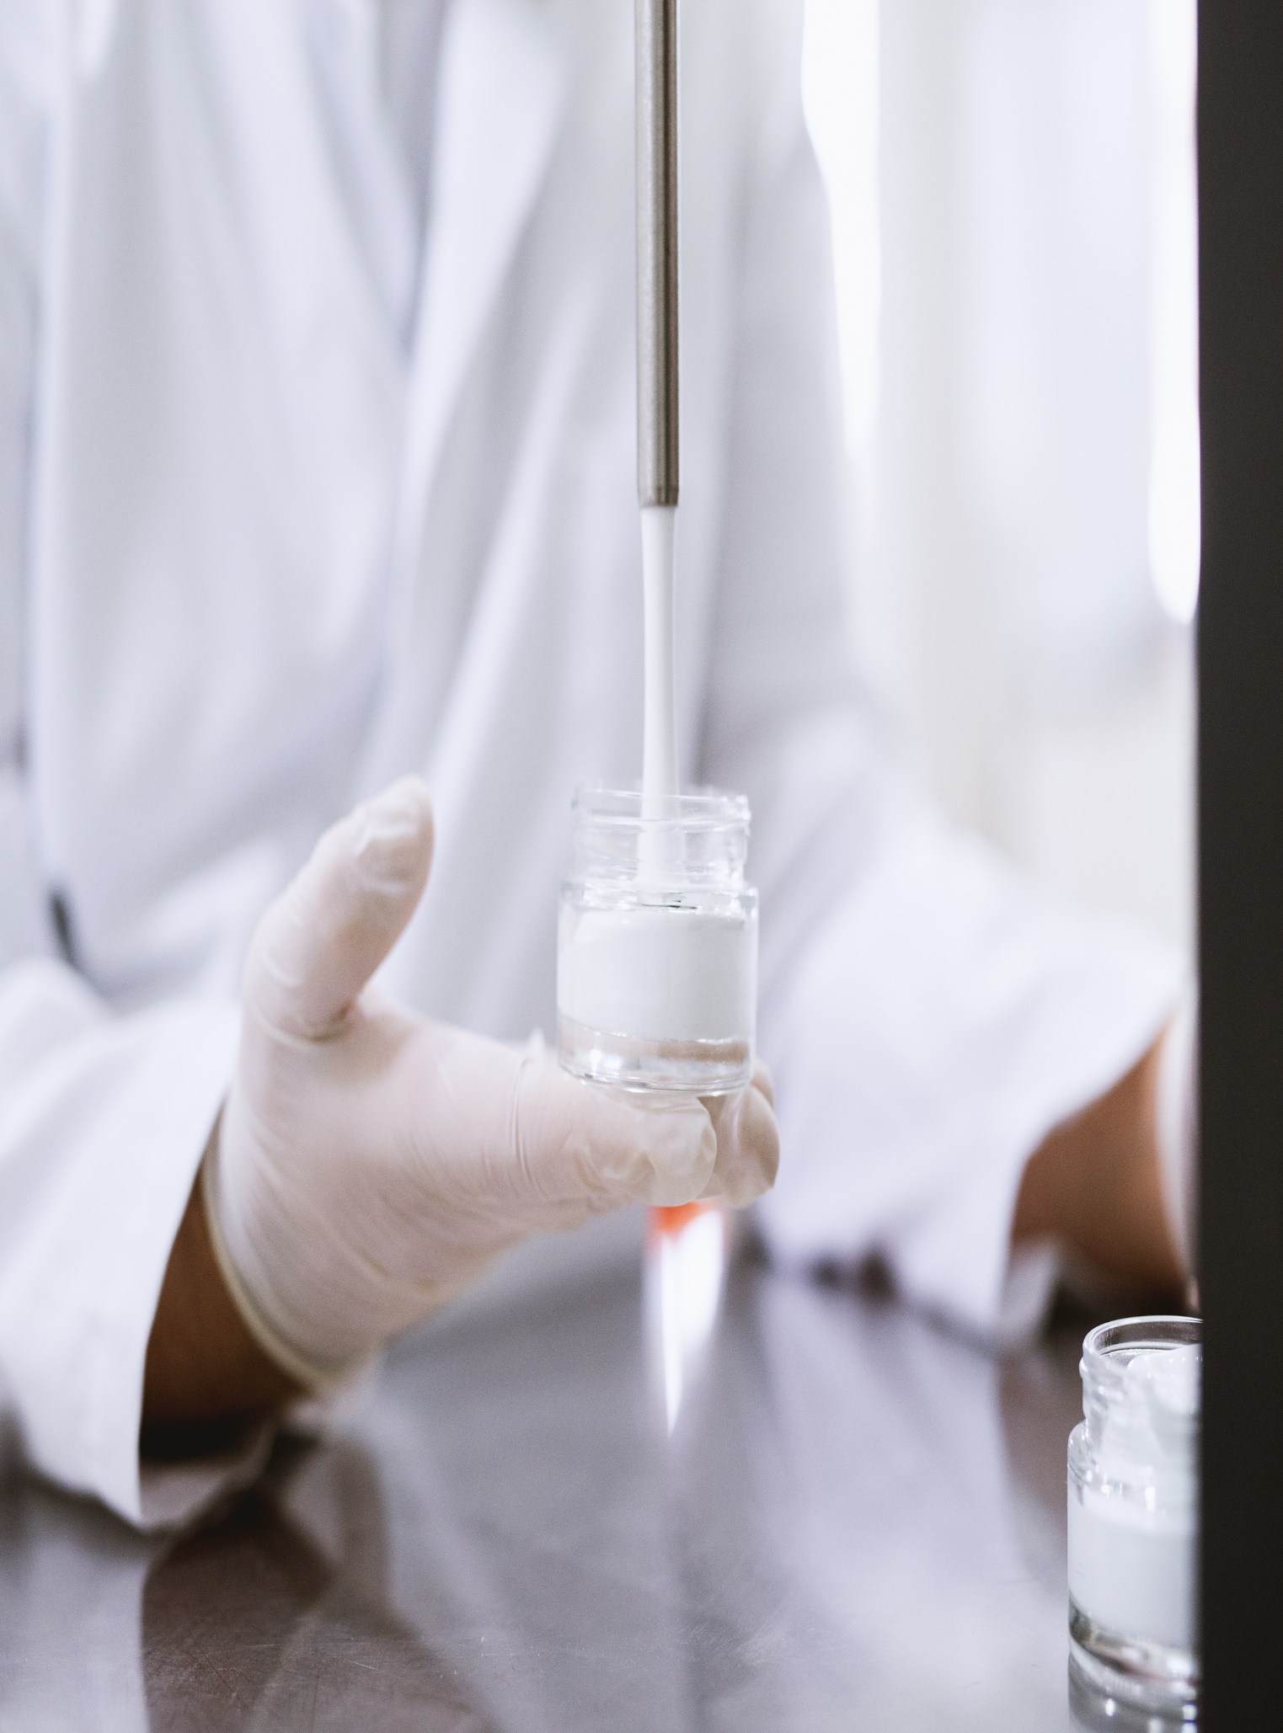

**KPMG Address**

**Title Data**

**June 20, 2023**