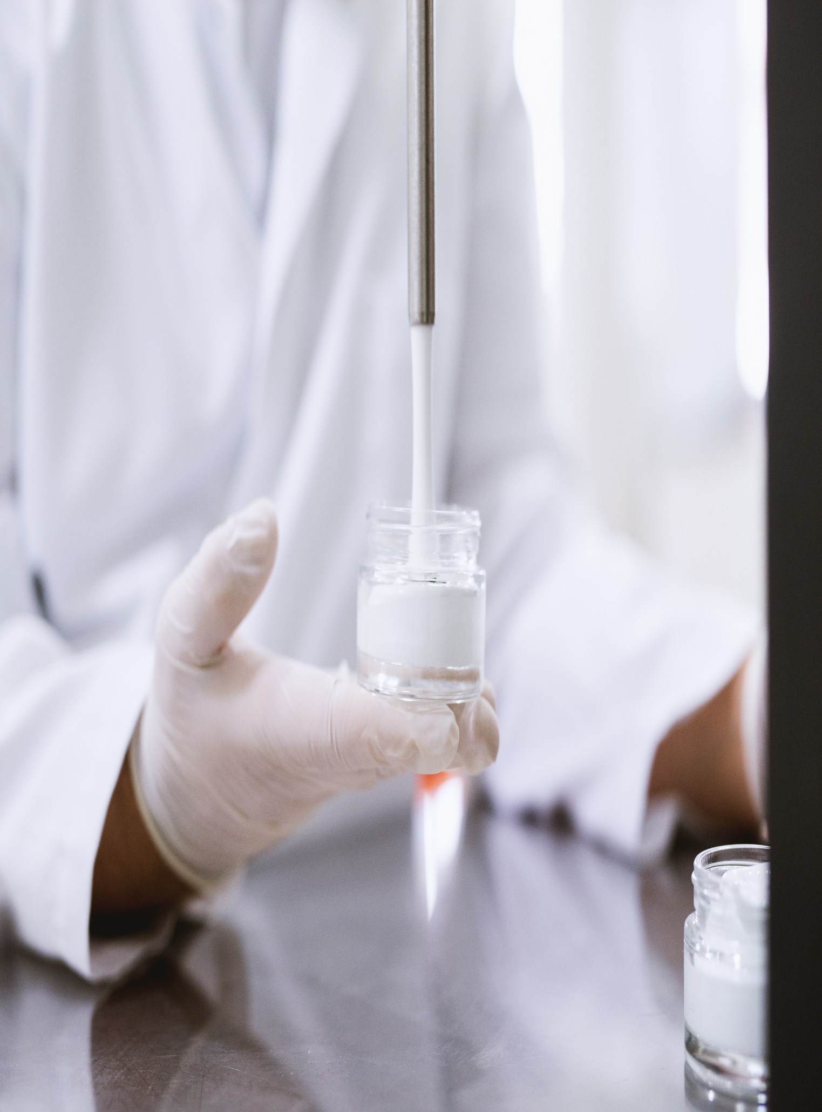

**60 Moorabool Street**

**July 13, 2023**

**wwwww**