## Our methodology: Powered Enterprise

KPMG’s proprietary Powered Enterprise (PE) methodology was developed to address the unique challenges of implementing transformation solutions enabled by cloud-based technology.

Powered Enterprise is based on the premise of achieving business transformation and sustainable change using technology as an enabler. PE brings an integrated, market-leading approach to transform all back office business functions including Finance, Human Resources, Supply Chain and IT.

The foundation of Powered Enterprise is the Target Operating Model (TOM) framework which we introduced and utilized significantly during Phase 1. Our TOM framework is tailored and fully integrated with Workday functionality and will continue to be leveraged to drive key process design and configuration decisions within the Workday platform. This approach will enable us to deliver a seamless process and technology enabled solution for CW. Further, our work together on the CW TOM assessment from Phase 1 will help accelerate the TOM changes needed to optimize your implementation by informing the design requirements for Workday. In our experience, without a TOM foundation in place, a Workday implementation becomes just a lift-and-shift of obsolete, outdated processes into a new technology. We will make sure CW avoids this trap.

### Powered Enterprise target operating model

The TOM framework we utilized in Phase 1 to complete the assessment work and define the implementation strategy is summarized below. As stated earlier we will continue to use this framework for the implementation as it is fully integrated with our PE solution for Workday.

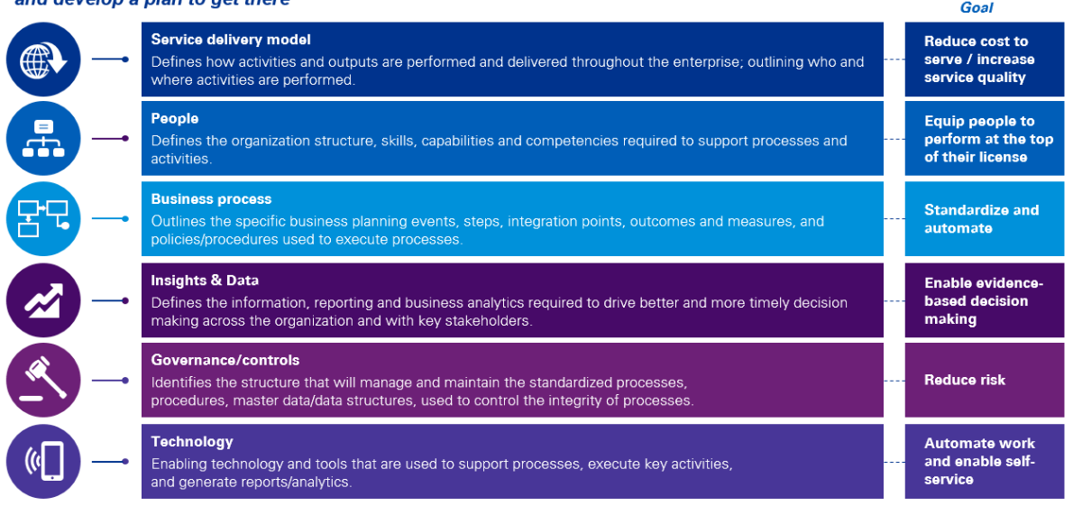

### The Value of Powered Enterprise for Workday enabled transformation

The real value of the Powered Enterprise solution for Workday goes beyond providing leading practices. The PE solution, by starting with a leading practice model that is typically 80% compatible with business requirements of healthcare systems like CW, provides a key operating model design accelerator which helps mitigate time line risk in addition to driving you toward a leading practice design. We are confident the PE approach is a good fit for CW and will help our collective teams achieve:

* Leading practice end to end process design
* Leading practice roles and responsibility design
* Process performance metrics including identifying how each process would be improved through Workday
* Alignment of process design to Workday configuration documentation
* Linkage of roles and responsibility design to Workday global risk and compliance (GRC) configuration

Reporting strategy with linkage to Workday financial data model (FDM) design and business reporting needs

An overview of the value we will bring to CW through our PE approach is summarized below.

Cloud Software as a Service (SaaS) solutions offer limited to no ability to customise the product. Where there are unique requirements that cannot be fulfilled through the product's configuration, clients have adapted their operating model (processes, policies, roles) to meet the needs.

KPMG’s Powered Enterprise for Workday is our unique and proven approach to HCM transformation. KPMG’s Powered Enterprise fuses decades of our HCM functional experience, leading HCM practices and future HCM trends to develop pre-configured deliverables, most notably a pre-validated Target Operating Model (TOM) for HCM, roles, job catalogue, leading practice business processes with embedded controls, test scripts and scenarios. All these pre-configured assets are aligned to Workday, providing you with 80% of the model answer allowing the program to focus on the remaining 20% that is unique to your business and what will make you competitive in the market.

Success in this program cannot just focus on the Workday technology and End-User Training, it requires a broader Change Management capability in order to embed new ways of working and there needs to be a focus on the Service Delivery Model optimised to drive benefits from the Business Case. Even on a “minimum viable scope” for Workday, the implementation requires a focus on people, process, data, integration, and culture in order to deliver on the business outcomes and employee experience.

We know that even the best technical solution is only successful with appropriate engagement, prototyping, testing, and training. We will apply our tried and tested methodologies to secure buy-in to the case for change, deliver against end-user requirements in the Solution Design, promote ease-of-mind during implementation and generate user uptake of the end solution, enhancing the user experience.

Managing the people and change impacts will be critical to success and will need to be a significant focus for the project. At KPMG, we understand that change is personal; individuals experience change to different extents and process change at different speeds. The impacts and changes to the ways of working will be experienced very differently across HR and employees and people managers across [Client]. Leveraging KPMG’s ‘Powered Change and Deployment’ methodology, which is embedded within our KPMG Powered Enterprise, we address the personal needs and look at a holistic solution to manage business change, drive business readiness and maximise change adoption to deliver against required business outcomes. Although only training is assumed to be in scope at this stage, we are keen to leverage our assets, described in the value-adds. At the heart of our approach, Change and Training must work together, and we will ensure that KPMG Training and [Client] change work shoulder-to-shoulder as one team.