## Our methodology: Powered Enterprise

KPMG’s proprietary Powered Enterprise (PE) methodology was developed to address the unique challenges of implementing transformation solutions enabled by cloud-based technology.

Powered Enterprise is based on the premise of achieving business transformation and sustainable change using technology as an enabler. PE brings an integrated, market-leading approach to transform all back office business functions including Finance, Human Resources, Supply Chain and IT.

The foundation of Powered Enterprise is the Target Operating Model (TOM) framework which we introduced and utilized significantly during Phase 1. Our TOM framework is tailored and fully integrated with Workday functionality and will continue to be leveraged to drive key process design and configuration decisions within the Workday platform. This approach will enable us to deliver a seamless process and technology enabled solution for CW. Further, our work together on the CW TOM assessment from Phase 1 will help accelerate the TOM changes needed to optimize your implementation by informing the design requirements for Workday. In our experience, without a TOM foundation in place, a Workday implementation becomes just a lift-and-shift of obsolete, outdated processes into a new technology. We will make sure CW avoids this trap.

### Powered Enterprise target operating model

The TOM framework we utilized in Phase 1 to complete the assessment work and define the implementation strategy is summarized below. As stated earlier we will continue to use this framework for the implementation as it is fully integrated with our PE solution for Workday.

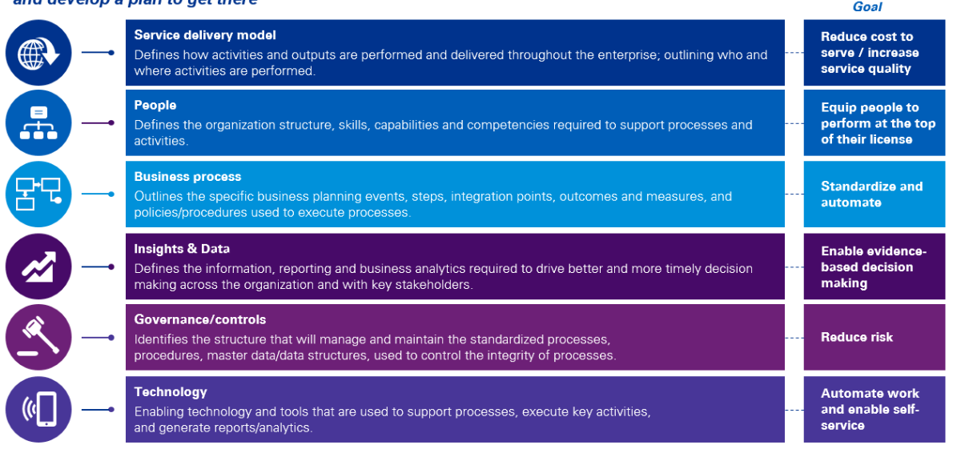

### The Value of Powered Enterprise for Workday enabled transformation

The real value of the Powered Enterprise solution for Workday goes beyond providing leading practices. The PE solution, by starting with a leading practice model that is typically 80% compatible with business requirements of healthcare systems like CW, provides a key operating model design accelerator which helps mitigate time line risk in addition to driving you toward a leading practice design. We are confident the PE approach is a good fit for CW and will help our collective teams achieve:

* Leading practice end to end process design
* Leading practice roles and responsibility design
* Process performance metrics including identifying how each process would be improved through Workday
* Alignment of process design to Workday configuration documentation
* Linkage of roles and responsibility design to Workday global risk and compliance (GRC) configuration

Reporting strategy with linkage to Workday financial data model (FDM) design and business reporting needs

An overview of the value we will bring to CW through our PE approach is summarized below.

|  |  |
| --- | --- |
| Services | Description |
| Base Services | The Base Services will be fulfilled by applying the standard processes used within the KPMG Powered Evolution Service Desk. |
|  | Incident Management  The KPMG Service Desk will be the single point of contact to manage Level 3 incidents or defect tickets. |
| Workday Bi-annual Update Assessment - Functional Update Support  Provide [Client] with a report detailing the impact on your environment, opportunities for Workday major release management (Bi-annual updates): |
| Enrichment Services | Enrichment Services allow clients to fulfil a changing demand through service catalogue items or change requests. KPMG is engaged via a Service Request mechanism. |
|  | Enhancements  An enhancement is a requested addition to documented functionality or a request to change the existing functionality of the Workday solution. KPMG will package each change for release, handing it over to the Client for final integration and UAT, and then planning and migration to production. These may include configuration changes, report writing, integration services, data load services, training, documentation etc. |
| Tenant Management  Management of [Client]‘s Workday tenants is done via a service request to support on-going development, configuration changes, minor Workday updates, and regular functional updates. |
| Workday Bi-annual Update Deployment – Test and Deployment  Configure the enhancements and new features within the test and sandbox environments. Test the new functionality against the existing configuration in a sandbox environment. Deploy the new configuration into the production environment. |
| Problem Management  A problem is a recurring incident or request by which resolving a root cause will resolve a new instance of the incident or request.  As Problem investigation can be time-consuming and, in most instances, leads to a request to resolve an underlying issue, we require [Client] approval before engaging in the investigation process. |
| Governance Services | The Governance services oversee the delivery of services that meet the service level appropriate for Client needs and as detailed in the service contract. The effort is reviewed and adjusted every quarter depending on [Client] needs and other services provided. |
|  | Change Management  Management of any changes required to maintain the service alongside release planning, testing, packaging, and scheduling. Provision of input into the Client Change Management process (Client will provide a dedicated development environment for KPMG to provide their services to the Client, any development work will be packaged and handed over to the Client to deploy into production). |
|  | Strategy and Roadmap Planning  Functional update planning services provide a forward-looking plan outlining your roadmap for future adoption and maturity improvement. The plan will be the basis for establishing an updated schedule. |
|  | Reporting  Provide critical oversight and account management to help ensure that the right policies, procedures, and processes are compiled, and accurate financial and management reports are produced. KPMG CSM will conduct a monthly Service Review with the Client. The Service Review reporting pack will cover performance against agreed SLA targets with red-amber-green status and cover significant cases and Service Requests. It will also cover changes that were delivered to the Client for the period and arose from cases, regression testing and Service Requests. |