# Intelligent RFP Builder UI Feedback

## General

1. The Phase 2 wish list appears to have a number of items that are still not incorporated into the application. Can you please review and update the spreadsheet on MS Teams ([Phase 2 Scope](https://kpmgaust.sharepoint.com/:f:/r/sites/AU-Powered-WorkdayPlatform-RFPAutomation/Shared%20Documents/RFP%20Automation/Phase%202%20Scope?csf=1&web=1&e=t0g4WY)) to indicate what was released or moved to phase 3.
2. Can you please confirm if the application has a responsive layout for resizing on mobile and tablet. Subha: Not sure whether we would be able to check on this

## Landing Page

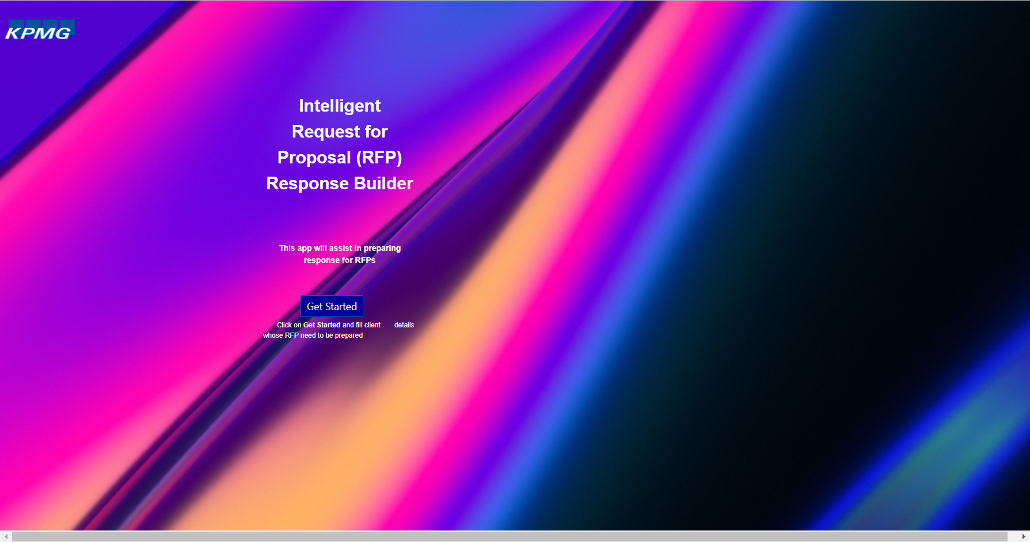

1. Rename the application to “Powered Enterprise Intelligent RFP Builder”.
2. Replace the KPMG logo with the following transparent version. Ensure the image is not stretched when resizing:

1. Remove the background image and add the coloured banner to the top (replicate other pages).
2. The banner should include a button for “Feedback” on every page. This should launch a new email addressed to myself.
3. Every page should include a “Legal” and “Privacy” link as well as copyright at the bottom of the screen:

© 2023 Copyright owned by one or more of the KPMG International entities. KPMG International entities provide no services to clients. All rights reserved. KPMG refers to the global organization or to one or more of the member firms of KPMG International Limited (“KPMG International”), each of which is a separate legal entity. KPMG International Limited is a private English company limited by guarantee and does not provide services to clients. For more detail about our structure please visit <https://home.kpmg/governance>.

1. The new title should be central to the page and if possible, across one line only.
2. Replace “This app will assist in preparing response for RFPs” with the following:

Welcome to the Powered Enterprise Intelligent RFP Builder v1.0. This application will currently assist you in the creation of an RFP response for the following Powered solutions:

Powered Enterprise for Workday

Powered Enterprise for Workday Healthcare

Powered Enterprise for Workday Higher Education

Please click the “**Get Started**” button to proceed.

## Page 1

## Contact Information

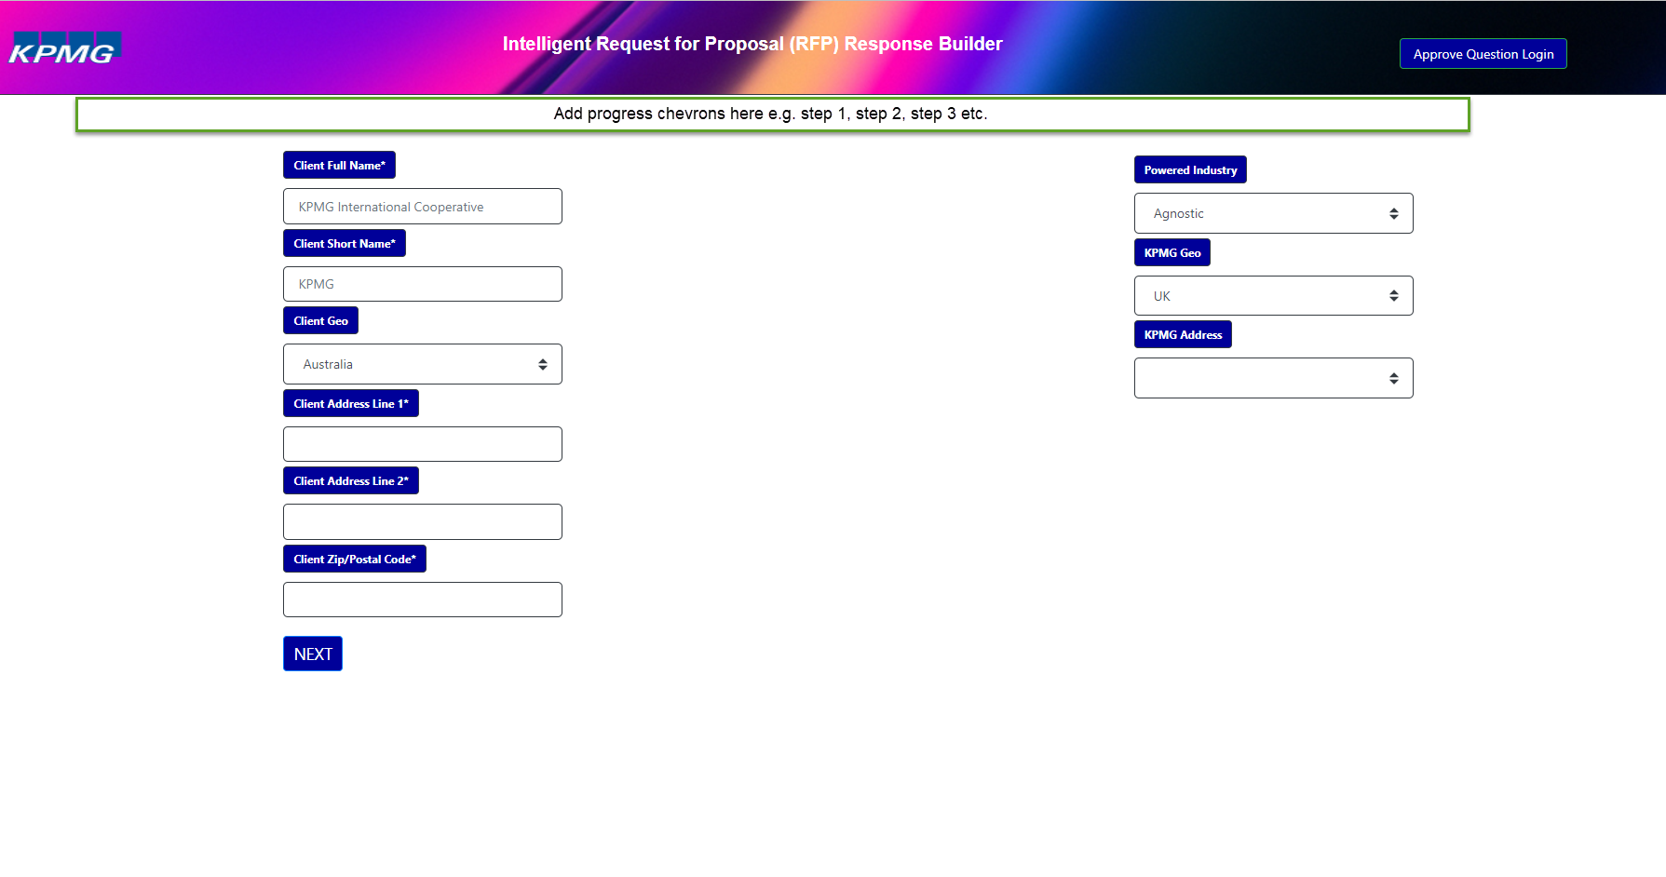

1. Add progress chevrons across all input pages (see above for location). The Chevron should include the step sequence and name e.g., Step 1: Contact Information”. Once the page is complete, the related chevron step should be updated to include a tick to show completion.
2. Add the following page header below the chevrons “Contact Information”.
3. Add the following text below the header and above the input form:

Please complete the following client information, the required Powered Industry that aligns to the client, KPMG responding country and address. Please note: the information provided will be incorporated into the RFP response document.

1. Remove the example entries from “Client Geo”, “powered Industry” and “KPMG Geo”.
2. Client Address line 2 should be optional. Add address line 3 as “Town/City” and make required.
3. Add address line 4 as “State/Region” and make mandatory.
4. “Client Geo” is a required field.
5. Powered Industry is a required field – remove “Financial Services” from the drop-down list.
6. Rename “KPMG Geo” to “KPMG Lead Geo”. This is a required field.
7. “KPMG Address” – data to follow.
8. Add a new field “KPM Tax Reference”.
9. Add a new field “Lead Partner”. This should be a free-text field.
10. Add a new “Back” button after the “Next” button. This should be consistent for all pages.

# Page 2

## Document Sections

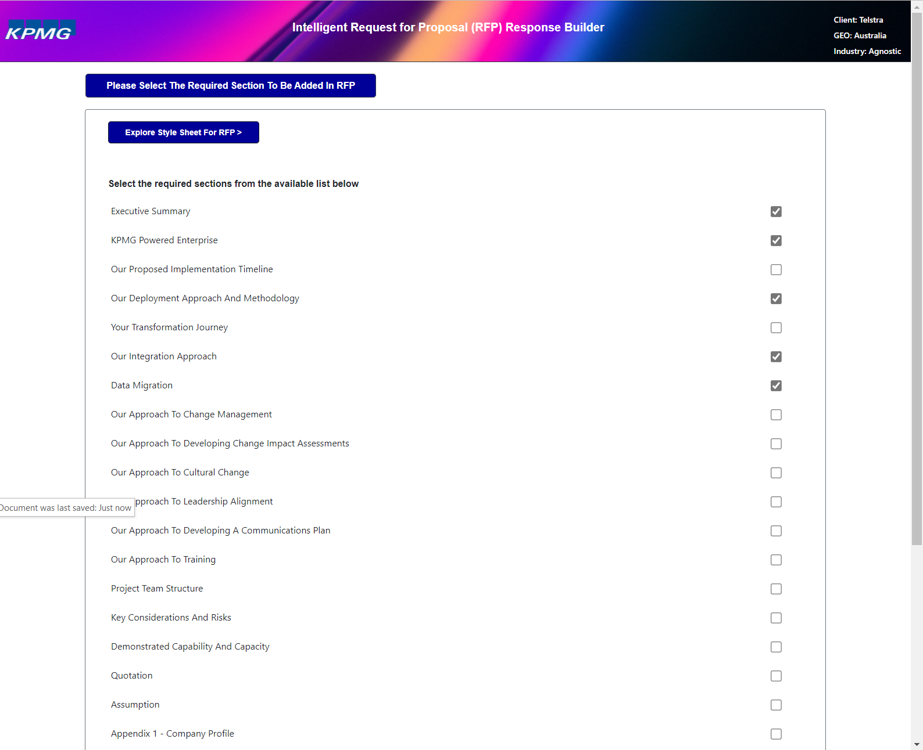

1. Add progress chevrons across all input pages.
2. Add the following page header below the chevrons “Document Sections”.
3. Add the following text above the style sheet button:
4. Click the “Style Sheets” button to view all available style sheets. You can select from a pre-existing style sheet or upload your own.
5. Rename the button “Explore Style Sheet for RFP >” to “Style Sheets >”.
6. Style sheet selection should be a required step. An error message should be generated when the form is submitted without a selection or upload.
7. Style sheet options saved to Teams directory here -> [Style Sheets](https://kpmgaust.sharepoint.com/:f:/r/sites/AU-Powered-WorkdayPlatform-RFPAutomation/Shared%20Documents/RFP%20Automation/Style%20Sheets?csf=1&web=1&e=hJMSTi)
8. Style sheet upload functionality does not appear to work
9. Replace the existing style sheets with the new available in MS Teams and group available style sheets by Industry (replicate the MS Teams folder)
10. The following sections are required for all responses:
    1. Executive Summary
    2. KPMG Powered Enterprise
11. Remove the option “Do you want to ask more Ques&Ans”.
12. Rename the button “SAVE” to “Next”.
13. Add a new “Back” button after the “Next” button. This should be consistent for all pages.

# Page 3

## Executive Summary

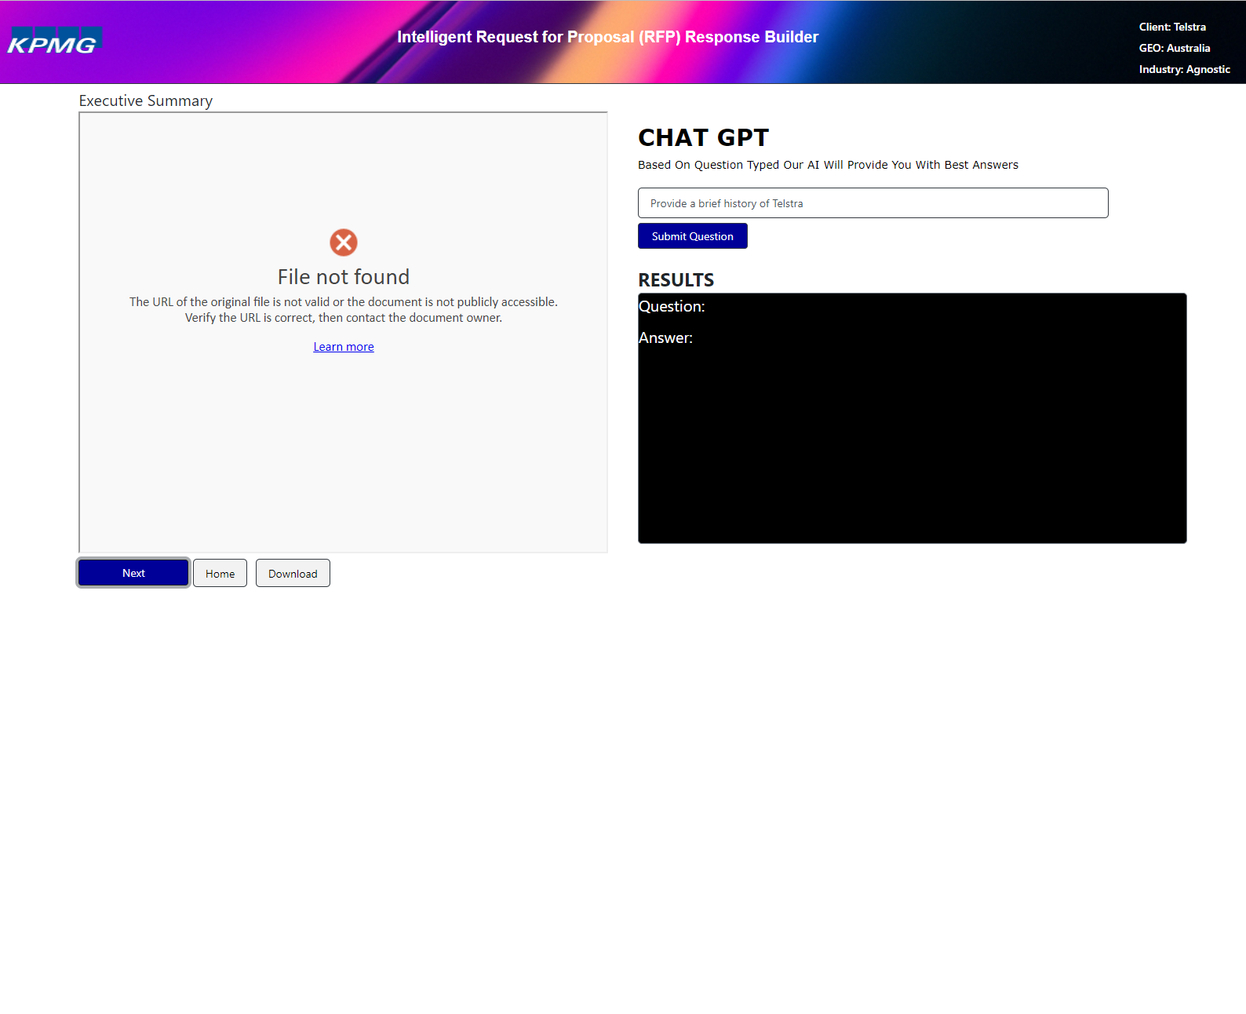

1. Add progress chevrons across all input pages.
2. Add the following page header below the chevrons “Section: Executive Summary”.
3. Add the following text after the header:

The Executive Summary section provides an example for the industry you previously selected. This section should be rewritten specifically for your opportunity.

To help inspire your response we have included a Chat GPT interface that will allow you to ask specific questions in relation to the client or industry. Please Note: Chat GPT processes data offshore and by using this platform, you agree and understand that ChatGPT may use any content to develop and improve its services, and therefore once data has been fed into the software, ChatGPT owns that Intellectual Property.

1. File not found error in document viewer needs to be fixed.
2. Document viewer should be full width of screen with Chat GPT below (full width).
3. The Chat GPT results box should be framed and have a white background with black text.
4. The Chat GPT interface should include the following options as toggle switches:

Act as a: CEO, CIO, CFO, CHRO, Consultant, IT Expert

Tone of Voice: Friendly, Professional

1. The Chat GPT interface was extremely slow and did not generate a response.
2. Reorder the buttons to “Next”, “Download” and “Home”
3. Rename the “Home” button to “Back”

# Other Items

1. Sections I had previously selected were not presented to me in the UI.
2. With the exception of the Executive Summary section, each additional section should display the document (full width) and a section to add additional content via the “Q&A” functionality which is limited to the relevant document.
3. The ability to download the complete file produced an error.
4. The ability to enter a question produced no output .e.g., “How would you recommend we implement end user training?”.
5. The application became unresponsive even after closing the browser and restarting.