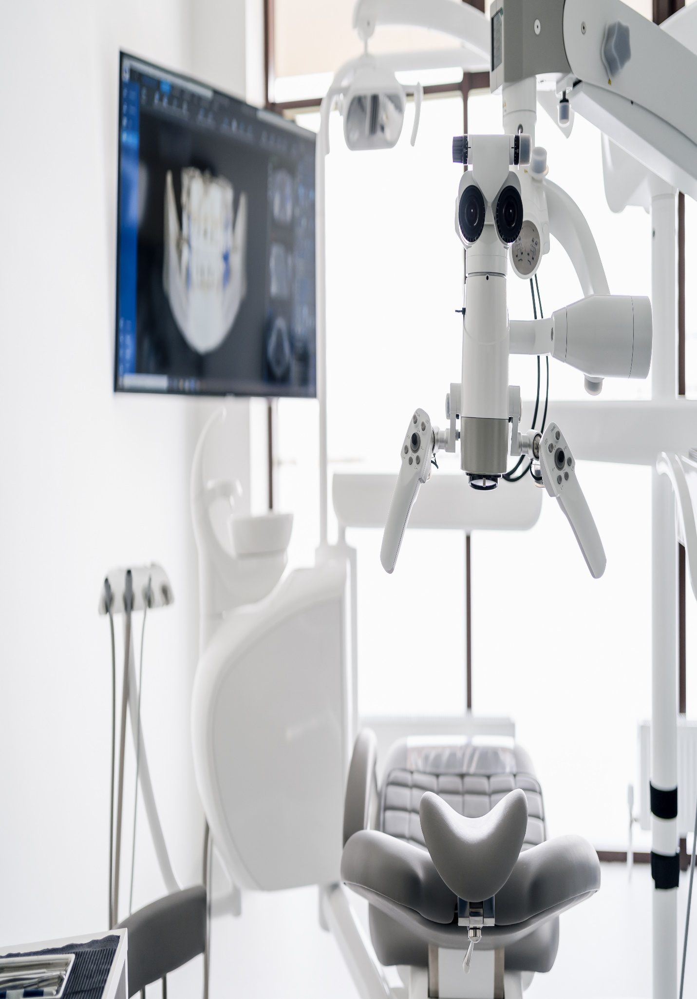

**testing**

**Full Address**

**June 19, 2023**