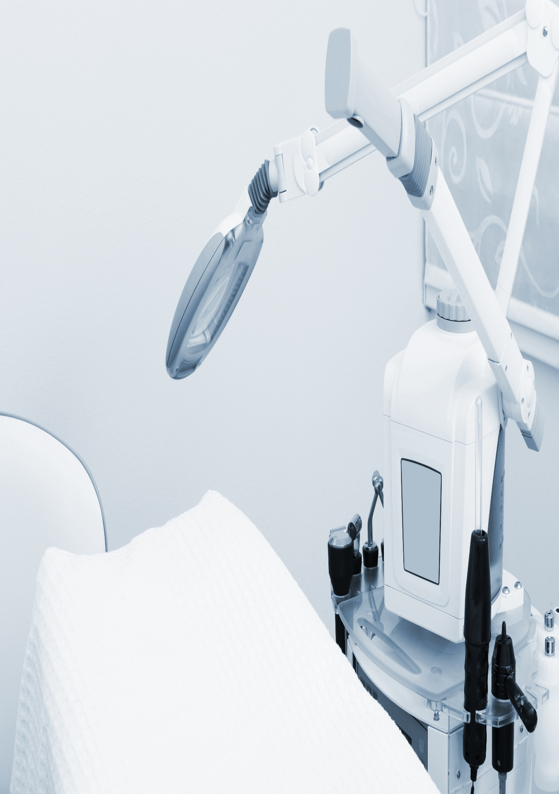

**{{ KPMG_address }}**

**{{ curr_date }}**

**{{ title }}**