## Implementation Timeline Overview

As discussed in previous sections, we recommend utilizing our Powered Enterprise methodology to support the implementation as this approach will enable leading practice adoption and de-risk the timeline. We believe a successful implementation can be achieved over a 19 month timeline. The high-level project timeline jointly developed in Phase 1 is provided below and has been updated to reflect an assumed start date of November 2021.

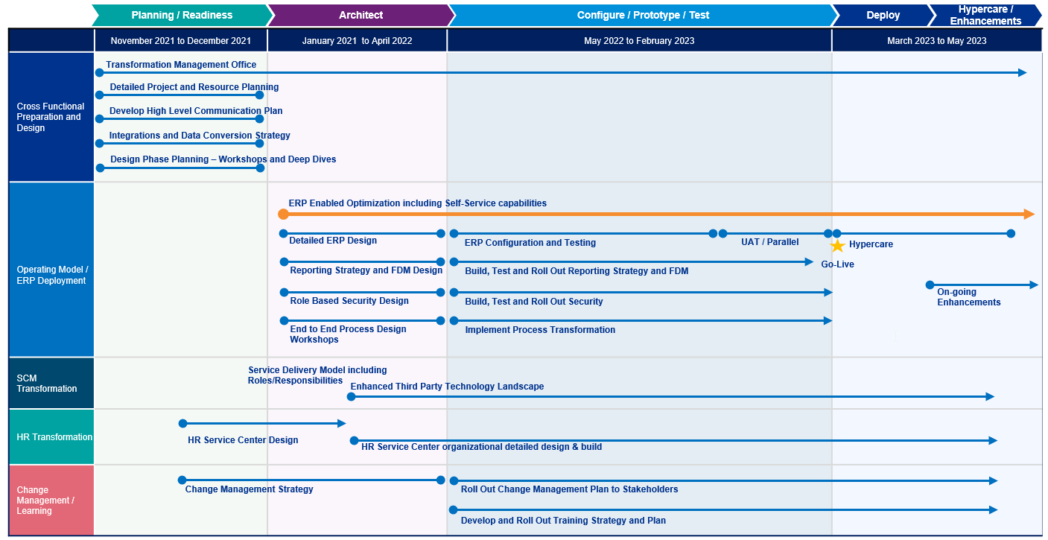

Following the timeline above, the program will be deployed within the 5 phases of the Powered Enterprise methodology as outlined in the diagram below. Much of the Vision and Plan work has been completed during our Phase 1 effort and will therefore be replaced by a short Readiness phase beginning in November 2021 so that the Architect phase can begin in early January 2022.

