KPMG Powered Change Responses Repository

Our Approach to Change Management

KPMG's Change Management method is underpinned by our five-step approach to Change Management and People Readiness for the implementation.

**Maximising OCM benefits from our KPMG Powered Higher Education delivery approach**

KPMG Powered delivery approach provides a strong platform for Organisational Change Management and we have seen this in practice in previous programs such as [insert previous client(s)]. There are two key parts:

* Firstly, KPMG Powered provides a pre-configured solution, out-of-the-box business processes, and delivery tools meaning we understand up to 80% of the future-state ERP solution at commencement. We draw on this existing asset base as key Organisational Change Management inputs, providing a jump start for activities such as change impact assessments, change plans, and change risk assessments.
* Secondly, our delivery approach supports **early solution visibility** for stakeholders **so they can experience the system as early as possible. This includes a 2-week Socialisation** phase demonstrating the first prototype and **Experience (XAT) Sessions where** users can run processes and transactions as they would expect to see them in future. Our OCM approach will integrate with these activities to provide meaningful stakeholder engagement opportunities through.

Backed by experience, our Organisational Change Management approach will ensure full integration with program delivery, maximising the value of KPMG Powered.

**Our Change Management Methodologies**

Our approach to delivering the Organisational Change Management is underpinned by our leading and globally recognised Behavioural Change Management (BCM) Methodology (below) bringing rigour and structure to end-to-end delivery. Behind our framework sits a full suite of tools and frameworks supporting detailed change activities.

Analysts including ALM Intelligence, Forrester, IDC, and Gartner, have all our rated change capability and thought leadership highly, noting that “KPMG’s Change Leadership approach is a differentiator”. Importantly, our approach aligns with our Powered Methodology, seamlessly integrating OCM activities into program delivery. We will apply our BCM methodology as our core guiding framework, tailoring to the [client] context.

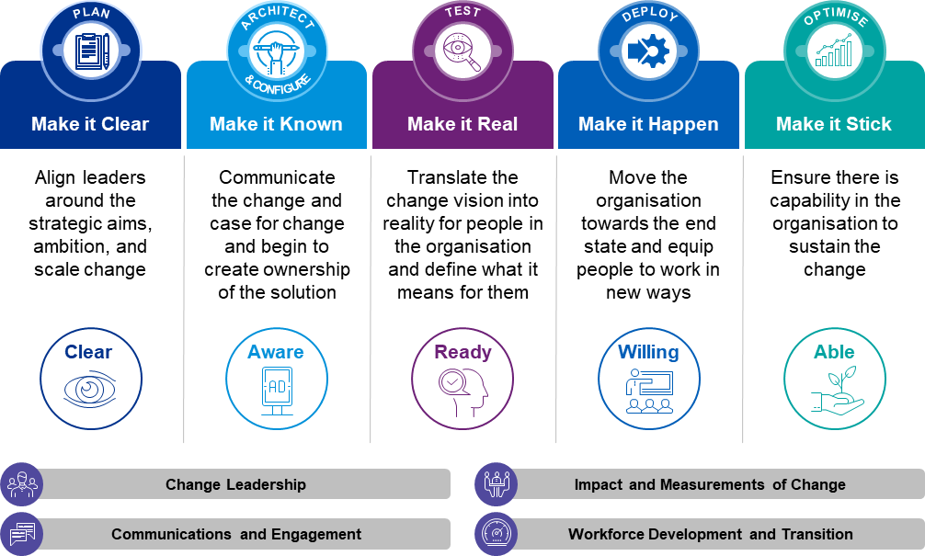

**Figure X: KPMG's Behavioural Change Management Methodology.**

Our five-stage BCM Methodology drives specific outcome-based change management activities and ensures clarity, consistency, and quality, while accelerating change adoption across the life of the program.

1. In the first stage, **'Make it Clear'**, we identify, engage, and align appropriate members of your senior and functional leadership teams around the strategic aims, ambition, and scale of change.
2. The second stage, **'Make it Known'**, involves developing the approach for communicating the change vision and need for change to the wider stakeholders and audiences. Given the proposed delivery model, with close KPMG, and [client] collaboration in every project team, this stage will be crucial for building stakeholder engagement and ownership throughout the change process.
3. In the third stage, **'Make it Real'**, we draw the change from abstraction into reality, defining concretely what the change will mean for staff day-to-day activities. We do this by exposing staff to the system and the art of the possible early and frequently.
4. We will embed new ways of working in the fourth **'Make it Happen'** stage by building out workforce transition activities and assessing business readiness.
5. Finally, at the **'Make it Stick'** stage, we will empower key stakeholders with the skills, experience, and knowledge to embed new ways of working following project end.

To illustrate application to [client’s] [project name], below is an adaptation of our framework mapping to our program delivery phases and in-scope change activities (both [client] and KPMG led).

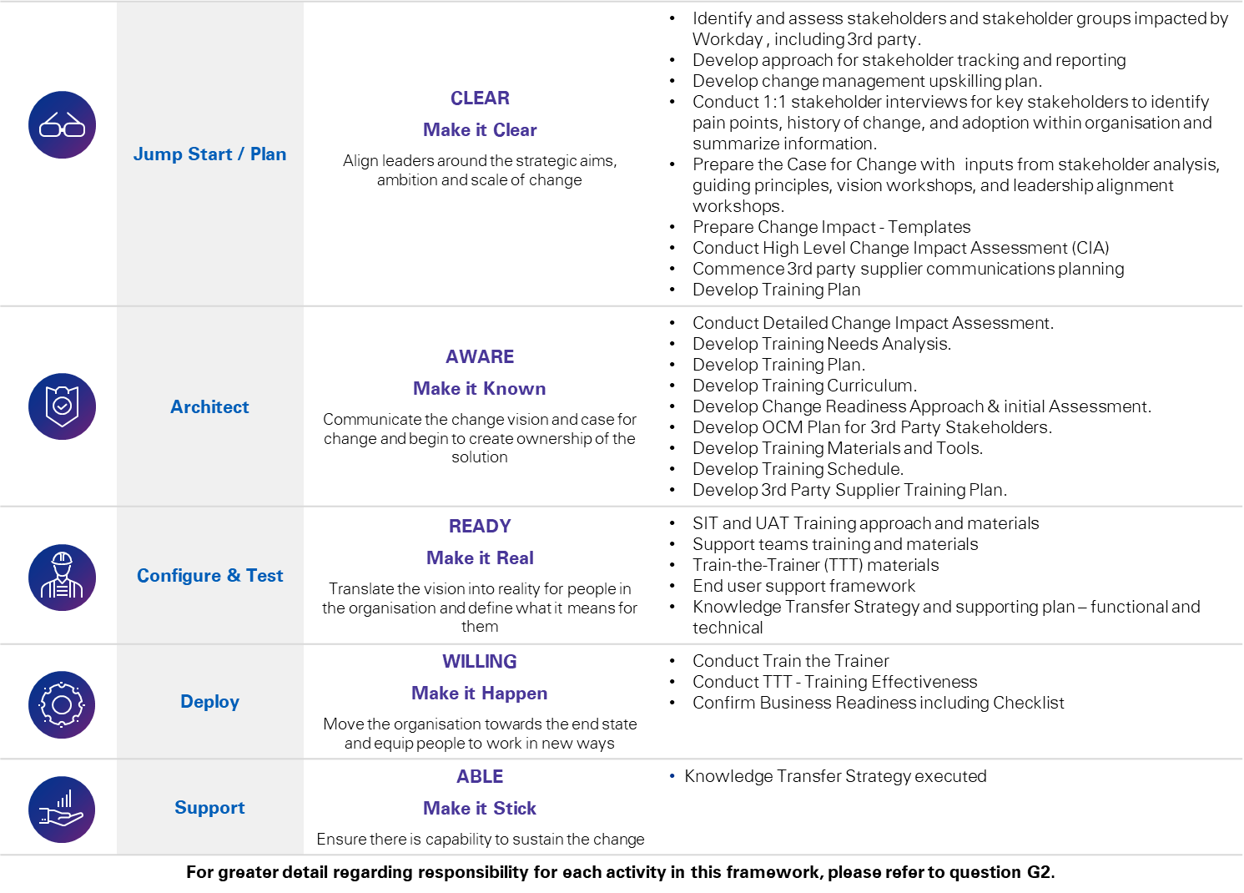

**Figure X: KPMG's Behavioural Change Management Methodology Adapted to this Program.**

In addition to our BCM Methodology, KPMG's Eight Levers of Change represent sub-streams within our change management approach. This ensures a holistic approach to managing change, giving consideration to, and delivering activities against each of the eight elements. Each of the eight levers is described below.

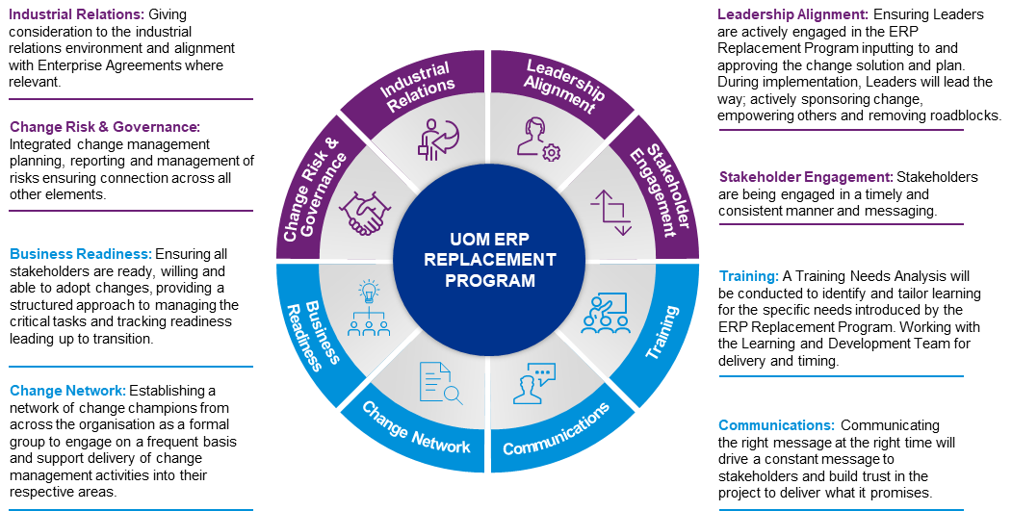

**Figure 3: KPMG's Eight Levers of Change.**

Change Management Activities

Guided by our tried and tested Powered methodology, we have a clear list of deliverables based on project milestones. Along with the key dependencies for each, these are outlined below within **Table X: Change Management Activities.**

Where [client] is the responsible party who will deliver the activity, we have noted "KPMG to support" confirming that where required, KPMG can provide [client] with advice and insights based on our expertise and experience.

Note, following the table are additional activities we have included in this proposal.

**Table X: Change Management Activities.**

| **Activity** | **Responsible Party** |
| --- | --- |
| OCM Strategy | KPMG or [client] |
| OCM Charter | KPMG or [client] |
| Leadership alignment workshops and 1-page Relationship Charter | KPMG or [client] |
| Change Management Upskilling | KPMG or [client] |
| Change Management Risk Assessment and Mitigations | KPMG or [client] |
| Development of core benefits | KPMG or [client] |
| Change Impacts – templates | KPMG or [client] |
| Change Impacts – development and maintenance | KPMG or [client] |
| OCM Plans | KPMG or [client] |
| Business Readiness | KPMG or [client] |
| OCM Plan for 3rd Party Stakeholders | KPMG or [client] |
| Change Initiatives | KPMG or [client] |
| Change Network | KPMG or [client] |
| Stakeholder Analysis | KPMG or [client] |
| Senior Stakeholder Engagement Plan | KPMG or [client] |
| Stakeholder Engagement Plan | KPMG or [client] |
| Stakeholder tracking and reporting | KPMG or [client] |
| Communication strategy and associated plans | KPMG or [client] |
| Communication channels | KPMG or [client] |
| Key Stakeholder Messages | KPMG or [client] |
| 3rd Party Supplier Communications Plan and associated materials | KPMG or [client] |
| Communications asset and materials development | KPMG or [client] |
| Training Strategy | KPMG or [client] |
| Training Plan | KPMG or [client] |
| Training Needs Analysis approach and tools | KPMG or [client] |
| Training Curriculum | KPMG or [client] |
| Training Schedule | KPMG or [client] |
| Train-the-Trainer Coaching | KPMG or [client] |
| Training Effectiveness | KPMG or [client] |
| 3rd Party Supplier Training Plan | KPMG or [client] |
| SIT and UAT Training approach and materials | KPMG or [client] |
| Support teams training and materials | KPMG or [client] |
| End-user materials | KPMG or [client] |
| End-user support framework | KPMG or [client] |
| Train-the-Trainer approach and supporting activities | KPMG or [client] |
| Knowledge Transfer Strategy and supporting plan – functional and technical | KPMG or [client] |

If required, we welcome further scoping sessions as a way of understanding the detailed change scope and providing the chance to explore handovers and accountability across the change management activity and the strengths we each bring to the table to make the chance effort a success.

Throughout the course of the engagement will work closely with [client]’s Change Management lead to ensure an integrated approach to Change, as it is essential to view these activities holistically.

Our Approach to developing Change Impact Assessments

Given our intimate knowledge of Workday, we understand the wide-reaching impacts to stakeholders from functional areas (HR and Finance) to your people across the organisation.

We bring a rigorous approach to developing change impact assessments (CIAs). The following principles underpin our CIA approach, and we look forward to working with you to incorporate insights from your experience in our approach.

* **Connection with our KPMG Powered delivery approach and Workday experience.** Our CIA approach builds from our KPMG Poweredsuite that will accelerate the process and provide deeper richer insights. Our existing knowledge of ~80% of future-state processes provides an advanced starting position with these key CIA inputs already known to us. In addition, we will leverage relevant change management insights to further drive forward CIA development and enhance content.
* **Impacts need to be owned by [client].** Often CIAs are developed within program teams and not in collaboration with impacted stakeholders from leadership teams to 'end-user' staff in functional teams, divisions, and departments. This not only results in inaccuracies (missed service channels, missed local 'shadow' systems and processes), but also misses an opportunity to drive ownership of change within and across the business. As change management leaders within the [client’s] program, we will bring program teams together shoulder-to-shoulder with impacted stakeholders (e.g., functional teams and end-users), leveraging other perspectives to develop high-value CIA insights. In addition to critical organisational knowledge, we value the intellectual insight that [client] stakeholders will bring. We will provide change leadership, structure, and experience, and ensure that we leverage each other’s strengths and knowledge to establish a shared understanding of the change impacts and how to manage them. Lastly, we will always obtain formal, representative stakeholder endorsement, as identified for each project team or stage, for sign-off on all CIA deliverables. This will be our success measure. From lessons learned, this is a critical step and where required endorsement has not occurred, this will be escalated to be managed as a program risk, acknowledging the importance of stakeholder ownership at a program level.
* **The CIA must be fit-for-purpose.** We take a highly considered approach to the CIA tools, templates, and formats that we use, ensuring they are fit-for-purpose, and use clear language that resonate with the audience. The CIA should balance simplicity with insight. We will use varying presentation layers to present insights tailored to the audience to ‘bring the change to life' (e.g., organisational heatmaps, and Power BI visualisations).
* **Outcome-based.** Our CIA work is always based on outcomes. It is not only the process by which we assess and analyse change impacts, but also how we identify risk mitigation (e.g., training to address a capability need). CIAs can be an exercise, a series of workshops, or a spreadsheet of line items. While the primary purpose is to establish an understanding of impacts, the same conversation moves stakeholders forward to identify the necessary action or change management intervention and invests them with a sense of ownership.

**Change Impact Assessment Approach Overview**

The CIA plays a critical role in assessing the breadth and depth of the impacts, establishing an understanding of what is changing, for whom, and when. Most importantly, it informs what changes need to be managed, to ensure that appropriate interventions can be designed and planned for (e.g., new processes, new capabilities, retirement of duplicated 'shadow' processes, or new support documentation). We understand that process change will not be uniform across [client] and we will need to factor the existing process differentiation within departments and divisions. Our approach to assessing impacts is holistic and we will work with you to consider change types across five key impact categories including people, process, systems, policy and other (refer to diagram below).

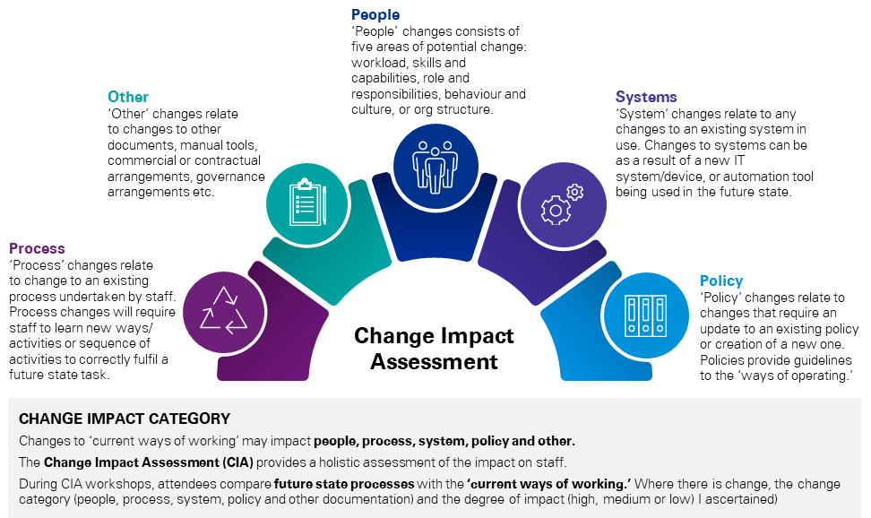

**Figure X: Change Impact Categories.**

Our CIA approach is grounded in best-practice behavioural science and aims to understand the required shift in human mindset and behaviours.

**We understand the critical importance of the CIA work to drive adoption as it provides the necessary inputs into communications plans, stakeholder plans, change management plans, and training, some of which will be [client’s] responsibility**. While we will drive and lead delivery of the CIA work, we see the KPMG and [client] partnership as crucial to change team members including [client] Change Leaders establishing a shared understanding, providing a strong foundation for subsequent change management activities.

We will develop both high-level and detailed change impact assessments. Upon program commencement we will develop a high-level CIA summarising known impacts across key stakeholder groups, building awareness and understanding of the change, and bringing attention to the areas requiring the most change management support to achieve early engagement with all stakeholders. Following this the detailed CIA will commence in line with the process outlined below. While there is focused development upfront, the detailed CIA remains a 'live document' requiring maintenance throughout the program where new impacts are identified.

**Developing Change Impact Assessments**

Our three-step approach to developing CIAs consists of the following stages: **identify, assess**, and **analyse**. This section describes our proposed activities at each stage.

**1. Identify the impacts**

To identify the impacts, we start by establishing some key foundations. Firstly, we must be collectively confident we have identified all stakeholder groups to be considered within the CIA. Our Powered toolkit provides the start point to assess the change impact as this is the initial future-state. We will then work with [client] and program teams to build upon this where required, to ensure we have a comprehensive list of all stakeholder groups and any differentiation across the business and relevant departments, (functional teams, operational support teams, end-user groups, third parties). Secondly, we must identify those key individuals who we will engage in developing the CIA, who will bring business knowledge and insight into identifying detailed impacts. We will engage functional leads from across [client], the change network and other stakeholders as required to inform the CIA, ensuring integrity in the development process and the content within it.

We will use several methods to assess **on-system and off-system impacts** across each stakeholder group. This includes running dedicated CIA workshops with [client] change team members, key program leads (KMPG), functional/end-user stakeholders and/or members of the change network, facilitating a structured process for gathering CIA inputs. We will also actively participate in design workshops to capture CIA inputs, including **Socialisation** and **Experience (XAT) Sessions** in line with early solution visibility principles within our program **delivery** approach. Within these sessions change impacts will be surfaced and discussed and we will utilise feedback tools such as Mentimeter to capture impacts in real-time. In identifying impacts, we will ensure there is a validation process where relevant stakeholders confirm the CIA inputs to be correct.

**2. Assess**

Once impacts are identified, we will continue work with the same key stakeholders mentioned above to assess the details of the impact determining type (people, process, people, technology) and the degree of change (high, medium, low). An illustrative rating table is below for reference and will be tailored together with [client].

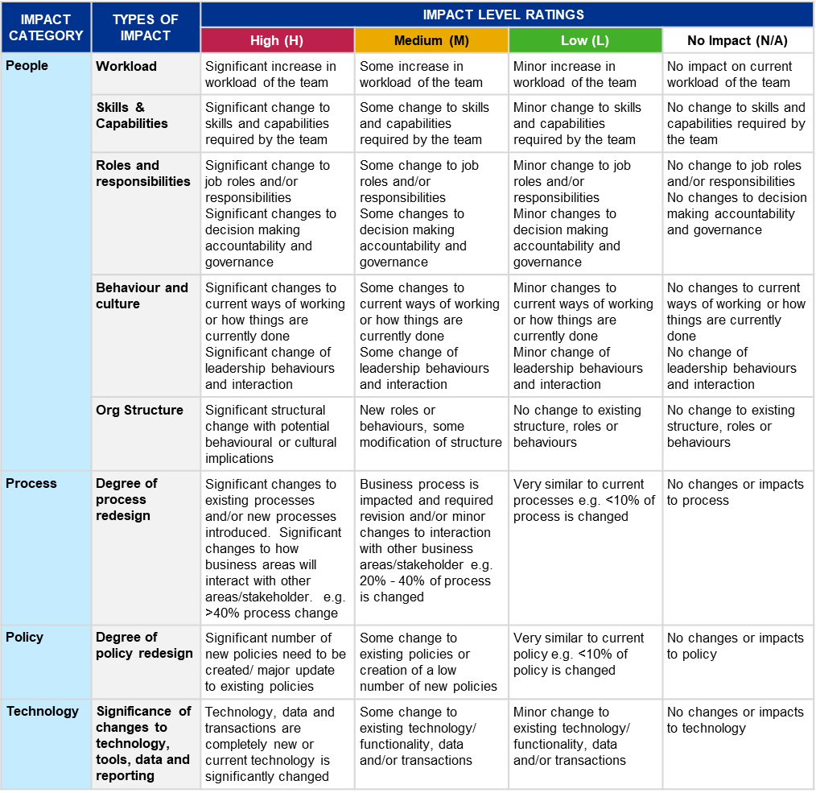

**Figure X: Change Impact Assessment Rating Table.**

The assess stage allows categorisation of impacts as we are able to 'tell the story' from the data. This includes magnitude of change to determine which groups are most impacted and therefore need to be closely supported.

**3. Analyse**

Finally, we will analyse impacts to determine the change management interventions required, moving focus to towards required solutions. Working with stakeholders we will utilise the KPMG Change Interventions Framework below providing specific, actionable strategies to address impacts. This ensures the CIA provides the necessary inputs to subsequent change activities and deliverables such as the change management plans, training strategy, communications plans, and in informing any cultural or behavioural changes required.

Working alongside [client] change team members we will ensure effective transition of the CIA outputs into [client] led change management activities.

The KPMG **Change Interventions Framework** can be used to help identify the types of change interventions that may be required. We can then provide these as inputs to the Change Strategy for [client] to consider. Below is an example of four highlighted areas for intervention (circled in red): understanding, skill development, access to support, and role alignment. These interventions have then been expanded on in the below table.

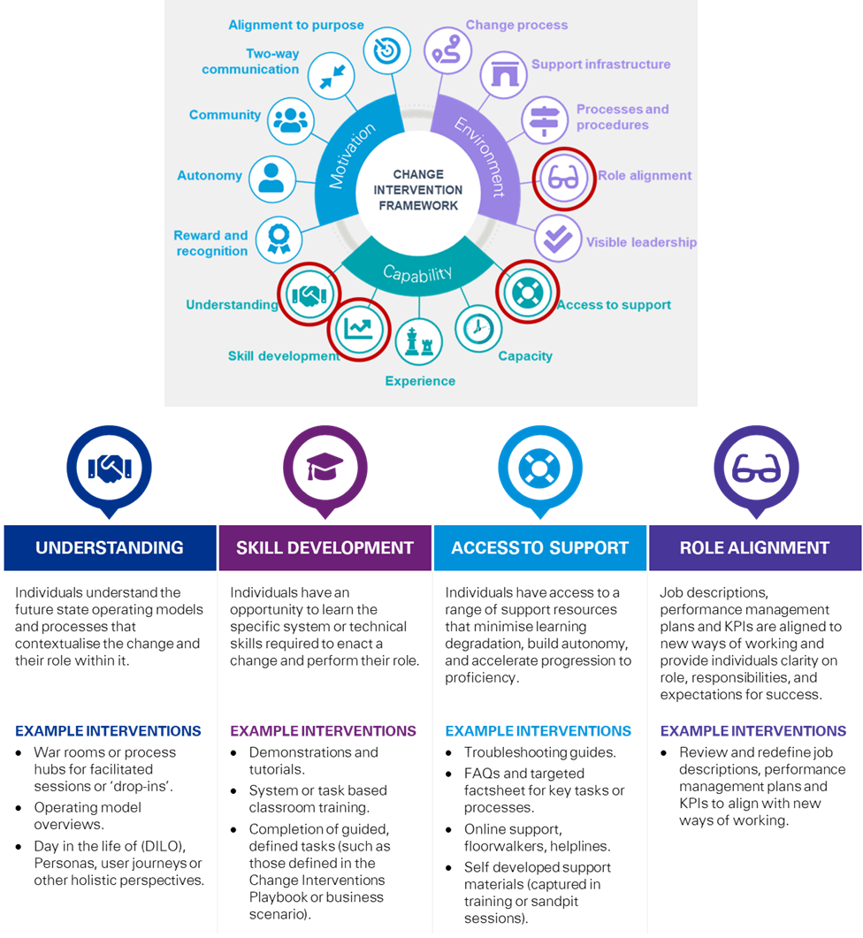

**Figure X: KPMG Change Interventions Framework.**

**Change Impact Assessment (CIA) Examples and Visualisations**

Our detailed change impact assessments are typically built in MS Excel to undertake efficient analysis, however separate to this we will use varying presentation layers to present CIA insights tailored to the different audiences, bringing the change 'to life'. This is a crucial step to communicating the impacts in an engaging way. This includes a 'high-level CIA' and 'change heatmaps' to provide a summary view of change on a single page understanding which stakeholders are most impacted and how. We will also utilise PowerBI to provide interactive visualisation, illustrating impacts from varying perspectives (e.g., by stakeholder group, degree of change, location, and impact category).

We will work along [client] to determine the most impactful visualisations for a given purpose and audience.

Example images included below for illustrative purposes.

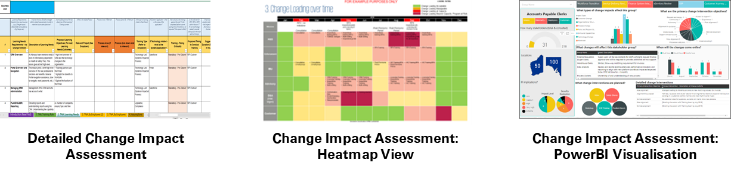

**Figure X: Illustrative Examples of Change Impact Assessments.**

Our Approach to Cultural Change

Culture determines how an organisation operates in response to internal and external challenges. It is the product of shared basic assumptions that underpin values, norms, and behaviours. At KPMG we see culture as the accumulation of implicit and explicit rules, practices, and habits of the people in the organisation, patterns of interaction, and preferences when making choices and dealing with dilemmas.

Given the HR and Finance functions are entering a period of significant change that will also impact multiple staff across [client], it is important that the culture within those functions and across the business is right to ensure the necessary behaviour change can be facilitated. We also understand that [client] has experienced significant change in recent times, including but not limited to [insert previous change projects the client has recently undertaken]. This type of change can have a significant impact on the type of culture that is created. We know that 'self-serve' can be challenging to sell in complex organisations and the benefits can be challenged by impacted individuals. We understand this and will work through this by providing access early so that staff can understand what will be required of them and think through together the solutions that best position the change and future culture outcomes. We look forward to working with you to understand the additional cultural challenges that will come with your ERP implementation.

Once a target cultural environment has been agreed, appropriate interventions are required to ensure this change is managed effectively. Cultural change is not a one-off change. We will work with [client] in identifying and recommending the design of the intervention to implement with you. The below diagram outlines KPMG’s recommended approach to cultural change.

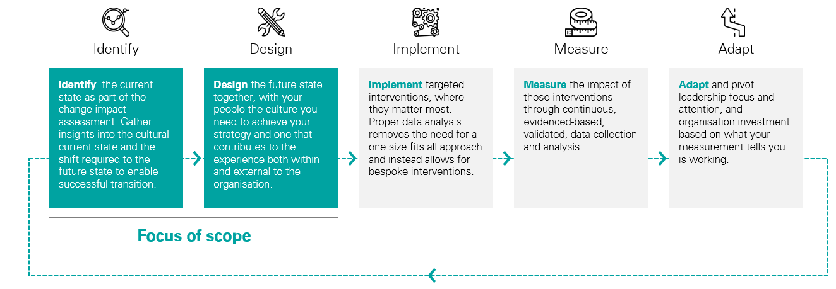

**Figure X: KPMG’s Recommended Approach to Cultural Design and Adaptation.**

**Understanding Culture, Behaviours and Mindsets for Change**

Our approach to behavioural change (BCM) is grounded in best-practice behavioural science which tells us that changing behaviour happens gradually, and intentionally. It is therefore essential to understand and identify existing behaviours, biases, mindset, and cultures so that we can determine where change is required for successful transformation to occur.

We understand that [client], while a single organisation, may operate as parts rather than as a whole, and different cultures are likely to operate within different pockets of the business. We will need to work closely with you, leveraging your knowledge and experience and our frameworks and global experience to identify areas where change interventions are required to ensure all teams are able to adopt the new solution.

Identification of the mindset, cultural and behavioural changes need to happen at various points within the change framework:

* **As part of the kick-off**, a leadership alignment workshop is recommended by aligning on the desired future-state culture required to support new ways of working identifying biases and barriers.
* As part of our **change impact assessment,** targeted questions are asked to understand the change from the current state to the future-state (supported and accelerated by our Powered methodology). Traditional change impact assessments identify change to process, technology, and roles, and identify support needed like training and communications. KPMGs behavioural insights approach to change management and change impact assessment also identifies current state culture, behaviour, and mindset, and any changes that may be required as part of transition to the future-state.
* If significant cultural change is required, **specific activities** may be required to diagnose and analyse the current state to plan for and execute a targeted cultural intervention. For the purposes of this engagement this level of cultural intervention is not expected.
* The below table outlines KPMG’s seven “**culture drivers**”. These also act as areas where we can to seek to understand if change is required to enable [client] to transition to the future-state.

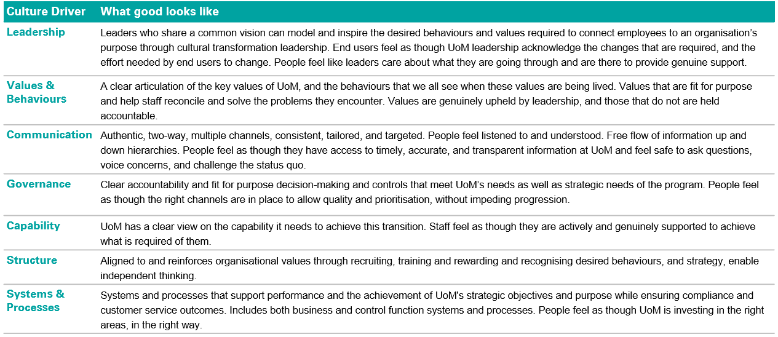

**Figure X: KPMG’s Seven Culture Drivers.**

**Changing Individual Behaviour**

While culture and behaviour can be viewed at a macro level, there is also often a need to look at changing behaviour at the individual level. In our approach, we will look to you to bring [client’s] own knowledge of people in [client], combined with our methods, and tools to ensure the right habits are changed in the right way. There are several ways to support individual behaviour change including:

* Nudging: Intentionally designed nudges can have a powerful effect on human behaviour and can be built into a communications plan. For example, subtle changes in the environment through use of subliminal messaging that gently "nudge" people in the right direction (adapt welcome screen when logging into laptop, notifications, reminders). They can also be used as part of the technology build e.g., carefully selected default options, placement of instructions, and reminders etc.
* Acknowledge that people are human, and humans are subject to bias. Use understanding of human bias to ensure that communications, training, and cultural interventions are designed and implemented to maximise impact.
* Ensure principles of reinforcement are applied in embedding desirable behaviours to ensure uptake of new behaviour is incentivised enough to count.

Application and use of the EAST framework (below) to the training and capability approach and plan to ensure that training is easy, attractive, social, and timely.

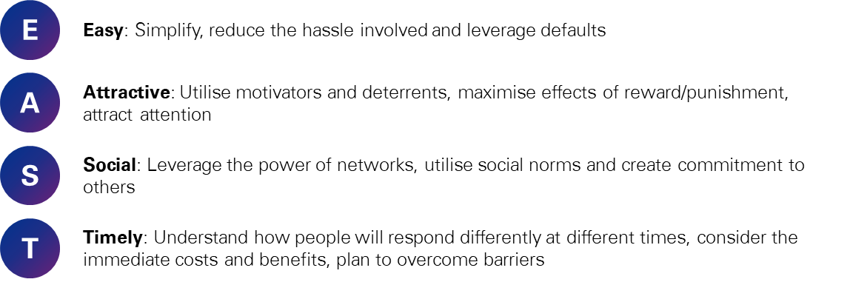

**Figure X: EAST Framework.**

The above activities and considerations are built into our BCM approach, within the case for change, the change impact analysis, stakeholder analysis, communications, and training plans. They are intended to be used in conjunction with your advice, experience, and expertise in delivering effective behavioural change.

Our Approach to Leadership Alignment

**Understanding the [client] Leadership Context:**

We understand that [client] is at the precipice of an ambitious and important journey, an integration into a single system for HR and Finance and successfully embedding new ways of working into the business. The fact that this business transformation occurs at a time of increasing complexity and ambiguity in the sector following the pandemic, means that adaptive leaders are needed to ensure that [client] continues to thrive. We know that there are challenges facing leaders at [client] now more than ever – some challenges we are aware of include:

* Continuing to operate through a constantly shifting social, political, and health environment because of the COVID-19 pandemic
* Maintaining the agency for change at all levels in the organisation, despite hierarchy.
* Understanding the impact of different types of leaders.
* Workplace relations complexity.

**To ensure leadership alignment and support:**

We aim to engender leadership alignment and support by embedding specific alignment, culture building, and support activities throughout the program, not as a standalone element. We recognise that while we bring best-practice industry knowledge and experience across program management, change management, and leadership culture, you bring the intellect, and understanding of [client] as a unique and complex organisation. As such, it will be critical we work closely to enable us to be progressive, together.

We believe the below **principles are crucial to delivering a successful transformation:**

* **Visible [client] leadership:** To ensure the program is truly leadership led, and IT enabled, it is critical that the program has visible and active support from the leadership team at all stages of the program, even though the formal program management may sit within IT. We know from experience that it is critical to engage the senior leadership hierarchy early to set the tone, empower the program, and send a message to stakeholders as to its importance. Intentional, visible leadership engagement will be achieved via a series of leadership team kick-off workshops to facilitate the required drive and energy to lead, collaboratively.
* **Co-design methodology:** We know that people perform best in a world that they have designed. The process will draw upon a co-design methodology, recognising the expertise of your team and the complementary skills we can bring. Working closely with you to ensure the approach is sufficiently bespoke in nature and addresses the areas of focus for [client] that will ensure the delivery is impactful. This starts with a leadership kick-off workshop at the beginning of the engagement to understand individuals' concerns, priorities, and preferences.
* **Regular, honest channels for communication:** We know that changing behaviour happens gradually and involves ‘nudging’ – using deliberate techniques to change daily habits. Leadership performance (especially in a period of leading through a large, complex transformation) requires ongoing adjustment and adaptability to the changing environment. The program will ensure that there is regular opportunity to come together as leaders, to clarify expectations, air grievances, clarify roles, and responsibilities, and learn as a group. KPMG leaders will work closely with [client] to ensure facilitation of this time and appropriated support is provided throughout.
* **Role clarity and accountability:** We have learned from experience that when things go wrong, it is often a result of a lack of clarity or miscommunication. This is especially true in transformations that are “IT led” where lack of clarity often arises when it comes time for embedding new ways of working into the rest of the business. Building in time upfront to make sure leaders and program leads are clear on what is required, and whose role, and responsibility it is to fulfil this requirement is vital. As well as an initial meeting to determine roles and responsibilities, ongoing sessions will be established to allow for ongoing provision of clarity and to ensure accountability for agreed responsibilities.
* **Leadership exists outside formal leadership roles:** Leaders exist at all levels; leaders have the power to shape the outcome of the transformation in contribution to its success. When completing detailed stakeholder analysis, careful consideration must be taken to identify all leaders to ensure that a plan to actively include them in collaboration and communication activities. For example, this may involve establishing communications mechanisms that may not have previously existed, and bringing the HR community together for information, cross collaboration and to encourage local change leadership/adoption, early identification of change agents etc.

**How do we propose to do this?**

We know for a successful and genuine partnership to exist between [client] and KPMG It must be built on a foundation of trust and collaboration. This will not happen by accident, therefore intentional steps, and effort are required to ensure this happens from the outset. We suggest a relationship charter is established initially, with targeted leadership workshops to occur throughout.

* **Relationship charter:** One of the critical lessons we have learned on large scale transformations is the need to ‘Go Slow to Go Fast’. Time spent at the front end, setting up the program, and engaging every team, and individual who will play a role is critically important for success. Many organisations start with a strong intent to invest in comprehensive induction, but invariably, delays in the procurement process, onboarding, impatience from the business, or other delays, result in this phase being reduced.
* In our experience, investing properly in the establishment of the program, the induction of program participants and then alignment of leaders, is one of the most valuable investments the program can make. Our approach proposes a very comprehensive approach to Program Establishment and Mobilisation.
* We recommend a **two-day kick-off session** attended by key members of the [client] and KPMG to:
  + establish common mindset.
  + get to know one another.
  + develop shared ways of working.
  + understand core capabilities and roles and responsibilities.
  + These outputs will be captured in a charter that will remind [client] and KPMG of what was agreed throughout the project.
* **Ongoing leadership alignment workshops**: To enable the principles listed above it is suggested that the Program Leads and the [client] Executives allocate dedicated, scheduled time to connect and to allow:
* Revisit the relationship charter and ensure continued alignment, making changes, providing clarification when needed.
* Ensure continued co-design.
* Provide channel or regular, honest communication.
* Confirm role clarity and accountability.

**Change champion/Change Agent network:** A core component of the Communications and Engagement approach are the change champions and super users.

The change champions and super users will act as advocates of the transformational change and act as a two-way liaison point between the program and impacted teams. They are critical for a program to support the embedding of the change and continuous improvement as they are part of a team onsite long after the program has finished.

The change champions and super users will ensure coverage, including employees from all highly and moderately impacted areas. They will act as the eyes and ears on the ground providing two-way communication between the program and it’s impacted stakeholders. Significant involvement is recommended for identified change agents, for example attendance at showcases, roadshows, launch events, input and validation of the change impact assessment as well as input into communications plan and contribution to the delivery of communication were appropriate.

We will work with you in identifying suitable change champions from across the [client] to ensure that all relevant groups are represented. We know from our experience that, for change to be successful change champions should have the following attributes:

* **Be a Change Leader**, someone who embraces change, anchors to the vision, and is resilient throughout the change journey
* **Be a proven effective communicator** someone who communicates in a clear and succinct way that makes understanding the messages easy.
* **Be seen as a trusted peer or leader**someone who actively develops close and trusted partnerships across all levels of the business.
* **Possess good business acumen** someone who understands the connection between business performance and the change journey.

Our Approach to developing a communications plan

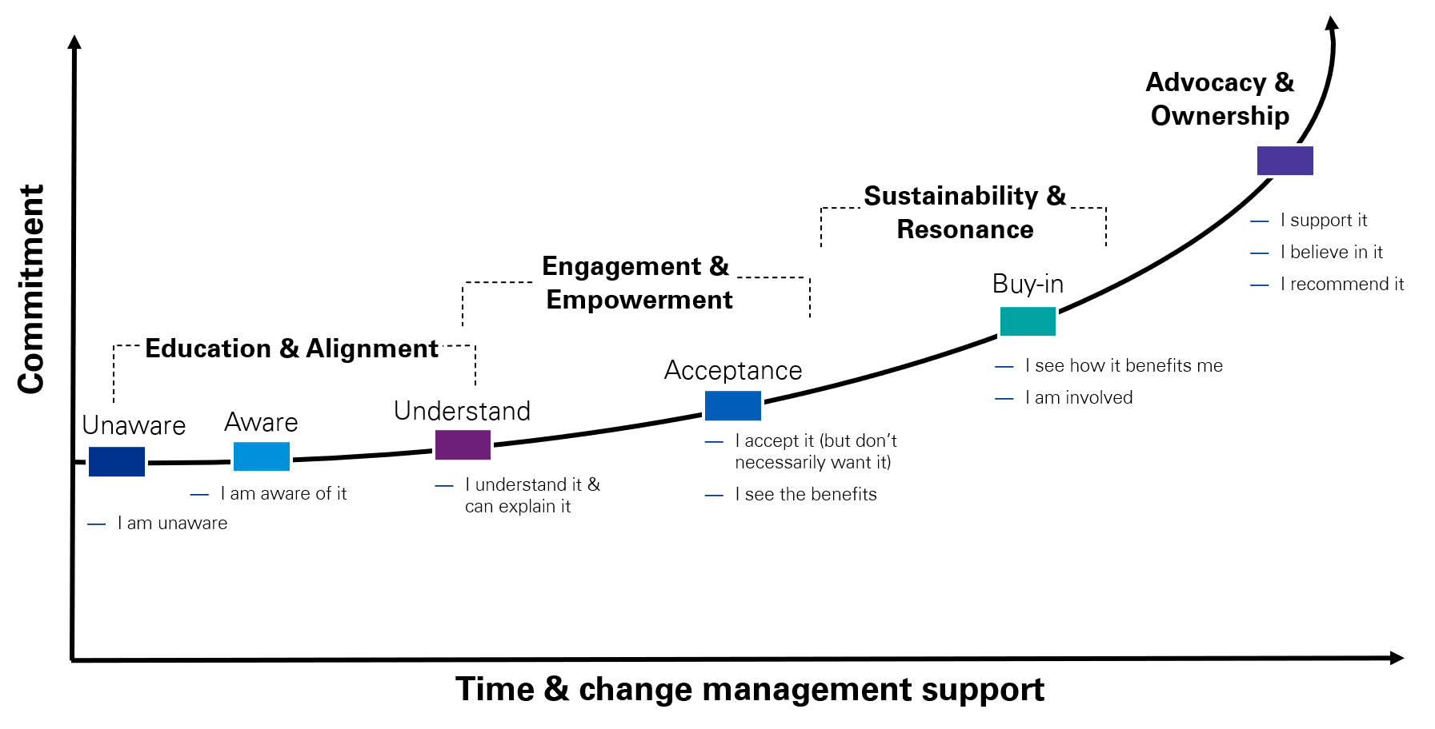Communications will be one of the most important change levers for this program. Through communications, we will deliver clear and consistent messaging that resonates with [client]'s stakeholder audience. Communications is the critical change enabler that supports stakeholders along the commitment curve through awareness, understanding, acceptance, buy-in and ownership (shown in the diagram).

We will bring a rigorous process to developing the communications plan, ensuring it achieves the objectives below:

**1. We are clear and consistent in what we say**

Messaging must be clear and consistent. We will work with you to develop a compelling change narrative as well as key messages that we anchor to throughout the program. This ensures stakeholders are receiving the same consistent messaging.

**2. We know who we need to communicate to**

We must establish in full view, the stakeholders to be engaged throughout the program and understand their unique needs. Drawing from an established toolset and our knowledge of your stakeholder landscape, we will conduct stakeholder analysis ensuring we understand levels of influence and impact, and those stakeholders who must be prioritised such [client] leaders, functional teams, and key end-user groups.

**3. We know how we will communicate**

Messaging is only as effective as the communication channel through which it is received. Bringing an understanding of the [client]'s communications environment, we will work with you to efficiently determine the most effective channels for each stakeholder group (e.g. email, forums, briefings, presentations, digital channels) to achieve communication objectives.

**4. We know when we will communicate**

The plan must be actionable. We will achieve through a communications schedule which specifies who we need to communicate to, when (specific timing), who the responsible owner is, and how it will happen (channel). Communications will be distributed through channels all of which have specific processes for distribution. Lead times will need to be considered within the schedule to allow for approvals. While building the schedule we also consider other significant communications which may impact the target audiences during our proposed period, to ensure we are not overwhelming the audience.

**5. Communications governance ensures disciplined execution**

Throughout program delivery, communications will move quickly. Communication products will need to be developed, approved, and distributed rapidly, often with short turnaround times. We will therefore establish clear roles and responsibilities, as well as review, and sign-off processes. We will work closely with [client]'s internal communications teams and key faculty/department communications staff to leverage capability as well as in-house knowledge of communications processes and procedures, and tone of voice guidance.

**6. We ensure a feedback loop to provide stakeholders with a voice and evaluate communication effectiveness**

We utilise a range of feedback channels (verbal, digital, change network) to support stakeholder dialogue. By providing stakeholders with a ‘voice’, valued feedback allows continued adjustment of the communications plan including changes to messaging, style, and format. We understand that the inclusion of feedback loops in communications is critical for identifying what stakeholders understand or misapprehend and where information gaps exist across all phases of program implementation. It is also an important way of demonstrating that program implementation is about communicating 'with' as opposed to communicating 'at' stakeholders.

**Communications Voice and Tone**

Our experience in the successful implementation of [project] at [client A] and [project] at [client B], as well as some [number of projects] projects across the sector in the past 3 years, has given us an intimate understanding that communications must speak to [client’s] commitment to collaboration, and stakeholders' commitment to [insert project objective].

We will establish a rigorous process for developing communications that reflect your voice and values, and are consistent in tone, look, and feel with existing communications. We have extensive experience in developing communications on behalf of our clients and understand the importance of representing the institutional tone of voice. To enable this, we will review existing materials, as well as establish an iterative drafting process to help us understand the personal preferences and stylistic voice of our key communicators; by working collaboratively with the [client].

As well as liaising with [client’s] Corporate Communications on communications processes and procedures, and style guides, we will work with you to identify and support change champions where appropriate as the voice for the program.

Our Approach to Training

Our team at KPMG training team are highly experienced in developing and delivering solutions for our clients within the [insert sector] sector. Our holistic approach considers how learning occurs in the workplace and how training advances change. Knowing the complexity that surrounds the [insert sector] sector means we can bring additional learnings from our recent [insert recent engagement]. These learnings include:

* Ensuring we enhance customer and deep dive sessions within [insert project stages] stages to foster improved collaboration within the [client] HR community that ultimately supports ownership of the solution and end user adoption.
* Considering deeply the level of administrative (and functional) users that wear multiple hats when servicing key stakeholder needs.
* Continuing to bring key business representatives to engage early in the Program Phases to support improved validation of the design, fitness for purpose and end user engagement of the solution.

In alignment with your needs for an approach that considers the HR and Finance system users existing across multiple areas (i.e., [insert relevant business areas]), our training is a tailored approach built around users and utilises a train-the-trainer model. This will help to future-proof [client] through the development of in-house skills for onboarding and training of new people going forward.

KPMG views training and development as a core component of the end-to-end change management approach for [client’s] transformation program that will integrate closely with communications, stakeholder engagement, and workforce transition. When designed and delivered effectively, training is a mechanism to deliver process and system knowledge to end-users and a real opportunity to promote behavioural, skill, and cultural change for individuals, teams, and the organisation.

We have highlighted key learning principles here and welcome the opportunity to enhance this together with your team.

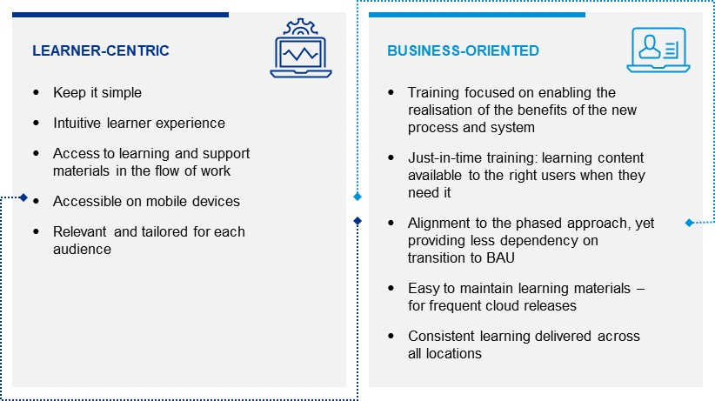

**Figure X: Recommended Training Principles.**

**Tools, techniques, and methodology used to ensure successful delivery**

**Methodology**

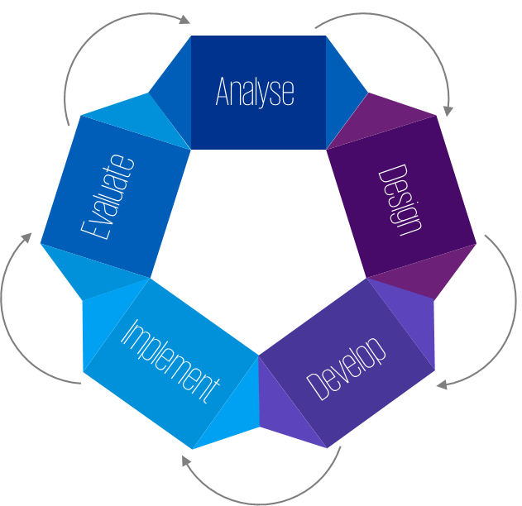KPMG employs a five-stage approach to delivering successful training outcomes:

* **Analyse:** As part of a training needs analysis, we will work with you and your subject matter experts (SMEs) to determine key processes, policies, and key messaging for the various training mediums and their intended audiences.
* **Design:** We will develop a course outline that describes the learning outcomes for the training sessions and how we will ensure that participants achieve the required level of proficiency within the relevant HCM and Finance processes.
* **Develop:** We will work alongside you and your SMEs to develop engaging and fit-for-purpose training materials and activities. Using adult learning principles, we know that learning is optimised when adults are presented with information that is relevant, meaningful, and applicable to their everyday needs, as we such will embed the actual system in the training. Learning is promoted when participants are engaged in solving real-life problems and so for your medium- to high-frequency users (unique to train-the-trainer) we will utilise a scenario-based approach which addresses common [client] situations which permits the user to apply training in a practical manner.
* **Deliver:** We will facilitate training sessions using a range of tools and techniques that allow your business to achieve the learning outcomes and ensure [client] realises the benefits of implementing the Workday HCM Solution. Given your preference to roll out training to the End-Users via online channels, this will be a key consideration in how we approach our training program.
* **Evaluate:** We will evaluate the success of the training program throughout the delivery phase by observing participant performance in formal training sessions held, as well as seeking feedback from the various user types. We will also gather feedback from the go-live support team on any key training issues arising post go-live, which require coaching, or communication support.

The training team will be dedicated to working with you closely as part of the change management activities to integrate the training approach, plan, and delivery to drive user adoption and the time taken to proficiency.

**Tools and techniques**

From our experience over multiple Workday implementations (including within the [insert sector] sector), we recommend a blended training approach and different training tools and techniques for the different groups of stakeholders performing HR and Finance activities across [client]. The diagram below illustrates our three main recommended tools and techniques for training delivery for your HCM Transformation Program. These are characterised as Self-Guided Training (SGT), Virtual Instructor Led Training (VILT) and Instructor Led Training (ILT). Given your preference for training to be rolled out via [insert training delivery preference] (including self-guided, VLT), this will be a key consideration in how we design the end-to-end training program.

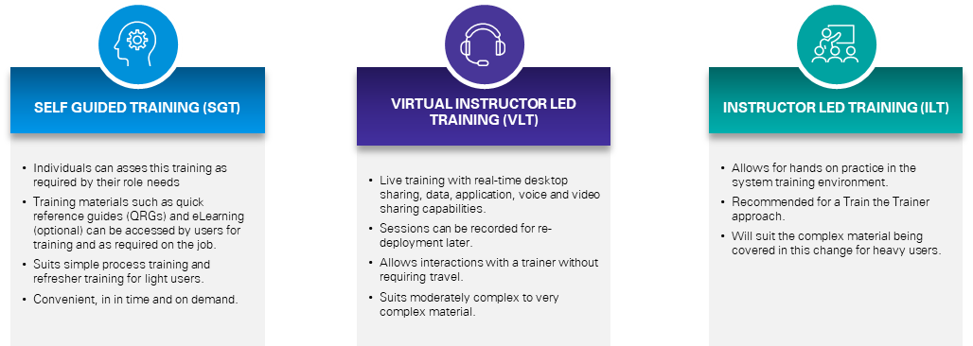

**Figure X: Example Training Tools and Techniques.**

These types of training sessions will be supported by training content developed through various forms, including,

* Quick Reference Guides (QRGs).
* Facilitator and Learner Guides.
* eLearning (e.g., process demonstration videos, targeted simulations).

A sample of the materials that will be produced and can be flexibly deployed for the various types of user communities is illustrated below:

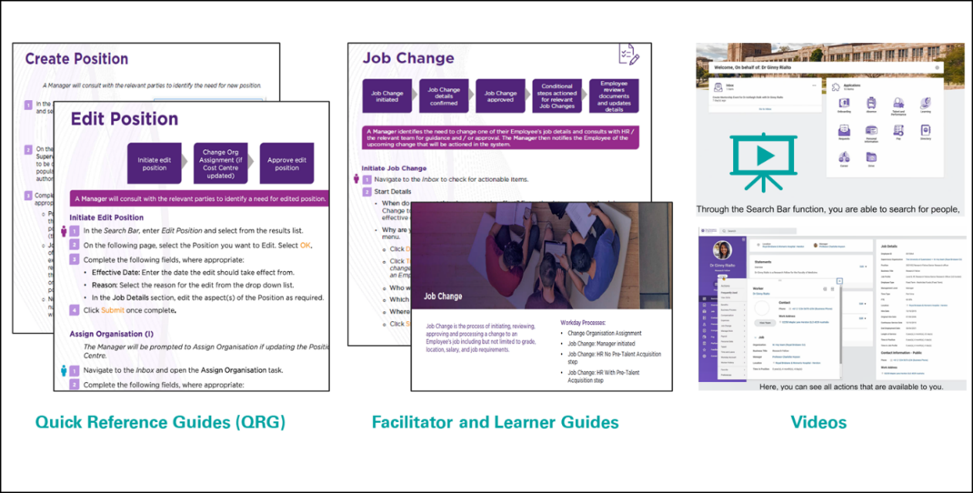

**Figure X: Sample Training Material.**

**Flexibility of Our Training Approach**

Our training approach is aimed to be flexible, modular, and adaptable to the expected stakeholder groups participating in training as well as ensuring scalability to the broader end-users. In designing the training content, a role-based training pathway approach will be undertaken, which will also define how training content will be developed, packaged, and subsequently delivered.

The following key principles will inform our training design:

* Security Role-based Learning pathways will be aligned to the Security Roles as defined within Workday.
* Each training pathway will include:
  + The training pathway(s) the learner needs to understand to do their job using the new solution (and the modules that sit within them).
  + Modes of training delivery.
  + Duration.
  + Modules required to be completed by certain Security Roles prior to go-live.
* The modules included within a training pathway directly correspond to the system access that will be granted to the user due to the mapping of positions to Workday Security Role(s). Where more than one position has been mapped to a Security Role, the Learner will need to attend multiple training pathways.

To illustrate further, this example training pathway below describes the learning requirements of an Induction Officer. There are two courses that result in a learning commitment of 1.5 hours, across two modes of delivery: Workday Online and Workday Resources.

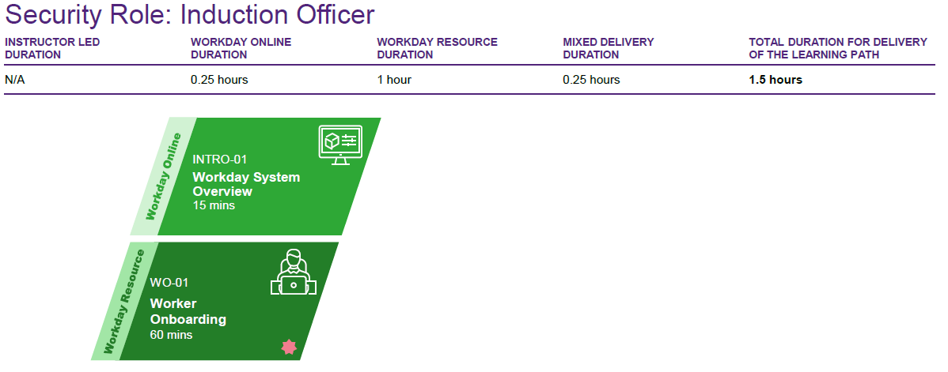

**Figure X: Training Pathway Example – Induction Officer.**

As part of the training design, we will work with your team to review how different training modules can be grouped together into single courses for the purpose of training delivery.

Given the nature of the modules, these will be grouped together to form the various training pathways required for train-the-trainer (TTT) sessions as well as training pathways for the end-user community and the various teams involved in interacting with the new systems and processes.

**Support materials and mechanisms available to users following implementation and for new users**

Upon the completion of the development of the training artefacts, we will carry out the train-the-trainer program to equip nominated [client] trainers, who will subsequently roll out end-user training for the broader community.

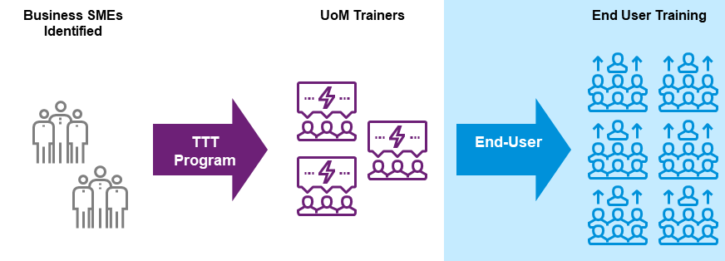

**Figure X: End-User Training.**

As mentioned earlier, our proposed list of materials will consist of the following:

* Quick Reference Guides (QRGs).
* Facilitator and Learner Guides.
* eLearning (e.g., process demonstration videos, targeted simulations).

We will need to ensure these materials are loaded onto the [client] Learning (e.g. Learning Management System) / Knowledge repository (e.g. Knowledge Management Sites) and it should be easily accessible and available to support End-Users (as part of the end-user support framework and enabling self-guidance where possible). Working closely with the Change and Communications workstreams, this will be communicated to the right end-users in the most appropriate channels with the right timings.

To further support the end-user community in their adoption of the new systems and processes, we propose the implementation of the Workday in-application learning tools (illustrated below). These tools are excellent as self-guidance training tools and enable for a just-in-time approach within the platform while users are interacting with the new processes and systems. It provides on-screen tutorials for users with step-by-step instructions on how to complete even the most complex tasks. A key benefit of Workday in-application learning tools for [client] is that it can be utilised across your highly dispersed end-user population, guiding users on demand in real-time.

*Note*: the implementation of these Workday self-guidance tools will be subject to Workday licenses.

To ensure these tools are established and implemented to the requirements and business needs of [client], we will work closely with your team to establish, design, and implement the tailored content accordingly.

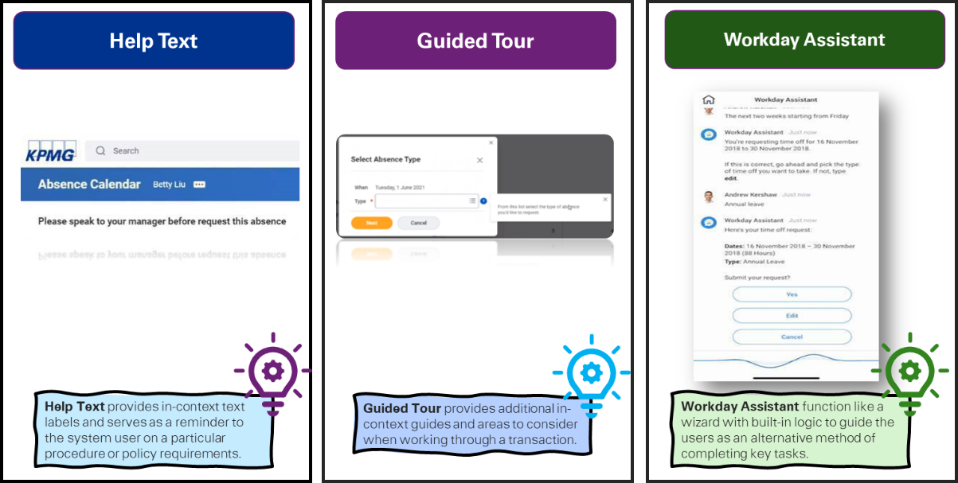

**Figure 16: Self-Guidance Tools.**

All content will be handed over the [client] as part of end-user training. The [client] team may choose to make further edits/changes in line with their business context and this can be done in a straightforward manner via standard MS office tools.

**Key training activities**

The key activities aligned to our training approach are defined in the table below.

Please note that in addition to our traditional deliverables we have also included an optional ‘coaching’ workshop to support your nominated trainers (participating in train-the-trainer) to be comfortable with delivering training and provide a quick reference guide of tips and tools for delivering successful sessions.

It is critical to ensure a strategic alignment between change management and training activities to ensure that we are successful in our outcomes. Key to the development of the training strategy, training needs analysis, and the construction of the content, will be a clear linkage to the change impacts to the end-to-end processes, as captured during the change impact assessments exercise.

**Table X: Training Activities.**

| **Activities** | **Details** | **Responsible** | **Support** |
| --- | --- | --- | --- |
| **Training Strategy**  Details initial strategy for training, performance, timing, and support | Formulate the training strategy /approach for the transformation program. This should ideally consider the overarching principles that would support a successful training outcome for [client].  The strategy will also need to consider the integration and successful alignment to the [client] change management approach to ensure it is consistent and aligned.  The strategy should (where possible) confirm the train-the-trainer approach and where possible, any considerations for curriculum design, delivery methods, audience analysis, and key timelines. | KPMG or [client] | KPMG or [client] |
| **Training Plan**  To further expand on the Training Strategy, building on the key principles as highlighted. | Provide the detailed approach to training analysis, design, development, and implementation activities planned.  To describe the considerations, risks/issues, as well as to outlined clear roles and responsibilities (RASCI) between various parties.  Outline any logistical, technical or administrative requirements, including technology enablers to support training (e.g., training environment, set up of transactional data) and learning management systems administrative details. | KPMG or [client] | KPMG or [client] |
| **Training Needs Analysis approach & tools**  Provides an end-to-end approach for assessing current capability, development needs, learning intervention design, and capability uplift. | Review “To Be” state and define capability, and therefore training.  This should be aligned to the Stakeholders as defined in the Stakeholder Analysis.  Provide further refinement to the key elements of the training approach as outlined in the Training Strategy. | KPMG or [client] | KPMG or [client] |
| **Training Curriculum**  Details the full spectrum of training activities. | Based on the input captured in the training needs analysis, define training curriculum design, outlining details including the modules to be developed, delivery method, intended audiences, and proposed timing of each training course. | KPMG or [client] | KPMG or [client] |
| **Training Schedule**  Details the proposed rollout schedule for train-the-trainer and a recommendation for end-user. Outlines the key content development timings to ensure critical path planning is incorporated into the integrated schedule. | Confirm key milestones (including interim milestones) as part of the training pathway.  Incorporate into overall integrated schedule.  Schedule will also incorporate timing for logistical requirements (e.g. learning management systems, systems/data readiness) – this will also require confirmation on responsibility and readiness of these logistical requirements. | KPMG or [client] | KPMG or [client] |
| **Training Effectiveness**  Details the types of evaluation techniques that will be suitable based on the [client] context. | Develop and agree evaluation measures. | KPMG or [client] | KPMG or [client] |
| **3rd Party Supplier Training Plan**  Determine the type of training required for 3rd Party Supplier and how this will be rolled out. | As part of analysis to be conducted (via training needs analysis and curriculum design), identify the training requirements for third party suppliers.  Determine how best to roll out the training, including delivery timings, channels, methods, and logistics. | KPMG or [client] | KPMG or [client] |
| **SIT and UAT Training approach and materials**  Collateral used to train nominated users/program team members participating in SIT and UAT. | To determine the optimal approach to roll out a controlled training for users nominated to support SIT and UAT.  As this may take place while end-user training materials are not fully ready, other alternatives may be deployed, including the use of showcase-demos and test scripts, or granting access to the (e.g. UAT, SIT or training) systems for exploration and familiarisation. | KPMG or [client] | KPMG or [client] |
| **Support Teams training and materials**  Collateral used to support the knowledge transfer and training of nominated users involved in supporting the new system and process. | Refer to Knowledge Transfer section of our response for a further outline of the approach to be undertaken by KPMG.  Knowledge Transfer Strategy and supporting plan – functional and technical. | KPMG or [client] | KPMG or [client] |
| **End-User Materials Collateral**  (Training content) ready to be rolled out to the Business /End-User Community. | Consult relevant business and program team SMEs on HR business processes and policies.  Design and develop materials ready for Self-Guided Training (SGT), Virtual Instructor Led Training (VILT) and Instructor Led Training (ILT).  The following materials will be developed.  A set of Quick Reference Guides (QRG) associated with each Workday Module (and aligned to the Powered Processes) per security role, with up to ten pages of content for each set/ each in-scope Workday HR/Finance module. The set of QRGs will be defined, scoped, and agreed with [client], based on criticality, complexity, and likelihood for re-use (e.g., for future training sessions, or as self-service reference materials).  Learning Videos are aimed at highly complex and/or high-volume activities. These will be capped at ten Learning Videos, of average five mins duration, for Finance, and ten Learning Videos for HR.  Participant Guides/ Facilitator Guides will be developed per In-scope Workday Module to support an effective rollout of TTT and EUT.  We expect these materials to be suitable and ready to deploy, firstly via Train-the-Trainer (TTT) Trainers, and for [client] to then leverage on these materials to be rolled out to the End-User via the Trainers.  The materials will be built in a modular way and allows for these to be deployed flexibly. However, if [client] wishes to further enhance/ enrich these materials with additional content, this will be managed by [client] resources and is out of KPMG's scope.  The production of these materials will be developed by KPMG, but will require [client] SME effort to provide input, review, and validation by [client] resources.  As part of the end-user material, the Workday In-Application Help Tools (including Help Text, Guided Tour and Workday Assistant) will be built. Note: implementation will require additional effort with [client] Business /SME effort to be provided. These self-help tools will be subjected to Workday licenses. Refer to key assumptions. | KPMG or [client] | KPMG or [client] |
| End-user Support framework  As part of the end-user support framework, ensure that there is a robust mechanism in place to support the End-User as the system and processes are deployed. | Incorporate end-user support framework as part of the Business Readiness set-up. | KPMG or [client] | KPMG or [client] |
| Train-the-Trainer approach and Supporting Activities. | It is expected that [client] will ensure there is sufficient resources nominated to be part of the TTT resource pool. TTT Resources are expected to participate in the TTT training at the agreed set of dates.  Profile and number of trainers to be confirmed but is expected to conduct end-user training sessions as well as being part of the end-user support framework.  Train-The-Trainer (TTT) training will be conducted over no more than 20 days across the course of the implementation. The sessions will cover in-scope areas and will be limited to 15 attendees per session. Any additional TTT sessions (out of the abo will be managed by [client]. | KPMG or [client] | KPMG or [client] |
| Train-the-Trainer Coaching – Provide guidance and workshops to your Train-the-Trainer population to increase their comfort with delivering the training. | Conduct a workshop to provide nominated [client] trainers with the resources and tools they need to facilitate a successful training workshop.  Provide a Quick Reference Guide (QRG) to support the TTT outcomes. | KPMG or [client] | KPMG or [client] |
| End-User Training Delivery – The vehicle(s) used to transfer of knowledge from trainer (or training materials) to the End-User. | End-user training will be delivered by the nominated trainers. The timing of the end-user training delivery should consider the proportion of completion prior to cutover vs post-cutover and/or during business-as-usual (BAU) operations.  It is expected that [client] will be utilising an online training approach for training end-users. Any other specialised users (e.g. Administrators, Super Users) will be managed as part of the Knowledge Transfer approach.  There will be a need to ensure the training environment (with [client] transactional data) will be maintained and refreshed on a sustainable basis.  KPMG will work with the [client] team to understand the training effectiveness, any remediation required, as well as participation/completion rate in our role as the SI Partner. Any remediation efforts will need to be assessed for root-causes and addressed accordingly. KPMG will support the building of the measurement templates, and execution, collection of data and analysis of these data (around effectiveness) for the End-User community will be the responsibility of [client]. | KPMG or [client] | KPMG or [client] |

Our Approach to Knowledge Transfer

**Overview**

We understand the criticality of ensuring an effective knowledge transfer between KPMG and [client] to acquire and sustain knowledge as part of the implementation journey.

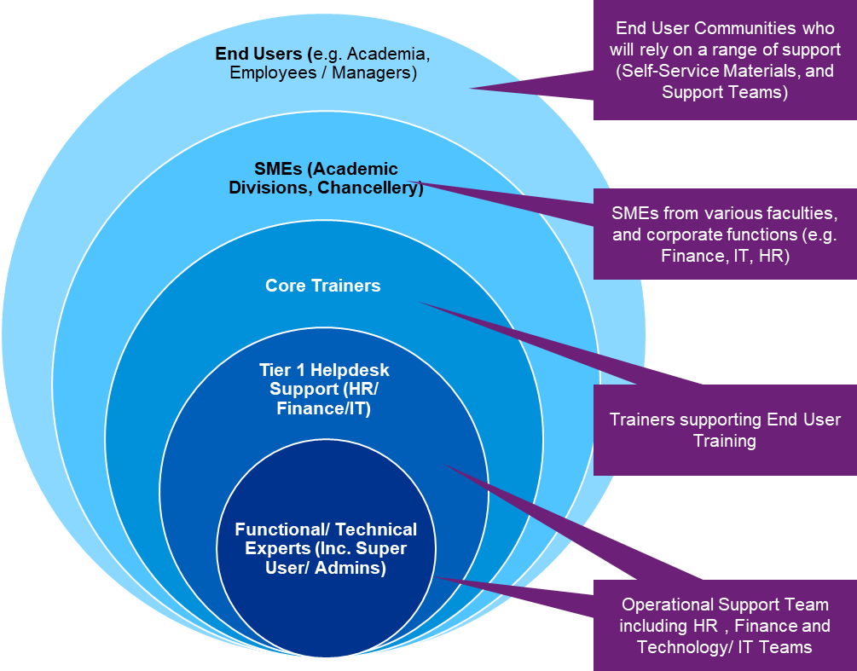

**Figure X: Illustration of the User Groups Across Business, Technical, and IT Users.**

By knowledge transfer we refer to all activities supporting the uplifting of skills, knowledge, and capabilities to adopt the new solution and ways of working. Knowledge Transfer will involve a range of stakeholders, including:

1. The **General End-Users** (e.g. [insert clients end users])

2. The **SMEs from the [insert client departments]** who will play a key role in being champions or early adopters (and hence will likely be involved as part of the Change Network).

3. **Core Trainers** – who will need to attend Train-the-Trainer and be equipped to support End-User Training.

4. **Helpdesk support** (for HR, Finance and IT) and

5. The **core HR/ Finance Functional or IT/ Technical experts** (e.g., Administrators) who will be closely supporting the operations of the new system during the Business-as-Usual (BAU) period.

To begin with the “end in mind”, we approach knowledge transfer firstly by understanding how these expected user groups would like to be supported and engaged throughout the program journey.

As a Knowledge Transfer approach, the following steps will be undertaken:

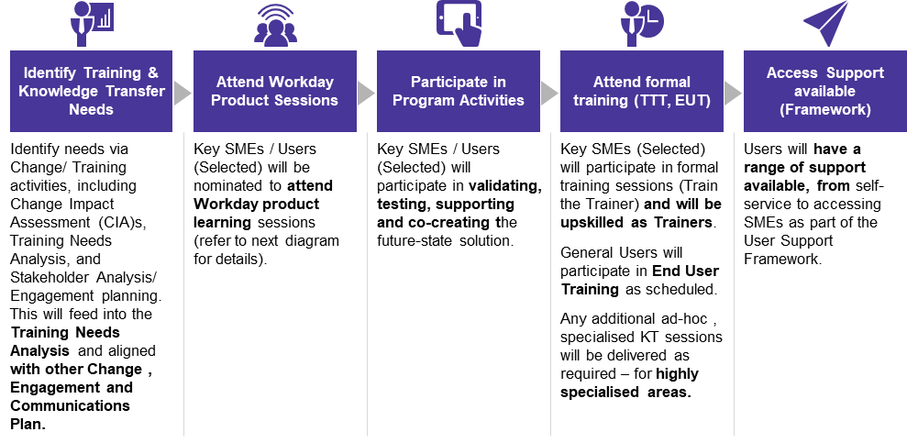

**Figure X: Knowledge Transfer Approach.**

Starting early in the Program Phases, key SMEs across the functional, technical/IT and Business areas will be involved early, representing their Academic Divisions, or Chancellery areas of operations. The intent is to take them along the journey of change and support the retention of knowledge as early as possible**.** The **following diagram** expands on this approach and highlights a range of Knowledge Transfer activities that will be introduced to support [client]**.**

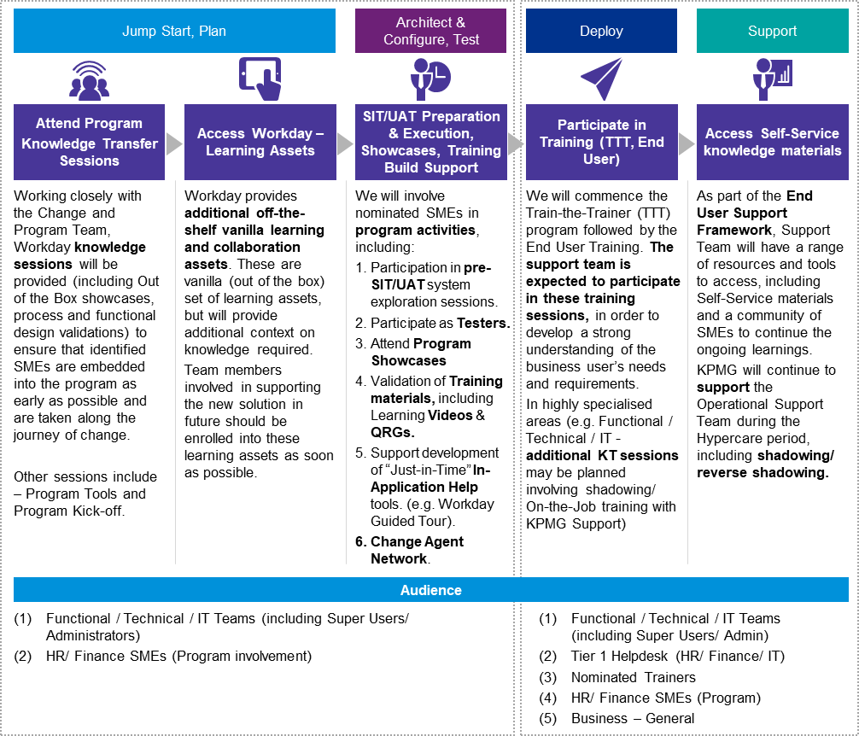

**Figure X: Knowledge Transfer Activities.**

Throughout the **Program journey** – we will roll out showcases (i.e., to showcase solution, in an incremental fashion) to allow for early exposure and awareness, validation of solution (incrementally), and to develop an understanding of what will be expected as the future-state matures. Such showcases will be woven throughout the program. During the **Architect, Configure and Test phases**, program involvement including SIT/UAT preparation and execution, participating in Change Agent Network (as Change Champions), supporting the review and validation of training/knowledge materials, amongst others.

During the **Deploy**, formal training (Train-the-Trainer and End-User Training) will take place. As part of the transition, all engagement deliverables will be handed over to [client] at an agreed timeframe.

Finally, during the **Support Phase**, Knowledge Transfer activities will continue throughout the Support phase (Hypercare), where End-Users are able to access to a range of resources (including Self-Service/ Service Guidance materials as well as a community of SMEs and Support network. Operational Support Teams from HR, Finance, and IT will receive support from KPMG in resolving Tickets, via a combination of **shadowing and reverse shadowing**. This is outlined in greater detail in Section 11 (BAU Support Model).

Underpinning this set of knowledge transfer activities will be the **70:20:10** adult learning principles. The **70:20:10 adult learning** principles are based on the knowledge that:

* 70% of learning is undertaken on the job.
* 20% of learning is undertaken through interacting with others, generally in a coaching capacity (with KPMG as your SI Partner and with the SME Community – refer to Support Framework).
* 10% is learned using formal methods such as in virtual and face-to-face classrooms (e.g. formal train-the-trainer or end-user training sessions).

The **70:20:10 blend of learning approaches** will be supported throughout with the range of training or knowledge artefacts, including: Quick Reference Guides, Facilitator and Learner Guides, and eLearning materials (e.g., process demonstration videos, targeted simulations), as well as other change or supporting materials (e.g., communications artefacts, process maps etc).

**Evaluation of Effectiveness**

KPMG recommends using the Kirkpatrick Learning Levels when designing the learning evaluation process. By far the most popular model for learning evaluation, the Kirkpatrick Model suggests four possible levels of evaluation that increase in distance from the learning intervention. The model can help structure thinking about what type of evaluation activities need to be undertaken. KPMG will undertake an understanding of the effectiveness of the training or knowledge transfer sessions primarily across Level 1 and Level 2, with additional interventions to be considered as part of ongoing change/engagement activities with [client]. Evaluation measures will take into consideration of the scope of the program, the design methodology, and the audiences in mind.

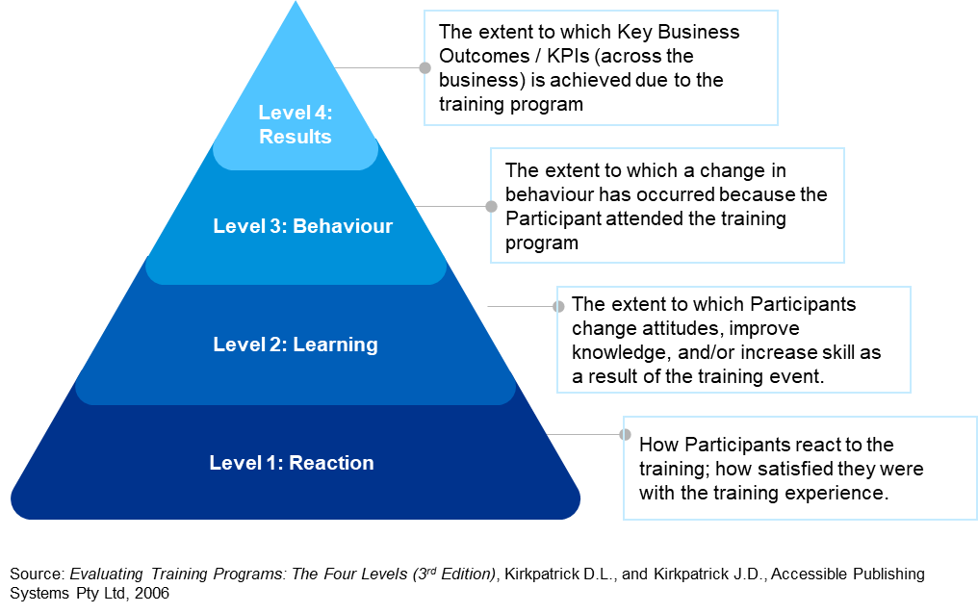

**Figure X: Kirkpatrick Model.**

The measurement of training effectiveness will review the following areas, enabling the program team to provide the necessary interventions as required.

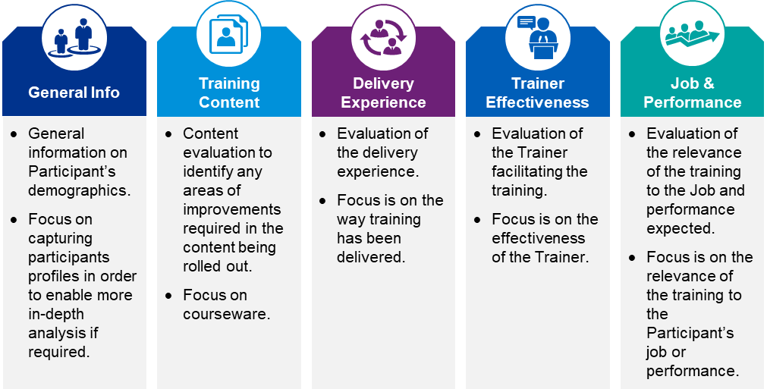

**Figure X: Knowledge Transfer Evaluation Areas.**

We will work closely with you to design an appropriate and consistent set of evaluation measurements and agree on the appropriate frequency and channel to roll these out. The data collected in a consistent manner will enable the program team to baseline, track, and understand the overall progress and effectiveness of the training or knowledge transfer activities.

We recommend that all training delivery (TTT, EUT) sessions include training evaluation to assess effectiveness, ideally administered via [client’s] learning management system. Additional ad-hoc focus-group measurements can be rolled out, in coordination with the broader Change Management activities.

KPMG will support the building of an evaluation template and will deploy these evaluation activities in the tool as agreed with [client] (ideally via a Learning Management System), during Train-the-Trainer. During EUT, [client] will be responsible to deploy these evaluations and will collect, analyse, and report against these measures to the broader program readiness. Any issues or remediation will be managed on a case-by-case basis depending on the root-causes, with both sides working jointly as a one-team approach to resolving any challenges.