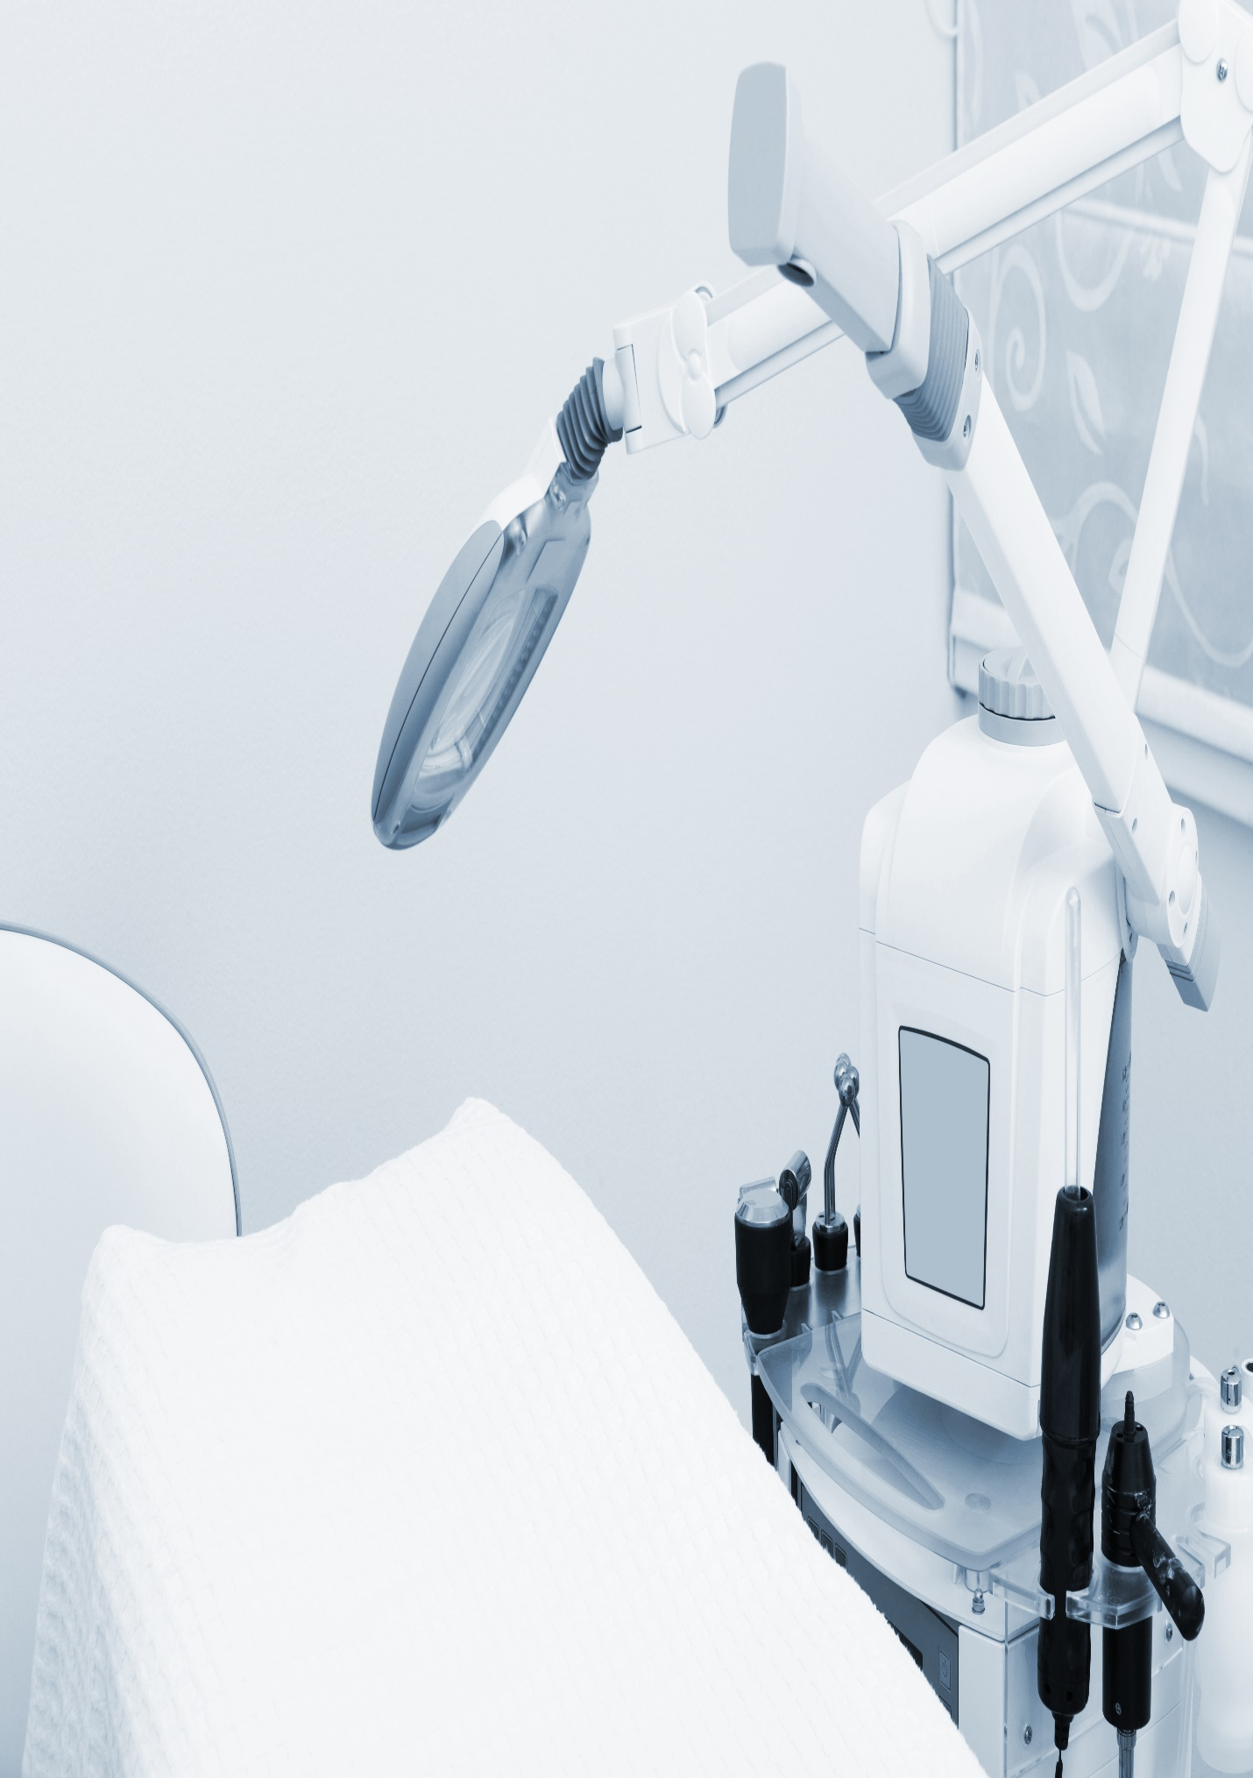

**Riparian Plaza, Level 16, 71 Eagle Street, Brisbane QLD 4000**

**June 20, 2023**

**test**