IMAGE

**Images:**

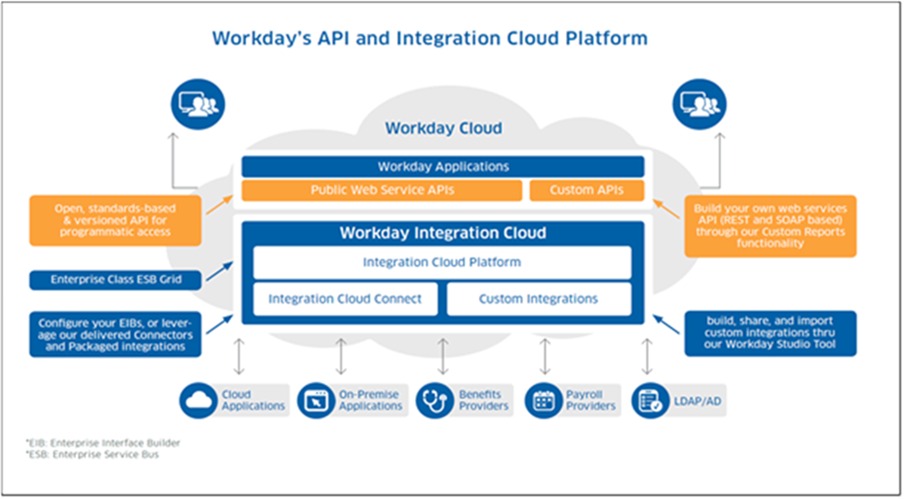

**Images:**

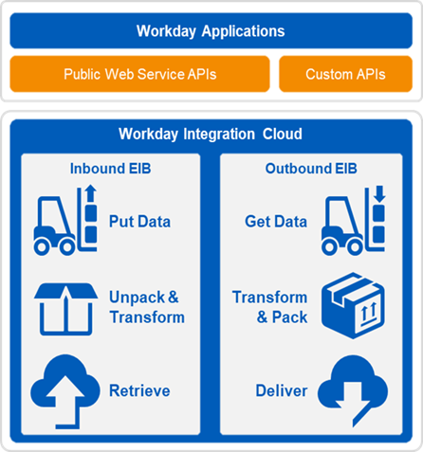

Assuptions

**1: Disputes with third parties (editor or other service providers)**

**2: Inadequate decision-making process**

**3: Lack of action plan and decision monitoring**

Key Consideration And Risk

**1: The proposed Go-Live date assumes that KPMG commences this SOW (project start date) on [CURR_DATE]. If the project start date is beyond this date, then the proposed project schedule will shift by an equivalent number of business days. The project will close for a two (3) week period over any Christmas and New Year holiday period.**

**2: The main project team is located at the [CLIENT_NAME]’s in Perth, and KPMG team members are assumed to work from this same location. KPMG’s onshore team may work remotely or from KPMG’s Melbourne or Sydney office location where on-site workspaces are limited or services do not require on-site presence. KPMG’s offshore team is assumed to work from KPMG’s offshore project location. KPMG assumes that there will be no commuting to other project sites.**

**3: KPMG assumes the provision of adequate on-site workspace/desks, necessary equipment, and facilities at the Project Site for KPMG resources to perform onshore project activities.**