**Getting started with REST services using JAX-RS in Eclipse**

1. Eclipse Java EE Version is required or install JavaEE features in Java Eclipse instance.
2. New Project Dynamic Web Project

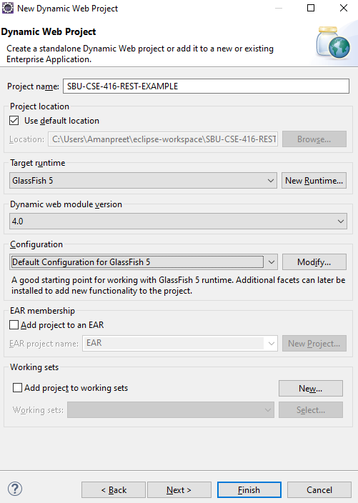

Server Used – GlassFish 5.1 (setup using New Runtime as T)

**\*Eclipse doesn’t show GlassFish in list of servers by default in the latest version.**

**To set it up:**

1. **Server Files Download:** <https://www.eclipse.org/downloads/download.php?file=/glassfish/glassfish-5.1.0.zip>
2. **Server Adapter for Eclipse:**

<https://stackoverflow.com/questions/51338220/cannot-install-glassfish-tools-in-eclipse-photon-eclipse-ide>

**Once done with the above setup, you should be able to select GlassFish from the list of Servers and start a new server instance as well.**

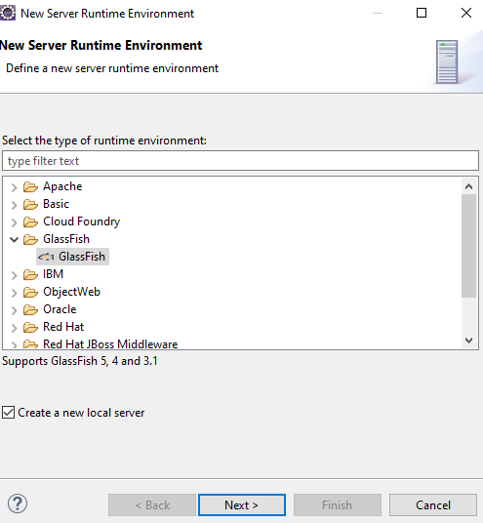

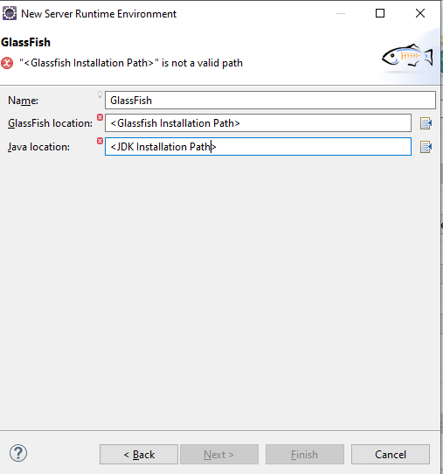



1. Create a REST service by Clicking on Project Name RESTful Web Service from Pattern

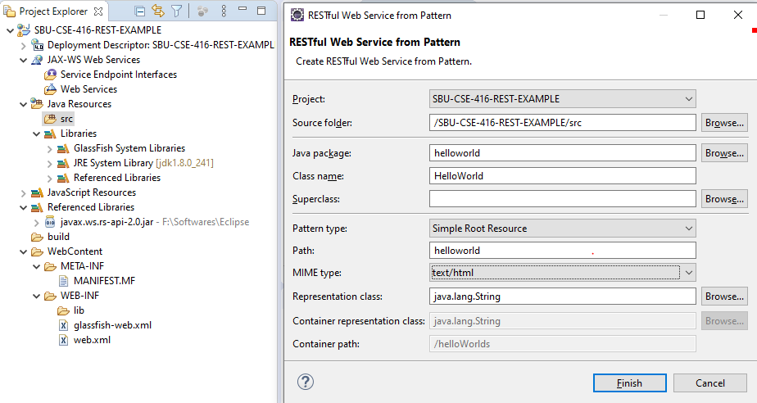

1. Create the **HelloWorld.java** and **ApplicationConfig.java** classes under package helloworld and import the jax-rs jar into the build path.
2. Start the GlassFish server and deploy the application

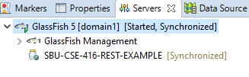

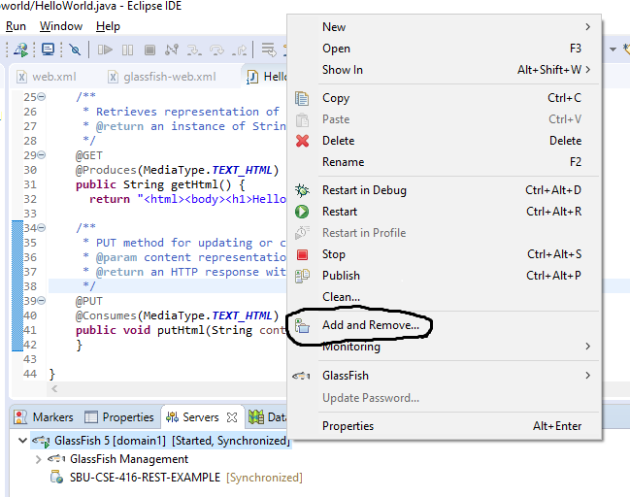

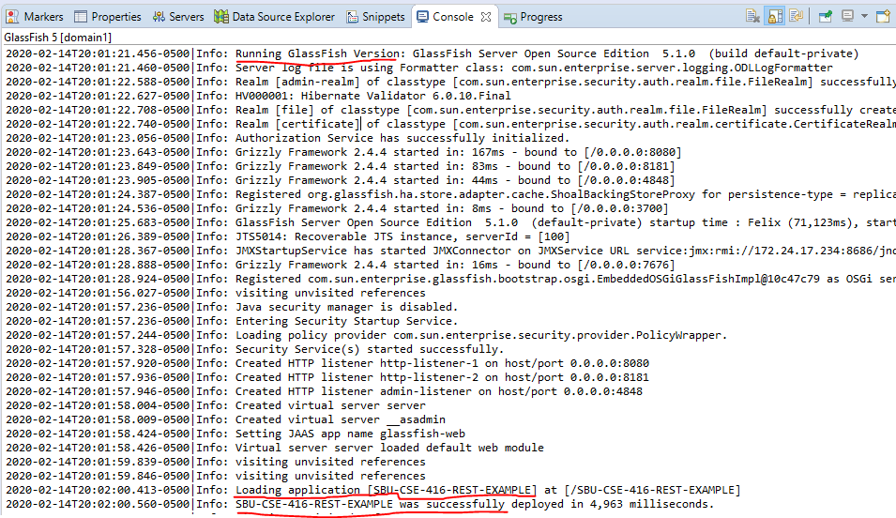

1. Go to your browser and log on to [**http://localhost:<Port>/SBU-CSE-416-REST-EXAMPLE/webresources/helloworld**](http://localhost:%3cPort%3e/SBU-CSE-416-REST-EXAMPLE/webresources/helloworld)which is translated from

localhost:<port>/<Project-Name>/<Path in ApplicationConfig>/<Path in HelloWorld>.

