1. Login to <https://community.cloud.databricks.com/login.html> and try community edition

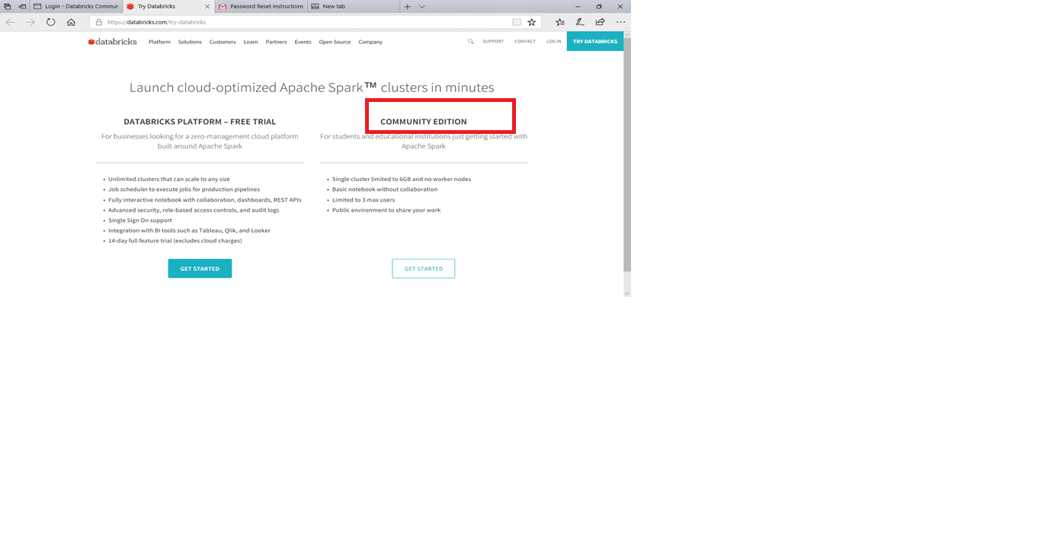

1. Click New cluster to create the cluster

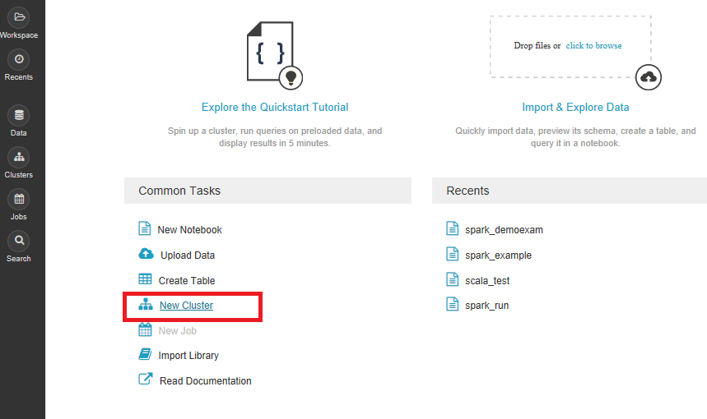

1. Give name to the cluster . The cluster is havig 6GB RAM., 0.88 CPU cores

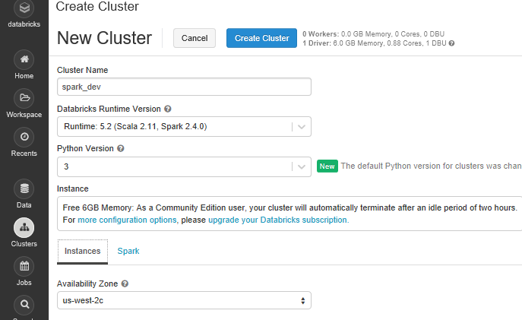

1. Click Create Cluster

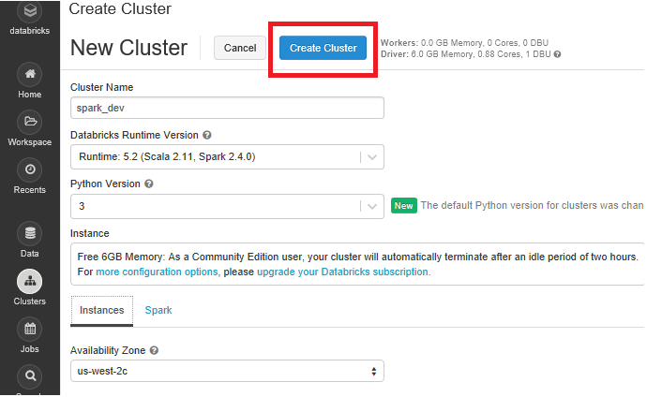

1. Your Spark Cluster is ready now to use

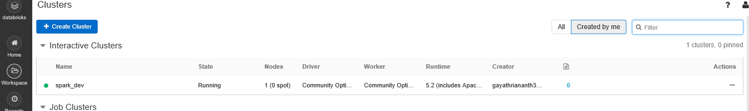

1. To execute spark jobs, click Workspace

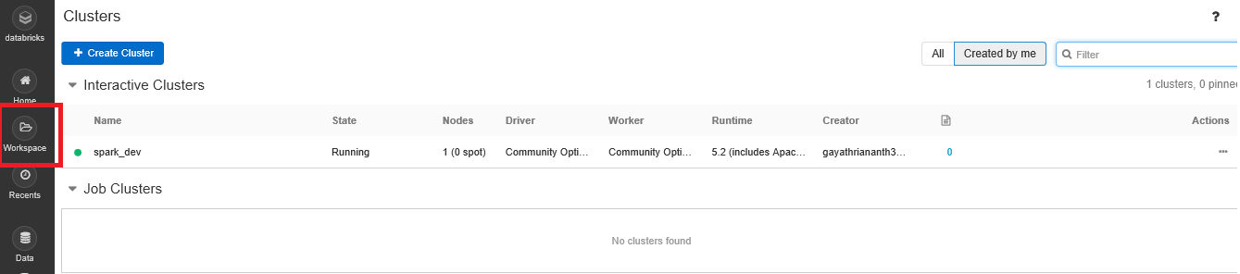

1. Click Workspace->Shared->Create->Notebook

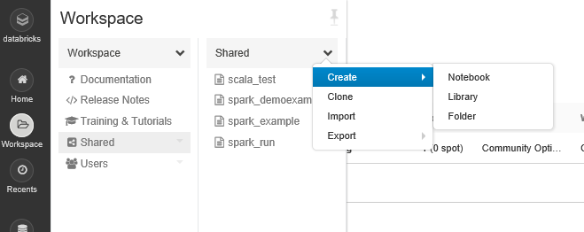

1. In Notebook, provide the name and choose the program you prefer and then click Create

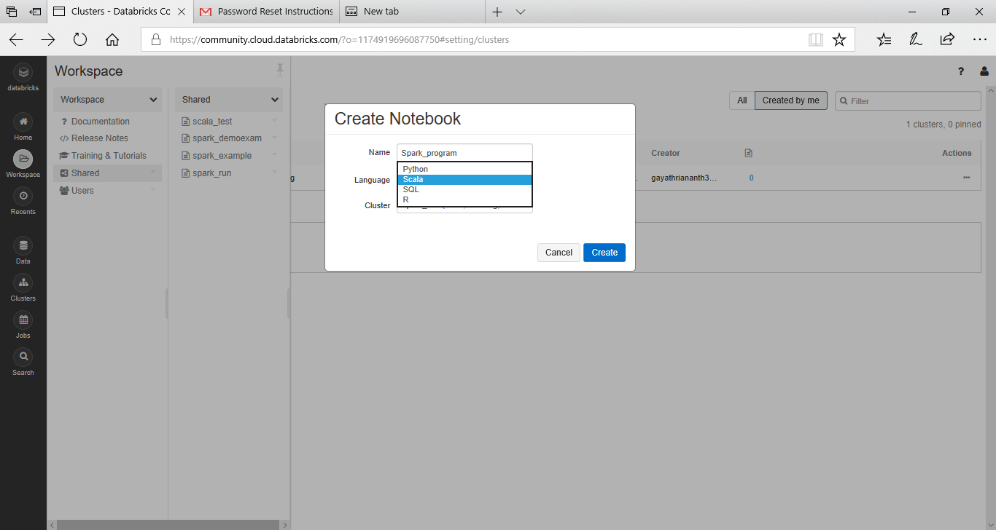

1. Here you can execute your spark program.

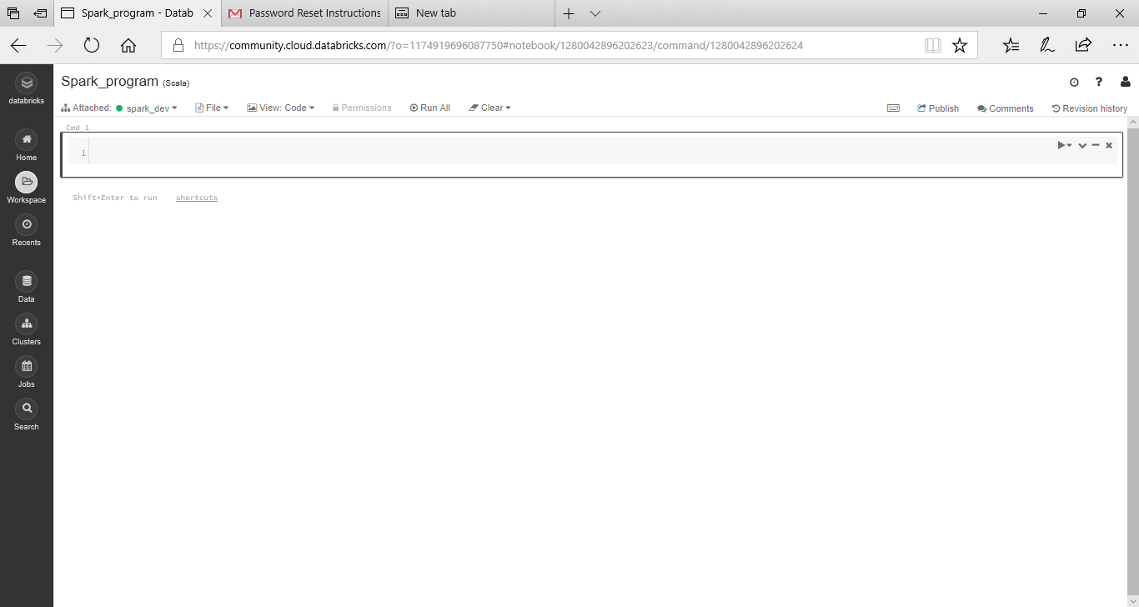

1. Click Run All, to run the program

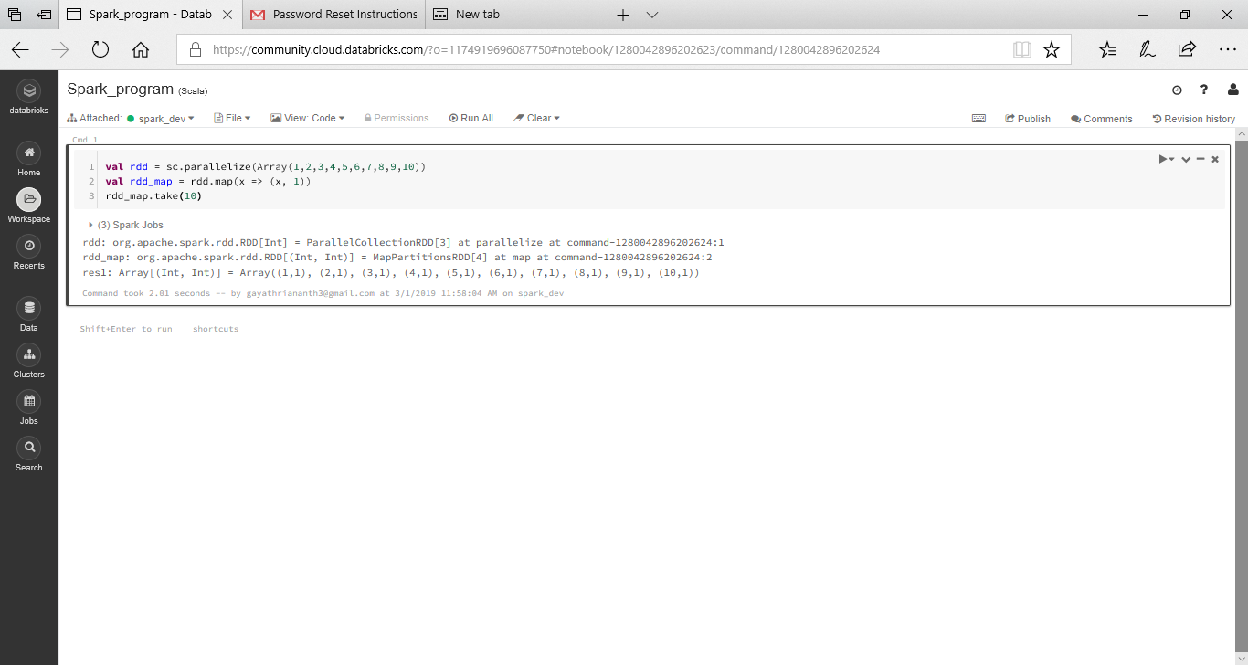

For adding files, click Data and then click Add Data

s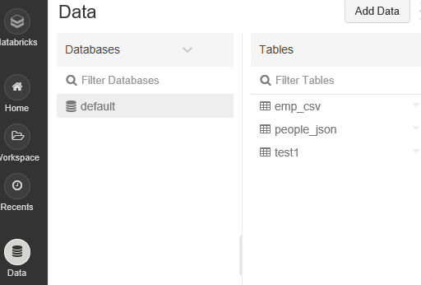

Click Upload File and click browse to add the file from Windows to Databricks. The file location would be /FileStore/tables/<<filename>>

