Part-A Code:

import numpy as np

# Number of faces on each die

num_faces = 6

# Total combinations

total_combinations = num_faces * num_faces

print("Total combinations:", total_combinations)

# Number of faces on each die

num_faces = 6

# Initialize a 6x6 matrix to hold the distribution

distribution_matrix = np.zeros((num_faces, num_faces), dtype=int)

# Fill the matrix with counts of sums

for die_a in range(1, num_faces + 1):

    for die_b in range(1, num_faces + 1):

        sum_ab = die_a + die_b

        distribution_matrix[die_a - 1][die_b - 1] = sum_ab

print("Distribution matrix of sums:")

print(distribution_matrix)

# Initialize a dictionary to hold the counts of each sum

sum_counts = {i: 0 for i in range(2, 13)}

# Calculate the counts for each sum

for die_a in range(1, num_faces + 1):

    for die_b in range(1, num_faces + 1):

        sum_ab = die_a + die_b

        sum_counts[sum_ab] += 1

# Calculate probabilities

total_combinations = num_faces * num_faces

probabilities = {sum_val: count / total_combinations for sum_val, count in sum_counts.items()}

print("Sum counts:", sum_counts)

print("Probabilities of each sum:")

for sum_val, prob in probabilities.items():

    print(f"P(Sum = {sum_val}) = {prob:.4f}")

import numpy as np

# Number of faces on each die

num_faces = 6

# Total combinations

total_combinations = num_faces * num_faces

print("Total combinations:", total_combinations)

# Number of faces on each die

num_faces = 6

# Initialize a 6x6 matrix to hold the distribution

distribution_matrix = np.zeros((num_faces, num_faces), dtype=int)

# Fill the matrix with counts of sums

for die_a in range(1, num_faces + 1):

for die_b in range(1, num_faces + 1):

sum_ab = die_a + die_b

distribution_matrix[die_a - 1][die_b - 1] = sum_ab

print("Distribution matrix of sums:")

print(distribution_matrix)

# Initialize a dictionary to hold the counts of each sum

sum_counts = {i: 0 for i in range(2, 13)}

# Calculate the counts for each sum

for die_a in range(1, num_faces + 1):

for die_b in range(1, num_faces + 1):

sum_ab = die_a + die_b

sum_counts[sum_ab] += 1

# Calculate probabilities

total_combinations = num_faces * num_faces

probabilities = {sum_val: count / total_combinations for sum_val, count in sum_counts.items()}

print("Sum counts:", sum_counts)

print("Probabilities of each sum:")

for sum_val, prob in probabilities.items():

print(f"P(Sum = {sum_val}) = {prob:.4f}")

Output Screenshot:

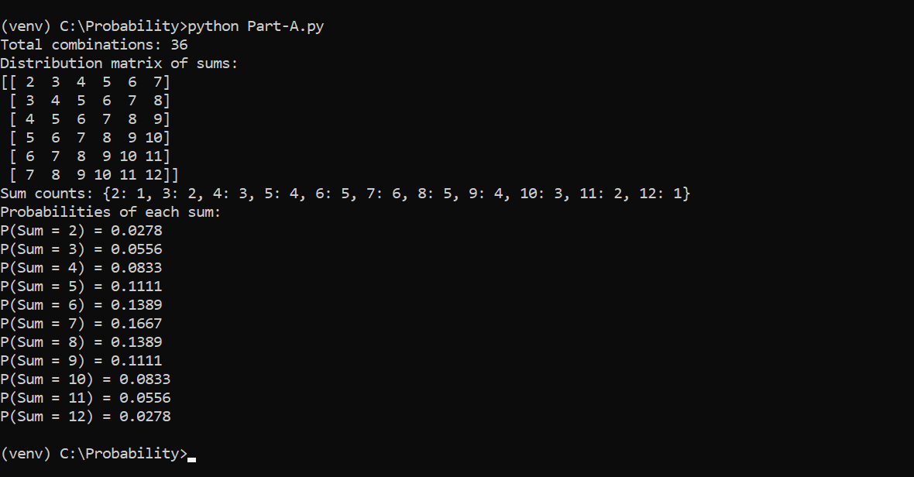

Part B:

from collections import defaultdict

def calculate_combinations(die_a, die_b):

    count = 0

    for i in die_a:

        for j in die_b:

            count += 1

    return count

def generate_all_combinations(die_a, die_b):

    combinations = []

    for i in die_a:

        for j in die_b:

            combinations.append([i, j])

    return combinations

def calculate_probabilities(die_a, die_b):

    combinations = []

    for i in die_a:

        for j in die_b:

            combinations.append(i + j)

    count = defaultdict(int)

    probabilities = {}

    total_combinations = len(combinations)

    for i in combinations:

        count[i] += 1

    for i in range(2, 13):

        count_i = count.get(i, 0)

        probability_i = count_i / total_combinations

        probabilities[i] = {"count": count_i, "probability": round(probability_i, 5)}

    return probabilities

def undoom_dice(die_a, die_b):

    new_die_a = [min(i, 4) for i in die_a]

    new_die_b = die_b  # This function does not modify Die_B, as there is no constraint on Die_B

    return sorted(new_die_a), sorted(new_die_b)

def main():

    die_a = range(1, 7)

    die_b = range(1, 7)

    # Calculate original probabilities

    original_probabilities = calculate_probabilities(die_a, die_b)

    # Generate all possible combinations of the original dice

    all_combinations = generate_all_combinations(die_a, die_b)

    # Transform dice according to the constraints

    new_die_a, new_die_b = undoom_dice(list(die_a), list(die_b))

    # Calculate modified probabilities

    modified_probabilities = calculate_probabilities(new_die_a, new_die_b)

    # Print results

    print("Total Combinations:", calculate_combinations(die_a, die_b))

    print("All Combinations:")

    for combination in all_combinations:

        print(combination)

    print("\nOriginal Probabilities:")

    for sum_combination, probability in original_probabilities.items():

        print(f"Sum: {sum_combination}, Count: {probability['count']}, Probability: {probability['probability']}")

    print("\nModified Probabilities:")

    for sum_combination, probability in modified_probabilities.items():

        print(f"Sum: {sum_combination}, Count: {probability['count']}, Probability: {probability['probability']}")

if __name__ == "__main__":

    main()

from collections import defaultdict

def calculate_combinations(die_a, die_b):

count = 0

for i in die_a:

for j in die_b:

count += 1

return count

def generate_all_combinations(die_a, die_b):

combinations = []

for i in die_a:

for j in die_b:

combinations.append([i, j])

return combinations

def calculate_probabilities(die_a, die_b):

combinations = []

for i in die_a:

for j in die_b:

combinations.append(i + j)

count = defaultdict(int)

probabilities = {}

total_combinations = len(combinations)

for i in combinations:

count[i] += 1

for i in range(2, 13):

count_i = count.get(i, 0)

probability_i = count_i / total_combinations

probabilities[i] = {"count": count_i, "probability": round(probability_i, 5)}

return probabilities

def undoom_dice(die_a, die_b):

new_die_a = [min(i, 4) for i in die_a]

new_die_b = die_b # This function does not modify Die_B, as there is no constraint on Die_B

return sorted(new_die_a), sorted(new_die_b)

def main():

die_a = range(1, 7)

die_b = range(1, 7)

# Calculate original probabilities

original_probabilities = calculate_probabilities(die_a, die_b)

# Generate all possible combinations of the original dice

all_combinations = generate_all_combinations(die_a, die_b)

# Transform dice according to the constraints

new_die_a, new_die_b = undoom_dice(list(die_a), list(die_b))

# Calculate modified probabilities

modified_probabilities = calculate_probabilities(new_die_a, new_die_b)

# Print results

print("Total Combinations:", calculate_combinations(die_a, die_b))

print("All Combinations:")

for combination in all_combinations:

print(combination)

print("\nOriginal Probabilities:")

for sum_combination, probability in original_probabilities.items():

print(f"Sum: {sum_combination}, Count: {probability['count']}, Probability: {probability['probability']}")

print("\nModified Probabilities:")

for sum_combination, probability in modified_probabilities.items():

print(f"Sum: {sum_combination}, Count: {probability['count']}, Probability: {probability['probability']}")

if __name__ == "__main__":

main()

Output:

