**Java script Assignment**

1. Landing Page of To-Do List App

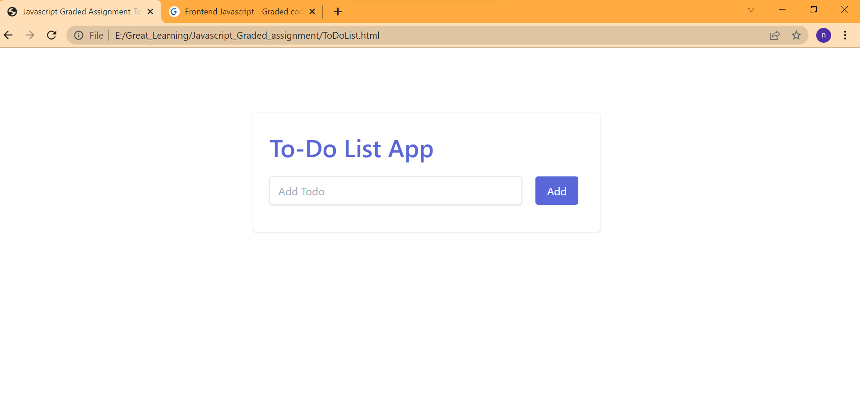

1. Added Few To-Do List

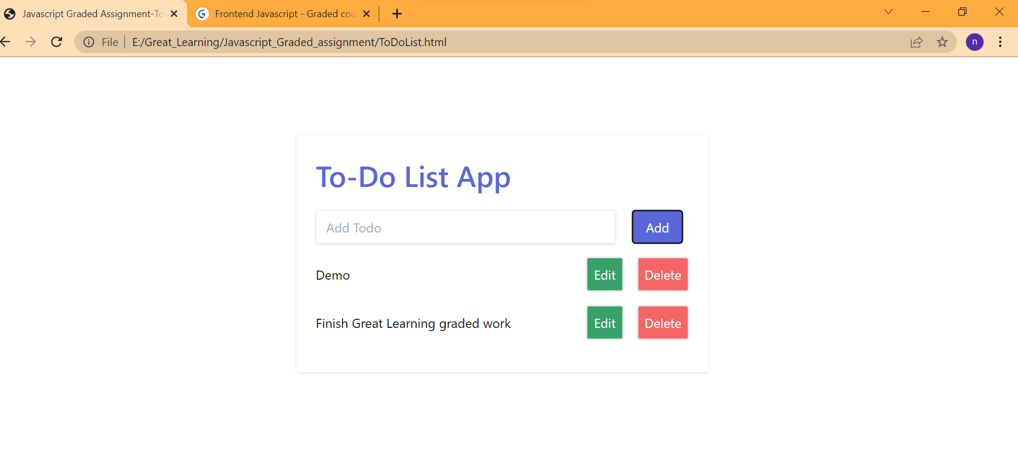

1. Edit Todo List App

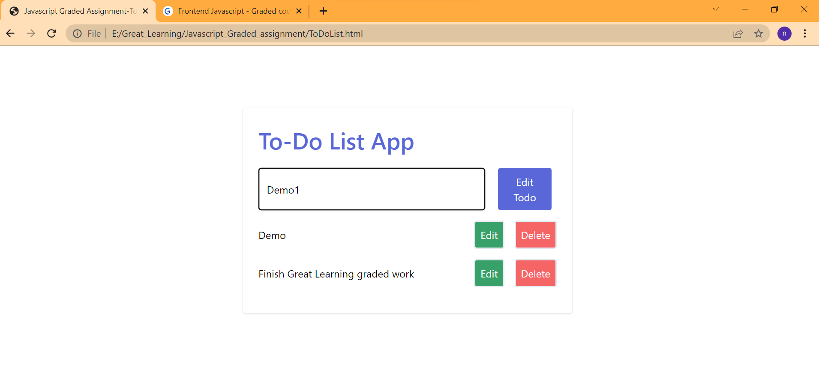

1. After Edit in the list

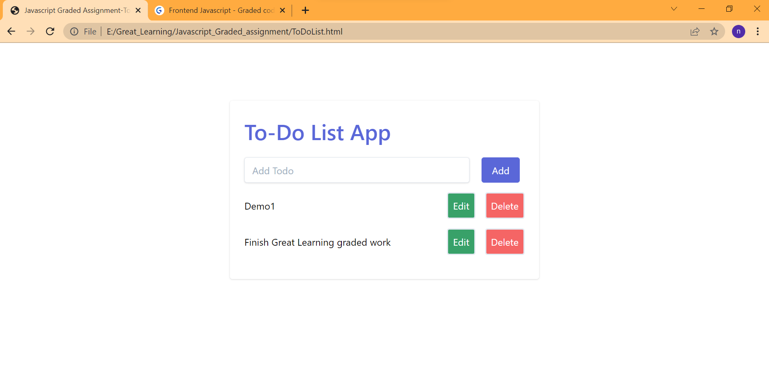

1. After Delete the Todo List App

