E:\Great_Learning\Html_Lab_Session\LabSession-Html-Css-main\LabSession-Html-Css-main\bar.html

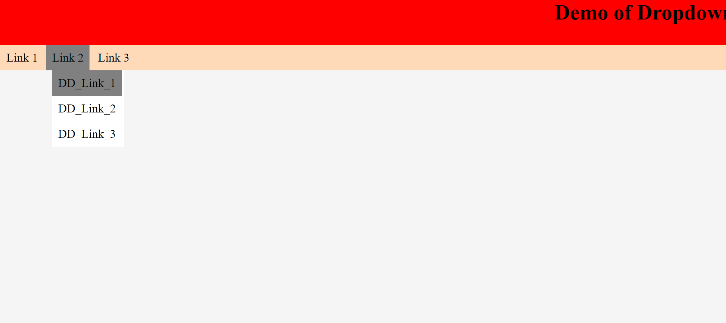

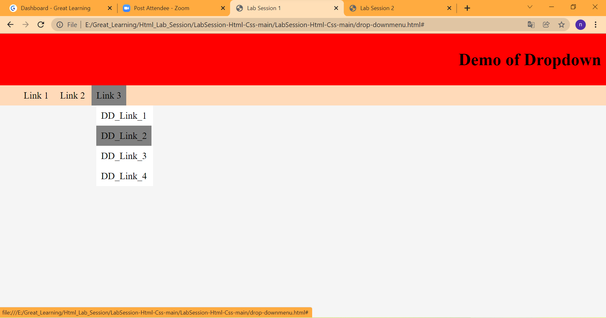

<file:///E:/Great_Learning/Html_Lab_Session/LabSession-Html-Css-main/LabSession-Html-Css-main/bar.html>

