**Test Evidence**

Customer Relation Ship Assignment:-

***Read Operation:-***

<http://localhost:8080/CustomerRelationShip/customer/list> - Customer List

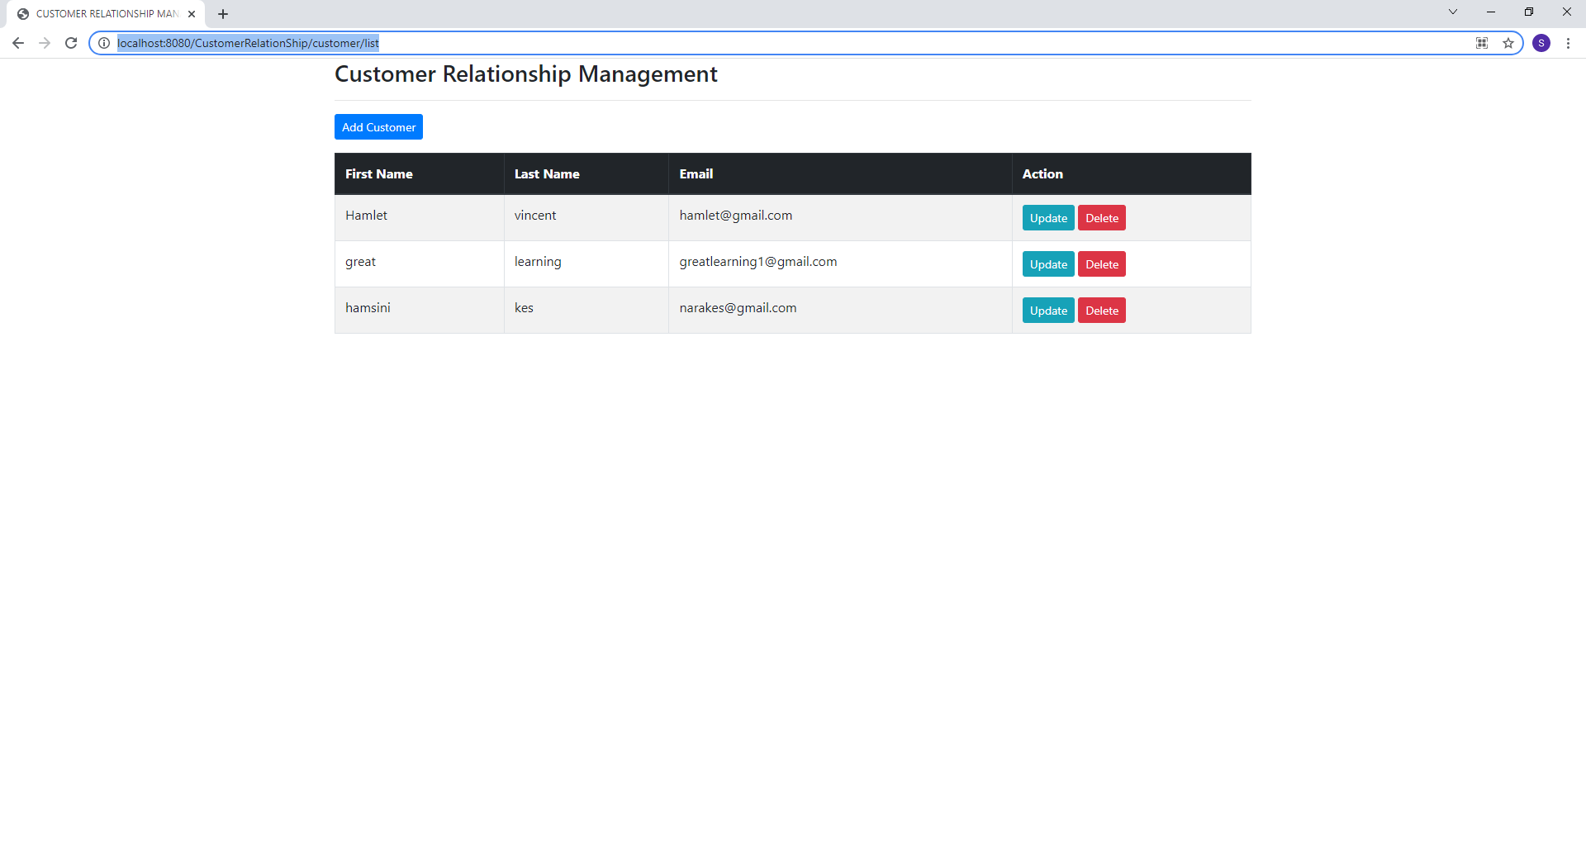

***Create Operation:-***

<http://localhost:8080/CustomerRelationShip/customer/showFormForAdd> - Save Customer

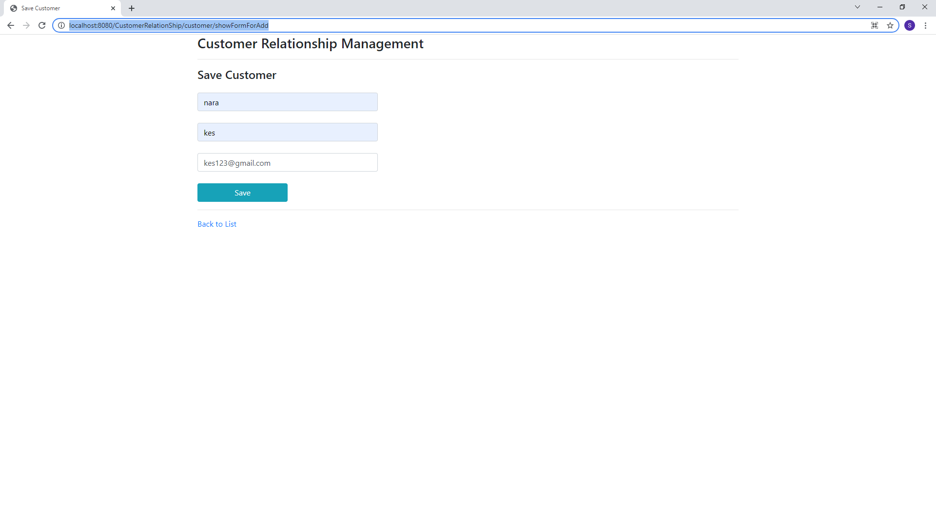

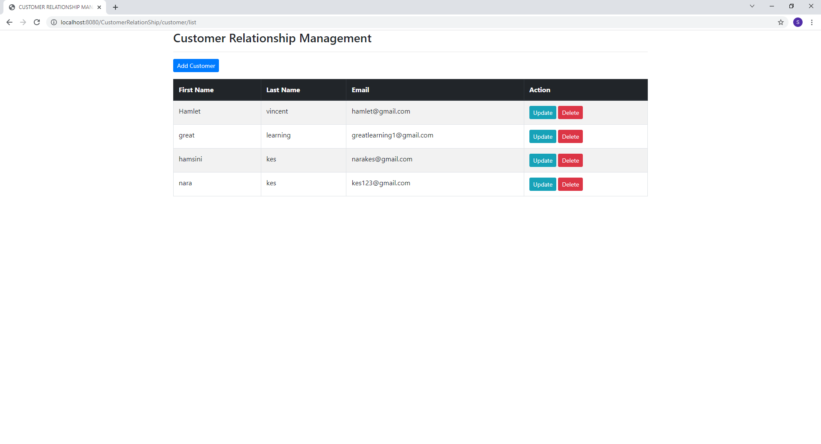

***Update Operation:-***

<http://localhost:8080/CustomerRelationShip/customer/showFormForUpdate?custId=6> – Update Customer

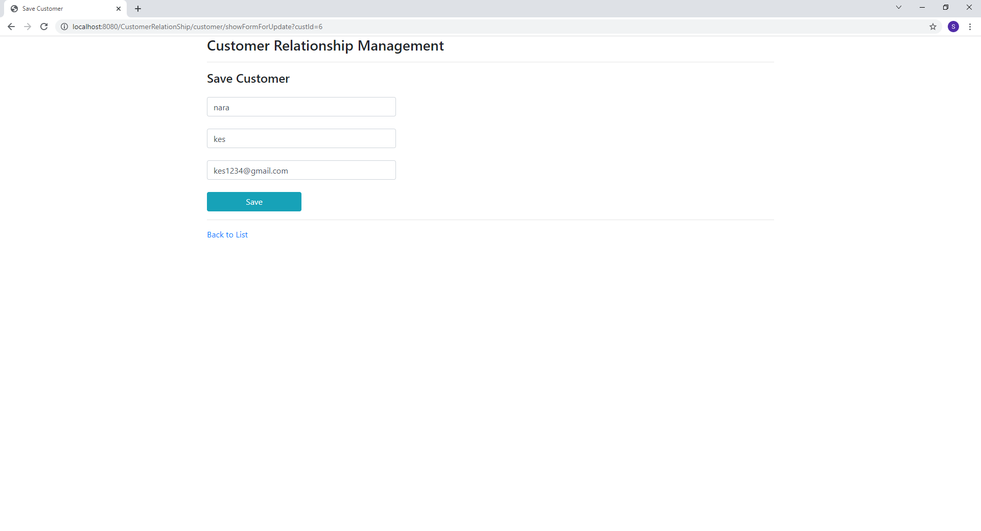

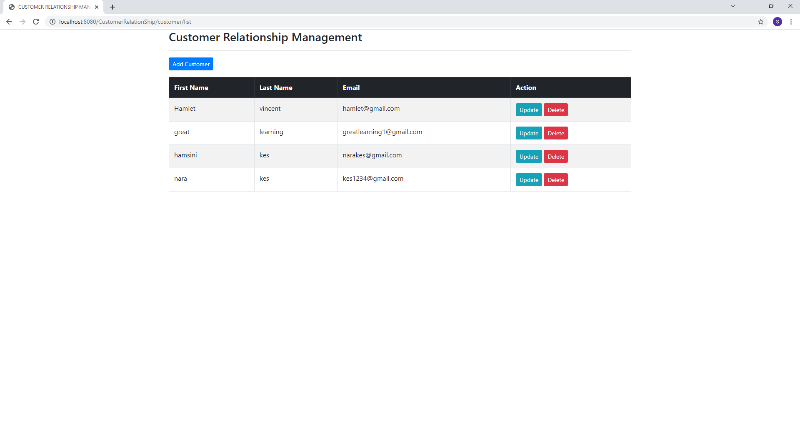

***Delete Operation:-***

