

Programming Manual

Original Instructions

Logix 5000 Controllers I\O and Tag Data

1756 ControlLogix, 1756 GuardLogix, 1769 CompactLogix,

1769 Compact GuardLogix, 1789 SoftLogix, 5069

CompactLogix, 5069 Compact GuardLogix, Studio 5000 Logix Emulate

Rockwell Automation Publication 1756-PM004L-EN-P - November 2023 Supersedes Publication 1756-PM004K-EN-P - November 2022



Logix 5000 Controllers I/O and Tag Data

## Important User Information

Read this document and the documents listed in the additional resources section about installation, configuration, and

operation of this equipment before you install, configure, operate, or maintain this product. Users are required to familiarize themselves with installation and wiring instructions in addition to requirements of all applicable codes, laws, and standards.

Activities including installation, adjustments, putting into service, use, assembly, disassembly, and maintenance are required to be carried out by suitably trained personnel in accordance with applicable code of practice.

I f this equipment is used in a manner not specified by the manufacturer, the protection provided by the equipment may be impaired.

In no event will Rockwell Automation, Inc. be responsible or liable for indirect or consequential damages resulting from the use or application of this equipment.

The examples and diagrams in this manual are included solely for illustrative purposes. Because of the many variables and

requirements associated with any particular installation, Rockwell Automation, Inc. cannot assume responsibility or liability for actual use based on the examples and diagrams.

No patent liability is assumed by Rockwell Automation, Inc. with respect to use of information, circuits, equipment, or software described in this manual.

Reproduction of the contents of this manual, in whole or in part, without written permission of Rockwell Automation, Inc., is prohibited.

Throughout this manual, when necessary, we use notes to make you aware of safety considerations.



WARNING: Identifies information about practices or circumstances that can cause an explosion in a hazardous environment, which may lead to personal injury or death, property damage, or economic loss.



ATTENTION: Identifies information about practices or circumstances that can lead to personal injury or death, property damage, or economic loss. Attentions help you identify a hazard, avoid a hazard, and recognize the consequence.

**IMPORTANT** Identifies information that is critical for successful application and understanding of the product.

Labels may also be on or inside the equipment to provide specific precautions.



SHOCK HAZARD: Labels may be on or inside the equipment, for example, a drive or motor, to alert people that dangerous voltage may be present.



BURN HAZARD: Labels may be on or inside the equipment, for example, a drive or motor, to alert people that surfaces may reach dangerous temperatures.

ARC FLASH HAZARD: Labels may be on or inside the equipment, for example, a motor control center, to alert people to potential Arc Flash. Arc Flash will cause severe injury or death. Wear proper Personal Protective Equipment (PPE). Follow ALL Regulatory requirements for safe work practices and for Personal Protective Equipment (PPE).



Rockwell Automation recognizes that some of the terms that are currently used in our industry and in this publication are not in alignment with the movement toward inclusive language in technology. We are proactively collaborating with industry peers to find alternatives to such terms and making changes to our products and content. Please excuse the use of such terms in our content while we implement these changes.

This manual includes new and updated information. Use these reference tables to locate changed information.

Grammatical and editorial style changes are not included in this summary.

#### Global changes

None in this release.

**New or enhanced features**

|  |  |
| --- | --- |
| **Change** | **Topic** |
| Added OPC UA Access information | Introduction - data access control on page 57 |
| Added OPC UA Access information | Create a tag on page 31 |
| Removed image | Configure external access in the New Tag dialog box on page 59 |
| Removed image | Set up external access in the Tag Properties  dialog box on page 60 |
| Removed image | Set up a constant in the New Tag dialog box on page 72 |
| Removed image | Configure a constant in the Tag Properties dialog box on page 72 |
| New topic | OPC UA Access on page 67 |
| New topic | Configure OPC UA Access on page 68 |
| New topic | OPC UA options on page 68 |
| New topic | Set up OPC UA Access in the Tag Properties dialog box on page 68 |
| New topic | View and select OPC UA Access status on the Tag Editor on page 69 |
| New topic | OPC UA Access availability on page 69 |
| New topic | Mapping tags to controllers for OPC UA Access on page 70 |
| New topic | Imported tag behavior for OPC UA Access on page 71 |

**Summary of changes****Preface**

**Communicate with I/O modules**

**Organize tags**

Studio 5000 environment 9

Additional resources 10

Legal Notices 10

**Chapter 1**

I ntroduction 13

Requested packet interval 13

Communication format 14

Direct or rack-optimized connection 15

Ownership 15

E lectronic keying 17

More information 18

Address I /O data 18

Buffer I /O 19

**Chapter 2**

I ntroduction 21

Tag type 22

Data type 23

Tag scope 25

Program parameter scope 26

Guidelines for tags 27

Create a tag 31

Add extended properties to a tag 32

Create an array 33

Configure an array 35

User-defined data types 36

Guidelines for user-defined data types 38

Create a user-defined data type 38

Add extended properties to a user-defined data type 39

Describe a user-defined data type 41

Activate pass-through and append descriptions 42

Paste a pass-through description 43

Address tag data 44

Alias tags 44

Display alias information 46

Assign an alias 46

I ndirect addresses 47

Expressions 48

Array subscript out of range 48

Tag documentation 49

**Table of Contents**

**Force I/O**

**Data access control**

Project documentation 49

Chapter 3

I ntroduction 51

Precautions 51

Enable forces 51

Disable or remove a force 51

Check force status 52

Force status indicator 52

GSV instruction 53

When to use I /O force 53

Force an input value 54

Force an output value 54

Add an I /O force 54

Remove or disable forces 55

Remove an individual force 55

Disable all I /O forces 56

Remove all I /O forces 56

Chapter 4

I ntroduction 57

External access 57

Configure external access 58

External access options 58

Configure external access in the New Tag dialog box 59

Set up external access in the Tag Properties dialog box 60

View and select external access status on the Tag Editor 60

Find a base tag with Go To 61

External access availability 62

User-defined type considerations 63

Add-on instructions external access considerations 64

Tag mapping considerations 66

I mported tag behavior 67

OPC UA Access 67

Configure OPC UA Access 68

OPC UA Access options 68

Configure OPC UA Access in the Tag Properties dialog box 68

View and select OPC UA Access status on the Tag Editor 69

OPC UA Access availability 69

Mapping tags to controller s for OPC UA Access 70

I mported tag behavior for OPC UA Access 71

Constant value tags 71

**Index**

**Table of Contents**

Configure constant tags 71

Set up a constant in the New Tag dialog box 72

Configure a constant in the Tag Properties dialog box 72

Designate a constant in the Tag Editor 73

Track a constant tag 74

Constant check box availability 74

Add-on instructions constant value considerations 75

## Preface

This manual shows how to access I /O and tag data in Logix 5000 controllers. This manual is one of a set of related manuals that show common procedures for programming and operating Logix 5000 controllers.

For a complete list of common procedures manuals, refer to the [Logix 5000](http://literature.rockwellautomation.com/idc/groups/literature/documents/pm/1756-pm001_-en-e.pdf) [Controllers Common Procedures Programming Manual,](http://literature.rockwellautomation.com/idc/groups/literature/documents/pm/1756-pm001_-en-e.pdf) publication

[1756-PM001.](http://literature.rockwellautomation.com/idc/groups/literature/documents/pm/1756-pm001_-en-e.pdf)

The term Logix 5000 controller refers to any controller based on the Logix 5000 operating system.

Rockwell Automation recognizes that some of the terms that are currently used in our industry and in this publication are not in alignment with the movement toward inclusive language in technology. We are proactively collaborating with industry peers to find alternatives to such terms and making changes to our products and content. Please excuse the use of such terms in our content while we implement these changes.

## Studio 5000 environment

The Studio 5000 Automation E ngineering & Design E nvironment® combines engineering and design elements into a common environment. The first element is the Studio 5000 Logix Designer® application. The Logix Designer application is the rebranding of RSLogix 5000® software and will continue to be the product to program Logix 5000ő controllers for discrete, process, batch, motion, safety, and drive-based solutions.

The Studio 5000® environment is the foundation for the future of

Rockwell Automation® engineering design tools and capabilities. The Studio 5000 environment is the one place for design engineers to develop all elements of their control system.

Preface

## Additional resources

## Legal Notices

Documents that contain additional information concerning related Rockwell Automation products.

|  |  |
| --- | --- |
| **Resource** | **Description** |
| [Logix 5000 Controllers Program Parameters](http://literature.rockwellautomation.com/idc/groups/literature/documents/pm/1756-pm021_-en-p.pdf) [Programming Manual,](http://literature.rockwellautomation.com/idc/groups/literature/documents/pm/1756-pm021_-en-p.pdf) publication [1756-PM021](http://literature.rockwellautomation.com/idc/groups/literature/documents/pm/1756-pm021_-en-p.pdf) | Describes how to use program parameters when programming Logix 5000 controllers. |
| Product Certifications website, [http://ab.rockwellautomation.com](http://ab.rockwellautomation.com/) | Provides declarations of conformity, certificates, and other certification details. |

View or download publications at

[http://www.rockwellautomation.com/literature.](http://www.rockwellautomation.com/literature) To order paper copies of technical documentation, contact the local Rockwell Automation distributor or sales representative.

Rockwell Automation recognizes that some of the terms that are currently used in our industry and in this publication are not in alignment with the movement toward inclusive language in technology. We are proactively collaborating with industry peers to find alternatives to such terms and making changes to our products and content. Please excuse the use of such terms in our content while we implement these changes.

Rockwell Automation publishes legal notices, such as privacy policies, license agreements, trademark disclosures, and other terms and conditions on the

[Legal Notices](https://www.rockwellautomation.com/en-us/company/about-us/legal-notices/software-cloud-services-agreement.html) page of the Rockwell Automation website.

#### Software and Cloud Services Agreement

Review and accept the Rockwell Automation Software and Cloud Services Agreement [here.](https://www.rockwellautomation.com/en-us/company/about-us/legal-notices/software-cloud-services-agreement.html)

#### Open Source Licenses

The software included in this product contains copyrighted software that is licensed under one or more open source licenses. Copies of those licenses are included with the software. Corresponding Source code for open source packages included in this product are located at their respective web site(s).

Alternately, obtain complete Corresponding Source code by contacting Rockwell Automation via the Contact form on the Rockwell Automation website:

<http://www.rockwellautomation.com/global/about-us/contact/contact.page> Please include "Open Source" as part of the request text.

A full list of all open source software used in this product and their

corresponding licenses can be found in the OPENSOURCE folder. The default installed location of these licenses is C:\Program Files (x86)\Common Files\Rockwell\Help\<Product Name>\Release Notes\OPENSOURCE\index.htm.

Preface

## Chapter 1

# Communicate with I/O modules

## Introduction

## Requested packet interval

To communicate with an I /O module in your system, you add the module to the **I/O Configuration** folder in the **Controller Organizer**.

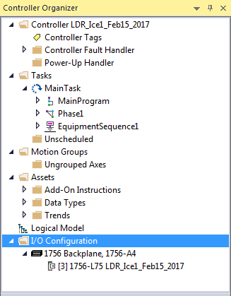

When you add the module, you also define a specific configuration for the module. While the configuration options vary from module to module, these are some common options that you typically configure:

* Requested packet interval on page 13
* Communication format on page 14
* Electronic keying on page 17

The Logix 5000 controller uses connections to transmit I /O data.

|  |  |
| --- | --- |
| **Term** | **Definition** |
| Connection | A communication link between two devices, such as between a controller and an I/O module, PanelView terminal, or another controller.  Connections are allocations of resources that provide more reliable communications between devices than unconnected messages. The number of connections that a single controller can have is limited.  You indirectly determine the number of connections the controller uses by configuring the controller to communicate with other devices in the system. The following types of communication use connections:   * I/O modules * Produced and consumed tags * Produced and consumed program parameters * Certain types of Message (MSG) instructions (not all types use a connection) |
| Requested packet interval (RPI) | The RPI specifies the period at which data updates over a connection. For example, an input module sends data to a controller at the RPI that you assign to the module.   * Typically, you configure an RPI in milliseconds (ms). The range is 1 ms (1000 microseconds)…536870.911 ms. * If a ControlNet network connects the devices, the RPI reserves a slot in the stream of data flowing across the ControlNet network. The timing of this slot may not coincide with the exact value of the RPI, but the control system guarantees that the data transfers at least as often as the RPI. |

In Logix 5000 controllers, I /O values update at a period that you configure in the I /O configuration folder of the project. The values update asynchronous to the execution of logic. At the specified interval, the controller updates a value independently from the execution of logic.

WARNING: Make sure that data memory contains the appropriate values throughout a task’s execution. You can duplicate or buffer data at the beginning of the scan to provide reference values



for your logic.

* + Programs within a task access input and output data directly from controller-scoped memory.
    - Logic within any task can change controller-scoped data.
    - Data and I /O values are asynchronous and can change during the course of a task’s execution.
    - An input value referenced at the beginning of a task’s execution can be

different when referenced later.

* + - To prevent an input value from changing during a scan, copy the value to another tag and use the data from there (buffer the values).

Tip: Starting with Logix Designer version 24, you can use program parameters to share data between programs in much the same way as you have used controller-scoped tags. Input and Output program parameters automatically buffer data, without using another program parameter or tag. For more information on program parameters, refer to the *Logix 5000 Controllers Program Parameters Programming Manual*, publication no. *1756-PM021*.

## Communication format

#### See also

[Logix 5000 Controllers Program Parameters Programming Manual,](http://literature.rockwellautomation.com/idc/groups/literature/documents/pm/1756-pm021_-en-p.pdf) publication no. [publication no. 1756-PM021](http://literature.rockwellautomation.com/idc/groups/literature/documents/pm/1756-pm021_-en-p.pdf)

The communication format that you choose determines the data structure for the tags that are associated with the module. Many I /O modules support

## Direct or rack-optimized connection

## Ownership

different formats. Each format uses a different data structure. The communication format that you choose also determines:

* Direct or rack-optimized connection on page 15.
* Ownership on page 15.

The Logix 5000 controller uses connections to transmit I /O data. These connections can be direct connections or rack-optimized connections.

|  |  |
| --- | --- |
| **Term** | **Definition** |
| Direct connection | A direct connection is a real-time, data transfer link between the controller and an I/O module. The controller maintains and monitors the connection with the I/O module. Any break in the connection, such as a module fault or the removal of a module while under power, sets fault bits in the data area associated with the module.    A direct connection is any connection that does not use the Rack Optimization Comm Format. |
| Rack-optimized connection | For digital I/O modules, you can select rack-optimized communication. A rack-optimized connection consolidates connection usage between the controller and all the digital I/O modules in the chassis (or DIN rail). Rather than having individual, direct connections for each I/O module, there is one connection for the entire chassis (or DIN rail). |

In a Logix 5000 system, modules multicast data. This means that multiple devices can receive the same data at the same time from a single device.

When you choose a communication format, you have to choose whether to establish an owner or listen-only relationship with the module.

|  |  |
| --- | --- |
| **Term** | **Definition** |
| Owner controller | The controller that creates the primary configuration and communication connection to a module. The owner controller writes configuration data and can establish a connection to the module.    An owner connection is any connection that does not include Listen-Only in its Comm Format. |
| Listen-only connection | An I/O connection where another controller owns/provides the configuration data for the I/O module. A controller using a listen-only connection only monitors the module. It does not write configuration data and can only maintain a connection to the I/O module when the owner controller is actively controlling the I/O module. |

Use the following table to choose the type of ownership for a module.

|  |  |  |  |
| --- | --- | --- | --- |
| **If module is** | **And another controller** | **And you want to** | **Then use this type of connection** |
| Input module | Does not own the module | - > | Owner (not listen-only) |
| Owns the module | Maintain communication with the module if it loses communication with the other controller | Owner (not listen-only)  Use the same configuration as the other owner controller. |
| Stop communication with the module if it loses communication with the other controller | Listen-only |
| Output module | Does not own the module | - > | Owner (such as, not listen-only) |
| Owns the module | - > | Listen-only |

There is a noted difference in controlling input modules versus controlling output modules. The following table lists the differences.

|  |  |  |
| --- | --- | --- |
| **Controlling** | **This Ownership** | **Description** |
| Input modules | Owner | An input module is configured by a controller that establishes a connection as an owner. This configuring controller is the first controller to establish an owner connection.  Once an input module has been configured (and owned by a controller), other controllers can establish owner connections to that module. This lets additional owners to continue to receive multicast data if the original owner controller breaks its connection to the module. All other additional owners must have the identical configuration data and identical communications format that the original owner controller has; otherwise, the connection attempt is rejected. |

|  |  |  |
| --- | --- | --- |
| **Controlling** | **This Ownership** | **Description** |
|  | Listen-only | Once an input module has been configured (and owned by a controller), other controllers can establish a listen-only connection to that module. These controllers can receive multicast data while another controller owns the module. If all owner controllers break their connections to the input module, all controllers with listen-only connections no longer receive multicast data. |
| Output modules | Owner | An output module is configured by a controller that establishes a connection as an owner. Only one-owner connection is allowed for an output module. If another controller attempts to establish an owner connection, the connection attempt is rejected. |
| Listen-only | Once an output module has been configured (and owned by one controller), other controllers can establish listen-only connections to that module. These controllers can receive multicast data while another controller owns the module. If the owner controller breaks its connection to the output module, all controllers with listen-only connections no longer receive multicast data. |

## Electronic keying

Electronic Keying reduces the possibility of using the wrong device in a control system. Electronic Keying compares the device defined in the project to the installed device. I f keying fails, a fault occurs.

These attributes are compared:

|  |  |
| --- | --- |
| **Attribute** | **Description** |
| Vendor | The device manufacturer. |
| Device Type | The general type of the device, for example, digital I/O module. |
| Product Code | The specific type of device. The Product Code maps to a catalog number. |
| Major Revision | A number that represents the functional capabilities of a device. |
| Minor Revision | A number that represents behavior changes in the device. |

These**Electronic Keying** options are available:

|  |  |
| --- | --- |
| **Keying Option** | **Description** |
| Compatible Module | Lets the installed device accept the key of the device that is defined in the project when the installed device can emulate the defined device. Typically, use Compatible Module to replace a device with another device that has these characteristics:   * Same catalog number * Same or higher Major Revision * Minor Revision:   + If the Major Revision is the same, the Minor Revision must be the same or higher.   + If the Major Revision is higher, the Minor Revision can be any number. |
| Disable Keying | Indicates that the keying attributes are not considered when attempting to communicate with a device. With Disable Keying, communication can occur with a device other than the type specified in the project.  ATTENTION: Be extremely cautious when using Disable Keying. If used incorrectly, this option can lead to personal injury or death, property damage, or economic loss.  We strongly recommend not using Disable Keying.  If using Disable Keying, take full responsibility for understanding whether the device being used can fulfill the functional requirements of the application. |
| Exact Match | Indicates that all keying attributes must match to establish communication. If any attribute does not match precisely, communication with the device does not occur. |

Carefully consider the implications of each keying option when selecting one.

## More information Address I/O data

**IMPORTANT** Changing Electronic Keying parameters online interrupts connections to the device and any devices that are connected through the device. Connections from other controllers can also be broken.

A loss of data may occur if an I/O connection to a device is interrupted.

For more information on Electronic Keying, see [Electronic Keying in <LOGI](http://literature.rockwellautomation.com/idc/groups/literature/documents/at/logix-at001_-en-p.pdf)  [X5K> Control Systems Application Technique,](http://literature.rockwellautomation.com/idc/groups/literature/documents/at/logix-at001_-en-p.pdf) publication [LOGIX-AT001.](http://literature.rockwellautomation.com/idc/groups/literature/documents/at/logix-at001_-en-p.pdf)

I /O information is presented as a set of tags.

* Each tag uses a structure of data. The structure depends on the specific features of the I /O module.
* The name of the tag is based on the location of the I /O module in the

system.

* + When you add a module to the I /O Configuration folder, the software automatically creates controller-scoped tags for the module in

Controller Tags.

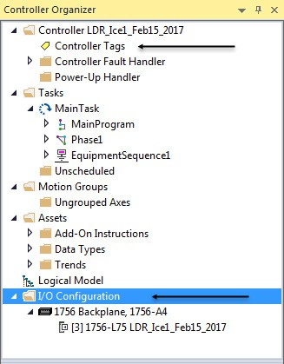

An I /O address uses this format:

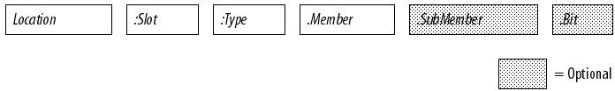

**Where**

Location

**Is**

Network location

LOCAL = same chassis or DIN rail as the controller

|  |  |
| --- | --- |
| **Where** | **Is** |
|  | ADAPTER_NAME = identifies remote communication adapter or bridge module |
| Slot | Slot number of I/O module in its chassis or DIN rail |
| Type | Type of data I = input  O = output  C = configuration S = status |
| Member | Specific data from the I/O module; depends on what type of data the module can store.   * For a digital module, a Data member usually stores the input or output bit values. * For an analog module, a Channel member (CH#) usually stores the data for a channel. |
| SubMember | Specific data related to a Member. |
| Bit | Specific point on a digital I/O module; depends on the size of the I/O module (0–31 for a 32-point module) |

## Buffer I/O

Buffering is a technique in which logic does not directly reference or

manipulate the tags of real I /O devices. Instead, the logic uses a copy of the I /O data. Buffer I /O in the following situations:

* + To prevent an input or output value from changing during the

execution of a program. (I /O updates asynchronous to the execution of logic.)

* + To copy an input or output tag to a member of a structure or element of an array.

Tip: Starting with Logix Designer version 24, you can use program parameters to buffer data in a program without having to copy the data to a second tag. Input and Output program parameters automatically buffer data while the program routines execute. For more information on program parameters, refer to the *Logix 5000 Controllers Program Parameters Programming Manual*, publication no. *1756-PM021*.

Follow these steps to buffer I /O.

1. On the rung before the logic for the function, copy or move the data from the required input tags to their corresponding buffer tags.
2. In the logic of the function, reference the buffer tags.
3. On the rung after the function, copy the data from the buffer tags to the corresponding output tags.

The example copies inputs and outputs to the tags of a structure for a drill machine. The examples are of buffer I /O by mapping values to tags.

The main routine of the program executes the subroutines in this sequence.

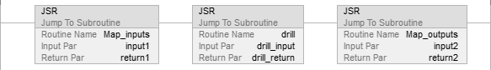

The map_inputs routine copies the values of input devices to their corresponding tags that are used in the drill routine.

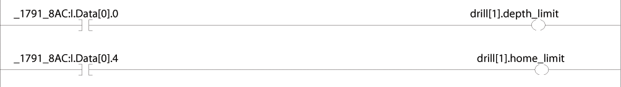

The drill routine executes the logic for the drill machine.

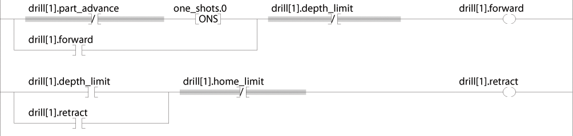

The map_outputs routine copies the values of output tags in the drill routine to their corresponding output devices.

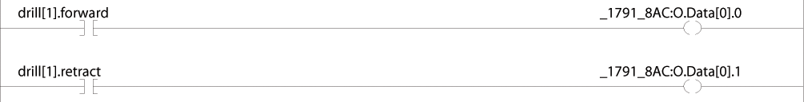

The example uses the CPS instruction to copy an array of data that represent the input devices of a DeviceNet network.

**EXAMPLE** Buffer I/O using CPS instruction

Local:0:I.Data stores the input data for the DeviceNet network that is connected to the 1756-DNB module in slot 0. To synchronize the inputs with the application, the CPS instruction copies the input data to input_buffer.

* While the CPS instruction copies the data, no I/O updates can change the data. As the application executes, it uses the input data in input_buffer for its inputs.

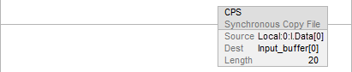

#### See also

[Logix 5000 Controllers Program Parameters Programming Manual,](http://literature.rockwellautomation.com/idc/groups/literature/documents/pm/1756-pm021_-en-p.pdf) publication no. [1756-PM021](http://literature.rockwellautomation.com/idc/groups/literature/documents/pm/1756-pm021_-en-p.pdf)

## Chapter 2

# Organize tags

## Introduction

With a Logix 5000 controller, you use a tag (alphanumeric name) to address data (variables).

|  |  |
| --- | --- |
| **Term** | **Definition** |
| Tag | A text-based name for an area of the controller’s memory where data is stored.   * Tags are the basic mechanism for allocating memory, referencing data from logic, and monitoring data. * The minimum memory allocation for a tag is four bytes. * When you create a tag that stores data that requires less than four bytes, the controller allocates four bytes, but the data only fills the part it needs. |

The controller uses the tag name internally and does not need to cross-reference a physical address.

* In conventional programmable controllers, a physical address identifies each item of data.
  + Addresses follow a fixed, numeric format that depends on the type of data, such as N7:8, F8:3.
  + Symbols are required to make logic easier to interpret.
* In Logix 5000 controllers, there is no fixed, numeric format. The tag name itself identifies the data. This lets you:
  + Organize your data to mirror your machinery.
  + Document (through tag names) your application as you develop it.

**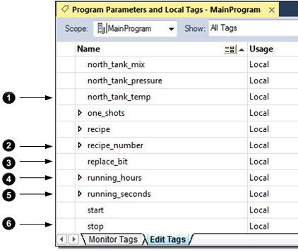****Example**

|  |  |
| --- | --- |
| **Item** | **Description** |
|  | Analog I/O Device |
|  | Integer Value |
|  | Storage Bit |
|  | Counter |
|  | Timer |
|  | Digital I/O Device |

## Tag type

The tag type defines how the tag operates within your project.

|  |  |
| --- | --- |
| **If you want the tag to** | **Then select this type** |
| Store a value or values for use by logic within the project | Base |
| Represent another tag | Alias |
| Send data to another controller | Produced |
| Receive data from another controller | Consumed |

I f you plan to use produced or consumed tags, you must follow additional guidelines as you organize your tags.

#### See also

[Logix 5000 Controllers Produced and Consumed Tags Programming](http://literature.rockwellautomation.com/idc/groups/literature/documents/pm/1756-pm011_-en-p.pdf) [Manual,](http://literature.rockwellautomation.com/idc/groups/literature/documents/pm/1756-pm011_-en-p.pdf) publication no. [1756-PM011](http://literature.rockwellautomation.com/idc/groups/literature/documents/pm/1756-pm011_-en-p.pdf)

## Data type

Data type applies to tags and structures.

|  |  |
| --- | --- |
| **Term** | **Definition** |
| Data type | The data type defines the type of data that a tag stores, such as a bit, integer, floating-point value, string, and so forth. |
| Structure | A data type that is a combination of other data types.   * A structure is formatted to create a unique data type that matches a specific need. * Within a structure, each individual data type is called a member. * Like tags, members have a name and data type. * A Logix 5000 controller contains a set of predefined structures (data types) for use with specific instructions such as timers, counters, Function Blocks, and so forth. * You can create your own structures, called a user-defined data type |

This table outlines the most common data types and when to use each.

|  |  |
| --- | --- |
| **For** | **Select** |
| Analog device in floating-point mode | REAL |
| Analog device in integer mode (for very fast sample rates) | INT |
| ASCII characters | String |
| Bit | BOOL |
| Counter | COUNTER |
| Digital I/O point | BOOL |
| Floating-point number | REAL |
| Integer (whole number) | DINT |
| Sequencer | CONTROL |
| Timer | TIMER |

#### To add Extended Properties

You have the option to add extended properties to select tags. The extended properties include:

* Min
* Max
* E ngineering Units
* State0
* State1

When these properties are added, their values are made available for use by some Rockwell Automation HMIs.

Extended properties for a tag are added and modified in the Tag **Properties**

pane.

The minimum memory allocation for a tag is four bytes. When you create a tag that stores data that requires less than four bytes, the controller allocates four bytes, but the data only fills the part it needs.

|  |  |  |  |  |  |  |
| --- | --- | --- | --- | --- | --- | --- |
| **Data Type** | **Bits** | | | | | |
| **31** | **16** | **15** | **8** | **7**  **1** | **0** |
| **BOOL** | Not used |  |  |  |  | 0 or 1 |

|  |  |  |  |  |  |
| --- | --- | --- | --- | --- | --- |
| **SINT** | Not used |  |  |  | -128…+127 |
| **INT** | Not used |  | -32,768…+32,767 | | |
| **DINT** | -2,147,483,648…+2,147,483,647 | | | | |
| **REAL** | -3.40282347E38…-1.17549435E-38 (negative values)  0  -1.17549435E-38-…3.40282347E38 (positive values) | | | | |

The COUNTER and TIMER data types are examples of commonly used structures.

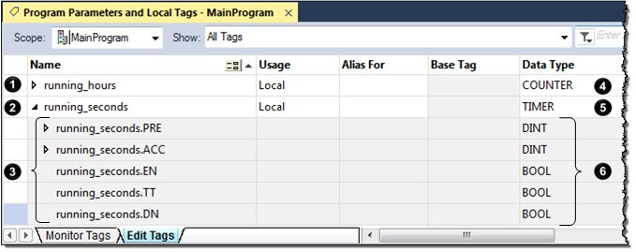

|  |  |
| --- | --- |
| **Item** | **Description** |
|  | To expand a structure and display its members, click theicon. |
|  | To collapse a structure and hide its members, click the icon. |
|  | Members of running_seconds. |
|  | COUNTER Structure. |
|  | TIMER Structure. |
|  | Data Type Members. |

To copy data to a structure, use the COP instruction.

#### See also

[Logix 5000 Controllers General I nstructions Reference Manual,](http://literature.rockwellautomation.com/idc/groups/literature/documents/rm/1756-rm003_-en-p.pdf) publication no. [1756-RM003](http://literature.rockwellautomation.com/idc/groups/literature/documents/rm/1756-rm003_-en-p.pdf)

## Tag scope

When you create a tag, you define it as either a controller tag (global data) or a local tag for a specific program (local data).

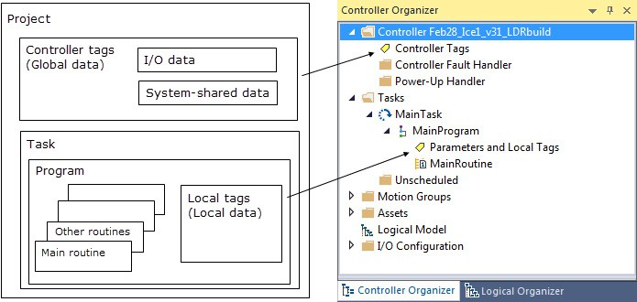

A Logix 5000 controller lets you divide your application into multiple

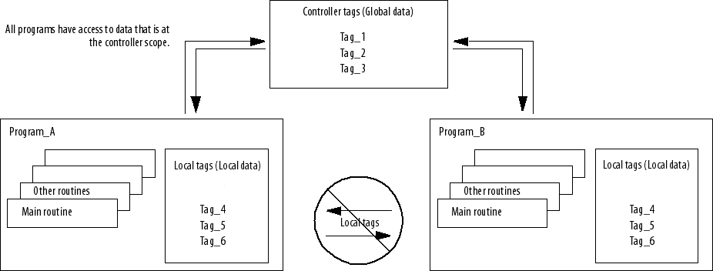programs, each with its own data. There is no need to manage conflicting local tag names between programs. This makes it easier to reuse both code and tag names in multiple programs.

Data at the program scope is isolated from other programs.

* + Routines cannot access data that is at the local scope (local tag) of another program.
  + You can reuse the tag name of a local tag in multiple programs.
  + For example, both Program_A and Program_B can have a local tag named Tag_4.
  + You can also use program parameters to share data between

programs as an alternative to controller-scope tags. See *Program parameter scope*.

Avoid using the same name for both a controller tag and a local tag. Within a program, you cannot reference a controller tag if a local tag of the same name exists for that program.

Certain tags must be controller scope (controller tags).

|  |  |
| --- | --- |
| **If you want to use the tag** | **Then assign this scope** |
| In more than one program in the project | Controller scope (controller tags) |
| In a Message (MSG) instruction |
| To produce or consume data  In any of the seven AXIS data types To communicate with a PanelView terminal |
| None of the above | Program scope (local tags) |

## Program parameter scope

#### See also

Program parameter scope on page 26 Program parameters are similar to tags:

* You create program parameters at the program level, and use them to

manage data.

* Program parameters behave like controller-scope tags in that they can pass data between programs.

Among other benefits, program parameters allow you to clearly define the inputs to the routines in a program, and the outputs from those routines.

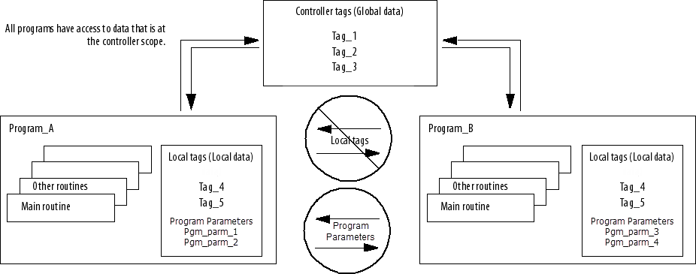Input and Output parameters also automatically buffer data, so that you do not have to create separate tags to buffer IO data.

I f you want to restrict data to only the local program scope, you can use local tags. See *Tag scope* .

For more information on program parameters, refer to the *Logix 5000 Controllers Program Parameters Programming Manual*, publication no.

*1756-PM021*.

#### See also

Tag scope on page 24

## Guidelines for tags

[Logix 5000 Controllers Program Parameters Programming Manual,](http://literature.rockwellautomation.com/idc/groups/literature/documents/pm/1756-pm021_-en-p.pdf) publication no. [1756-PM021](http://literature.rockwellautomation.com/idc/groups/literature/documents/pm/1756-pm021_-en-p.pdf)

Use these guidelines to create tags for a project.

|  |  |  |
| --- | --- | --- |
| **Guideline** | **Details** | |
| Create user-defined data types | User-defined data types (structures) let you organize data to match your machine or process. A user-defined data type provides these advantages:   * One tag contains all the data related to a specific aspect of your system. This keeps related data together and easy to locate, regardless of its data type. * Each individual piece of data (member) gets a descriptive name. This automatically creates an initial level of documentation for your logic. * You can use the data type to create multiple tags with the same data layout.   For example, use a user-defined data type to store all the parameters for a tank, including temperatures, pressures, valve positions, and preset values. Then create a tag for each of your tanks based on that data type. | |
| Use arrays to quickly create a group of similar tags | An array creates multiple instances of a data type under a common tag name.   * Arrays let you organize a block of tags that use the same data type and perform a similar function. * You organize the data in one, two, or three dimensions to match what the data represents.   For example, use a two-dimensional array to organize the data for a tank farm. Each element of the array represents a single tank. The location of the element within the array represents the geographic location of the tank.  Important: Minimize the use of BOOL arrays. Many array instructions do not operate on BOOL arrays. This makes it more difficult to initialize and clear an array of BOOL data.   * Typically, use a BOOL array for the bit-level objects of a PanelView screen. * Otherwise, use the individual bits of a DINT tag or an array of DINTs. | |
| Take advantage of program-scoped tags | If you want multiple tags with the same name, define each tag at the program scope (local tags) for a different program. This lets you reuse both logic and tag names in multiple programs.  Avoid using the same name for both a controller tag and a local tag. Within a program, you cannot reference a controller tag if a tag of the same name exists as a local tag for that program.  Certain tags must be controller scope (controller tag). | |
| **If you want the tag** | **Then assign this scope** |
| In more than one program in the project | Controller scope (controller tags) |
| In a Message (MSG) instruction |
| To produce or consume data |
| In any of the seven AXIS data types |
| To communicate with a PanelView terminal |
| None of the above | Program scope (local tags) |
| For integers, use the DINT data type | To increase the efficiency of your logic, minimize the use of SINT or INT data types. Whenever possible, use the DINT data type for integers.   * A Logix5000 controller typically compares or manipulates values as 32-bit values (DINTs or REALs). * The controller typically converts a SINT or INT value to a DINT or REAL value before it uses the value. * If the destination is a SINT or INT tag, the controller typically converts the value back to a SINT or INT value. * The conversion to or from SINTs or INTs occurs automatically with no extra programming. But it takes extra execution time and memory. | |
| Use most restrictive external access | External access limits the exposure of controller tags by defining a user’s ability to edit tags to Read/Write, Read Only and None. This helps:   * Reduce the risk of inadvertently changing tags. * Reduce the number of tags to browse when configuring HMI. See *External access*. | |
| Enable constant attribute for tags that should not be changed by logic | You can assign a constant value to a tag to prevent the table-backed data from being changed programmatically. This helps reduce the risk of inadvertently changing tags.  See *Constant value tags*. | |

|  |  |  |
| --- | --- | --- |
| **Guideline** | **Details** | |
| Limit a tag name to 40 characters | Here are the rules for a tag name:   * Only alphabetic characters (A–Z or a–z), numeric characters (0–9), and underscores (_) * Must start with an alphabetic character or an underscore * No more than 40 characters * No consecutive or trailing underscore characters (_) * Not case sensitive | |
| Use mixed case | Although tags are not case sensitive (upper case *A* is the same as lower case *a*), mixed case is easier to read. | |
| **These tags are easier to read** | **Than these tags** |
| Tank_1 | TANK_1 |
| Tank1 | TANK1 |
| tank_1 |
| tank1 |
| Consider the alphabetical order of tags | Logix Designer application displays tags of the same scope in alphabetical order. To make it easier to monitor related tags, use similar starting characters for tags that you want to keep together. | |
| Starting each tag for a tank with ‘Tank’ keeps the tags together. | Otherwise, the tags may end up separated from each other. |
| Using extended properties in logic | You can access limit extended properties defined on tags using the .@Min and .@Max syntax. However, you cannot write to extended properties values in logic.  For example, in the Ladder Editor, you can use limit extended properties on an instruction’s source operand. | |

|  |  |
| --- | --- |
| **Guideline** | **Details** |
| Using extended properties in logic (continued) | In the Function Block Editor, you can access extended properties in logic by wiring an Input Reference to a block’s input pins.    In the Structured Text Editor, you can access limit extended properties in logic on the right hand side of an assignment operation or in a comparison statement. You can also access limit extended properties in logic when you embed structured text in the Sequential Function Chart Editor.    You need to know which tags have limit extended properties associated with them as there is no indication in the Tag Browser that extended properties are defined for a tag. However, if you try to use extended properties that have not been defined for a tag, the editors show a visual indication (that is: a rung error in Ladder Logic, a verification error X in Function Block Diagrams, and the error underlined in Structured Text) and the routine does not verify.   * The following restrictions apply when you use extended properties in logic.   + You must use extended properties as an input operand.   You can use extended properties on an instruction as long as the input (source) operand is a non-boolean atomic data type. That is, if an instruction has operands whose data type is non-atomic or BOOL, limit extended properties cannot be used. For example, the ALMD instruction in Ladder Logic does not support extended properties because its configurable operands are of type BOOL.  In the Ladder Editor, when limit extended properties is used in logic, the value field associated with the source operand is unavailable. You can change the tag's extended properties only in the Tag Editor Properties Pane.   * + You cannot access alias tags with extended properties in logic.   If you use alias tag extended properties in logic, the routine does not verify. |

|  |  |
| --- | --- |
| **Guideline** | **Details** |
| Using extended properties in logic (continued) | * Array Tags are constrained   A constraint on array tags applies if the array tag uses indirect addressing to access limit extended properties. If an array tag is using indirect addressing to access limit extended properties in logic, the following conditions apply.   * + If the Array Tag has limit extended properties configured, the extended properties are applied to any array element that does not explicitly have that particular extended property configured. For example, if the MyArray has Max configured to 100, then any element of the array that does not have Max configured inherits the value of 100 when being used in logic. However, it is not visible to you that the value inherited from MyArray is configured in the tag properties.   + At least one array element must have specific limit extended property configured for indirectly referenced array logic to verify. For example, if MyArray[x].@Max is being used in logic, at least one array element of MyArray[] must have Max extended property configured if Max is not configured by MyArray. If this is not done, if you attempt to access Max in logic on MyArray in logic, the routine does not verify.   + Under the following circumstances the software uses a data type default value:     - Array is accessed programmatically with indirect reference.     - Array tag does not have the extended property configured.     - Member of array does not have the extended property configured. For example for Array of SINT type, when max limit is called in logic for a member, the value 127 is used. * Removing Extended Properties   You cannot remove extended properties that are accessed in logic when the project is online with the controller. The Max and Min check boxes in the Extended Properties box in the Tag Properties pane are unavailable. You have to go offline to remove the extended properties.  Removing extended properties in logic on structure tags is unavailable at the tag level. For example, if MyUDTTag has 2 members, Mem1 being a DINT and the Mem2 being a SINT, if you define limit extended properties in Logic on both members, but are only accessing Max extended properties on Mem1, the Max check box is unavailable in Extended Properties for both members. You are not able to remove the Max extended properties for MyUDTTag .Mem2 online.  The same applies for Array tags. If you define limit extended properties on an array element and that element is accessed in logic, then you cannot remove the limit extended properties from any of the array elements. |

## Create a tag

#### See also

External access on page 57 Constant value tags on page 71

Use the **Tag Editor** to create and edit tags using a spreadsheet-style view of the tags.

**IMPORTANT** The Logix Designer application also automatically creates tags when you:

* Add an element to a sequential function chart (SFC).

• Add a function block instruction to a function block diagram.

#### To create a tag

1. In the **Controller Organizer**, right-click **Controller Tags** and then select **Edit Tags**.
2. In the Tag Editor, from the **Scope** box, choose a scope for the tag using the table as a guide.

|  |  |
| --- | --- |
| **If You Use The Tag** | **Then Choose** |
| In more than one program within the project | The controller name |

|  |  |
| --- | --- |
| **If You Use The Tag** | **Then Choose** |
| As a producer or consumer |  |
| In any of the seven AXIS data types In a message |
| In only one program within the project | Program that uses the tag |

This also limits the tag display to only tags with the same scope.

1. In the **Name** box, type a name for the tag.
2. In the **Data Type** box, enter the data type.

You can also select the **Browse** button and then in the **Select Data Type**

dialog box, choose a data type for the tag.

1. (optional) In the **Description** box, type a description for the tag.
2. (optional) Select the **Constant** check box if you want the tag to have a constant value.
3. In the **External Access** box, choose the external access for the tag.

See *Data access control* for information on the **External Access** and

**Constant** attributes.

1. In **OPC UA Access**, set the access that external OPC UA clients have to tags.

## Add extended properties to a tag

#### See also

Data access control on page 57 To add extended properties to a tag:

1. In the Tag Editor, select the tag.
2. I f the **Properties** pane is not visible, select **Properties**.

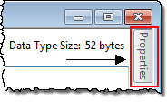

1. In the **Properties** pane, select **Extended Properties**, and select the properties that you want to add.

The entries in the list depend on the tag’s data type. You can select more than one property.

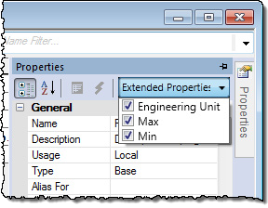

|  |  |
| --- | --- |
| **For data type** | **You can add the following extended property** |
| Array and string | Engineering Unit |
| BOOL | State0 State1  Engineering Unit |
| DINT, INT, LINT, SINT, and REAL and corresponding array member | Min Max  Engineering Unit |

The added properties are displayed in the Tag Editor **Properties** pane under **Data**.

Clear the check box to remove the property from the tag. This also

removes the properties from the Data properties category. Note that once the property is removed, any value associated to the property is removed from the system.

The list is not available for other types of tags. The following table lists the minimum and maximum values for DINT, INT, LINT, SINT, and REAL Data Types.

|  |  |
| --- | --- |
| **Data Type** | **Range** |
| DINT | -2,147,483,648...2,147,483,647 |
| INT | -32,768...32,767 |
| LINT | 0...32535129599999999 |
| SINT | -128...127 |
| REAL | -3.402823E38 to -1.1754944E-38 (negative values) and  0  and  1.1754944E-38 to 3.402823E38 (positive values) |

## Create an array

Arrays can also be used to organize data.

|  |  |
| --- | --- |
| **Term** | **Definition** |
| Array | A tag that contains a block of multiple pieces of data. |

|  |  |
| --- | --- |
| **Term** | **Definition** |
|  | * An array is similar to a file. * Within an array, each individual piece of data is called an element. * Each element uses the same data type. * An array tag occupies a contiguous block of memory in the controller, each element in sequence. * You can use array and sequencer instructions to manipulate or index through the elements of an array. * You organize the data into a block of one, two, or three dimensions. |

The subscript identifies each individual element within the array. A subscript starts at 0 and extends to the number of elements minus 1(zero based).

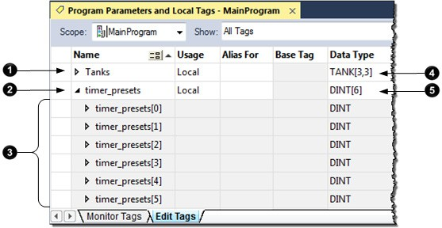

|  |  |
| --- | --- |
| **Item** | **Description** |
|  | To expand a structure and display its members, click the  icon. |
|  | To collapse a structure and hide its members, click the  icon. |
|  | Six elements of timer_presets. |
|  | This two-dimensional array contains nine elements (three by three array). |
|  | This one-dimensional array contains six elements of the DINT data type. In this example, a single timer instruction times the duration of several steps. Each step requires a different preset value. Because all the values are the same data type (DINTs), use an array. |

This example compares a structure to an array.

This is a tag that uses the Timer structure (data type). This is a tag that uses an array of the Timer data type.

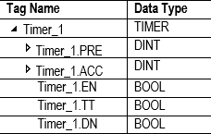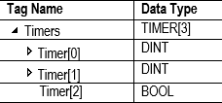

**EXAMPLE** Two-dimension array

A drill machine can drill one through five holes in a book. The machine requires a value for the position of each hole from the leading edge of the book. To organize the values into configurations, use a two-dimension array. The first subscript indicates the hole that the value corresponds and the second subscript indicates how many holes are to be drilled (one through

five).

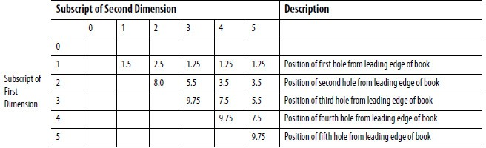

In the Tag Editor, the elements are in the order in the graphic.

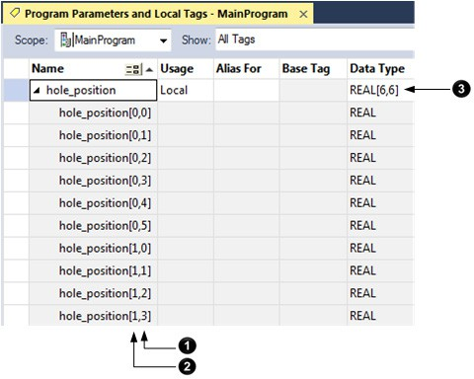

|  |  |
| --- | --- |
| **Item** | **Description** |
|  | The rightmost dimension increments to its maximum value then starts over. |
|  | When the rightmost dimension starts over, the dimension to the left increments by one. |
|  | This array contains a two-dimensional grid of elements, six elements by six elements. |

## Configure an array

To create an array, you create a tag and assign dimensions to the data type.

1. In the **Controller Organizer**, right-click **Controller Tags** and then select **Edit Tags**.

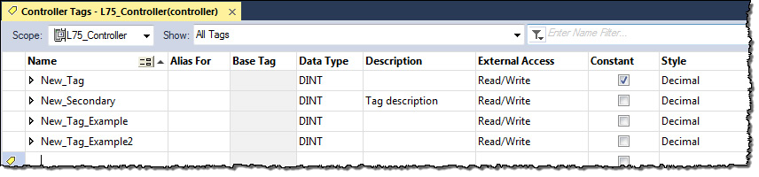

1. In the Tag Editor, from the **Scope** box, choose a scope for the tag using the table as a guide.

|  |  |
| --- | --- |
| **If You Use The Tag** | **Then Choose** |
| In more than one program within the project | The controller name |
| As a producer or consumer |
| In any of the seven AXIS data types  In a message |
| In only one program within the project | Program that uses the tag |

This also limits the tag display to only tags with the same scope.

1. In the **Name** box, type a name for the tag.
2. In the **Data Type** box, enter the data type the array dimensions. In the table, Data_type represents the actual data type you enter.

|  |  |  |
| --- | --- | --- |
| **If the tag is** | **Then type** | **Where** |
| One-dimension array | Data_type[x] | Data_type is the type of data that the tag stores.   * X is the number of elements in the first dimension. * Y is the number of elements in the second dimension. * Z is the number of elements in the third dimension. |
| Two-dimension array | Data_type[x,y] |
| Three-dimension array | Data_type[x,y,z] |

You can also select the **Browse** button and then in the **Select Data Type**

dialog, choose a data type and the array dimensions for the array.

## User-defined data types

User-defined data types (structures) let you organize your data to match your machine or process.

**EXAMPLE** User-defined data type that stores a recipe.

In a system of several tanks, each tank can run a variety of recipes. Because the recipe requires

a mix of data types (REAL, DINT, BOOL, so forth), a user-defined data type is used.

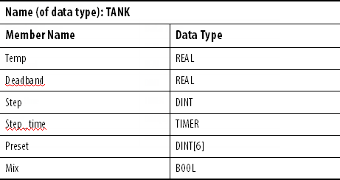

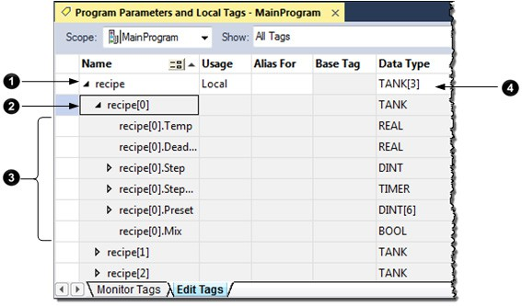An array that is based on this data type looks like this example.

|  |  |
| --- | --- |
| **Item** | **Description** |
|  | Array of recipes |
|  | First recipe |
|  | Members of the recipe |
|  | Array containing three elements of the TANK data type |

**EXAMPLE** User-defined data type that stores the data that is required to run a machine.

Because several drill stations require the following mix of data, use a user-defined data type.

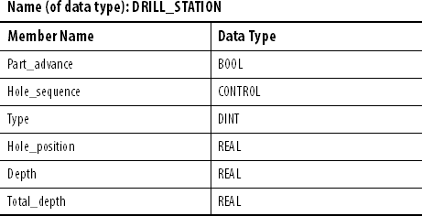

An array that is based on this data type would look like this example.

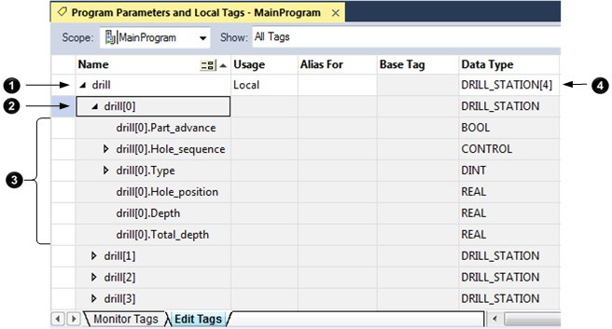

|  |  |
| --- | --- |
| **Item** | **Description** |
|  | Array of drills |

|  |  |
| --- | --- |
|  | First drill |
|  | Data for the drill |
|  | Array containing four elements of the DRILL_STATION data type |

## Guidelines for user-defined data types

## Create a user-defined data type

When you create a user-defined data type, use these guidelines.

* I f you include members that represent I /O devices, you must use logic to copy the data between the members in the structure and the

corresponding I /O tags. Refer to *Address I/O data*.

* I f you include an array as a member, limit the array to a single dimension. Multi-dimension arrays are not permitted in a user-defined data type.
* When you use the BOOL, SINT, or INT data types, place members that use the same data type in sequence.

**More Efficient Less Efficient**

|  |
| --- |
| BOOL |
| BOOL |
| BOOL |
| DINT |
| DINT |

|  |
| --- |
| BOOL |
| DINT |
| BOOL |
| DINT |
| BOOL |

#### See also

Address I /O data on page 18

Use this procedure to create user-defined data types.

#### To create a user-defined data type

1. In the **Controller Organizer**, expand **Data Types**, then right-click

**User-Defined** and then select **New Data Type**.

1. In the **Data Type Editor**, in **Name**, type a name for the user-defined data type.
2. (optional) In **Description**, type a description for the user-defined data type.
3. Select **Add Member** to add a new data type member.

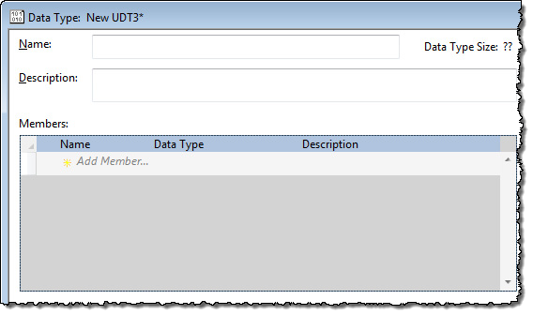

1. In **Name**, type a name for the data type member.
2. In **Data Type**, enter the data type for the member.

Or, select the **Browse** button and in the **Select Data Type** dialog box, choose a data type for the tag.

Limit any arrays to a single dimension. See *Configure an array*.

1. (optional) In **Description**, type a description for the data type member.
2. I f the **Properties** pane is not visible, select **Properties** to display the properties for the data type member.



Tip: You may have to click in the data type member again to display the properties for the member instead of the properties for the data type.

* 1. In the **Properties** pane, select the box next to **External Access**, and select an attribute.
  2. To display the value of the member in a different style (radix), select the box next to **Style**, and select the style.

1. Select **Apply**.
2. Repeat this procedure to add as many members as needed.

## Add extended properties to a user-defined data type

#### See also

Configure an array on page 35

Add Min, Max, Engineering Units, State 0, and State 1properties to a data type or its member. When you add these properties, other Rockwell Automation HMIs can use their values.

#### To add extended properties to a user-defined data type

1. In the **Controller Organizer**, expand **Data Types**, then expand **User-Defined**. Right-click the user-defined data type and select **Properties**.
2. In the **Data Type** Editor, either:
   * Select the data type **Name** to choose the data type.
   * Select the data type member **Name** to choose the data type member.
3. I f the **Properties** pane is not visible, select **Properties**.



1. Select **Extended Properties**.
2. 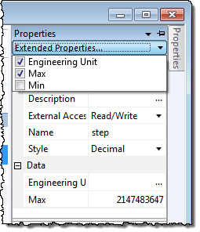Select one or more properties to add. The properties in the list depend on the selected data type or member’s data type.

|  |  |
| --- | --- |
| **For data type** | **Add these extended property** |
| Array and string | Engineering Unit |
| BOOL | State 0  State 1 Engineering Unit |
| DINT, INT, LINT, SINT, and REAL | Min Max  Engineering Units |

**IMPORTANT** The list is unavailable for other types of data type members.

The table shows the minimum and maximum values for DINT, INT, LINT, SINT, and REAL Data Types.

|  |  |
| --- | --- |
| **Data Type** | **Range** |
| DINT | -2,147,483,648…2,147,483,647 |
| INT | -32,768…32,767 |
| LINT | 0…32535129599999999 |
| SINT | -128…127 |
| REAL | -3.402823E38…-1.1754944E-38 (negative values) and  0  and  1.1754944E-38…3.402823E38 (positive values) |

## Describe a user-defined data type

In version 13 or later, the Logix Designer application lets you automatically build descriptions out of the descriptions in your user-defined data types.

This greatly reduces the amount of time you have to spend documenting your project.

As you organize your user-defined data types, keep in mind these features of the Logix Designer application.

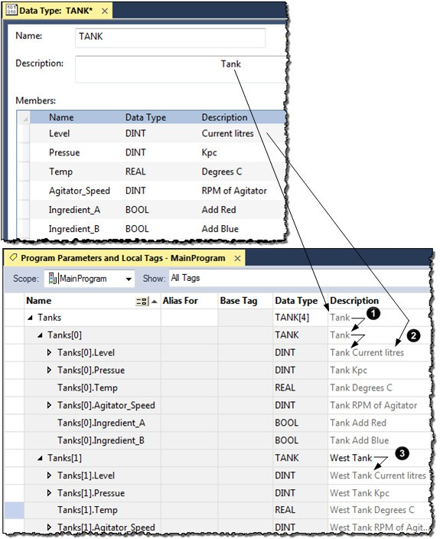

**Item**

**Description**

|  |  |
| --- | --- |
|  | Pass through of descriptions—When possible, the Logix Designer application looks for an available description for a tag, element, or member.   * Descriptions in user-defined data types ripple through to the tags that use that data type. * Description of an array tag ripples through to the elements and members of the array. |
|  | Append description to base tag—the Logix Designer application automatically builds a description for each member of a tag that uses a user-defined data type. It starts with the description of the tag and then adds the description of the member from the data type. |
|  | Paste pass-through description—Use the data type and array description as a basis for more specific descriptions.  In this example, Tank became West Tank. |

The Logix Designer application uses different colors for descriptions.

|  |  |
| --- | --- |
| **If the Color of the Description Is** | **It is a** |
| Gray | Pass-through description |
| Black | Manually entered description |

## Activate pass-through and append descriptions

Follow these steps to use pass-through descriptions and append to base tag descriptions.

#### To activate pass-through and append descriptions

1. In the **Controller Organizer**, right-click the controller at the top and then select **Properties**.

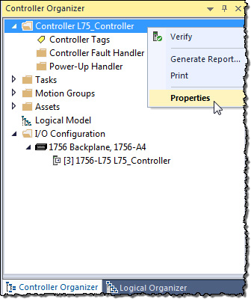

1. In the **Controller Properties** dialog box, select the **Project** tab.

##### Check Show Pass-Through Descriptions and Append to Base Tag Descriptions.

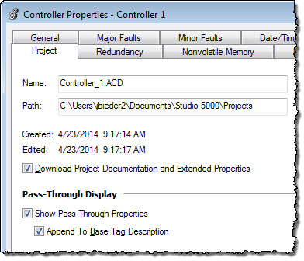

1. Select **OK**.

## Paste a pass-through description

Choose this command to paste a pass-through value of an item into the

**Description**, **Engineering Unit**, **State 0**, or **State 1** field of another item.

Follow these steps to use a pass-through description as the starting point for a more specific description.

1. 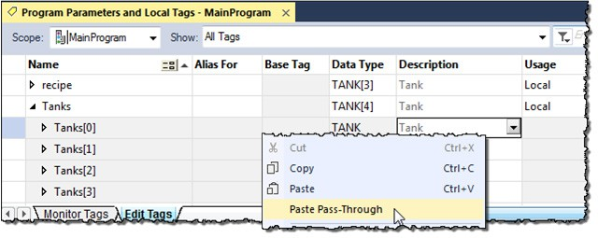In the **Controller Tags** Editor, right-click the **Description** box, and then select **Paste Pass-Through**.
2. Edit the description and press **CTRL+Enter.**

## Address tag data

|  |  |
| --- | --- |
| **Where** | **Is** |
| *Name* | Name that identifies this specific tag. |
| *Element* | Subscript or subscripts that point to a specific element within an array.   * Use the element identifier only if the tag or member is an array. * Use one subscript for each dimension of the array. For example: [5], [2,8], [3,2,7]. |
| To indirectly (dynamically) reference an element, use a tag or numeric expression that provides the element number.   * A numeric expression uses a combination of tags, constants, operators, and functions to calculate a value. For example, Tag_1-Tag_2, Tag_3+4, ABS (Tag_4). * Keep the value of the tag or numeric expression within the dimensions of the array. For example, if a dimension of an array contains 10 elements, then the value of the tag or numeric expression must be   0…9 (10 elements). |
| *Member* | Specific member of a structure.   * Use the member identifier only if the tag is a structure. * If the structure contains another structure as one of its members, use additional levels of the*.*Member format to identify the required member. |
| *Bit* | Specific bit of an integer data type (SINT, INT, or DINT). |
| *Index* | To indirectly (dynamically) reference a bit of an integer, use a tag or numeric expression that provides the bit number.   * A numeric expression uses a combination of tags, constants, operators, and functions to calculate a value. For example, Tag_1-Tag_2, Tag_3+4, ABS(Tag_4). * Keep the value of the tag or numeric expression within the range of bits of the integer tag. For example, if the integer tag is a Dint (32-bits), then the value of the index must be 0…31 (32-bits). |

## Alias tags

A tag name follows this format.

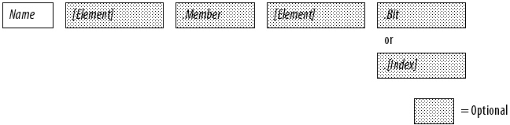

An alias tag lets you create one tag that represents another tag.

* + Both tags share the same value.
  + When the value of one of the tags changes, the other tag reflects the change as well.

Use aliases in these situations:

* + Program logic in advance of wiring diagrams.
  + Assign a descriptive name to an I /O device.
  + Provide a simpler name for a complex tag.
  + Use a descriptive name for an element of an array.

The tags window displays alias information.

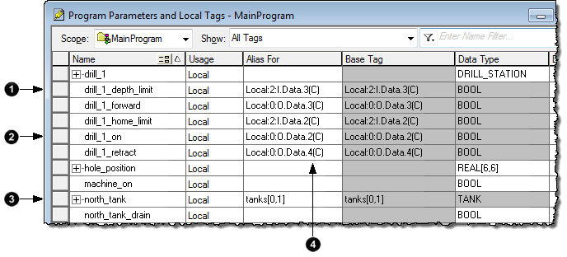

|  |  |
| --- | --- |
| **Item** | **Description** |
|  | drill_1_depth_limit is an alias for Local:2:I.Data.3 (a digital input point). When the input turns on, the alias tag also turns on. |
|  | drill_1_on is an alias for Local:0:O.Data.2 (a digital output point). When the alias tag turns on, the output tag also turns on. |
|  | north_tank is an alias for tanks[0,1]. |
|  | The (C) indicates that the tag is at the controller scope. |

A common use of alias tags is to program logic before wiring diagrams are available.

1. For each I /O device, create a tag with a name that describes the device, such as conveyor for the conveyor motor.
2. Program your logic by using the descriptive tag names. You can even test your logic without connecting to the I /O.
3. Later, when wiring diagrams are available, add the I /O modules to the I /O configuration of the controller.
4. Finally, convert the descriptive tags to aliases for their respective I /O points or channels.

This logic was initially programmed by using descriptive tag names, such as stop and conveyor_on. Later, the tags were converted to aliases for the

corresponding I /O devices.

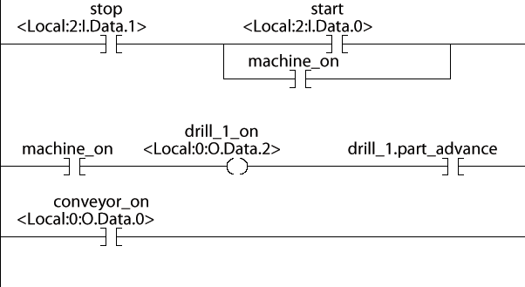

* + **stop** is an alias for **Local:2:I.Data.1** (the stop button on the operator panel)
  + **conveyor_on** is an alias for **Local:0:O.Data.0** The starter contactor for

the conveyor motor)

## Display alias information

## Assign an alias

Follow these steps to show (in your logic) the tag to which an alias points.

1. On the Menu bar, Select **Tools > Options**.
2. In the **Workstation Options** dialog box, expand **Ladder Editor** and then select **Display**.
3. Select the **Show Tag Alias Information** check box.
4. Select **OK**.

Follow these steps to assign a tag as an alias tag for another tag.

1. On the **Controller Organizer**, right-click **Controller Tags** and then select **Edit Tags**.
2. In the Tag Editor window, to the right of the tag name, select the **Alias For** cell.
3. In the cell, select.
4. Select the tag that the alias represents.

|  |  |
| --- | --- |
| **To** | **Do This** |
| Select a tag | Double-click the tag name. |
| Select a bit number | 1. Select the tag name. 2. To the right of the tag name, select +. 3. Select the required bit. |

1. Select another cell.

## Indirect addresses

I f you want an instruction to access different elements in an array, use a tag in the subscript of the array (an indirect address). By changing the value of the tag, you change the element of the array that your logic references.

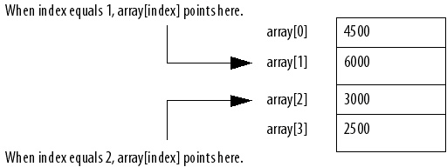

This table outlines some common uses for an indirect address.

|  |  |
| --- | --- |
| **To** | **Use a tag in the subscript and** |
| Select a recipe from an array of recipes | Enter the number of the recipe in the tag. |
| Load a specific machine setup from an array of possible setups | Enter the desired setup in the tag. |
| Load parameters or states from an array, one element at a time | 1. Perform the required action on the first element. 2. Use an ADD instruction to increment the tag value and point to the next element in the array. |
| Log error codes |
| Perform several actions on an array element and then index to the next element |

This example loads a series of preset values into a timer, one value (array element) at a time.

**EXAMPLE** Step through an array.

The timer_presets array stores a series of preset values for the timer in the next rung. The north_tank.step tag points to which element of the array to use. For example, when north_tank.step equals 0, the instruction loads

timer_presets[0] into the timer (60,000 ms).

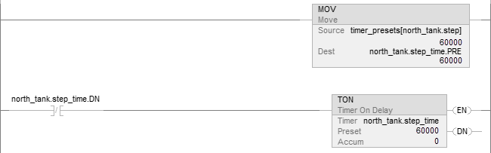

When north_tank.step_time is done, the rung increments north_tank.step to the next number and that element of the timer_presets array loads into the

timer.

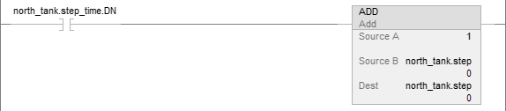

When north_tank.step exceeds the size of the array, the rung resets the tag to start at the first element in the array. (The array contains elements 0–3.)

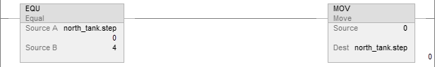

## Expressions

## Array subscript out of range

|  |  |  |
| --- | --- | --- |
| **If the operator requires** | **Use this format** | **Example** |
| One value (tag or expression) | operator(value) | ABS(tag_a) |
| Two values (tags, constants, or expressions) | value_a operator value_b | * tag_b + 5 * tag_c AND tag_d * (tag_e ** 2) MOD (tag_f / tag_g) |

You can also use an expression to specify the subscript of an array.

* An expression uses operators, such as + or -, to calculate a value.
* The controller computes the result of the expression and uses it as the array subscript.

You can use these operators to specify the subscript of an array.

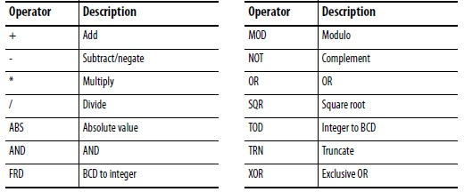

Format your expressions as shown in this table.

Every instruction generates a major fault if the array subscript is out of range. Transitional instructions also generate a major fault even if the rung is false. The controller checks the array subscript in these instructions even if the rung is false.

**Example**

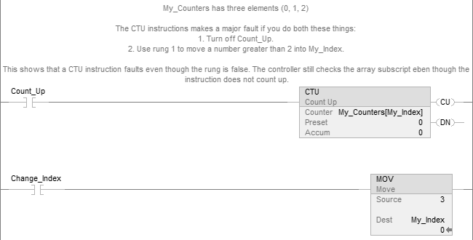

## Tag documentation

## Project documentation

For more information on handling major faults, refer to the *Logix 5000 Controllers Major and Minor Faults Programming Manual*, publication no. *1756-PM014*.

The table outlines the four types of tags and their descriptions.

**IMPORTANT** The Logix Designer application automatically assigns what are called pass-through descriptions of the created tags as an option.

|  |  |
| --- | --- |
| **Tag** | **Description** |
| Base | When creating a tag without specifying a tag type, the Logix Designer application automatically assigns the tag a default type of Base. Use base tags to create internal data storage and document tag descriptions. |
| Alias | Use alias tags to assign unique names to an existing tag, structure tag member, or bit. In the description of your alias tag, you can describe the tag that your alias tag references. |
| Produced | A produced tag refers to a tag that is consumed by another controller. In the description of your produced tag, you can describe the remote controllers that you want to make your produced tag available through controller-to-controller messaging. |
| Consumed | A consumed tag refers to a tag that is produced by another controller and whose data you want to use in your controller. In the description of your consumed tag, you can describe how you want to use a produced tag’s data or the data-producing controller. |

With version 17 and later of the Logix Designer application, you have the

option to display project documentation variables for any supported localized language, such as:

* Component descriptions in tags, routines, programs, equipment phases, equipment sequences, user-defined data types, and Add-On Instructions.
  + Engineering units and state identifiers added to tags, user-defined data types, or Add-On I nstructions.
  + Trends.
  + Controllers.
  + Alarm messages (in configuration of ALARM_ANALOG and ALARM_DIGI TAL tags).
  + Tasks.
  + Property descriptions for a module in the **Controller Organizer.**
  + Rung comments, Sequential Function Chart text boxes, and Function Block Diagram text boxes.

You can store project documentation for multiple languages in a single project file rather than in language-specific project files. You define all the localized languages that the project supports and set the current, default, and optional custom localized language. The application uses the default language if the current language's content is blank for a particular component of the project. H owever, you can use a custom language to tailor documentation to a specific type of project file user.

E nter the localized descriptions in your Logix Designer project, either when programming in that language or by using the import/export utility to

translate the documentation off-line and then import it back into the project. Once you enable documentation languages in the Logix Designer application, you can dynamically switch between languages as you use the application.

For more information on enabling a project to support multiple translations of project documentation, see the online help.

## Chapter 3

# Force I/O

## Introduction

## Precautions

## Enable forces

## Disable or remove a force

Use a force to override data that your logic either uses or produces. For example, use forces to:

* Test and debug your logic.
* Check wiring to an output device.
* Temporarily keep your process functioning when an input device has failed.

Use forces only as a temporary measure. They are not intended to be a permanent part of your application.

When you use forces, take these precautions.

ATTENTION: Forcing can cause unexpected machine motion that could injure personnel. Before you use a force, determine how the force affects your machine or process and keep personnel away from the machine area.



* + Enabling I/O forces causes input, output, produced, or consumed values to change.
  + Enabling SFC forces causes your machine or process to go to a different state or phase.
  + Removing forces may still leave forces in the enabled state.

• If forces are enabled and you install a force, the new force immediately takes effect.

Enable forces for a force to take effect. Only enable and disable forces at the controller level.

* Enable I /O forces and SFC forces separately or at the same time.
* Enable or disable forces for a specific module, tag collection, or tag element.

**IMPORTANT** When downloading a project that has forces enabled, the application prompts to enable or disable forces after the download completes.

When forces are in effect (enabled), a appears next to the forced element.

To stop the effect of a force and let the project execute as programmed, disable or remove the force.

* Disable or remove I /O and SFC forces at the same time or separately.
* Removing a force on an alias tag also removes the force on the base tag.

ATTENTION: Changes to forces can cause unexpected machine motion that could injure personnel. Before you disable or remove forces, determine how the change affects your



machine or process and keep personnel away from the machine area.

## Check force status

## Force status indicator

Before you use a force, determine the status of forces for the controller. You can check force status.

|  |  |
| --- | --- |
| **To determine status** | **Use any of the following** |
| I/O forces | * Online toolbar * FORCE status indicator * GSV instruction |
| SFC forces | Online toolbar |

The Online toolbar shows the status of forces. I t shows the status of I /O forces and SFC forces separately.

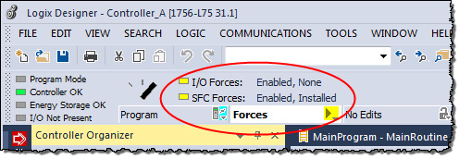

|  |  |
| --- | --- |
| **This** | **Means** |
| Enabled | * If the project contains any forces of this type, they are overriding your logic. * If you add a force of this type, the new force immediately takes effect |
| Disabled | Forces of this type are inactive. If the project contains any forces of this type, they are not overriding your logic. |
| Installed | At least one force of this type exists in the project. |
| None Installed | No forces of this type exist in the project. |

I f your controller has a FORCE Status Indicator, use it to determine the status of any I /O forces.

**IMPORTANT** The FORCE Status Indicator shows only the status of I/O forces. It does not show that status of SFC forces.

|  |  |
| --- | --- |
| **FORCE Status Indicator** | **Then** |
| Off | * No tags contain force values. * I/O forces are inactive (disabled). |
| Flashing | * At least one tag contains a force value. * I/O forces are inactive (disabled). |
| Solid | * I/O forces are active (enabled). * Force values may or may not exist. |

## GSV instruction

## When to use I/O force

This ladder rung shows how to use a GSV instruction to get the status of forces.

**IMPORTANT** The ForceStatus attribute shows only the status of I/O forces. It does not show the status of SFC forces.

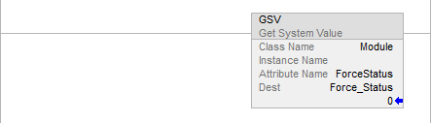

Use the following table where Force_Status is a DINT tag.

|  |  |  |
| --- | --- | --- |
| **To determine if** | **Examine this bit** | **For this value** |
| Forces are installed | 0 | 1 |
| No forces are installed | 0 | 0 |
| Forces are enabled | 1 | 1 |
| Forces are disabled | 1 | 0 |

Use an I /O force to override:

* An input value from another controller (that is, a consumed tag).
* An input value from an input device.
* Logic and specify an output value for another controller (that is, a produced tag).
* Logic and specify the state of an output device.

**IMPORTANT** • Forcing increases logic execution time. The more values forced, the longer it takes to execute the logic.

* + I/O forces are held by the controller and not by the programming workstation.

Forces remain even if the programming workstation is disconnected.

Use these guidelines when forcing an I /O value.

* Force all I /O data, except for configuration data.
* I f the tag is an array or structure, such as an I /O tag, force a BOOL, SINT, INT, DINT, or REAL element or member.
* I f the data value is a SINT, INT, or DINT, force the entire value or force individual bits within the value. I ndividual bits can have a force status of:
  + No force
  + Force on
  + Force off
* Force an alias to an I /O structure member, produced tag, or consumed tag.
  + An alias tag shares the same data value as its base tag, so forcing an alias tag also forces the associated base tag.
    - Removing a force from an alias tag removes the force from the associated base tag.
  + I f a produced tag is also Constant, it cannot use forces.
  + I f a produced tag is forced, it cannot be a Constant.

## Force an input value

## Force an output value

## Add an I/O force

Forcing an input or consumed tag:

* Overrides the value regardless of the value of the physical device or produced tag.
* Does not affect the value received by other controllers monitoring that input or produced tag.

Forcing an output or produced tag overrides the logic for the physical device or other controller. Other controllers monitoring that output module in a

listen-only capacity also see the forced value.

To override an input value, output value, produced tag, or consumed tag, use an I /O force.

ATTENTION: Forcing can cause unexpected machine motion that could injure personnel. Before using a force, determine how the force affects the machine or process and keep personnel away from the machine area.



* + Enabling I/O forces causes input, output, produced, or consumed values to change.

If forces are enabled and you install a force, the new force immediately takes effect.

#### To add an I/O force

1. Check the state of the I /O Forces status indicator.

|  |  |
| --- | --- |
| **If** | **Then note** |
| Off | No I/O forces currently exist. |
| Flashing | No I/O forces are active. But at least one force already exists in the project. When enabling I/O forces, all existing I/O forces also take effect. |
| Solid | I/O forces are enabled (active). When installing (adding) a force, it immediately takes effect. |

1. Open the routine that contains the tag to force.
2. Right-click the tag and then select **Monitor**.

I f necessary, expand the tag to show the value to force (that is, BOOL value of a DINT tag).

1. Install the force value.

|  |  |
| --- | --- |
| **To force a** | **Do this** |
| BOOL value | Right-click tag and then select Force On or Force Off. |
| Non-BOOL value | In Force Mask, type the value to force the tag. Press Enter. |

1. Verify that I /O forces are enabled (see step 1). I f they are not, select **Menu** > **Logic > I/O Forcing > Enable All I/O Forces**, and then select **Yes** to confirm.

## Remove or disable forces

Remove forces, or disable them.

ATTENTION: Changes to forces can cause unexpected machine motion that could injure personnel. Before disabling or removing forces, determine how the change affects the machine or process and keep personnel away from the machine area.



This section describes how to remove and disable forces.

|  |  |  |
| --- | --- | --- |
| **To** | **And** | **Then** |
| Stop an individual force | Leave other forces enabled and in effect | Remove an Individual Force |
| Stop all I/O forces but leave all SFC forces active | Leave the I/O forces in the project | Disable All I/O Forces |
| Remove the I/O forces from the project | Remove All I/O Forces |

## Remove an individual force

You can remove an individual force.

ATTENTION: ATTENTION: If you remove an individual force, forces remain in the enabled state and any new force immediately takes effect.



ATTENTION: Before you remove a force, determine how the change affects your machine or process

and keep personnel away from the machine area.

#### To remove an individual force

1. Open the routine that contains the force that you want to remove.
2. Determine the language of the routine.

|  |  |
| --- | --- |
| **If** | **Then** |
| SFC | Go to step 4. |
| Ladder logic | Go to step 4. |
| Function block | Go to step 3. |
| Structured text | Go to step 3. |

1. Right-click a tag that has the force and then click **Monitor.**

If necessary, expand the tag to show the value that is forced, for example, BOOL value of a DINT tag.

1. Right-click a tag or element that has the force and then select **Remove Force**.

## Disable all I/O forces Remove all I/O forces

To disable, on the Menu bar, select **Logic > I/O Forcing > Disable All I/O Forces**. Select **Yes** to confirm.

To remove, on the **Menu bar**, select **Logic > I/O Forcing > Remove All I/O Forces**. Select **Yes** to confirm.

## Chapter 4

# Data access control

## Introduction

## External access

In version 18 or later of the Logix Designer application, there are tag

attributes that allow you to control access to tag data. These attributes are:

* External Access
* Constant
* OPC UA

The External Access attribute controls how external applications, such as

HMIs, can access tags. I t has possible values of Read/Write, Read Only, and None. See *Configure external access*.

The Constant attribute value determines if controller logic can change a tag. Also, by using FactoryTalk Security software, it is possible to control which users can change tags designated as constants in the Logix Designer

application. See *Constant value tags* for more information on the Constant attribute.

The OPC UA attribute determines the access that external OPC UA clients have to tags.

By using these attributes, you can help safeguard tag data by preventing unwanted changes to tag values. Also, by reducing the number of tags exposed to external applications, you can reduce the time required to develop HMI

screens.

Use the **External Access** attribute to control how external applications and devices access tags.

Using external access reduces the number of tags for an application that appear when you reference them in applications or devices. I t can also

improve system performance by reducing the number of tags RSLinx has to maintain, scan, and cache. Reducing the number of externally accessible tags can improve the performance of the RSLinx data server and other related applications.

External applications and devices include:

* RSLinx Classic and FactoryTalk Linx software.
* Other Logix controllers.
* PanelView terminals.
* PLC/SLC controllers.
* FactoryTalk Historian software.
* Other third-party software.

## Configure external access

## External access options

Configure external access from a menu when creating a new tag or data type.

Change that value just like other tag attributes and make these changes throughout the application. For example, make the changes in the

**User-defined Data Type Editor**, **New Tag** dialog box, and the **Tag Properties**

dialog box.

|  |  |
| --- | --- |
| **External Access Settings** | **Description** |
| Read/Write | External applications and devices have full access to the tag and can read and change the tag’s value. |
| Read Only | External applications can read, but cannot change, the tag’s value. |
| None | External applications cannot read or change the tag’s value. |

**IMPORTANT** • The Logix Designer application has full access to all tags, regardless of their external access settings. External access applies to all program, controller, and Add-On Instruction scoped tags.

* If the controller is in safety locked mode, only the safety tags are disabled from being

accessed. The standard tags have the same behavior as in the unlocked mode.

Choose one of three options: **Read/Write**, **Read Only**, or **None** from the

**External Access** list on the Logix Designer dialog boxes.

* **New Tag** (See *Configure external access in the New Tag dialog box*)
* **Tag Properties** (See *Set up external access in the Tag Properties dialog box*)

The default value in the **External Access** list depends on the usage and type of the tag. The table describes the values.

|  |  |
| --- | --- |
| **If the tag is** | **Default value is** |
| Alias | Same as its target. See the Important note following this table. |
| Controller or program scoped and equipment phase input parameters | The initial value is Read/Write.  Thereafter, when creating a new tag, the default external access tag keeps the value of the previous choice.(1) |
| Equipment phase output parameters | The initial value is Read Only.  Thereafter, when creating a new tag, the default external access tag keeps the value of the previous choice.(1) |

1. The external access default value for tag creation is stored for each Windows login account.

**IMPORTANT** For alias type tags, the External Access list is unavailable. You cannot change the external access of an alias tag. However, the External Access list updates its value to be the same as the external access of the base target.

See *Find a base tag with Go To* for procedures to locate the base tag for an alias.

See *External access availability* for additional tag considerations.

#### See also

Configure external access in the New Tag dialog box on page 59

## Configure external access in the New Tag dialog box

Set up external access in the Tag Properties dialog box on page 60 Find a base tag with Go To on page 61

External access availability on page 62

Create these types of tags in the **New Tag** dialog box.

* Base
  + Alias
  + Produced
  + Consumed

The parameters on the dialog box depend on the type of tag. For tag descriptions, see *Tag type*.

#### To configure external access in the New Tag dialog box

Choose the external access attribute for a new tag in the **External Access** list on the **New Tag** dialog box. Follow these steps.

1. In the **Controller Organizer**, right-click **Controller Tags** and then select **New Tag**.

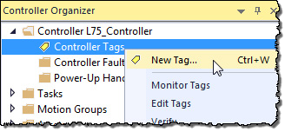

1. In **New Tag**, in the **Type** list, choose a tag type.
2. In the **External Access** list, choose an external access option.
3. Select **OK**.

As shown in this example, the **External Access** list is unavailable for an alias tag.

There may be many alias tags in a program. To locate an associated base tag to assign an external access, use the **Go To** feature. See *Find a base tag with Got To* for details.

For other tag considerations, see *External access availability*.

The **Connection** button (next to the **Type** box) becomes active when you select either a produced or consumed tag type. The button displays a dialog box to set up produced and consumed tag connections. See the *Logix 5000 Controller Produced and Consumed Tags Programming Manual*, publication no. *1756-PM011*.

## Set up external access in the Tag Properties dialog box

## View and select external access status on the Tag Editor

#### See also

Tag type on page 22

Find a base tag with Go To on page 61 External access availability on page 62

[Logix 5000 Controllers Produced and Consumed Tags Programming](http://literature.rockwellautomation.com/idc/groups/literature/documents/pm/1756-pm011_-en-p.pdf) [Manual,](http://literature.rockwellautomation.com/idc/groups/literature/documents/pm/1756-pm011_-en-p.pdf) publication no. [1756-PM011](http://literature.rockwellautomation.com/idc/groups/literature/documents/pm/1756-pm011_-en-p.pdf)

Use the **Tag Properties** dialog box to edit properties of existing tags. You can change tag attributes and change tag types.

Follow these steps to choose an external access option for an existing tag.

#### To set up external access in the Tag Properties dialog box

1. In the Tag Editor, right-click a tag and then select **Edit (tag name) Properties**.

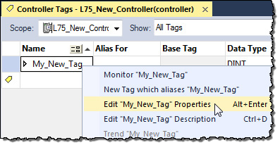

1. In **Tag Properties**, in the **Type** list, choose a tag type.
2. In the **External Access** list, choose an external access option.

The **External Access** list is unavailable for an alias tag. I f a tag is a module tag, the only external access option is **Read/Write**.

See *External access availability* for other considerations.

1. Select **OK**.

#### See also

External access availability on page 62

View the external access status of a tag in the Tag Editor. The **External Access**

column displays the tag as **Read/Write**, **Read Only**, or **None**.

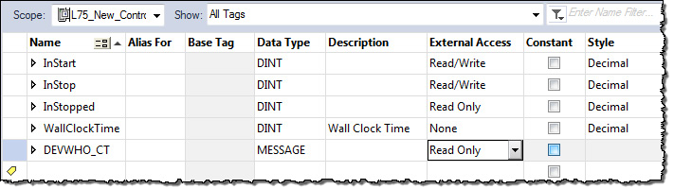

#### To view and select external access status on the Tag Editor

1. Select multiple rows and set the external access at one time on the Tag Editor.

To select multiple individual rows, hold down the **Ctrl** key and select the desired rows.

1. Right-click a selected tag, and then select **Set External Access for (tag name)** to select an external access option.

This updates the external access for all highlighted rows that are enabled for changing external access.

See *External access availability* for considerations when the **External Access**

column is unavailable.

## Find a base tag with Go To

#### See also

External access availability on page 62

You can only change the external access setting of an alias tag through its base tag. The **Go To** command on the **Search** menu of the Logix Designer application is a convenient way to find the base tag among all the

cross-reference records.

#### Find a base tag with Go To

1. In the Tag Editor select the alias tag, and then on the Logix Designer application Menu bar, select **Search > Go To**.

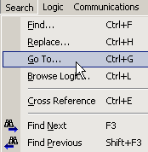

You can also right-click the alias tag and then select **Go To**.

1. In the **Go To** dialog box, in the **Go to what** list, choose **Base Tag**.

The **Go To** box displays the target of the alias tag. I f there is an alias chain, all alias tags in this chain appear in the **Go to** list.

1. In the **Go to** list, choose a target of the alias tag.

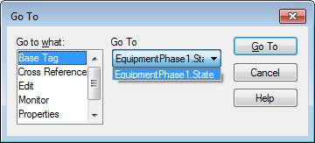

1. Select **Go To**.

The target is located with a black box around it.

## External access availability

The table describes the conditions in which the **External Access** list is unavailable.

**IMPORTANT** The External Access list is always unavailable for any tag whose data type is Alarm Analog or Alarm Digital. The external access status is always Read/Write for these data types.

|  |  |
| --- | --- |
| **Dialog Box/Window** | **Considerations** |
| New Tag | The External Access list is unavailable if:   * The tag is an alias tag. * The controller is user locked online.   Changing the tag type from base to alias also makes the External Access list unavailable. If you select a target for an alias tag in the Alias For list, the External Access list remains unavailable, but the external access value for the target tag appears in the External Access list.  You can only change the external access value of an alias tag through its base tag. |
| Tag Properties | The External Access list is unavailable if:   * You do not have permission to change the external access settings. * The redundancy controller is in any state that does not allow changes. * The controller is user-locked online from another computer. * The controller is safety-locked and the tag is a safety tag. * The tag scope is an equipment phase and the equipment phase feature is not activated in the current license. * The tag is an alias tag. * The controller is in hard-run mode. |

|  |  |
| --- | --- |
| **Dialog Box/Window** | **Considerations** |
| Tag Editor | The External Access list is unavailable if:   * You do not have permission to change the external access settings. * The redundancy controller is in any state that does not allow changes. * The controller is user-locked online. * The controller is safety-locked and the tag is a safety tag. Only the safety tags’ External Access list is disabled. * The tag scope is an equipment phase and the equipment phase feature is not activated in the current license. * The tag is an alias tag. * The controller is in hard-run mode. * The row represents an expanded array dimension, bit, or data member.   For tags of Predefined (Atomic and Structural), Module-Defined Data Types and String, all of these tag members have the same external access level because:   * They are all hard-coded to Read/Write and you can only view, not change, this value. You also cannot change external access for the data type members. * An external access change on the tag results in an update on all tag members. For array tags, all elements: * Must have the same external access level. * Of all data members for predefined or module-defined data types have the same external access setting. * Of each data member for user-defined type (UDT) and Add-On Instruction have the more restrictive external access setting between the element external access setting and the external access setting of the member in the type definition. |

## User-defined type considerations

You select the external access options for a tag—**Read/Write** (default), **Read Only**, or **None**—from the Data Type Editor **Properties** pane.

1. In the **Controller Organizer**, right-click the data type and then select

##### Properties.

1. In the Data Type editor, select the **Properties** tab to display the **Properties** pane. Select the pushpin icon to keep the **Properties** pane open.

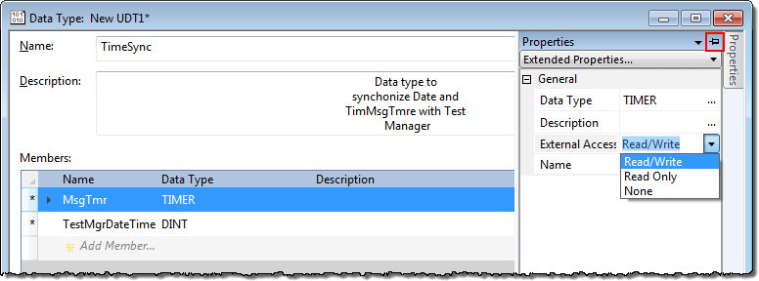

1. In the **External Access** list, choose the external access option. Three external access rules apply for members of User-defined data types.
   * You can only set external access for the top members of that

User-defined data type. **External Access** boxes for the child-members are unavailable on the User-defined Data Type E ditor.

* + I f the member’s data type is **Predefined structural**, **Module-defined**, or **String**, you cannot set external access of child-members. The external access level of the parent member applies to its child-members.
  + I f the member’s data type is **User-defined** and the child-member has a

different external access level from its parent, the more restrictive external access level applies to the child-members.

This table describes the conditions in which the **External Access** column is unavailable.

|  |  |
| --- | --- |
| **To pick** | **Considerations** |
| Change existing data type | The **External Access** column is unavailable if: You do not have permission to change the external access settings.(1)  The redundancy controller is in any state that does not allow changes.  The data type is applied to tags and the controller is online.  **Tip:** Data type size is not affected by the  external access attribute. |
| Predefine d, module-d efined, Strings  type | The **External Access** column is always visible but unavailable. The **Set External Access** entry is added to the bottom of the row header context menu, but it is always unavailable. |

1.If you have User-defined Data Type Modify permission, you also can modify external access of a User-defined data type.

## Add-on instructions external access considerations

You can use external access settings with parameters and local tags of Add-On I nstructions. For example, if you define an input parameter with external access of read only, the member that represents that parameter in the Add-On Instruction data type cannot be written.

This table describes the external access options for various Add-On Instruction parameters and tags.

|  |  |
| --- | --- |
| **Add-0n Instruction Parameters and Tags** | **External Access Options** |
| Local tag | Read/Write Read Only None |
| Input parameter |
| Output parameter |

|  |  |
| --- | --- |
| **Add-0n Instruction Parameters and Tags** | **External Access Options** |
| EnableIn parameter | Read Only |
| EnableOut parameter |
| InOut parameter | Not Applicable |

You can choose the external access for an Add-On Instruction tag from the list on the **New Add-On Instruction Parameter** or **Local Tag** dialog box or from the **External Access** column on the Tag Editor.

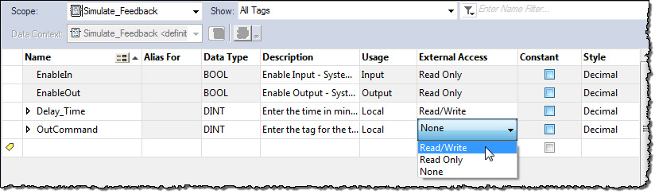

You can configure the external access of an Add-On Instruction’s parameters and local tags in the **Add-On Instruction Definition** dialog box and on the **Add-On Instruction Parameters and Local Tags** dialog boxes.

For alias parameters, the external access type is equal to the type configured for the base local tag.

|  |  |
| --- | --- |
| **Dialog Box/Window** | **Considerations** |
| **New Add-On Instruction Parameter or Local Tag** | If the current usage is:   * Input parameter, then the External Access list is available and the displayed value is your last selection when creating an equipment phase input parameter or Add-On Instruction input parameter. * Output parameter, then the External Access list is available and the displayed value is your last selection when creating an equipment phase output parameter or Add-On Instruction output parameter. * InOut parameter, then the External Access list is unavailable and blank. * Local tag, then the External Access list is unavailable and the displayed value is None. |
| **Parameters/Local Tag Properties** | No change is applied to the External Access list if you switch the usage among Input parameter, Output parameter or Local Tag, except when the usage is Local Tag, then the list is unavailable.  If you change the usage from InOut parameter to:   * Input or output parameter, then the External Access list is available and your last selection for creating an equipment phase/Add-On Instruction input parameter or an equipment phase/Add-On Instruction output parameter is displayed accordingly. * Local tag, then the external access is updated to None and the list is unavailable. The External Access list also is unavailable if: * You do not have permission to change external access settings.(1) * The controller is online. * The tag is an alias tag. * The Add-On Instruction is in Source Protection mode. |

|  |  |
| --- | --- |
| **Dialog Box/Window** | **Considerations** |
| **Add-On Instruction Definition - Parameters Tab** | The External Access column is unavailable for:   * InOut parameters, for which there are no external access options. * EnableIn and EnableOut parameters, which default to Read Only. The External Access column is unavailable when: * You do not have permission to change the external access settings.(1) * The controller is online. * The tag is an alias tag. * The Add-On Instruction is in Source Protection mode. * The row represents an expanded bit, or data member.   For new parameters, changing Usage changes the External Access default:   * To Read/Write for Input Parameter, equipment phase input parameter, and Add-On Instruction input parameter. * To Read Only for Output Parameter, for equipment phase output parameter, and Add-On Instruction output parameter. * To blank and unavailable for InOut Parameter. Changing external access attributes cause: * An error message if you change a tag from Input or Output Parameter to InOut Parameter and the present attribute is either Read/Write, or Read Only. * No change if you switch between Input Parameter and Output Parameter. * The value of the external access updates to the new target for an alias. |
| **Add-On Instruction Definition - Local Tags Tab** | The External Access column is unavailable if:   * You do not have permission to change external access settings.(1) * The controller is online. * The Add-On Instruction is in Source Protection mode. * The row represents an expanded array dimension, bit, or data member. |
| **Add-On Instruction Edit Tags** | Note: External access is not applicable for InOut parameters because they are just references until invoked. The External Access column is unavailable for:   * EnableIn and EnableOut parameters, which default to Read Only.   The External Access column is unavailable when:   * You do not have permission to change the external access settings.(1) * The controller is online. * The tag is an alias tag. * The Add-On Instruction is in Source Protection mode. * The row represents an expanded array dimension, bit, or data member. For new parameters, changing Usage changes the External Access default: * To Read/Write for Input Parameter, equipment phase input parameter, and Add-On Instruction input parameter. * To Read Only for Output Parameter, for equipment phase output parameter, and Add-On Instruction output parameter. * To blank and unavailable for InOut Parameter. * To None and unavailable for Local Tag. Changing the external access attribute causes: * A warning message if you change a tag from Input Parameter or Output Parameter to InOut Parameter and the parameter attribute is either Read/Write, or Read Only. * No change if you switch between Input Parameter or Output Parameter and Local tag.   Finally, the external access value updates to the value from the new target if you change the target for an alias for an Input or Output parameter. |

1.If you have User-defined Data Type Modify permission, you also can change the external access for a User-defined data type.

## Tag mapping considerations

Only tags with external access settings of **Read/Write** or **Read Only** can be mapped to a PLC-2 controller and PLC-5/SLC controllers.

1. In the PLC-2 or PLC-5/SLC Mapping dialog box, type a file number.
2. Choose a tag from the **Name** list. Only eligible tags that are set to either

**Read/Write** or **Read Only** appear in the menu.

I f you manually type the name of a tag whose external access is set to

**None**, an error message appears.

1. Select **OK**.

## Imported tag behavior

## OPC UA Access

The Logix Designer application preforms a check to verify an imported

program file has a valid external access value. A default value is assigned to unspecified tags that are imported from programs created in the Logix Designer application earlier than version 18.

An error message appears in the Logix Designer application for imported files that contain tags with any value other than **Read/Write**, **Read Only**, and **None**.

|  |  |
| --- | --- |
| **Object Name** | **Default External Access** |
| Controller and program-scoped standard tags | Read/Write |
| All safety tags | Read Only |
| Add-on Instruction local tags | Read/Write |
| Add-on Instruction Input parameters | Read/Write |
| Add-on Instruction Output, EnableIn and EnableOut parameters | Read Only |
| Add-on Instruction InOut parameters | N/A |
| Equipment phase output parameters | Read Only |
| Members of all data types | Read/Write |

The **OPC UA Access** property setting allows you to specify the level of access (Read-only, Read/write, or None) that OPC UA clients have to tags. This

property setting applies to tags exposed to OPC UA clients directly from the controller. Configure OPC UA access when you create a tag. After you create a tag, you can modify the tag's OPC UA access. You can configure OPC UA Access for controller and program-scoped tags.

 Tip: OPC UA access is inoperable in redundant systems.

|  |  |
| --- | --- |
| **OPC UA Access setting** | **Description** |
| Read/write | External OPC UA clients have full access to the tag and can read and change the tag's value. |
| Read-only | External OPC UA clients can read, but cannot change, the tag's value. |
| None | External OPC UA clients cannot read or change the tag's value. |

For constant tags, OPC UA server access is limited to None and Read-only. For output parameters, OPC UA server access is limited to None and

Read-only.

For InOut parameters, OPC UA server access is limited to Read/write. For safety tags, there are certain limitations:

* When the controller is online, it is not possible to edit the OPC UA

Access of a safety tag.

## Configure OPC UA Access

## OPC UA Access options

## Configure OPC UA Access in the Tag Properties dialog box

* When the controller is online, it is not possible to delete the safety tag if the tag is published in the OPC UA server.
* When the controller is online, it is not possible to rename a safety tag if the tag is published in the OPC UA server.
* When the controller is online, it is not possible to rename safety programs that expose safety tags in the OPC UA server or safety programs that are parents of such safety programs.
* When creating a safety tag when the controller is online, None is the only level of access that is available for selection.
* Safety tags only have Read-only or None levels of access.

The OPC UA Access property setting allows you to specify the level of access that external OPC UA clients have to tags.

Configure OPC UA access from a menu when creating a new tag.

|  |  |
| --- | --- |
| **OPC UA Access Settings** | **Description** |
| Read/write | External OPC UA clients have full access to the tag and can read and change the tag's value. |
| Read Only | External OPC UA clients can read but cannot change the tag's value. |
| None | External OPC UA clients cannot read or change the tag’s value. |

Tip: OPC UA access is fully independent of External Access for the OPC UA server embedded in Logix Designer controllers. In case of the OPC UA server in FactoyrTalk Linx Gateway, the OPC UA access depends on External Access.

For OPC UA Access, choose one of three options: **Read/write**, **Read-only**, or

##### None.

|  |  |
| --- | --- |
| **If the tag is** | **Default value** |
| Alias | Same as the alias target.  If a target tag does not exist, the OPC UA Access field is empty. |
| Controller or program scoped | None |
| Equipment phase and Equipment Sequence | None |

Use **Tag Properties** to edit the properties of tags.

1. In **Tag Editor**, right-click a tag and then select **Edit (tag name) Properties**.
2. In **Tag Properties**, in the **Type** list, choose a tag type.
3. In **OPC UA Access**, choose an access option. The OPC UA Access list is unavailable for an alias tag. I f a tag is a module tag, the only external access option is Read/write.
4. Select **OK**.

## View and select OPC UA Access status on the Tag Editor

## OPC UA Access availability

Configure the OPC UA Access of a tag in the Tag Editor. Perform one of these steps:

* + Select multiple rows and then set the OPC UA Access.
  + Select multiple individual rows by pressing **Ctrl** while selecting rows.
  + Right-click a selected tag and then select **OPC UA Access for (tag name)**. This action updates the OPC UA Access for all highlighted rows that are enabled for changing OPC UA Access.

This table contains the conditions in which **OPC UA Access** options are unavailable.

|  |  |
| --- | --- |
| **Dialog Box/Window** | **Considerations** |
| New Tag | The OPC UA Access list is unavailable if:   * The tag is an alias tag. * The controller is user -ocked online from another computer.   Changing the tag type from base to alias also makes the OPC UA Access list unavailable. If you select a target for an alias tag in the Alias For list, the OPC UA Access list remains unavailable, but the OPC UA Access value for the target tag appears in the OPC UA Access list.  You can only change the OPC UA Access value of an alias tag through its base tag. |
| Tag Properties | The OPC UA Access list is unavailable if:   * You do not have permission to change the OPC UA Access settings. * The redundancy controller is in any state that does not allow changes. * The controller is user-locked online from another computer. * The tag is a safety tag and the controller is safety-locked or a project contains a safety signature. * The tag scope is an equipment phase and the equipment phase feature is not activated in the current license. * The tag scope is an equipment sequence and the equipment sequence feature is not activated in the current license. * The tag is an alias tag. * The controller is in hard-run mode. |
| Tag Editor | The **OPC UA Access** list is unavailable if:   * You do not have permission to change the OPC UA Access settings. * The redundancy controller is in any state that does not allow changes. * The controller is user-locked online from another computer. * The controller is safety-locked or a project contains a safety signature and the tag is a safety tag. As a result, safety tags as a whole are not editable. * The tag scope is an equipment phase and the equipment phase feature is not activated in the current license. * The tag is an alias tag. * The controller is in hard-run mode. * The row represents an expanded array dimension, bit, or data member.   OPC UA access can only bet set on a tag's level, and not on the tag's subitems. The subitems of tags inherit their properties from the parent tag. As such, it is not possible to set OPC UA access on:   * + arrays   + any structure members   + bit members |

## Mapping tags to controllers for OPC UA Access

You can only map tags with OPC UA Access settings of Read/write or Read-only to a PLC-2 controller and to PLC-5/SLC controllers.

1. In **PLC-2** or **PLC-5/SLC Mapping**, type a file number.
2. In **Name**, choose a tag. Only tags that are set to either Read/write or Read-only appear.
3. Select **OK**.

## Imported tag behavior for OPC UA Access

## Constant value tags

## Configure constant tags

The Logix Designer application performs a check to verify that an imported program file has a valid OPC UA Access value. A default value is assigned to unspecified tags that are imported from programs created in the Logix Designer application earlier than version 36.

An error message appears in the Logix Designer application for imported files that contain tags with any value other than Read/write, Read-only, and None.

In version 18 and later of the Logix Designer application, you can designate tags as constants to protect them from being changed programmatically by:

* The controller programming application
* Logic in the controller

The tags that you cannot designate as constants are User-defined type members, Add-On Instruction input and output parameters, and local tags. Make a tag a constant value tag by selecting the **Constant** check box on the tag creation dialog boxes and tag editor/monitor windows.

Use FactoryTalk security to control who is permitted to change values of constants and who can change the constant attribute of a tag. To change the value of a constant, you must have the Tag: Modify Constant Tag Values

permission. To change the constant attribute of a tag, you must have the Tag: Modify Constant Property permission.

For details on setting permissions, see the *FactoryTalk Security System Configuration Guide*, publication no. *FTSEC-QS001*.

For an alias tag, the default constant setting of this tag is the same as its target tag. For all other conditions, the default value is unchecked, indicating the tag is not a constant value tag.

When you designate an InOut parameter as a constant, it cannot be written to within the Add-On I nstruction.

Tip: You cannot pass a constant value tag as an argument to an Output parameter of an Add-On Instruction. You cannot pass a constant tag to an InOut parameter that is not also designated as a constant value.

#### See also

[FactoryTalk Security System Configuration Guide,](http://literature.rockwellautomation.com/idc/groups/literature/documents/qs/ftsec-qs001_-en-e.pdf) publication no. [FTSEC-QS001](http://literature.rockwellautomation.com/idc/groups/literature/documents/qs/ftsec-qs001_-en-e.pdf)

This section describes the various ways you can configure a constant attribute for a tag.

## Set up a constant in the New Tag dialog box

## Configure a constant in the Tag Properties dialog box

Follow these steps to configure a tag as a constant.

#### To set up a constant in the New Tag dialog box

1. On the **Controller Organizer**, right-click **Controller Tags** and then select **New Tag**.



1. In **New Tag**, in the **Type** list, choose a tag type.
2. Select **Constant**.
3. Select **Create**.

See *Constant check box availability* for considerations.

#### See also

Constant check box availability on page 74

Follow these steps to designate a tag as a constant on the **Tag Properties**

dialog box.

#### To configure a constant in the Tag Properties dialog box

1. On the Tag Editor, right-click a tag and then select **Edit (tag name) Properties**.



1. In **Parameter/Local Tag Properties**, select **Constant** check box.
2. Select **OK**.

See *Constant check box availability* for considerations.

## Designate a constant in the Tag Editor

#### See also

Constant check box availability on page 74

The **Constant** column in the Tag Editor provides a way to designate tags that cannot be modified in the Logix Designer program. The Constant property applies to an entire tag; all members of the tag take on the same setting. The **Constant** column cells are blank for members of the constant tag.

#### To designate a constant in the Tag Editor

An error message appears when attempting to change the data type of a constant tag to a data type that cannot be constant.

Follow these steps to add a constant value in the Tag Editor.

1. In the **Controller Organizer**, right-click **Controller Tags** and then select **Edit Tags**.

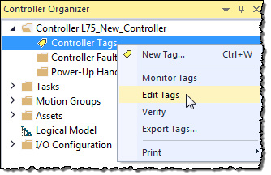

1. 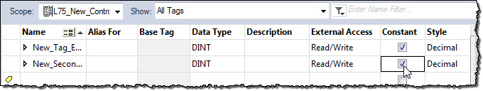In the Tag Editor, select the check box in the **Constant** column.

**IMPORTANT** In the Tag Monitor, the Constant setting for the tag appears in the same Constant column as shown in the previous illustration. However, you cannot change the value.

The Constant column also is available on the Equipment Phase Tag Editor and Equipment

Phase Tag Monitor.

## Track a constant tag

## Constant check box availability

Use component tracking to determine whether tracked components have been changed. The Logix Designer application creates an overall tracked value to indicate the current state of tracked components.

Tip: Component tracking is supported only on CompactLogix 5370, ControlLogix 5570, Compact GuardLogix 5370, and GuardLogix 5570 controllers in version 30.00 of the Logix Designer application.

Tracked components and their current states appear in the **Tracked Components** dialog box, which is accessible on the **Controller Properties dialog box - Security** tab.

The recommended limit on the number of constant tags that can be tracked is

300. I f this limit is exceeded, there might be a noticeable impact on

performance in the Logix Designer application. When tracking a base tag or an alias tag, the base tag and all alias tags are tracked.

Tip: To optimize performance, configure component tracking so that the tracked state value is calculated on demand rather than at regular intervals.

For more information on component tracking, see the *<LOGIX5K Controllers Information and Status Programming Manual*, publication no. *1756-PM015*.

The FactoryTalk Security permission **Tag: Modify Properties** controls a user's ability to change the tracking status for a constant tag.

#### To track a constant tag

Follow these instructions to enable tracking on an Add-On I nstruction.

1. In the **Tag Editor** or the **Data Monitor**, highlight the constant tag to track.
2. Right-click and select **Include in tracking group**.
3. To stop tracking a constant tag, right-click and select **Include in tracking group** again.

#### See also

[Logix 5000 Controllers Information and Status Programming Manual,](http://literature.rockwellautomation.com/idc/groups/literature/documents/pm/1756-pm015_-en-p.pdf) publication no. [1756-PM015](http://literature.rockwellautomation.com/idc/groups/literature/documents/pm/1756-pm015_-en-p.pdf)

The state of the **Constant** check box depends on a number of conditions.

|  |  |
| --- | --- |
| **Dialog Box/Window** | **Considerations** |
| **New Tag** | The Constant check box is unavailable if:   * The tag is an alias tag. * The Factory Talk Security action is not enabled for changing constant value property of a tag. * You do not have permission to change tag properties (Factory Talk Security Tag Modify is denied.) * The new tag is a consumed tag. * The tag’s data type is not a data table-backed type. * The tag is used in an Add-On Instruction as an input parameter, output parameter, or local tag. * Redundancy controller is in any state that does not allow changes. * The controller is safety-secured and the tag is a safety tag.(1) * If the tag scope is an equipment phase and the equipment phase feature is not activated in the current license. * The controller is in hard-run mode. * The Add-On Instruction is in Source Protection mode. |
| **Tag Properties Tag Editor** | Same considerations apply as for New Tag (preceding row). |
| **Tag Monitor** | You can change the value of a constant tag in the Tag Monitor if you have both standard Tag: Modify Values permission and Tag: Modify Constant Tag Values permission. You cannot change a constant value in any of the language editors or any other tag browser. The icon  in the Value column indicates that you are changing a constant value tag’s value. Any change to the values of a constant tag is recorded in the Controller Log for future reference.  For controller logging, see the *Logix 5000 Controllers Information and Status Programming Manual*, publication no. *1756-PM015*. |

* 1. If the controller is in safety-locked mode, only the safety tags are unavailable, and the standard tags will have the same behavior as in the unlocked mode. The Constant check box is unavailable in the Tag Properties dialog box only if the tag is a safety tag.

## Add-on instructions constant value considerations

#### See also

[Logix 5000 Controllers Information and Status Programming Manual,](http://literature.rockwellautomation.com/idc/groups/literature/documents/pm/1756-pm015_-en-p.pdf) publication no. [1756-PM015](http://literature.rockwellautomation.com/idc/groups/literature/documents/pm/1756-pm015_-en-p.pdf)

The Constant attribute applies only to InOut parameters. The default setting of the property is not a Constant Value.

The Constant attribute does not apply to Input, Output, EnableIn and

EnableOut Add-On Instruction parameters. I t does not apply to Add-On Instruction Local tags.

I f in an Add-On Instruction, you make an InOut parameter a constant, it means that within the Add-On I nstruction, nothing can write to that

parameter. The project fails verification if this type of write is attempted. Appropriate usage of Constant tags is monitored by logic verification.

# Index

**considerations**

Add-On Instructions constant value 75

external access 65

external access 62, 63

## Index

user-defined data type external access 63

### A

**access**

external 57

**add extended properties to a tag 30 add extended properties to user-defined**

**data type 39 Add-On Instruction**

constant value considerations 75 external access variables 65

**address**

assign indirect 47

tag 44

tag I/O module 14

**alias**

create 46

show/hide 46

use of 44

**array**

calculate subscript 48

create 34

index through 47

organize 25

overview 31

**availability**

constant value 74

external access 62, 63

### B

**base tag 61 buffer**

I/O data 16

### C

**communication**

format 11

ownership 11

I/O module 9

module I/O configuration 51

**compatible**

keying 13

**configure**

external access 58

**connection**

listen-only 11

overview 9

**constant**

track constant tags 74 value

availability 74

dialog box 72

tag editor 73

tag properties 72

value configuration 71

value tags 71

**controller**

tags 22

use of 22

**create**

alias 46

tag 29

user-defined data type 38

### D

**data**

block

See array (create) 31 I/O 14

table

See tag (organize) 51 type

choose 20

overview 20

structure 20

**description**

tag 41

user-defined data type 41

**direct connection 11 disable**

force 51

**document**

tag

description 41

user-defined data type 41

### E

**electronic keying**

I/O 13

**enable**

force 51

**exact match**

keying 13

**expression**

calculate array subscript 48

**extended properties 20**

adding extended properties to a tag 30

user-defined data type 39

**external**

access 57

Add-On Instruction 65

availability 62, 63

configure 58

configure tag dialog 59 configure tag properties 60 options 58

user-defined data type considerations

63

view tag editor 60

### F

**file**

See array 31

**force**

disable 51

enable 51

remove 51

**function block diagram**

force a value 51

### G

**global data**

See scope 22

**Go To 61**

### I

**I/O module**

buffer data 16

configuration 51 document

See alias 44

electronic keying 13

ownership 11 synchronize with logic 16 tag address 14

update period 9

**index**

See indirect address 47

**indirect address 47**

format 44

use of expression 48

### K

**keying**

See electronic keying 13

**L**

**ladder logic**

force a value 51 override a value 51

**local data**

See scope 22

### M

**memory**

allocation for tags 20

**Min and Max for DINT, INT, LINT, SINT, and REAL data types 30, 39**

**module**

I/O configuration 51

### N

**name**

guidelines for tag 25 reuse of tag name 22

### O

**OPC UA Access 68 ownership**

I/O module 11

### P

**pass-through description 41 program**

parameters 9, 16, 22, 24

tags 22

**program parameters 9, 16, 22, 24**

**project documentation 50**

### R

**rack-optimized connection 11 remove**

force 51

**requested packet interval (RPI) 9**

### S

**scope**

guidelines 25

parameters 9, 16, 22, 24

tag 22

**sequential function chart**

force element 51

**structure**

create 38

organize 25

overview 20

user-defined 38

**structured text**

force a value 51

**symbol**

See alias. 44

### T

**Index**

**tag**

address 44

alias 44

array 31

assign dimensions 34

constant value 71

configuration 71

create 29

create alias 46 data

type 20 dialog

external access 59 editor

view external access 60 guidelines 25

I/O 14

mapping

considerations 67

memory allocation 20

name 22

organize 25

overview 51 properties

external access 60 reuse of name 22 scope 22

track constant tags 74

type 20

### U

**user-defined data type**

create 38

external access variables 63 guidelines 37

overview 38

### V

**variables**

constant value 74

external access 62, 63 user-defined data type

external access 63

## Rockwell Automation support

Use these resources to access support information.

|  |  |  |
| --- | --- | --- |
| **Technical Support Center** | Find help with how-to videos, FAQs, chat, user forums, and product notification updates. | [rok.auto/support](http://rok.auto/support) |
| **Knowledgebase** | Access Knowledgebase articles. | [rok.auto/knowledgebase](http://rok.auto/knowledgebase) |
| **Local Technical Support Phone Numbers** | Locate the telephone number for your country. | [rok.auto/phonesupport](http://rok.auto/phonesupport) |
| **Literature Library** | Find installation instructions, manuals, brochures, and technical data publications. | [rok.auto/literature](http://rok.auto/literature) |
| **Product Compatibility and Download Center (PCDC)** | Get help determining how products interact, check features and capabilities, and find associated firmware. | [rok.auto/pcdc](http://rok.auto/pcdc) |

## Documentation feedback

Your comments help us serve your documentation needs better. If you have any suggestions on how to improve our content, complete the form at [rok.auto/docfeedback.](http://rok.auto/docfeedback)

## Waste Electrical and Electronic Equipment (WEEE)

 Note: At the end of life, this equipment should be collected separately from any unsorted municipal waste.

Rockwell Automation maintains current environmental information on its website at [rok.auto/pec.](http://rok.auto/pec)

Allen-Bradley, expanding human possibility, Logix, Rockwell Automation, and Rockwell Software are trademarks of Rockwell Automation, Inc. EtherNet/IP is a trademark of ODVA, Inc.

Trademarks not belonging to Rockwell Automation are property of their respective companies.

Rockwell Otomayson Ticaret A.Ş. Kar Plaza İş Merkezi E Blok Kat:6 34752, İçerenkÖy, İstanbul, Tel: +90 (216) 5698400 EEE YÖnetmeliğine Uygundur



Rockwell Automation Publication 1756-PM004L-EN-P - November 2023

Supersedes Publication 1756-PM004K-EN-P - November 2022 Copyright © 2023 Rockwell Automation Technologies, Inc. All Rights Reserved. Printed in the U.S.A.