Q.1. Are these statements optimal? If not, optimize them.
word=’word’
print(word.__len__())
Ans. No, these are not optimal. Let’s check the manual for this.
- >>> help(str.__len__)
Help on wrapper_descriptor:
__len__(self, /)
Return len(self).
__len__ is a wrapper descriptor which in turn makes a call to len(). So why not skip the work and do just that instead?
The optimal solution:
- >>> word='word'
- >>> len(word)
4
Q.2. Have you heard of the yield keyword in Python?
Ans. Yes, I have. This keyword bears the ability to turn any function into a generator. Much like the standard return keyword, but returns a generator object. It is also true that one function may observe multiple yields.
- >>> def odds(n):
- odd=[i for i in range(n+1) if i%2!=0]
- for i in odd:
- yield i
- >>> for i in odds(8):
- print(i)
1
3
5
7
Q.3. How will you print the contents of a file?
Ans.
- >>> try:
- with open('tabs.txt','r') as f:
- print(f.read())
- except IOError:
- print("File not found")
Q.4. How will you convert a list into a string?
Ans. We will use the join() method for this.
- >>> nums=['one','two','three','four','five','six','seven']
- >>> s=' '.join(nums)
- >>> s
‘one two three four five six seven’
Let’s revise the Python string in detail
Q.5. What will the following code output?
>>> a=1
>>> a,b=a+1,a+1
>>> a,b
Ans. The output is (2, 2). This code increments the value of a by 1 and assigns it to both a and b. This is because this is a simultaneous declaration. The following code gives us the same:
- >>> a=1
- >>> b,a=a+1,a+1
- >>> a,b
(2, 2)
Have a look at Python Built-in Functions
Q.6. Explain different ways to create an empty NumPy array in Python.
Ans. We’ll talk about two methods to create NumPy array-
- First method-
- >>> import numpy
- >>> numpy.array([])
array([], dtype=float64)
- Second method-
- >>> numpy.empty(shape=(0,0))
array([], shape=(0, 0), dtype=float64)
Q.7. How will you remove a duplicate element from a list?
Ans. We can turn it into a set to do that.
- >>> list=[1,2,1,3,4,2]
- >>> set(list)
{1, 2, 3, 4}
Let’s revise the Python List
Q.8. How many types of objects does Python support?
Ans. Objects in Python are mutable and immutable. Let’s talk about these.
- Immutable objects- Those which do not let us modify their contents. Examples of these will be tuples, booleans, strings, integers, floats, and complexes. Iterations on such objects are faster.
- >>> tuple=(1,2,4)
- >>> tuple
(1, 2, 4)
- >>> 2+4j
(2+4j)
- Mutable objects- Those that let you modify their contents. Examples of these are lists, sets, and dicts. Iterations on such objects are slower.
- >>> [2,4,9]
[2, 4, 9]
- >>> dict1={1:1,2:2}
- >>> dict1
{1: 1, 2: 2}
While two equal immutable objects’ reference variables share the same address, it is possible to create two mutable objects with the same content.
Q.9. What is a control flow statement?
Ans. A Python program usually starts to execute from the first line. From there, it moves through each statement just once and as soon as it’s done with the last statement, it transactions the program. However, sometimes, we may want to take a more twisted path through the code. Control flow statements let us disturb the normal execution flow of a program and bend it to our will.
Q.10. Create a new list to convert the following list of number strings to a list of numbers.
nums=[‘22’,’68’,’110’,’89’,’31’,’12’]
Ans. We will use the int() function with a list comprehension to convert these strings into integers and put them in a list.
- >>> [int(i) for i in nums]
[22, 68, 110, 89, 31, 12]
Questions for Python Interview for freshers – Q. 2,3,6,7,8,9
Questions for Python Interview for experienced – Q. 1,4,5,10
Q.11. What is the MRO in Python?
Ans. MRO stands for Method Resolution Order. Talking of multiple inheritances, whenever we search for an attribute in a class, Python first searches in the current class. If found, its search is satiated. If not, it moves to the parent class. It follows an approach that is left-to-right and depth-first. It goes Child, Mother, Father, Object.
We can call this order a linearization of the class Child; the set of rules applied are the Method Resolution Order (MRO). We can borrow the __mro__ attribute or the mro() method to get this.
Q.12. Are methods and constructors the same thing?
Ans. No, there are subtle but considerable differences-
- We must name a constructor in the name of the class; a method name can be anything.
- Whenever we create an object, it executes a constructor; whenever we call a method, it executes a method.
- For one object, a constructor executes only once; a method can execute any number of times for one object.
- We use constructors to define and initialize non-static variables; we use methods to represent business logic to perform operations.
Q.13. Can you explain the life cycle of a thread?
Let’s revise Python Multithreading
- To create a thread, we create a class that we make override the run method of the thread class. Then, we instantiate it.
- A thread that we just created is in the new state. When we make a call to start() on it, it forwards the threads for scheduling. These are in the ready state.
- When execution begins, the thread is in the running state.
- Calls to methods like sleep() and join() make a thread wait. Such a thread is in the waiting/blocked state.
- When a thread is done waiting or executing, other waiting threads are sent for scheduling.
- A running thread that is done executing terminates and is in the dead state.
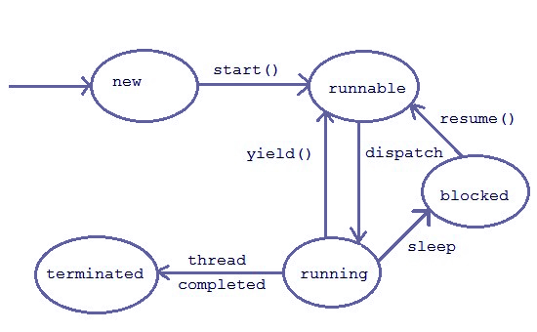
Questions for Python Interview – Life Cycle of a Thread
Q.14. Below, we give you code to remove numbers smaller than 5 from the list nums. However, it does not work as expected. Can you point out the bug for us?
>>> nums=[1,2,5,10,3,100,9,24]
>>> for i in nums:
if i<5:
nums.remove(i)
>>> nums
[2, 5, 10, 100, 9, 24]
Ans. This code checks for each element in nums- is it smaller than 5? If it is, it removes that element. In the first iteration, 1 indeed is smaller than 5. So it removes that from this list. But this disturbs the indices. Hence, it checks the element 5, but not the element 2. For this situation, we have three workarounds:
- Create an empty array and append to that-
- >>> nums=[1,2,5,10,3,100,9,24]
- >>> newnums=[]
- >>> for i in nums:
- if i>=5:
- newnums.append(i)
- >>> newnums
[5, 10, 100, 9, 24]
- Using a list comprehension-
- >>> nums=[1,2,5,10,3,100,9,24]
- >>> newnums=[i for i in nums if i>=5]
- >>> newnums
[5, 10, 100, 9, 24]
- Using the filter() function-
- >>> nums=[1,2,5,10,3,100,9,24]
- >>> newnums=list(filter(lambda x:x>=5, nums))
- >>> newnums
[5, 10, 100, 9, 24]
Q.15. What is the best code you can write to swap two numbers?
Ans. I can perform the swapping in one statement.
- >>> a,b=b,a
Here’s the entire code, though-
- >>> a,b=2,3
- >>> a,b=b,a
- >>> a,b
(3, 2)
Q.16. Explain the problem with the following piece of code-
>>> def func(n=[]):
#playing around
pass
>>> func([1,2,3])
>>> func()
>>> n
Ans. The request for n raises a NameError. This is since n is a variable local to func and we cannot access it elsewhere. It is also true that Python only evaluates default parameter values once; every invocation shares the default value. If one invocation modifies it, that is what another gets. This means you should only ever use primitives, strings, and tuples as default parameters, not mutable objects.
Best Python Interview Preparation
Q.17. Can you remove the whitespaces from the string “aaa bbb ccc ddd eee”?
Ans. I can think of two ways to do this.
- Using join-
- >>> s='aaa bbb ccc ddd eee'
- >>> s1=''.join(s.split())
- >>> s1
‘aaabbbcccdddeee’
- Using a list comprehension-
- >>> s='aaa bbb ccc ddd eee'
- >>> s1=str(''.join(([i for i in s if i!=' '])))
- >>> s1
‘aaabbbcccdddeee’
Q.18. Given the first and last names of all employees in your firm, what data type will you use to store it?
Ans. I can use a dictionary to store that. It would be something like this-
{‘first_name’:’Ayushi’,’second_name’:’Sharma’}
Q.19. What do you see below?
s = a + ‘[‘ + b + ‘:’ + c + ‘]’
Ans. This is string concatenation. If a, b, and c are strings themselves, then it works fine and concatenates the strings around the strings ‘[‘, ‘:’, and ‘]’ as mentioned. If even one of these isn’t a string, this raises a TypeError.
Q.20. If a function does not have a return statement, is it valid?
Ans. Very conveniently. A function that doesn’t return anything returns a None object. Not necessarily does the return keyword mark the end of a function; it merely ends it when present in the function. Normally, a block of code marks a function and where it ends, the function body ends.
Questions for Python Interview for freshers – Q. 11,12,13,15,18,20
Questions for Python Interview for experienced – Q. 14,16,17,19
Q.21. What good is recursion?
Ans. With recursion, we observe the following:
- Need to put in less efforts.
- Smaller code than that by loops.
- Easier-to-understand code.
Q.22. So does recursion cause any trouble?
Ans. Sure does:
- Needs more function calls.
- Each function call stores a state variable to the program stack- consumes memory, can cause memory overflow.
- Calling a function consumes time.
Q.23. How do you get the current working directory using Python?
Ans. Working on software with Python, you may need to read and write files from various directories. To find out which directory we’re presently working under, we can borrow the getcwd() method from the os module.
- >>> import os
- >>> os.getcwd()
‘C:\\Users\\Ayushi\\AppData\\Local\\Programs\\Python\\Python37-32’
Q.24. What is tuple unpacking?
Ans. Suppose we have a tuple nums=(1,2,3). We can unpack its values into the variables a, b, and c. Here’s how:
Have a look at Python tuple
- >>> nums=(1,2,3)
- >>> a,b,c=nums
- >>> a
1
- >>> b
2
- >>> c
3
Q.25. What does the following code give us?
>>> b=(1)
Ans. Not a tuple. This gives us a plain integer.
- >>> type(b)
<class ‘int’>
To let it be a tuple, we can declare so explicitly with a comma after 1:
- >>> b=(1,)
- >>> type(b)
<class ‘tuple’>
Q.26. What is the iterator protocol?
Ans. The iterator protocol for Python declares that we must make use of two functions to build an iterator- iter() and next().
- iter()- To create an iterator
- next()- To iterate to the next element
- >>> a=iter([2,4,6,8,10])
- >>> next(a)
2
- >>> next(a)
4
- >>> next(a)
6
- >>> next(a)
8
- >>> next(a)
10
- >>> next(a)
Traceback (most recent call last):
File “<pyshell#31>”, line 1, in <module>
next(a)
StopIteration
Q.27. Why do we need to overload operators?
Ans. To compare two objects, we can overload operators in Python. We understand 3>2. But what is orange>apple? Let’s compare apples and oranges now.
- >>> class fruit:
- def __init__(self,type,size):
- self.type='fruit'
- self.type=type
- self.size=size
- def __gt__(self,other):
- if self.size>other.size:
- return True
- return False
- >>> orange=fruit('orange',7)
- >>> apple=fruit('apple',8)
- >>> apple>orange
True
- >>> orange>apple
False
Q.28. What is the enumerate() function in Python?
Ans. enumerate() iterates through a sequence and extracts the index position and its corresponding value too.
Let’s take an example.
- >>> for i,v in enumerate(['Python','C++','Scala']):
- print(i,v)
0 Python
1 C++
2 Scala
Q.29. How do we make forms in Python?
Ans. We use the cgi module for this; we borrow the FieldStorage class from it. It has the following attributes:
- form.name: Name of field.
- form.filename: Client-side filename for FTP transactions.
- form.value: Value of field as string.
- form.file: File object from which to read data.
- form.type: Content type.
- form.type_options: Options of ‘content-type’ line of HTTP request, returned as dictionary.
- form.disposition: The field ‘content-disposition’.
- form.disposition_options: Options for ‘content-disposition’.
- form.headers: All HTTP headers returned as dictionary.
Q.30. How will you create the following pattern using Python?
*
**
***
****
*****
Ans. We will use two for-loops for this.
- >>> for i in range(1,6):
- for j in range(1,i+1):
- print('*',end='')
- print()
Questions for Python Interview for freshers – Q. 21,22,23,27,28,29
Questions for Python Interview for experienced – Q. 24,25,26,30
Get Python Developer’s Job with the Best Practices
So, this was all the Questions for Python Interview. Hope you like our explanation.
3. Conclusion – Python Interview Questions
So, you have completed the last part of Python Interview Questions. These Questions for Python Interview proves beneficial for both Python fresher and experienced. Do you have Questions for Python Interview to add? Hey, leave it in the comments below.

Q.1. What does the following code output?
- >>> def extendList(val, list=[]):
- list.append(val)
- return list
- >>> list1 = extendList(10)
- >>> list2 = extendList(123,[])
- >>> list3 = extendList('a')
- >>> list1,list2,list3
Ans. ([10, ‘a’], [123], [10, ‘a’])
You’d expect the output to be something like this:
([10],[123],[‘a’])
Well, this is because the list argument does not initialize to its default value ([]) every time we make a call to the function. Once we define the function, it creates a new list. Then, whenever we call it again without a list argument, it uses the same list. This is because it calculates the expressions in the default arguments when we define the function, not when we call it.
Let’s revise the Basis of Python Programming
Q.2. What is a decorator?
Ans. A decorator is a function that adds functionality to another function without modifying it. It wraps another function to add functionality to it. Take an example.
- >>> def decor(func):
- def wrap():
- print("$$$$$$$$$$$$$$$$$")
- func()
- print("$$$$$$$$$$$$$$$$$")
return wrap
- >>> @decor
- def sayhi():
- print("Hi")
- >>> sayhi()
$$$$$$$$$$$$$$$$$
Hi
$$$$$$$$$$$$$$$$$
Decorators are an example of metaprogramming, where one part of the code tries to change another. For more on decorators, read Python Decorators.
2. Basic Python Programming Interview Questions
Below are some Basic Python Programming Interview Questions and answers for freshers.
Q.3. Write a regular expression that will accept an email id. Use the re module.
Ans.
- >>> import re
- >>> e=re.search(r'[0-9a-zA-Z.]+@[a-zA-Z]+\.(com|co\.in)$','ayushiwashere@gmail.com')
- >>> e.group()
‘ayushiwashere@gmail.com’
To brush up on regular expressions, check Regular Expressions in Python.
Q.4. How many arguments can the range() function take?
Ans. The range() function in Python can take up to 3 arguments. Let’s see this one by one.
a. One argument
When we pass only one argument, it takes it as the stop value. Here, the start value is 0, and the step value is +1.
- >>> list(range(5))
[0, 1, 2, 3, 4]
- >>> list(range(-5))
[]
- >>> list(range(0))
[]
b. Two arguments
When we pass two arguments, the first one is the start value, and the second is the stop value.
- >>> list(range(2,7))
[2, 3, 4, 5, 6]
- >>> list(range(7,2))
[]
- >>> list(range(-3,4))
[-3, -2, -1, 0, 1, 2, 3]
c. Three arguments
Here, the first argument is the start value, the second is the stop value, and the third is the step value.
- >>> list(range(2,9,2))
[2, 4, 6, 8]
- >>> list(range(9,2,-1))
[9, 8, 7, 6, 5, 4, 3]
Q.5. Does Python have a switch-case statement?
Ans. In languages like C++, we have something like this:
- switch(name)
- {
- case ‘Ayushi’:
- cout<<”Monday”;
- break;
- case ‘Megha’:
- cout<<”Tuesday”;
- break;
- default:
- cout<<”Hi, user”;
- }
But in Python, we do not have a switch-case statement. Here, you may write a switch function to use. Else, you may use a set of if-elif-else statements. To implement a function for this, we may use a dictionary.
- >>> def switch(choice):
- switcher={
- 'Ayushi':'Monday',
- 'Megha':'Tuesday',
- print(switcher.get(choice,'Hi, user'))
return
- >>> switch('Megha')
Tuesday
- >>> switch('Ayushi')
Monday
- >>> switch('Ruchi')
Hi, user
Here, the get() method returns the value of the key. When no key matches, the default value (the second argument) is returned.
Any doubt yet in Python Programming interview Questions. Please Comment.
Q.6. How do you debug a program in Python? Answer in brief.
Ans. To debug a Python program, we use the pdb module. This is the Python debugger; we will discuss it in a tutorial soon. If we start a program using pdb, it will let us step through the code.
Q.7. List some pdb commands.
Some pdb commands include-
<b> — Add breakpoint
<c> — Resume execution
<s> — Debug step by step
<n> — Move to next line
<l> — List source code
<p> — Print an expression
Q.8. What command do we use to debug a Python program?
Ans. To start debugging, we first open the command prompt, and get to the location the file is at.
Microsoft Windows [Version 10.0.16299.248]
(c) 2017 Microsoft Corporation. All rights reserved.

C:\Users\lifei> cd Desktop
C:\Users\lifei\Desktop>
Then, we run the following command (for file try.py):
C:\Users\lifei\Desktop>python -m pdb try.py
> c:\users\lifei\desktop\try.py(1)<module>()
-> for i in range(5):
(Pdb)
Then, we can start debugging.
Q.9. What is a Counter in Python?
Ans. The function Counter() from the module ‘collections’. It counts the number of occurrences of the elements of a container.
- >>> from collections import Counter
- >>> Counter([1,3,2,1,4,2,1,3,1])
Counter({1: 4, 3: 2, 2: 2, 4: 1})
Python provides us with a range of ways and methods to work with a Counter. Read Python Counter.
Q.10. What is NumPy? Is it better than a list?
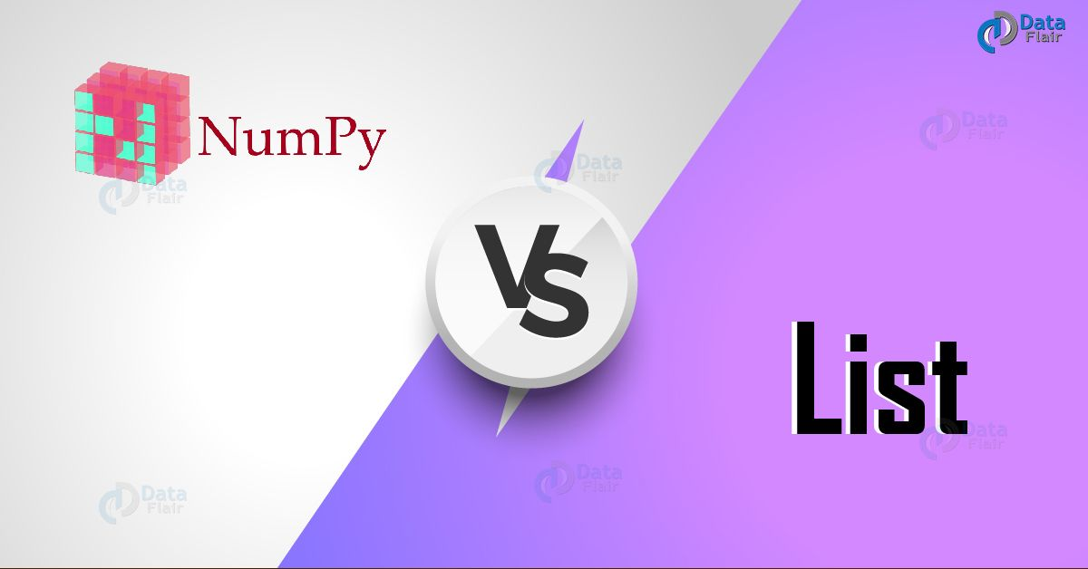
Python Programming Interview Questions – Numpy vs List
Ans. NumPy, a Python package, has made its place in the world of scientific computing. It can deal with large data sizes, and also has a powerful N-dimensional array object along with a set of advanced functions.
Yes, a NumPy array is better than a Python list. This is in the following ways:
- It is more compact.
- It is more convenient.
- It Is more efficiently.
- It is easier to read and write items with NumPy.
Read our latest tutorial on Python NumPy
Q.11. How would you create an empty NumPy array?
Ans. To create an empty array with NumPy, we have two options:
a. Option 1
- >>> import numpy
- >>> numpy.array([])
array([], dtype=float64)
b. Option 2
- >>> numpy.empty(shape=(0,0))
array([], shape=(0, 0), dtype=float64)
Refer Python Libraries
Q.12. What is PEP 8?
Ans. PEP 8 is a coding convention that lets us write more readable code. In other words, it is a set of recommendations.
Q.13. What is pickling and unpickling?
Ans. To create portable serialized representations of Python objects, we have the module ‘pickle’. It accepts a Python object (remember, everything in Python is an object). It then converts it into a string representation and uses the dump() function to dump it into a file. We call this pickling. In contrast, retrieving objects from this stored string representation is termed ‘unpickling’.
Q.14. What is a namespace in Python?
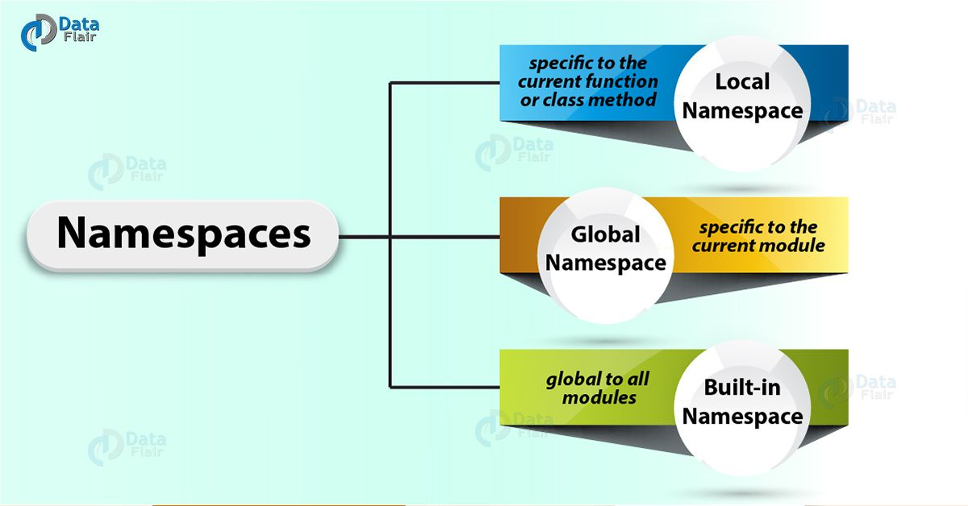
Python Programming Interview Questions and Answers – Python Namespaces
Ans. A namespace is a collection of names. It maps names to corresponding objects. When different namespaces contain objects with the same names, this avoids any name collisions. Internally, a namespace is implemented as a Python dictionary.
On starting the interpreter, it creates a namespace for as long as we don’t exit. We have local namespaces, global namespaces, and a built-in namespace.
Just Follow this link to know more about Python Namespace
Q.15. How would you perform unit-testing on your Python code?
Ans. For this purpose, we have the module unittest in Python. It has the following members:
FunctionTestCase
SkipTest
TestCase
TestLoader
TestResult
TestSuite
TextTestResult
TextTestRunner
defaultTestLoader
expectedFailure
findTestCases
getTestCaseNames
installHandler
main
makeSuite
registerResult
removeHandler
removeResult
skip
skipIf
skipUnless
So Q2 to Q15 were some Basic Python Programming Interview Questions and Answers for Freshers. Experienced can also refer these Python Interview Questions for revision.
3. Advanced Python Interview Questions and Answers
Below are some Advanced Python Programming Interview Questions For Experienced. I recommend freshers to also refer these interview questions for advanced knowledge.
Q.16. Explain the use of the ‘nonlocal’ keyword in Python.
Ans. First, let’s discuss the local and global scope. By example, a variable defined inside a function is local to that function. Another variable defined outside any other scope is global to the function.
Suppose we have nested functions. We can read a variable in an enclosing scope from inside he inner function, but cannot make a change to it. For that, we must declare it nonlocal inside the function. First, let’s see this without the nonlocal keyword.
- >>> def outer():
- a=7
- def inner():
- print(a)
- inner()
- >>> outer()
7
- >>> def outer():
- a=7
- def inner():
- print(a)
- a+=1
- print(a)
- inner()
- >>> outer()
Traceback (most recent call last):
File “<pyshell#462>”, line 1, in <module>
outer()
File “<pyshell#461>”, line 7, in outer
inner()
File “<pyshell#461>”, line 4, in inner
print(a)
UnboundLocalError: local variable ‘a’ referenced before assignment
So now, let’s try doing this with the ‘nonlocal’ keyword:
- >>> def outer():
- a=7
- def inner():
- nonlocal a
- print(a)
- a+=1
- print(a)
inner()
- >>> outer()
7
8
Q.17. So, then, what is the global keyword?
Ans. Like we saw in the previous question, the global keyword lets us deal with, inside any scope, the global version of a variable.
The problem:
- >>> a=7
- >>> def func():
- print(a)
- a+=1
- print(a)
The solution:
- >>> a=7
- >>> def func():
- global a
- print(a)
- a+=1
- print(a)
- >>> func()
7
8
Q.18. How would you make a Python script executable on Unix?
Ans. For this to happen, two conditions must be met:
- The script file’s mode must be executable
- The first line must begin with a hash(#). An example of this will be: #!/usr/local/bin/python
Q.19. What functions or methods will you use to delete a file in Python?
Ans. For this, we may use remove() or unlink().
- >>> import os
- >>> os.chdir('C:\\Users\\lifei\\Desktop')
- >>> os.remove('try.py')
- >>>
When we go and check our Desktop, the file is gone. Let’s go make it again so we can delete it again using unlink().
- >>> os.unlink('try.py')
- >>>
Both functions are the same, but unlink is the traditional Unix name for it.
Q.20. What are accessors, mutators, and @property?
Ans. What we call getters and setters in languages like Java, we term accessors and mutators in Python. In Java, if we have a user-defined class with a property ‘x’, we have methods like getX() and setX(). In Python, we have @property, which is syntactic sugar for property(). This lets us get and set variables without compromising on the conventions. For a detailed explanation on property, refer to Python property.
Any Doubt yet in Advanced Python Interview Questions and Answers for Experienced? Please Comment.
Q.21. Explain a few methods to implement Functionally Oriented Programming in Python.
Ans. Sometimes, when we want to iterate over a list, a few methods come in handy.
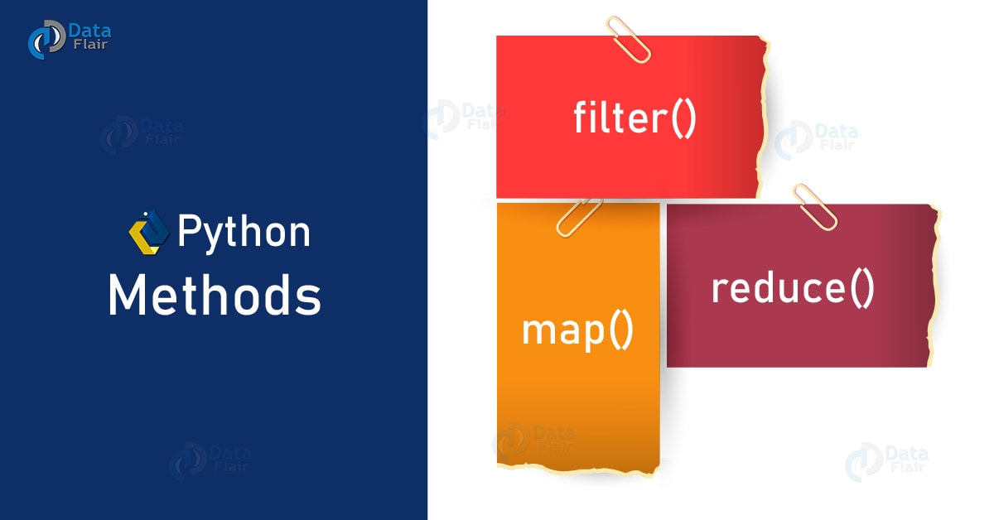
Python Interview Questions – Python Methods
a. filter()
Filter lets us filter in some values based on conditional logic.
- >>> list(filter(lambda x:x>5,range(8)))
[6, 7]
b. map()
Map applies a function to every element in an iterable.
- >>> list(map(lambda x:x**2,range(8)))
[0, 1, 4, 9, 16, 25, 36, 49]
c. reduce()
Reduce repeatedly reduces a sequence pair-wise until we reach a single value.
- >>> from functools import reduce
- >>> reduce(lambda x,y:x-y,[1,2,3,4,5])
-13
Q.22. Differentiate between the append() and extend() methods of a list.
Ans. The methods append() and extend() work on lists. While append() adds an element to the end of the list, extend adds another list to the end of a list.
Let’s take two lists.
- >>> list1,list2=[1,2,3],[5,6,7,8]
This is how append() works:
- >>> list1.append(4)
- >>> list1
[1, 2, 3, 4]
And this is how extend() works:
- >>> list1.extend(list2)
- >>> list1
[1, 2, 3, 4, 5, 6, 7, 8]
Refer Python Lists
Q.23. Consider multiple inheritances here. Suppose class C inherits from classes A and B as class C(A,B). Classes A and B both have their own versions of method func(). If we call func() from an object of class C, which version gets invoked?
Ans. In our article on Multiple Inheritance in Python, we discussed Method Resolution Order (MRO). C does not contain its own version of func(). Since the interpreter searches in a left-to-right fashion, it finds the method in A, and does not go to look for it in B.
Q.24. Which methods/functions do we use to determine the type of instance and inheritance?
Ans. Here, we talk about three methods/functions- type(), isinstance(), and issubclass().
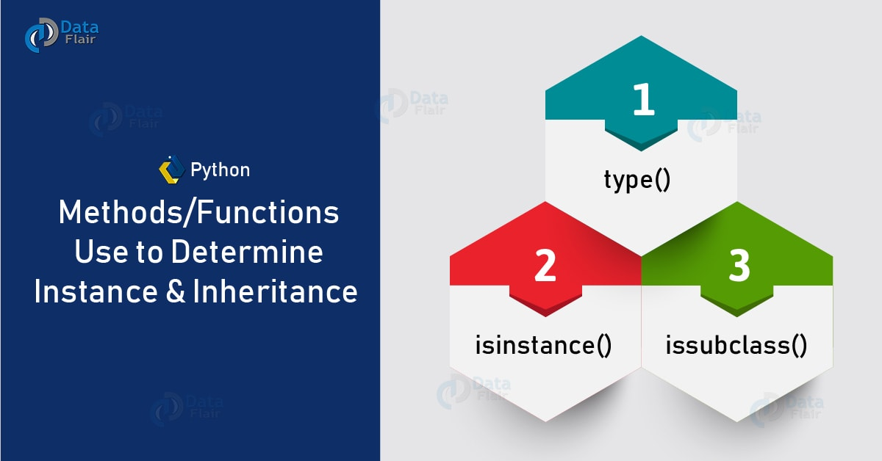
Python Interview Questions – Python Methods/Functions
a. type()
This tells us the type of object we’re working with.
- >>> type(3)
<class ‘int’>
- >>> type(False)
<class ‘bool’>
- >>> type(lambda :print("Hi"))
<class ‘function’>
- >>> type(type)
<class ‘type’>
b. isinstance()
This takes in two arguments- a value and a type. If the value is of the kind of the specified type, it returns True. Else, it returns False.
- >>> isinstance(3,int)
True
- >>> isinstance((1),tuple)
False
- >>> isinstance((1,),tuple)
True
c. issubclass()
This takes two classes as arguments. If the first one inherits from the second, it returns True. Else, it returns False.
- >>> class A: pass
- >>> class B(A): pass
- >>> issubclass(B,A)
True
- >>> issubclass(A,B)
False
Q.25. What do you mean by overriding methods?
Ans. Suppose class B inherits from class A. Both have the method sayhello()- to each, their own version. B overrides the sayhello() of class A. So, when we create an object of class B, it calls the version that class B has.
- >>> class A:
- def sayhello(self):
- print("Hello, I'm A")
- >>> class B(A):
- def sayhello(self):
- print("Hello, I'm B")

- >>> a=A()
- >>> b=B()
- >>> a.sayhello()
Hello, I’m A
- >>> b.sayhello()
Hello, I’m B
Refer this link to know more about Method Overriding in Python
Q.26. What is JSON? Describe in brief how you’d convert JSON data into Python data?
Ans. JSON stands for JavaScript Object Notation. It is a highly popular data format, and it stores data into NoSQL databases. JSON is generally built on the following two structures:
- A collection of <name,value> pairs
- An ordered list of values.
Python supports JSON parsers. In fact, JSON-based data is internally represented as a dictionary in Python. To convert JSON data into Python data, we use the load() function from the JSON module.
These were the advanced Python Programming Interview Questions.
This was all about the Python Programming Interview Questions and Answers.
4. Conclusion: Python Programming Interview Questions
Again, we discussed a variety of Python Programming Interview Questions and answers. But stay put, folks, this isn’t all. We meet again with another string of questions to guide you to your interview. Comment if you have a query on Python Programming Interview Questions.
Also see:
- Python Interview Questions Part I
- Python Interview Questions and Answers Part II

