Assignment No. 1

Q1. Explain the key characteristics of Cloud Computing.
Answer:
- On-Demand Self-Service – Users can automatically provision computing resources like storage and servers without human interaction.
- Broad Network Access – Services are accessible via internet using mobile phones, laptops, tablets, etc.
- Resource Pooling – Cloud provider pools computing resources to serve multiple users using multi-tenancy.
- Rapid Elasticity – Resources can be scaled up or down quickly based on workload demand.
- Measured Service – Resource usage is monitored and billed according to consumption (pay-per-use model).
- Scalability – Infrastructure can grow or shrink depending on business needs.
- High Availability – Services are available continuously with minimal downtime.
- Fault Tolerance – System continues working even if one component fails.
- Automation – Automatic deployment, configuration, and management of services.
- Security – Data encryption, firewalls, authentication, and access control mechanisms.
- Cost Reduction – No need for heavy investment in hardware and maintenance.
- Global Accessibility – Data and services can be accessed from anywhere in the world. 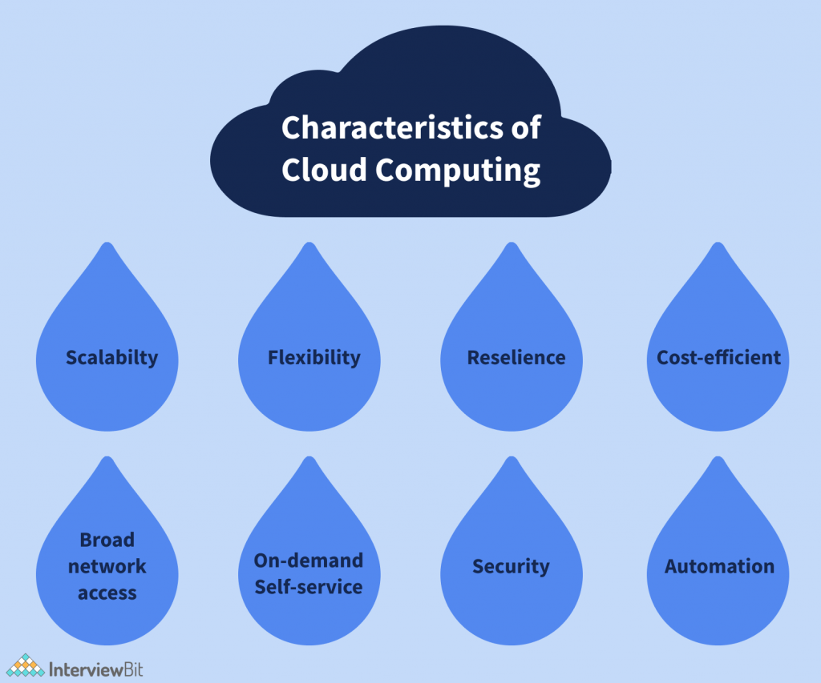

Q2. Discuss the different service models of Cloud Computing (IaaS, PaaS, SaaS) with examples.

1️⃣ IaaS (Infrastructure as a Service)
Example: Amazon Web Services
Explanation:
IaaS provides virtualized computing resources over the internet.
Points:
- Provides virtual machines (VMs).
- Offers storage and networking services.
- User manages operating system and applications.
- Flexible and scalable infrastructure.
- Pay-as-you-go pricing.
- Suitable for website hosting and data backup.
- Full administrative control.
- Reduces hardware cost.
- Provides disaster recovery solutions.
- Examples: EC2, S3.
- Used by startups and enterprises.
- Highly customizable environment.

2️⃣ PaaS (Platform as a Service)
Example: Google Cloud Platform
Explanation:
PaaS provides a platform to develop, test, and deploy applications.
Points:
- Provides development framework.
- No need to manage hardware or OS.
- Includes runtime environment.
- Supports multiple programming languages.
- Built-in database and middleware.
- Automatic updates and maintenance.
- Faster development cycle.
- Scalable environment.
- Improves productivity.
- Used for web/mobile app development.
- Example: Google App Engine.
- Cost-effective for developers.

3️⃣ SaaS (Software as a Service)
Example: Microsoft (Microsoft 365)
Explanation:
SaaS provides ready-to-use software applications over the internet.
Points:
- Accessible via web browser.
- No installation required.
- Subscription-based payment model.
- Automatic updates.
- Data stored in cloud.
- Multi-user collaboration.
- Low maintenance cost.
- Easy accessibility from anywhere.
- Secure data management.
- Examples: Microsoft 365, Gmail.
- User-friendly interface.
- Suitable for businesses and individuals. 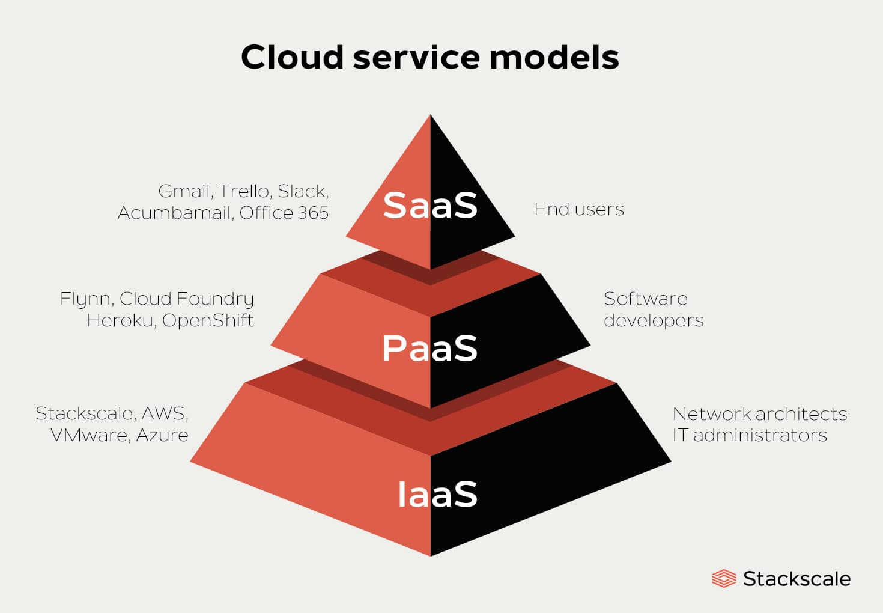

Q3. Draw and explain the architecture of Cloud Computing.

📌 Diagram:
+--------------------+
| End Users |
+---------+----------+
|
+---------v----------+
| Front End |
| Browser / Client |
+---------+----------+
|
Internet
|
-------------------------------------------------
| Cloud Backend |
| +---------------------------------------+ |
| | Application Layer (SaaS) | |
| | Platform Layer (PaaS) | |
| | Infrastructure (IaaS) | |
| | Virtualization Layer | |
| | Storage & Database | |
| | Security & Management System | |
| +---------------------------------------+ |
-------------------------------------------------

Explanation (12 Points)
- Front End – Client device interface.
- Back End – Cloud servers and data centres.
- Internet connects users to cloud.
- Application layer delivers SaaS.
- Platform layer delivers PaaS.
- Infrastructure layer delivers IaaS.
- Virtualization layer creates VMs.
- Storage system stores data.
- Database manages structured data.
- Security system protects data.
- Management software monitors performance.
- Load balancer distributes traffic. 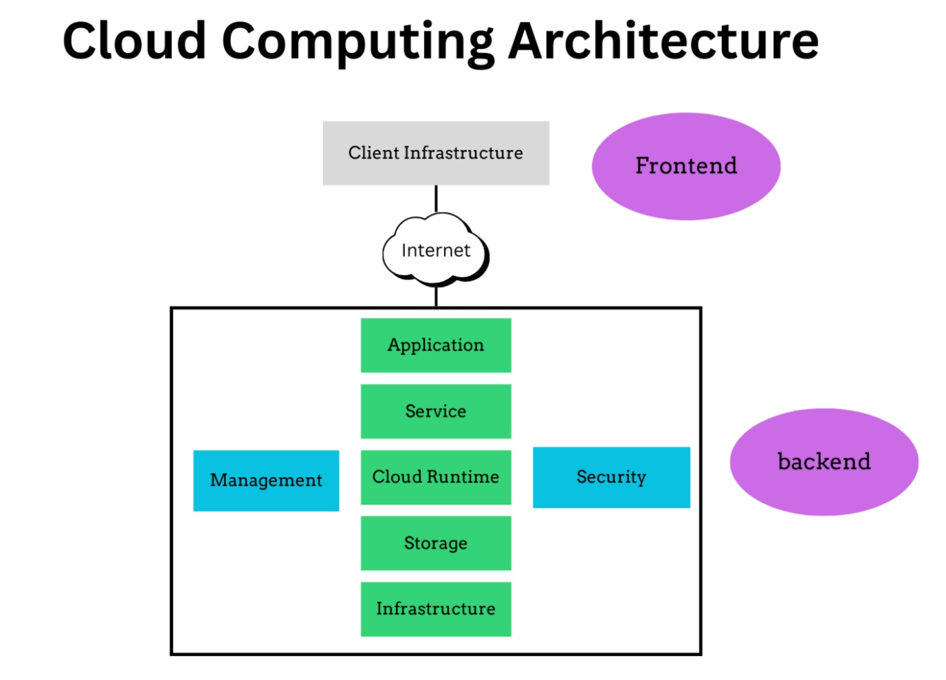

Q4. Explain the role of Virtualization in Cloud Architecture.

Definition:
Virtualization is the process of creating virtual versions of hardware resources like servers, storage, and networks. 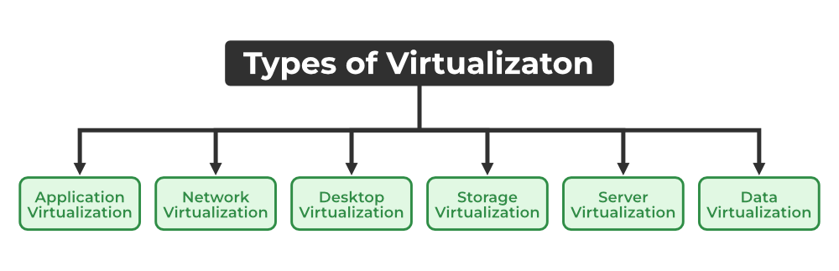

Points:
- Creates multiple virtual machines (VMs).
- Allows multiple OS on single physical machine.
- Improves hardware utilization.
- Provides isolation between users.
- Supports dynamic resource allocation.
- Enables live migration of VMs.
- Reduces operational cost.
- Enhances scalability.
- Improves disaster recovery.
- Provides efficient load balancing.
- Supports cloud automation.
- Backbone of IaaS model.

📌 Virtualization Diagram:
+----------------------+
| Physical Hardware |
+----------+-----------+
|
+-----v------+
| Hypervisor |
+-----+------+
|
-----------------------------
| | |
VM1 VM2 VM3
(OS+App) (OS+App) (OS+App)

Q5. Define Grid Computing with its advantages and limitations.

Definition:
Grid Computing is a distributed computing system where multiple computers work together to solve large and complex problems.
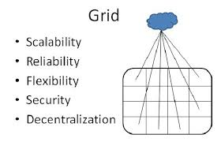

Advantages:
- Efficient use of idle resources.
- High performance computing.
- Cost-effective.
- Solves complex scientific problems.
- Flexible resource sharing.
- Scalable system.
- Parallel processing support.
- Improved productivity.
- Distributed workload.
- Suitable for research organizations.

Limitations:
- Complex management.
- Security risks.
- Network dependency.
- Resource coordination issues.
- High maintenance.
- Not suitable for small tasks.
- Requires high bandwidth.
- Difficult troubleshooting.
- Data synchronization problems.
- Limited control over distributed nodes.

📌 Grid Computing Diagram:
+---------+ +---------+
| Node 1 | | Node 2 |
+----+----+ +----+----+
\ /
\ /
+-------------------+
| Grid Controller |
+-------------------+
/ \
+----+----+ +----+----+
| Node 3 | | Node 4 |
+---------+ +---------+

